PSV Sizing Notes

1. Standards:

API STD 520 for sizing, selection and installation of pressure relieving devices

API STD 521 for pressure relieving and depressurizing system

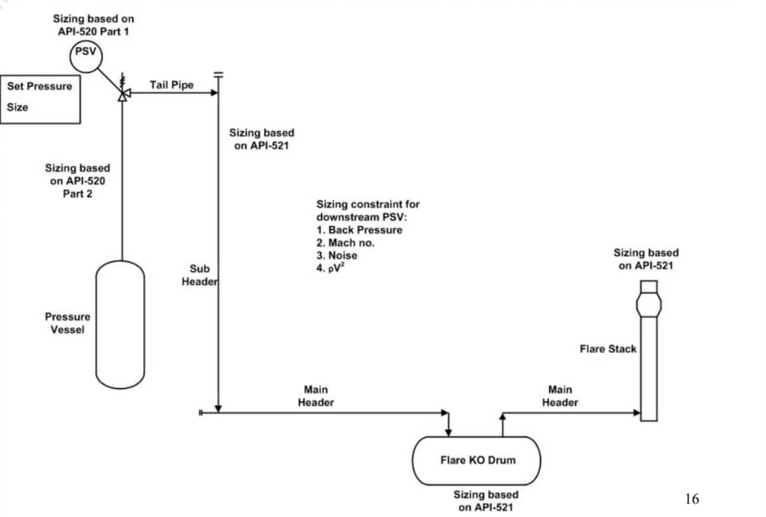

1. Procedure

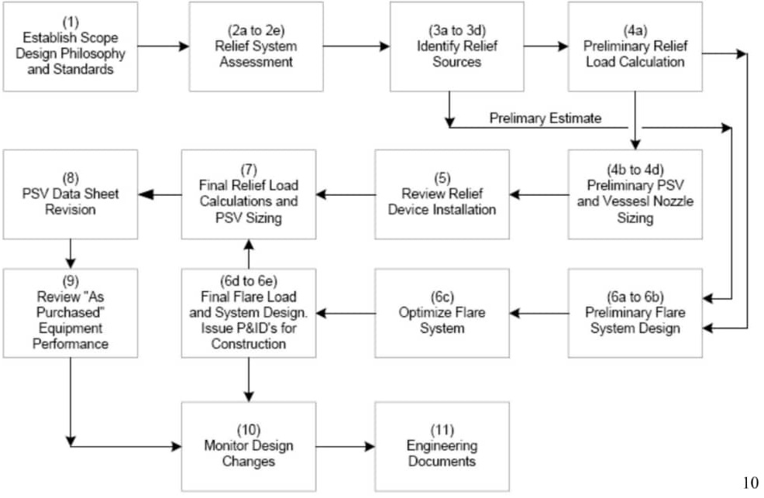

1. Design pressure is the most severe condition of coincident internal or external pressure and temperature (minimum or maximum) that results in the greatest required component thickness and the highest component rating
2. In most of the cases, however, the pressure relieving device is set at the design pressure and not at the M.A.W.P. because the latter is only known late in the design, when the detailed mechanical design of the vessel is completed.
3. Pressure Relief Valve: is an automatic pressure-relieving device actuated by the static pressure upstream of the valve, and which opens in proportion to the increase in pressure over the opening pressure. It is used primarily for liquid service.
4. Pressure Safety Valve: is an automatic pressure-relieving device actuated by the static pressure upstream of the valve and characterized by rapid full opening or pop action. It is used for gas or vapor service. (In the petroleum industry it is used normally for steam or air.)
5. Contingency: An abnormal event which is the cause of an emergency condition
6. MAWP >= DP
7. Set Pressure: is the inlet pressure at which the pressure relief valve is adjusted to open under service conditions.
8. 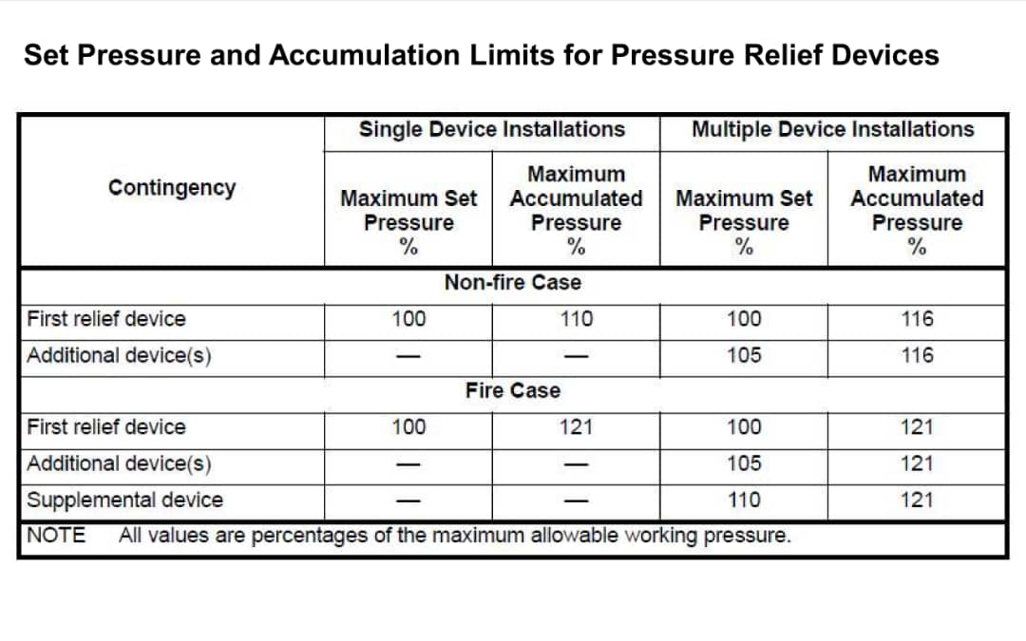Accumulation: The pressure increases over the maximum allowable working pressure of the vessel, expressed in pressure units or as a percentage of maximum allowable working pressure (MAWP) or design pressure. Maximum allowable accumulations are established by applicable codes for emergency operating and fire contingencies.
9. Overpressure: is the pressure increase over the set pressure of the primary relieving device during discharge. Overpressure is the same as accumulation only when the relieving device is set to open at the maximum allowable working pressure of the vessel.
10. Relieving Pressure: is equal to the valve set pressure (or rupture disk burst pressure) plus the overpressure.

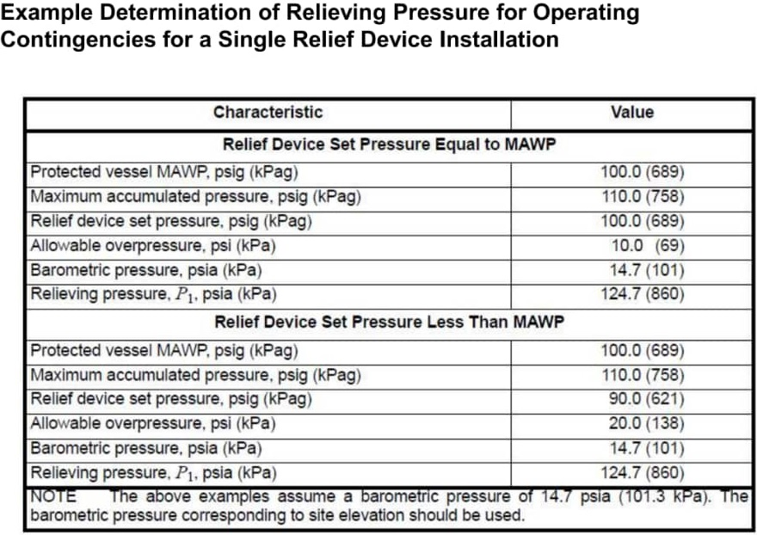is the difference between the set pressure and the reseating pressure of a pressure relief valve, expressed as percent of set pressure?

1. Superimposed Back Pressure: is the pressure at the outlet of the pressure relief valve while the valve is in a closed position. This type of back pressure comes from other sources in the discharge system; it may be constant or variable; and it may govern whether a conventional or balanced bellows valve should be used in specific applications
2. Built-up Backpressure: The increase in pressure at the outlet of a pressure relief device that develops as a result of flow after the pressure relief device opens.
3. In general, restrictions, either a specially designed spool piece or a restriction orifice, should not be used as a means of limiting the capacity of a pressurization path.
4. In case of evaluating the effects of operator response for the study to decide the maximum relieving load, it should be considered that the response time between 10 and 30 minutes for operator to take appropriate action ,depending on the complexity of the plants, is required.
5. When the increased operating condition will not exceed 10 hours at any one time or 100 hours per year, it is permissible to increase the pressure rating at the temperature existing during the increased operating condition, by a maximum of 33 %
6. When the increased operating condition will not exceed 50 hours at any one time or 500 hours per year, it is permissible to increase the pressure rating at the temperature existing during the increased operating condition, by a maximum of 20 %
7. Causes of Overpressure:

Closed (Blocked) outlet → External fire → Inadvertent control valve opening → Check-valve malfunction → Utility failure → Power → Cooling water → Instrument air → Steam → Fuel gas (Fuel oil) → Thermal expansion → Tube rupture of heat exchanger → Abnormal process condition : For example, runaway reaction, and so on → Equipment failure : Fans, Compressor, Pump, Blower, and so on → Column Relief Scenarios (Reflux Failure, Power Failure, etc.)

1. Closed outlet could be caused by:

Downstream control valve fails closed

Isolation valve inadvertently closed by operator

Chemical reactions create a flow blockage

Source pressure exceeds downstream equipment design pressure. Sources are:

Pumps

Compressors

High pressure utilities

High pressure upstream fluids

1. External Fire

All pressure vessels shall be protected from overpressure due to vaporization or expansion of contained fluid caused by exposure to fire by use of a pressure relief valve

In some cases of fire may heat the walls of pressure vessel to temperature

far beyond the specified metal design temperature, creating a real potential

for the vessel to fail at a pressure below the set pressure of the pressure relief

valve.

To determine vapor generation, it is necessary to recognize only that

portion of the vessel that is wetted by its internal liquid and is equal

to or less than 7,6 m (25 ft) above the source of flame

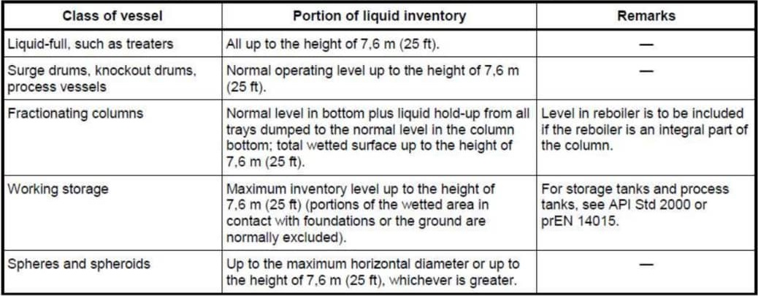

Either the vapor thermal-expansion relief load or the boiling-liquid

relief load, but not both, should be used. It is a practice

 that has been used for many years.

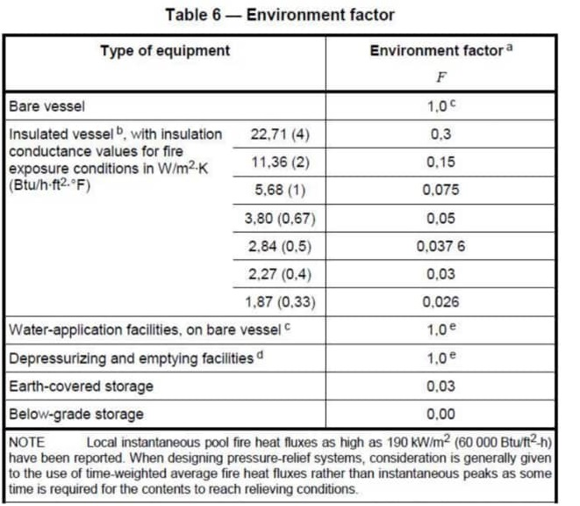

Credit for thermal insulation is typically not taken because it usually does not meet the fire-protection insulation requirements. Thermal insulation not equal to fire proof insulation.

The designer should be certain that any system of insulating materials permits the basic insulating material to function effectively at temperatures up to 900 °C during a fire for up to 2 hr.

The value of thermal conductivity used in calculating the environmental factor

credit for insulation should be the thermal conductivity of the insulation

at the mean temperature between 904°C and the process temperature

expected at relieving conditions. (Use of a conservative mean temperature

of 1000°F (540°C) is suggested.)

For insulated vessels, the environment factor is given by :

 

+Horizontal drum

Up to 25 ft (7.6 m) above grade - Use total wetted vessel surface up to

high liquid level.

Greater than 25 ft (7.6 m) above grade - Use the wetted area of the

vessel surface to high liquid level or up to the vessel center line whichever is

less.

+ Vertical Drums

The wetted vessel surface within 25 ft (7.6 m) of grade, based on high liquid

level, is used. If the entire vessel is more than 25 ft (7.6 m) above grade,

then only the surface of the bottom head need be included. For vessels

supported on skirts that do not require fireproofing of their inside surface the

surface of the bottom head need not be included in the wetted area

regardless of elevation.

Vertical Vessels

A wetted = 1.089 D 2 + π D h

Use this equation when the liquid surface elevation SE < 7.6 m. If the

surface elevation of liquid level is above 7.6 m, replace h by h - (SE – 7.6)

Horizontal Vessels:

# Liquid level below centerline

S=D Cos – 1 ((r- h) / r)

# Liquid level above centerline

S=D {π-Cos – 1 ((h- r) / r)}

A wetted=(2.178D2+ πDL)(S/ πD)

As with vertical vessels, these equations are directly useful when the liquid

surface elevation S E < 7.6 m. If the surface elevation of liquid level is above

7.6 m, replace h by h - ( S E – 7.6).

1. Trayed column

High liquid level in bottom plus liquid holdup from all trays. Level in reboiler is to be included if the reboiler is an integral part of the column. Total wetted surface up to the height of 7.6m. Vessel heads protected by support skirts with limited ventilation are not normally included as wetted surface area. Liquid hold-up on each tray shall be equal to the weir height plus 50mm.

1. Air-Coolers

It is not necessary to consider the bare area for air-cooled condensers, whether

partial or total condensing, as long as both of the following conditions are satisfied:

1. The tubes are sloped so that they are self-draining.

2. There is no control valve or pump connected directly to the condenser

liquid outlet.

1. Relief load calculation for single component:

Calculate Aw then calculate Q-fire then calculate landa then divide Q-fire to landa.

In order to calculate landa put Vf=0 and relieving pressure = 1.21pset + patm.