Tube Rupture Scenario  
 E-3003

**1. Heat Exchanger Data Input**

|  |  |
| --- | --- |
| **High pressure side** | **Syngas** |
| **Low pressure side** | **CW** |
| **Design Pressure of high-pressure side** | **99 barg** |
| **Design Pressure of low-pressure side** | **7.5 barg** |
| **Operating Pressure** | **83.7 barg** |
| **M** | **10.07** |
| **Cp/Cv** | **1.37** |
| **Z** | **1** |
| **Relieving Temperature** | **41.8** |
| **Tube OD** | **25.4** |
| **Tube Thk.** | **1.65** |

**2. Check if a PSV is needed**  
  
 In order to perform this step, do the calculation below:  
   
 multiply design pressure of high-pressure side by 10/13:  
  
 99 * 10/13 = 76.15 barg  
   
 So, design pressure of low-pressure side should be at least 76.15 barg in order not to   
  
 need a PSV. Here it is 7.5 bars, thereby requiring a PSV.

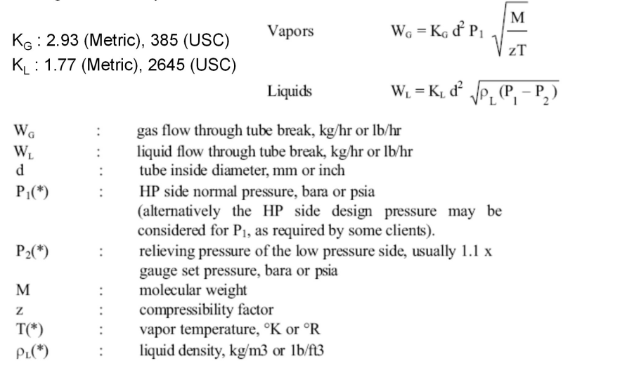**3. Use the formula below to calculate Relief Load**

**4. Relief Load Result**

|  |  |  |  |
| --- | --- | --- | --- |
| **Standard** | **API-521** | **Topsoe** | **TCC** |
| **Wg** | **21675 kg/h** | **19680 kg/h** | **20309 kg/h** |

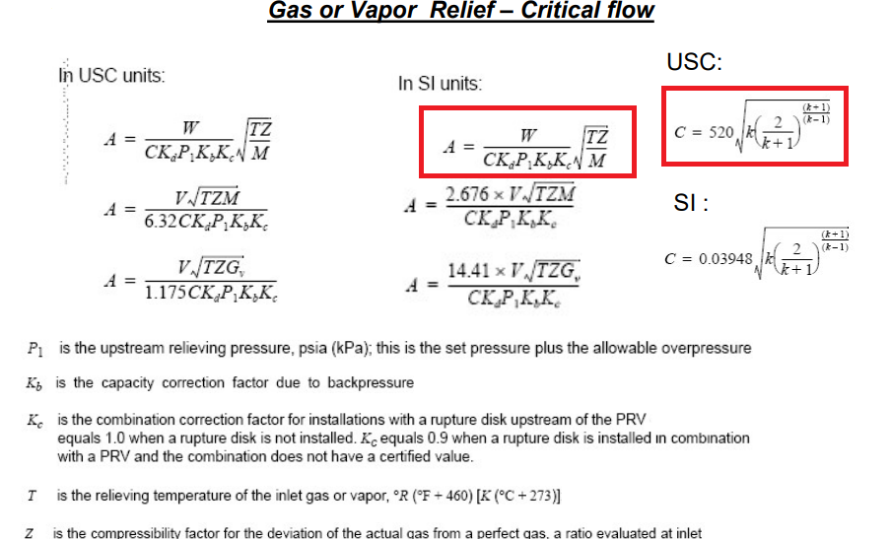**5. Use the formula below to calculate orifice area**

**6. Results**

|  |  |  |  |
| --- | --- | --- | --- |
| **Standard** | **API-521** | **Topsoe** | **TCC** |
| **Orifice area** | **50 cm2** | **45.28 cm2** |  |

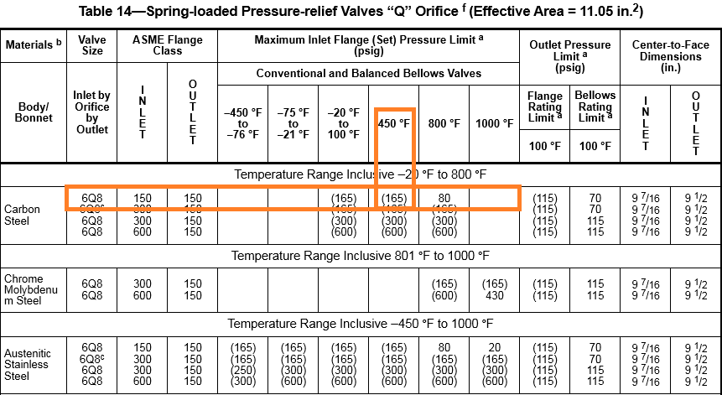

According to table above 6Q8 is selected.Due to low Pb/Pset conventional type can be selected

