Hydraulic Expansion Scenario

E-5010

PSV-5108

1. **Use the formula below to calculate Relief Load**



|  |  |
| --- | --- |
| **Parameters** | **value** |
| **av ( 1/k )** | **0.000454** |
| **duty (watts)** | **300000** |
| **specific gravity** | **0.99** |
| **c ( J/kg.K)** | **4176** |

**Relief Load Calculation**

|  |  |
| --- | --- |
| **Q (lit/m)** | **1.97** |
| **Q (kg/h)-API521** | **118.2** |
| **Q (kg/h)-Topsoe** | **112** |

1. **Calculate orifice area**



**Orifice area calculation**

|  |  |
| --- | --- |
| **Q** | **1.97** |
| **G** | **0.99** |
| **P1** | **8.25 barg** |
| **P2** | **0 barg** |
| **Kw** | **1** |
| **Kc** | **0.65** |
| **Kd** | **1** |
| **Kv** | **1** |

|  |  |
| --- | --- |
| **Calculated Orifice Area-API521** | **0.012cm2** |
| **Calculated Orifice Area-Topsoe** | **0.01cm2** |

**3. Kv calculation**  
 1. Estimate Kv=1  
  
 2. Calculate Orifice area  
  
 3. Calculate Reynold’s Number according to the following equation:

 4.Calculate new Kv

5. Divide calculated orifice area in step 2 by new Kv  
  
6. Check API-526 for nearest orifice area

**Results**

|  |  |
| --- | --- |
| **Selected orifice area** | **0.11 inch** |

|  |  |
| --- | --- |
| **PSV Designation** | **¾” D 1”** |

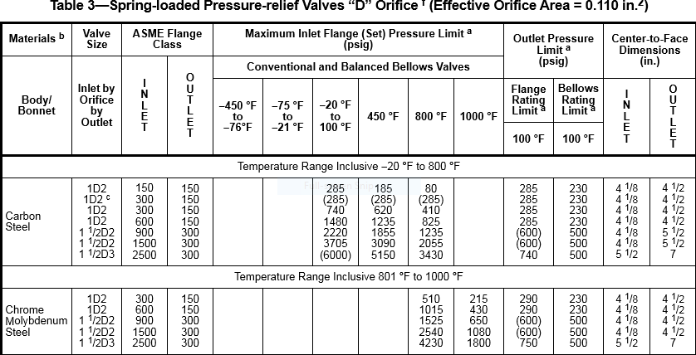

|  |  |
| --- | --- |
| Kv | 0.97 |
| Re | 6931 |

