PSV-2376-2380

Blocked Outlet Scenario

**1.Determine relief load**

The normal capacity of steam is about 388000 kg/h and the rated capacity is

achieved by multiplying the normal capacity by 1.1 which equals to 430000 kg/h.

The total orifice area needed for this case is about 11.75 in2 , which means PSV with Q or R

designation could be used but unfortunately, they are not able to withstand such temperature

and pressure rating.

|  |  |  |
| --- | --- | --- |
| **First relief device** | **Additional relief devices** | **Accumulation** |
| **112barg** | **115.2** | **119.66** |
| **100%** | **103%** | **106%** |

**2.Calculate orifice area**

Determine if it is in critical flow:



If so, then:





**Results**

|  |  |  |  |
| --- | --- | --- | --- |
| **T** | **597K** | **W** | **430000kg/h** |
| **Z** | **0.62** | **A** | **75.84 cm2** |
| **M** | **18.02** | **A** | **11.75 in2** |
| **C** | **0.0242** | **Accumulation** | **16%** |

Note that the relieving temperature is obtained from TOPSOE EXCEL

**5.Use API-526 to determine the designation and the inlet and outlet sizing**

TOPSOE has divided the load between 4 PSV with the designation of 3L6

and I would do the same.



**Select proper PSV type by checking backpressure**

According to licensor data, superimposed and build-up backpressure are max 12 barg. Since

the backpressure is constant and and more than 30% a balanced type could be selected

|  |  |  |
| --- | --- | --- |
| **superimposed** | **Build-up** | **Total** |
| **0 barg** | **3 barg** | **3barg** |
| **0%** | **2.6%** | **2.6%** |

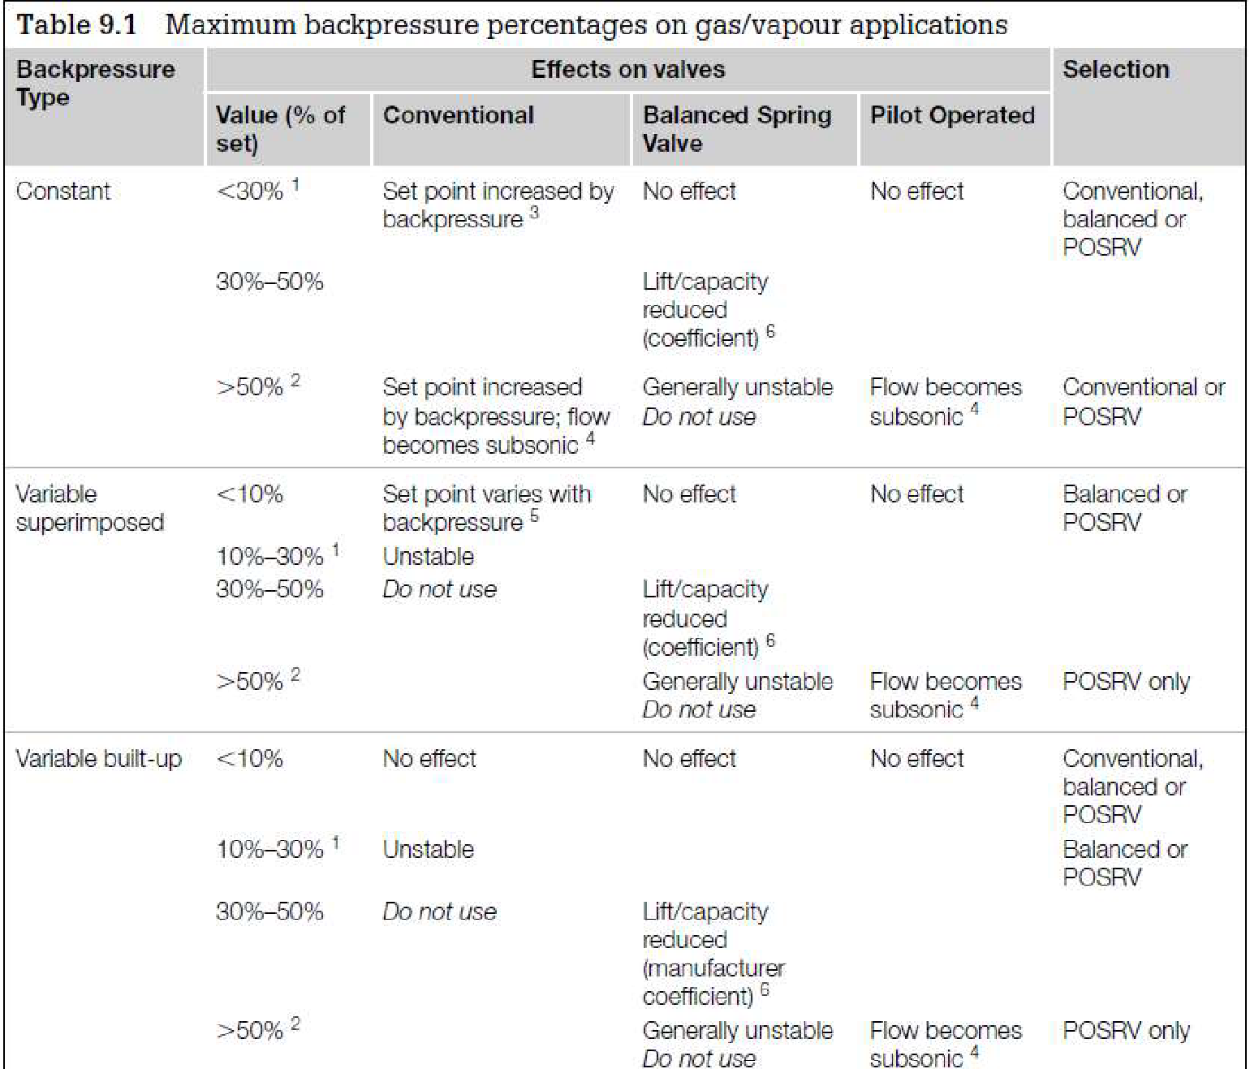

**Discussion**

TOPSOE has selected 4 PSV with 3L6 designation. Why other bigger designations are not

selected?

Simply L designation is the first to withstand such temperature and pressure rating.