PSV-2354-2360

Blocked Outlet Scenario

**1.Determine relief load**

The normal capacity of reformed gas is about 456508 kg/h and the rated capacity is

achieved by multiplying the normal capacity by 1.1 which equals to 502159 kg/h.

Remember since no PSV can discharge such load it is clear that more than 1 PSV is needed

So, accumulation of 16% is considered.

|  |  |  |
| --- | --- | --- |
| **First relief device** | **Additional relief devices** | **Accumulation** |
| **29barg** | **31.4** | **16%** |
| **100%** | **105%** | **116%** |

**2. Calculate orifice area**

Determine if it is in critical flow:

If so, then:







**Results**

|  |  |  |  |
| --- | --- | --- | --- |
| **T** | **633K** | **W** | **502159 kg/h** |
| **Z** | **1** | **A** | **464 cm2** |
| **M** | **13.14** | **A** | **72 in2** |
| **C** | **0.0265** | **Accumulation** | **16%** |

Note that the relieving temperature is obtained from Licensor EXCEL

Remember since no PSV can discharge such load it is clear that more than 1 PSV is needed

So, accumulation of 16% is considered.

**5.Use API-526 to determine the designation and the inlet and outlet sizing**

Licensor has divided the load between 6 PSV with the designation of 6Q8



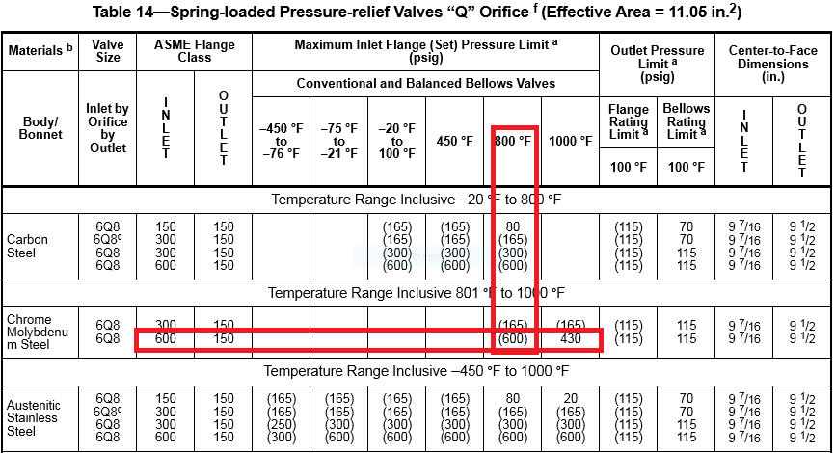

**Select proper PSV type by checking backpressure**

According to licensor data, superimposed and build-up backpressure are max 12 barg. Since

the backpressure is constant and and more than 30% a balanced type could be selected

|  |  |  |
| --- | --- | --- |
| **superimposed** | **Build-up** | **Total** |
| **1.5 barg** | **10.5 barg** | **12barg** |
| **5%** | **36%** | **41%** |

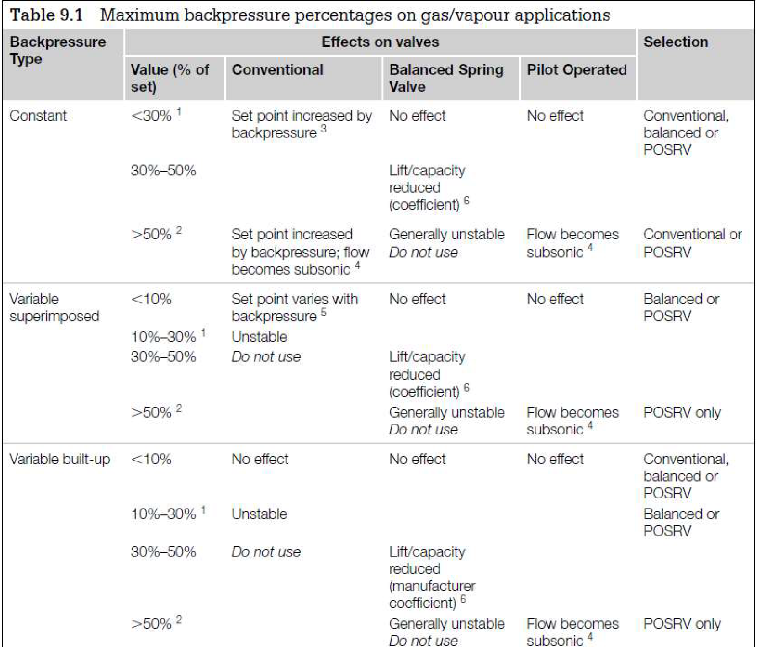

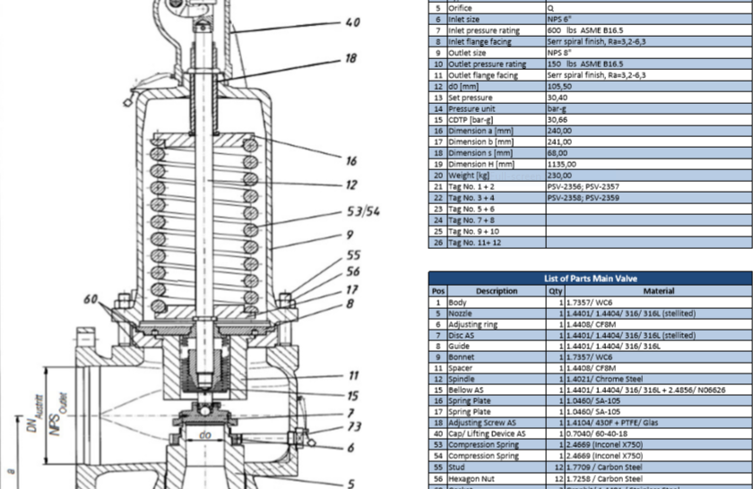**Material Selection**

**Discussion**

Licensor has selected 6 PSV with 6Q8 designation to handle such load to flare system. The

Licensor could have selected 5 PSV with 6R10 designation with total fluid of 550000 kg/h.

Remember PSV with T designation could not be selected since there is no rating for 600 Pound

for this PSV.