PSV-2171-2172

Blocked Outlet Scenario

**Determine relief load**

The rated capacity of FT-2001 is 48000 kg/h , so the relief load is 48000 kg/h.

**2.Calculate orifice area**

Determine if it is in critical flow:

If so, then:





**Results**

|  |  |  |  |
| --- | --- | --- | --- |
| **T** | **467 K** | **W** | **48000 kg/h** |
| **Z** | **0.93** | **A** | **121.89 cm2** |
| **M** | **18.02** | **A** | **18.89 cm2** |
| **C** | **0.0256** | **Accumulation** | **10%** |

Note that the relieving temperature is obtained from TOPSOE EXCEL

**5.Use API-526 to determine the designation and the inlet and outlet sizing**

Since it is more than 16 inch, then T is selected. Also, by checking its rating and temperature

limitation, 6Q8 is selected.



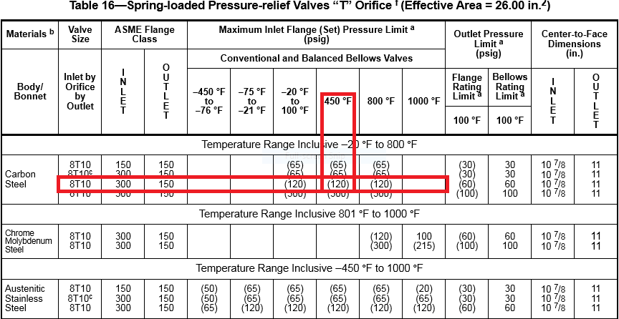

**Select proper PSV type by checking backpressure**

According to licensor data, superimposed and build-up backpressure are max 10 barg. Since

the backpressure is constant and it is discharged to atmosphere then a conventional type could

be selected even though the percentage is high.

|  |  |  |
| --- | --- | --- |
| **superimposed** | **Build-up** | **Total** |
| **0 barg** | **10 barg** | **10 barg** |
| **0%** | **100%** | **100%** |

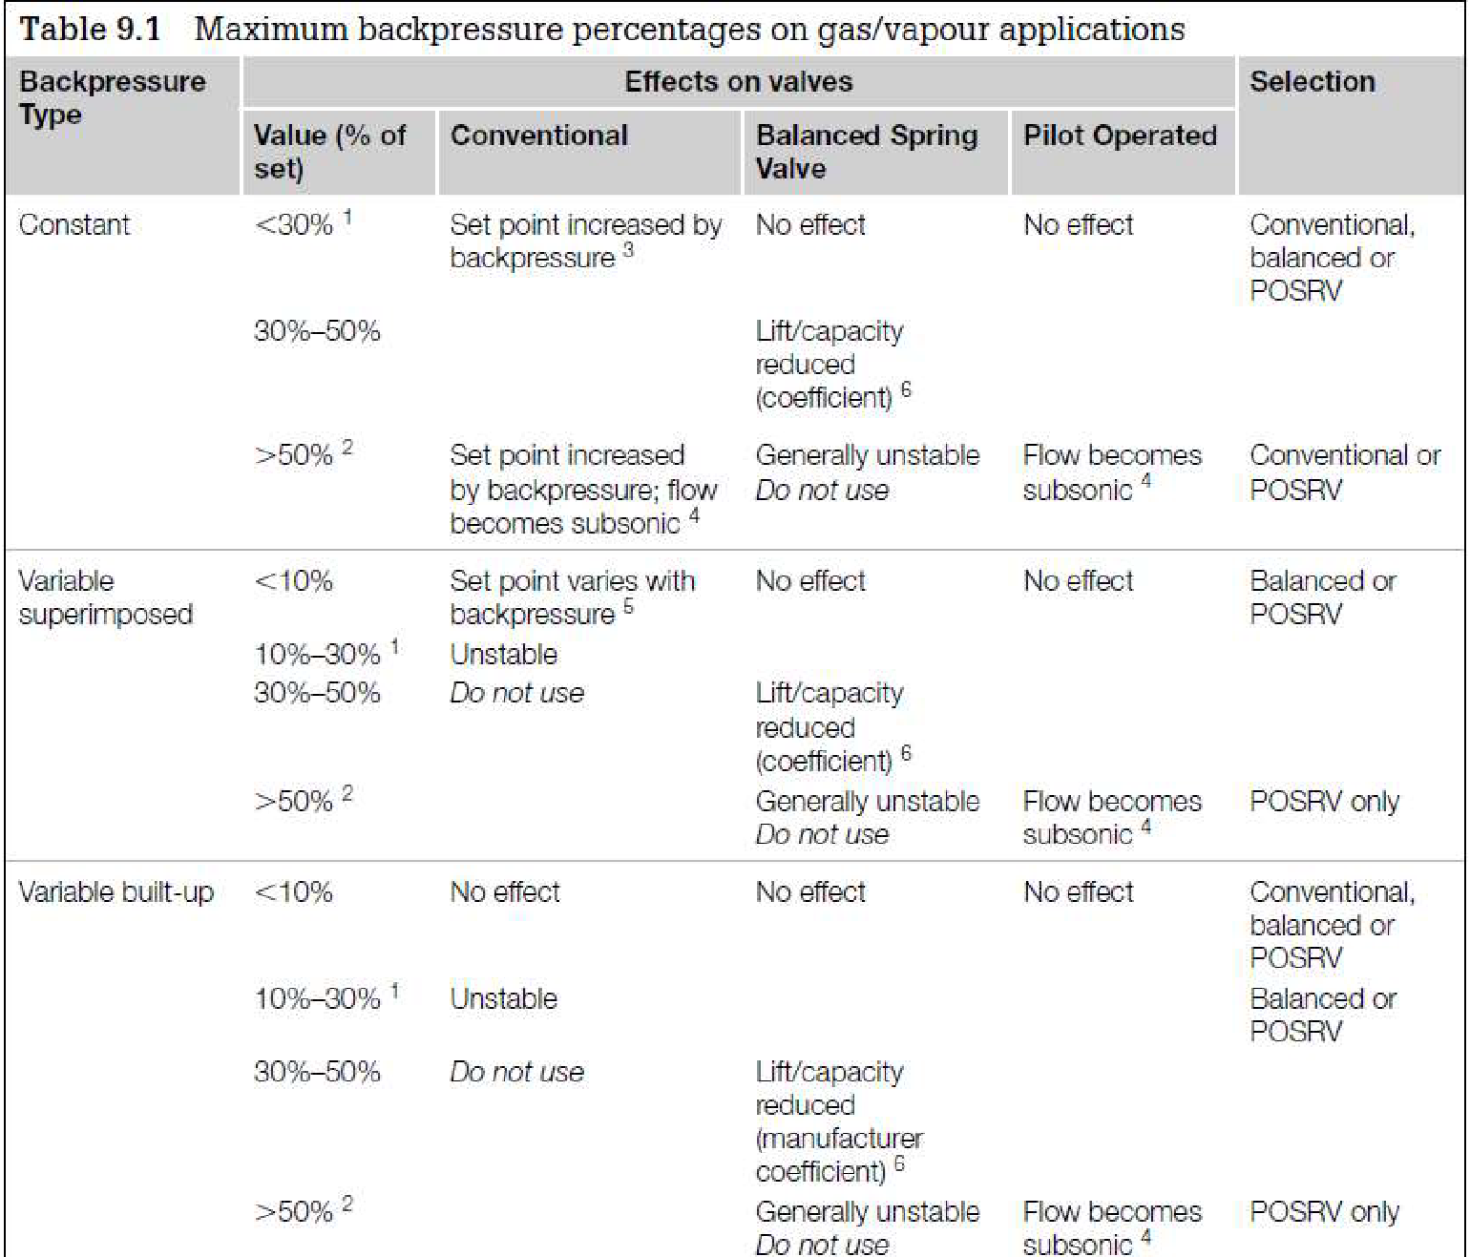

**Material Selection**

Since it is Steam, A216 WCB could be used for its body

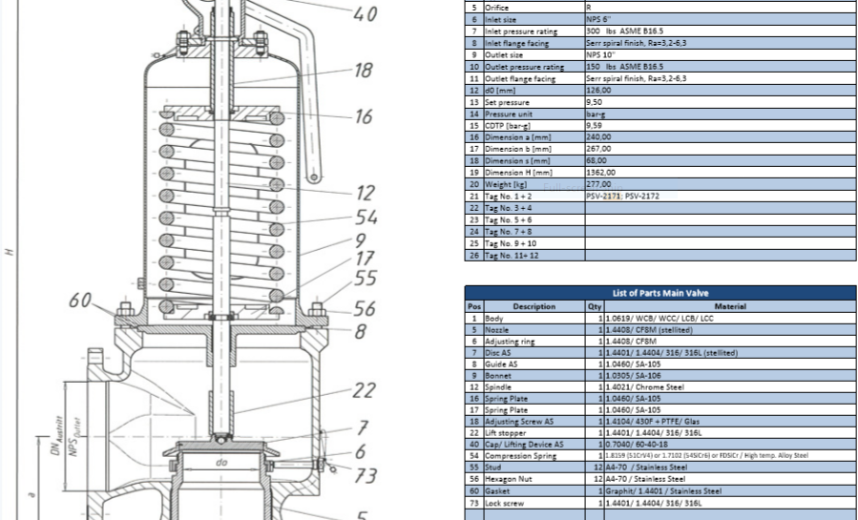

**Discussion**

TOPSOE has selected 6R10 and I, according to rated steam consumption has selected 8T10,

which is really big. Hence, I think TOPSOE is right and TCC has reported overrated steam

consumption which should be lower.