PSV-2121-2122

Blocked Outlet Scenario

**Determine relief load**

The rated capacity of FT-2002 is 27180 kg/h , so the relief load is 27180 kg/h.

**2.Calculate orifice area**

Determine if it is in critical flow:

If so, then:





**Results**

|  |  |  |  |
| --- | --- | --- | --- |
| **T** | **467 K** | **W** | **27180 kg/h** |
| **Z** | **0.93** | **A** | **58.5 cm2** |
| **M** | **18.02** | **A** | **9 in2** |
| **C** | **0.0256** | **Accumulation** | **10%** |

**5.Use API-526 to determine the designation and the inlet and outlet sizing**

Since it is more than 6.38 inch and less than 11.05, then Q is selected. Also, by checking its

rating and temperature limitation, 6Q8 is selected.



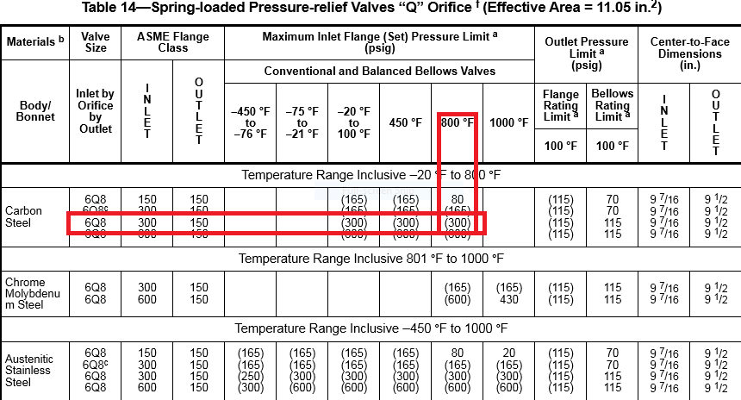

**Select proper PSV type by checking backpressure**

According to licensor data, superimposed and build-up backpressure are max 10 barg. Since

the backpressure is constant and it is discharged to atmosphere then a conventional type could

be selected even though the percentage is high

|  |  |  |
| --- | --- | --- |
| **superimposed** | **Build-up** | **Total** |
| **0 barg** | **1 barg** | **1 barg** |
| **0%** | **10%** | **10%** |

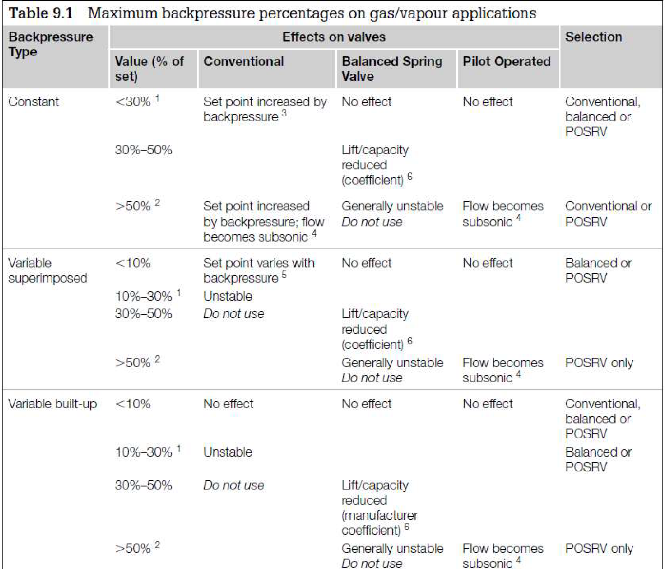

**Material Selection**

Since it is Steam, A216 WCB could be used for its body

