MEKPCO FLARE NETWORK DESIGN
ASPEN FLARENET



Content

- Description

- Design Procedure
  - Select proper Orientation
  - Select and Size proper Inlet Device, Inlet and Outlet ID
  - Calculate Vessel Diameter
  - Calculate Vessel Height
  - Select and Size Manholes, Vent, Drain, Vortex Breaker
  - Select a well-designed mist eliminator pad

Flare System Design Procedure

In order to design a flare package, the following procedure is taken:
- Determination of worst-case scenarios
- Flare network line sizing using Aspen flarenet and API-527
- Flare K.O.D sizing using API-527 excel sheet
- Stack height and diameter calculation by API-527

System Description
The overall Flare system consists of three parts:
1. The first part is made of flare network and K.O.D inside MEKPCO plant. The second part is
made of flare main pipes between the tie-in point of the plant and flare area at the northeast.
The third part consists of flare stack package which will be located on the north mountain. The
stack will be located at X:652388, Y:3051685, Z:135.
2. The flare main header approximate length is considered 2715 for hydraulic analysis
implementation, including the flare piping length 305m between the starting point and the tie-in
point in methanol plant and the flare piping length 2410 between the tie-in point and the actual
flare site.
3. For the flare piping routing, one stress expansion loop is set at about 60 m distance, about
27 stress expansion loops between the tie-in point and the flare stack.
4. For the flare piping routing, the elevation changes between the tie-in location of
methanol plant and the actual flare site is about 111m.
5. The backpressure at the flare stack is 1.4 bara.

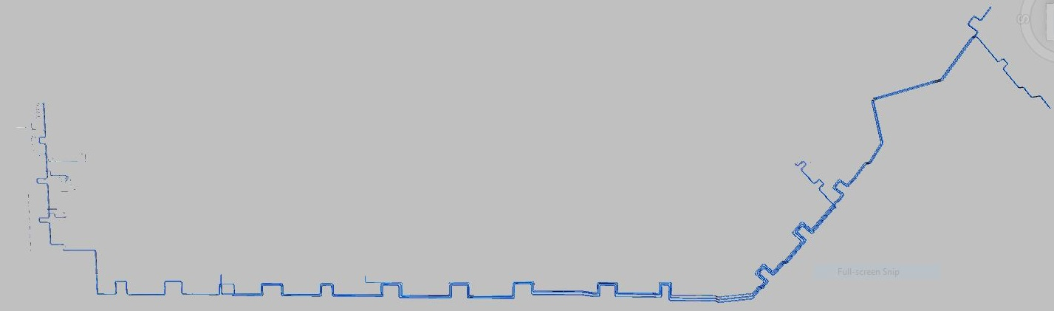
The Whole Plot

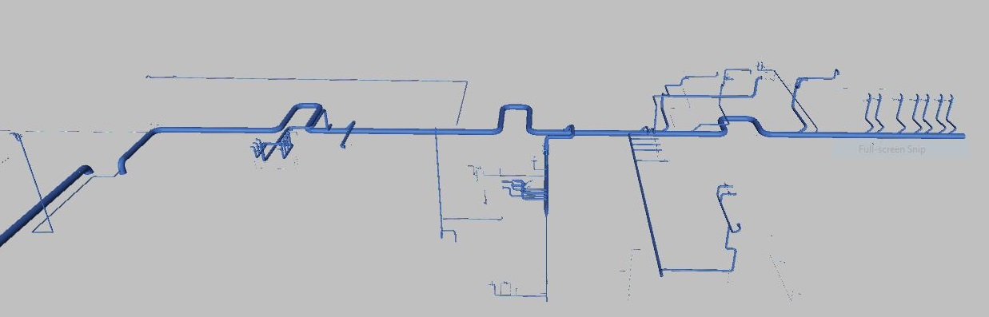
In Site Flare Header
Criteria and Design Basis
The sizing of relief discharge piping can usually be simplified by starting at the system outlet,
where the pressure is known, and working back through the system to verify acceptable
backpressure at each PRD Calculations is performed in a stepwise manner for each pipe
segment of constant diameter.
Several methods for calculating the size of discharge piping have been developed using
isothermal or adiabatic flow equations. Actual flow conditions in relief systems are normally
somewhere between isothermal and adiabatic conditions. For most cases, the slightly more
conservative isothermal equations are recommended.
- For both header and tailpipes, the Mach number of both 0.1 and 0.5 are taken into account.
- The maximum ρν2 for the whole piping should be 150000 kg/m/s2
- The sound/ noise level should not exceed the recommended value of 100 DBA

Determination of worst-case scenario
All possible sources of relief load are summarized below and the worst-case scenario is
detected.
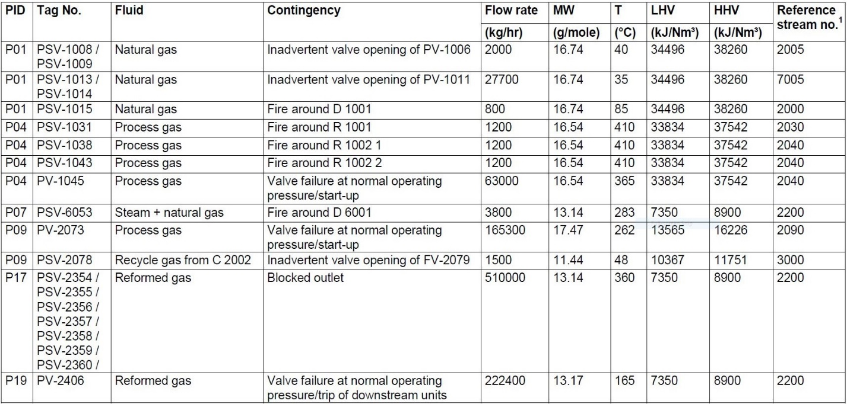
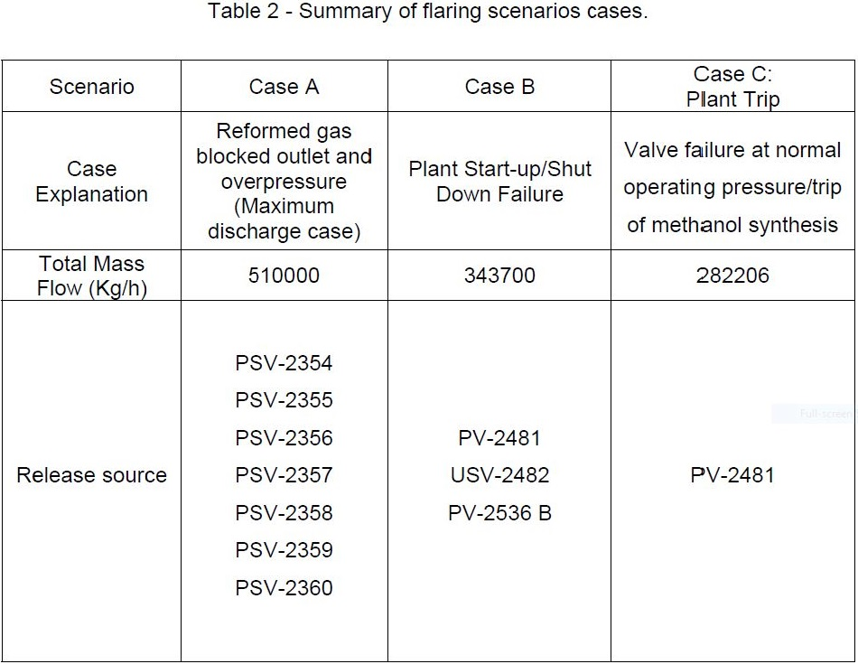
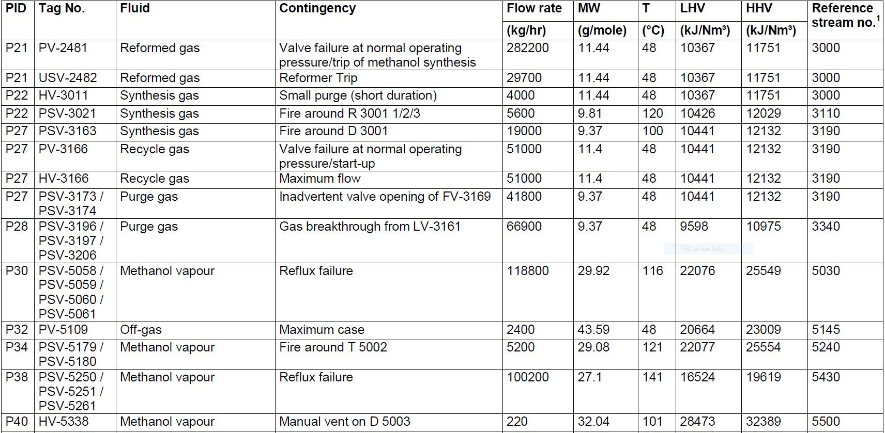
Flare network line sizing using Aspen flarenet and API-527
Procedure: The discharge load of each release point, the backpressure of flare stack, the
diameter and length of each pipe segment is given to seek the Mach number and
backpressure alongside each pipe segment.
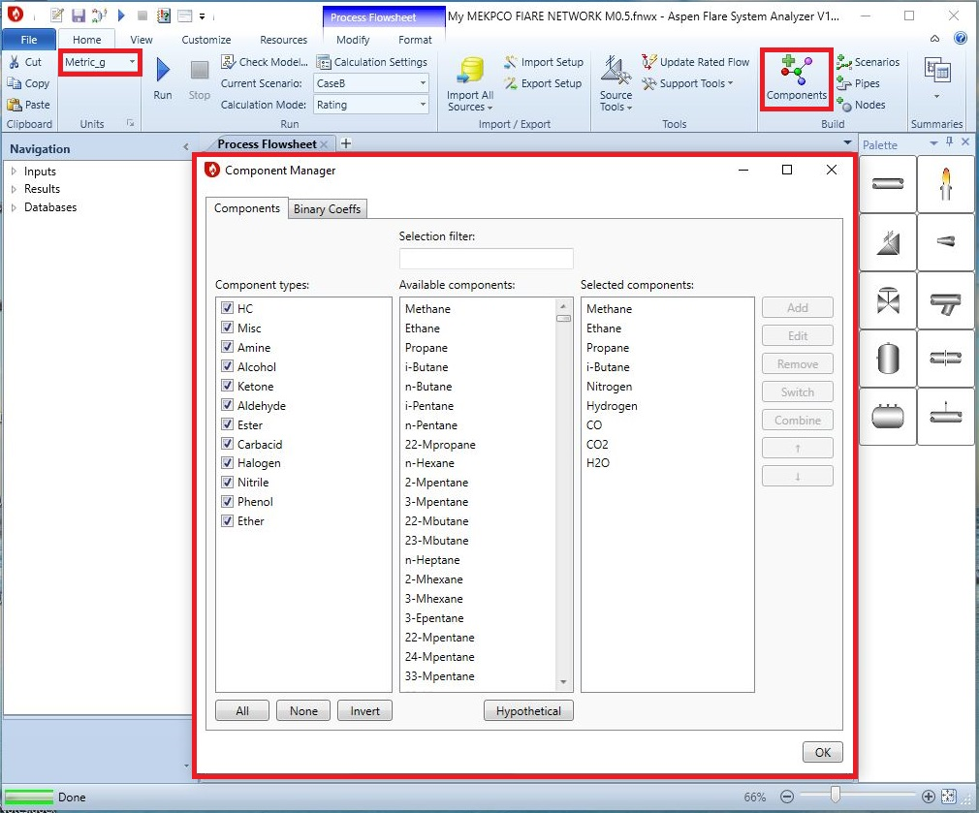
1st Step: Create the component and set the unit

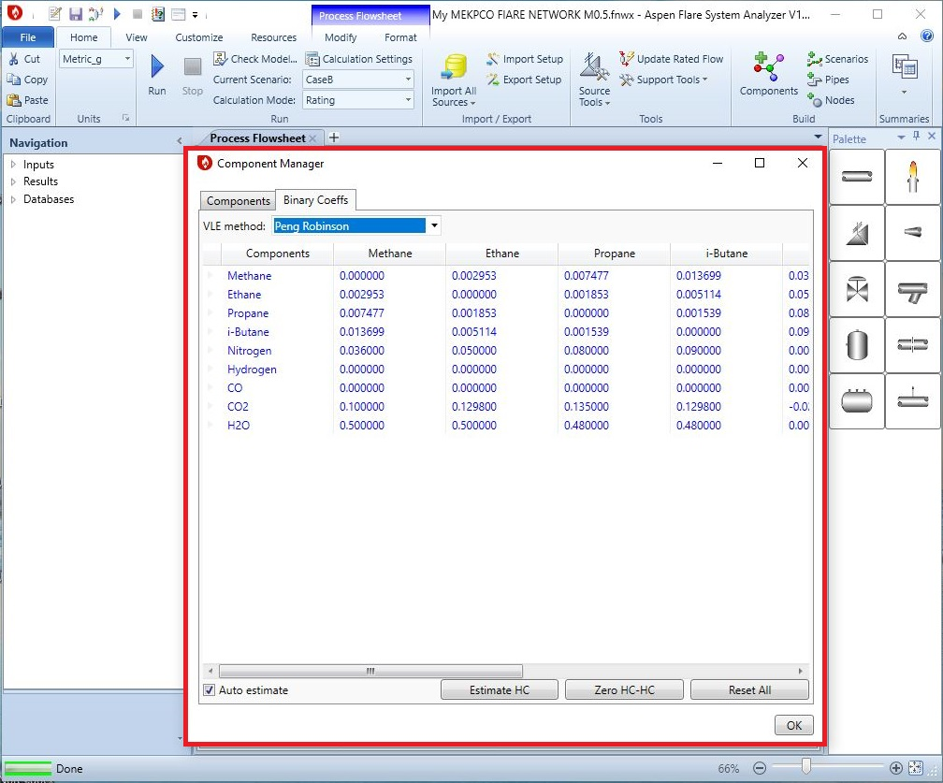

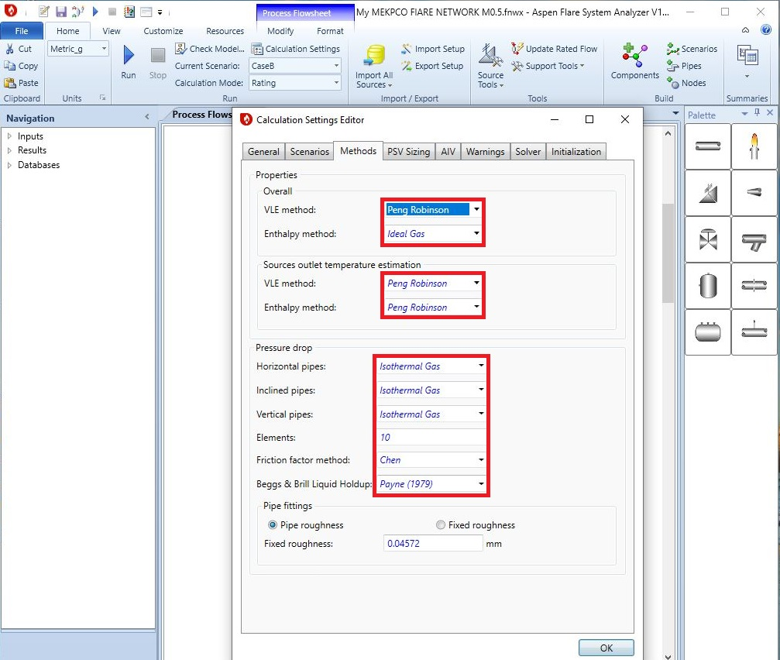
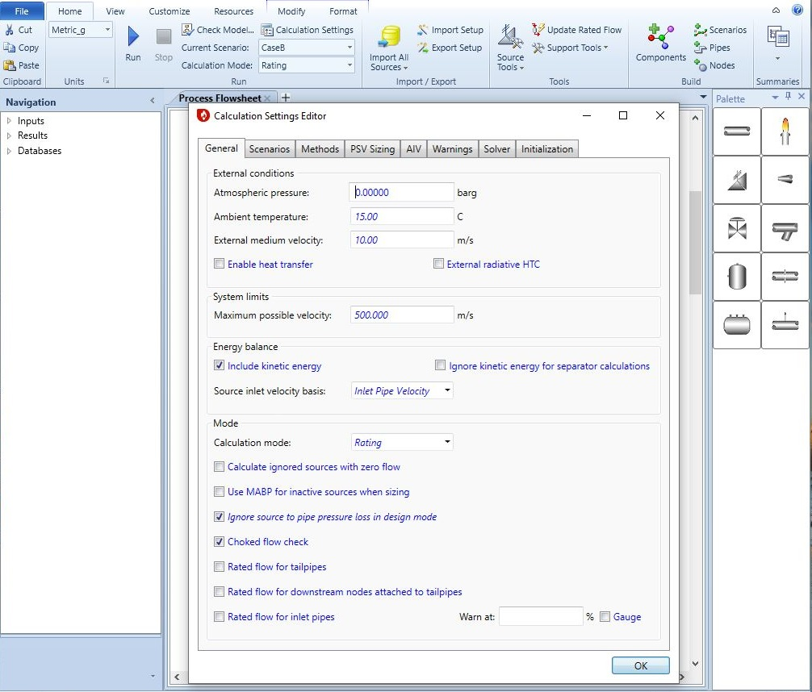
2nd Step: Checking “Calculation Setting”
Note: There is no need to change PSV sizing, Solver, Initialization and AIV tabs in calculation
setting.
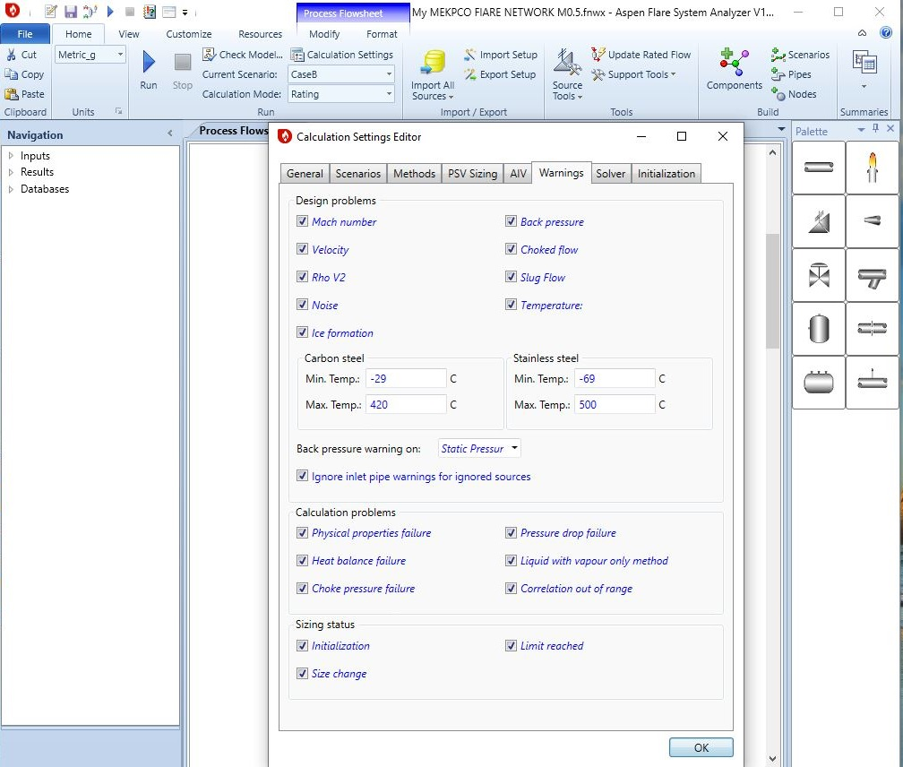

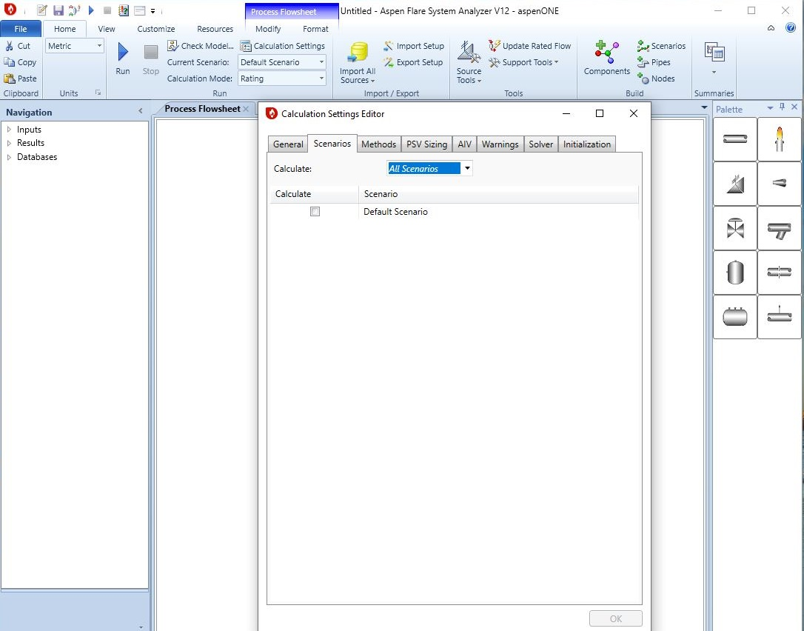

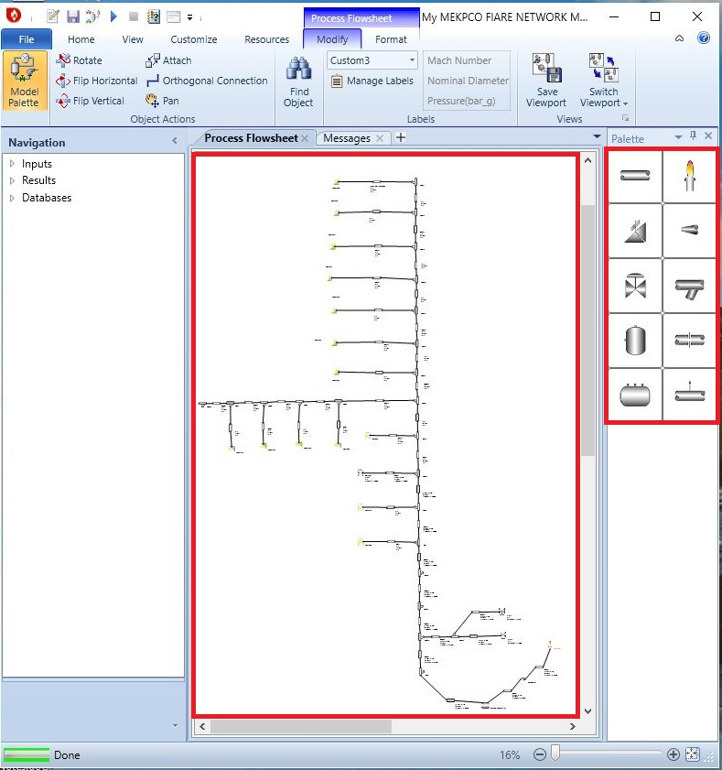
3rd Step: Create the layout

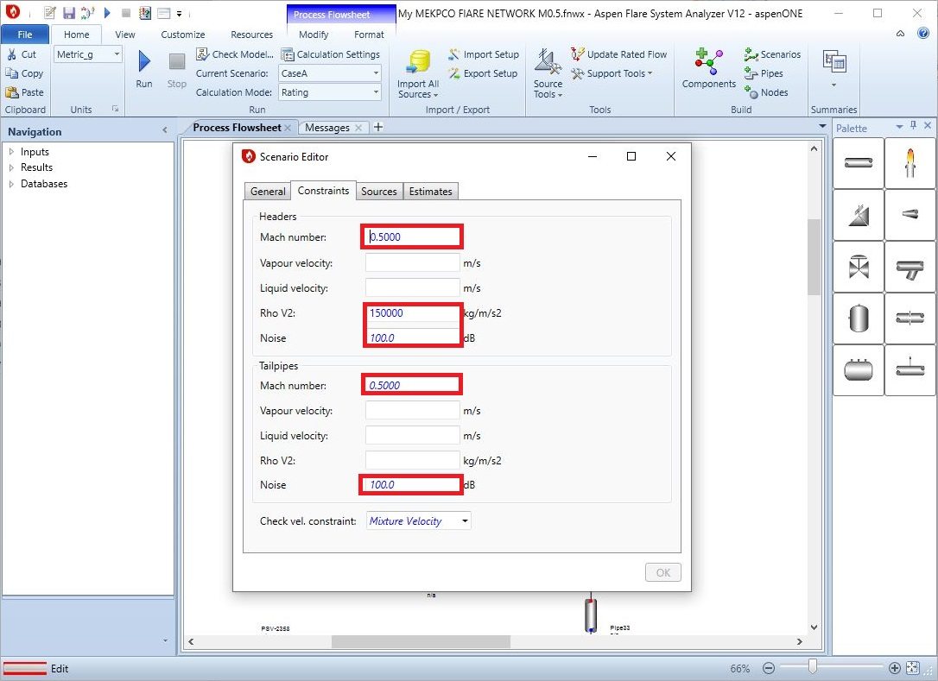
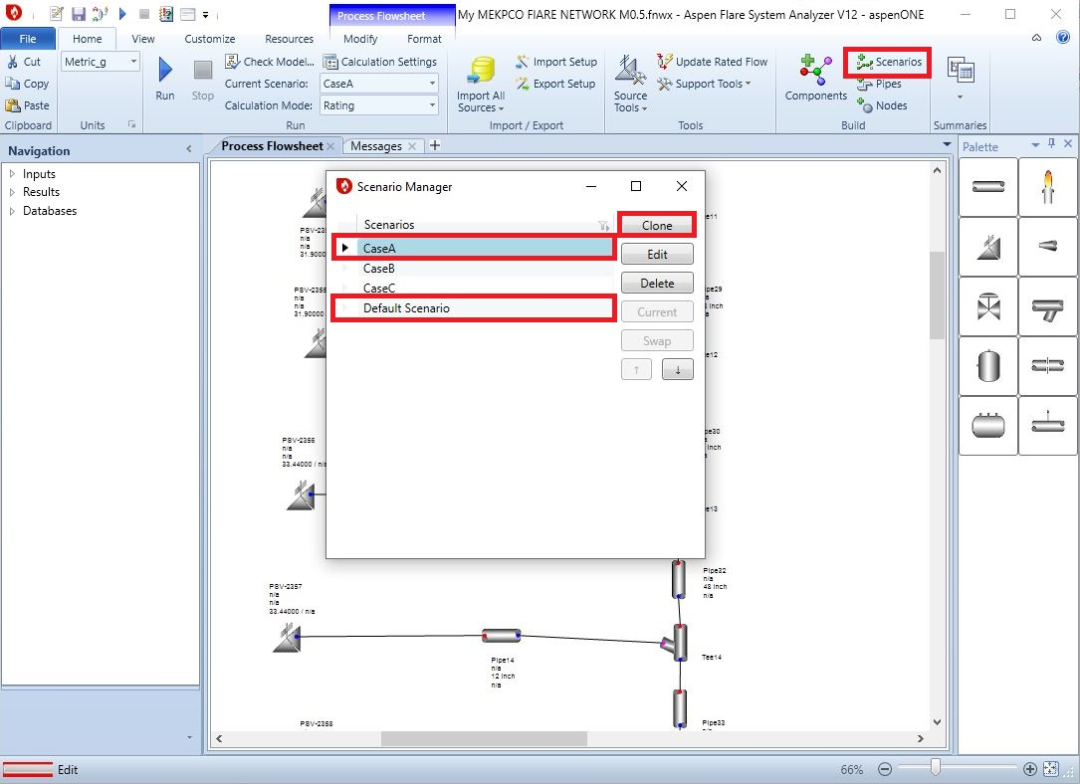
4th Step: Definition of Scenarios

In order to define a scenario, at first “clone” a new scenario from default scenario and then
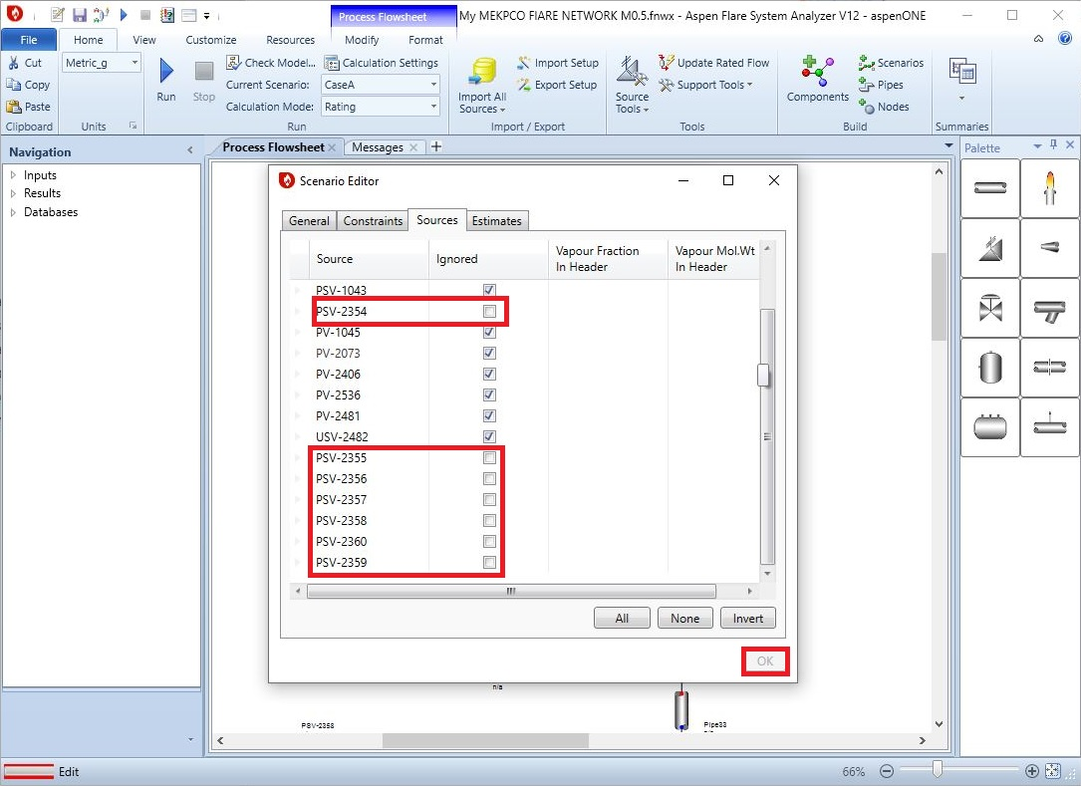
complete the Scenario. Also, in “sources” tab, do not select the PSVs included in the scenario.

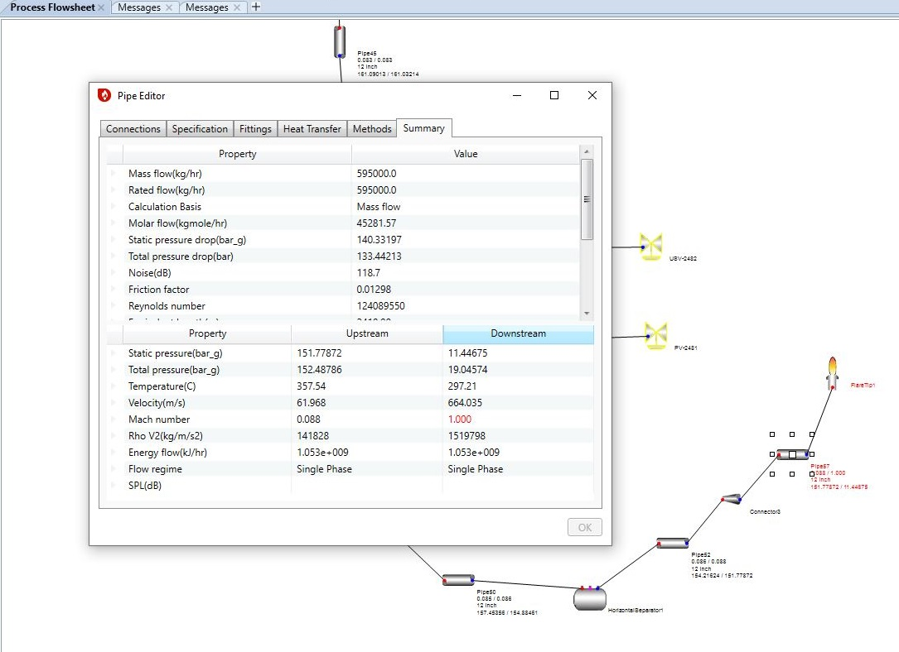

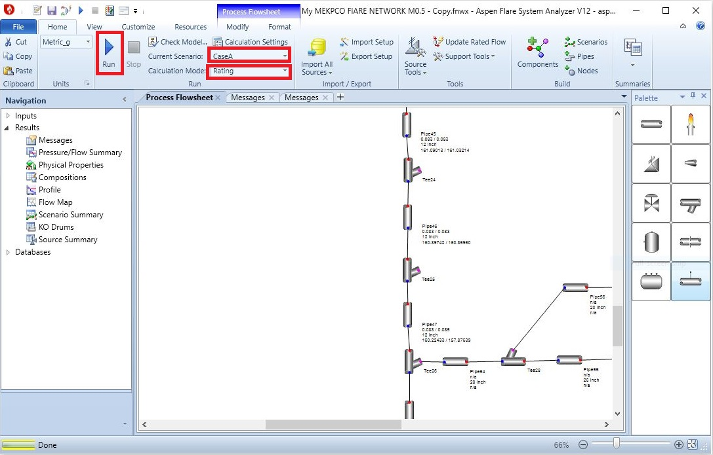
5th Step: Act accordingly and Run the software

Results
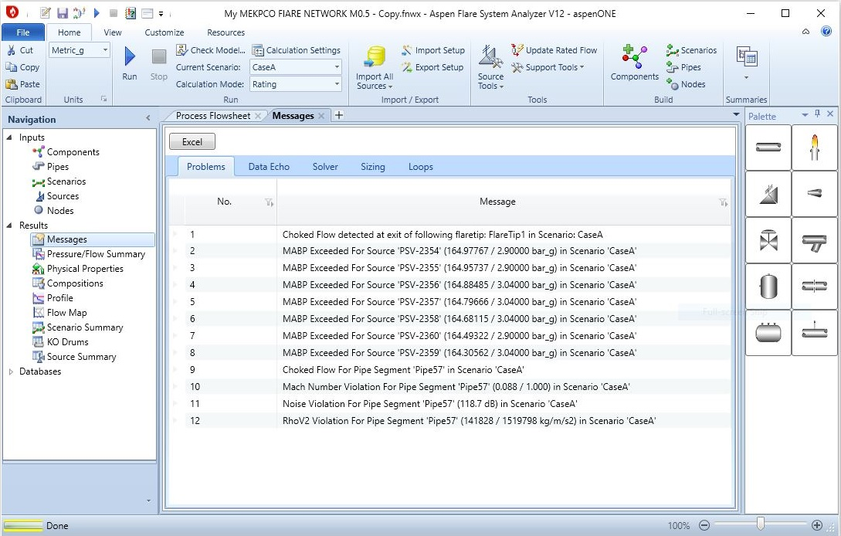

Solution
In order to resolve the warnings, pipe diameters (all 12’) are increased till the constrains are
met. The Starting point is from last pipe segment. When the pipe ID is increased to 54’ then the
Mach number for last segment is decreased to 0.46. it was observed that only last pipe has
experience Mach number violation.
This could be justified by the fact that the pressure in other pipe is too high that the volumetric
flow has reduced dramatically in a way that Mach number is not a problem for these pipes.
Interesting!!
Then other pipe segment diameter were increased and when other pipe ID, one by one,
reached 46’, the whole header and tail pipes Mach number met the constraints. By the way for
smaller diameters like 42’ the tests were carried out but the pipes in the middle of header could
not bear and Mach number criterion was not met.
Also, tail pipe ID were increased to 20’ but the backpressure on PSV-2356-60 was higher than
the set value, therefore, the PSV type were changed to balanced type and their compatibility to
system backpressure was increased and as a result, the warning disappeared. The final
diameter for tail pipes were 12’ and smaller diameter were tested but the Mach number criterion
failed. So, 12’ was selected.
Also, case B and C were tested and for PV-2481, the pipe ID of 28’ was suitable. For PV-
2536B the pipe ID of 8’ was found suitable.
All above calculation are based on Mach number of max 0.5. It is interesting to notice that in
Marjan Project the main header before K.O.D is 48’ and the header after K.O.D to flare site is
expanded to 64’. It seems that in Marjan Project the max Mach number of 0.5 has been
considered as basis of design.
In MEKPCO Project, the max Mach number of 0.1 has been regarded as design basis and as a
result, the main header before K.O.D is 56’ and the header after K.O.D to flare site is expanded
to 64’.Also ,in next page the comparison between IMPLANT and ASPEN FLARENET results for
Mach number of 0.1 is shown.

Case A
PSV-2354 | PSV-2355 | PSV-2356 | PSV-2357 | PSV-2358 | PSV-2359 | P-52-in | P-52-out | P-57-in  Mach | P-57-ou Mach
2.836 | 2.837 | 2.838 | 2.845 | 2.849 | 2.85 | 2.474 | 2.427 | 0.11 | 0.129
2.02 | 2.05 | 2.12 | 2.17 | 2.17 | 2.13 | 1.55 | 1.48 | 0.18 | 0.33

Case B
PV-2481 | USV-2482 | PV-2536 | P-52-in | P-52-out | P-57-in  Mach | P-57-out Mach
1.37 | 1.36 | 1.34 | 1.22 | 1.20 | 0.08 | 0.09
0.87 | 0.99 | 0.78 | 0.67 | 0.65 | 0.11 | 0.14

Discussion
It sounds that TCC has set Mach number of 0.1 as the criterion in order to have noise level
within reasonable limits. Furthermore, Implant and Aspen Flarenet results are compared which
shows good Compatibility.
Also, the deviation might stem from different composition because in absence of exact
composition, MW Of each source were given to Aspen Flarenet and aspen flarenet estimates
the composition.

Flare K.O.D Sizing
1.Knockout drums are typically located on the main flare line upstream of the flare stack or any
liquid seal. If there are particular pieces of equipment or process units within a plant that release
large amounts of liquid to the flare header, it is desirable to have knockout drums inside the
battery limits to collect these liquids. This reduces the sizing requirements for the main flare
knockout drum, as well as facilitates product recovery.
2. The economics of drum design can influence the choice between a horizontal and a vertical
drum. If a large liquid storage capacity is desired and the vapor flow is high, a horizontal drum is
often more economical. Also, the pressure drops across horizontal drums is generally the lowest
of all the designs. Vertical knockout drums are typically used if the liquid load is low or limited
plot space is available. They are well suited for incorporating into the base of the flare stack.
3. Among disparate configurations proposed in API-527, a combination of a vertical drum in the
base of the flare stack and a horizontal drum upstream to remove the bulk of the liquid entrained
in the vapor has been selected for MEKPCO. Horizontal drum with the vapor entering one end
of the vessel and exiting at the top of the opposite end (no internal baffling);
4.A split-entry or split-exit configuration can be used to reduce the drum diameter (but increase
the length) for large flow rates and should be considered if the vessel diameter exceeds 3.66 m
(12 ft). Careful consideration should be given to the hydraulics of split-entry configurations to
ensure the flow is indeed split in the desired proportion. Inlet nozzles should include means
such as baffles or long sweep elbows to prevent re-entrainment of liquid. Long sweep elbows
are typically used up to DN 300 (NPS 12) inlet diameter. Baffles are typically used for larger
inlet diameters. Neither of these rules has been applied for MEKPCO application.
5. In general, vapor outlet nozzles should not be fitted with any devices (e.g. deflection plates,
baffles, demister pads, vane packs, etc.), because of the potential for such devices to fail or
plug and obstruct the outlet. Such devices should be used only if the drum is equipped with an
alternate outlet nozzle sized for the drum’s design vapor flow rate and fitted with a rupture disk
(or pin-actuated device) whose burst pressure is selected both to protect the drum against
overpressure and to permit proper operation of the drum and relief system in the event the
normal vapor outlet becomes obstructed.
6. Liquid droplets 300 um and larger may drop out of the gas stream at less than 2 m/s. If liquids
are not drained from the system, flare flows with gas velocities exceeding about 3 m/s or 4 m/s
can entrain liquid droplets up to 1000 μm in size. Liquid droplets exceeding 1000 μm can readily
lead to burning rain regardless of flare type.
7. Among different flare burner types alluded to in API-527 steam and air-assisted flare burner
has been selected for MEKPCO project. For this design, Flare gases containing less than 1 %
by mass of liquids up to a liquid droplet size of 600 μm can be handled smokeless and without
burning rain. Some air assisted burners with small ports and operated at significant pressures
can handle larger amounts, and with larger droplet size, without smoke.
8. The liquid holdup capacity of a flare knockout drum is based on consideration of the amount
of liquid that can be released during an emergency situation without exceeding the maximum
level for the intended degree of liquid disengagement. The holdup times vary between users,
but the basic requirement is to provide sufficient volume for a 20 min to 30 min emergency
release. Longer holdup times might be required if it takes longer to stop the flow. This holdup
should also consider any liquid that can have previously accumulated within the drum that was
not pumped out. If there has been a liquid discharge to the knockout drum whereby the liquid
level exceeds the maximum level required for adequate vapor-liquid separation, then liquid shall
be removed to reduce the level back below this maximum level.
9. It is important to realize as part of the sizing considerations that the maximum vapor release
case might not necessarily coincide with the maximum liquid. Therefore, the knockout drum size
should be determined through consideration of both the maximum vapor release case as well as
the release case with the maximum amount of liquid. If no valid liquid case exists and the vapor
is either condensable or has a condensable component, then the design liquid case should be a
minimum of 2 wt. % of the maximum gas rate to the flare knockout drum.

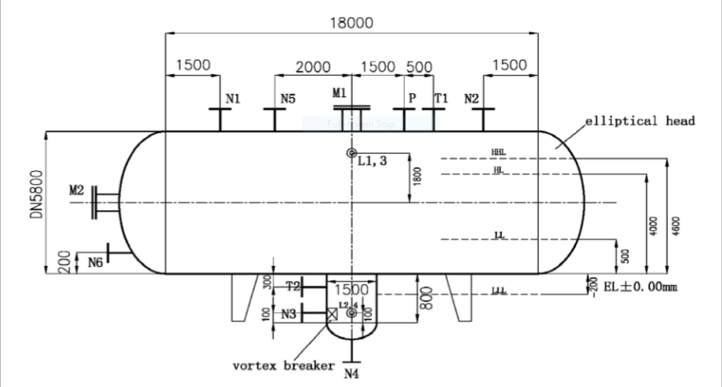

1st Step: Nozzle Sizing
The criterion for inlet nozzle sizing is velocity limitation which should be 7-13 m/s.
The criterion for gas outlet nozzle sizing is velocity limitation which should be 15-30 m/s.
The criterion for inlet nozzle sizing is velocity limitation which should be 2-4 m/s.

Parameter | Inlet Nozzle | Gas Outlet Nozzle | Water Outlet Nozzle
Mass | 540000 kg/h | 510000 kg/h | 30000 kg/h
Density |  | 6.82 kg/m3 | 988 kg/m3
Qv | 20.25m3/s | 20.24 m3/s | 0.01 m3/s
ID-TCC | 64’ | 72’ | 4’
Velocity | 9.76 m/s | 7.7 m/s | 1.04 m/s
My ID | 64’ | 64’ | 3’
Velocity | 9.76 m/s | 9.76 m/s | 1.85 m/s

Note that according to API-521, when there is no criterion stipulating the exact amount of water
which should be separated a minimum of 2% by weight of total vapor mass could be selected as
basis for calc.
But TCC has assumed 30000 m3/h as the rated capacity of K.O.D pump which is Another
matter is that the vendor has selected 72’ as outlet nozzle ID which is a bit bigger than what the
criterion stipulates. Perhaps the vendor was more concerned with droplet sizing so that the
higher the outlet nozzle ID, the lower particle sizing. Probably maximum 300 um has been taken
for Design Basis.

2nd Step: K.O.D Diameter and Length Sizing
1. Assume Diameter and consider L= 2.5 or 3 D
2. Calculate AL and AT according to the following equation:
AL = Q.t/ (L.N) AT = П(D^2)/4 t = Hold-up time
3. Calculate AL/AT and calculate hL/D from the following equation:

4. Calculate hV = D. ( 1 – hL/D)
Parameters | Values
Vapor mass  kg/h | 510000
Liquid mass  kg/h | 30000
ρv  Kg/m3 | 6.8
ρl  Kg/m3 | 990
Dp  um | 300
Hold-up time  minute | 30
L/D | 3
D  meter | 3.5
L  meter | 10.5

5.Calculate uc by following equation:
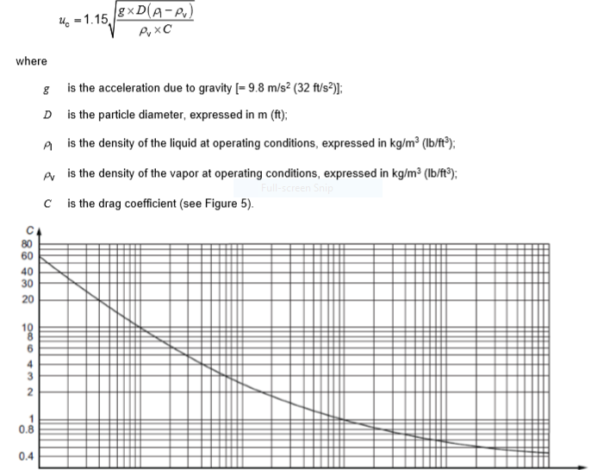

6. Calculate φ = hv/uc
7. Calculate AV = AT-AL
8. Calculate Uv = Qv / (Av.N)
9. Calculate Lreq = Uv. φ .N

Parameters | Value
AL | 1.44
AT | 9.62
AL/AT | 0.15
hL/D | 0.21
ERROR | Goal Seek  Function
hV/D | 0.79
hV | 2.77
Uc | 0.75
φ | 3.7
AV

Parameters | Value
Uv | 2.55
Lmin  m | 9.42
Inlet ID  inch | 64
Outlet ID  inch | 72
LT | 14.6

Parameters | Value
AL | 6.2
AT | 9.62
AL/AT | 0.64
hL/D | 0.61
ERROR | Goal Seek  Function
hV/D | 0.39
hV | 1.35
If initial volume is not zero and is about 50 m3

Parameters | Value
Uc | 0.75
φ | 1.8
AV | 3.42
Uv | 6.1
Lmin  m | 10.98
Inlet ID  inch | 64
Outlet ID  inch | 72
L | 10.5

10.Verification: If L _{Req} is greater than L, increase the drum diameter and repeat the L _{Req}
calculations again until L _{Req} is less than L. Also, hl/D should be max 0.5.
Since L _{Req} is less than L then, we ought to increase K.O.D ID to 4 meter and repeat the
procedure.
So for doing this, we use Goal seek function in Excel to help us reach exact point of hL/D.

Parameters | Value
D | 4
L/D | 3
L | 12
Uc | 0.75

Parameters | Value
AL | 5.43
AT | 12.57
AL/AT | 0.43
hL/D | 0.44
ERROR | Goal Seek  Function
hV/D | 0.55
hV | 2.21

Parameters | Value
φ | 2.95
AV | 7.14
Uv | 2.92
Lmin  m | 8.62
Inlet ID  inch | 64
Outlet ID  inch | 72

TCC has ordered a K.O.D with the following sizing which is oversized in my opinion but
appears to be good in handling such amount of gas and condensate.

Parameters | TCC | API-521 | Sabalan
Diameter | 5.8 m | 4 m | 5m
Length | 18 m | 14 m | 10m

Flaresim Design
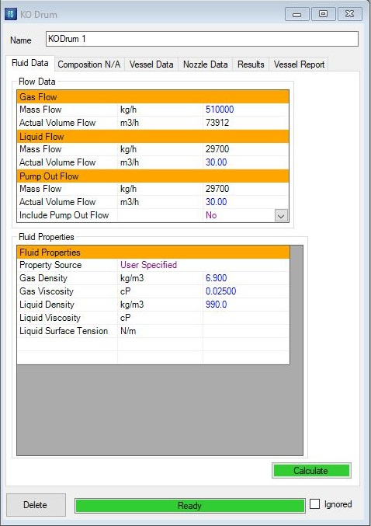

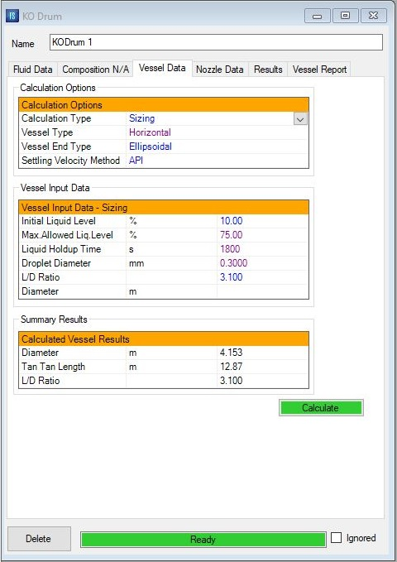

Flare Thermal Radiation Assessment
Based on
API-521 and Schlumberger Flaresim



Calculation of Flare Stack Diameter

In order to calculate Flare Diameter, the following equation between Mach number and
Diameter is used.

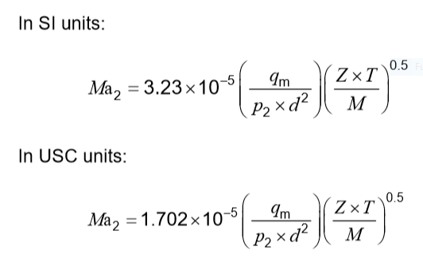

According to TCC calculation a flare stack with diameter of 1.6 m and a height of 44.45 m
Here according to API-521 , the calculated diameter is about 2.46 m when the temperature is
273 K and when the temperature is 633 K for blocked outlet scenario then the calculated
diameter is 3.04 m.

Parameters | Value
T | 273.15 K
Z | 1.33
M | 13.44
P2 | 141 kpa
Mach | 0.1
DD | 2.46

Calculation of Flame Length

1.Calculate liberated heat by following formula and then use next page Figure to determine
Flame Length.
Q = Mass (kg/h) . LHV (kJ/kg) . (1h/3600s)
Q = 712342 Nm3/h . 7964 / 3600 = 1.57 $×$10^6 kW
According to the next-page diagram the estimated Flame Length is round about 70 m.
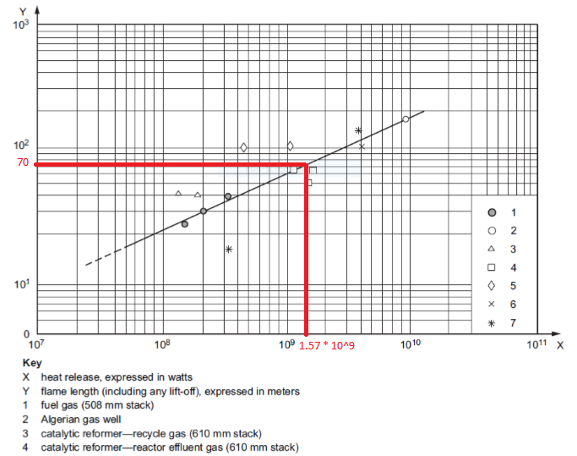

Calculation of Flame Distortion Caused by Wind Velocity

- Calculate vapor volume flow rate
- Divide wind velocity to flare tip velocity
- Use next-page diagram to calculate ∆X and ∆Y.
- Use distance equation and plot to estimate flare stack height.

1st Step

T = 273K
qv = $\text{(51000/3600)}×\left(\frac{22.4}{13.4}\right)×$ (273/273) = 236.8 m3/s
T = 633K
qv = $\text{(51000/3600)}×\left(\frac{22.4}{13.4}\right)×$ (633/273) = 549 m3/s

2nd Step

In order to perform this step, at first, we need to calculate flare tip exit velocity according to
following formula
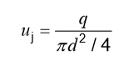

T=273K
uj = 49.6 m/s
T=633K
uj = 75 m/s

So now wind velocity to tip velocity is divided by taking into account 16 m/s as local wind
velocity
T=273K
u/uj = 0.32
T=633K
u/uj = 0.21
T=633K
According to next-page diagram, ∆Y/L = 0.3 therefore ∆Y = 21m
According to next-page diagram, ∆X/L = 0.9 therefore ∆X = 63m
T=273K
According to next-page diagram, ∆Y/L = 0.23 therefore ∆Y = 16m
According to next-page diagram, ∆X/L = 0.93 therefore ∆X = 65m
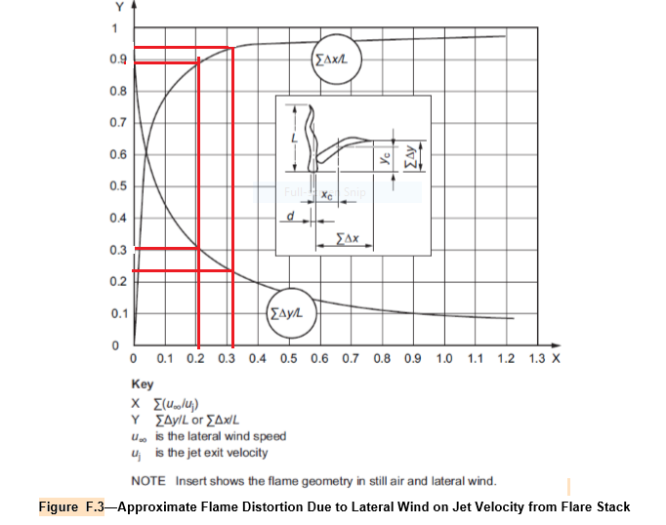

A common approach to determining the flame radiation to a point of interest is to consider the
flame to have a single radiant epicenter and to use the following empirical equation by Hajek
and Ludwig. Equation (F.1) may be used for both subsonic and sonic flares, provided the
correct F-factor is used.
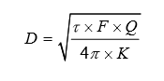

Parameters | Values
τ | 1
F | 0.2
Q | 1.57 $×10^6$
K | 3.13
D | 89.5 m

Parameters | Values
τ | 0.8
F | 0.15
Q | 1.57 $×10^6$
K | 3.13
D | 70 m

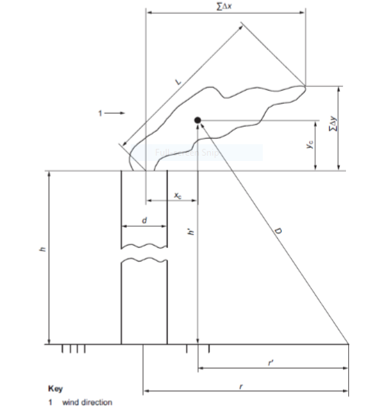
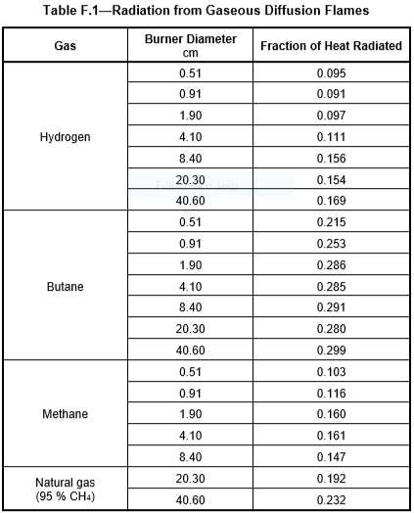
F-factor
T=233K
In order to calculate flare height, the following equation is used.

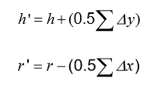

Parameters | Values
r | 35
∆X | 65
r’ | 2.5
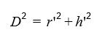

Parameters | Values | Values
D | 89.5 | 70
r’ | 2.5 | 2.5
h’ | 89.4 | 69.9

Parameters | Values | Values
h’ | 89.4 | 69.9
∆Y | 16 | 16
h | 81.4 m | 62 m

T=633K
In order to calculate flare height, the following equation is used.

Parameters | Values
r | 35
∆X | 63
r’ | 3.5

Parameters | Values | Values
D | 89.5 | 70
r’ | 3.5 | 3.5
h’ | 89.4 | 69.9

Parameters | Values | Values
h’ | 89.4 | 69.9
∆Y | 21 | 21
h | 78.4 m | 59 m

An average Flare Stack Height of 70 m is accepted for preliminary design which should be
confirmed by Flaresim.
In MEKPCO project there is one set of elevated flare in Flare system which is supported by
derrick. The total height of flare is 70 m (Flare stack + K.O.D =60m and Molecular Seal and
Flare tip each 5 meter)



1st Step: Click on “Fluid TAB” and “Add” a Fluid Table
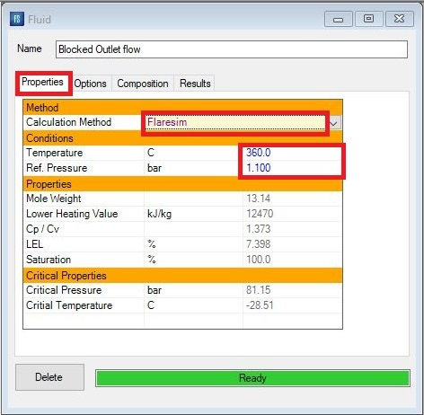
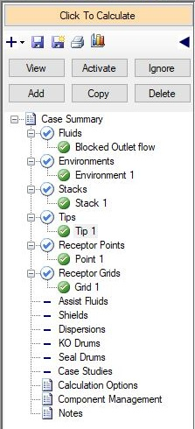

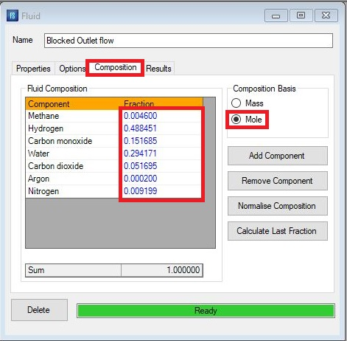

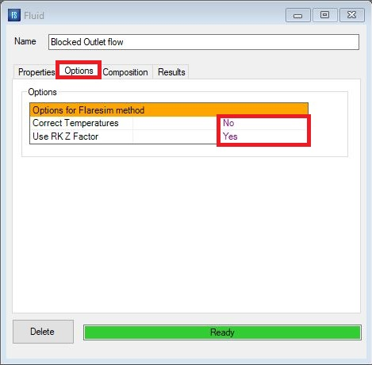

2nd Step: Click on “Environment TAB” and “Add” a Environment Table
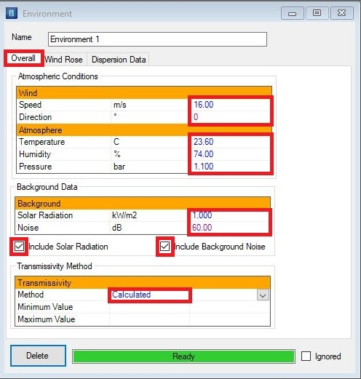

Thermal Radiation and Noise Criteria

According to API-521, the followings are important to notice when designing a flare stack.
Recommended Design Thermal Radiation for Personnel.
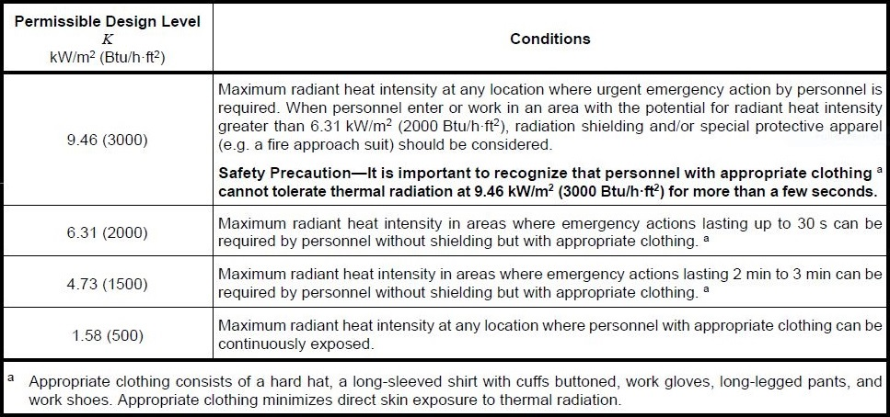

The incident solar radiation for the site. Typical values for different geographical locations are
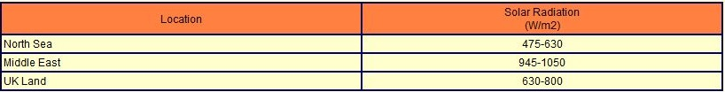
given in the following table.

The decision on whether to include solar radiation when designing flare systems is one for the
user.
API 521 recommends that this be considered on a case-by-case basis. Some consider it more
realistic to exclude solar radiation in calculations.
In deciding whether to include solar radiation consideration should be given to the frequency
and duration of the flaring event, the probability of personnel being present in the exposed
location, the possibility of sun and flare radiation impinging from the same general direction, the
likelihood of protective clothing being worn and the ease or difficulty of escape from the exposed
location.
Including solar radiation leads to more conservative designs and its impact can be significant if
the flare system design is controlled by low total radiation limits at longer distances from the
flare.
Determining whether solar radiation has been included or excluded is important when
comparing flare system designs.
In MEKPCO Project, solar radiation has been included.

Noise
The background noise is used as a reference noise level to which the noise from the flare
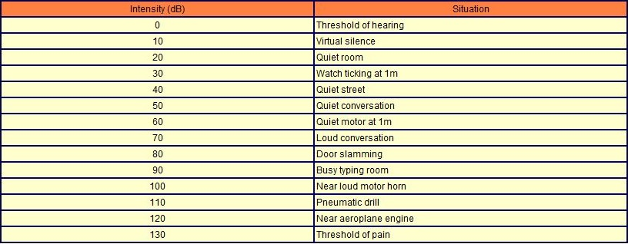
system is added.

In MEKPCO Project, a typical value of 60 dB has been selected for background noise.

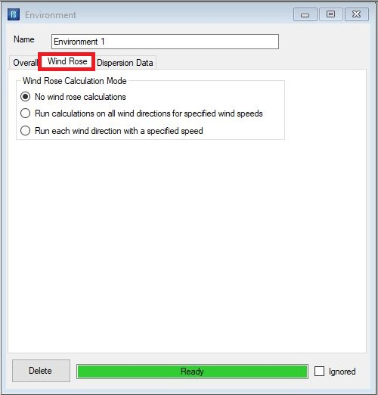

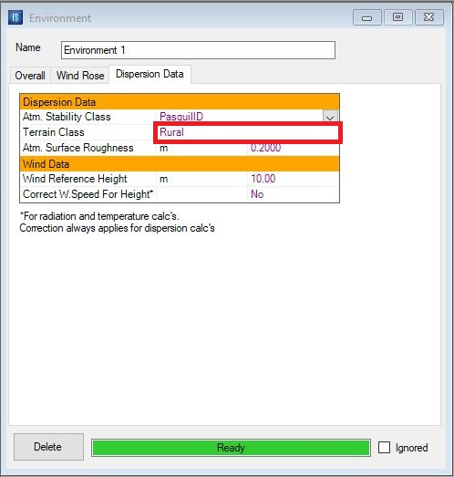

Stability Class
PasquillA through PasquillF
This defines the atmospheric stability class to be used to characterize the atmospheric
turbulence for both Gaussian and jet dispersion calculations.
Flaresim uses the widely used Pasquil stability class designation from A to F where A is the
most turbulent or most unstable atmosphere and F the least turbulent or most stable.
Here as typical, PasquillD is selected.
10-meter high is reference height at which the wind speed is specified. This will be used
together with the atmosphere and terrain characterization information to calculate the wind
speed at a given height when required.

3rd Step: Click on “Stack TAB” and “Add” a Stack Table
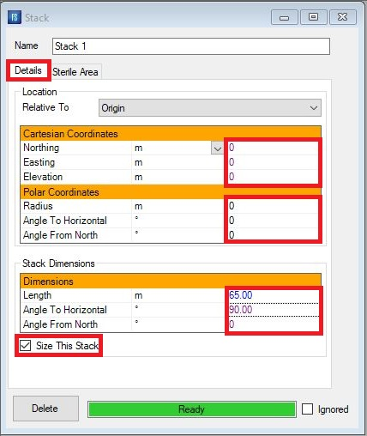

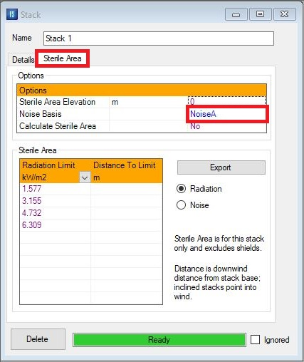

At first estimation, a stack length of 65 m is selected. Since the stack is vertical 90 degrees for
Horizontal angle is selected.
Notice that Noise A means Noise weighted for human ear sensitivity

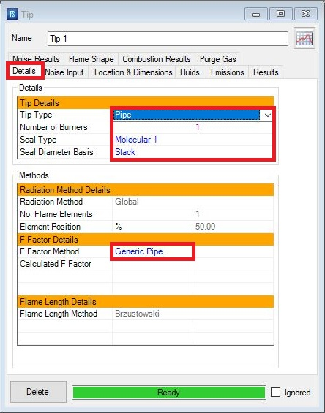
4th Step: Click on “Tips TAB” and “Add” a Tip Table

For gases, either the pipe or sonic tip types may be selected. Pipe flares are the simplest type
of tip and may be specified for both high- and low-pressure gases. If the pressure available is
greater than 2 bar (30 psi) at the tip then a sonic tip can be utilized. Sonic flare tips have the
advantage of low flame emissivities due to more efficient combustion of the flare gas. For lower
pressures a pipe flare is generally used possibly with steam or air Assist fluid.
Where a combined HP/LP tips is selected the HP tip is assumed to be a sonic tip and the LP a
sub-sonic one. The flow ratio of HP to LP fluids should be 3 or greater.
For liquids a Welltest tip type should be selected.
In MEKPCO Project, Pipe is selected.
Seal Type
There are two basic types of seal, Fluidic or Molecular. Seals are only appropriate for pipe and
sonic flare tips. If the tip type is set to Welltest the seal type will be set to None automatically.
The figure below shows the general design concept for the fluidic seal.

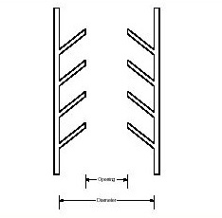

The type selection is a function of the opening as defined below
- Fluidic1: 50% of total area
- Fluidic2: 40% of total area
- Fluidic3: 35% of total area

The figure below shows the general design concept for the molecular seal.

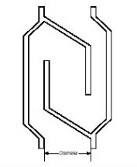

The type selection is a function of the diameter as defined below:
Molec.1: Traditional design. Maximum diameter is 1.7 times the tip diameter. The pressure drop
correlation is based on a design which gives a body length of 5.5m (18ft) regardless of the tip
diameter.
Molec.2: Low pressure drop design. Maximum diameter is 2 times the tip diameter. The
pressure drop correlation is based on a design which gives a body length which is a function of
the tip diameter.

The fluidic seal has a number of advantages over the traditional molecular seal:-
- Lower purge gas requirements and consequent operating costs.

- The seal still operates with a high efficiency even if rain water or chunks of refractory

material drops into the baffles. In fact, the water is quickly dissipated because the fluidic

seal is located at a high temperature section of the flare stack.

- Lower cost due to the simple construction and light weight. A 48" fluidic seal will typically

weigh less than half the weight of a 6" molecular seal.

In MEKPCO Project, Molecular 1 is selected.

Seal Diameter Basis

This entry defines whether the seal calculations are based on the tip diameter or stack diameter.
effectively this specifies whether the seal is located within the tip or the stack.
Here Stack has been selected.

F Factor
The fraction of the total net heat release from the flame which is radiated.
- Natural gas: Correlation based on tip exit velocity assuming a natural gas fluid of
molecular weight 19.
- Tan: Correlation based on mole weight
- Kent: Correlation based on mole weight
- High Efficiency: Proprietary correlation between tip type, exit velocity, fluid molecular
weight and degree of hydrocarbon saturation. Formally known as the Flaresim method in
versions prior to 1.2.
- Cook: Correlation based on exit velocity.
- Generic Pipe: Correlation based on refitting Kent, Tan, Natural gas and Cook methods
across a range of exit velocities and molecular weights.
- Modified. Chamberlain: Correlation based on mole weight and exit velocity.

Which one to select?
Where flare vendor data is available it should be used in preference to a correlation. In the
absence of vendor data, the Generic Pipe method is recommended for a conservative design.
For clean burning, smokeless flares from well-designed flare tips in good condition the High
Efficiency method can be used.
In practice this means flares burning paraffinic hydrocarbons of low molecular weight fluid (<60)
at reasonable exit velocities (> 0.2 Mach). For fluids other than paraffinic hydrocarbons vendor
advice should be sought. In the absence of advice, user specified F Factors of 0.3 to 0.4 are
generally reasonable.
If the Fraction Heat Radiated Method is set to User Specified then the required value for the
fraction of heat radiated must be entered here. Otherwise, the calculated result for the selected
calculation method will be displayed after the model has been run.
Here Generic Pipe is selected.

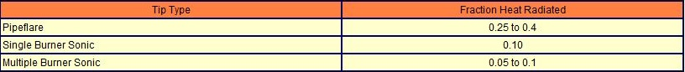

Flame Length Method

- API - Flame length is calculated from heat released according to equation presented in
API 521.
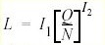
- FLARESIM - Flame length is calculated from heat released using following equation.
Where

L is flame length in m
Q is heat release in J/s
N is number of tips
The constants I1 and I2 take the following values for different tip types
- Brzustowski - Flame length is calculated from flammability limits using Brzustowski &
Sommer method
Here Brzustowski is selected by the Flaresim.

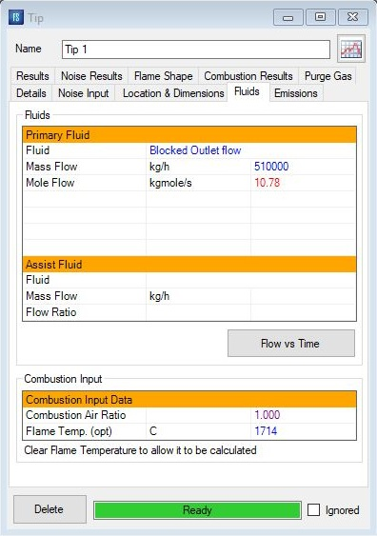

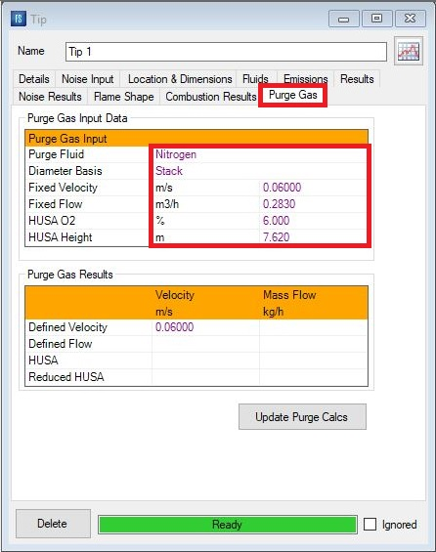

The physical length of the burner tip. The value is used in calculating the true gas exit point for
flame Length calculations and gas dispersion calculations.
For Exit Diameter calculation, click “Size Me” and enter 0.11 as Design Mach number in order to
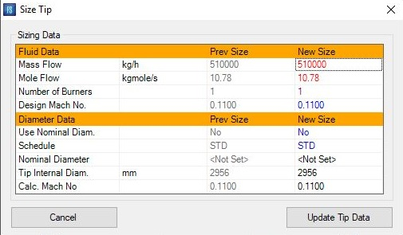
allow the software to calculate proper exit diameter.
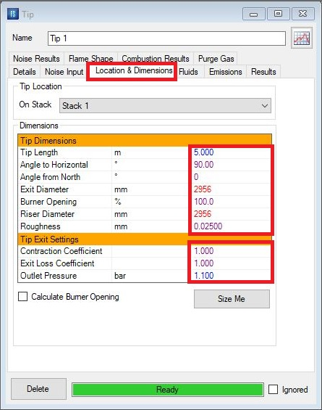

Noise input
Selects the noise calculation method to be used.
1. Acoustic Efficiency method
2. Reference Curve method
The Reference Curve method is based on a reference spectrum of noise at a known heat
release.
Select Noise Curve
1.Standard
2.Low Noise
The Standard and Low Noise reference data options are
proprietary data supplied by a flare system vendor.
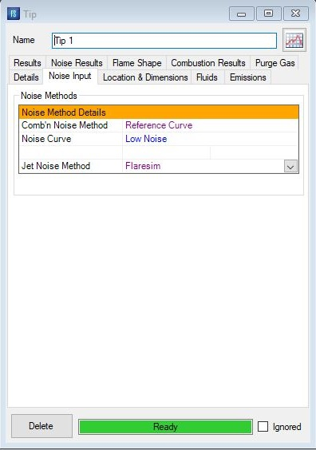

5th Step: Click on “Calculation Option TAB” and “Add” a Table
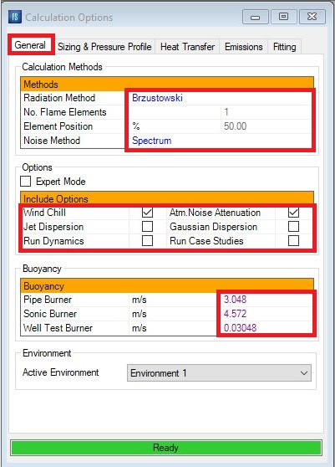

Select the method to be used to model the thermal radiation from the flame.
- The Flaresim API and Strict API methods model the single point source method of Hajek
and Ludwig given in API RP-521. The difference between the methods is in the method
of calculating the flame shape before finding the center point to act as the source. The
Flaresim API method uses the vector-based flame shape method and allows multiple
flame elements to be used to model the shape more accurately even though a single,
center point will be used as the source. The Strict API method uses the graphical
method presented in API 521 through a curve fit to the data presented there. The API
method in DOS versions of Flaresim and Flaresim for Windows versions prior to version
2.0 was the Flaresim API method. Either API method may be generally applied to most
flare systems.
- The Point source method is a multiple point extension of the API method in which the
flame is assumed to be completely transparent such that radiation from one point does
not either interfere with or occlude another. The flame is divided into a series of smaller
point source elements whose contributions are summed to derive the total radiation from
the flame. In practice this method generally gives more realistic and less conservative
values than the API method. It does however tend to over predict thermal radiation in the
near field.
- The Diffuse source method assumes that the flame is completely opaque such that
radiation is emitted entirely from the surface of the flame envelope. This method tends to
under predict the thermal radiation in the near field.
- The Mixed source method is an empirical combination of both the Point and Diffuse
source methods. This has been found to give more realistic results in both the near and
far fields.
- The Brzustowski method is a single point method in which the flame center is
determined from jet dispersion theory. The method as described in API RP-521 is
subject to a number of limitations in its implementation in Flaresim: -

- Only vertical tips may be modelled.
- Air assisted flares may not be modelled.
- Liquid burners may not be modelled.
- The M.Point Brz method is a Flaresim extension to the standard Brzustowski method to
allow the number of flame elements and the element position to be specified by the user.
In versions of Flaresim prior to 1.2 these options could be set for the Brzustowski
method. In Flaresim 1.2 the Brzustowski method is forced to be a single flame element
with fixed element position. Old cases that specify the Brzustowski method will be
updated automatically to M.Point Brz if they have more than one flame element or the
element position is not 50%.
- The Chamberlain method, also known in the industry as the Shell Thornton method is
based on a modelling the flame as a conical frustum radiating from its surface with a
uniform emissive power. The method was developed to provide more accurate
predictions of flame shape and radiation in the near field.

Number of flame element

The number of elements that the flame is divided into for calculation of flame shape and
the sources for the Point, Diffuse and Mixed methods. Larger values will generally give
more realistic values for the thermal radiation at the expense of calculation time.
1 Element is set for this case.

Element Position

The element position indicates the source point within a flame element that is used for
calculations. Typically this is 50% i.e. the middle of the flame element is taken to be the
point source. 0% indicates the source is the start of the element, 100% is the end.
50% is set in this project.
Noise Method
Selects the method to be used for the noise calculations. The API method taken from
RP521 is a simple single value method and considers jet noise only. The Spectrum
method uses multiple frequency values and includes combustion noise. Generally, the
Spectrum method is recommended.
Spectrum is selected.

Windchill
When set an empirical Windchill correlation is used to correct the incident thermal radiation at
any receptor point by taking into account the heat losses due to passage of wind over the point.
Use of this option will generally be a matter of individual judgement or your company standards.
It is recommended that you do not use this option if you are interested in the surface
temperature calculations. Note that effective of wind on convective heat transfer in the surface
temperature calculations is independent of the setting of this option.

Atm. Noise Attenuation
When set a correction will be applied to the noise calculations to allow for the attenuation in
noise due to atmospheric absorption. This option should normally be set

Jet Dispersion
Selecting this enables the jet dispersion calculations and will calculate concentrations of flare
fluid at receptor points and for receptor grids under flame out conditions

Gaussian Dispersion
Selecting this enables the calculations for all Gaussian Dispersion objects defined in the model

Run Dynamics
Selecting this enables dynamics calculations to be run to evaluate the change in radiation and
other results with time as the flare flow varies with time. The variation in flare flow with time must
be defined on the Tip Dynamics View and the results variation with time can be viewed on the
Receptor.

Point Dynamics View
The dynamics calculations are run in addition to the defined base case. Receptor Grid objects
and Dispersion objects are not included int the dynamic calculations

Buoyancy
For all methods except the Brzustowski and Chamberlain methods, the flame shape is
calculated by resolving the velocity vectors in three dimensions. The main components are the
tip exit velocity and the wind velocity. There is however an additional velocity component which
is due to the density differences between the hot combustion gases and the surrounding air.
This is referred to as the flame buoyancy term.

Buoyancy - Pipe
The flame buoyancy which should be used for Pipe flares. A value of 3.0 m/s is recommended
unless specific vendor information suggests otherwise.

Buoyancy - Sonic
The flame buoyancy to be used for Sonic flare tips. A value of 4.6 m/s is suggested unless
specific vendor information suggests otherwise.

Buoyancy - Welltest
The flame buoyancy to be used for Liquid flare tips. A value of 0.03 m/s is suggested unless
specific vendor information suggests otherwise.
The recommended buoyancy values are based on empirical information supplied by a flare
vendor. The wide range of allowed values is intended to provide flexibility for users with specific
information and the validity of any values entered is the responsibility of the user.
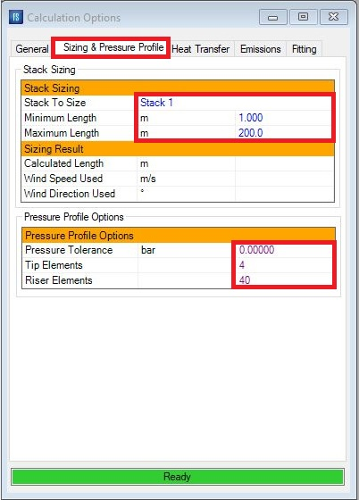

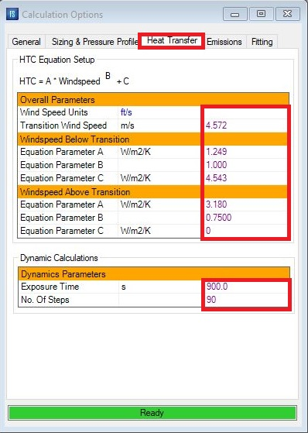

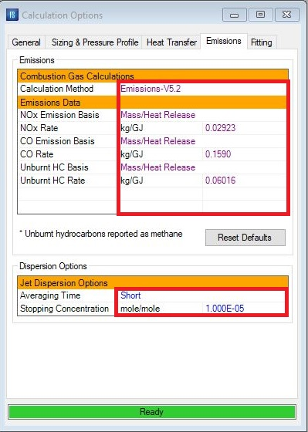

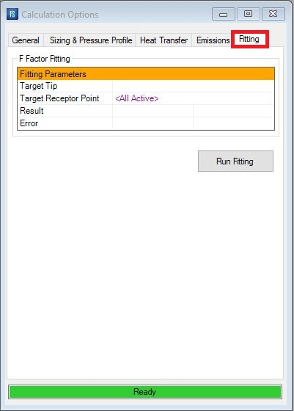

6th Step: Click on “Receptor point TAB” and “Add” a Point
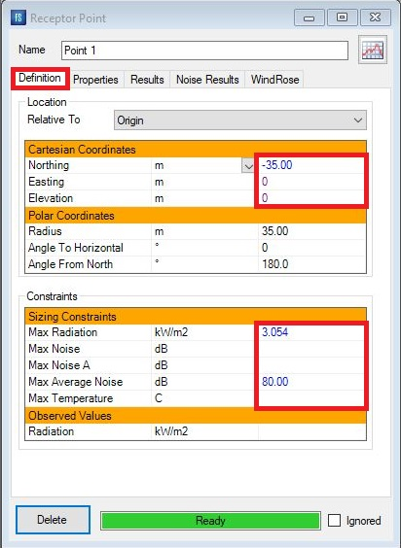

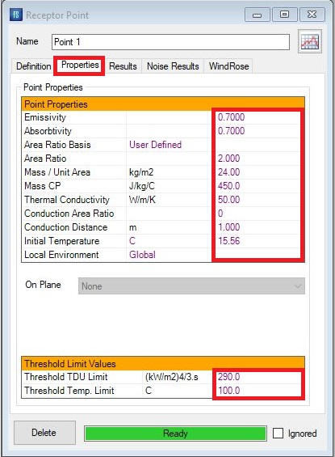

Results/Tip
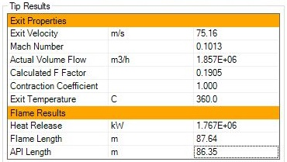
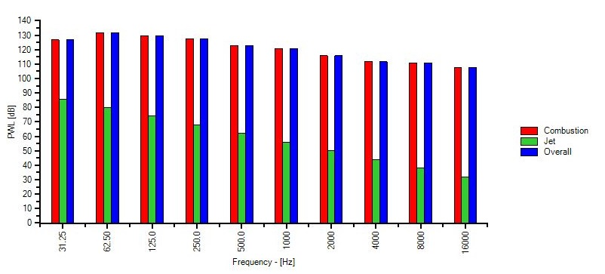

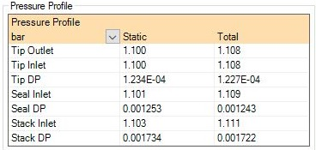

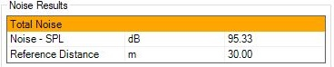

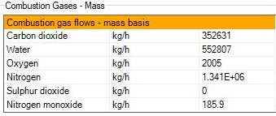

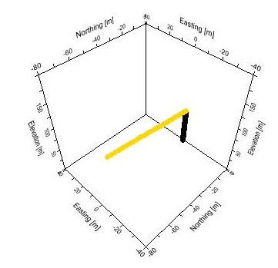

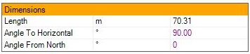

Results/Point1
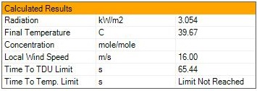

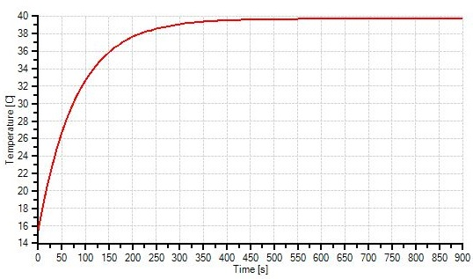

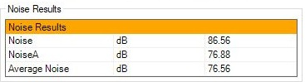

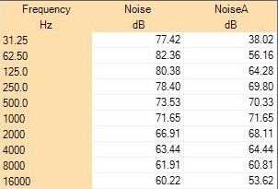

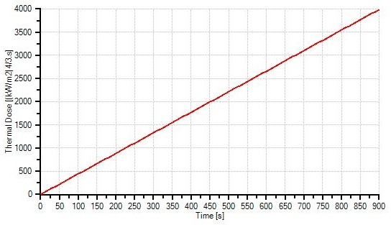

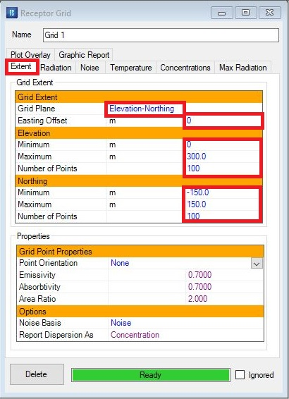
7th Step: Click on “Receptor Grid TAB” and “Add” a Grid1

Results/Grids
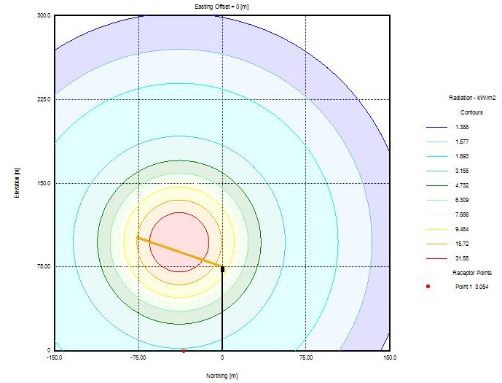
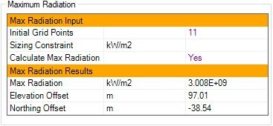

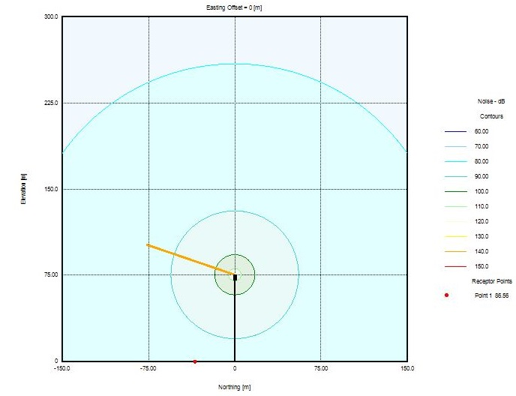
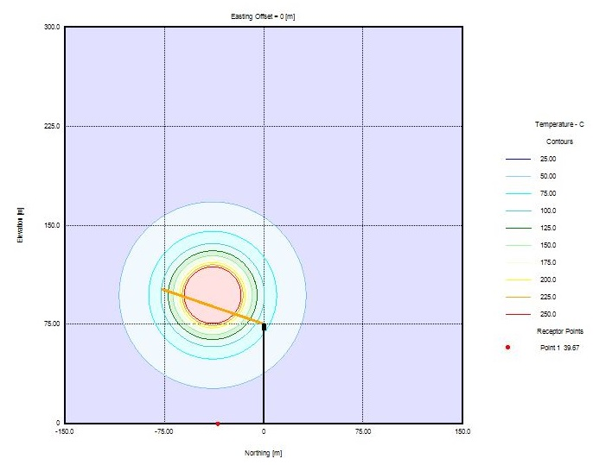
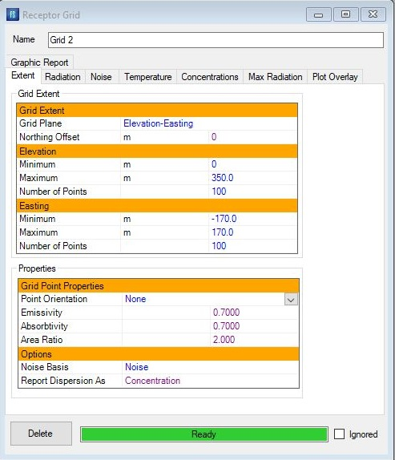
7th Step: Click on “Receptor Grid TAB” and “Add” a Grid2

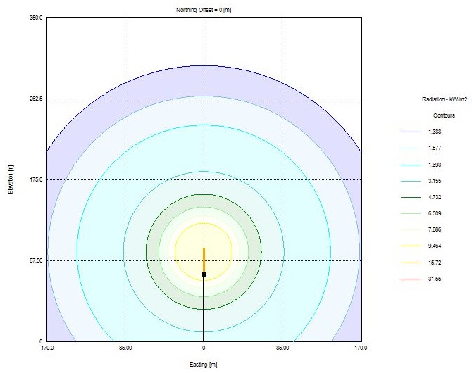
Results/Grids

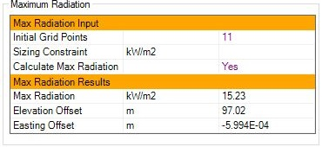

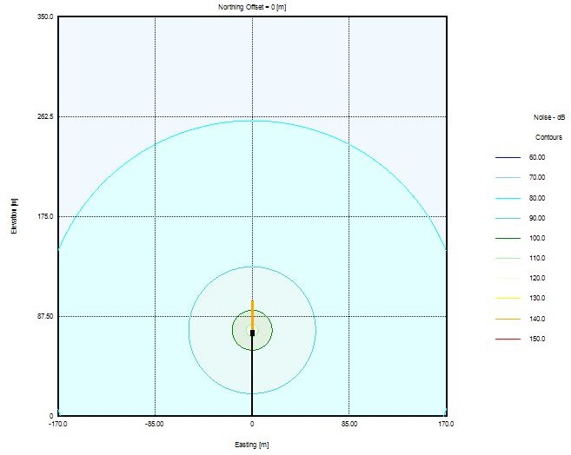
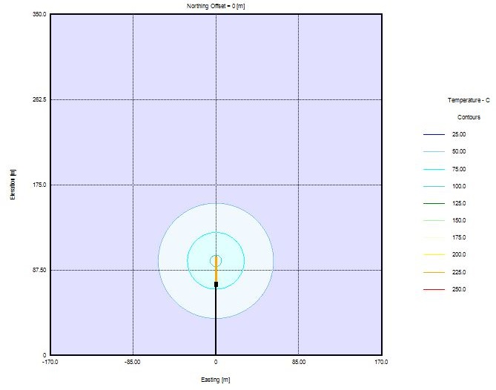

A Comparison Study
1.In Calculation Option TAB, Brzustowski method was changed to Flaresim API.
2.In “Options” just Atm. Noise Attenuation is enabled.

Results
Parameter | Flaresim API | Brzustowski
Stack Height | 68.4 | 70.3

Tip Result Comparison
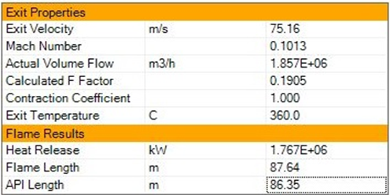

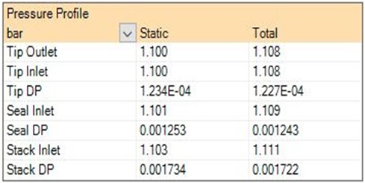

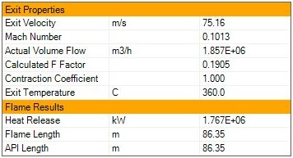
Flaresim API
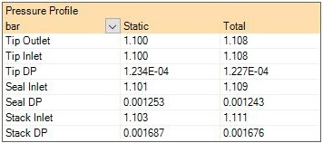

Point Result Comparison

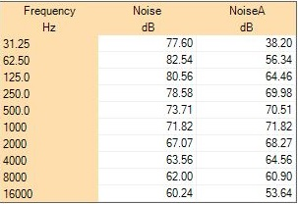
Flaresim API
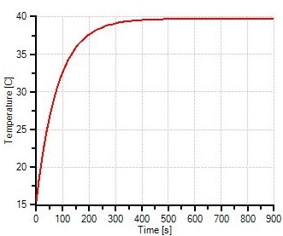

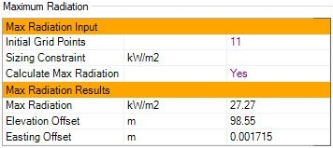

Notes and Discussion
- The radius of public , exposure limit ( 1.58 kW/m2 ) is 172m in Easting Direction.
- The maximum radiation value on ground is 3.135 kW/m2.
- If exposure limit for all direction is set to be 1.58 kW/m2 then the flare stack height
should be 152m!
- Vendor has selected a fixed height and no constraint in Point Tab but here we allowed
the software to size the stack height by setting 3.13 kW/m2 as sizing constraint in Point
Tab.
Flare Burner / Tip
In MEKPCO project, a steam-assisted flare tip is used to not only help the combustion be
flameless but also cool down the equipment.

The quantity of steam required for smokeless burning is a function of the gas composition, the
flare burner size and design, the steam-injector design and operating pressure, and the
environmental conditions. While steam assist enhances the combustion of relief gases that
smoke, it adversely affects the combustion of relief gases with a high level of inerts. Relief
gases with a high level of inerts, when flared from a steam-assisted flare, can require a greater
calorific value to sustain the required flame stability and hydrocarbon-destruction efficiency.

Flare tip length is normally between 3-5 meter. In MEKPCO project, pipe flare type is used due
to low Mach number.

Steam is often injected into the relief gas discharge at the top of a flare burner. Typically, a
steam ring that has a number of injection nozzles or slots is employed. The design and location
of injector nozzles varies as different flare manufacturers each have their own proprietary
design.

The upper steam injection functions to inspirate air and to force the air mixture into the relief gas
discharging from the flare burner. The steam-injection pattern is intended to enhance fuel-air
mixing and can add to the momentum of the relief gas discharge. The steam and air acts to
dilute the hydrocarbon fuel content, which also reduces the smoking tendency. The steam vapor
can also participate in the combustion kinetics, assisting in the conversion of carbon to carbon
monoxide.

The effective addition of steam from an upper steam ring increases the turbulence of
combustion. The overall noise level of the flare burner increases due to both the additional
combustion noise and jet noise from the steam nozzles. Steam-assisted, smokeless flares can
have significantly increased overall noise levels in comparison to flares with no steam assist.

The allowable flare burner exit velocity is a function of relief gas composition, flare burner
design, and the gas pressure available. These parameters are interrelated. Some flare tips
incorporate a flame-retention device or other means that provides a stable burning flame either
attached or detached relative to the flare tip. There is evidence that flame stability can be
maintained at relatively high velocities depending on the discharge properties and the type of tip
used.
Experience has shown that a properly designed and applied flare burner can have an exit
velocity of more than Mach 0.5, if pressure drop, noise, and other factors permit. Many pipe
flares, assisted or unassisted, and air-assisted flares have been in service for many years with
maximum Mach numbers of Mach 0.8 and higher.

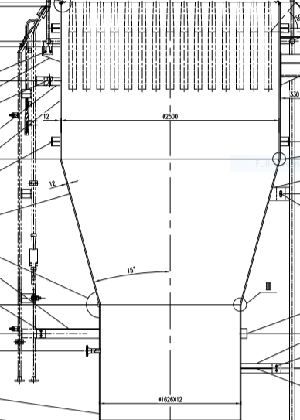

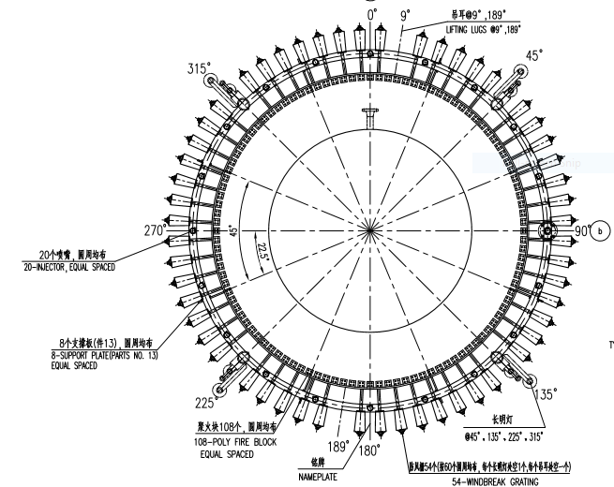

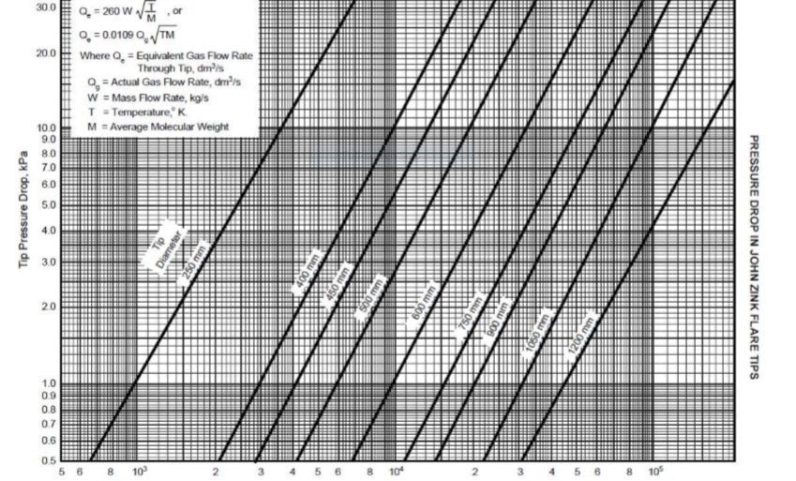

Molecular Seal
- Air seals (also called purge reduction or gas seals) prevent air from entering the stack,
and are often recommended to prevent flashbacks and explosions in a flare system.

- Purge-reduction seals are not flame arrestors; that is, they will not stop a flashback.
They are designed as energy-conservation devices to reduce purge-gas flows required
to mitigate air infiltration into the stack.

- Air present in the stack can create a potentially explosive mixture with incoming flare gas
during low-fare gas flow rate conditions.

- There are two common types of mechanical seals, usually located at/or below the flare
tip that are used to reduce the amount of continuous purge gas required to prevent air
infiltration into the flare stack : molecular seals (sometimes called diffusion, buoyancy or
labyrinth seals), and velocity (fluidic) types.

- In the event of loss of purge-gas flow (and assuming that there is no other waste-gas
flow) the oxygen level below the velocity type seal will almost immediately begin to
increase. In the case of the buoyancy seal there is a time delay between the moment the
purge gas flow stops and the time the oxygen level below the seal begins to increase.

- The molecular seal consists of a baffled concentric cylinder arrangement, which uses the
difference in molecular weight of the flare gas and the ambient air to prevent air from
entering the flare stack. This seal normally reduces the purge-gas velocity required
through the tip to 0,003 m/s (0,01 ft/s).

