Bio-dispersant / Surfactant

**SURFACTANTS**

The name “surfactant” is an acronym for Surface Active Agent. Surfactants are organic

chemicals, which because of their chemical structure are capable of wetting materials or hard

surfaces, lowering surface tension, emulsifying oils, dispersing and suspending particulate soils,

and breaking the adhesion of soils to surfaces. They can be used for a variety of applications

in cooling tower systems, including bio-dispersants, oil dispersants, and cleaning

applications. There are four basic types of surfactants. They are classified as the following:

1. Anionic (negative charge)

2. Cationic (positive charge)

3. Nonionic (no formal charge)

4. Amphoteric (both a negative and positive charge

Examples of anionic surfactants are soap (sodium stearate) and LAS (linear alkyl benzene

sulfonate). Anionic surfactants are generally the least expensive and the oldest known

surfactants. Both soap and LAS will combine with calcium to form insoluble calcium deposits

(Soap scum). LAS is the most widely used surfactant for both industrial and household cleaning

products. However, it is not biodegradable, so its use is limited in some areas or countries for

environmental reasons. Cationic and amphoteric surfactants are primarily used in fabric

softeners, bacteriostats, cosmetics and personal care products, and other specialty

applications. Finally, cationic surfactants are typically not used in cooling water applications. The

positive charge on these surfactants would neutralize the anionic polymers that are widely used

as dispersants. This charge neutralization can inactivate the polymer, as well as the surfactant

and cause precipitation in the cooling water. Nonionic surfactants are widely used as dispersants

or emulsifiers in many applications. All surfactants contain a non-charged, hydrocarbon tail as the

hydrophobic group.

Examples of hydrophobic groups used as the starting point for both nonionic and anionic

surfactants include alkylphenols, fatty acids or alcohols, sugars such as sorbitol, and various

chain lengths of polypropylene glycol (polypropylene oxide).

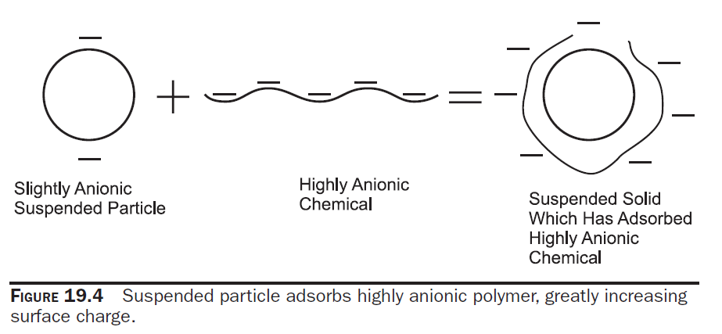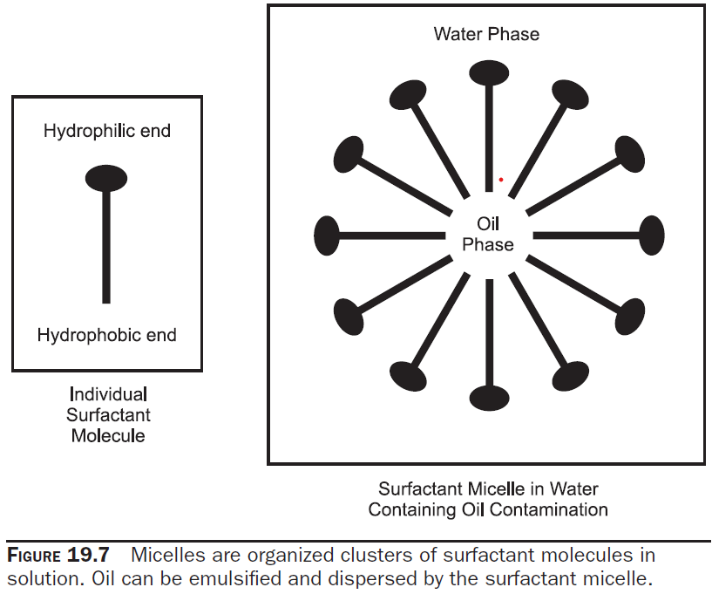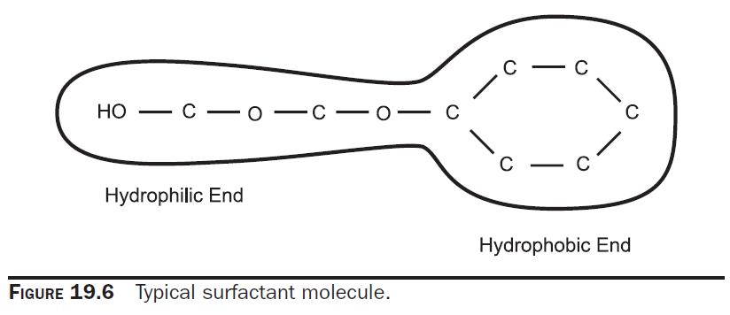

For nonionic surfactants, the hydrophilic portion is almost always

made only from ethylene oxide. In contrast, the hydrophilic portion of anionic surfactants can

include sulfonates, sulfates, carboxylates, or other highly charged functional groups, sometimes

even in combination with ethylene oxide. Nonionic surfactants have several advantages over

anionic surfactants like soap or LAS. They are less sensitive to water hardness (less tendency to

precipitate) and thus, provide better detergency under hard water conditions. Nonionic surfactants

can be made to be lower foaming than anionic surfactants. As a result,foaming is less of a problem

as compared to anionic-based detergents. Figure 3.9.31 represents drawings of typical examples

of all categories of surfactants. Surfactants can be very beneficial in cooling water programs.

Materials that reduce the interfacial tension between water and bacterial slime can help to remove

these deposits. These bio-dispersants can remove the slime layer and make chlorination or

bromination more effective. Surfactants be beneficial during process leaks of organic materials

that may occur in refineries or chemical plants. If an organic process fluid that contaminates

the cooling system is a liquid at normal temperatures, it may foul metal surfaces because it is

“pushed” to the surface by the interfacial tension of water. Surfactants can impact this by

Emulsifying the oils and keeping them dispersed in the water phase. Other types of surfactants

can be useful in dispersing soils or suspended solids due to their detergency. These are not often

used on a continuous basis, but may be part of aperiodic cleaning program. Most

pretreatment programs also contain surfactants to help remove surface deposits and allow the

metal surfaces to be better contacted by the passivating agent.

One caution when using surfactants in cooling towers is the foam that may result. As mentioned,

nonionic surfactants can be made to be low foaming, and these are commonly used for cooling

system applications. However, even low foaming materials can create undesirable foam,

especially if overfed in the highly aerated environment of the cooling tower. Control of the dosage

is important in all applications to minimize foaming. When a cleaning or pretreatment program is

applied, it is valuable to have antifoam on hand in the event that undesirable foaming

occurs.

