Non-Oxidizing Biocide

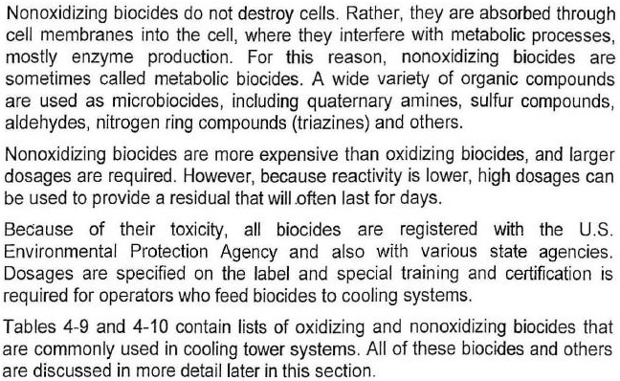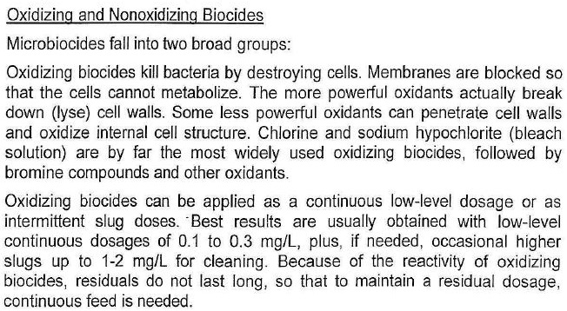

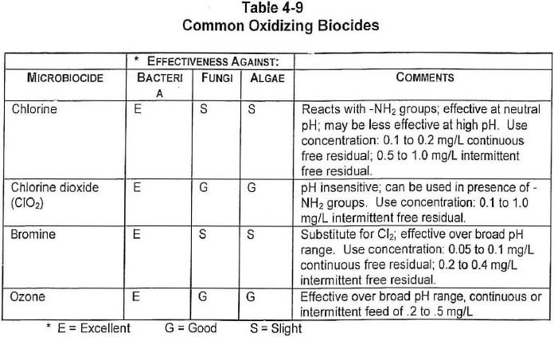

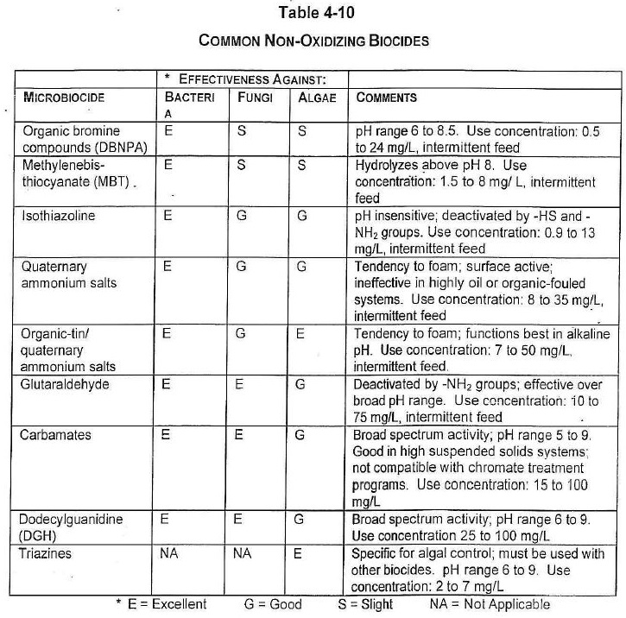

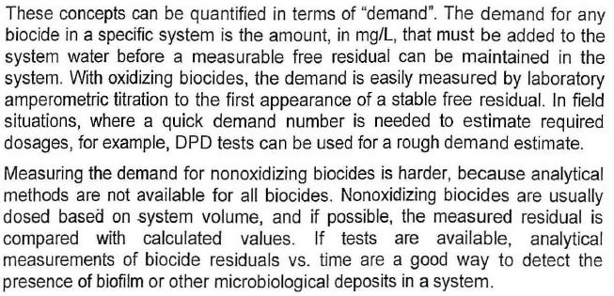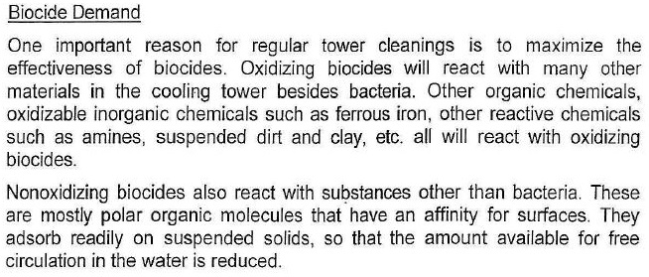

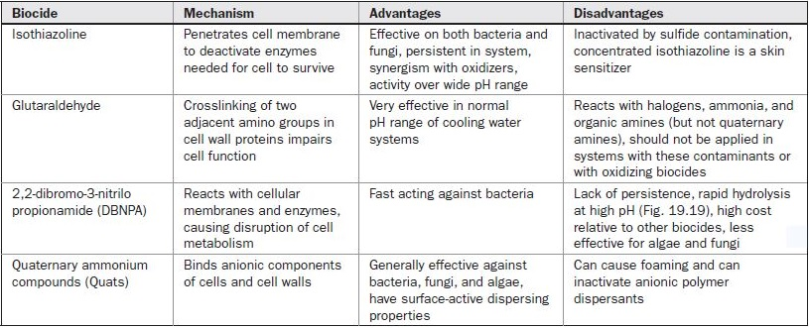

**Section 2 : Common Non-Oxidizig Biocide**

**Isothiazolines**

Alkyl isothiazolin-3-ones. Organo-sulfur group. Good, wide-spectrum

bactericide and algaecide that is effective over a wide range of pH. Isothiazolines

kill by inhibiting microbial respiration and food transport through the cell wall. It is

recognized as an industry standard product for cooling systems but can be expensive. Isothiazolines are supplied to some markets as a 13.9% active concentrated blend (10.1% 5-chloro-2-methyl-4-isothiazolin-3-one and 3.8% 2-methyl-4-isothiazolin-3-one). It is always marketed to the end user, as a 1.5% active (1.11% + 0.39% to 1.15% + 0.35%)in-use blend. Isothiazolines are amber to yellow-green liquids that require every careful handling due to severe skin and eye irritant properties. They are effective against both general aerobic and spore-forming bacteria, over a pH range of 6.5 to 9.0. Isothiazolines are very effective algaecides and fungicides, but only at acid to slightly alkaline pH levels. Contact time is typically 5 to 6hours. Dose rate is typically 50 to 120 mg/L, for 1.5% active isothiazoline. Availability exists as several possible permutations of the product, under the KATHON™ brand from Rohm & Haas Company. Also, AMA®-215 (1.5%)from Vinings Industries, and as 33% aqueous dispersion of 1,2-benzisothiazolin-3-one (BIT), under the Proxel™ BD brand, from ICI PLC.BIT is also available as XBINX® from PMC Specialties Group, Inc. (U.S.).

Consumption:

System Volume: 7500 m3

Required Dosage = 50 mg/l

Required Dosage per each injection $50\frac{mg}{l} ×7500 m3 ×\frac{1000l}{m3} ×\frac{kg}{1000000mg}=375\frac{kg}{inj}.$

**Glutaraldehyde**

Pentane-1,5-dial. Aldehyde group. Glutaraldehyde is a good bactericide, especially with difficult and persistent organisms due to its good penetrating ability. It has limited effectiveness against algae and fungi. The kill mechanism is by cross-linking outer proteins of cell and preventing cell permeability. Glutaraldehyde is a fast-acting biocide (3 to 4 hours, perhaps 4 to 6 hours with difficult slimes), non-ionic, non-foaming, effective over a wide pH range (typically pH 6.5 to 9.0),. It is also effective against SRBs and biofilms. The half-life tends to be short, depending upon the particular cooling system parameters, but typically 4 to 12 hours. Careful evaluation is needed before application on some larger systems, especially as it may not be particularly cost effective. Glutaraldehyde is readily biodegradable. Typical use concentration is 100 to 125 mg/L at 45% active material, although heavily slimed cooling systems may need 200 to 300 mg/L as an initial, cleanup shock dose. It is an effective choice for biological control in air washers. Glutaraldehyde is probably a good biocide where the risk of *Legionella sp.* exists. Although concentrated glutaraldehyde reacts with ammonia, at typical in-use concentrations the rate of reaction is slowed and glutaraldehyde can be suitable for SRB and slime removal in large process systems, where 25 to 50 mg/L or more, of ammonia is present. This biocide is particularly associated with Aquacar® 515, 542, 545 (15, 42, 45% active product), from Union Carbide Corporation, a subsidiary of The Dow Chemical Company.

Consumption:

System Volume: 7500 m3

Required Dosage = 50 mg/l

Required Dosage per each injection $100\frac{mg}{l} ×7500 m3 ×\frac{1000l}{m3} ×\frac{kg}{1000000mg}=750\frac{kg}{inj}.$

**Quats (ADBACs)**

Alkyldimethylbenzylammonium chloride (also known as alkylbenzyldimethyl ammonium chloride or benzalkonium chloride). Quaternary ammonium compound group. There are many popular products in this group that are widely available. The primary amine salts are of limited benefit in cooling systems, but diamine quats are effective. Quats are cationic, surface active products with a tendency to foam, especially above pH 8.0. The kill mechanism is due to the cationic nature, whereby an electrostatic bond is formed with the cell wall, which affects permeability and protein denaturing. Quats are effective algaecide and reasonably good bactericide, and can be applied over a wide range of pH (optimum pH 6.5-8.5). At typical in-use concentrations, diamines will help maintain clean cooling systems, and reduce populations of general algal and bacterial organisms. However, they tend to have only a bacteriostatic effect over *Pseudomonas sp*. and SRBs. An advantage of quats is their relatively low-cost. The disadvantage is that quats are deactivated by high hardness (typically over 500 mg/L), chlorides, oil, dirt, silt and debris. Quats have poor compatibility with polyanionics polymers. Typical end-user product is 10% active strength quat in an alkaline solution, with a dose rate of 50 to 100 mg/L. Contact time is typically 4 to 6 hours. Examples of quat concentrates are Barquat® OJ50 and OJ80 (50 and 80% active ADBAC), from Lonza Inc., Synprolam™ 35DMBQC 50 and 80 (50 and 80% active) from ICI PLC, Arquad™ B-100, from Akzo Nobel B.V. Examples of diamines are Redicote® E9, Duomeen® C and Arquad® DMMCB-50, from Akzo Chemicals BV.

Consumption:

System Volume: 7500 m3

Required Dosage = 50 mg/l

Required Dosage per each injection $50\frac{mg}{l} ×7500 m3 ×\frac{1000l}{m3} ×\frac{kg}{1000000mg}=375\frac{kg}{inj}.$

**DTEA, DTEA II**

2-(Decylthio)ethanamide. Alkylthio amine group. This is one of the few, genuinely new biocides to enter the market in recent years. DTEA or DTEA IIwas designed to operate effectively under a wide range of pH levels (pH 6 to10 or greater), but especially for the higher pH's now common with "AllOrganic" and similar, high alkalinity tolerant inhibitor programs. It was also designed as a specific sessile bactericide, biofilm remover and biofilm growth control agent. DTEA or DTEA II functions by forming reversible Chelant complexes with the salts and inorganic ions found in biofilm structures, which severely weakens the biofilm and reduces its adhesiveness. DTEA or DTEA IIare highly surface active and can be thought of as a "biocidal soap" to be used for clean-up programs (biofilm debris will quickly be in evidence and foaming may occur), as a biocide component with chlorine (although it is not recommended to be used at the same time as chlorine) and as a maintenance biostat. Application rates are typically 50 to 100 mg/L. It is consumed and decays rapidly in heavily fouled systems (typically in 3 to 4 hours), consequently, it is recommended to slowly add the complete dose over a four-hour period. DTEA or DTEA II is manufactured as a 15% active material. It is distributed primarily through AMSA Corp. in the U.S.

Consumption:

System Volume: 7500 m3

Required Dosage = 50 mg/l

Required Dosage per each injection