**Internal Chemical Treatment Programs**

Scale formation in low-pressure boilers [<1000 psig (6.9 MPag)] and feedwater systems can be controlled in two primary ways:

1. Proper operation and maintenance of all makeup and feed­water pretreatment systems. Hot and cold lime softeners, filters, sodium softeners, water-cooled packing glands on feedwater pumps, etc., must be operating properly before chemical treatment can be effectively applied. Otherwise

erratic and unpredictable quantities of scale-forming compo­nents will be fed to the boiler system, and results will be compromised.

Chemical treatment is then used to condition any remaining minerals leaking through to the boiler. Among the treatments in common use today are:

• Coagulation treatment programs that were commonly used in the past (1900–1950). Although still in use today, modern, inexpensive pretreatment technology has made their use almost obsolete

• Phosphates (residual with and without polymer)

• Chelates

• All-polymer treatments

**Phosphate Residual Programs—Low Pressure Industrial Systems**

Tricalcium phosphate has an extremely low solubility. Hence, when properly controlled, the addition of phosphate to boiler water removes calcium so completely and efficiently that calcium sulfate, calcium carbonate, and calcium silicate scales can be prevented. In the presence of sufficient alkalinity, the actual phosphate precipitate formed is calcium hydroxyapatite [Ca10(PO4)6(OH)2], which is a less sticky, more readily conditioned reaction product than tricalcium phosphate.

Although phosphate can precipitate with magnesium as magne­sium phosphate if the phosphate is overfed, proper boiler chemistry will preferentially precipitate magnesium as a less adherent and more easily conditioned magnesium hydroxide, magnesium silicate, or the preferred lizardite Mg3Si2O5(OH)4 (formerly serpentine). The best solution to boiler scale is proper softening of the makeup water to remove all calcium and magnesium, followed by a good chemical control program.

Phosphate residual programs are acceptable where feedwater hardness is less than 0.3 mg/L.2 Numerous chemicals can be used to furnish the phosphate ion necessary for internal softening treatment. Compounds of the orthophosphate ion (PO4–3) are the most widely used. Other phosphate ions that can be used are meta (PO3–), tripoly (P3O10 –5), and pyro (P2O7–4). Some of these salts are called polyphos­phates because they form inorganic polymers. Among these are the glassy sodium polyphosphates (hexa- and heptametaphosphate) and crystalline sodium polyphosphates such as sodium tripolyphosphate

and tetrasodium pyrophosphate. The polyphosphates can be described as molecularly dehydrated orthophosphates. When added to water, polyphosphates rehydrate (at a rate that is temperature dependent) to the orthophosphate form from which they were derived.

Although this discussion of phosphates is rather limited, it is a reminder that the precipitation of tricalcium phosphate (or calcium hydroxyapatite) in the boiler can occur only when the phosphate in use has been converted to trisodium orthophosphate by heat and reacted with boiler alkalinity.

If the product is to be fed directly to the steam drum of a boiler, the best choice is an orthophosphate formulation, because the conversion to trisodium orthophosphate (in the case of mono- or disodium orthophosphate) is extremely rapid. Conversely, feeding a meta- or pyrophosphate (polyphosphate) directly to the boiler may delay chemical reactions undesirably. This is particularly true if the boiler pressure is less than 50 psig (345 kPag) and if the cycles of con­centration are low (<10). If a phosphate product is fed directly to a boiler steam drum or feedwater, where water temperature exceeds 400°F (204°C), the product should be diluted to less than a 10% solu­tion of the product, or feed the undiluted (neat) product into a feed­water bypass line into the drum. The feed of a concentrated product directly into the steam drum, or feedwater line of greater than 400°F (204°C), may result in plugging the chemical feed line. If, on the other hand, a phosphate is to be fed to the boiler feedwater, a polyphos­phate product is chosen to avoid the possibility of deposits caused by softening reactions occurring in the feedwater lines, economizer tubes, etc. An orthophosphate formulation would be entirely unsuit­able for such a feed point. When feedwater hardness is greater than 3 mg/L, all phosphates are usually fed to the steam drum to prevent deposition in the feedwater system and the economizer.

Each of the common phosphates has an effect on boiler water alkalinity as well. When hardness in the feedwater is precipitated by direct reaction with alkalinity (as in a coagulation program), available alkalinity generally decreases.

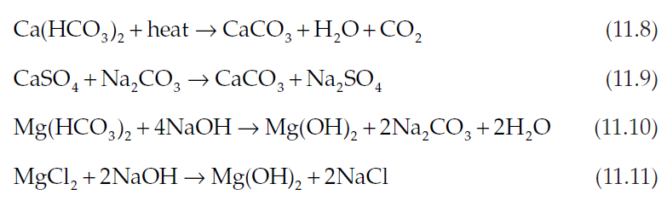

When phosphates are used to precipitate the calcium hardness, however, some of the alkalinity associated with calcium hardness is retained in the form of sodium alkalinity in the boiler. The amount of alkalinity retained depends upon the type of phosphate used. Because

phosphates must be converted to trisodium orthophosphate in the boiler before precipitation of calcium occurs, some alkalinity con­sumption results.

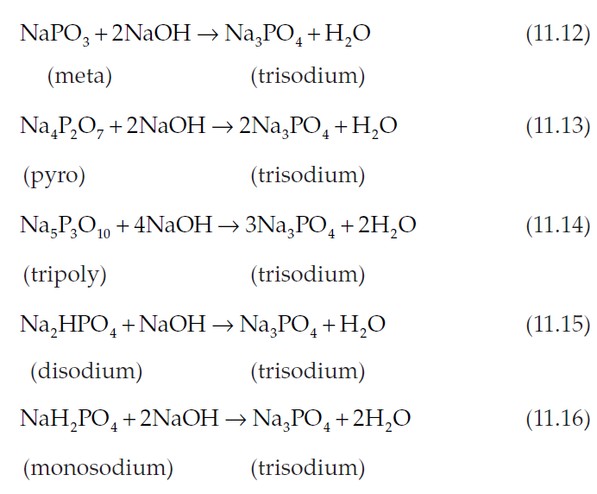

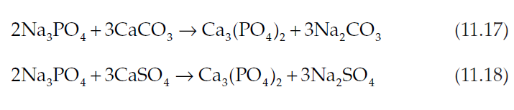Once the phosphate has been converted to trisodium ortho­phosphate, the reactions with calcium hardness proceed, as shown in Eqs. (11.17) and (11.18). Calcium hardness is represented by CaSO4 and CaCO3, although other species may coexist.

While the overall tendency when using phosphates to soften the water will be to increase the amount of retained alkalinity in the boiler (as compared to coagulation program reactions), the amount of increase is a function of the type of phosphate used. Thus far, only the amount of phosphate consumed in reacting with calcium has been considered. Because a certain level of phosphate residual is always carried (present as trisodium orthophosphate), additional alkalinity is consumed for each mg/L of phosphate residual required [Eqs. (11.12)–(11.16)]. Hence, the net gain in available alkalinity becomes a function of the following:

• Type of phosphate used

• Amount and form of calcium hardness

• Level of magnesium hardness

• Level of residual phosphate carried

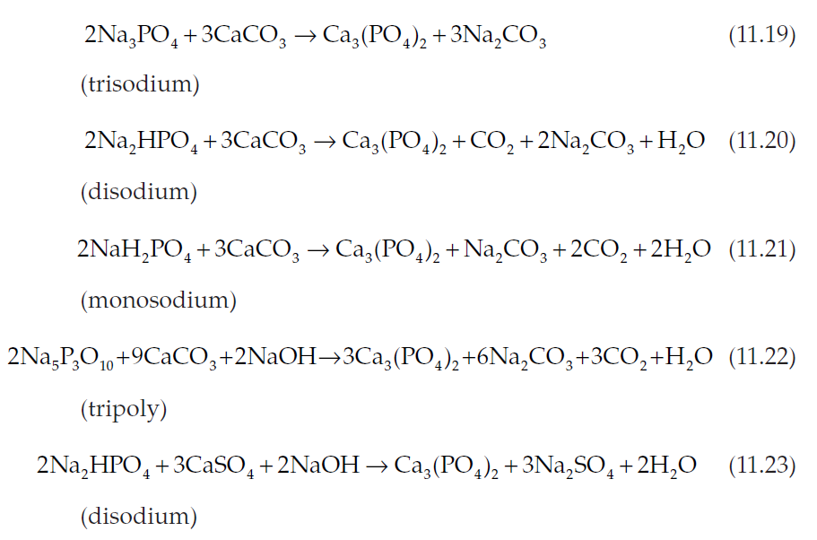These principles can be demonstrated more clearly if the typical calcium-phosphate reactions are considered as one step, rather than as two separate steps. Equations (11.19) to (11.23) demonstrate the effect on retained sodium alkalinity. The reactions controlling magne­sium precipitation [Eqs. (11.10) and (11.11)] and those controlling phosphate conversion for phosphate residuals [Eqs. (11.12)–(11.16)] must be added to these reactions.

Although these reactions are complex, they are important to understanding boiler water chemistry.

**Applications**

Phosphate residual treatment programs are best suited for feed­waters that are consistently below 0.30 mg/L hardness, have low magnesium, and have silica content greater than one-third the mag­nesium content. The greater the feedwater hardness is above 0.3 mg/L the greater the deposit accumulation rate will be in the boiler and the greater the need to periodically clean the boiler as well.

Phosphate programs can be effectively applied to boilers with operating pressures up to 2800 psig (19.3 MPag), although residual phosphate is rarely applied at operating pressures above 1200 psig (8.3 MPag).

**Program Controls**

Control of a phosphate residual program involves adjusting solu­ble orthophosphate residuals in the boiler water by adjusting chemical feed rates. It is also important to adjust boiler water hydroxide (O) alkalinity (2P-M); the simple control of P alkalinity

alone is not sufficient. As in all programs, proper levels of total dis­solved solids, suspended solids, and silica must be maintained.

Phosphate residuals for any given system should be recom­mended based on boiler operating pressure; however, they should reflect the degree of control capability practical and the consistency of feedwater quality. Hydroxide alkalinity levels are similarly pressure related, and should be set according to individual conditions such as boiler silica levels expected.

Table 11.5 gives optimum limits at various boiler pressures. The values given in this table are guidelines; individual applications dictate the actual acceptable limits.

**Phosphate-Polymer Programs**

Simply stated, phosphate-polymer programs affect the proper cal­cium and magnesium precipitation reactions, then act to condition the resultant sludge. These programs result in cleaner boilers than are normally seen using a conventional phosphate program.

Phosphate-polymer programs are similar to the phosphate-residual and the phosphate-organic programs in that they use the same precipitation chemistry for calcium and magnesium. There are two important differences between the phosphate-organic and phosphate-polymer programs, however. These are the organic dosage requirements and the boiler water phosphate residual requirements (Table 11.6).

The organic portion of the phosphate-organic programs, is a blend containing various natural occurring organics. The polymers in the phosphate-polymer product line have a remarkable ability to alter the crystalline structure of the sludge (reaction products), pre­venting any seeding action and giving exceptional fluidity to the boiler water sludge.

Any use of the word or concept of chelation leads to a quick association with ethylenediaminetetraacetic acid (EDTA) and nitri­lotriacetic acid (NTA). There are, however, many chemicals that exhibit chelation properties, including the polymers present in these products. Polymers, however, exhibit a much lower corrosion potential.

**Applications**

Phosphate-polymer programs are well suited to boilers with feed­water hardness levels up to 0.3 mg/L. (Hardness above 0.3 mg/L can be handled by phosphate-polymer treatment but at poorer econ­omies. Usually, feedwater hardness >0.3 mg/L calls for corrective action.) For ion exchange softened feedwaters, except where iron is the sole or primary contaminant, phosphate-polymer programs normally give better results than 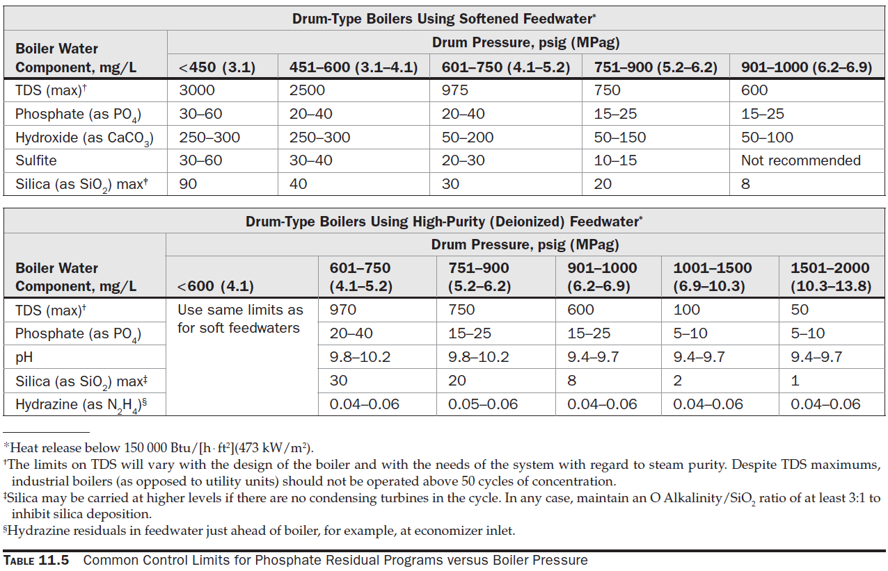conventional phosphate-organic programs.

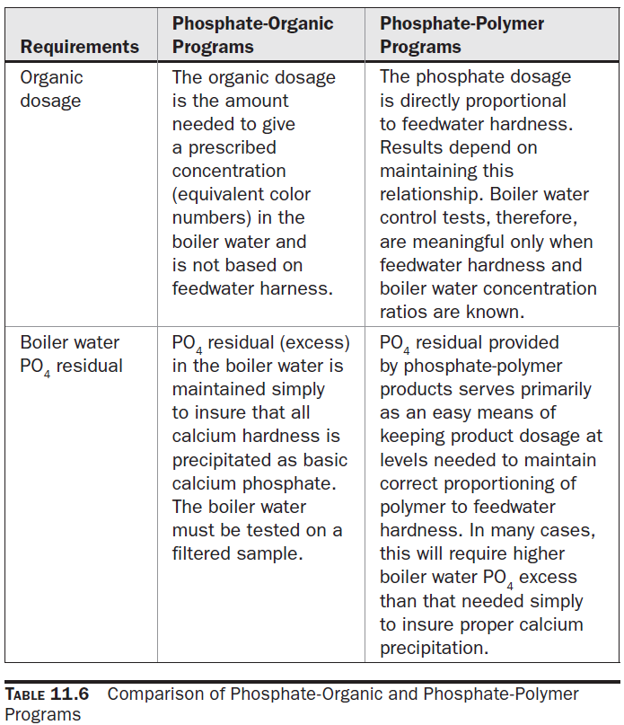

The phosphate-polymer programs have the same advantages and disadvantages as the conventional phosphate programs, with two exceptions:

1. Phosphate-polymer programs can provide much cleaner boilers than the conventional phosphate programs.

2. Much stricter control is required with these programs. Chemical dosages must be adjusted corresponding to feed­water hardness fluctuations to maintain the proper phosphate-to-hardness ratio.

**Program Controls**

Phosphate-polymer programs are controlled by phosphate residual readings on a filtered sample of the boiler water blowdown. In most cases, the phosphate control range will be established by normal product dosage calculations.

**Special Considerations**

At normal use dosages, the deposit removal capability of the phosphate-polymer products is dramatic. Deposit removal occurs by sloughing, which can block tubes and headers.

If, after inspecting a boiler, acid cleaning seems warranted, then the boiler should be cleaned. Do not try to substitute a phosphate-polymer treatment for an out-of-service cleaning. The odds are very much against such an approach succeeding. Online boiler cleaning is never recommended.

When a phosphate-polymer program is recommended for any boiler, except a new or a freshly cleaned one, special precautions should be taken. Where possible, schedule an inspection in 60 to 90 days to observe the condition of the boiler, particularly the lower areas, such as water-wall headers, near-horizontal tube runs, and the mud drum at the blowdown connection. Remove any accumulations of chip scale or sludge before putting the boiler back in service. During the first few months of operation on a phosphate-polymer program, increase the frequency of bottom blows, where applicable, to facili­tate removal of materials sloughed from boiler surfaces. This should be done with greater frequency when turbidity levels increase in the boiler water.

If a phosphate-polymer program does not appear to be pro­ducing good results in an oil-contaminated system, change to a phosphate-starch organic product. The starch organic should help in handling the oil. The source of the oil contamination should be located and eliminated.

Very little, if any, change has been noted in the composition of sludge formed on a phosphate-polymer program as compared with sludge formed on a standard phosphate-organic program. Normal calcium and magnesium reaction products are formed, and normal interpretation of results can be made. There are visible differences, though. In the absence of dark lignin organics, the sludge is very light buff in color. The light film formed on metal surfaces may also appear grainy or granular. Light finger pressure will usually remove the light film, exposing the boiler metal. The volume of sludge will be proportional to the feedwater hardness levels.

**Phosphate Programs—High Pressure Industrial Systems**

Sodium phosphates provide the desired pH in boiler water, while controlling the presence of free sodium hydroxide, as shown by these hydrolysis reactions:

Na PO

**Chelates and Chelate-Polymer Programs**

The nature of metal ions and how they behave must first be under­stood before discussing chelation and the use of chelating agents in the control of metal ions. When metal-containing compounds are ion­ized in water, the metallic component exists as a positively charged, freely moving ion in the solution. These free metal ions react to sur­round themselves with negative ions or polar molecules that are present in the solution. The number of such molecules or negative ions that coordinate with the metal ion varies, but for most metals it is usually four or six. These centers of activity of the metal ion may be termed reactive sites. In general, the reactions caused by free metal ions in solution are due to these reactive sites.

In an aqueous solution containing only a simple metal salt, the reactive sites will be occupied by water molecules. When materials are added that interact more strongly or compete more effectively than the water molecule for the reaction site, the sheath of water molecules is displaced, and the metal ion acquires new properties. An example of this is the reaction of copper ions with ammonia (Fig. 11.13).

The water molecules being held at the four reactive sites of the copper ion are displaced by ammonia. The ammonia forms a stronger attachment to the copper ion than does the water, so the resultant ammonia-copper complex is more stable. The ammonia can be dis­placed by adding some material capable of forming a still more stable complex with copper.

**Figure**