Neutralizing Amine

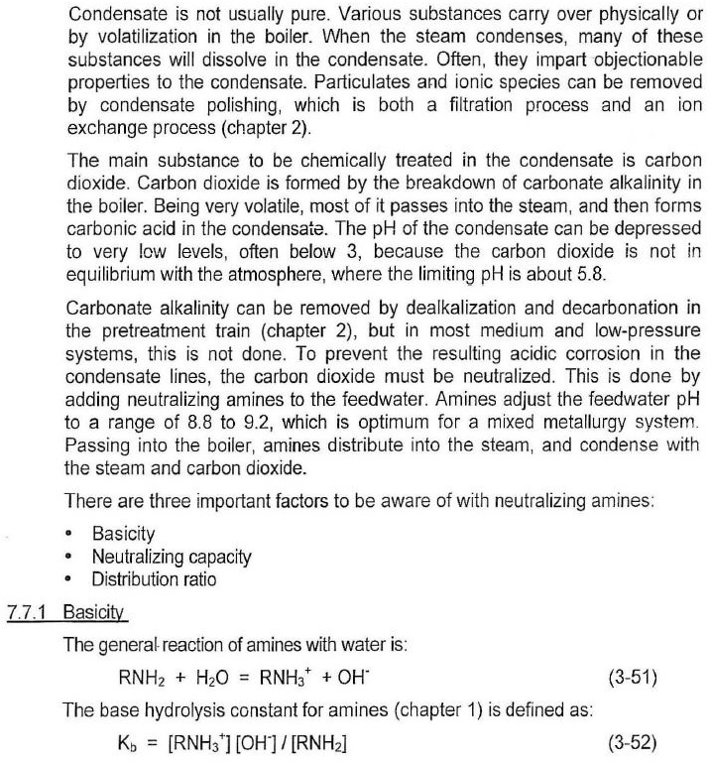

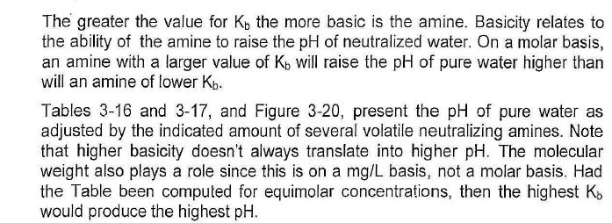

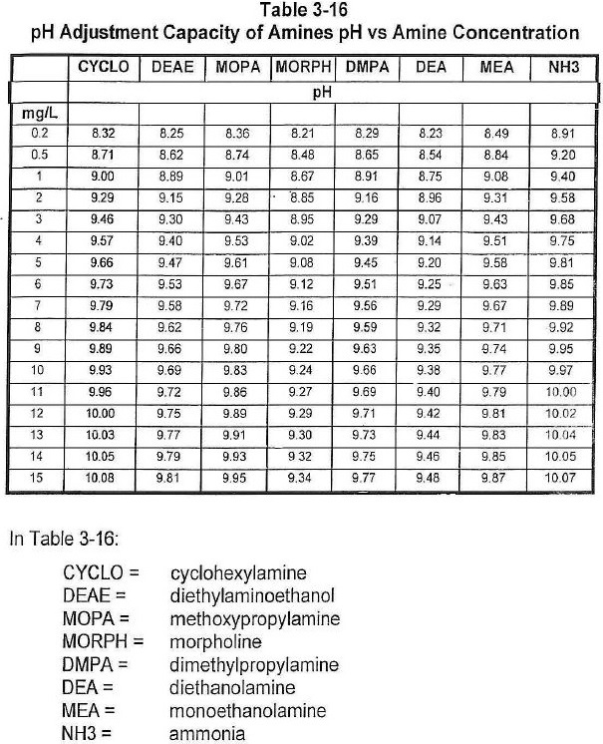

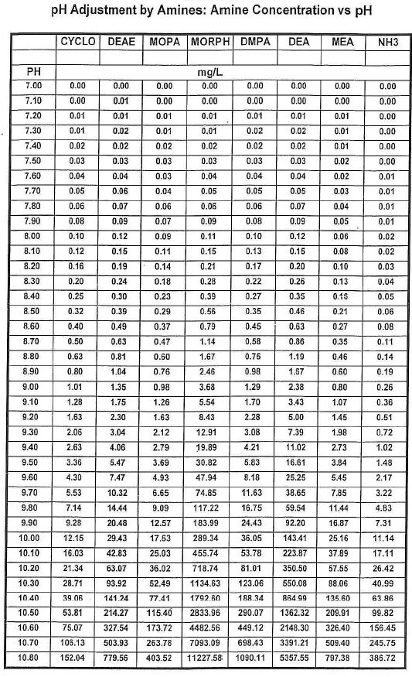

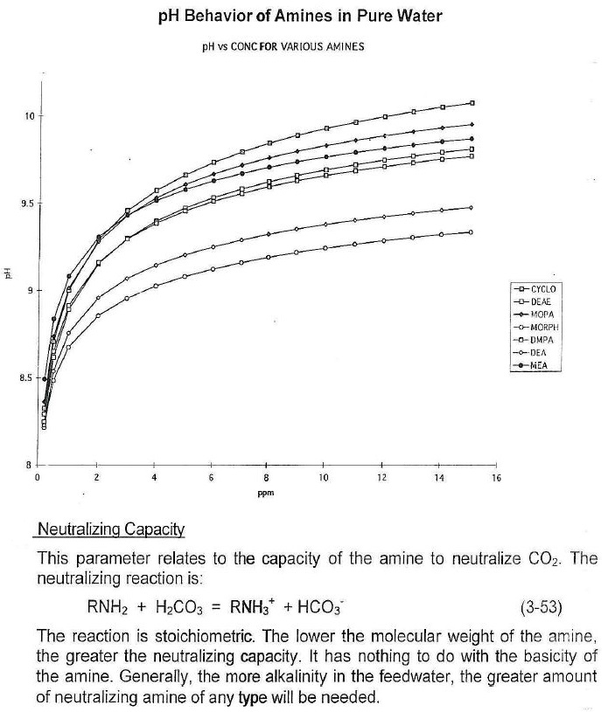

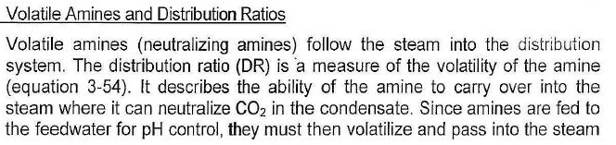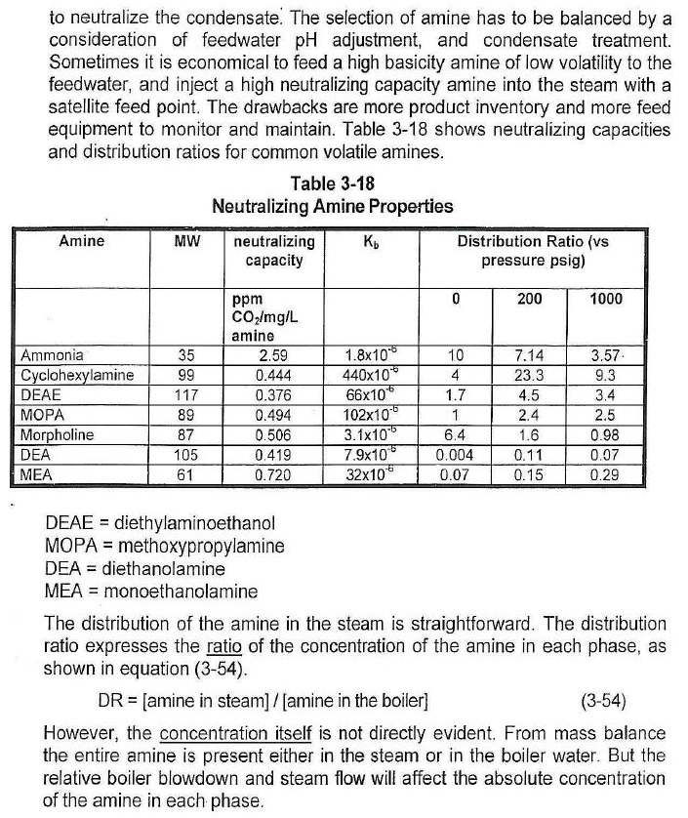

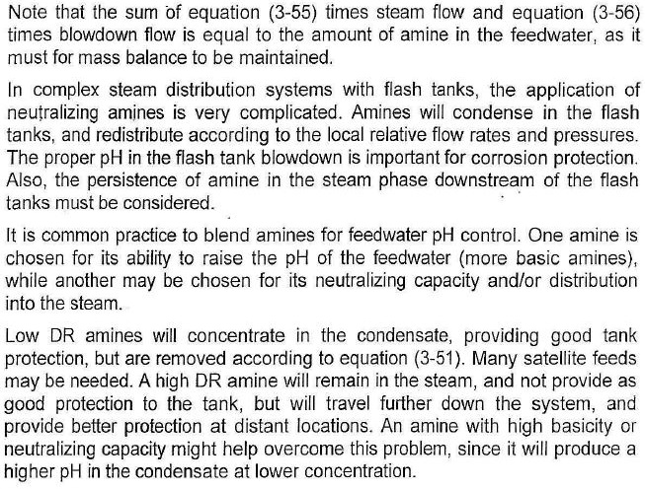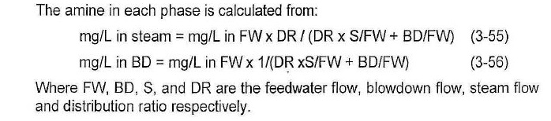

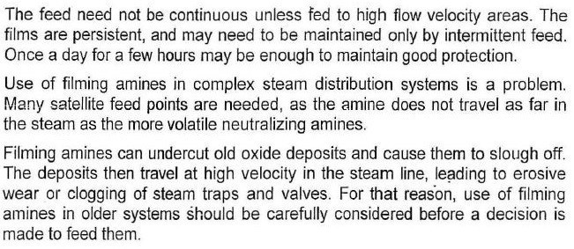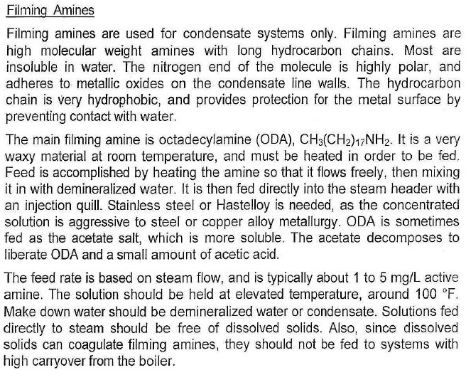

**Notes**

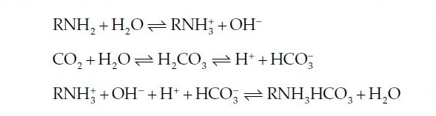

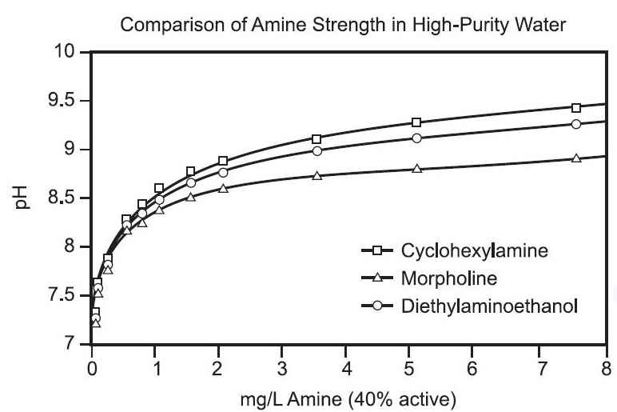

**Thermal Stability**

All organic molecules, including amines, have specific temperature limitations, above which they

thermally decompose. Most water treat­ment chemicals commonly used in boiler systems have been chosen for their exceptional thermal stability, yet all eventually break down in the boiler system given sufficient heat and holding time.

Amine thermal stability is primarily dependent on time at tem­perature, but system oxygen can also be a factor. The superheater is typically the location of highest heat within the boiler system. Because exposure time to superheat temperatures is extremely short, many amines can be used at temperatures above their known decomposi­tion temperatures without appreciable loss. Amines used in systems with reheat have significantly more exposure time at high tempera­tures and typically see a higher percentage loss.

In work reported by the Electric Power Research Institute (EPRI) in the early 1990s, the relative stability of several amines was listed as:

Monoethanolamine > methoxypropylamine > morpholine

Table 13.5 shows suggested temperature limitations for some of the neutralizing amines commonly used.

Thermal degradation of the neutralizing amines typically results in the generation of lower molecular weight amines and organic acids, as well as ammonia.

