Part 8

Utilities in Aspen Plus



UTILITIES

In this tutorial, you will use the Utilities feature. This is basically a convenient way of tracking the costs and amounts of utilities that your plant requires. These include electricity, different types of

steam, different types of cooling, fuels, refrigerants, and others. Basically, you create your own list of utilities available to your plant, along with appropriate temperature ranges and costs of use. Then, for units such as heat exchangers, pumps, compressors, etc., you simply select in each block which utility you are going to use. Then, Aspen Plus will figure out how much of that utility you need and how much it costs.

What Are Utilities?

Most everyday people understand what “utilities” are since they routinely pay utility bills as a part of living expenses. The term has a very similar meaning in a chemical engineering context. When a chemical process consumes a utility, it is essentially “purchasing” heating, cooling, refrigeration, or electricity from some other provider, even though that provider may just be another business unit of the same company. In practice, other services may be considered utilities, such as waste removal, water treatment, pressurized air, high-purity oxygen, process water, or solvents of various kinds. However, in Aspen Plus, “utilities” refer only to energy services: heating, cooling, and electricity. Conceptually, utilities are provided “on demand” and are not directly integrated into your chemical process. A chemical process designer is not often concerned with exactly how those utilities are provided; the designer instead determines what utility is needed and how much. It is important to understand that when you are purchasing utilities like steam, cooling water, or refrigeration, you are not actually purchasing the actual steam, water, or refrigerant—you instead purchase the heating or cooling service they provide. For example, when you purchase high pressure steam as a utility, you are really only purchasing the latent heat it carries. In fact, your chemical plant would normally have a condensate return line where the used, condensed steam (still hot and at high pressure) returns to the steam generation plant. If you buy refrigeration utility, you are only buying the service of removing low-temperature thermal energy from your plant (making it colder). This is why utility accounting uses a cost-per-unit-energy framework, because you are only purchasing the energy.

Defining Utilities

To use utilities in Aspen Plus, you must first define what utilities are available for you to purchase. Start with a blank simulation in Aspen Plus, preferably with the Chemicals with Metric Units template. You can define a utility in the Utilities folder under the Simulation tab (or click Process Utilities in the Economics ribbon). Click New to make a new utility, and call it something meaningful (see Figure 6.1). Let’s make LPS (low-pressure steam).

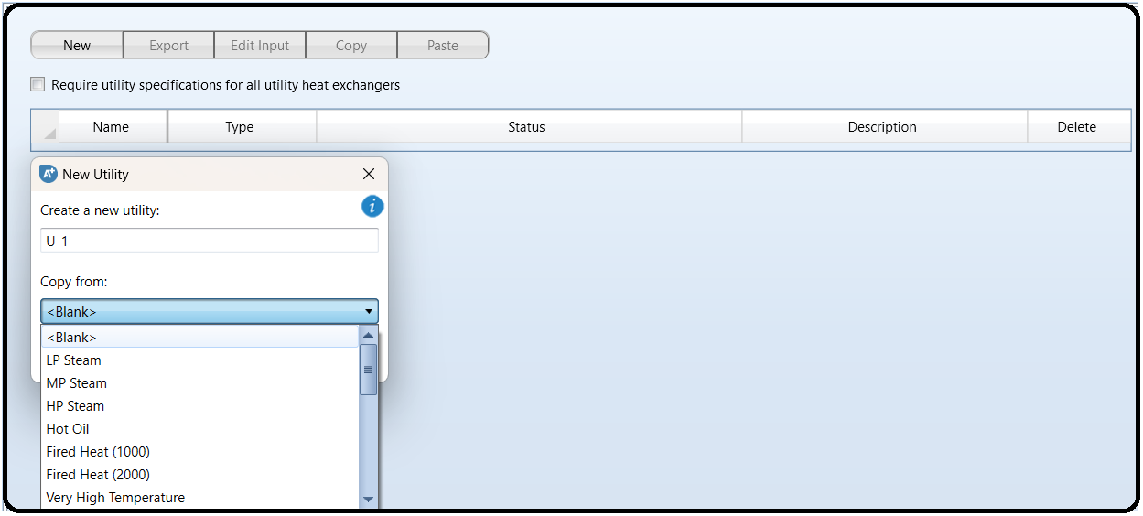

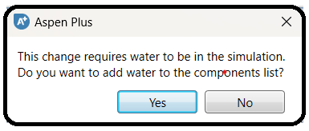In the Copy Form, choose LP Steam. Aspen Plus comes with default prices and settings for LPS. These are heuristics which may or may not be correct for your plant, and you’ll see the actual numbers show up in the Specifications and Inlet/Outlet tab once you choose LP Steam and select OK. Note also that if you have not added water to your components list, you will be prompted to do so (do it).

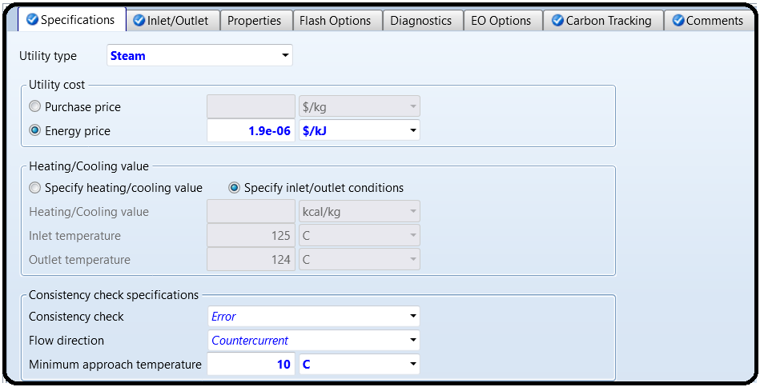These numbers are very convenient, but are they right? The energy prices given here are $1.9×10-6 per kJ, which is $1.9 per GJ.

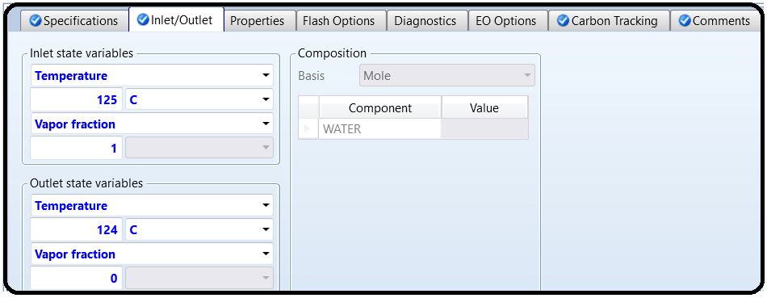

Aspen Tech sometimes updates these numbers, but of course the prices will be different for each specific circumstance and point in time.3 The bottom line is that it will vary with the price of energy. At the same time, there are differences in the temperature/pressure ranges of the steams between Aspen Plus’s default and heuristics given in other sources. There is no standard! Essentially, each plant will have access to steam levels depending on the other plants that sit nearby. For example, a company with lots of different processes on-site may have standard steam lines for that location. Or, individual plants may have custom steam pressure lines which are optimized to some particular values. My point is, don’t just blindly go with the default numbers.

Now I’ve said that, let’s blindly go with the default numbers since we’re just learning how to use the tool and are less concerned about what the numbers actually are. In the Inlet/Outlet tab, you’ll notice that the vapor fraction is defined as 1 for the inlet and 0 for the outlet. This means that heat is provided by condensing steam (this is normal). As mentioned in earlier tutorials, Aspen Plus uses a convention that if you *specify* vapor fraction = 1 or vapor fraction = 0 in an input form, that means you are defining that the inlet is exactly saturated vapor at the dew point or the outlet is exactly saturated liquid at the bubble point. The temperatures are given, so the pressures will be computed from this information. The outlet is defined to have a slightly lower temperature than the inlet so that the outlet will have a slightly lower pressure than the inlet. In the event that you wanted superheated steam or subcooled liquid, you would enter the temperature and pressure combination instead of a temperature and vapor pressure combination. Usually, real systems superheat and subcool by a few degrees as a safety margin.

Notice that there is a Carbon Tracking tab. This is a new feature that can help with sustainability analyses. On this tab, you’ll see that by default it chose a U.S. Environmental Protection Agency rule for computing the amount of global warming potential (measured in CO2 equivalents). It also selected natural gas combustion to produce the heat to make the steam, and an efficiency of 85%. Aspen Plus has a default number for the average composition of natural gas and its

heat of combustion. It takes the amount of steam duty you need and then divides that by 0.85 to determine the total natural gas combustion duty that is required to produce it (so only 85% of the

chemical energy from the natural gas is used to make steam via combustion, the rest is assumed lost as waste heat). Then it assumes that all the carbon atoms in the natural gas end up as CO2,

and then outputs that number. So Aspen Plus computes the *total direct emissions* for this utility, but does not account for the CO2 thatwas emitted in order to produce the natural gas and pipeline itacross the country and into your plant.

Now, go ahead and add a utility for electricity, using the default.We are going to add our own electric utility that assumes the electricpower is produced by a coal power plant with a solvent-based CO2capture system on it.

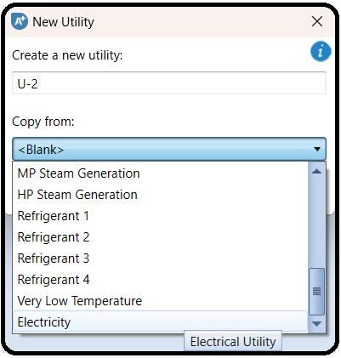

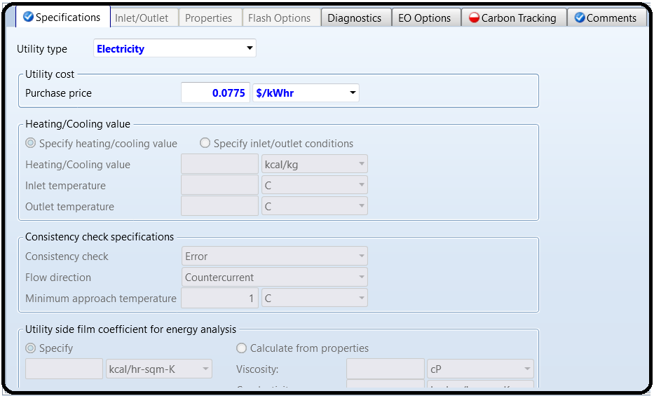

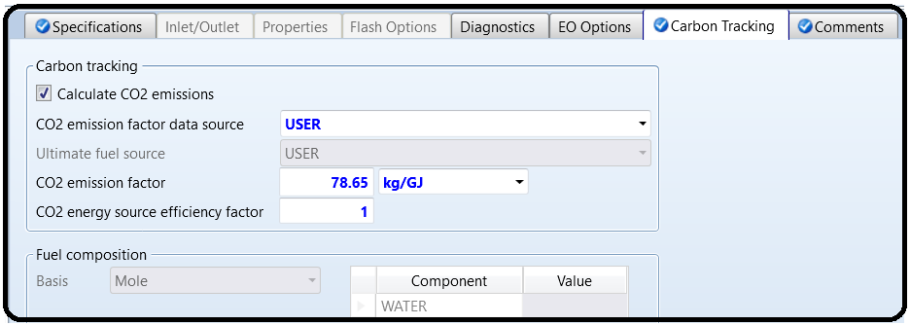 The default electricity setting in Aspen Plusassumes classic power plants with no CO2 capture, at a rathertypical price of about 8 cents per kWh. However, there is a powerplant by SaskPower in Saskatchewan, Canada which is the first of itskind to implement CO2 capture at a meaningful scale from coal,which has about 80% lower emissions per kWh than traditionalpulverized coal. Of course, it is more expensive than classic powerplants without CO2 capture. According to the U.S. Department ofEnergy (document DOE/NETL-2007/1281), we can predict that theprices for this type are higher, at 13.2 cents per kWh (in the UnitedStates), after adjusting for inflation. So make the change in theSpecifications tab. Similarly, the CO2 emissions should also be changed since they are much lower. A recent life cycle analysis study determined that the total cradle-to-grave life cycle emissions for a power plant of this new type should be about 78.65 kg of CO2 equivalent per GJ of electricity. That includes the construction of the power plant, the mining and transport of the coal, the construction and use of the CO2 capture, pipeline and storage system, and eventhe electricity transmission losses from connecting the power plant to your plant. So it’s a much better number to use than what Aspen Plus has because it includes more of the life cycle. Anyway, enter this number by setting the CO2 emission data factor source to USER, typing the number into the CO2 emissions factor box, and setting the efficiency factor to 1.0 since the efficiency factor is already included in the 78.65 kg/GJ number.

Finally, add utilities for medium- and high-pressure steam, and for boiler feedwater (BFW) streams at low, medium, and high pressure,using the defaults in Aspen Plus. Note that the BFW defaults are “Steam Generation” items. They are basically backward versions of the corresponding steam utility and actually make money and“consume” CO2 instead of costing money because the energy price and CO2 efficiency is negative. It is an accounting trick. The idea is that it prevents the cost of steam and the emission of CO2 somewhere else by making it here. Also, note the temperature ranges of these utilities for later. For example, cooling water comes in at 20°C and comes out at 25°C, which is rather generous but we’ll go with it. It also has a temperature approach maximum of 5°C by default. That means that for countercurrent flow, the coldest anything can get is 25°C (cold in = 20°C + 5°C = 25°C). If you violate this by assigning the utility where it shouldn’t be used (your heat exchanger comes too close to temperature crossover or actually does crossover, as discussed in Tutorial 4), Aspen Plus will throw you an error.5

Using Utilities

Ok, let’s see how utilities are used in the software. In this example, we are going to separate a 100 kmol/hr mixture of acetone (27 mol%, *T*bp = 56°C), methanol (38 mol%, *T*bp = 65°C), and *n*-butanol (35 mol%, *T*bp = 117°C) at 25°C and 1 bar that we get after a biofuel production process. Acetone and methanol form a low boiling azeotrope at 55°C, so we’re going to use pressure swing distillation again.

The process shown in Figure 6.2 can be used, with all of the remaining design parameters given. Simulate this process in Aspen Plus. You should be able to do this, given what you already know.

Remember, it is better to get one block working at a time before adding another one, and get all three columns working without recycle first before connecting the final recycle stream. When it is

finished, you should be able to get at least 98 mol% purity in each of the three product streams. Assume the distillation columns and their supporting reboilers and condensers are at constant pressure throughout. Use RADFRAC for the distillation columns of course and the NRTL-RK property package. Remember the best practices we learned from earlier tutorials: *change the property package first* *before adding the chemicals!* (butanol is *n*-butanol). Go back to check and make sure that the binary parameters come from the VLERK database and not the VLE-IG one! Do this by looking at the Source drop-downs of the different chemical pairs under the Input tab of the Properties | Parameters | Binary Interaction | NRTL-1 form.

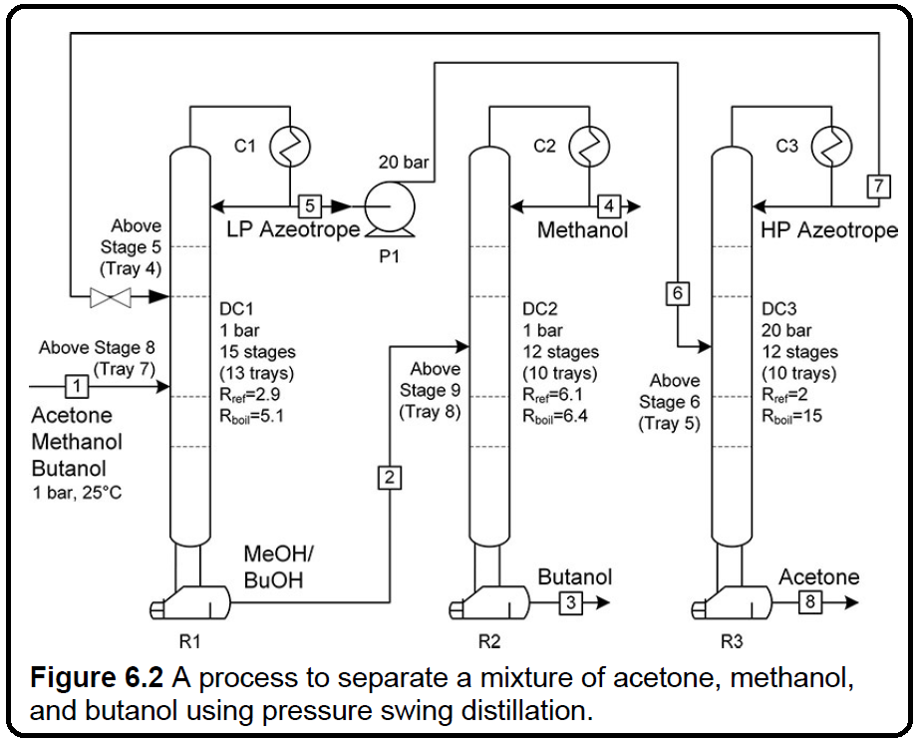

.

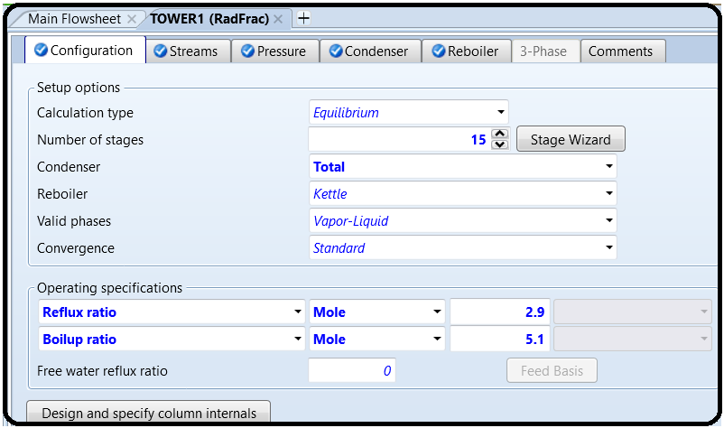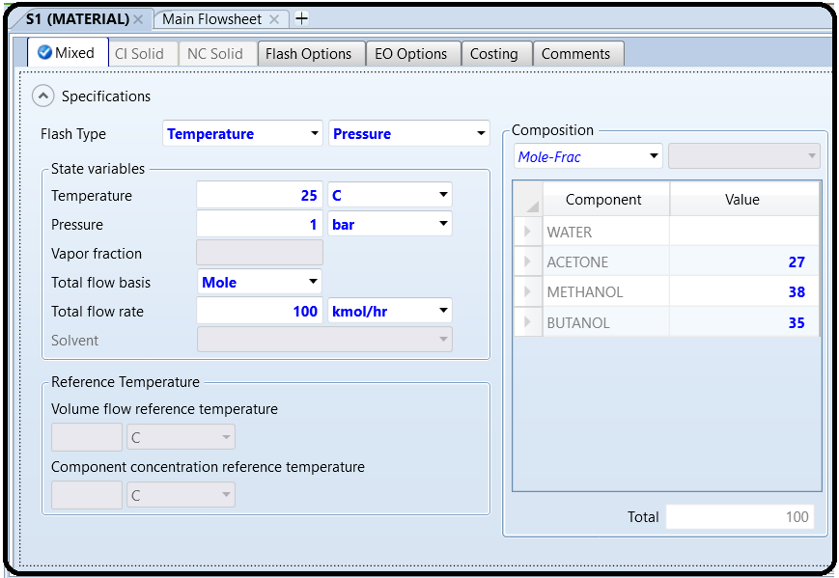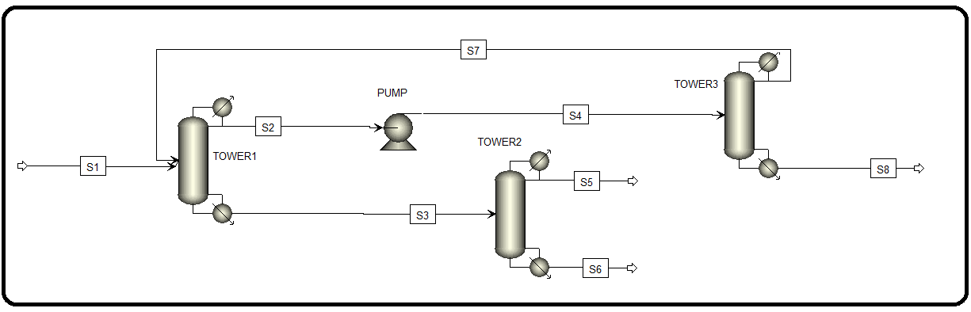

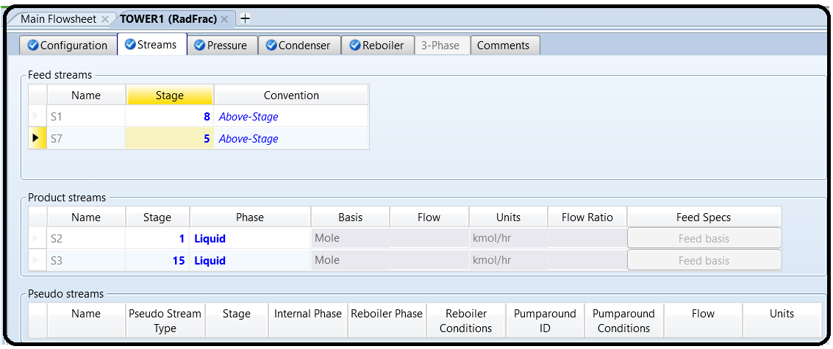

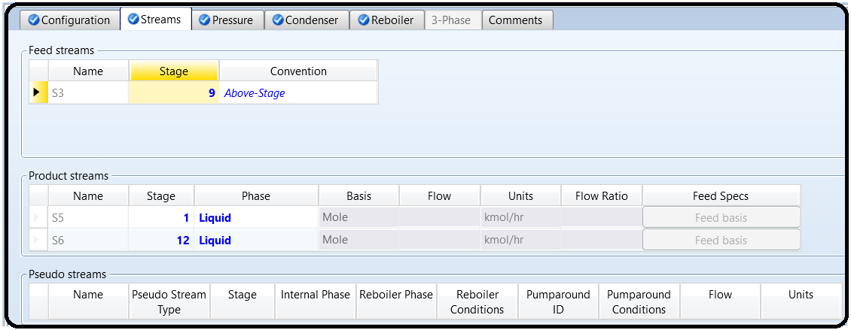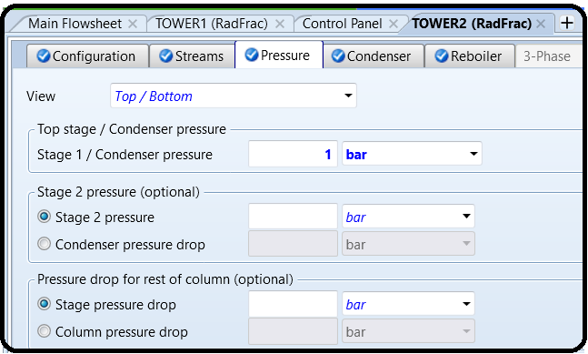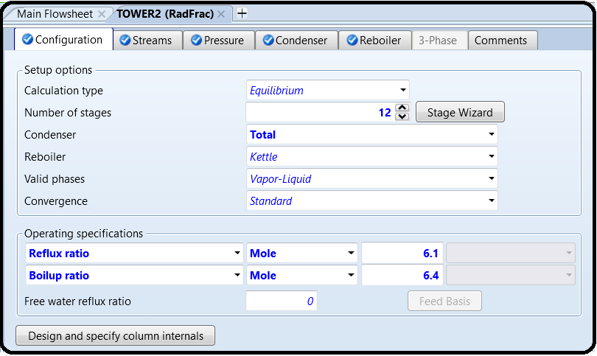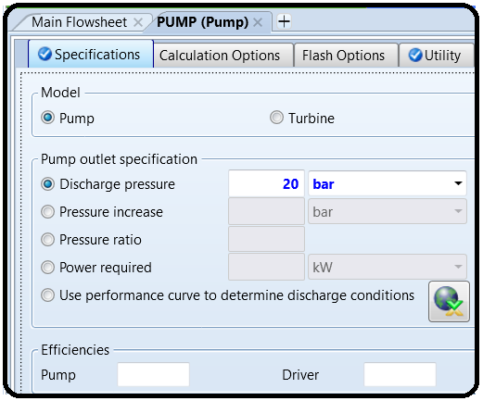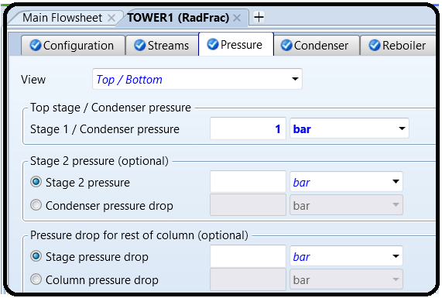

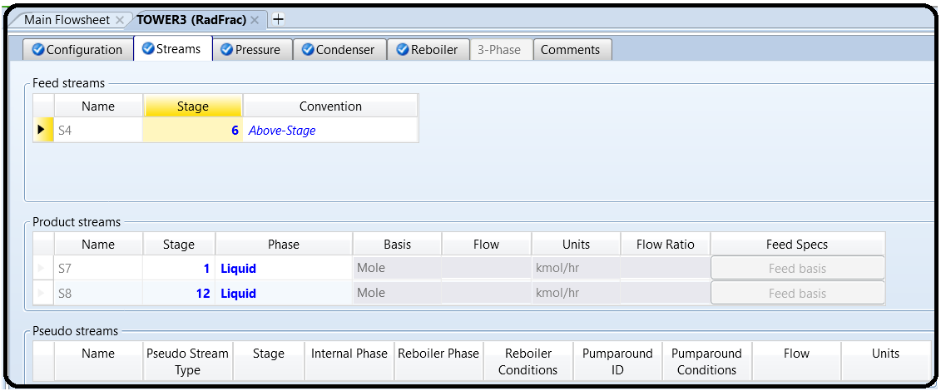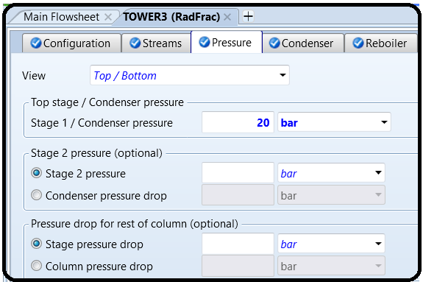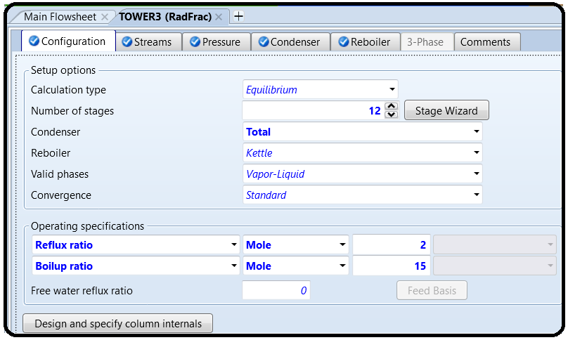

Ok, let’s go back and assign utilities to the process units. Each block has a different way of doing this. For example, in the Pump, there is a Utility tab, where you select which of the utilities that you created to be used with it (see Figure 6.3). In the RADFRAC blocks, you can find the utility specification in the Condenser (see Figure 6.4) and Reboiler tabs (Figure 6.5), respectively, at the bottom.

Go through and choose the correct utilities for each. You can use your simulation results to help you select. Remember not to violate the second law of thermodynamics! Remember, use BFW for cooling whenever you can because you’ll generate steam instead of paying for cooling! Rerun the simulation. You can check the utility results in the block’s results form, in the Utility tab or similarly named. Note: When selecting utilities, you generally want to

choose the cheapest utility that does the job. Suppose for example, you need to deliver 1.2 GJ/hr of heat to a stream that you want to heat up to 150°C. Your choices may include LPS (available at 125°C), MPS (175°C), HPS (250°C), and Fired Heat (e.g., inside a furnace with a minimum of 400°C). In this case, you cannot use LPS because it is not hot enough, so rule that out. MPS will work because it is 25°C hotter than your maximum needed heating temperature, which is well above the 5–10°C approach temperature we often assume. HPS and Fired Heat are even hotter and can also be used, but they are more expensive per GJ. (The default in Aspen Plus for HPS is $2.5/GJ but MPS is only $2.2/GJ.) So, we select MPS because it is cheaper, with a total cost of $2.64/hr.

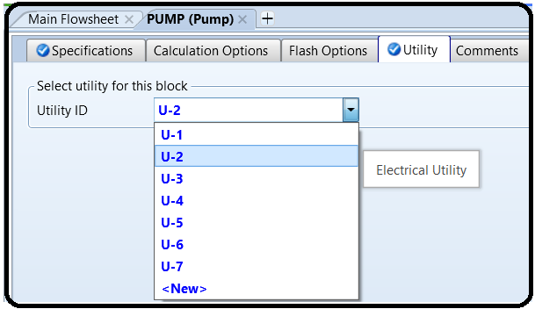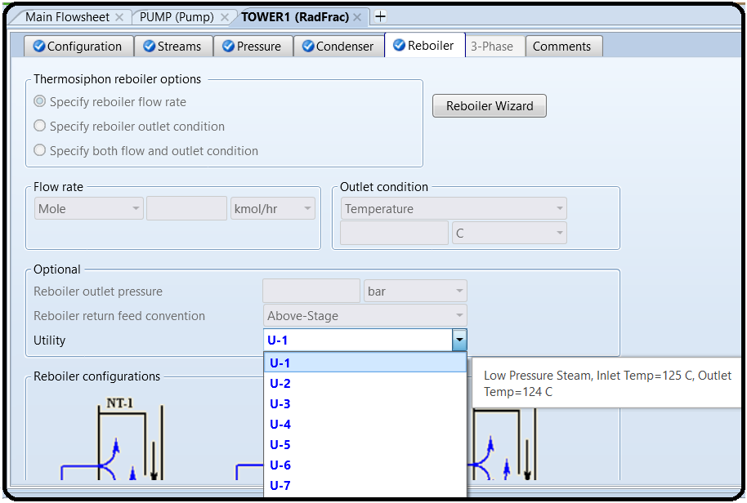 Note: Although Aspen Plus lets you select Electricity as the utility for almost any heat exchanger, this is very rarely the actual utility used in practice. Electric heaters (e.g., using resistors or actually shocking the target directly) are usually special cases only.

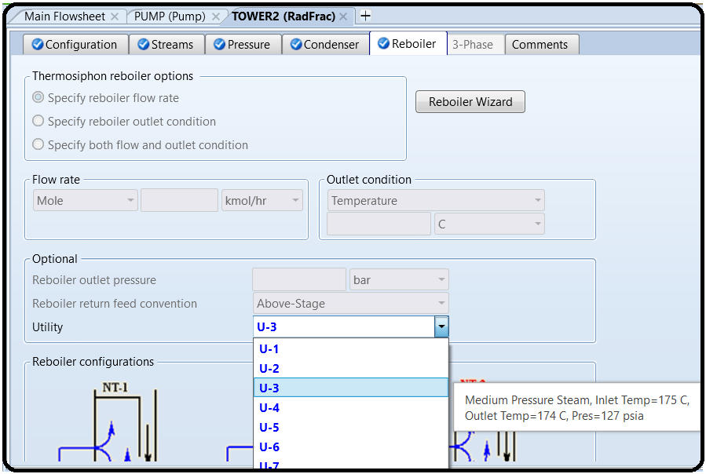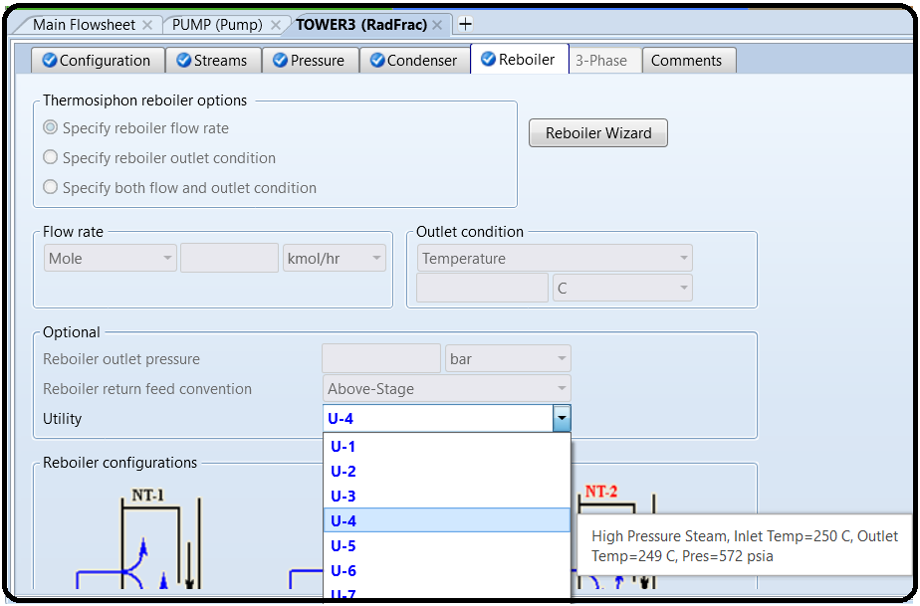

Results

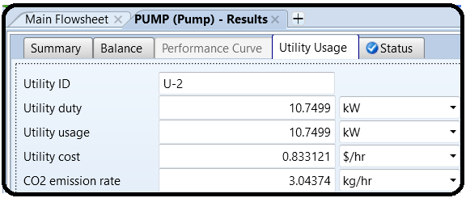

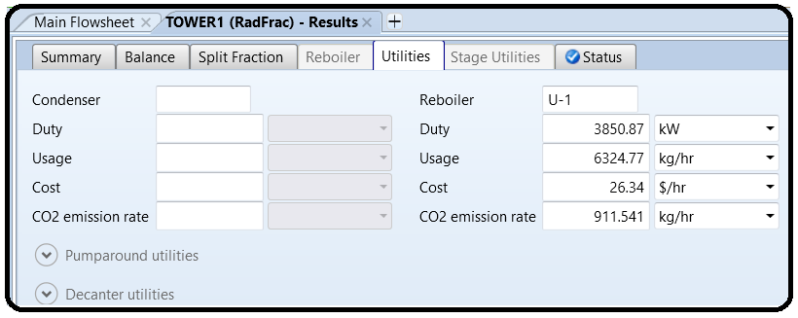

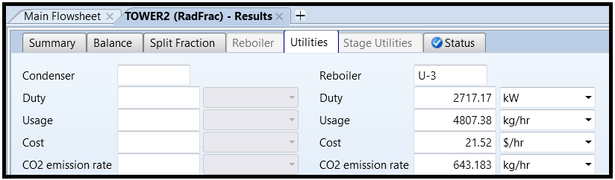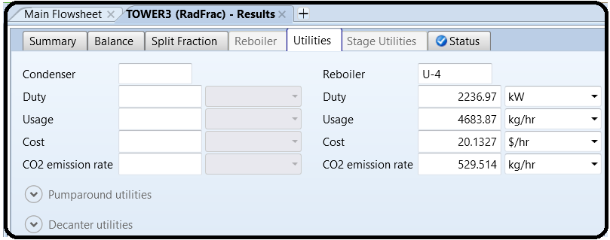

References:

1.EIEPD members’ experience

2. Aspen Plus build-in help

3.Learn Aspen Plus in 24 hr. by Thomas A. Adams II