Part 9

Solid Modelling in Aspen Plus



Problem Definition

Solids handling is important in some chemical industries, such as specialty chemicals (e.g., fertilizers and silicones), extractive processes (e.g., oil shale, copper, and alumina), and biofuel processes (e.g., corn stover and sugarcane).

Unlike liquids, solids handling requires the knowledge of additional characteristics, such as average particle size and density, moisture content, solubility, color, shape, porosity, and particle size distribution, which is usually expressed in terms of the mean particle size and a factor describing the degree of scatter around themean (e.g., standard deviation). Moreover, it is not possible to infer bulk from microscopic (single particles) properties of solids, in general. Aspen Plus has already many useful features that can deal with solids as it perfectly dealt with liquids and gases, as we have seen so far in the previous sessions. Formore information about the different solids unit operations, refer to “APPENDIX”.

Since there are many applications that involve more or less solid materials, we pick up some of them to demonstrate the important features of Aspen Plus in dealing with solidmaterials.

Example: THE CRUSHER

A feed stream of KCL with flowrate of 1250 kg/hr at 20 C and 1 bar with particle size distribution of median 5 mm and standard diviation of 1 mm with upper limit of 10 mm and lower limit of 0 mm passes a crusher which reduces the particle size of the feed stream.

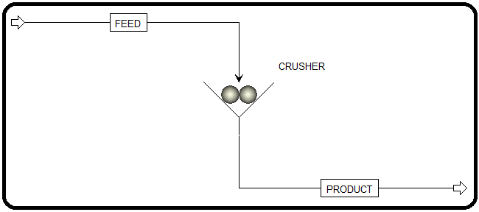

How to simulate

1.Using Aspen Plus, start a new simulation by choosing the “Solids” category and selecting

“Solids with Metric Units” template to create a steady-state flowsheet. Notice that Aspen

Plus, does not assign a default property method. So, we will set it to “SOLIDS”.

2. In “Navigation” pane menu tree, go to “Components” | “Specifications” | “Selection” sheet. Click on “Find” button to search for “KCL”. Once you find “KCL”, add it to the list of components and change its “Type” from “*Conventional*” to “*Solid*”, as shown in Figure 14.2.

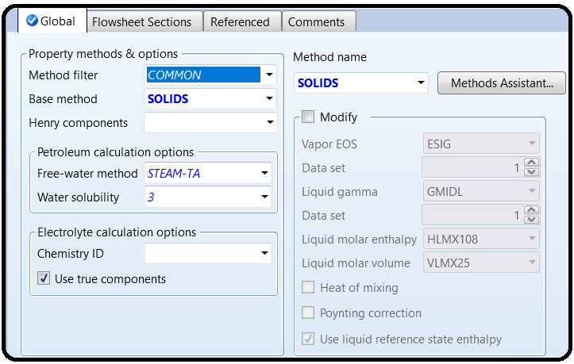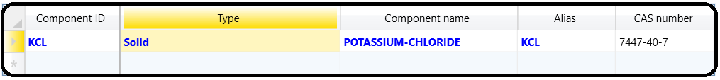

NOTE #1: “KCL” being defined as solid type will be treated as an inert solid with known molecular structure and it will not be involved in aqueous phase equilibrium (i.e., no association/dissociation reactions). However, as we will see shortly that it requires knowledge of further attributes that have to deal with particle size distribution (PSD). Thus, the substream class type for the feed (or product) stream class will be Conventional Inert with PSD (“CIPSD”).

3. Click on “Next” button, run the simulator, and monitor serious warning and errors (if any) via the “Control Panel”. Once you successfully manage to complete the property analysis step, switch to “Simulation” environment.

4. From “Model Palette”, select “Solids” tab, click on “Crusher” icon, and add the crusher icon to the flowsheet area. In addition, add the proper input and output stream, as shown in Figure 14.1. Click on “Next” button and Aspen Plus will bring you to “FEED” stream input form.

Notice here that entering solid-containing feed stream properties are different from those of a conventional feed stream, which has no “Solid” type component. Figure 14.3 shows the typical input data to be entered for a feed stream; however, we will use the second tab, that is, “CI Solid” tab for a conventional inert solid as in our case.

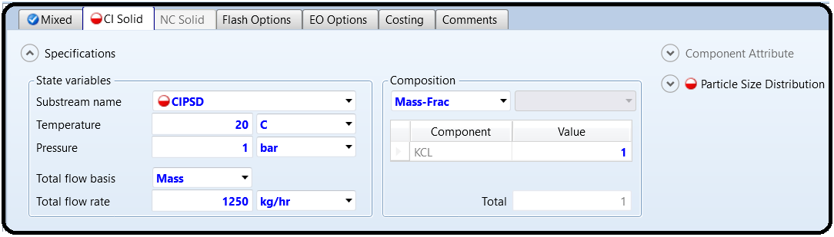

Notice that the half-filled red circle shown in Figure 14.3 indicates that input data pertaining to “FEED” stream is still incomplete, and the reason for this is simply because the stream class is of “MIXCIPSD” type with a substream of “CIPSD” type. Under such stream and substream definitions, we need to define or associate a PSD with the feed stream as well as define a simulation PSD for presentation of results.

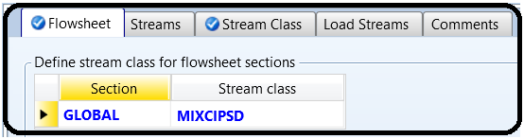5. Figure 14.4 (*top*) shows “Setup” | “Stream Class” | “Flowsheet” tab window where it shows that the stream class for the “Global” section (i.e., entire flowsheet) is of “MIXCIPSD” type. See “APPENDIX” for further information on stream classes. Stream classes ease the integration of solids and fluids in one simulation. The stream class can either be created or selected from a predefined type. Upon one’s need, a predefined class type can also be modified. Moreover, the “Stream Class” tab window (Figure 14.4 *bottom*) shows the selected substream class types for the given stream class of type “MIXCIPSD”. One can select the stream class from the drop-down list and see what substreams are already associated with.

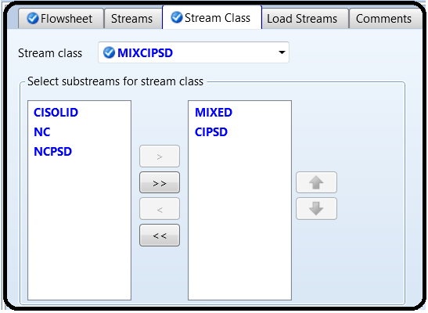

6.Defining the Particle Size Distribution (PSD)

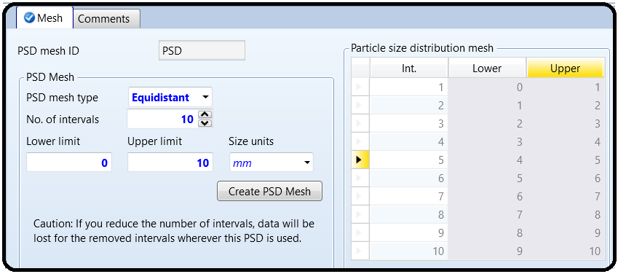Regarding the particle size distribution (PSD), we will define two PSD types one for the entire simulation and another for the feed stream. Notice here that both PSD types have to be within the same range; that is, the PSD mesh of the simulation within which we monitor the product stream solid attributes should not be too fine or too coarse for the feed stream PSD mesh. So, let us define the simulation PSD first in terms of size unit, lower limit, and upper limit. Figure 14.5 shows that we have selected the “PSD mesh type” to be “*Equidistant*” with parameters as shown in the figure. Do not forget to click on “Create PSD Mesh” button to confirm the creation of the selected PSD.

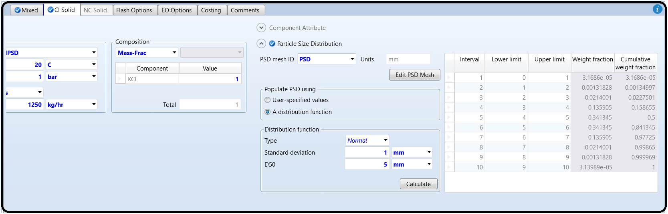7. Figure 14.6 shows the “CI Solid” tab window for “FEED” stream where we need to define a PSD for the solid of the feed stream. Notice here that you can edit (or modify) the simulation PSD via clicking on “Edit PSD Mesh” button, which will invoke the form shown earlier in Figure 14.5. Moreover, we define a PSD of “FEED” stream, here, as “*Normal*” with a standard deviation of 1mm and median (D50) of 5 mm.

Click on “Calculate” button to generate both the tabulated and graphic representation of PSD for “FEED” stream. Figure 14.7 shows the populated PSD values over the selected PSD mesh, which extends from 0 up to 10mm with equal subintervals. Notice that we have the frequency (i.e., weight fraction) is normally (i.e., symmetrically) distributed around its mean value that lies at about 5 mm. The range of simulation PSD acts like a window through which we have the chance to look at the effect of solids crushing on the PSD of the feed stream.

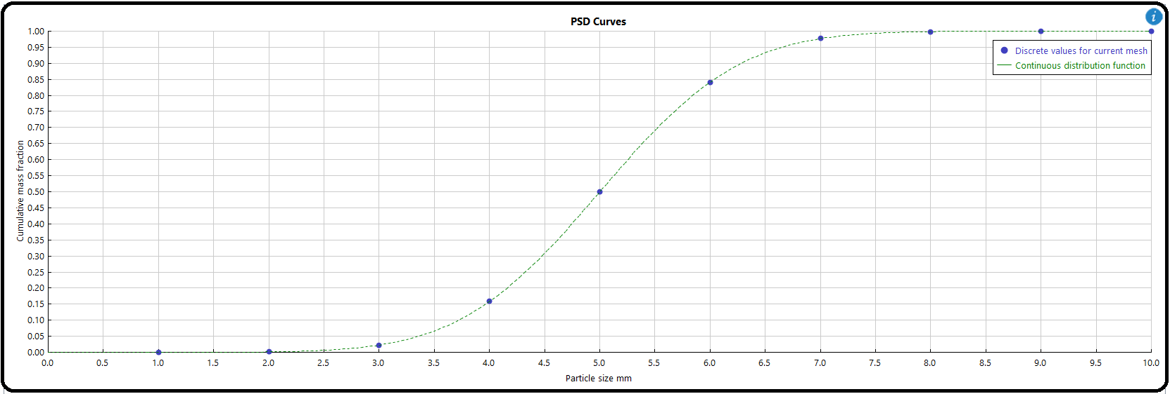Figure 14.8 shows the plot of cumulative mass fraction as a function of particle size (mm).

8.Calculation of the Outlet PSD

Click on “Next” button and the “Blocks” | “CRUSHER” | “Input” | “Specifications” tab sheet will show up, as shown in Figure 14.9. The outlet PSD will be calculated based on one of three methods: The first method is to spell out the crusher type, breakage function parameters, impact/rotor velocity, and/or some of its sizing parameters.

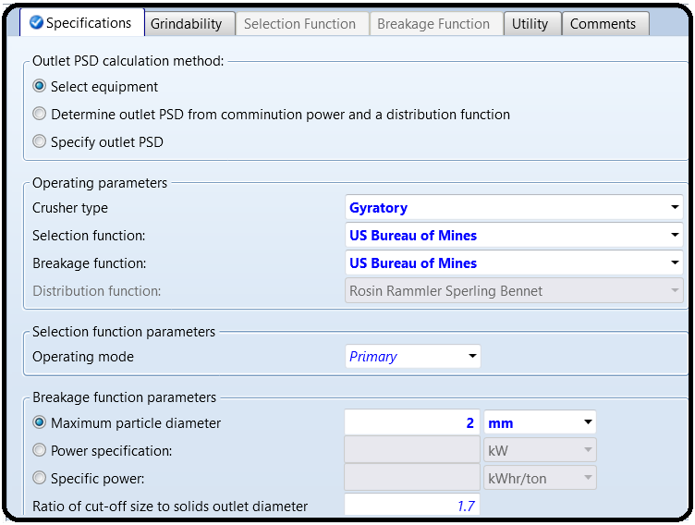The second method is based on known comminution (disintegration) power and some specifie distribution function parameters. Finally, the third method is based on known outlet PSD, which can be either user-specified or common built-in distribution function, such as GGS, RRSB, Normal, and Log normal

9. Click on “Next” button, run the show, and watch out any serious warning or error in“Control Panel”. Figure 14.10 (*left*) shows the “Summary” tab window for “CRUSHER” block under “Results” sheet. Obviously, there is a size reduction between the feed and the outlet stream. The size reduction ratio is 5.656 evaluated at the median. The Sauter mean diameter (see “APPENDIX 14.E”) is also reduced from 4.76 to 0.725 mm. For example, Figure 14.10 (*right*) shows that 98.782% of total particles fall below 3mm diameter size or 99.99997% of them lie below the 4mm diameter dividing cut.

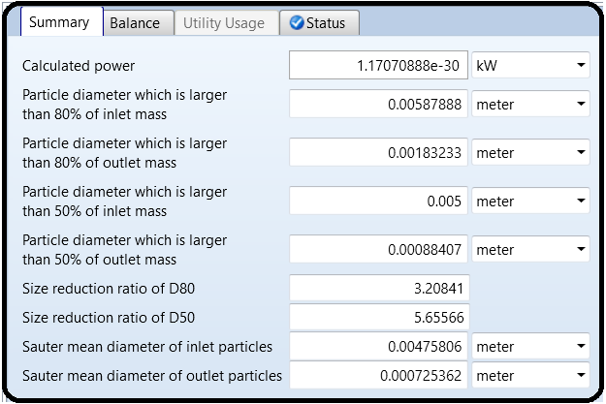

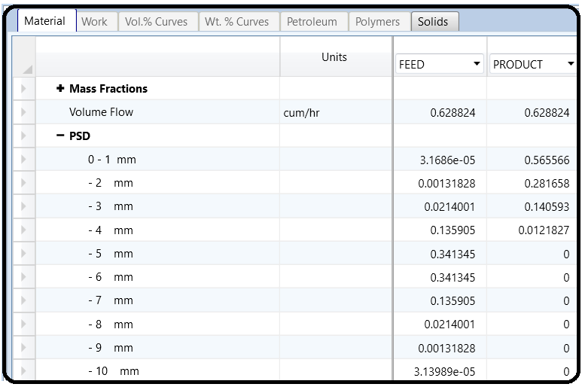

10. Repeat the same task of reducing the particle size of “FEED” stream but this time using the second method, which is “*Determine outlet PSD from comminution power and a distribution* *function*” (see Figure 14.9). Under “Specifications” tab, use “*Rosin Rammler Sperling* *Bennet*” distribution function; power specification of 1kW; and select “*D50*” parameter with “*1mm*” from “Distribution function parameters” option. Under “Grindability” tab, use “*Bond*’*s law*” as the “Comminution law” and for “CIPSD” substream use “*3 kWhr*/*ton*” under “Bond work index” column. See Aspen Plus built-in help: “Bond’s Law” for further information on Bond work index. Bond considered that the work necessary for reduction is inversely proportional to the square root of the size produced. This applies for particles between 0.05 and 50 mm.

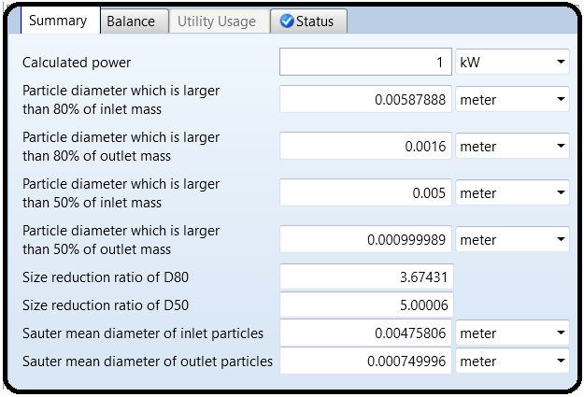

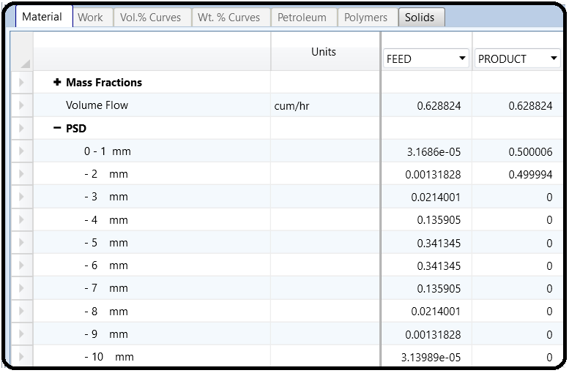

11. Repeat the same task of reducing the particle size of “FEED” stream but this time using the third method, that is, “*Specify outlet PSD*” (see Figure 14.9). Under “Specifications” tab, select “Substream ID” as *CIPSD*; select “*Use distribution* *function*”; the “*Bypass fraction*” is set to *0*; create a new distribution function ID and nameit *1*; select the “*Distribution function*” as *Normal*; select D50 parameter with 1mm and standard deviation of 1 mm.

Under “Grindability” tab, you may keep it blank (i.e., no entries at all); however, if you use Bond’s law as the comminution law and for “CIPSD” substream use “*3 kWhr*/*ton*” under “Bond work index” column, then you will be able to calculate the power needed to achieve the mission, that is, size reduction of feed stream particles down to the specified outlet PSD.

Report the outlet stream solid attributes in terms of particle size cut, reduction, mean, and distribution (i.e., PSD). Also, report the calculated power (kW) needed to carry out the crushing mission. I hope toward the end of this exercise that you managed to crush the information needed to deal with crushers.

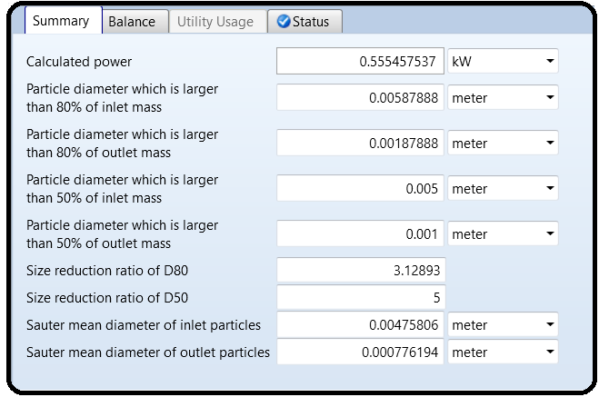

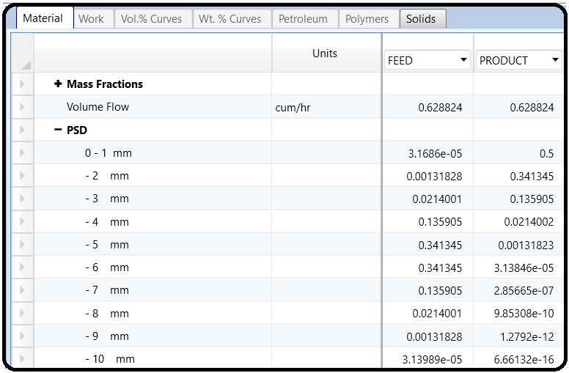

Part 2

Problem Definition

THE FLUIDIZED BED FOR ALUMINADEHYDRATION

In this problem, we will handle the fluidized bed with a chemical reaction. Fluidized beds are used in a variety of industrial processes, which include drying, cooling, heating, and as reactors. The feed stream is made of aluminum trihydroxide (Al(OH)3), which will be dispensed in the form of solid particles to the entrance of the fluidized bed where it will be pneumatically lifted or fluidized by means of a hot air stream. This will cause the phenomenon known as fluidization visualizing solid particles behaving as fluid-like molecules (i.e., they gain the translational, vigorous vibrational, and rotational kinetic energy as well). This being the case, we will enhance the simultaneous mass and heat transfer rates from and to the solid particles. The dehydration reaction

2Al (OH)3 → Al2O3 + 3H2O

can be put in another form:

Al2O3 ⋅ 3H2O → Al2O3 + 3H2O

So, the reaction is basically a solid transformation from the hydrated into the anhydrous unit crystal. Thus, heating by convection (by the air) and conduction (through the solid particle) will liberate the combined water molecules from the crystal. Keep in mind that this process is a sort of “roasting” process rather than drying. For a typical wet-hydrated alumina or inorganic solids, in general, water molecules are trapped within the solid matrix itself (i.e., within the macropores of a solid pellet, compared with the tiny small size of the unit crystal).

How to Simulate

1. Using Aspen Plus, start a new simulation by choosing the “Solids” category and selecting “Solids with Metric Units” template to create a steady-state flowsheet. We will set the default property method to “SOLIDS”.

2. In “Navigation” pane menu tree, go to “Components” | “Specifications” | “Selection” tab sheet. Add the following components and change the “Type” of both “*AL*(*OH*)*3*” and “*AL2O3*” from “*Conventional*” to “*Solid*”, as shown in Figure 14.11.

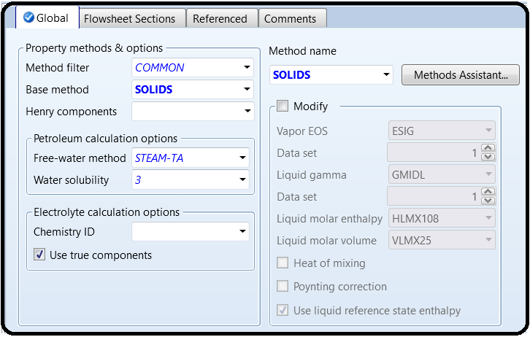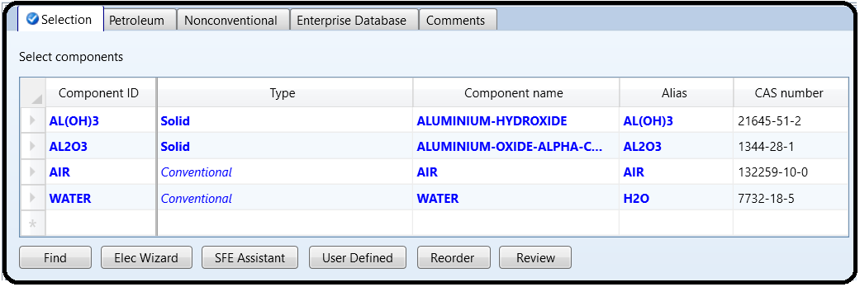

3. Click on “Next” button, run the simulator, and monitor warnings and errors (if any) via the “Control Panel”. Once you successfully manage to complete the property analysis step, switch to “Simulation” environment.

4. From “Model Palette”, select “Solids” tab, click on “Fluidbed” icon, and add the fluidized bed icon to the flowsheet area. Add one compressor unit from “Pressure Changers” tab. In addition, add the proper input and output streams, as shown in Figure 14.12. Notice that “SIN” and “SOUT” stream stand for the inlet and outlet solid streams, respectively.

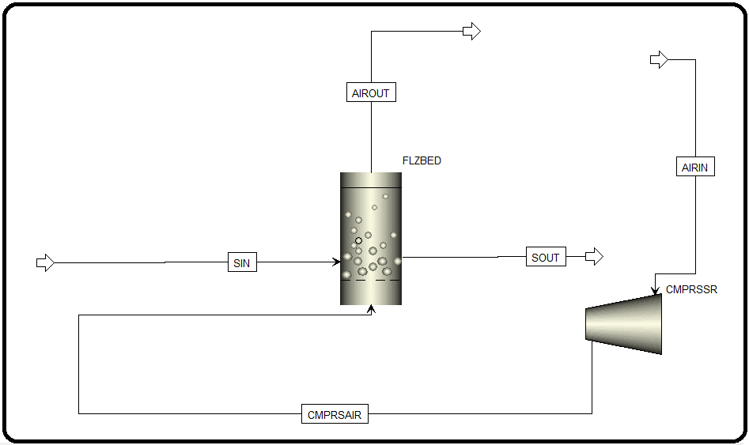

5. Air stream (“**AIRIN**”) will be introduced to the compressor at a rate of 4500 kg/h at room temperature and pressure and the discharge pressure of the compressor will be set at 12 bar. Of course, the temperature of air will increase as a result of adiabatic compression. On the other hand, the solid feed stream (“**SIN**”) will enter at a rate of 300 kg/h at room temperature and a pressure of 12 bar as pure Al(OH)3. Moreover, Figure 14.13 (*left*) shows the

simulation PSD mesh and that of “**SIN**” stream (*right*).

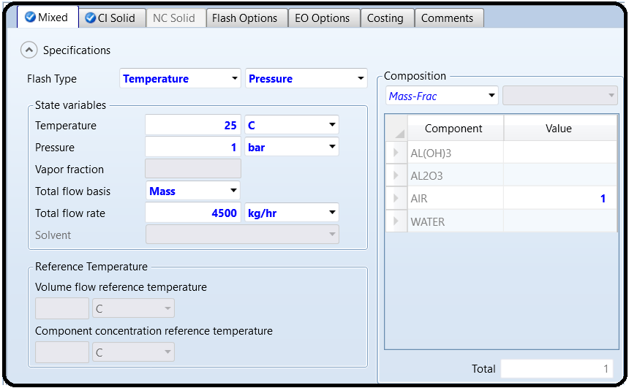

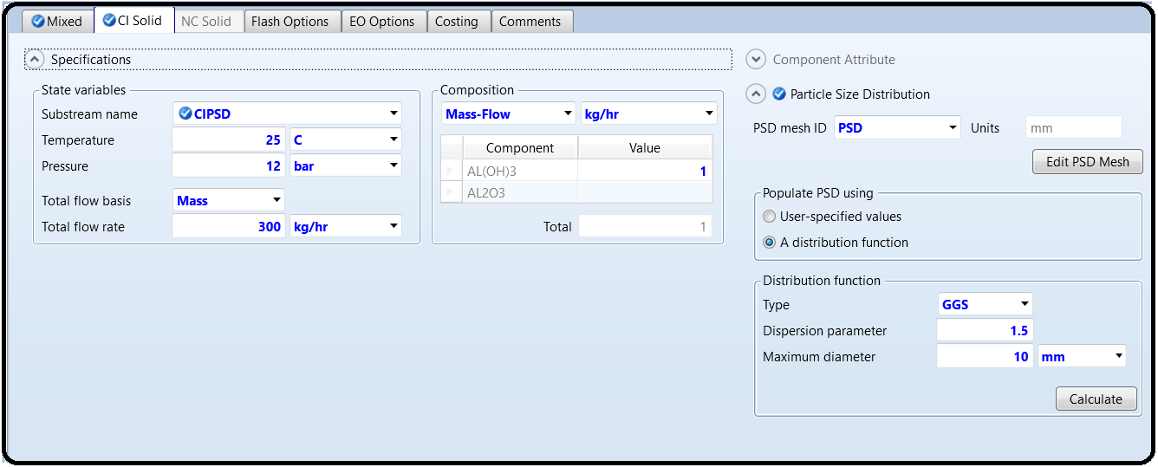

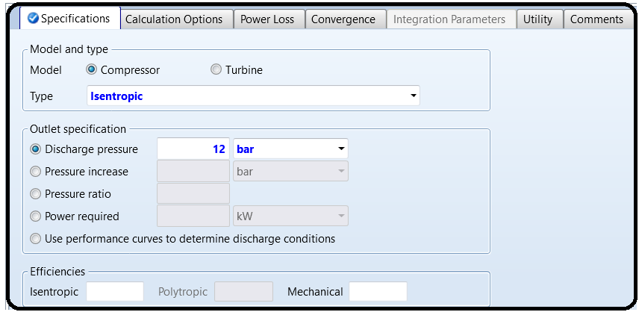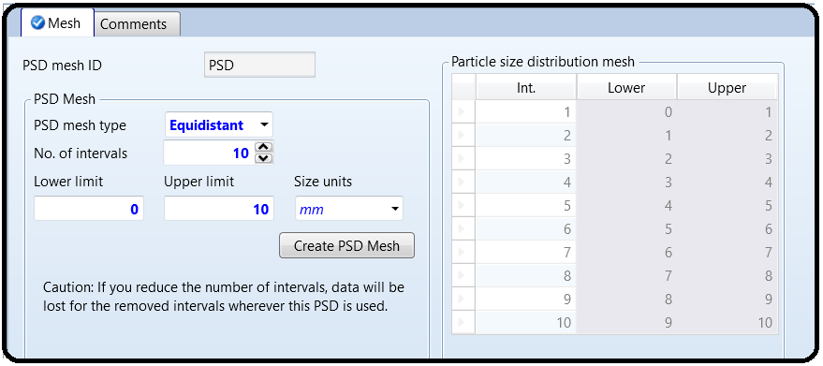

6.For the fluidized bed block, the following design specifications are entered, as shown in Figure 14.14. First, under “Specifications” tab, the bed mass is set to *120 kg*; “*Geldart B*” classification; and “*Ergun*” model for finding the minimum fluidization velocity. Second, under “Geometry” tab, the bed height is set to *4m*; the solid discharge location *0*.*95* (i.e.,0.95 × 4=3.8m, measured from the bottom of the bed); and the cross-sectional area with a constant diameter equal to *0*.*5m*. Third, under “Gas Distributor” tab, its type is set to “*Perforated plate*” with number of orifices equal to *40*, diameter equal to *10*mm each, and the default orifice discharge coefficient of *0*.*8*. Fourth, under “Convergence” tab, for mass balance convergence, the solver is set to “*Newton*” instead of “*Broyden*”, as the latter did not properly converge for a reasonable solution for the given fluidization case. Finally, under “Reactions” tab we will associate the reaction “R-1” set to the 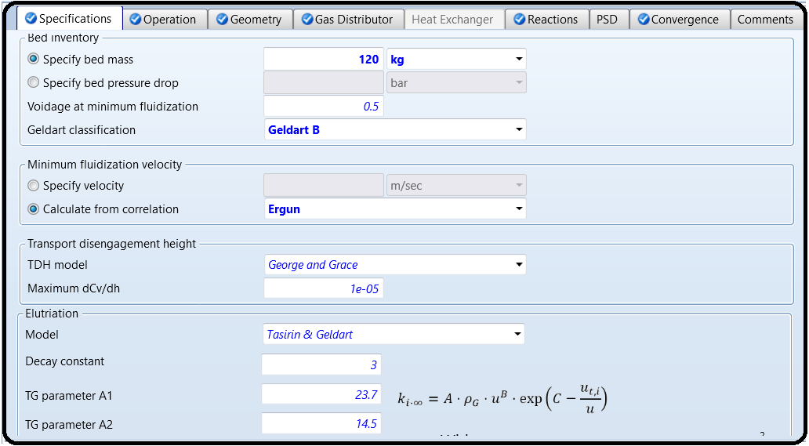fluidized bed. The reaction “R-1” set will be created shortly.

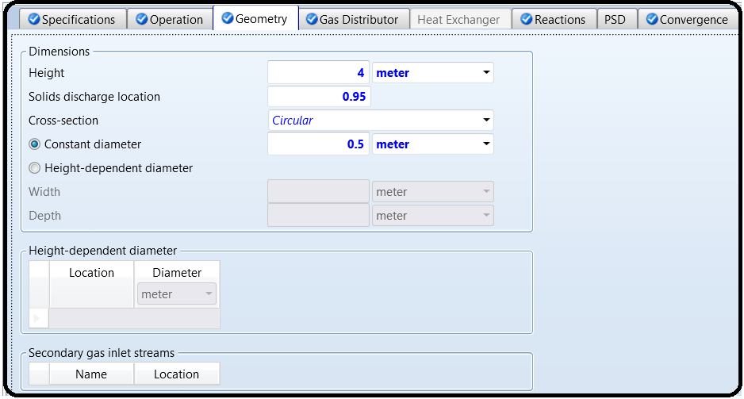

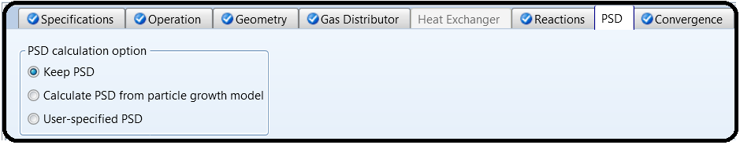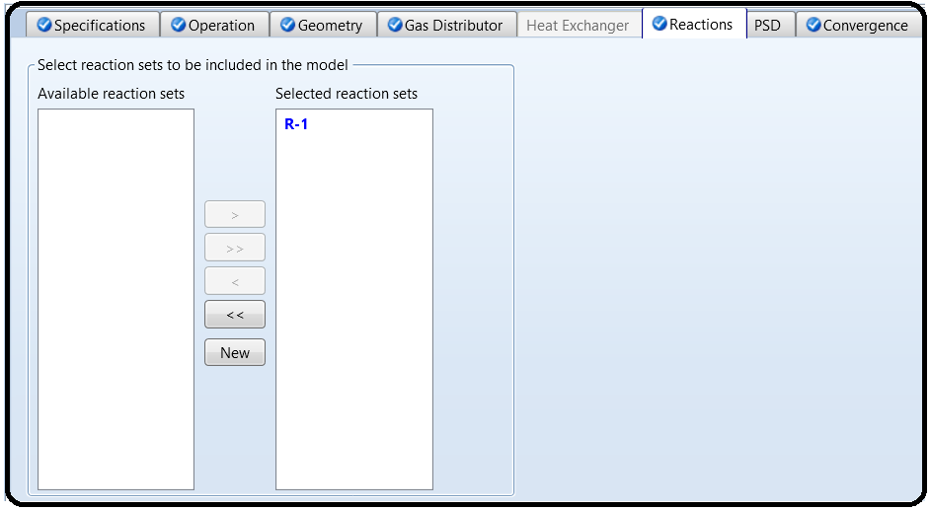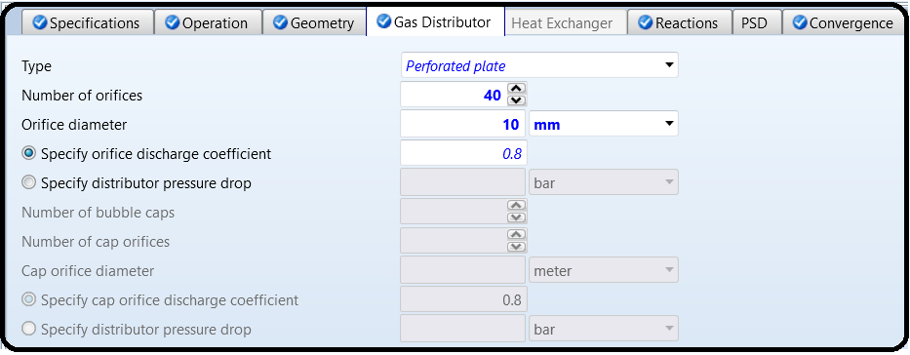

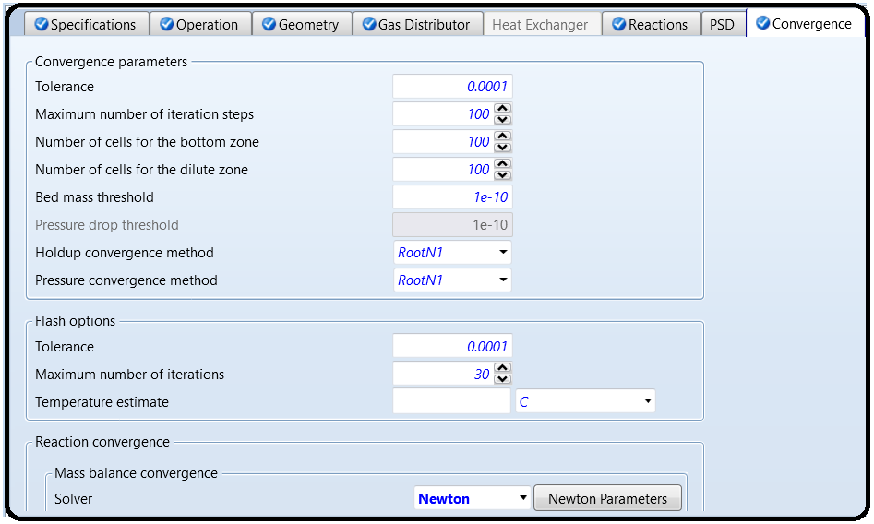

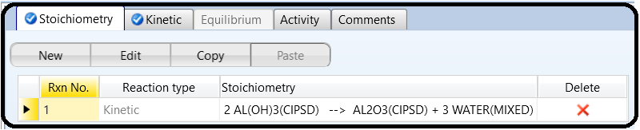The reaction “**R-1**” set will be created under “**Reactions**” folder. Figure 14.15 shows the stoichiometry and kinetic data associated with alumina transformation from a hydrous to anhydrous state.

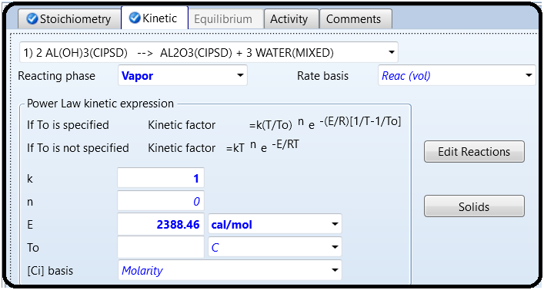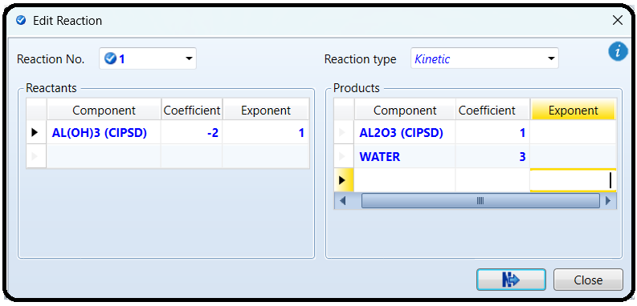

Results

Figure 14.16 (*left*) shows the results summary of the calculated geometrical and operational variables of the fluidized bed and the moisture profile of air stream where dry air enters at the bottom and becomes moist as it moves upward (*right*).

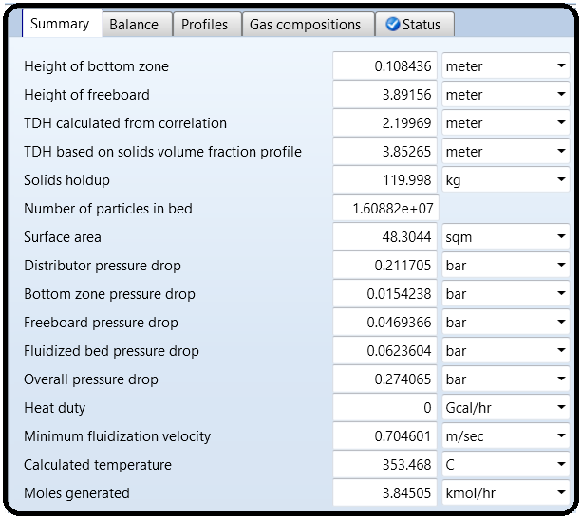

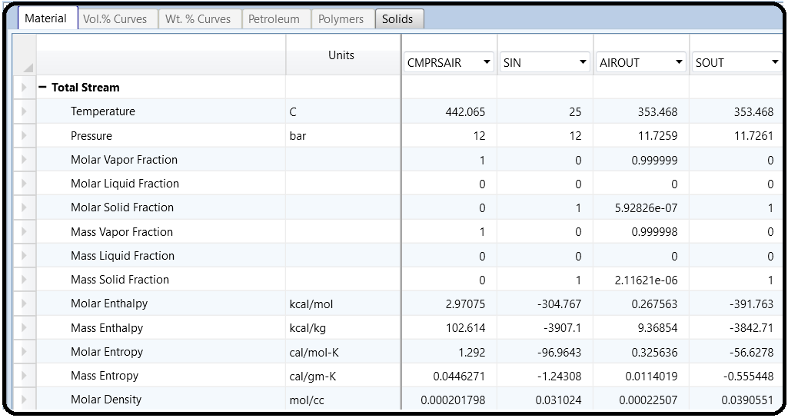

Part 3

Problem Definition: KCL DRYING

Consider the process of KCl drying using hot air, where moisture will migrate from the wet solid to the dry air and the heat needed will be convectively supplied by the hot air.

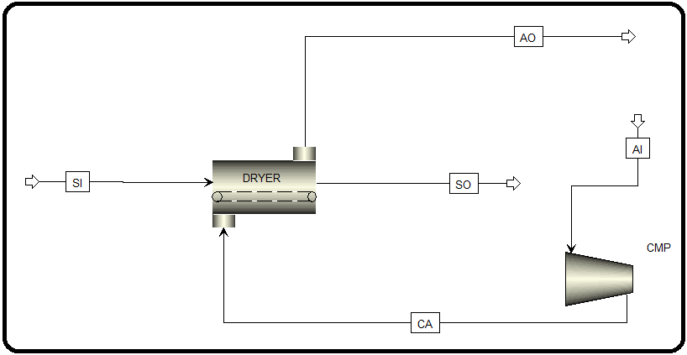

How to Simulate

1. Using Aspen Plus, start a new simulation by choosing the “Solids” category and selecting “Solids with Metric Units” template to create a steady-state flow sheet. Notice that Aspen Plus does not assign a default property method. So, we will set it to “SOLIDS”.

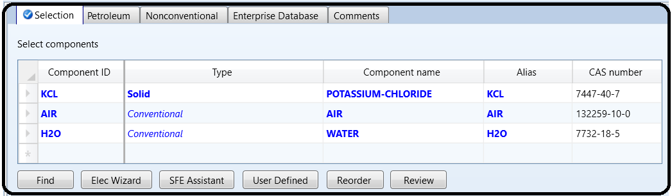2. In “Navigation” pane menu tree, go to “Components” | “Specifications” | “Selection” sheet. Click on “Find” button to search for “KCL”. Once you find “KCL”, add it to the list of components and change its “Type” from “*Conventional*” to “*Solid*”. Add water and air as well, as shown in Figure 14.18.

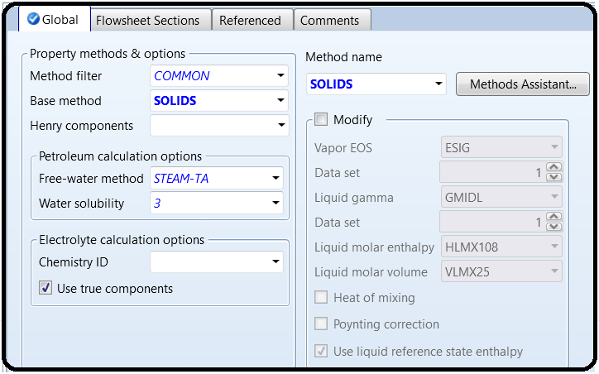

3. Click on “Next” button, run the simulator, and monitor warnings and errors (if any) via the “Control Panel”. Once you successfully manage to complete the property analysis step, switch to “Simulation” environment. From “Model Palette”, select “Solids” tab, click on “Dryer” icon, and add the dryer icon to the flowsheet area. Add one compressor unit from “Pressure Changers” tab. In addition, add the proper input and output streams, as shown

in Figure 14.19.



Under “**Solids**” folder, selectwater as the moisture component, as shown in Figure 14.20.

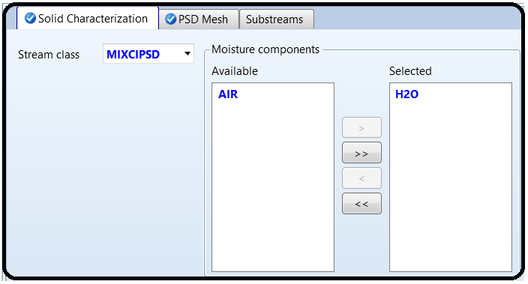

Figure 14.21 shows the creation of a simulation PSD mesh for monitoring the effect of drying on the particle size distribution of the substance being dried.

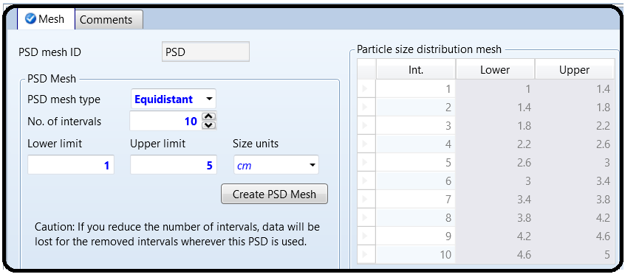

Figure 14.22 shows the solid inlet stream properties in terms of *P*, *T*, compositional flowrate, and PSD

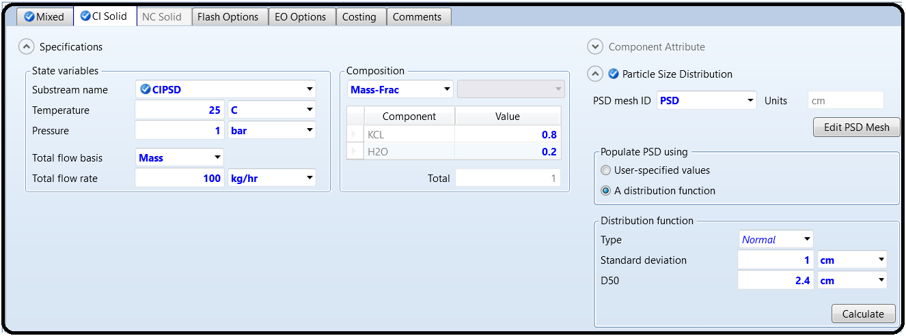

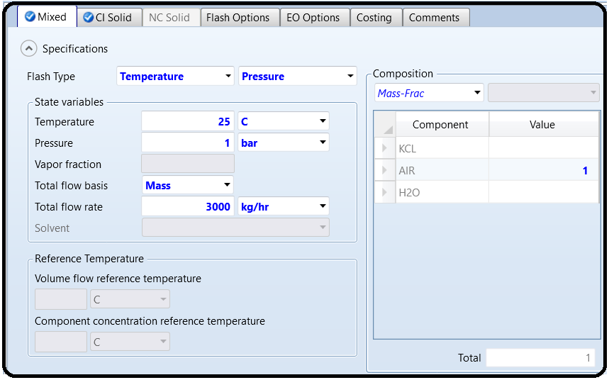The inlet air stream enters the compressor at a flow rate of 3000 kg/h at room temperature and pressure and will leave it at 6 bar. The dryer specifications are shown in Figure 14.23.

5.Click Next to go to Compressor Block.

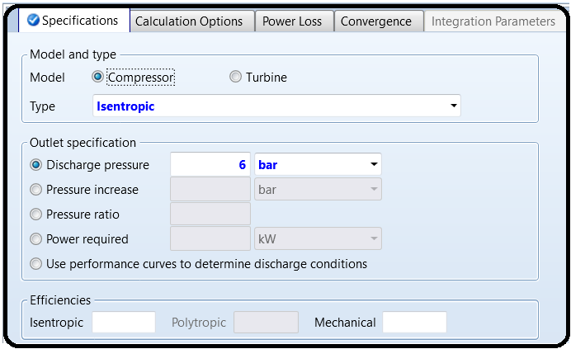

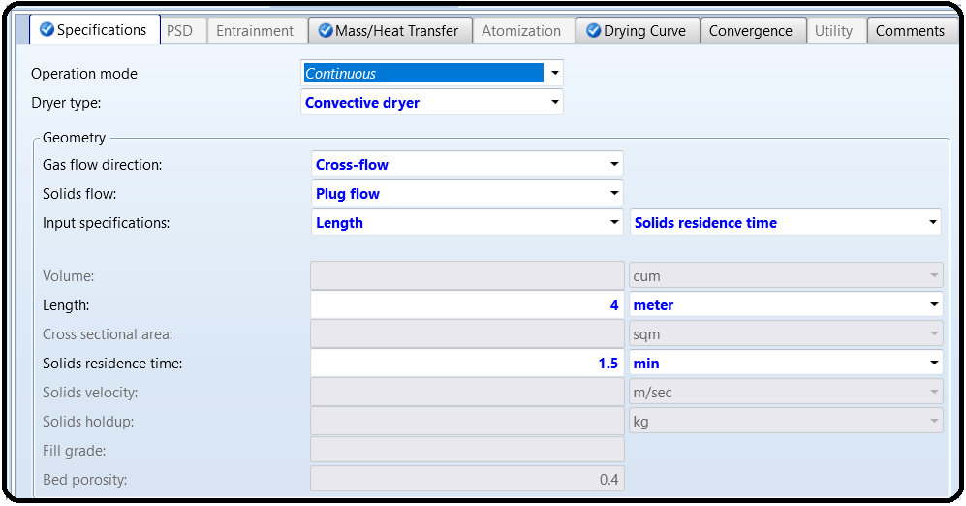Notice that the “**Shortcut**” is simpler than the “**Convective dryer**” method in terms of inputrequirements, nevertheless, less rigorous. The drying curve characteristics are shown in Figure 14.24. Notice that the **critical solids** **moisture content** is the moisture content at which further evaporation is mass-transfer limited and the second drying phase begins, and the **equilibrium solids moisture content** is the ultimate moisture content at which point no further drying is possible.

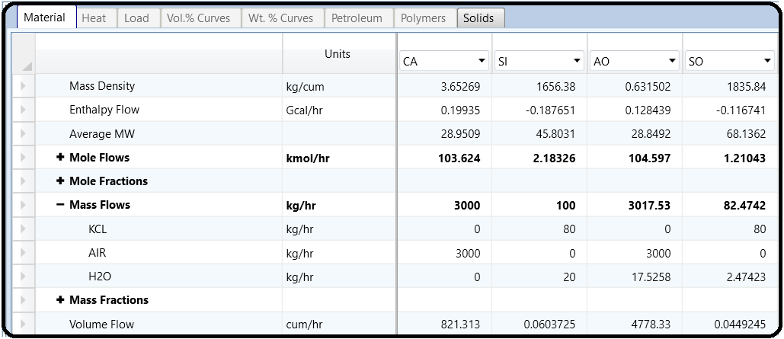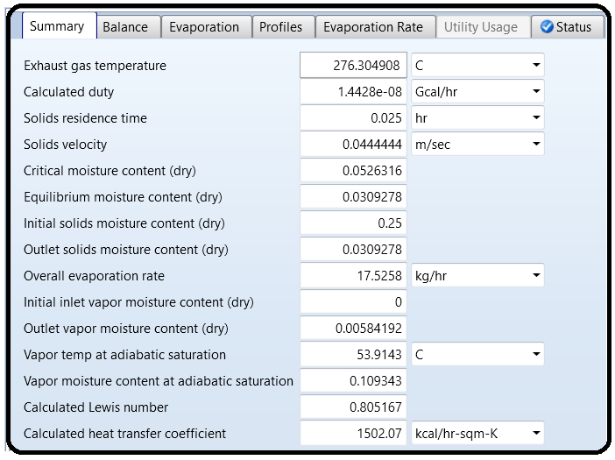Results

Part 4

Example: KCL CRYSTALLIZATION

Consider the process of KCl crystallization from KCl solution using heat to evaporate the water and result in a supersaturated solution that will be the cause for solid precipitation at the bottom of the mother liquor.

1. Using Aspen Plus, start a new simulation by choosing the “Solids” category and selecting “Solids with Metric Units” template to create a steady-state flowsheet. Notice that Aspen Plus does not assign a default property method. So, we will set it to “SOLIDS”.

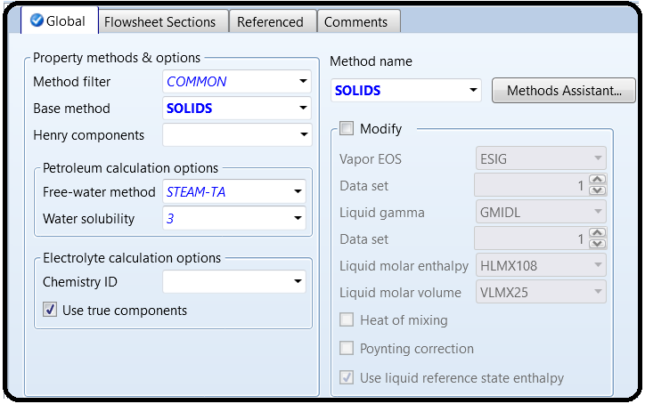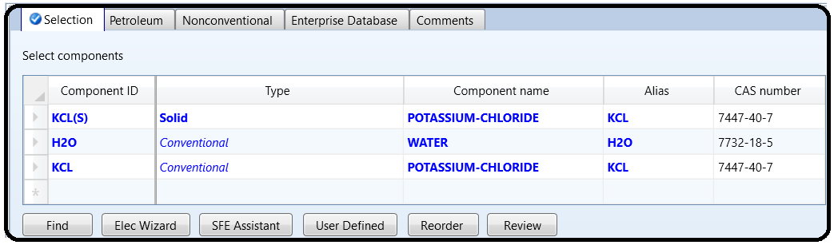2.In “Navigation” pane menu tree, go to “Components” | “Specifications” | “Selection” sheet. Add KCl twice once as “*Solid*” (i.e., “KCL(S)”) and another as “Conventional” (i.e., “KCL”) to the list of components and add water as well, as shown in Figure 14.25.

3. Click on “Next” button, run the simulator, and monitor warning and errors (if any) via the “Control Panel”. Once you successfully manage to complete the property analysis step, switch to “Simulation” environment.

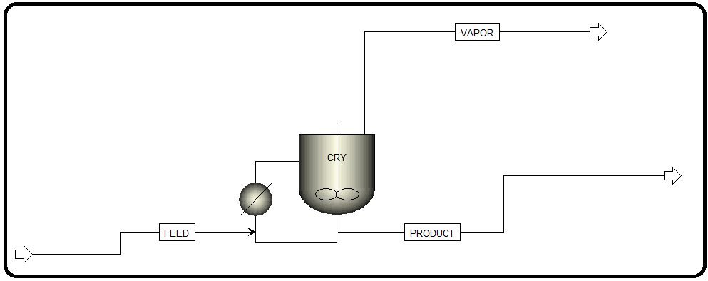4.From “Model Palette”, select “Solids” tab, click on “Crystallizer” icon, and add the crystallizer icon to the flowsheet area. In addition, add the proper input and output streams, as shown in Figure 14.26.

5.Figure 14.29 shows the feed stream properties in terms of *P*, *T*, and compositional flowrate. There will be no need for PSD specification because the feed stream is a saturated aqueous KCl solution entering at the maximum solubility, which is 35 g KCl/100 g water (amounts to KCl mass fraction of 0.26).

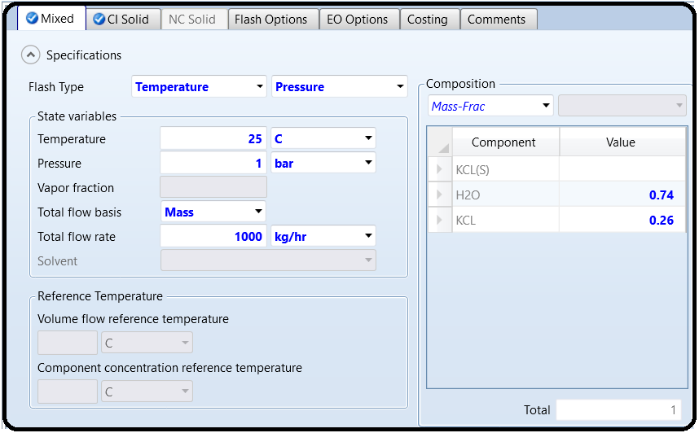

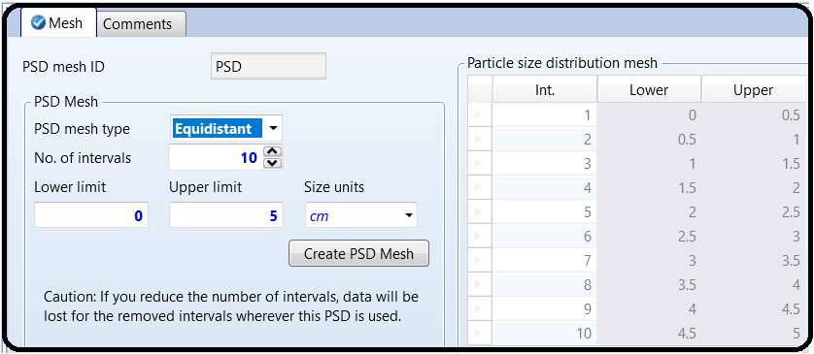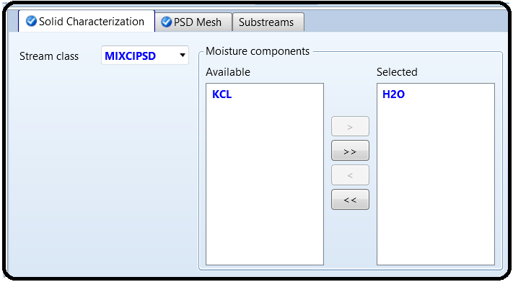Under “**Solids**” folder, selectwater as the moisture component, as shown in Figure 14.27.

Figure 14.30 shows the “**Specifications**” tab window for the crystallizer. A heat duty of 300kW will be supplied to evaporate water (the solvent) and concentrate KCl solution. The “**Operating mode**” is set to “*Crystallizing*”. Under this mode, the amount of crystals should increase in the flow and a warning will be issued if the crystal product flow rate iszero or smaller than that of the inlet. The opposite is true for the “*Dissolving or melting*” mode. No warning will be issued if the mode is set to “*Either*”. Figure 14.31 shows the “Crystallization” tab window where we define the 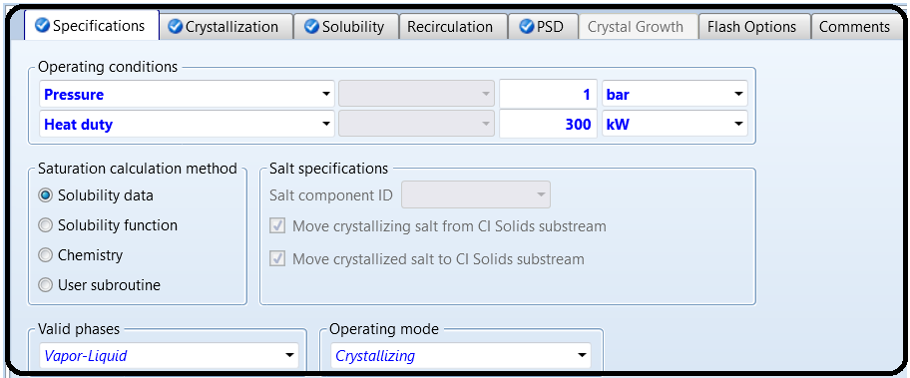sort of speaking “physical” reaction:KCl(aq) → KCl(S).

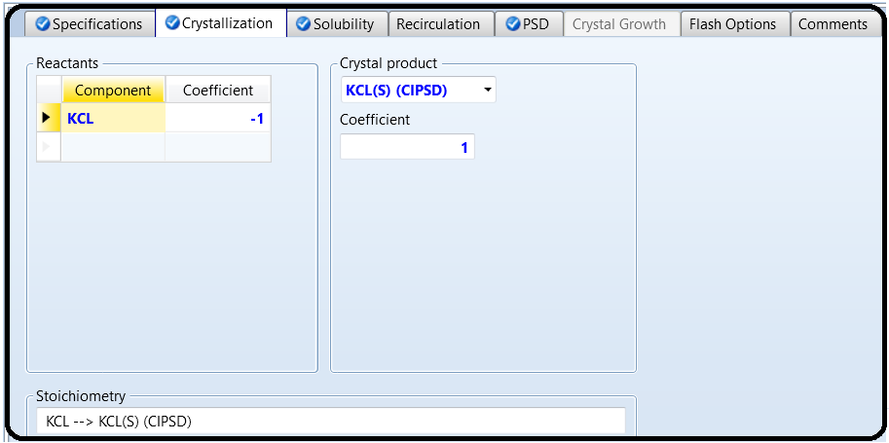

Figure 14.32 shows the “Solubility” tab window where we enter the solubility data for KCl in water at room temperature. In the literature, it is reported as 35 g KCl per 100 g H2O.

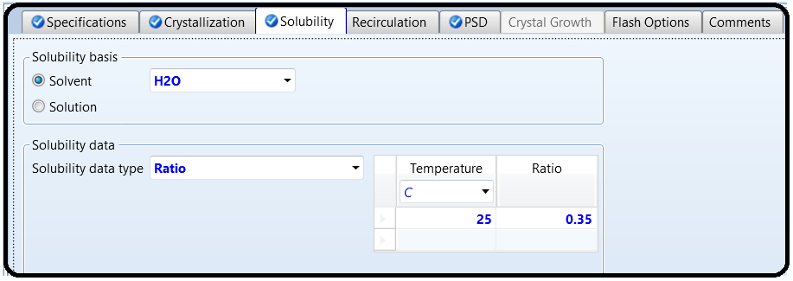

Figure 14.33 shows the “**PSD**” tab window where the outlet PSD is defined in terms of a built-in known distribution function; namely, the normal distribution.

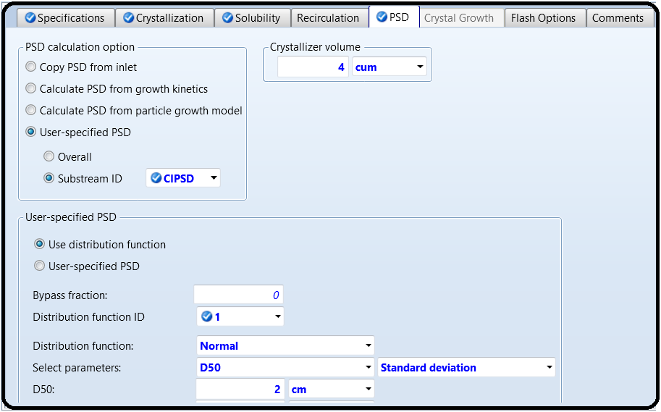

Results

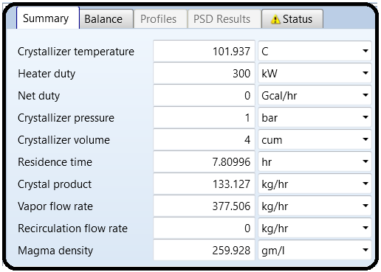

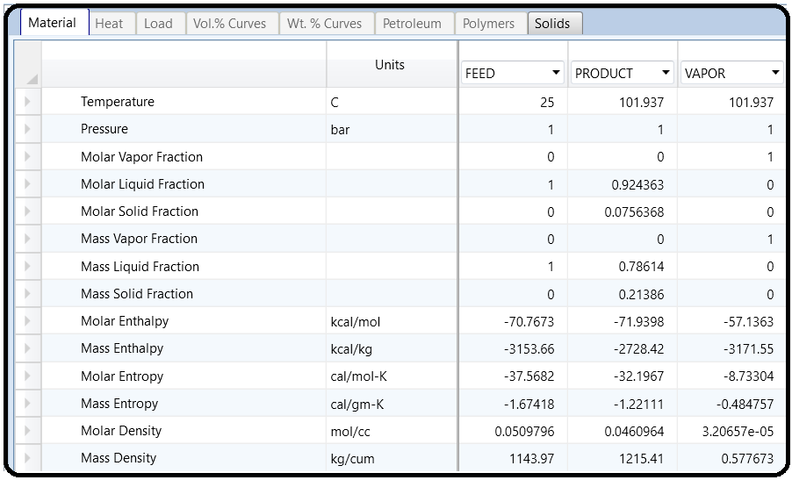

Appendix

Unit operations models used to describe treatment steps carried out on solids in the form of formation, size modification, size-based separation, washing, drying, and fluidization. Aspen Plus built-in unit operation solid models are

1. Crystallizer: produces crystals from solution based on solubility.

2. Crusher: breaks down solid particles to a smaller size.

3. Screen: separates solid particle based on their particle size.

4. Swash: separates solid particles from an entrained liquid of a solids stream using a washing liquid.

5. CCD: separates solid particles from an entrained liquid of a solids stream using a washing liquid in a countercurrent decanter or a multistage washer.

6. Dryer: evaporates volatile moisture components from wet solids.

7. Spray Dryer: evaporates moisture to form particles from sprinkled droplets.

8. Granulator: increases the size of solid particles.

9. Classifier: separates solid particles based on settling velocity.

10. Fluidized Bed: considers both chemical reactions and fluid mechanics.

Solids Separators Models

Unit operation models for separating solids from gases and/or liquids are shown in Table 14.A.1.

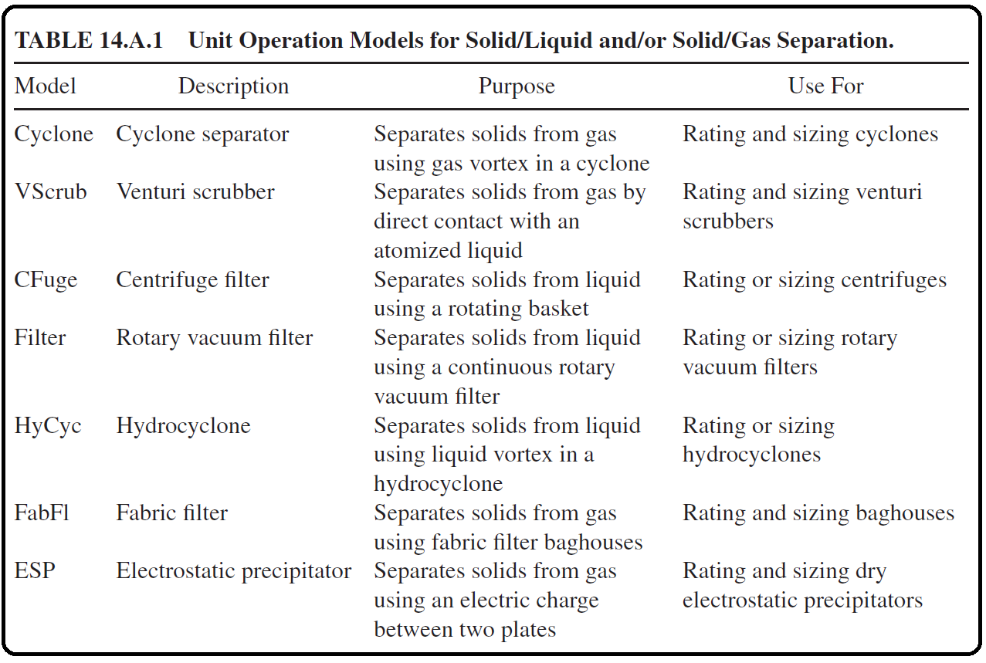

Solids Handling Models

Pneumatic conveyance of granular solid materials over short and long distances through pipes. This includes solids transport through a single pipe or pipeline network.

SOLIDS CLASSIFICATION

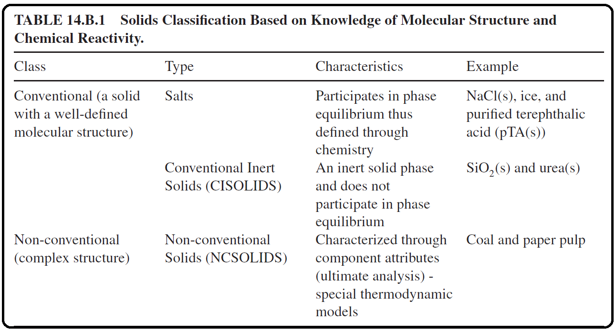Solids are classified by Aspen Plus as shown in Table 14.B.1.

Figure 14.B.1 shows how one can define the same component using different types; hence, a different “Component ID” will be created each time. For example, if “NACL” is defined as “*Conventional*”, then it will be part of the aqueous medium (i.e., participates in phase equilibrium); on the other hand, if it is defined as “NACL(S)”, that is, “*Solid*”, then it will be treated as inert (i.e., will not be part of the aqueous medium). Silica being defined as “*Solid*” means it is with a known molecular structure; on the other hand, coal being defined as “*Nonconventional*” means that it has a complex structure.

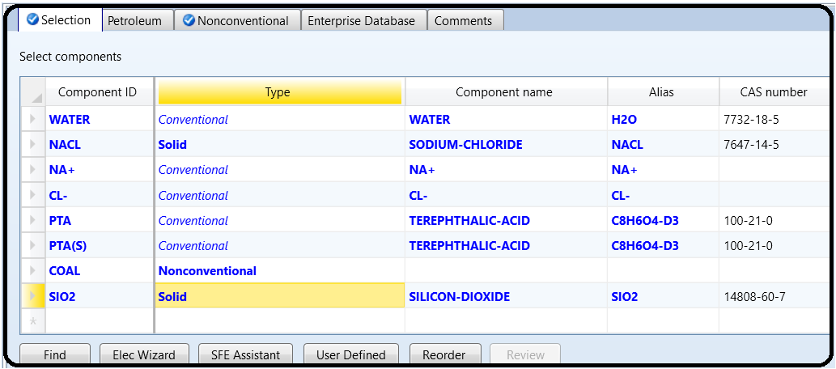

PREDEFINED STREAM CLASSIFICATION

Stream classes are very useful when modeling solids because they can be used to differentiate between the properties of each substream in the simulation. Stream classes ease the integration of solids and fluids in one simulation. The stream class can either be created or selected from a predefined type. Upon one’s need, a predefined class can also be modified. Aspen Plus predefined stream classes are in general sufficient for most applications. All unit operation models, except “Extract”, can handle stream classes with solid substreams. Table 14.C.1 shows different Aspen Plus built-in stream classes.

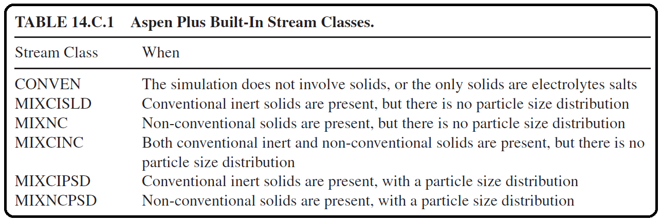

The stream class can be changed to a different class using the stream class changer (manipulator) as shown in Figure 14.C.1.

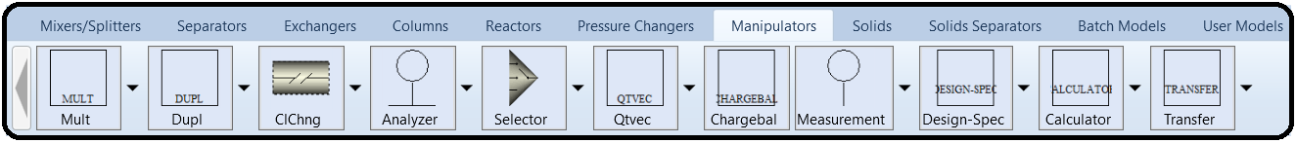

**SUBSTREAM CLASSES**

Substream classes are the building blocks of stream classes. They can either be predefined or customized. Predefined substream classes are shown in Table 14.D.1:

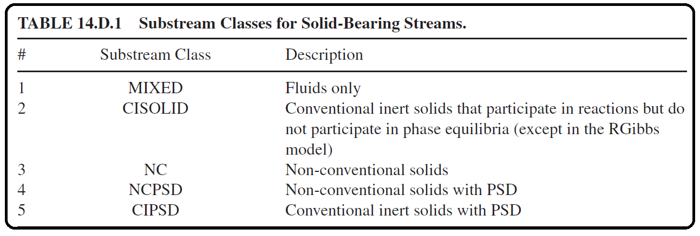

Notice that PSD can be specified for each substream in a stream class. Such an advantage permits the user to have different PSD functions for different streams or flowsheet sections. On the other hand, customized substream classes are additional substream types that can be created by the user to complement the existing predefined substreams. Customized substreams are usually used to ease the treatment of different solids in one simulation and permit the use of different PSDs for one predefined substream type, as shown in Figure 14.D.1.

PARTICLE SIZE DISTRIBUTION (PSD)

In Aspen Plus, particle size distribution (PSD) is represented by the weight fractions per particle size interval, given the number of intervals and the size range for each interval. In other words, a PSD describes the amount of particles in a sample of material with respect to size. The built in Aspen Plus particle size distribution has 10 predefined size intervals. The user can modify the built in particle size distribution by changing the number of intervals or the size ranges for the intervals. In some situations, he/she may want to have two or more particle size distribution definitions, with different size ranges. This will be useful if different sections of the flowsheet have different particle sizes. In this regard, a PSD mesh is defined (i.e., a grid with size intervals over which the particle sizes will be described). The PSD is populated via experimental results (i.e.,

user-specified weight fractions) or utilizing built-in distribution functions. In Aspen Plus, there are simulation PSD meshes coined for a substream under which all the results for multiple streams will be presented and input stream PSD meshes that are defined for individual feed streams. For user-specified PSD meshes, Aspen Plus provides four types: equidistant, geometric, logarithmic, and user-defined, where the user is required to enter the lower limit, upper limit, and size unit (i.e., mm, μm, angstrom, etc.). Depending on the selected type, the user may also have to enter the number of intervals. For the user-defined type, it is suited for experimental data where the user can copy and paste values from other spreadsheet packages such as Microsoft Excel sheet.

For built-in distribution functions, the user, however,must specify the function parameters that describe, in general, the mean or a reference datum and the degree of scatter around that mean or reference value, as in the following distributions:

1. Gates–Gaudin–Schuhmann (GSS): It has two parameters: one for the maximum particle size (i.e., at which the cumulative mass fraction *Q*(*d*)=*1*) and another for describing the profile (shape) of the distribution itself (i.e., narrow vs. broad). GGS is suited for coarse grinding.

2. Rosin–Rammler–Sperling–Bennet (RRSB): It has two parameters: one for the particle size (i.e., at which the cumulative mass fraction *Q*(*d*)=*0*.*632*) and another for describing the profile of the distribution itself (i.e., narrow vs. broad). RRSB is suited for fine grinding.

3. Normal: It has two parameters: one for the mean or median (at which the cumulative mass fraction *Q*(*d*)=*0*.*5*) and another for describing the profile of the distribution itself (i.e., narrow vs. broad).

4. Log Normal: It has two parameters: one for the median (the median at which the cumulative mass fraction *Q*(*d*)=*0*.*5*) and another for describing the profile of the distribution itself (i.e., narrow vs. broad). If particles are broken up at random, they will end up with such a distribution.

When viewing and analyzing the results for solid components, Aspen Plus provides sets of properties:

1. Median value (D50): the size at which 50% of particles are larger.

2. Mean particle size (D1_0): the sum over all intervals for the multiplication of the

average particle size, in one interval, by the fraction.

3. Specific surface area (VSSA): the ratio of the surface area of a particle to its volume.

For a completely spherical object, it is . For other non-spherical

objects, a shape or sphericity factor is used.

4. Sauter mean diameter (D3_2 or SMD): an average particle size. SMD is the diameter of spheres with the same volume/area ratio as the particle mixture. For example, if *V* is the total volume of particles and *A* is their total surface area, then *SMD*=*6V*/*A*=*Dparticle*. SMD is inversely proportional to VSSA. SMD is the characteristic diameter for a packed bed flow and is mainly used in fluidized bed calculations.

FLUIDIZED BEDS

The Aspen Plus fluidized bed model describes a bubbling or circulating fluidized bed and tackles five different aspects: Entrainment of Particles: It takes into account the geometry of the vessel and additional gas supply and provides options to determine the minimum fluidization velocity,

transport disengagement height, and distributor pressure drop for either a porous plate or bubble cap.

Chemical Reactions: After defining the reaction stoichiometry and its kinetics, the calculation method treats the gas as plug flow, the solids ideally mixed, and each balance cell is considered as CSTR (i.e., uniform in properties).

Fluid Mechanics: It assumes one-dimensional fluidmechanics and considers the impact of volume production/or reduction and heat exchange on fluid mechanics. Change in PSD: Table 14.F.1 demonstrates different options of tackling the outlet PSD with respect to the inlet PSD.

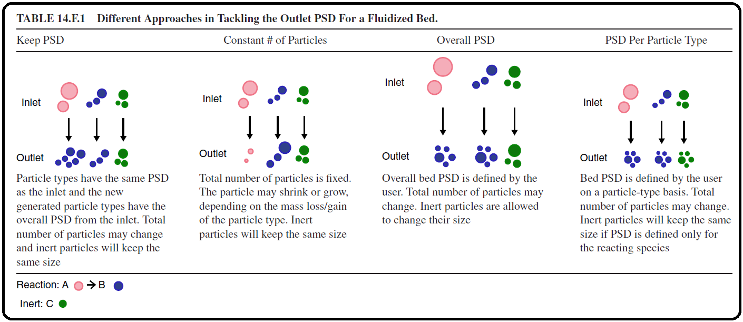Thermodynamics: Solids and vapors are in thermodynamic equilibrium while the model considers the impact of heat exchange and heat effect on bed temperature.

The Aspen Plus fluidized bed model treats the bed as made of two zones. See Figure 14.F.1.

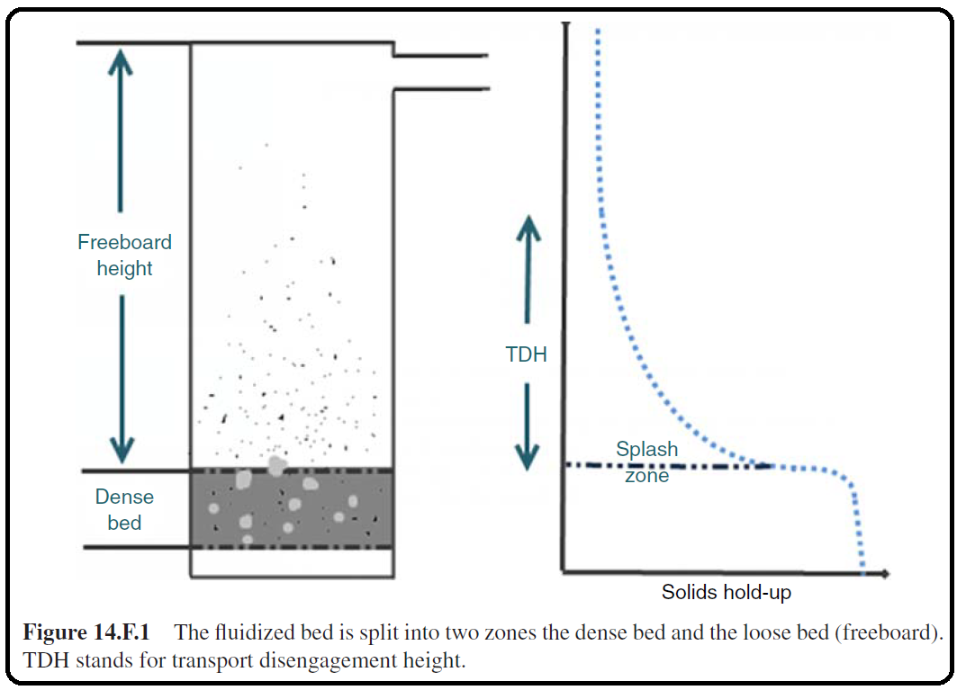

The bottom zone (dense bed): High solids concentration and fluid mechanics is dealt with according to Werther and Wein [1], which considers the growth and splitting of bubbles. Bubble-related profiles (e.g., bubble diameter, bubble rise velocity, interstitial gas velocity, pressure, and solid volume concentration profiles can all be calculated.

The freeboard zone (loose bed): Relatively low solids concentration and fluid mechanics is dealt with according to Kunii and Levenspiel [2]. Using the selected entrainment correlation, the solids mass flow and PSD at the outlet condition can be calculated. Overall, once the user defines bed inventory, by specifying the pressure drop or the solids hold-up, the height of the bottom zone and the freeboard can be determined.

Reference

1. Our team experience

2. Werther, J. and Wein, J. (1994) Expansion behavior of gas fluidized beds in the turbulent regime. AIChE Symposium Series, **90** (301), 31–44.

3. Kunii, D. and Leven spiel, O. (1991) Fluidization Engineering, Butterworth-Heinemann, Boston.

4. Aspen Plus – Chemical Engineering Application by KAMAL I.M. AL-MALAH