Part 3

Separation and Mixing in Aspen Plus



PROBLEM DESCRIPTION

A mixture containing 50.0wt% acetone and 50.0wt% water is to be separated into two streams: one enriched in acetone and the other in water. The separation process consists of extraction of acetone from water into methyl isobutyl ketone (MIBK), which preferentially dissolves acetone but is nearly immiscible with water. The overall goal of this problem is to separate the feed stream into two streams that have greater than 95% purity of water and acetone, respectively. In this chapter, we begin to learn the basics of running Aspen Plus® and building a process flowsheet. This episode introduces you to a number of features that must be understood to complete even a simple simulation. Our goal at the end of this episode is to understand some of the features of Aspen Plus while creating a simulation of the mixture of a feed stream of 100 kg/h of the 50/50 acetone–water mix with a solvent stream of 100 kg/h of MIBK.

How To Simulate

we select the “Chemical Processes” main template followed by “Specialty Chemicals with Metric Units” subtemplate. We add three compounds: acetone, water, and MIBK. To add acetone, just type in its exact name followed by hitting the Tab/Enter key, and Aspen Plus will recognize it. Repeat the same steps for adding water. For MIBK, select the first portion of its string, that is, “methyl-iso” and refine the “Compound class” to “*Ketones*”, select either “*Begins with*” or “*Contains*” option for the “Search Criteria”, click on “Find Now” search button, and finally after locating the right compound, click on “Add selected compounds” button to add the desired compound, as shown in Figure 2.1.

Of course, the default assigned name “METHY-01” can be renamed “MIBK” simply via editing (or clicking on) the row pertaining to its name and entering the new name. Diligently, hit “Tab” or “Enter” key and Aspen Plus requests an answer from you as what to do with the name modification step. Click on “Rename” button, as shown in Figure 2.2.

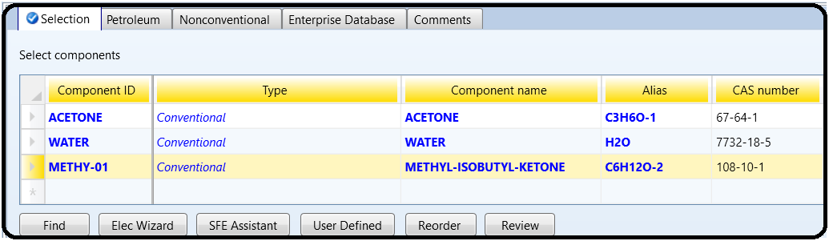

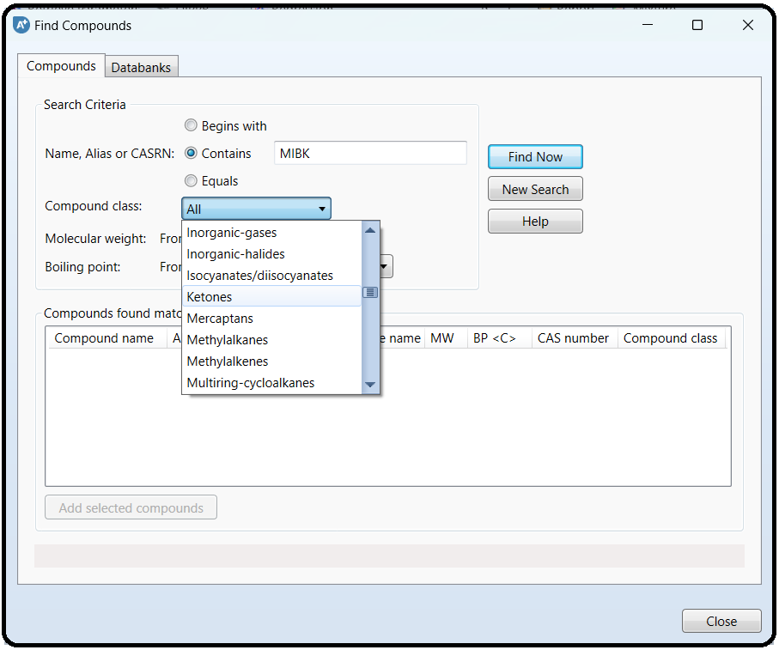

BINARY INTERACTIONS

Notice that there is a half-filled red circle under “Methods” folder. Click on “Next” button found in “Run” tab within “Home” ribbon. This brings you to “Binary Interaction - NRTL-1 (T-Dependent)” | “Input” tab window. Notice all permutations of pairwise interactions are already given and, in fact, there is no need to select “Estimate missing parameters by UNIFAC” option, as shown in Figure 2.3. Notice that the source of data is “APV88 VLE-IG”, which means that the liquid phase is handled by “NRTL” (i.e., activity coefficient-based model) and the gas phase is assumed to be an ideal gas mixture. Again, the prefix “APV88” will be dropped from either the source or databank name, if Aspen Plus is not the enterprise version. However, if the applied pressure is relatively high (e.g., above 10 bar), then the source of data can be changed from “APV88 VLE-IG” to a non-ideal gas mixture, such as “APV88 VLE-RK” (i.e., Redlich–Kwong equation of state). Figure 2.4 shows the new binary interaction parameters after changing the source of data from “APV86 VLE-IG” to “APV88 VLE-RK”, “NISTV88 NIST-RK”, or any other available source. In this running example, we do have an applied (operating) pressure below 10 bar; hence, there is no need to go to the non-ideal gas mixture.

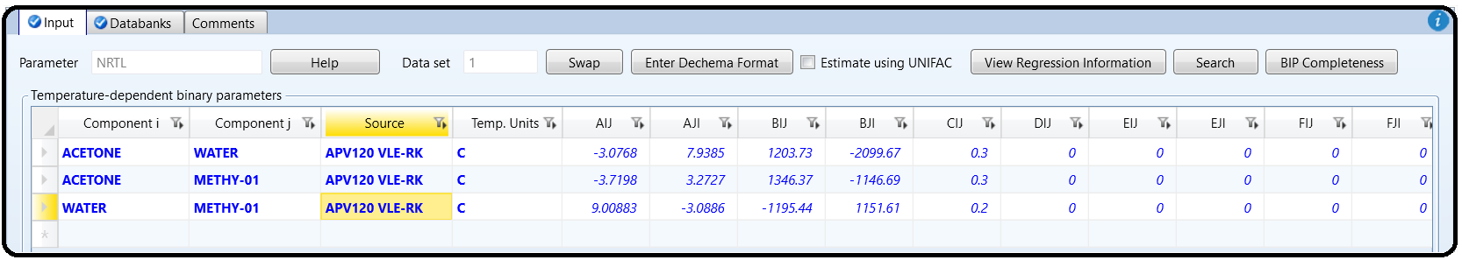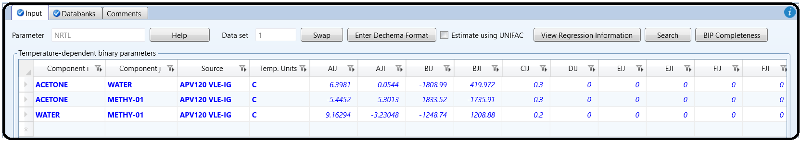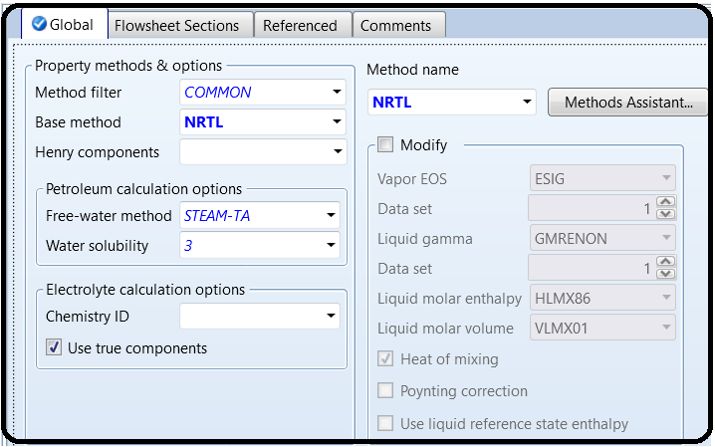

NOTE #1: If xy plot is generated for acetone/water mixture under both cases “APV88 VLE-IG” and “APV88 VLE-RK”, you will notice that both plots do exhibit the same pattern, except that they slightly differ in predicting the onset of azeotropic condition at higher values of acetone mole fraction.

THE “SIMULATION” ENVIRONMENT: ACTIVATION DASHBOARD

After successfully completing the properties analysis and setup, switch to “Simulation” environment so that we can add the required blocks and input and output streams. You will notice that there exists a dashboard, which lies exactly above the flowsheet window. This dashboard initially contains three disabled large buttons that can be activated upon completing a successful task under “Simulation” environment. The three buttons account for economics (or cost), energy, and EDR exchanger feasibility analysis, respectively. We will come to such three dashboard items later in more details. At this stage, you may select to collapse the dashboard to make the flowsheet window a more spacious. Alternatively, you may enable/disable activation dashboard via going to “File” | “Options” | “Advanced” tab and then deselecting/selecting “Disable activation dashboard” check button. Click on “OK” button to close the “Advanced Options” window.

PLACING A BLOCK AND MATERIAL STREAM FROM MODEL PALETTE

To place a unit operation (or piece of equipment) into the flowsheet window, select it from the “Model Palette” ribbon, shown at the bottom of the process flowsheet, and then click on the flowsheet window where you would like the piece of equipment to appear. Do this for each piece of equipment that you would like to add to your simulation. For this simulation, we will add one “TRIANGLE” stream mixer (found in the “Mixers/Splitters” tab). You may want to go through the rest of the “Model Palette” tabs to see what other types of equipment are available in Aspen Plus package. Figure 2.5 shows the addition of a stream mixer, which was automatically given the name “B1” (stands for Block 1) by Aspen Plus. To change the default prefix assigned by Aspen Plus for an added block or stream, go to “File” | “Options” | “Flowsheet” tab and type in the new prefix for labeling the newly added block or stream.

It should be pointed out that after adding your desired unit operations, you must click on the “Cancel insert mode” button to stop the insertion of additional blocks. If you do not select this button, you will continue to add equipment to the process flowsheet. To delete extraneous equipment, simply highlight that object and hit the Delete key on the keyboard. Alternatively, after adding the desired model equipment, right-click the mouse and the insert mode will turn off.

To add a material stream to your simulation, click on the “Material stream” icon (other options include heat and work, but we will not be using those at this time), which is the first icon appearing in the “Model Palette” ribbon (see Figure 2.5). In this regard, Aspen Plus has a feature that will indicate to you where streams are required. When you select the material stream option, a number of arrows will appear on each of the unit operations. Red arrows indicate required streams and blue arrows indicate optional streams (see Figure 2.6). Streams can be added by clicking on the process flowsheet where you would like the stream to begin and clicking again where you would like the stream to end. To connect to a piece of equipment, you must have the desired stream type selected and then begin from or terminate at one of the arrows shown on the piece of equipment (depending on whether your stream is a product from or feed to the equipment). In a similar manner to the model equipment, each click will add a new stream to the process flowsheet until you click on the “Cancel insert mode” button.

NOTE #2: *Do not forget to save your work from time to time.*

For this running example, we will add two feed streams into the mixer, and one product stream out of the mixer. Some pertinent features of Aspen Plus are worth mentioning here.

BLOCK AND STREAM MANIPULATION

a) To rotate or rename a stream or block, simply select the object that you would like to manipulate and right click on it. This will present you with a number of options for changing each object. I suggest renaming both the material streams and the mixer to names that will better reflect their function or content (rather than the default numbers and letters).

To resize the block, here are the steps:

• Left-click on the block and a rectangle, made of square-dotted (◾) boxes, highlights or embraces the selected block.

• Move the cursor to any corner of the rectangle until you notice a change in the cursor from a single to double arrow.

• In drag (left mouse being clicked) mode, move the mouse either in or out of the rectangle.

c) To relocate the entire process flowsheet as one piece or a portion of it, you need to entirely highlight it or a portion of it. To highlight an iconic object, you need to left click the mouse at some point slightly faraway from one edge and diagonally move your mouse to the opposite edge and then relax the mouse. Highlighting will impose squared dots (◾) around the block itself. Use right/left and up/down arrow keys to move the highlighted object(s). After moving to a new location, left-click away from the highlighted object(s) and Aspen Plus will unhighlight the object(s) and stick to the new location.

d) To highlight a single stream, left-click anywhere on the stream where it becomes square-dotted (◾) along the stream. You can also use the right/left and up/down arrow keys to lengthen/shorten or displace the stream.

e) To displace the point of contact with the block for either an input or output stream, highlight the requested stream and you will notice a small tiny portion of the selected stream becomes blue. This small tiny blue portion represents either the endpoint for the input stream or start point for the output stream. Hover the mouse over that tiny portion that is in contact with the block itself. Left-click on this tiny blue portion and you will notice that either an inlet or an outlet arrow shows up, similar to those shown in Figure 2.6. After that, you will be able to move the arrow around the block to decide on the new port for the selected stream.

f) To exchange an already existing block icon with another within the same group (such as mixers/splitters group) of blocks, right-click on the existing block and select “Exchange Icon” submenu from the context shortcut menu. Repeat this step more than once to probe group icons until you finally decide on or reach at the proper icon that better represents the unit operation or chemical process in hand. At this point, your process flowsheet should be complete, and it should resemble the one shown in Figure 2.7. Notice the “Simulation Status” at the left-bottom corner has been changed from “*Flowsheet not Complete*” to “*Required Input Incomplete*”. This switch in

the simulation status means that the block and its associated input and output streams are already defined. What remains is to enter the properties of the two feed streams and this explains why the simulation status says that the required input is incomplete and we can see two half-filled red circles hooked to both input forms of the feed streams, as can be seen in Figure 2.7.

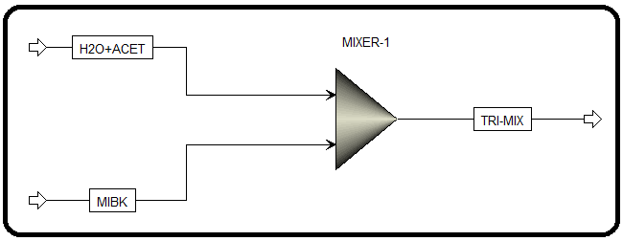

Table 2.1 gives a brief information about the three categories of mixer/splitter types.

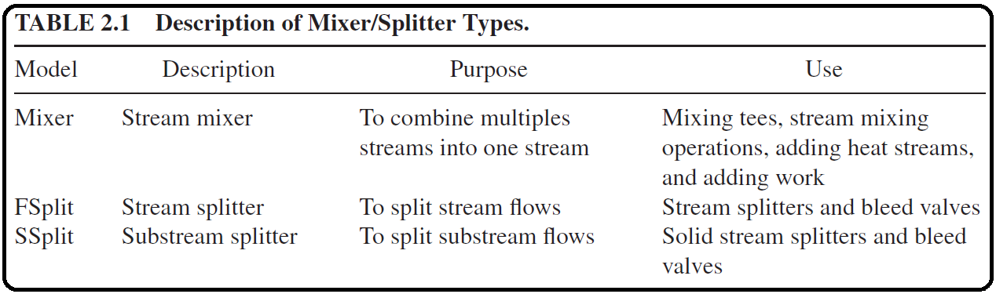

DATA INPUT, PROJECT TITLE, AND REPORT OPTIONS

Up to this point, all data input is complete except for the feed streams. Under the “Simulation” environment, and from the “Home” ribbon, click on the “Next” ( ) button (shortcut key F4 or fn/F4) and this will bring us to where we input the first feed stream properties in terms of pressure, temperature, and compositional flow rate, as shown in Figure 2.8. Notice that Aspen Plus highlights the areas where the input has been completed and has not been completed with the use of either a blue check mark or a half-filled red circle, as seen in Figure 2.8 for “Streams” folder because the second stream properties are not yet entered.

Click ( ) button and Aspen Plus will bring us to where we enter the second feed stream properties in terms of pressure, temperature, and compositional flow rate, as shown in Figure 2.9. Notice that all input data are now complete and the “Simulation Status” changed from “*Required Input Incomplete*” to “*Required Input Complete*”.

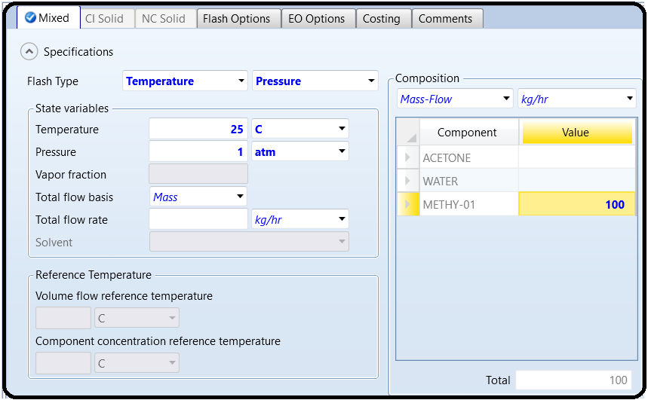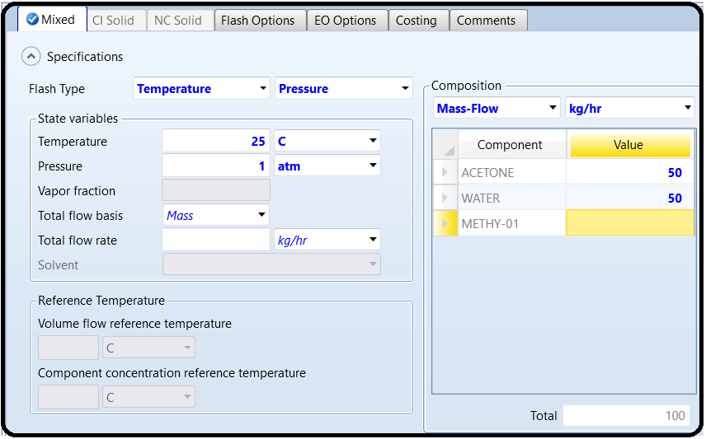

Before showing the simulation results, let us show where to modify how the results can be presented. Figure 2.10 shows the “Global” tab window where the user defines the title of the simulation project and the option to change or select the global unit set. Clicking on “Setup” | “Report Options” will bring the form shown in Figure 2.11. Here, the user instructs Aspen Plus what items are to be included in the report via the “General” tab form (*left*) and how Aspen Plus shall report the stream conditions whether they are reported on a molar basis, mass basis, or both via the “Stream” tab form (*right*).

RUNNING THE SIMULATION

Clicking on the “Next” ( ) button will tell us that the simulator is ready as shown in Figure 2.12. Here, it indicates that the all required input data are complete, which means that Aspen Plus is happy now as it has the minimum number of input data. However, if the user has more to input, especially for a more complex process, then it is time to select “Cancel” button and go for the folder/subfolder property where the user can input more data. Otherwise, click on the “OK” button.

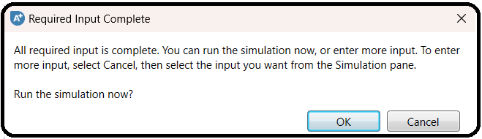

Here, we have no more data to input; hence, we will click on the “OK” button. Remember that we will use the pairwise interaction parameters given in Figure 2.3 not in Figure 2.4*.* Clicking on “OK” button in Figure 2.12 will trigger Aspen Plus simulator to carry out steady-state material, component, and energy balances simultaneously. The “Control Panel” will tell the user the result of attempting to solve the set of algebraic and differential equations (i.e., with time as in unsteady-state or with space as in a steady-state plug flow reactor). If there is no simulation error, a convergence is reached but not necessarily realistic. On the contrary, if there exists a simulation error, it will show up in the “Control Panel” and the solution diverges. In addition, there is something called warning rather than error. In this case, the user needs to pay attention to the warning statement to see whether the warning indicates a serious issue that the user need to consider or it can be ignored. We will explain this shortly. In previous versions of Aspen Plus, a window used to pop up as in Figure 2.13. Aspen Plus prompted the user to go to the next step, that is, economic analysis. Of course, to proceed, the user would click on “Activate” button. Else, the user would click on “Close” button. We handle the economic aspects in a separate chapter. The user can also activate the economic analysis feature from “Economics” ribbon under “Simulation” environment. Take into account that the default behavior for cautionmessages and reminder prompts issued by Aspen Plus can be reclaimed, in general, via visiting “File” | “Options” | “Advanced” tab and clicking on restore buttons.

Have a look at the “Control Panel” where Aspen Plus shows the status of the solver after carrying out one attempt to solve for the steady-state condition of the process represented by the flowsheet. Figure 2.14 shows that there is a warning saying that “PCES” cannot use “Group-Contribution” methods to estimate missing properties. This warning is not serious and can be relieved if the user selects “Estimate missing parameters using UNIFAC” option, as shown in Figure 2.3. Moreover, the final block and stream results will not be affected whether or not the user selects to go with the previous option, as all pairwise interaction parameters are already given ahead.

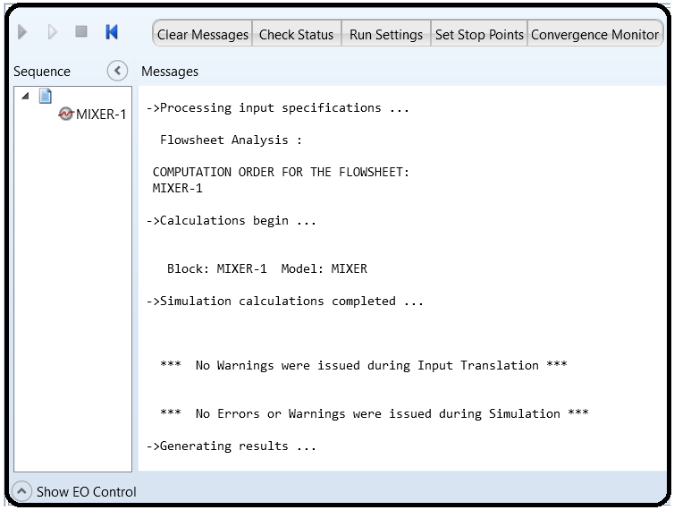

Finally, clicking on the “Results Summary” | “Streams” sheet (shown in “Navigation” pane as a blue check-mark folder), or on the stream summary ( ) button, found in “Home” ribbon while being under “Simulation” environment, will enable the user to see the results, as shown in Figure 2.15

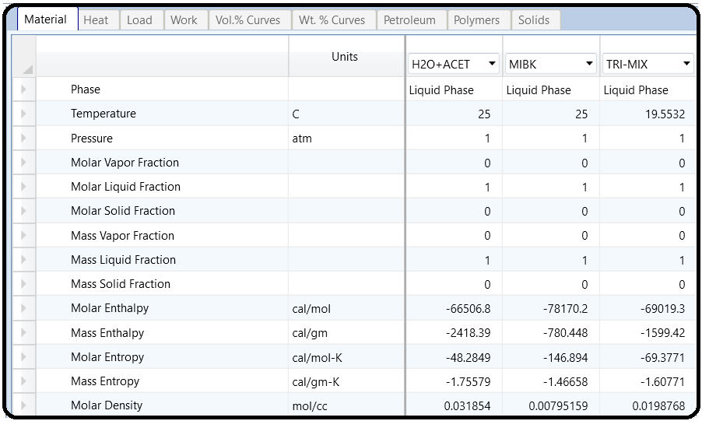

NOTE #3: DO NOT FORGET TO SAVE YOUR FILE.

THE DIFFERENCE AMONG RECOMMENDED PROPERTY METHODS

For a chemical process, three methods are suggested by the “Property Method Selection Assistant” (see: Section 1.6). These are “NRTL”, “WILSON”, and “UNIQUAC”.We will show how each method affects the estimation of the mixer mass and energy balance. If we select “WILSON” as the property method, then we will notice that not all pairwise interactions are initially given by Aspen Plus. So, let us instruct Aspen Plus to complete the mission (i.e., estimate the missing parameters using UNIFAC). On the other hand, “UNIQUAC”, such as “NRTL” method, has all three pairwise interaction parameters initially given.

Figure 2.16 shows the mixer material and energy balance using the three recommended property methods: “NRTL”, “WILSON”, and “UNIQUAC”. The difference lies in estimating the enthalpy value of input and output stream but the difference is quite insignificant between one method and another.

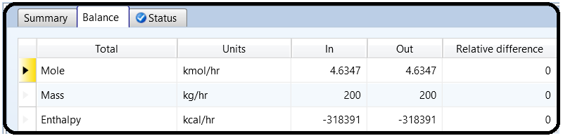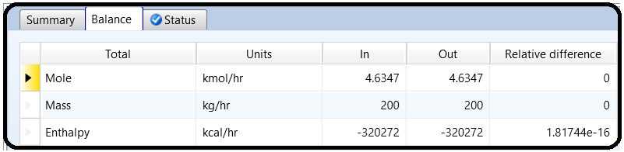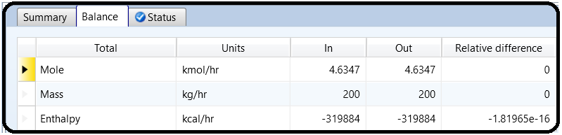

NIST/TDE EXPERIMENTAL DATA

An attempt was made to make use of the experimental data available through NIST/TDE databank.

Figure 2.17 shows the overall data quality for acetone–MIBK binary interaction parameters. Obviously, the experimental data failed the consistency tests and thus are not recommended as an alternative for group-contribution method calculated binary data.

Figure 2.18 shows the overall data quality for MIBK–water binary interaction parameters. Again, the experimental data failed the consistency tests and thus are not recommended as an alternative for group-contribution method calculated binary data. Figure 2.19 shows the overall data quality for acetone–water binary interaction parameters. Here, some experimental data sets failed the consistency tests and others passed. Hence, one set of isobaric VLE data with an overall data quality equal to unity was selected for regression purposes. The data source is from [Huang, R., Gu, Y. and Hou, Y. (1984) VLE of acetone-water-isobutyraldehyde system. *Chemical Engineering (China)*, 4, 26–29]. The regression step was carried out for such a set of isothermal VLE data for water–acetone solution, using the three recommended activity coefficient-based methods: “NRTL”, “WILSON”, and “UNIQUAC”. Two elements or parameters were used in the regression step. It was found that “UNIQUAC” method gave the minimum residual root mean square error (RRMSE), as shown in Table 2.2. Figure 2.20 shows the pairwise interaction parameters for the three components using “UNIQUAC” as the property method. Notice that the source for the first data column is taken from regression folder with a regression data set called “DR-3”, which exploits “UNIQUAC” as the regression property method; the other two data columns are automatically calculated or given by Aspen Plus. One can see that the value of enthalpy for the outlet stream is lower than any of those given earlier in Figure 2.16. Claiming that the experiment-based, “UNIQUAC”-regressed value has more credit than that estimated by the group contribution (PCES) method, the maximum percent relative error (PRE) among the three tested methods will be

PRE = |−321465 − (−319829)| |−321465| × 100% = 0*.*509% *≪* 10*.*0%

NOTE #4: This PRE value of 0.51% lies way below the generally accepted PRE borderline of 10% for measured or estimated quantities in engineering applications. Moreover, what really matters will be the enthalpy difference between in and out, which will reflect the amount of heat added into or extracted out of the control volume under study. This will make the PRE value associated with the heat duty even smaller and smaller as a result of using different property methods. In brief, we are quite confident to use the auto calculated binary parameters by Aspen Plus using the group contribution method (i.e., UNIFAC). Be happy!

NOTE #5: For the sake of having a linear learning curve with time (i.e., while proceeding from here onward), we will walk in parallel with the pace and content of each presented chapter. Consequently, for a given problem statement, we will start with a simple process and as we move onward, the process will continuously grow up as far as the corresponding flowsheet that describes the real process is concerned. Once we are done with covering the essential features of Aspen Plus we will have a complete stand-alone task.

THE CLEAN PARAMETERS STEP

As pointed out in Chapter 2, it was found that while accounting for the reliable NIST/TDE VLE data, the difference in estimating energy flow around the mixer between one recommended property method and another lies within the universally accepted engineering limit; that is, an associated PRE value being smaller than 10% for a typical measured or estimated quantity in engineering applications. In addition to its dependence on experimental data in terms of their validity or reliability, the regression goodness of any experimental data will also depend on the thermodynamic model being tackled and the number of parameters to plug in that model. This will make the entire process of regression non-calibrated and thus will vary from one user to another. To avoid confusion and inconsistency, we set the property method to “NRTL” and clear all estimated binary parameters of NIST/TDE VLE data regression, which was carried out in Chapter 2, for the sake of comparison between the results shown here and any results generated by the user should he/she attempt to rerun the same problem at hand. Reopen your simulation by using “Open” folder and under “Recent Models” select the file that pertains to Chapter 2.We will rerun the existing simulation of Chapter 2. The selection of the property method is explained in detail in Chapters 1 and 2. Regarding clearing any estimated parameters, click on the “Clean Parameters” button found in “Home” ribbon while running the simulator under “Properties” environment. Figure 3.1 (*top*) shows the “Clean Property Parameters” window where the user may select more than a choice. The first choice removes property parameters that have been added to input forms as a result of running regressions, estimations, and/or retrieving property parameters from the databanks for review.

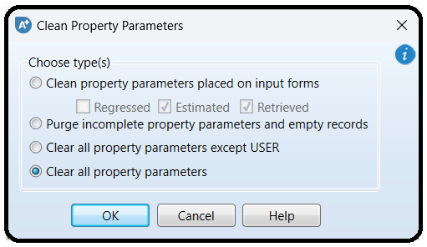

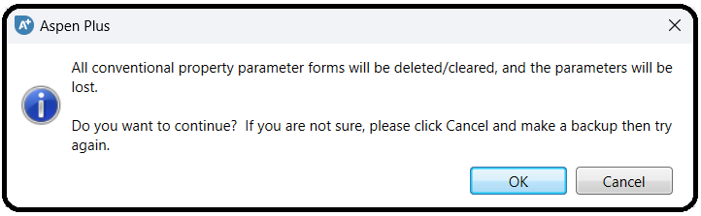

The second choice removes property parameters that are incomplete because of missing value, component ID, or parameter name. Such parameters can exist because the forms were incompletely filled out, or because a component with a property parameter data was removed, or because a property method was removed and there were parameters specified that only exist for that particular property method. The third and last choice removes all specified data for conventional parameters and UNIFAC binary parameters. This restores these forms under “Methods” | “Parameters” to their initial state in a new simulation.

So, we will select “Clear all property parameters” option to clear out any residue and be back to the new born baby condition. Clicking on the “OK” button will pop up another window (Figure 3.1 bottom) that will tell the user what such a cleaning step will do. Click on the “OK” button of the bottom window to complete the execution of the cleaning step. After carrying out the cleaning step, you will notice that all binary interaction parameters were cleared out. Next, be sure that under “Methods” | “Parameters” | “Binary Interaction” | “NRTL-1” sheet the “Estimate missing parameters by UNIFAC” option is selected. Click on the “Next” button and select “Run Property Analysis/Setup” option from the pop-up window titled “Properties Input Complete”. Click on the “OK” button to complete estimating missing parameters.

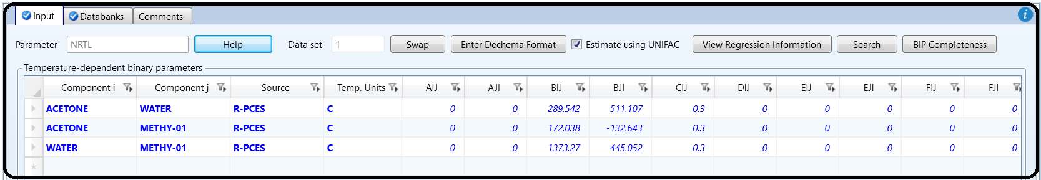Figure 3.2 (left) shows “NRTL-1” sheet where the binary interactions parameters are now estimated utilizing Regression by Property Constant Estimation (“R-PCES”) method (see Chapter 1).

For each of the three columns, select “APV88 VLE-IG” as the source for binary data to replace “R-PCES”, as shown in Figure 3.2 (right). Click on the “Next” button and select “Run Property Analysis/Setup” option from the pop-up window titled: “Properties Input Complete”. Click on the “OK” button to assure that the new values take into effect.

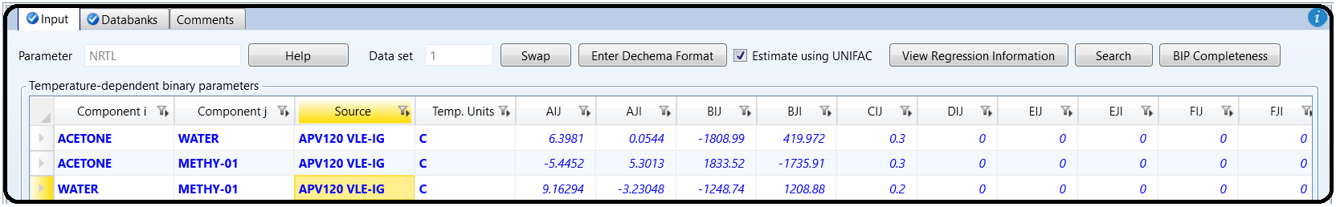

Doing so will bring us back to the simulation state (or status) as if we were to create a new Aspen Plus file from “Chemicals” template, add the three components, and run the simulation under “Properties” environment. The theme here is to learn how to deal with parameters clearing/cleaning step without requiring us to create a new file from scratch. Switch from “Properties” to “Simulation” environment.

SIMULATION RESULTS CONVERGENCE

One should recall that when using a computer simulation package, the incorrect input data or programming can lead to solutions that are superficially “correct” based on the user’s entered specifications, but unrealistic with respect to real-life applications. For this reason, it is very important that the user scrutinizes at least the basic balances to make sure that the simulation results are reasonable, based on his/her experience and the expected results. At the end of Chapter 2, we had completed a simulation of the first mixer in our acetone separation process. Let us reset the simulator back to the initial state (or point) via using the “Reset” button, found in “Home” ribbon under “Simulation” environment this time. Figure 3.3 shows the “Reinitialize” window where it tells the user that upon executing this step, the solver will not proceed from where it stopped last run; instead it will make a step back to the initial state, of course, depending on the level of reinitialization to be carried out. If the user selects “*Simulation*”, then Aspen Plus will reinitialize the entire process of calculations. Any other choice such as “*Block*”, “*Convergence*”, or “*Streams*” will result in a partial reinitialization to a block, streams, or convergence (i.e., the solver for design specifications, sensitivity analysis, optimization procedure, and data fit testing).

Figure 3.4 shows the pop-up warning window (*top*) about the reset step and what it does upon execution and “Control Panel” (*bottom*) shows the solver message upon clicking on the “OK” button.

NOTE #1: The reset feature is useful when modifying an existing simulation in terms of input data, operating condition(s), and/or any constraint imposed on a given block. The solver, for example, may converge for all blocks except for a few (i.e., one or two) blocks, then the user’s duty is to keep changing specifications for that particular non-converging block until a converging and reasonable solution is reached. So does the case for any “Flowsheeting Options” or “Model Analysis Tools” case study. In this regard, the reset feature for that particular non-converging “Block” or “Convergence” will be very useful and time saving. Moreover, I occasionally found that the “Reset” button did nothing upon clicking; alternatively, one may click on the “ ” button at the top of “Control Panel”, as shown in Figure 3.4.

Now that the simulation has been reset, run it again, using the “Next” button. On clicking the “Next” button to run the simulation, the program will show information about its convergence in “Control Panel”. This means that Aspen Plus will make “Control Panel” as the active window, which can be seen by the user. On the other hand, if you click the “Run” button instead of the “Next” button, after executing the “Reset” process, the status of the run can be seen via clicking the “Control Panel” button found in “Home” ribbon, given that “Control Panel” is not active. Since our simulation is very basic, we should not have any convergence problems. However, as our simulation becomes more intricate in the coming chapters; that is, we will be adding more complicated unit operations (blocks), which may require multiple iterations to solve. In this case, we examine both the “Control Panel” messages and convergence algorithm results to make sure that the simulation did converge with reasonable tolerance (or accuracy).

NOTE #2: Some factors that usually lead to convergence difficulties are a poor choice for the property method (i.e., thermodynamics) and the creation of recycle streams. The “Control Panel” will also list any warnings or errors that may arise based on your input choices.

If our simulation normally converges, it does not necessarily mean that the solution will be reasonable. We now move on to another basic check that should be done when completing simulations. Click on the “Stream Summary” button found in “Home” ribbon. When you do this you will be presented with a stream material summary table as shown earlier in Figure 2.15. While we expect Aspen Plus to be correct, it is advisable to run a few simple checks on the data presented in this table.

As mentioned earlier, Aspen Plus can give “correct” but unreasonable results due to convergence

or the selected thermodynamic properties, so it is highly recommended that you verify the results presented in this table. Some checks to perform include a quick material balance, a quick heat balance, and a comparison to available experimental or operating data. Later in your professional life, you will be able to use your experience to quickly tell whether the results do not appear to make sense. However, even then you should look at every number that is presented in the results. If your results appear to be acceptable, you can move on and add the simulation results to the process flowsheet for ease of demonstration.

On the other hand, clicking on “Home” ribbon | “Summary” tab | “Model Summary” button will provide the user with the used property method and a summary view of important variables of all unit operations (i.e., blocks) models and, if applicable, design specs, utilities, and stream prices.

ADDING STREAM TABLE

Click on the “Stream Summary” button found in “Home” ribbon. Go over some options for formatting and modifying your stream tables. As shown in Figure 3.5, you will see two of the options for varying the stream table: “Display” and “Format”. Under “Display” drop-down menu, there are three options, “All streams”, “Hierarchy streams”, or “Streams”.

“All streams” will show all streams found within the flowsheet. The “Hierarchy streams” has to deal with hierarchy blocks to provide hierarchical structure to complex simulations. Hierarchy blocks may be added automatically when importing templates into a simulation. Hierarchy blocks may contain streams and other blocks (even other hierarchy blocks) as well other features such as design specifications and sensitivity problems. Hierarchy blocks contain Setup and Methods form with some of the same information as the top-level Setup form and the Methods form from the Properties environment. The settings on these forms override the settings on the corresponding forms in higher-level hierarchy blocks or at the top level of the simulation for blocks within the hierarchy block. The scope of this textbook is not meant to deal with complex simulations; hence, we do not have hierarchical streams.

The “*Streams*” option allows the user to choose the streams he/she would like to see or show, one by one. Under the “Format” drop-down menu there are several types of stream tables. Each of the options presents the data in a slightly different manner, depending on the intended application. Finally, click on the “Stream Table” button to display the stream table on the main flowsheet window.

If we use “*CHEM_M*” option from the “Format” drop-down menu, and click the “Stream Table” button, then the stream table will be added to the main flowsheet window, as shown in Figure 3.6.

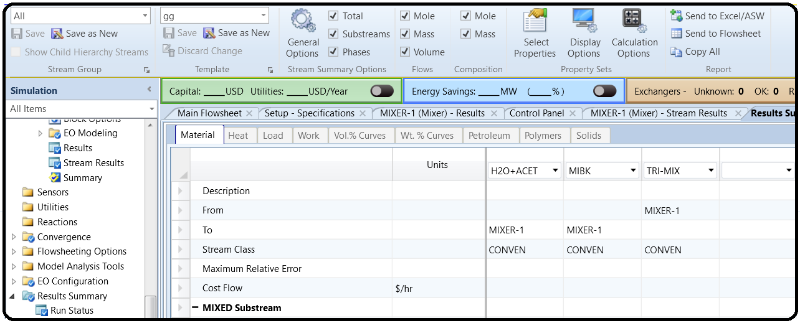

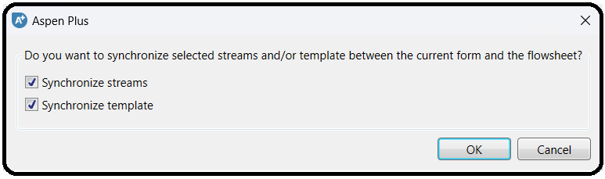

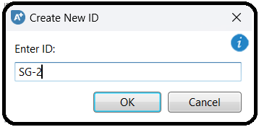

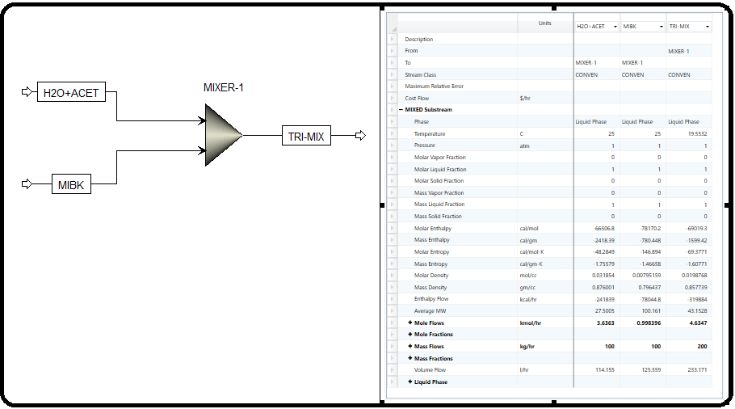

PROPERTY SETS

A property set is a collection of thermodynamic, transport, and other properties that you can use in physical property tables and analysis. The list of built-in property sets is determined by the template you choose when creating a new run. You can use a built-in property set and modify it to fit your needs, or you can create your own property sets. To see the built-in

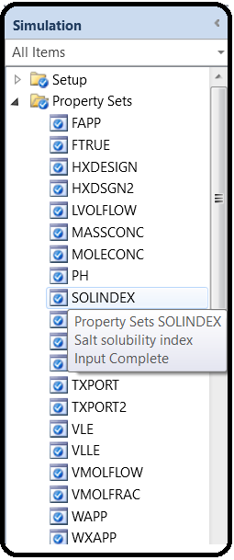sets available or select one, use the drop-down list on any property set list box. Figure 3.7 shows the built-in property sets associated with “*Specialty Chemicals with Metric Units*” template. Keep in mind that the active environment is “Simulation”. For more details on any property set, just hover the mouse over a particular set and Aspen Plus will prompt the user with a few descriptions, as shown in Figure 3.8.

For each property set, there may exist more than one thermodynamic, transport, or thermal property being defined so that they can be evaluated by Aspen Plus for a given stream. Figure 3.9 shows an example of a property set that contains more than one property to be evaluated. “RHOMX” stands for density of a mixture; “MUMX” for a mixture viscosity; and “SIGMAMX” for surface tension of a mixture.

Mass diffusivity is not one of the default variables that are reported by Aspen Plus, and it is only reported if the user defines a specific property set. The easiest way to do this is to modify an existing property set that reports other parameters of interest and then have Aspen Plus report this property set.

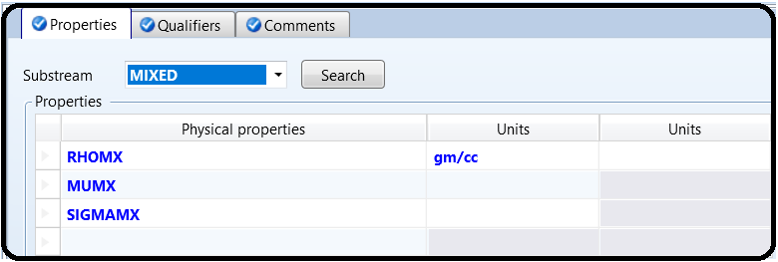We will modify the “TXPORT” property set so that it includes diffusivity values for our system. In the “Prop-Sets” window, select “TXPORT” and hit the “Edit” button at the bottom of the screen. Alternatively, you may directly go to the property set itself and Aspen Plus will open up its associated form.

Select the last row (or record) in the first column that is currently blank. In doing so, you will be presented with a scrolling window of physical properties that Aspen Plus can calculate for the user. Scroll down until you find “DMX” (Diffusivity of a mixture), which is the variable for diffusivity in Aspen Plus. You will notice that a description of each physical property appears as you hover the mouse over the variable name.

Figure 3.10 shows “TXPORT” of “Prop-Sets” in “Navigation” pane where “DMX” is added.

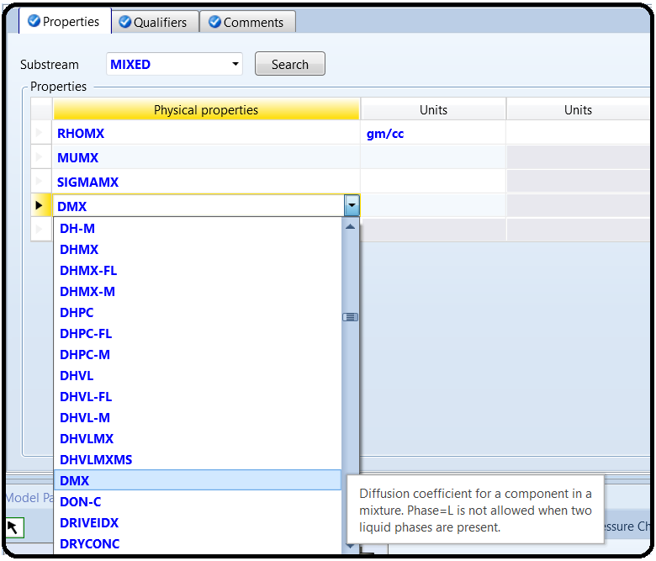

Figure 3.11 shows the “Qualifiers” tab. This window allows the user to input the phases they would like the property set to be reported for. Because we are not concerned about the vapor phase at this point, we keep only the liquid phase. The “Qualifiers” tab should now look like that seen in Figure 3.11.

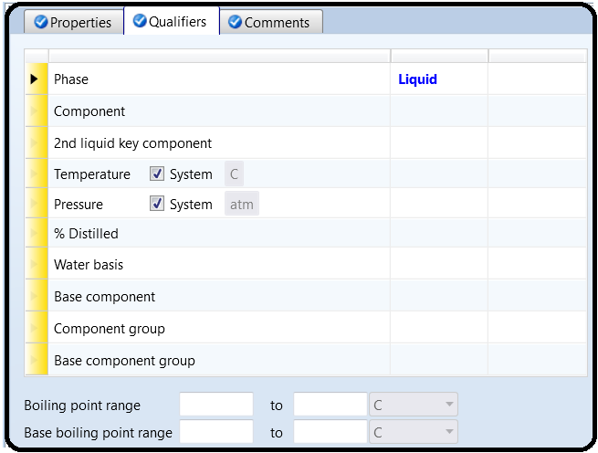

We must now add the “TXPORT” property set to the stream table that is shown in the process flowsheet. While “Simulation” environment is the active mode and using “Navigation” pane, go to “Setup” | “Report Options” | “Stream” tab form and click on the “Property Sets” button. Doing so will open up the window shown in Figure 3.12.

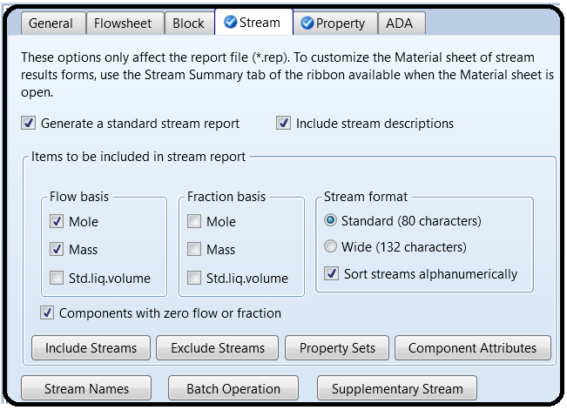

Select “TXPORT” and hit the single arrow button pointing to the right. This will move “TXPORT” to the side labeled “*Selected property sets*”, and it will now be displayed in the stream table. After doing this, close the “Property Sets” window.

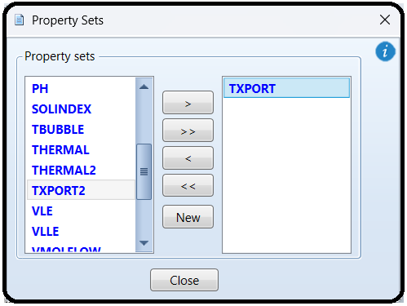

When you have done this, reset and rerun your simulation. In order to update the stream table, you will most likely need to click on the stream table and then click away from it. Another option is to delete the existing stream table and add a new one to the process flowsheet.

Figure 3.13 shows the stream table where its transport properties (“TXPORT”) are listed.

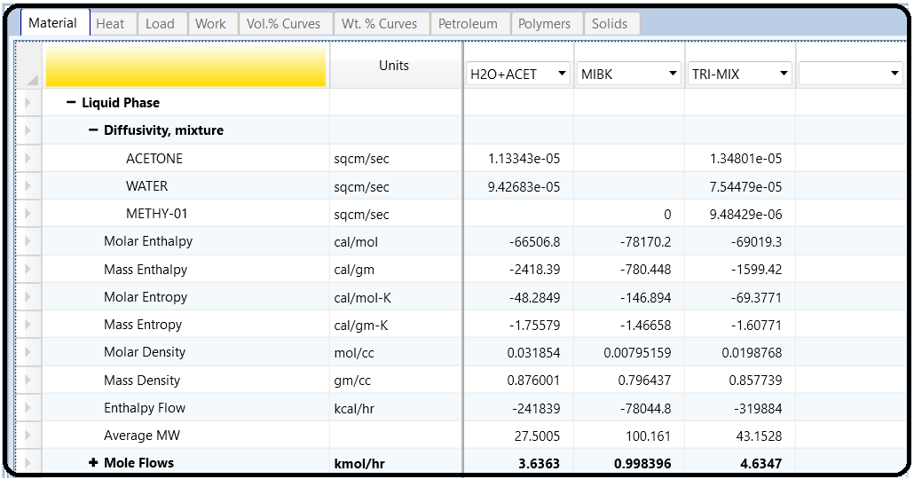

ADDING STREAM CONDITIONS

In a large simulation, it is common to add stream conditions directly to the streams themselves so the user does not have to search through a large stream table for values. Although this is not the case in our simulation, however, we will tag each stream by its temperature and pressure value, for the sake of learning. This can be done via clicking on “Options” submenu under “File” menu found in the “Top” toolbar, as shown in Figure 3.14. The number format (i.e., how many significant numbers) of these variables can be changed by changing the number in the format edit-box. For example, the default value is “*%.0f*”, which means

that the data will be presented as integer with no fraction. If you change the default format to “*%.1f*” then the value of temperature (∘C) will be shown as *25.0* instead of *25*. On the other hand, the associated units of measurement can be changed from the drop-down menu of “Units of measurement” option. For example, Figure 3.14 shows that “*METSPEC*” is selected as the “Units of measurement”.

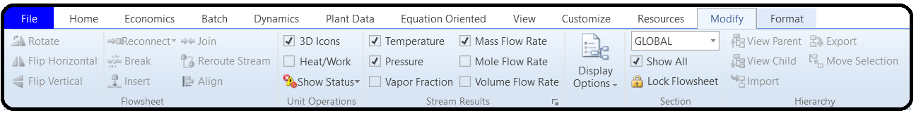

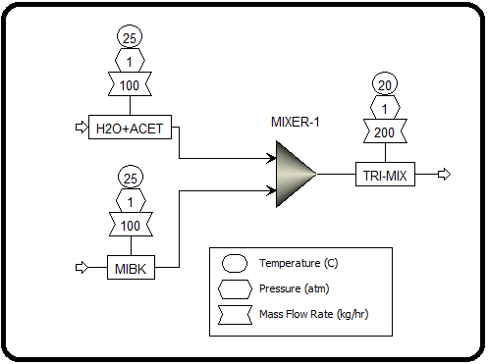

Go to the main flowsheet window and you will notice those two properties will now be shown in the process flowsheet, as shown in Figure 3.15.

PRINTING FROM ASPEN PLUS

Printing a process flowsheet can be easily completed from “File” | “Print” submenu found in “Top” toolbar. However, the user may want to select only a portion of a process flowsheet to print. To do this, either right-click on the flowsheet window and select “Page Break Preview” submenu, or go to “Top” toolbar | “View” | “Page Breaks” found in “Show” group. Doing so will place a gray box around your entire process diagram in the flowsheet window as shown in Figure 3.16. This box represents the area that will be printed, similar to the print preview option in other programs. This box can be moved around on the screen and/or reduced/enlarged to fit the user’s need. When the box is positioned to the users need, the flowsheet can be printed as mentioned here.

To change the printer type or page setup (i.e., page size and orientation), go to “File” | “Print Preview” and “Print Preview” window shows up. Select the first top-left icon that represents the printer type and the second top-left icon that represents the page setup.

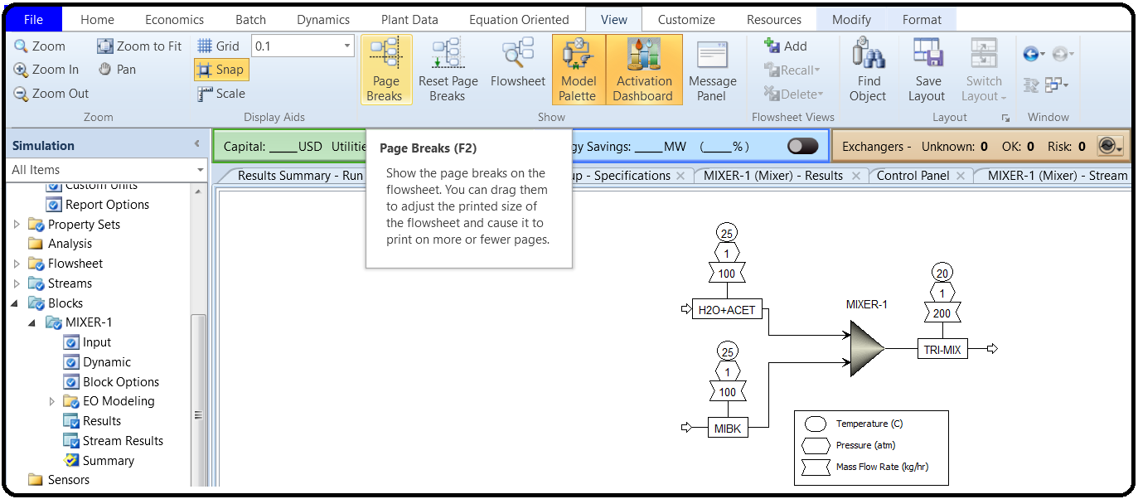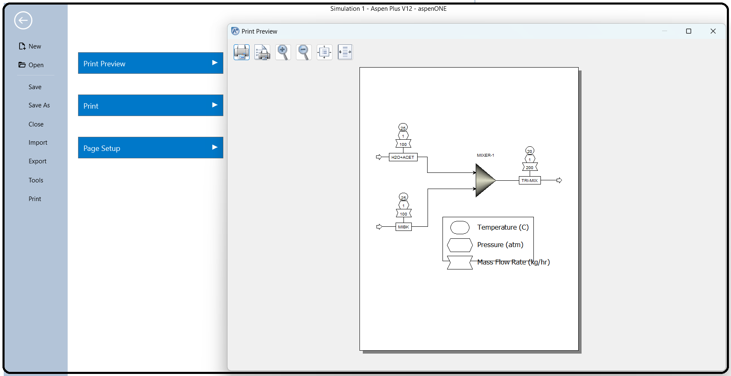

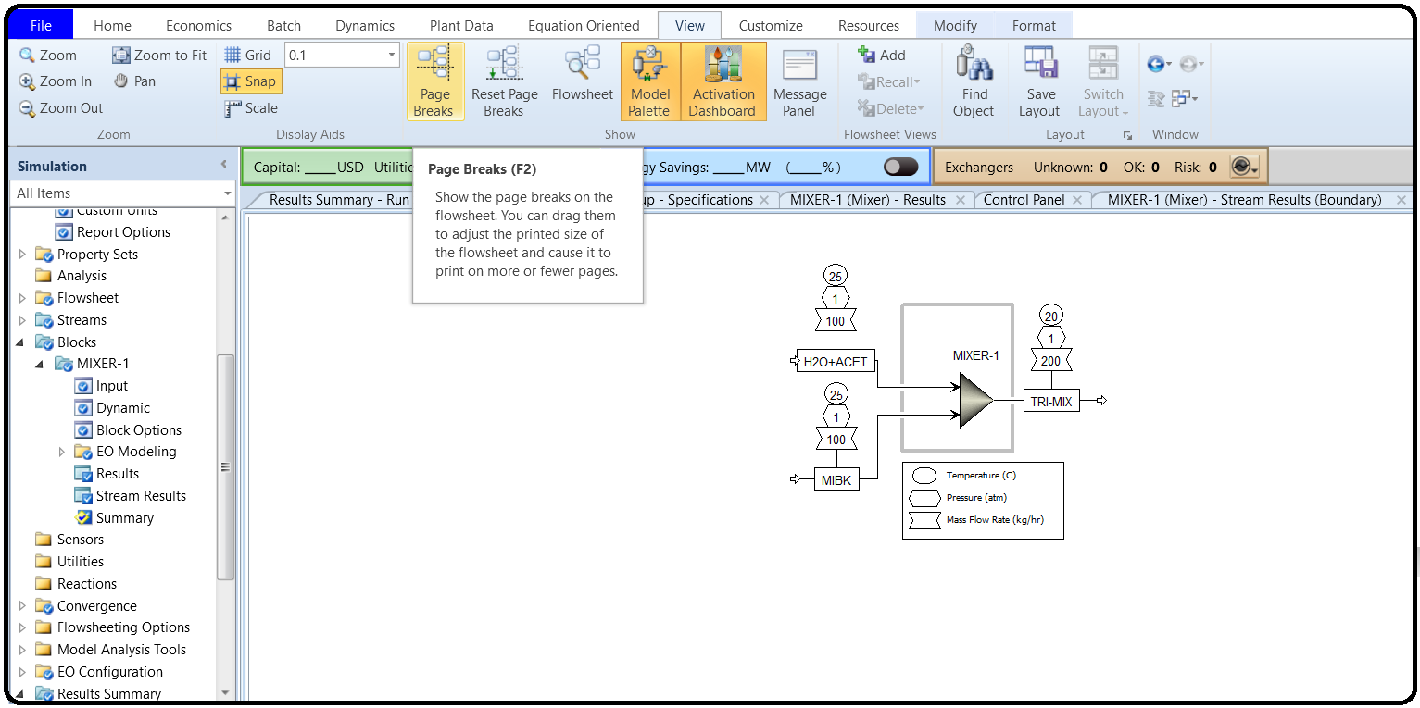

VIEWING THE INPUT SUMMARY

Another way for Aspen Plus users to present their results is through the input file of Aspen Plus. This is a useful way to check your input data for errors (or for a supervisor to check a junior engineer’s work quickly to look for bad assumptions etc.). The input summary is easily generated by clicking on “Home” ribbon | “Summary” tab | “Input File” button. The summary will be opened up in Notepad and it can be saved or printed directly from there. Figure 3.17 shows a portion of the Notepad file that is created upon invoking the “Input File” button.

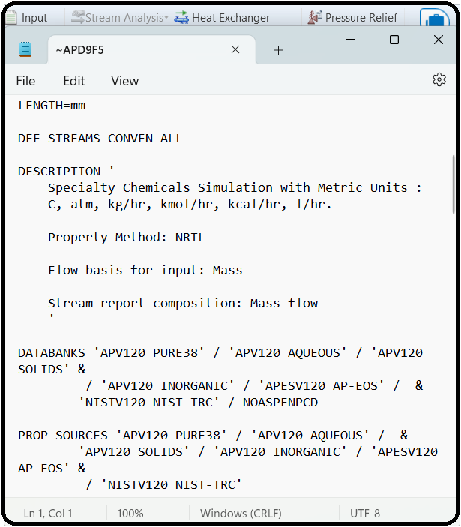

REPORT GENERATION

Clicking on “Home” ribbon | “Summary” tab | “Report File” button will open up the dialog box titled “Report”, where the user has the choice to select the item in the form of block, streams, convergence, sensitivity, and so on that will be included in the report as shown in Figure 3.18. For each drop-down menu item, shown in Figure 3.18, there may exist a corresponding flowsheet object, depending on the complexity of your flowsheet and the analysis you have already included.

After clicking on the “Apply” button for each selected item, in Figure 3.18, a Notepad file is created as a generated report, as shown in Figure 3.19. On the other hand, clicking on the “OK” button will do the same job but will also close the dialog box.

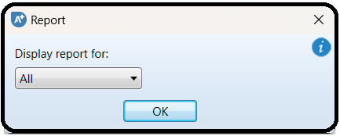

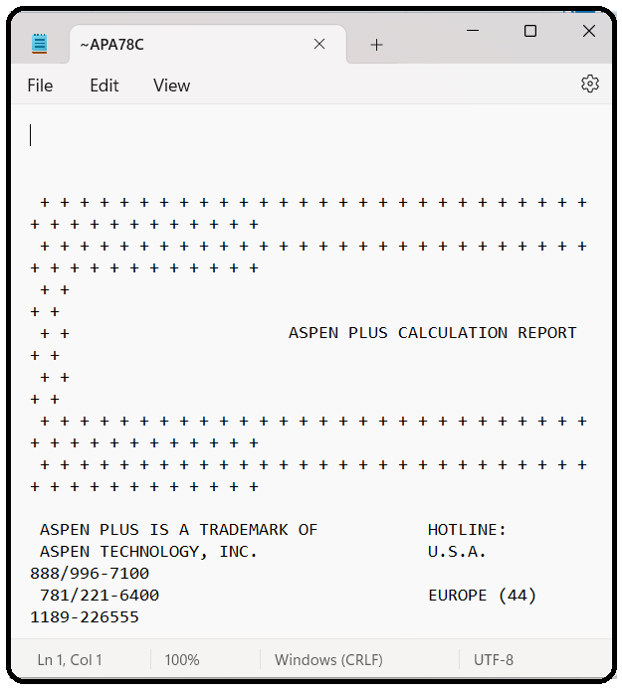

NOTE #3: What to include in the report (i.e., level of details) is done via “Report Options” in “Setup” folder of “Navigation” pane.

STREAM PROPERTIES

To show stream thermodynamic, transport, or both properties at specified temperature and pressure, make the flowsheet window active and select a given stream by right-clicking the mouse on that stream then go to “Analysis…” menu | “Stream Properties” submenu. Alternatively, you may click on “Home” ribbon | “Analysis” group | “Stream Analysis” button and then select “Stream Properties” item from the drop-down list. A stream property analysis (“SPROP-1”) form is created under “Analysis” folder in “Navigation” pane, as shown in Figure 3.20 for “TRI-MIX” stream. The “TXTPORT” property set was selected, the manipulated variable is temperature, and the parametric variable is pressure. Clicking on the “Run Analysis” button, Aspen Plus will refresh the user by the analysis results in the form of a parametric plot for transport mixture properties as a function of temperature at a fixed value of pressure in this case.

Notice that if the “Run Analysis” button is not active, then this means that the simulation status is such that no successful results are available. Consequently, Click on “Reset” followed by the “Next” button to run the simulator, which will then calculate the transport properties of “TRI-MIX” stream. Moreover, the property method to be used in analysis can be changed, as well.

Clicking on “Analysis” | “SPROP-1” | “Results” sheet will reveal the transport properties of “TRI-MIX” stream in tabulated form, as shown in Figure 3.21. Again, if no results are shown, then you have to run the simulator and arrive at successful results (i.e., a converging solution).

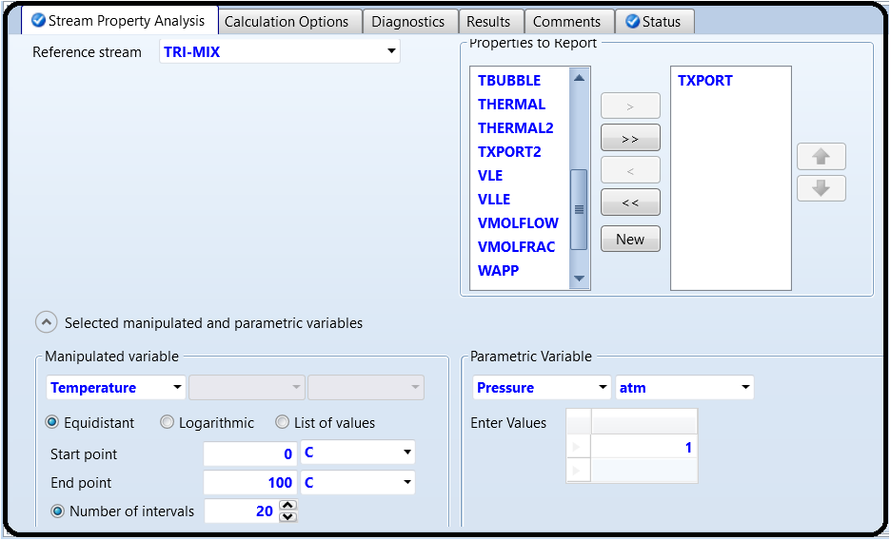

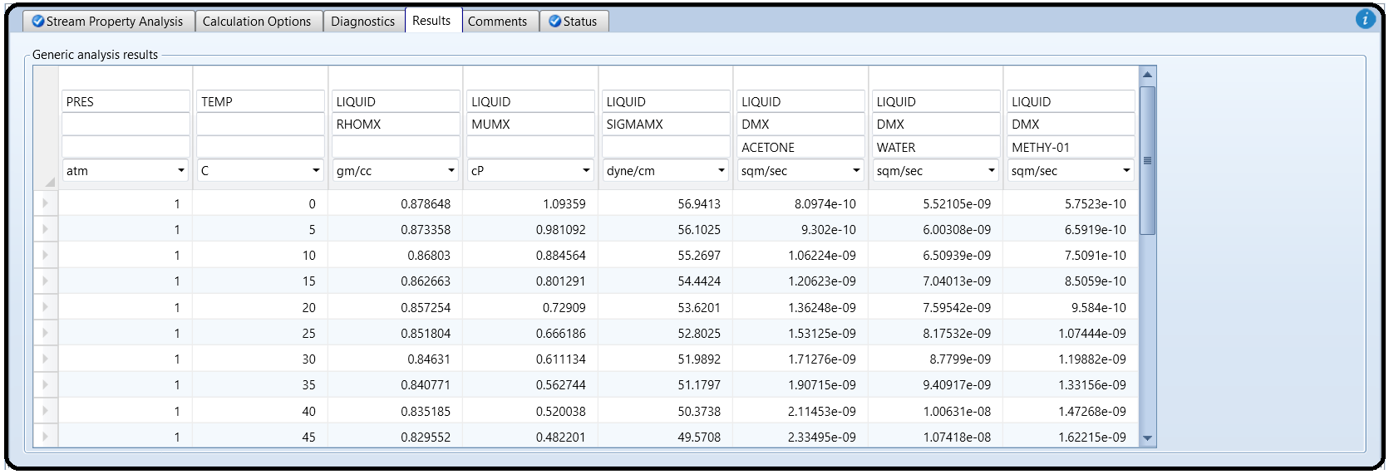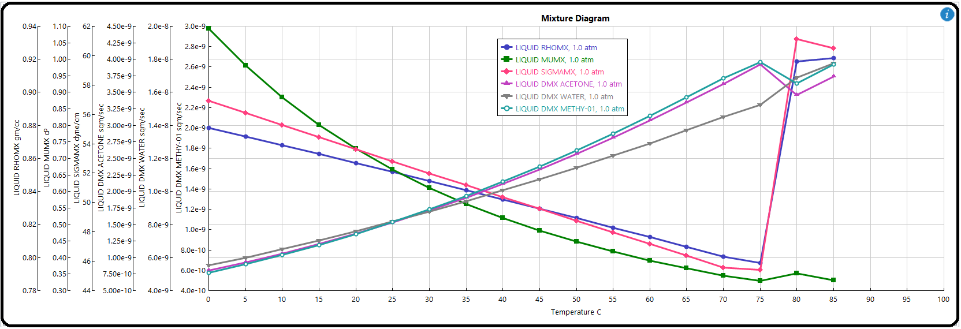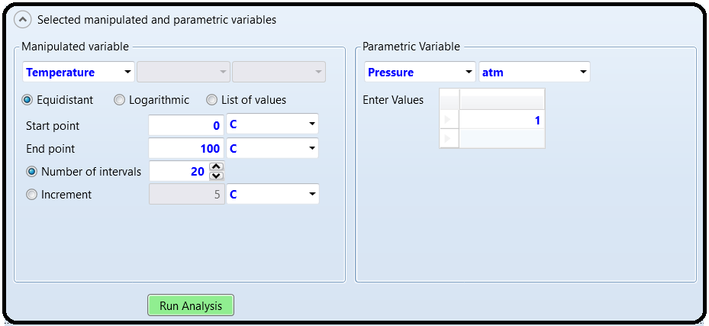

ADDING A FLASH SEPARATION UNIT

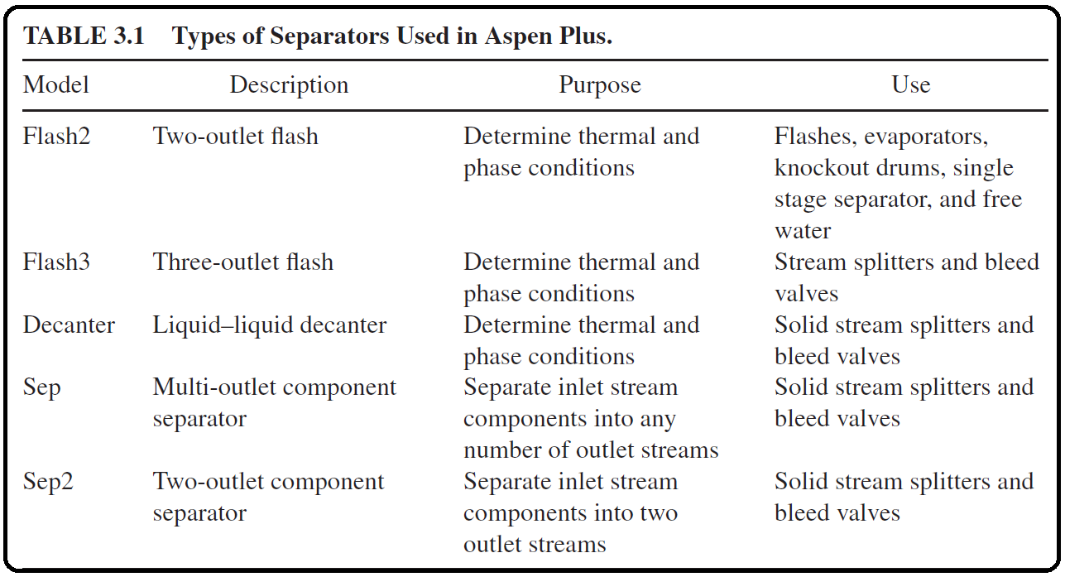From “Model Palette”, select the “Separators” tab. We will be using “Flash3” type separator using a rigorous vapor–liquid–liquid equilibrium (VLLE) to separate our stream for further purification. Remember that MIBK is immiscible with water; hence, this explains why we have to use VLLE. On the other hand, “Flash2” type is used to describe vapor–liquid equilibrium (VLE). Table 3.1 shows a brief description of different types of separators used in Aspen Plus.

Select the “Flash3” type separator and add one to your process flowsheet. Select the “Material” stream from the “Model Palette” and add three product streams leaving the flash separator from the top side, the middle, and the bottom side (where the red arrows indicate a product is required). Rename the three added streams as shown in Figure 3.22.

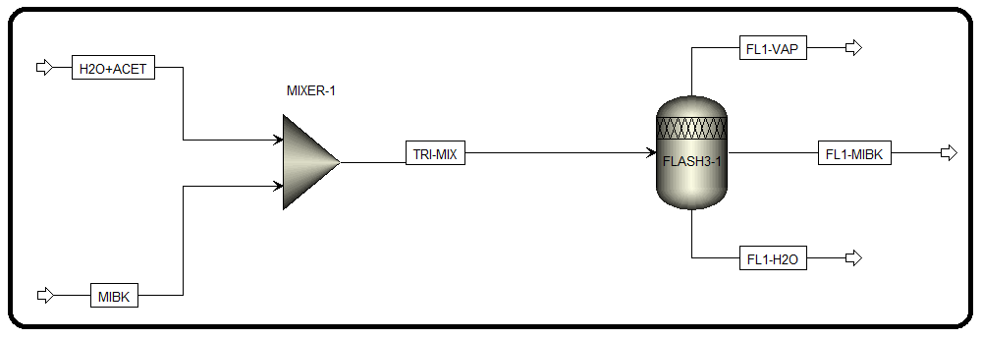

To hook “TRI-MIX” stream to the flash separator right-click on “TRI-MIX” stream, out of “MIXER-1”. Select “Reconnect” menu→“Reconnect Destination” submenu and attach this stream to the inlet arrow (a short red arrow appear at the inlet) of the flash separator. The modified process flowsheet is shown in Figure 3.23.

THE REQUIRED INPUT FOR “FLASH3”-TYPE SEPARATOR

You will notice that the simulation status has changed to “Required Input Incomplete” because of the new unit operation that we have added to our process flowsheet. All of the user input is complete except for that in the “Blocks” folder. One of the interesting and facilitating features of Aspen Plus is that you only need to add input data to new feed streams and new equipment and it will complete calculations to determine the missing properties, such as composition, *P*, and *T*, of all of the new intermediate and product streams. However, there is a drawback to this feature: if the selected thermodynamic method is not appropriate for the newly added unit or block, Aspen Plus will not force the users to go back to the thermodynamic selection to confirm that the user has properly selected the thermodynamic base for his/her problem and this can lead to convergence problems and unrealistic results if the selection is not appropriately considered.

Click on the “Next” button and Aspen Plus will bring you to “Blocks” folder | “FLSH3-1” subfolder | “Input” file | “Specifications” form. You will notice that the user can specify two out of four variables for the flash separator, depending on a particular application. These options are shown in Figure 3.24. In our simulation, we specify the temperature and pressure of our first flash separator to be 50∘C and 1.0 atm, respectively. After inputting these two values you will notice that the “Simulation Status”, at the bottom-left corner, changes from “Required Input Incomplete” to “Required Input Complete”.

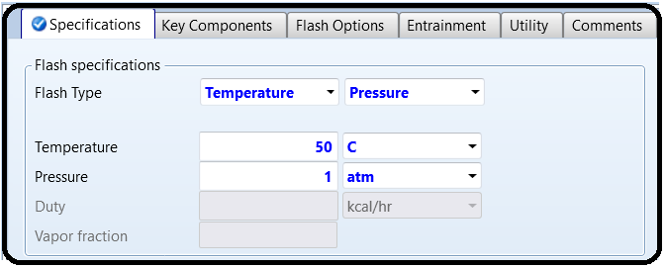

RUNNING THE SIMULATION AND CHECKING THE RESULTS

Run your simulation at this time. As pointed earlier, be sure to check your results for both convergence and run status. Figure 3.25 shows the “Control Panel” window that shows messages related to convergence and warnings.

Figure 3.26 shows the composition of the “Flash3”-type separator outlet streams. Notice that “FL1-H2O” stream is higher in water but it did not hit the target value; that is, the mass fraction should be at least 0.95 for H2O. In Chapter 4, we discuss about how to tackle this deficiency.

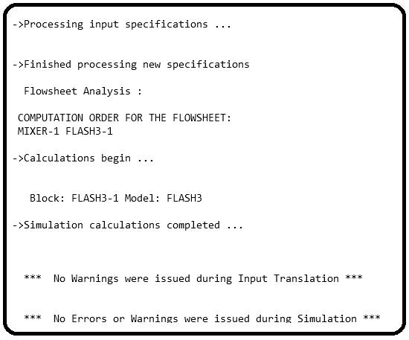

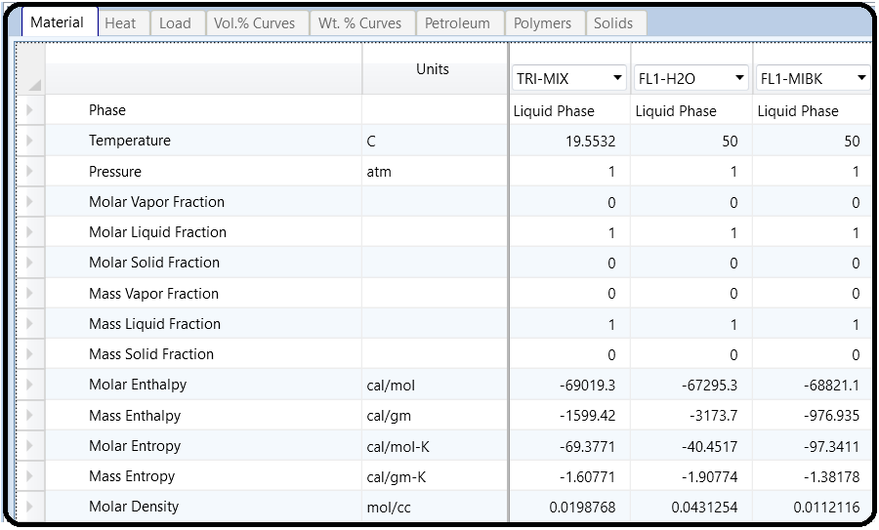

ADDING A SECOND MIXER AND FLASH

Open the previous chapter’s simulation project. Add a second mixer and a second flash separation unit to the process flowsheet and properly rename them. Connect the stream that is primarily water and acetone (the stream off the bottom of the first flash separator) to the new mixer and add in a new feed stream of MIBK that also feeds into this new mixer. Next, connect the product from the second mixer to the new “Flash3” type separation unit and add the required product streams. Your process flowsheet should be similar to that shown in Figure 4.1.

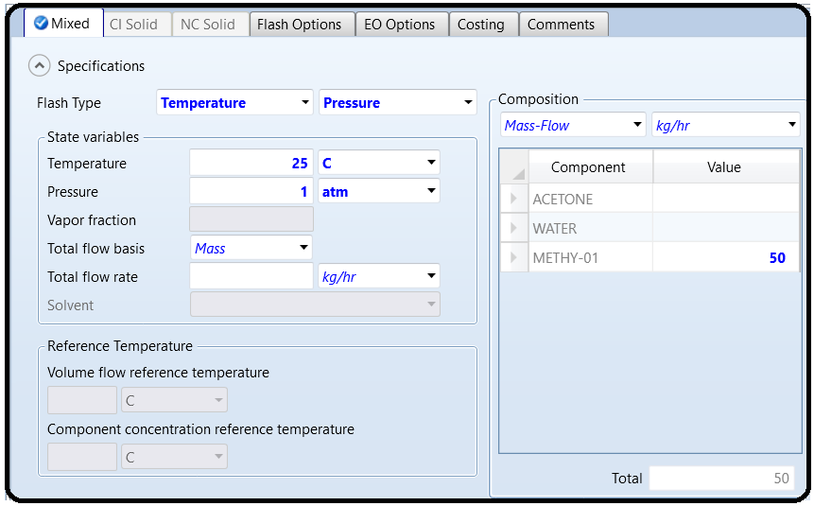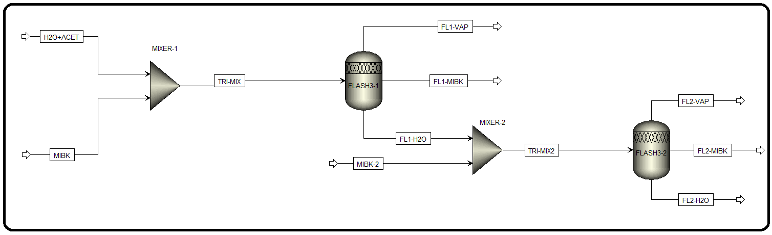Click “Reset” followed by “Next” button to update the inputs for the new additions to the process flowsheet. The new feed stream MIBK2 should have a flow rate of 50 kg/h of pure MIBK at a temperature of 25∘C and a pressure of 1.0 atm. The second mixer requires to specify that pressure drop is zero (i.e., assign a value of zero for the pressure in the input form) and the second flash separation unit should be operated at 50∘C and 1.0 atm. Notice that “Simulation Status”, at the bottom-left corner, changes from “Required Input Incomplete” to “Required Input Complete”.

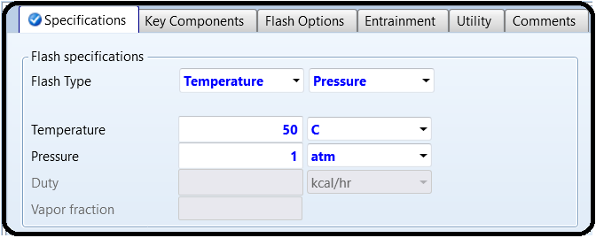

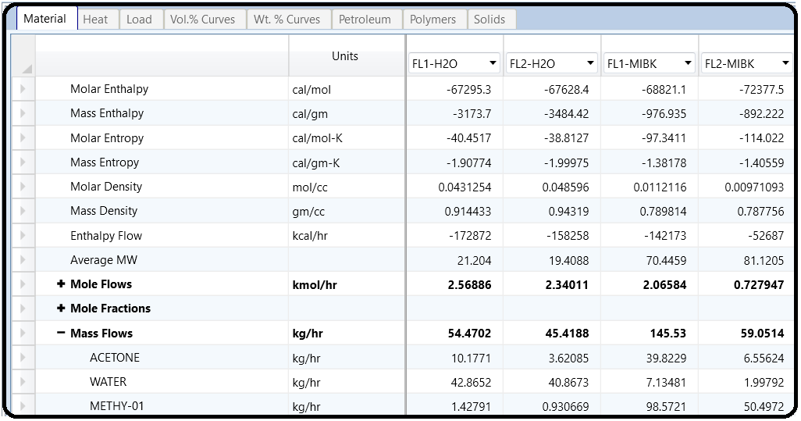Run the simulation at this point and check “Control Panel” for any warning or error. You should get results similar to those seen in the stream results shown in Figure 4.2. You will notice that we did not get yet the desired 95% purity of the water stream, which is specified in the problem statement. While we can simply rerun the simulation more than once such that a feed rate of “MIBK2” will give us this desired purity, we will instead instruct Aspen Plus® to complete the iterations for us before reporting the results. You may notice that the stream table shown in Figure 4.2 does not include all the streams. Remember that this is discussed in Section 3.4.

NOTE #0: The simulation and design specification results in this chapter will be subject to how we let Aspen Plus calculate binary interaction parameters among the three components. So, be sure that, under “Methods” | “Parameters” | “Binary Interaction” | “NRTL-1” sheet, the source for each of the three columns is selected as “APV88 VLE-IG” not “R-PCES”. See Chapter 3 on how to set the source as “APV88 VLE-IG”. Keep in mindthat this does not advocate using “APV88 VLE-IG” as the source for binary data. This only serves the calibration of process of learning by the user. The validity of simulation results are always governed by experimental data for a given

chemical process/components. We have elaborated on this critical issue in the first two chapters.

DESIGN SPECIFICATIONS STUDY

One of the powerful features of Aspen Plus is the ability to examine how a given independent variable will affect another dependent variable. Select the “Flowsheeting Options” folder in the “Navigation” pane and open up the “Design Specs” subfolder. At the bottom of the screen, select the “New” button and choose a name for this design specification. When you have done this, the “Define” tab form should look like that seen in Figure 4.3.

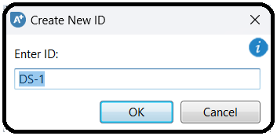

You will notice that there are three areas where we must input data in order for the required input to be complete. These are “Define”, “Spec”, and “Vary” tab. In the “Define” tab window, the user must set the dependent variable that he/she is interested in. For our case, this is the purity of the water product stream (or mass fraction of water). Either you click on “New…” button and name the new variable as “H2OMF” (i.e., water mass fraction) or directly key in the variable name under “Variable” column, as shown in Figure 4.4. Moreover, we need to specify that our variable is the mass fraction of water in the water-rich product stream “FL2-H2O”. Under “Category”, select “*Streams*”. From the “Type” drop-down menu, select “*Mass-Frac*”. In the “Stream” box, select your water product stream (*FL2-H2O*) and under the “Component” box, select “*WATER*”. Figure 4.4 shows the filled-in “Define” tab window. We are now done with the required input of the “Define” tab window and can move on to the “Spec” tab window. You will notice that we have three values that we must input into this form. The first, “Spec”, is the dependent variable that we want to set a target value for. This is the variable that we just defined in the “Define” tab window as “H2OMF”. Type this into this box. “Target” is the numeric value that we would like our dependent variable to be equal to at the completion of the calculation iterations. Our target value is 95% or 0.95.

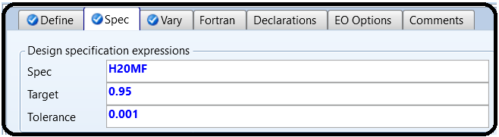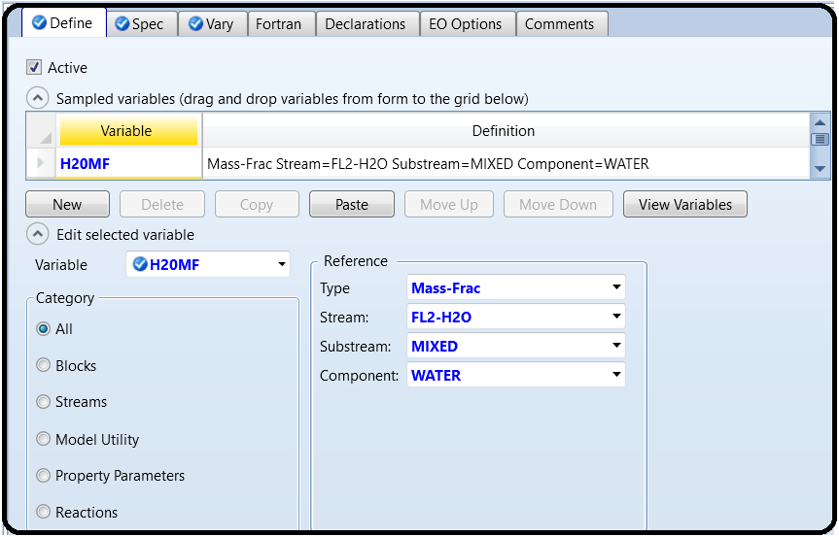

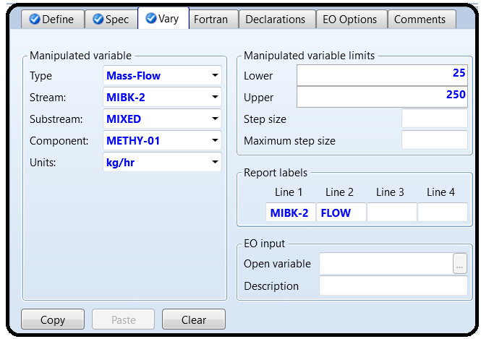

Finally, “Tolerance” entry accounts for themargin of acceptance. For our purpose, a tolerance of 0.1% is acceptable (this means 0.95±0.001 or [0.949–0.951] target value). After inputting those three parameters, the “Spec” tab window should be as shown in Figure 4.5.

To complete the input for our sensitivity analysis, we must input the variable that is to be varied or manipulated. This is done under the “Vary” tab. In this simulation, we are varying the flow rate of MIBK2 feed stream. Under the “Vary” tab, select “*Mass-Flow*” under the “Type” list. Under “Stream”, select the stream that corresponds to your second feed stream of MIBK (i.e., *MIBK2*). Next, select “*MIBK*” from the “Component” list. The values placed into the “Manipulated variable limits” boxes indicate the range that Aspen Plus can use during its iteration calculations. One thing to note is that the original input value under the stream inputs must fall within the range that is input here. Remember our original input is 50 kg/h. For this case, input a variable range from 25 to 250 kg/h.

The other blocks that can be filled on this screen relate to the step size that Aspen Plus takes during its iteration calculations. It is not necessary for the user to input values into these blocks, and we will use the default Aspen Plus values. At this point, the “Vary” tab window should look like that seen in Figure 4.6.

We are now ready to run the simulation again and check its convergence based on our input design specifications. Click on the “Run” button at this time and when the computer has finished its calculations, open up “Control Panel”. “Control Panel” indicates how many iterations Aspen Plus made during its determination of the flow rate that met our design specification (i.e., “DS-1”). If completed correctly, your simulation should contain neither warnings nor errors in this window.

Let us get information regarding the convergence of a simulation. In “Navigation” pane, go to “Convergence” | “Convergence” | “Solver01” | “Results” | “Spec History” tab sheet, as shown in Figure 4.7. In this sheet, one can see each of the values attempted by Aspen Plus during its iteration cycle.

You will also notice that Aspen Plus simulator executed seven iterations to determine MIBK2 flow rate such that the absolute value of error is less than the tolerance value (i.e., 0.0000632*<*0.001) that is specified in “Spec” tab sheet. Moreover, the final value of the manipulated variable MIBK2 flow rate is 192.877 kg/h of pure MIBK. The “Error” column indicates how far the final dependent variable (H2OMF) is from the specified value (i.e., “Target” in Figure 4.5) and the “Error / Tolerance” column indicates the division of “Error” value by “Tolerance” (0.001) value. An absolute large value in this column means that the simulation does not converge while an absolute value near 0 indicates an excellent convergence.

Figure 4.8 shows “Design Specs” | “DS-1” | “Results” sheet, which shows the value of the final manipulated variable (“MIBK2” mass flow rate) and the mass fraction of water in the outlet stream as obtained by Aspen Plus simulator after seven iterations.

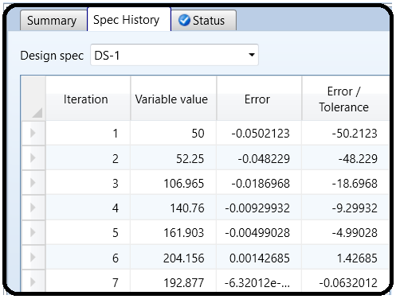

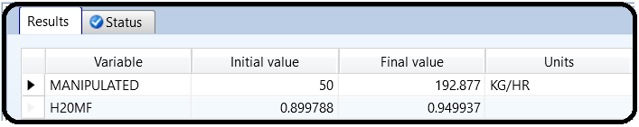

Reference:

1.Our team experience

2. Aspen Plus – Chemical Engineering Application by KAMAL I.M. AL-MALAH

3.Aspen build-in help