Safety Environment in Aspen Plus

Part 1

The natural gas liquids (NGLs) produced from wells must be conditioned before they can be economically transmitted through pipelines. The conditioning process generally involves removal of brine (salt water), hydrogen sulfide, sand, and dissolved light gases. The high pressure liquid from field gathering lines is depressurized and sent through a knock-out drum with water boot to separate brine from the hydrocarbon liquid. The knock-out drum and the let-down valves can be modeled together by “Flash2” type block connected to water decant stream. Moreover, The stabilization is carried out in distillation column, which removes hydrocarbons lighter than butanes. The amount of butane allowed in the liquid product depends on the Reid vapor pressure specifications. The NGL and gas products are then pressurized to the pipeline pressure. The goal here is to demonstrate the safety and energy aspects of such a petroleum process. Aspen Plus® provides “ngl.bkp” as an example (i.e., “C:\Program Files (x86)\AspenTech\Aspen Plus V8.8\GUI\Examples”), which can be reached via “Examples” button found in “Resources” ribbon.

THE “SAFETY ANALYSIS” ENVIRONMENT

I will not elaborate on the successful completion of the first two compulsory steps: “Properties” and “Simulation”, which are essential for any process flowsheet simulation. The components, the property method, and stream and block operating conditions are all given in the example. However, based on the warning messages issued by Aspen Plus, the following two databanks were added to the default selected databanks: “ETHYLENE” and “NRTL-SAC”. The property method is selected as “RK-SOAVE”. What you need to do is to save the file, in a separate folder, as an *.apw file, then run the file under “Properties” followed by “Simulation” environment. Let us switch to third environment, that is, “Safety Analysis”. Figure 16.1 shows the Aspen Plus under “Safety Analysis”

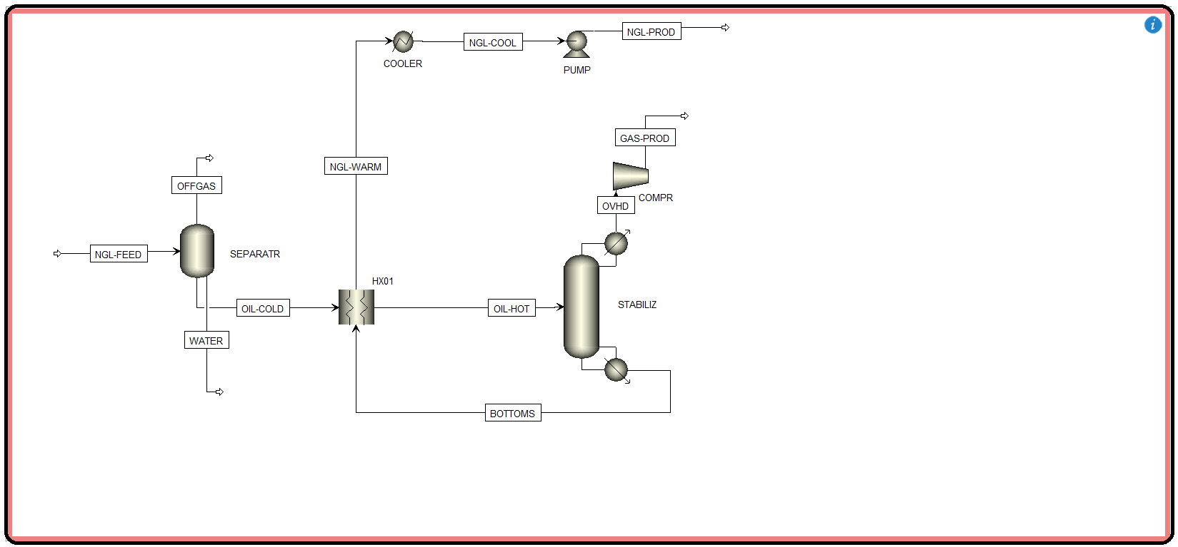environment.

NOTE #1: The “Safety Analysis” environment requires that the “Simulation” environment is successfully completed. When you switch to the “Safety Analysis” environment, if the “Simulation” environment is incomplete then you will be informed of this issue. Moreover, Aspen Plus will allow you to move back and forth among different environments, upon successful completion of the prerequisite step(s).

The “Safety Analysis” environment lets the user analyze overpressure scenarios, determine which contingencies require pressure relieving devices, size these devices according to appropriate standards, and generate appropriate documentation for analysis. Pressure Relieving Devices (PRDs) are critical components of the pressure relief and safety systems for chemical plants, refineries, and similar industrial applications. There are many types and designations of PRDs; some acronyms typically used in the domain are Pressure Relief Valves devices (PRVs), Pressure Safety Valves (PSVs), Relief Valves (RVs), Safety Relief Valves (SRVs), Safety Valves (SVs), Temperature Relief Valves (TRVs), or Temperature Safety Valves (TSVs). PRDs are attached to equipment in order to prevent over pressuring. Because the primary function of this equipment is safety, it is imperative that PRDs are designed properly. Process simulators can aid process engineers when analyzing overpressure scenarios and sizing PSVs as part of the pressure relief system in a plant. With the “Safety Analysis” environment, the user can use the same properties and process data for both equipment design and overpressure analysis. He/she can use the familiar

Aspen Plus flowsheet to visualize the process and simulation results to help the user perform

rigorous overpressure scenario analysis. He/she can also use relief load calculation schemes for common contingencies (such as fire and exchanger tube rupture). The “Safety Analysis” environment uses the latest API 520 and 521 pressure relieving device sizing equations (including Homogeneous Equilibrium Method, HEM) and performs design temperature and valve material checks in full accordance with API 526, resulting in better PSV types and flanges identification. It also provides the ability to calculate noise and reaction forces and perform line sizing calculations for single- and mixed-phase systems. The user can also use the “Safety Analysis” environment to create automatically generated documentation of relief devices with data used in sizing of PSVs. Moreover, the “Safety Analysis” environment lets the user perform low-pressure storage

tank calculations. Such a tank is designed to hold petroleum intermediates (gases or vapors) and finished products, as well as other liquid products commonly handled and stored by the various branches of the industry. The user can calculate thermal and liquid movement normal venting requirements in accordance with the latest API 2000 code and calculate emergency venting contingencies. The “Safety Analysis” environment provides the ability to quickly evaluate the requirement for normal and emergency venting for storage tanks. Tank design calculations fall under the scope of API 650 and 620, and pressure protection (overpressure and vacuum protection) calculations fall under the scope of API 2000. All accessory pressure parts, such as pipe fittings, valves, flanges, nozzles, welding necks, welding caps, manhole frames, and covers are taken into account to end up with a safe storage tank facility. This requires establishing procedures, methods, equipment, and other requirements to prevent or control the discharge of oil (i.e., oil spill) or gas release from vessels and facilities into the neighboring Mother Nature (as opposed to Father Artifact). You can view the “Tank Report” summarizing the storage tank calculations by selecting the “Calculation Sheet” button on the “Reports” contextual ribbon. See

Homework/Classwork 16.1. In addition, the “Safety Analysis” environment also provides methods to quickly determine the orifice area required and the rated capacity of a rupture disk device. The user can change PSVs to rupture disks and rupture disks to PSVs after defining scenarios and sizes. The “Safety Analysis” environment can quickly determine multiple valve configurations. In “Aspen Flare System Analyzer” the user can import PSV information from Aspen Plus “Safety Analysis” environment.

ADDING A PRESSURE SAFETY VALVE (PSV)

Since the NGL process is a high-pressure process, then there will be no need to add a low-pressure storage tank but we will show how to add a PSV. Click on “Add PSV” button found in “Home” ribbon under “Safety Analysis” environment. Move the cursor over the material stream that you would like to add a PSV to and the cursor will change to “+” crosshairs. At such a point in time and space, you can release the dragged mouse and “PSV” icon shows up unto the flowsheet as shown in Figure 16.2. Alternatively, you may click on the “Add PSV” button once and release the mouse, move to the flowsheet area where the cursor will change to “+” crosshairs, and once you hover the mouse over any potential stream, a blue square will be shown toward the end of the candidate stream where now you can click on the blue square to add a PSV.

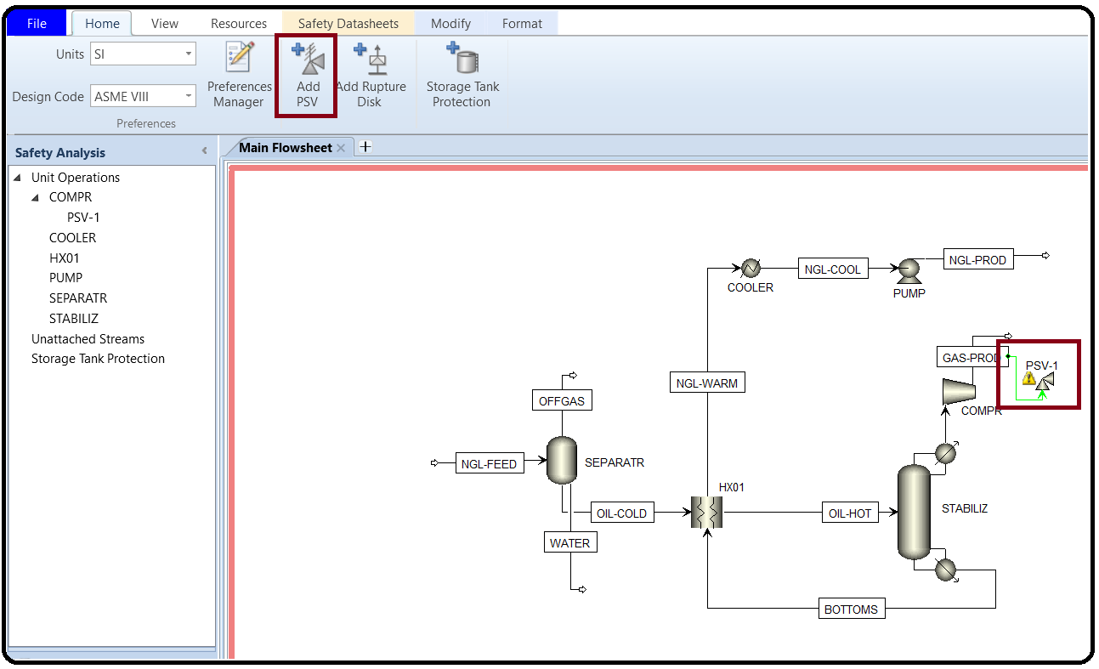

Next, we will customize the newly added PSV. From the “Safety Analysis” pane, click on “PSV-1” subfolder and “Equipment” tab form will show up as shown in Figure 16.3. You have the choice to enter the input data manually or by reference. To avoid yourself a headache, select the “Reference” option and Aspen Plus will complete the job.

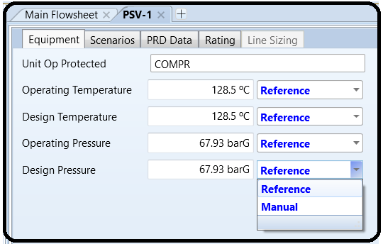

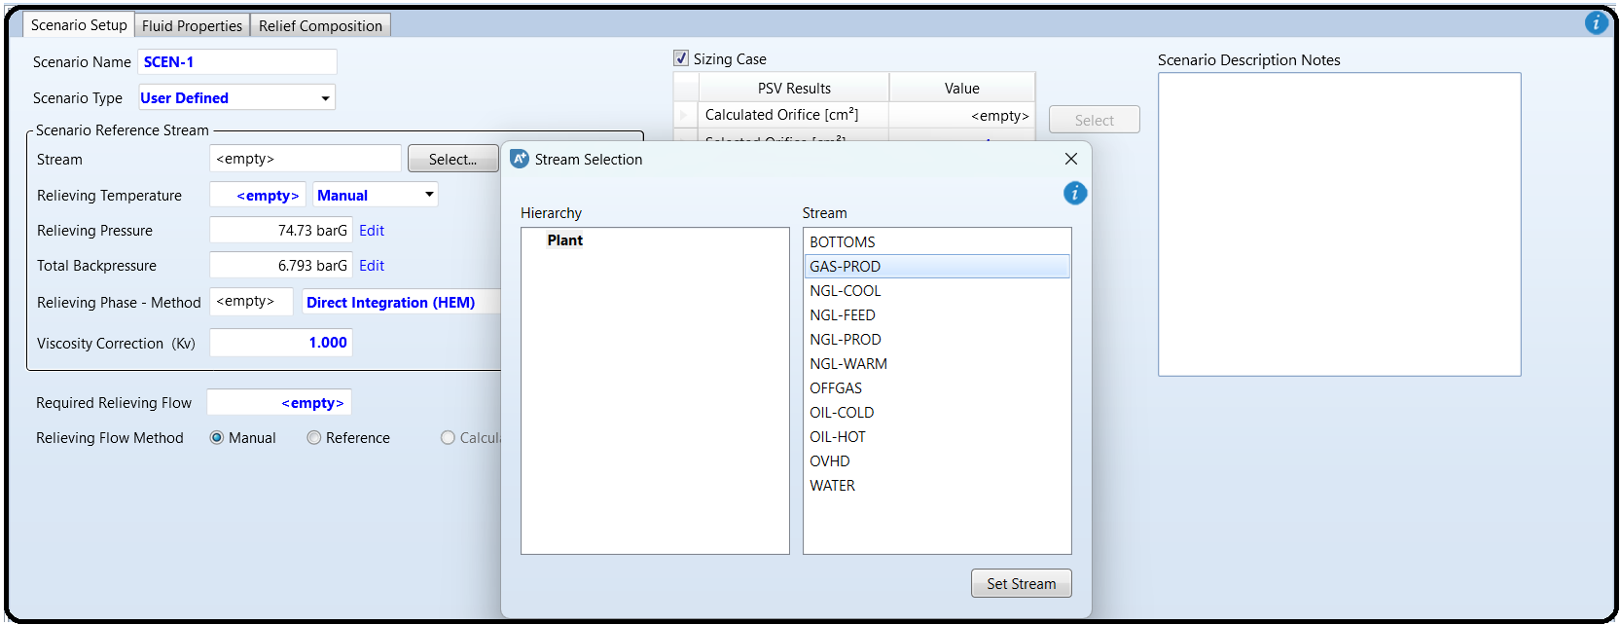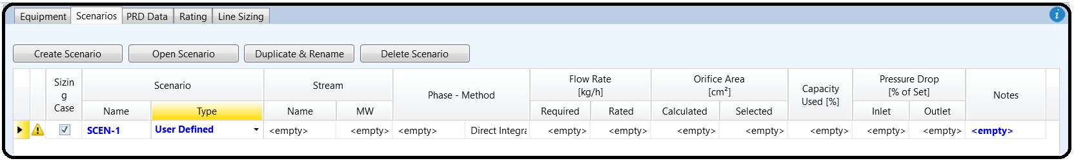Click on “Scenarios” tab and then on “Create Scenario” button to create a new scenario and the newly created scenario will show up as in Figure 16.4. Highlight (i.e., select) the scenario and “Open Scenario” button will become active. Click on “Open Scenario” button to edit the selected

scenario.

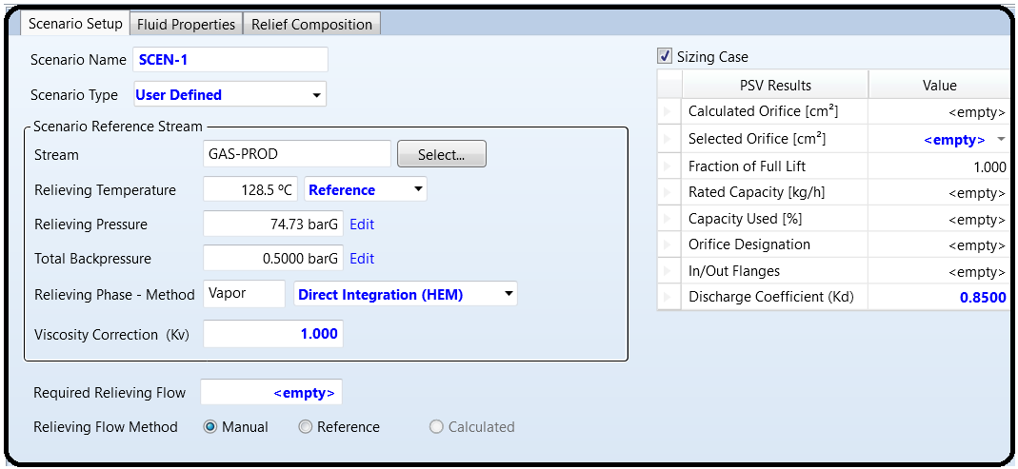

NOTE #2: For emergency scenario calculations, the fluid properties are obtained from a fluid with the same composition as the stream connected to the main PSV at the relieving conditions. Occasionally, a scenario will need a composition different from the default PSV stream. In that case, select the “Override” checkbox next to “Reference Stream” (see Figure 16.5) to override the reference stream in a specific scenario. A stream selection dialog box will appear and allow you to choose a new stream for the current scenario. Moreover, select the “Sizing Case” checkbox shown in Figure 16.4.

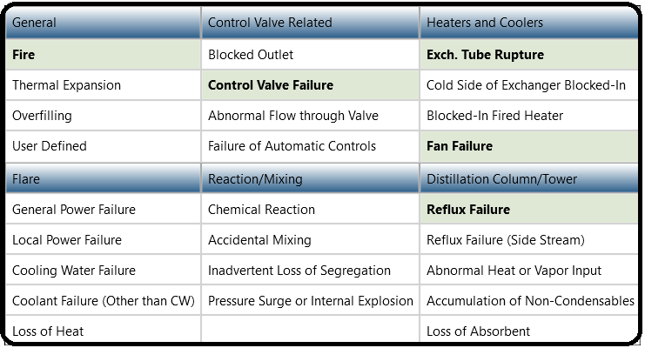Here, we can either define our own scenario via sticking to “*User Defined*” option or select from a drop-down menu, classified under different categories, as there are many possible scenarios to select from, as shown in Figure 16.6. Notice that Aspen Plus will notify the user if further information is required (a yellow strip at the bottom of the form) versus the information is complete (a green strip at the bottom).

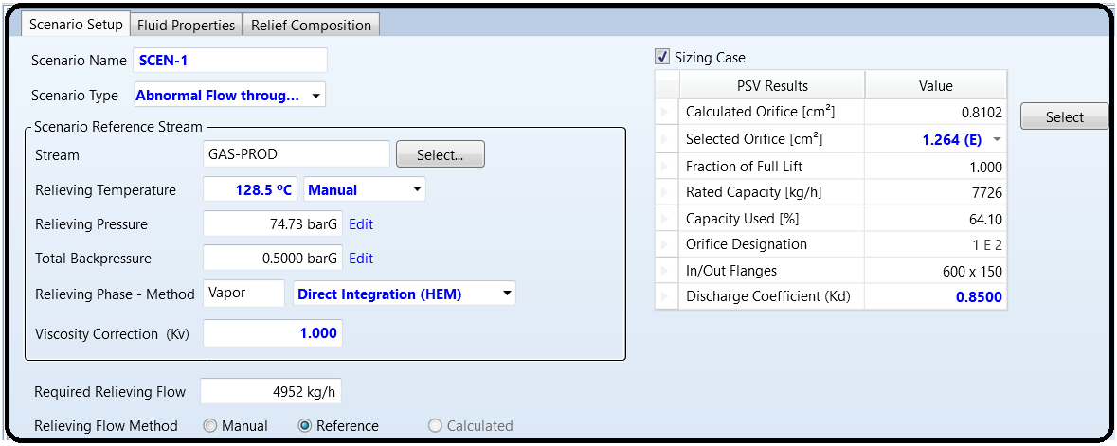Notice that we can create different scenarios for the same added valve as many as we wish but we will discuss one scenario here. Figure 16.7 shows the “*Abnormal flow through valve*” option as the “Scenario Type”. However, it requires further input data, namely, the required relieving flow; that explains why a yellow strip at the bottom of the form persists until the user enters the required input data; consequently, we need to enter the relieving flow via selecting the “*Reference*” option for the “Relieving Flow Method” calculation, which will transform the yellow strip into green. Furthermore, selecting the orifice area from the drop-down list can be carried out here (right pane in Figure 16.7). Alternatively, it can be postponed until we reach “Rating” tab (see later the discussion for selection under “Rating” tab). There is one more selection, that is, determining the properties of the relieving phase itself as being liquid, vapor, mixture of both, or supercritical fluid. The equations used with this option (“*Direct Integration (HEM)*”) are based on the Homogeneous Equilibrium Method (HEM), which assumes the fluid mixture behaves as a pseudo-single phase fluid, with a density that is the volume-averaged density of the two phases. This method is based on the assumption that thermal and mechanical equilibrium exist as the two-phase fluid passes through the PRV. For high momentum discharges of two-phase systems in nozzles longer than 4 inches (10 cm), both thermal and mechanical equilibrium can be assumed. These assumptions correspond to the homogeneous equilibrium flow model.

This method can be used for all two-phase discharge scenarios, including supercritical fluids in condensing two-phase flow. When using this method, the Aspen Plus built-in properties calculator is used in order to evaluate fluid properties along the isentropic path. After getting the green light (i.e., the green strip) from Aspen Plus, it will do at this stage some background calculations and the results are shown both in “Scenario Setup” and “Fluid Properties” tab form. Here is a summary for terms appearing on either form.

* Maximum Allowable BP: Percentage of the set pressure allowed as backpressure for

the valve. This value depends on the set pressure and the valve type considered (this

item is shown under the “Fluid Properties” tab).

* Total Backpressure: Pressure at the outlet of the relieving device; sum of the built-up

backpressure and the superimposed backpressure (constant and variable).

* Relieving Pressure: Pressure at the inlet of the relieving device; set pressure+

allowable overpressure.

* Relieving Temperature: Temperature of the relieving conditions at the inlet of the

relieving device.

The allowable overpressure percentage has a default value of 21% of the set pressure for

Fire emergency scenarios and 10% for all other scenarios.

Let us take, as an example, our lovely “GAS-PROD” outlet stream.

The operating pressure is 1000 psia (68.947 barA (absolute) or 67.934 barG (gage)

The set pressure is 67.934 barG

The allowable overpressure is 0.1 × 67.934=6.793 barG.

The relieving pressure is 67.934+6.793=74.73 barG (shown in Figure 16.7). For the “Total Backpressure” value, you may edit the value and an edit box will show up the details on how such a value is calculated by Aspen Plus. The “Relieving Temperature” is set to the operating temperature of “GAS-PROD” outlet stream.

Let us go to the third tab (see Figure 16.4), that is, “PRD Data” as shown in Figure 16.8. Since our gas stream leaves at a high pressure (1000 psia), we will chose “*HP Flare*” option.

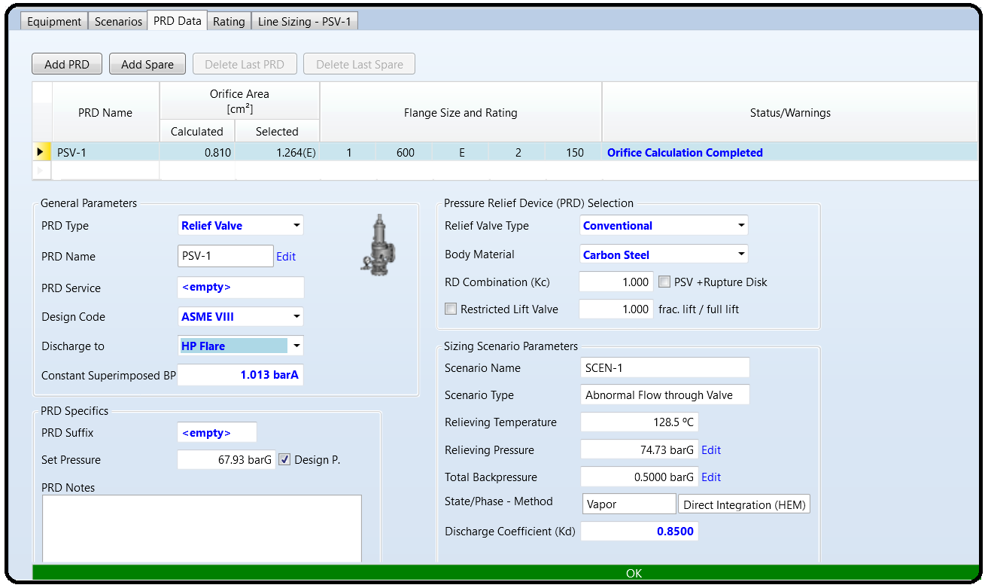

Under the fourth “Rating” tab, as shown in Figure 16.9, you may enter or adjust the orifice size specifications which will be selected from a drop-down list. Notice that if you select an orifice size larger than needed, you will end up with a yellow strip bearing the following warning message saying: “100 PSV-1: The required capacity is smaller than 60% of the PSV capacity. The selected PSV is likely to chatter. Consider selecting a smaller PSV or splitting the PSV in two or more smaller items”. In principle, you can start small and grow up to the limit where you are prompted by the warning; alternatively, you may start big and shrink in size until you get the green strip. Notice that the required capacity (4929 kg/h) is bigger than 60% of the PSV capacity (7696 kg/h). 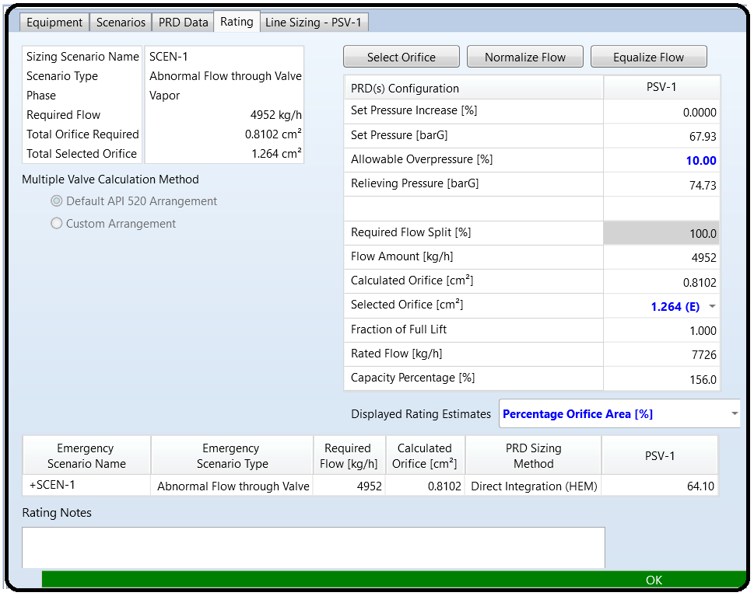Both values are shown in the right pane of Figure 16.9.

The fifth and last “Line Sizing” tab pertains to the line sizing of the inlet and outlet pipe. Figure 16.10 shows that we need to specify both the nominal diameter and schedule number for both inlet and outlet pipe. Here again, we have to play tricks such that the selected nominal diameter does not end up with an undesired result. Specifically, at a very low nominal diameter value, we violate the pressure drop limitation on both inlet and outlet side of the PSV. So, start simple and grow up in size until you get the green strip. This makes our life green and all required specifications are entered. What is next? Have a nap; it is now safe.

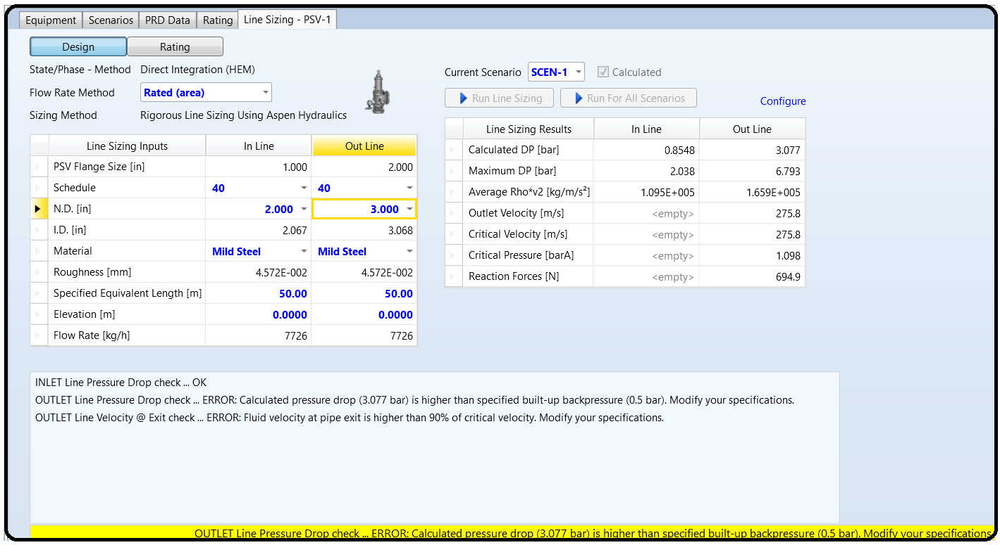

Part 2

ADDING A RUPTURE DISK (RD)

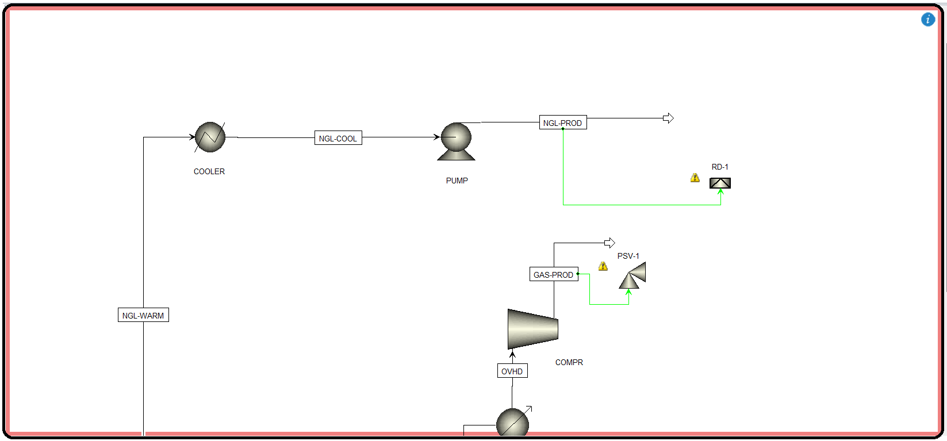In the same manner as we did with adding a PSV, we can add a rupture disk and hook it to the top liquid NGL (“NGL-PROD”) stream as shown in Figure 16.11.

Figure 16.12 shows the “Equipment” tab form where the “*Reference*” option is selected versus the “*Manual*”.

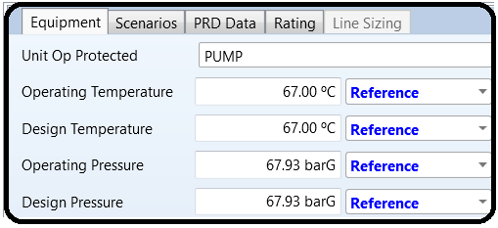

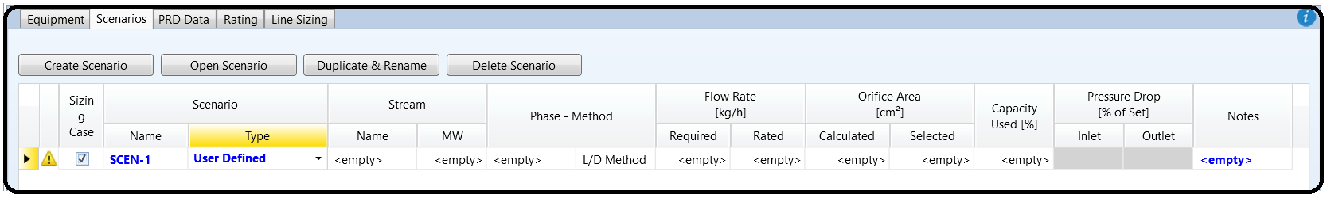Figure 16.13 shows the creation of a scenario to be associated with “**RD-1**” disk.

Highlight the scenario (“SCEN-2”) for “RD-1” disk and click on “Open Scenario” button to enter the scenario type and any required input data. Figure 16.14 shows the “Scenario Setup” tab form where we need to enter the “Scenario Type”, the “Relieving Phase Method”, the “Relieving Flow Method”, and rupture disk diameter. Points worth mentioning here are as follows:

Part 3

