Part 4

Reactor Modelling in Aspen Plus



Objectives:

1.Learn to use different pressure change elements such as pumps, valves, pipe segments.

2.Become familiar with pages and Tabs of each element and how to fill in the required inputs.

3.Get to know the critical conditions and its causes for each pressure change elements.

4.Learn to use Sensitivity in Aspen Plus

5.Learn to use Design Specs in Aspen Plus

6.Understand pressure level heuristics for compressors and turbines

7.Understand the difference between heat, material, and work streams

To demonstrate the concept of particle size distribution (PSD), we consider a simple solid handling case. Figure 14.1 shows the flowsheet that is made of a crusher, one feed stream, and one output stream. The crusher, as its name suggests, will reduce the particle size of the feed stream.

Problem Definition

In a treatment of the design of an acetic anhydride manufacturing facility, it is stated that one of the key steps is the vapor-phase cracking of acetone to ketene and methane:

CH3COCH3 → CH2CO + CH4

It is further stated that this reaction is first order with respect to acetone and that the specific reaction rate can be expressed by ln *k* = 34*.*34 − 34,222 **∕** *T* (6.2) In this design, it is desired to feed 7850 kg of acetone per hour to a tubular reactor. If the reactor is adiabatic, the feed is pure acetone, the inlet temperature is 1035 K, and the

pressure is 162 kPa (1.6 atm), what will be the tubular reactor volume needed to achieve 20% conversion?

Acetic anhydride is prepared by the reaction of ethenone (ketene) with acetic acid at 45–55∘C and low pressure (0.05–0.2 bar).

H2C = C = O + CH3COOH → (CH3CO)2O (Δ*H* = −63 kJ∕mol) (6.3)

There are two different ways by which we can define the reaction rate constant to Aspen Plus environment. We arrange Equation 6.2 in these two forms: one form contains a reference temperature, *T*o, and another does not. However, both forms are equivalent. Take the exponent value for both sides of Equation 6.2 and we have

Alternatively, *to* can be arbitrarily chosen and *k*\* will be calculated accordingly. Let us use *T*o =1000 K. We have



Equate both expressions of *k*, we have

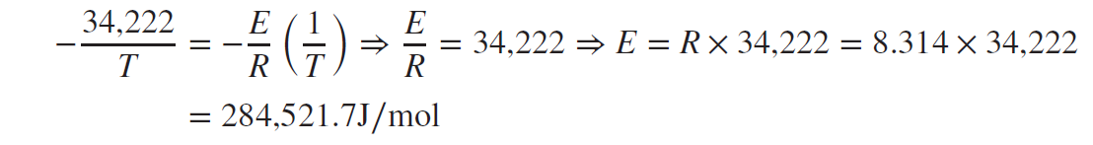First, equate the exponent terms, on both sides, which contain *1/T* term to calculate E:

Notice that *E* is the same as that in Equation 6.4. Second, substitute the value of *E* from Equation 6.7 into Equation 6.6 and equate constants on both sides of Equation 6.6.

Notice that *k\** is calculated in terms of *to* =1000 K. However, *E* is fixed for a given reaction and does not depend on *T*o. Equation 6.5 becomes



where *k* is in reciprocal seconds (for a 1st–order reaction) and *T* is in Kelvin. In general, the rate constant *k* can be expressed in either form, Equation 6.4 or 6.9, depending on the chemical reaction engineering textbook being used.

How to Simulate

1. Using “Specialty Chemicals with Metric Units” template, create an Aspen Plus project. Under “Properties” environment, in “Navigation” pane, go to “Setup” | “Global” sheet and enter the title: “*Production of Acetic Anhydride*”.

2. In “Navigation” pane, click on “Components” folder, and you will be faced by “Selection” tab window. Use “Find” button, shown at the bottom of “Selection” tab window, to search for components by name or chemical formula. Add the following components: ACETONE (CH3COCH3), KETENE (C2H2O), METHANE (CH4),

ACETIC-ACID (CH3COOH), and ACETIC-ANHYDRIDE (ACET-ANH) as shown in Figure 6.1.

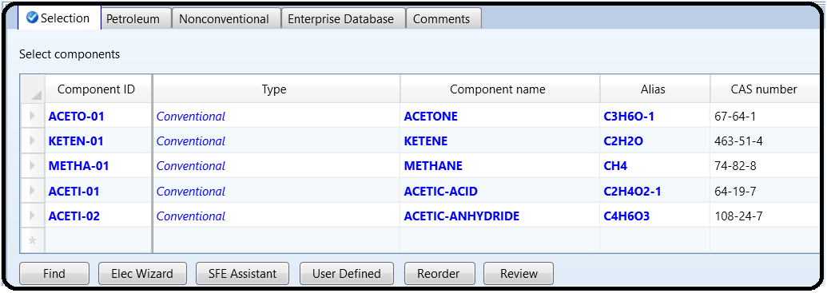

3. Go to “Methods” folder | “Global” sheet and use the “Property Method Selection Assistant” wizard by clicking on the “Methods Assistant…” button shown in Figure 6.2. Select “Specify process type”; followed by selecting the type of process to be “Chemical”; and finally clicking “Carboxylic acids” as a subset of “Chemical” processes. This will guide you to either “NRTL-HOC” or “WILS-NTH” as shown in

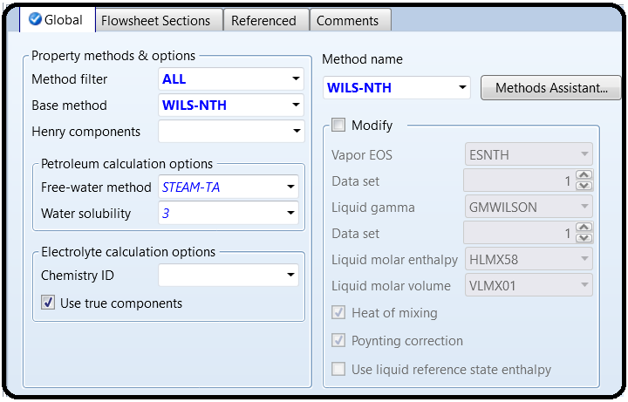Figure 6.3.

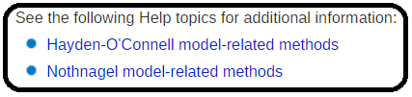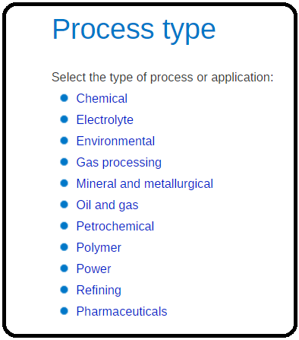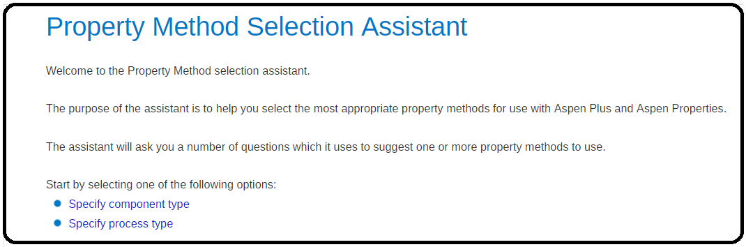

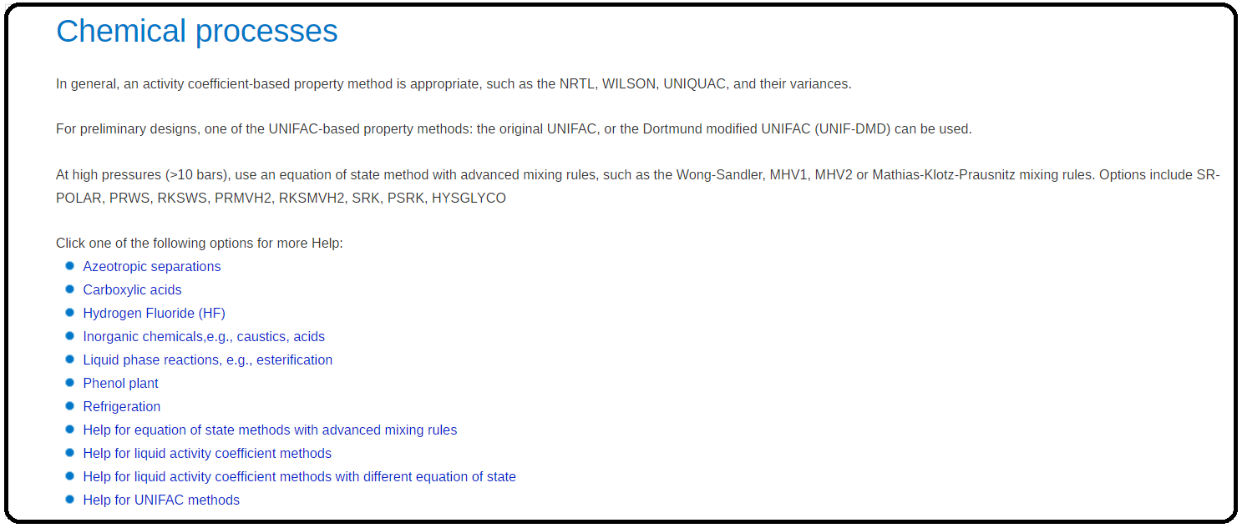

You can choose either one; so, in “Global” tab window, from the “Method name” pull-down menu selects “WILS-NTH” as shown in Figure 6.4.

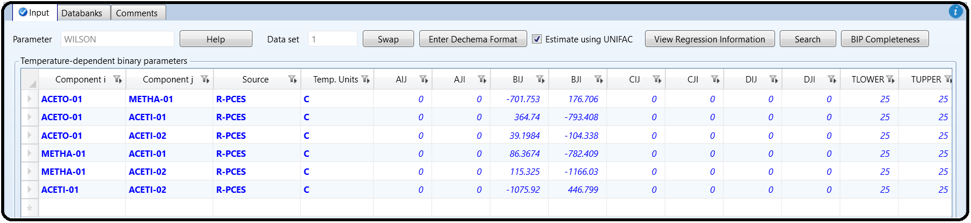Under “Methods” | “Parameters” | “Binary Interaction” | “WILSON-1” sheet be sure that the “*Estimate missing parameters by UNIFAC*” option is checked. Click “Reset” followed by “Next” button to run the simulation and assure that properties analysis completed successfully.

4. At the start, the flowsheet consists of one inlet stream, a plug-flow reactor (“PFR”), and one product stream. It should resemble Figure 6.5. This can be done by adding the “RPlug” reactor found under “Reactors” tab in “Model Palette”.

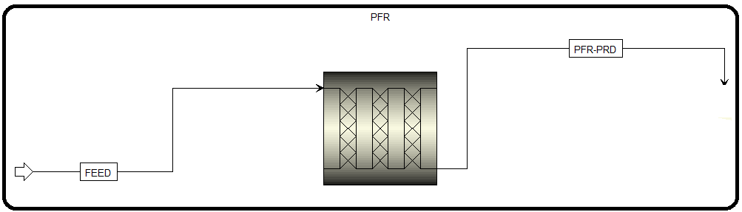

5. Click on “Next” button, and Aspen Plus will bring the user to entering feed stream properties

Temperature: 1035K (change units if necessary)

Pressure: 1.6 atm (change units if necessary)

Total flow: Change to Mass kg/h

For the total mass flow rate of “FEED” stream, type 7850. Leave ketene and methane at zero (no mass flow in the feed stream). For “Composition” drop-down menu, use “*Mass-Frac*” and enter 1.0 for acetone (CH3COCH3).

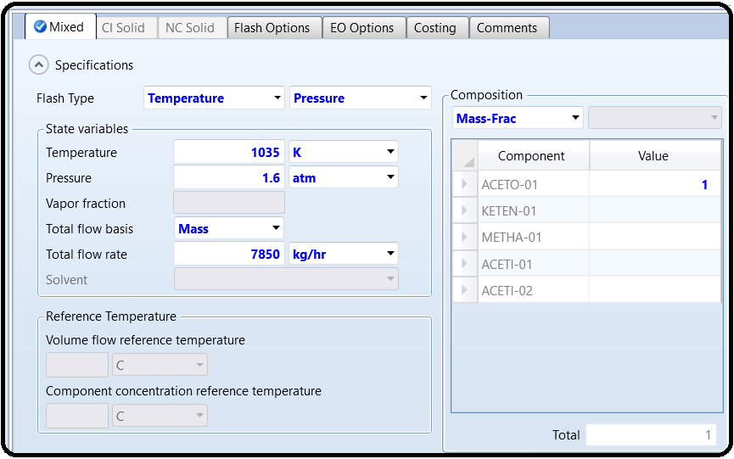

6. Click on “Next” button.

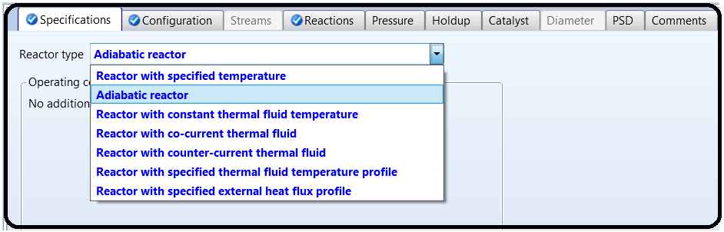7.Reactor Specification

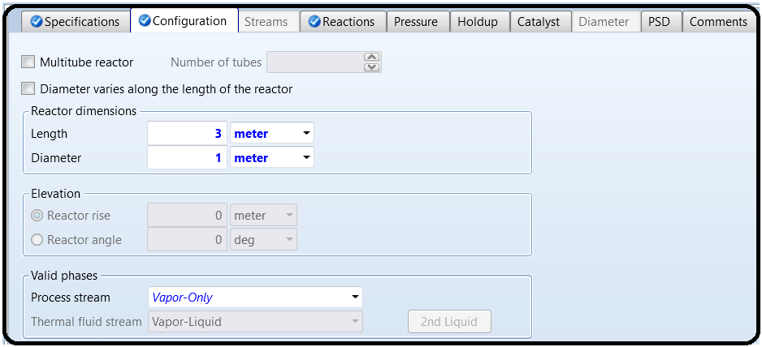

If you click on “Reactions” tab, you will notice that you need to associate a reaction set to “PFR” block; however, since we did not define any reaction yet, the available reaction sets side will be empty.

Click on “Next” button to create the reaction set as shown in Figure 6.9, which will be added later to the “Reactions” tab here. Figure 6.9 shows that we created “R-1” reaction set with “POWERLAW” type. The reason for describing “R-1” as a reaction set is simply because it may contain more than one reaction. Here, we have only one reaction as given by Equation 6.1.

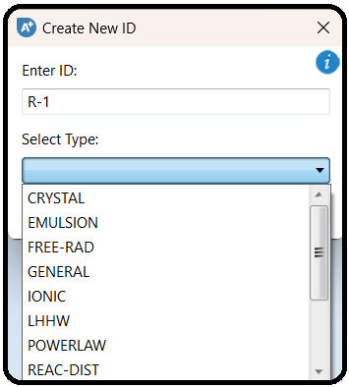

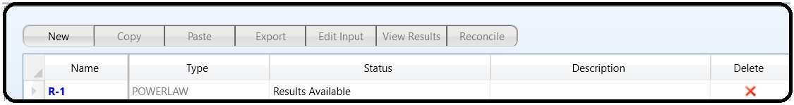Click on “New…” button and the “Edit Reaction” window will pop up where the user will be required to define the reaction equation, its type whether kinetic or equilibrium, and the reaction order (*i.e.*, exponent) if it is of kinetic type, as shown in Figure 6.11.

Under “**Reaction type**”, select “*Kinetic*”.

Under “**Reactants**”, select acetone (CH3COCH3) from the components pull-down menu

and set the “**Coefficient**” to −*1* and the “**Exponent**” to *1*.

Under “**Products**”, select ketene and methane and set both coefficients to *1*.

Click on “**Next**” button or “**Close**” button shown at the bottom of the “**Edit Reaction**” window.

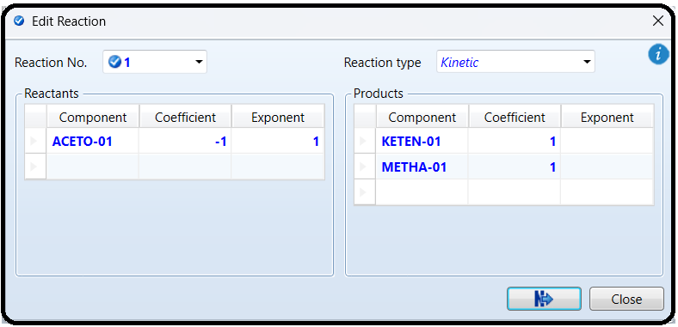

Figure 6.12 shows that the reaction stoichiometry is defined; however, the kinetic parameters are not yet defined.

Note : Based on Aspen Plus built-in help, here is how to enter kinetic parameters for a reaction:

If To is specified, then the general law expression will be

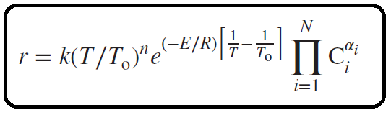

On the other hand if To is not specified, the general law expression will reduce to

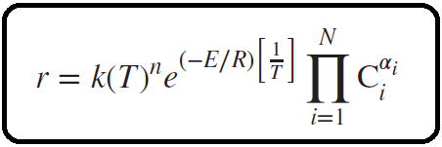

The rate is expressed in kmol∕(s ⋅ basis) where the basis is either m3 for “**Rate Basis:** Reac (vol)”, or kilogram catalyst for “**Rate Basis:** Cat (wt)”.The reactor volume or catalyst weight is determined by specifications in the reactorwhere the reaction is used

Next, click on the “**Kinetic**” tab where the user needs to input the kinetic parameters.

Change “**Reacting phase**” to “*Vapor*”. The “**Rate basis**” will be left as “*Reac(vol)*”.

Enter *1.125* for ***k*** (*i.e.*, *k*\* in Eq. 6.9)

Enter *1000*K for **To**

Enter the activation energy **E** of the Arrhenius equation, *E* = 284,521.7 J/mol (Eq. 6.4

or Eq. 6.7). Notice **E** is also equal to 284,521.7 kJ/kmol.

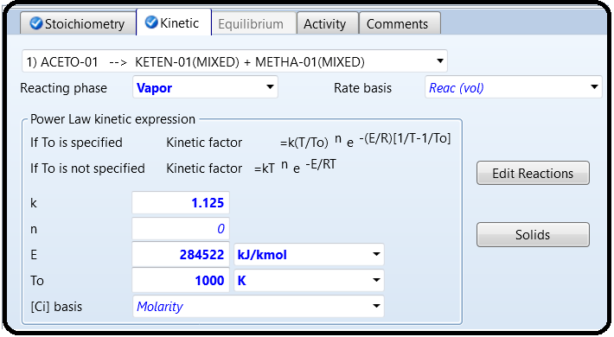Figure 6.13 shows the “**Kinetic**” tab window, after inputting the required data.

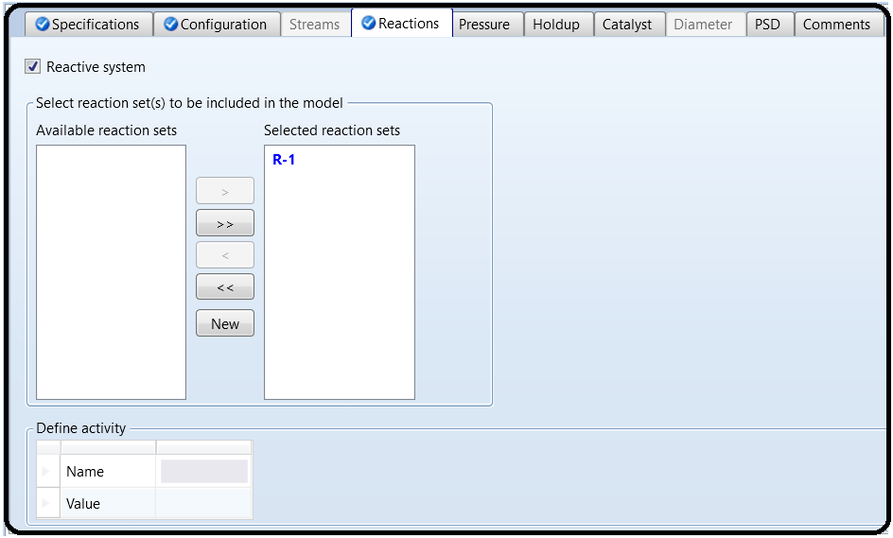Notice that in Figure 6.8 “PFR” block still lacks some information (*i.e.*, a half-filled red circle). Click on “Next” button and Aspen Plus will move to the “Setup” window of “PFR” block as shown in Figure 6.15.

8. Click on “**Next**” and “**OK**” buttons. When the simulation is complete, go to “**Blocks**” | “**PFR**” | “**Stream Results**”. Figure 6.16 shows the stream properties from and to “**PFR**” block.

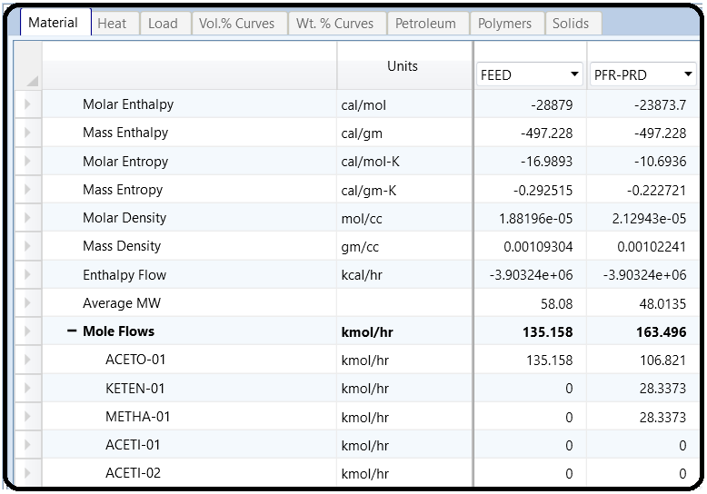Results

Check the conversion (*X*=moles reacted/moles fed). Does *X*=20%? If *X<*20%, you must increase the length of “**PFR**”. If *X>*20%, you must decrease the length of “**PFR**”. For our case, it is found that *X*=(27.89)/135.16=0.206 (20.6%). Luckily, the tube length is satisfactory.

On the other hand, if we look at the outlet composition of the reactor product stream (**PFR-PRD**), we will find that it contains an excessive amount of acetone, which means that we need to separate acetone from the products ketene and methane prior to sending ketene to the second reactor that will be installed later. So, we have to add an absorption tower that will basically split acetone from ketene and methane. Figure 6.17 shows the addition of two pieces of equipment: the first is the gas compressor and the second is “**RadFrac**” type absorption tower (rectifier). The rectifier is basically the upper half of a distillation tower with a condenser and no reboiler.

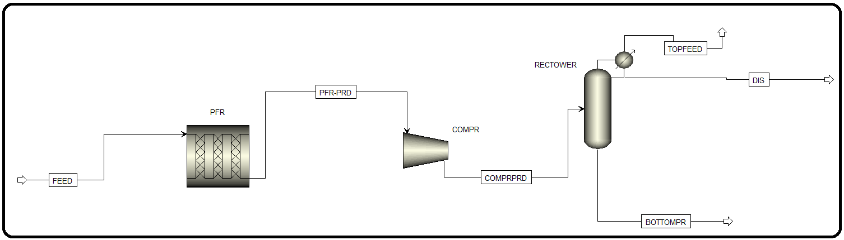

9. Figure 6.18 shows that the discharge pressure for the compressor is 3 bar and the convergence condition is such that we have vapor only while performing vapor–liquid (VL) check. Of course, an error will be issued if a two-phase system coexists within the compressor.

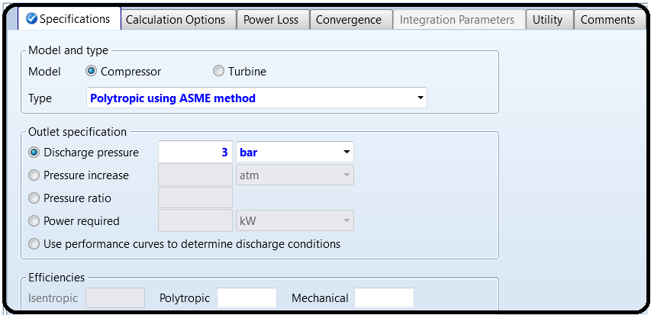

10. On the other hand, Figure 6.19 shows “**RECTIF**” | “**Specifications**” | “**Setup**” |“**Configuration**” tab window. The user must specify the number of stages, reboiler type (if any), condenser type, and one of “**Operating specifications**”, such as “*Bottoms rate*”. It is to be mentioned here that a bottoms mass flow rate of 6250 kg/h is a matter of trial-and-error approach because it affects the composition of both the top and bottom streams. Obviously, the value has to be somewhere between zero and that of the feed stream entering the tower.

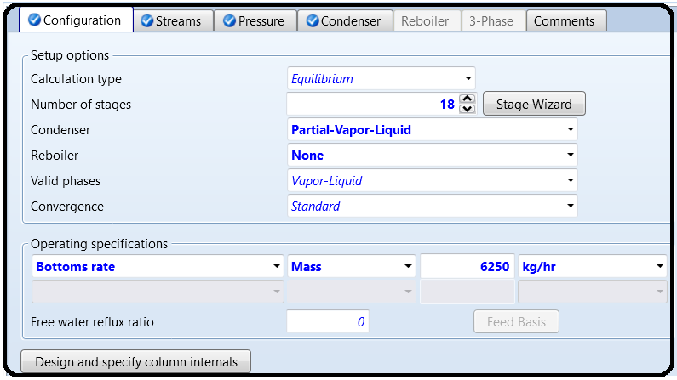

Click on “**Next**” button and Aspen Plus will move to the “**Streams**” tab window as shown in Figure 6.20. Here, the location of the feed stream (or feed tray) must be defined with respect to the top tray (#1). Notice that the location of the feed tray is way down at the bottom of the rectifier. This makes sense as we need not have a reboiler; the feed stream will be available as the vapor phase throughout the entire rectifying column.

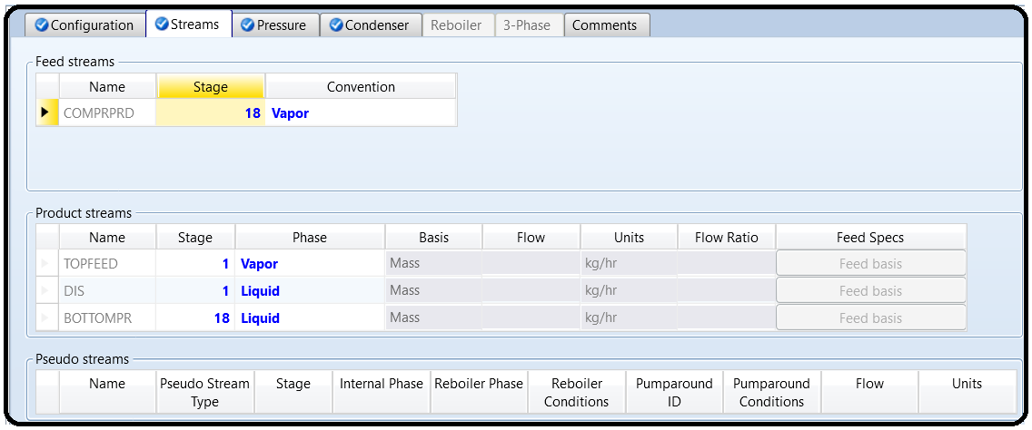

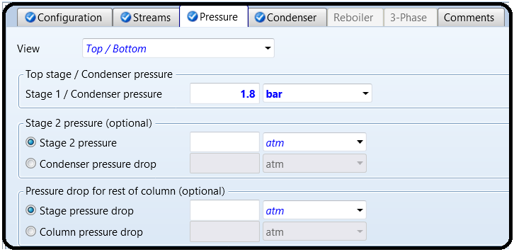Click on “**Next**” button and you will be prompted by “**Pressure**” tab window as shown in Figure 6.21. Here, the pressure at the top stage (condenser stage) must be defined. Enter *1.8 bar* for the condenser pressure.

Click on “**Next**” button and you will be prompted by “**Condenser**” tab window as shown in Figure 6.22. Here, the temperature of the condenser must be defined. Alternatively, the distillate vapor fraction can be defined. Enter −*130*∘*C* for the condenser temperature.

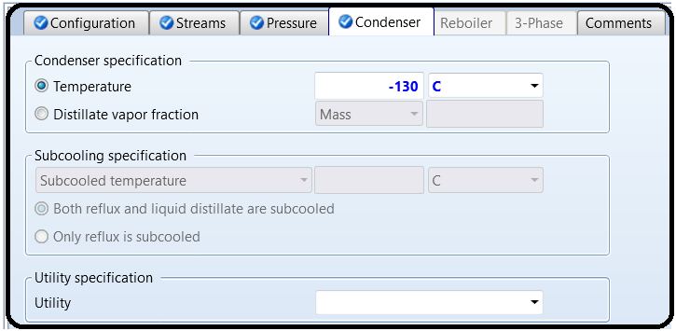

11. Click on “Reset” followed by “Next” and by “OK” button to allow Aspen Plus to do the calculations on your behalf. Figure 6.23 shows a portion of the results, which pertains to the absorption column. As you can see that the bottom (RECT-BTM) stream is 99.7wt% acetone and the top (RECT-TOP) stream is mainly composed of methane and ketene. The acetone stream will be recycled to the inlet of PFR. Moreover, the vapor portion of the top stream is 99.8wt% methane gas, which can be combined with another stream and be sent to a storage facility for methane. Here, we have a partial condenser (see Figure 6.19), which means not all of the rising vapor up the column will be condensed; a small portion will remain as is and the rest will be condensed and split into the top liquid (distillate) and returning (*i.e.*, reflux) stream.

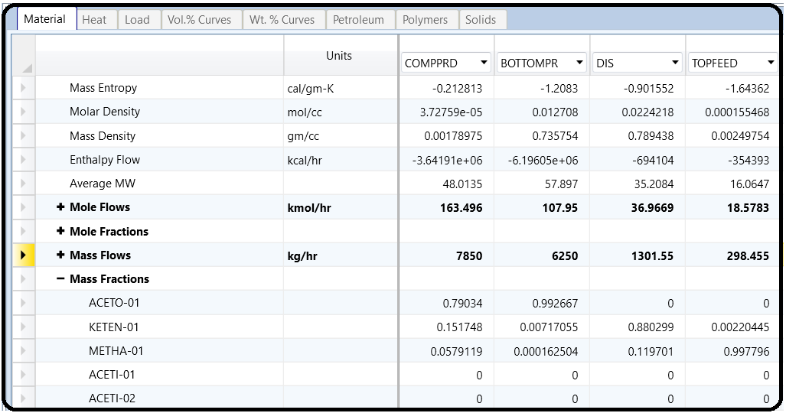

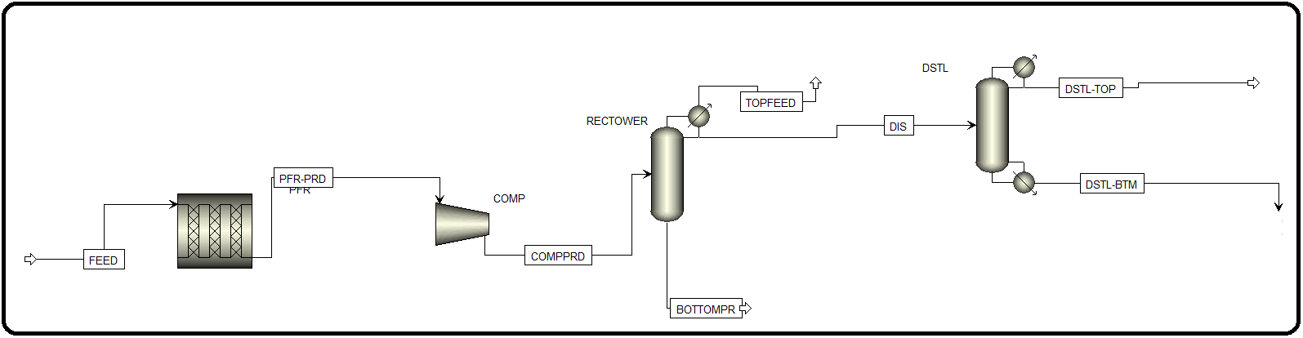12. As was done in the previous step, the top “**RECT-TOP**” stream will be sent to another “**RadFrac**” type distillation tower where methane will be separated from ketene, as shown in Figure 6.24.

Figures 6.25–6.27 show the specifications of the “**RadFrac**” type distillation column (**DSTL**).

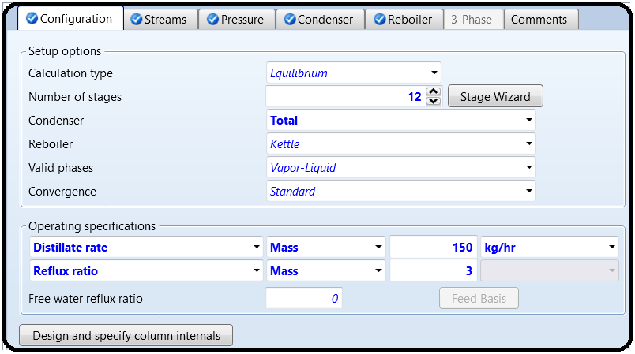

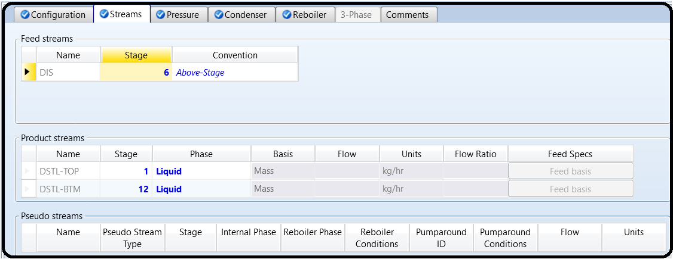

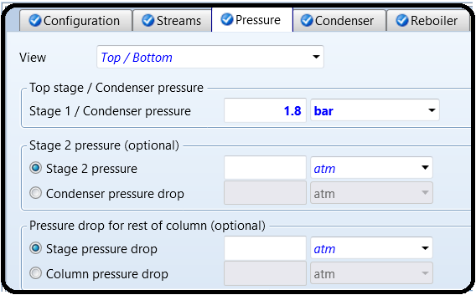

13.Reinitialize, click on “OK” button twice, click on (Next) button, and on “OK” button. See “Control Panel” if there is an error or serious warning regarding the process simulation. Figure 6.28 shows a portion of the results, which pertains to the recently added piece of equipment (*i.e.*, “DSTL”).

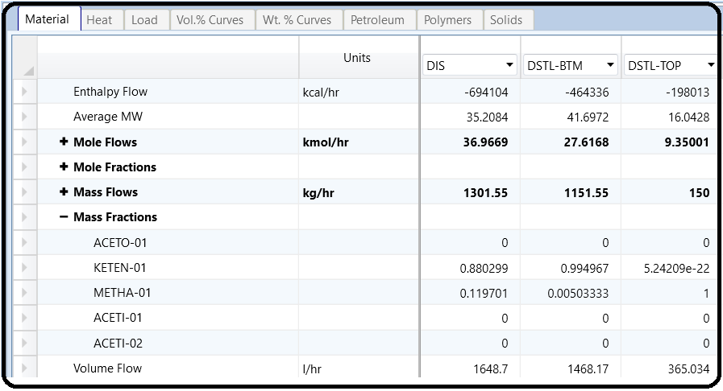

Of course, methane can be used either as a precursor for other chemical industries or as a fuel (*i.e.*, source of energy). On the other hand, ketene will be finally sent to the second reactor where it reacts with acetic acid to form acetic anhydride.

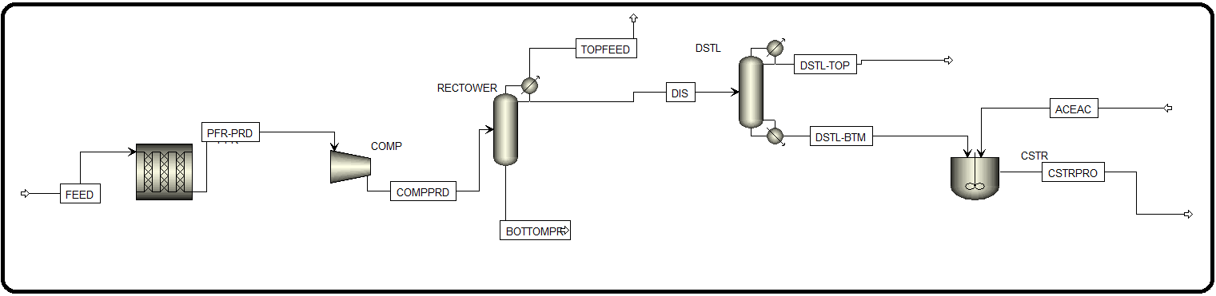14. Figure 6.29 shows that a rigorous CSTR (“**RCSTR**”) is added for carrying out the second reaction, that is, reaction of ketene with acetic acid to form acetic anhydride. In addition, acetic acid (“**ACETACID**”) stream is also added to the inlet of the new reactor.

Click on “NEXT” button and Aspen Plus will bring you to the input form of“ACETACID” stream. Here, the molar flow rate (kmol/h) of acetic acid will be equal to that of ketene present in “DST-BTM” stream. Figure 6.30 shows the “Mixed” tab input form of “ACETACID” stream.

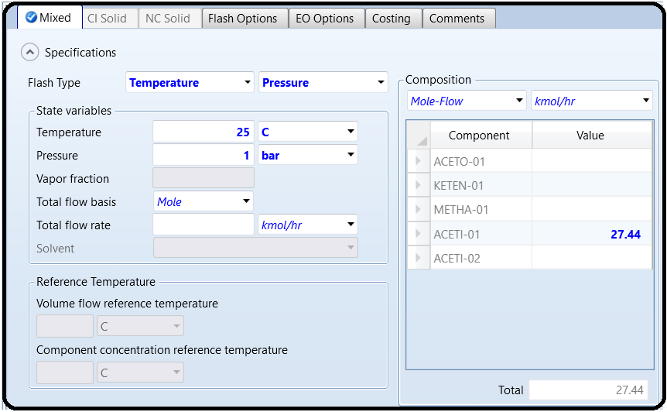

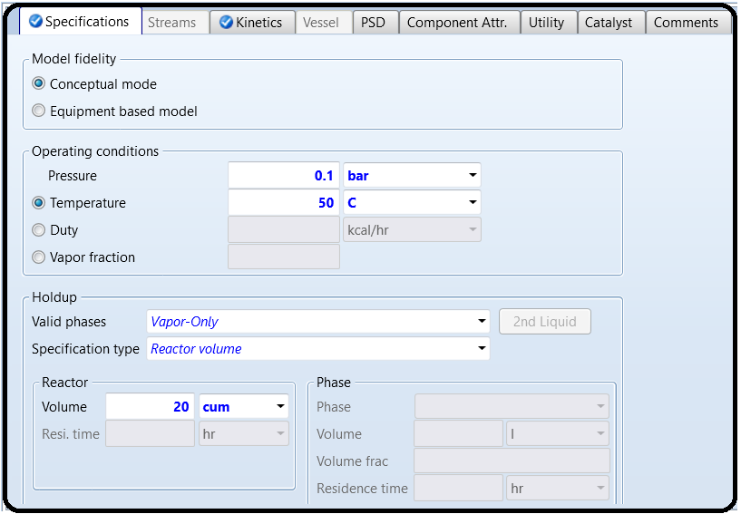Click on “Next” button and Aspen Plus will bring you to “RCSTR” | “Setup” window. Figure 6.31 shows that a temperature of 50∘C and a pressure of 0.1 bar were entered for the reactor condition. As a result of very low pressure, the reaction will be carried out in vapor phase (see Exercise 6.3). Twenty cubic meter is assumed as the reactor volume.

Now, it is time for defining the type of reaction in this reactor. Since we do not have the reaction kinetics (the rate constant, activation energy, and reaction order), then we will assume that the reaction attains equilibrium. If the reaction kinetic data is available, then the reaction type must be converted from equilibrium to kinetic so that reaction products will be better estimated.

For equilibrium reactions, ASPEN can predict or calculate equilibrium data. Let us go and define the reaction first, and then get back to “Reactions” tab under “RCSTR” | “Setup” window (shown as a half-filled red circle in Figure 6.31). Go to “Reactions” folder in “Navigation” pane so that we can define a new reaction that will account for the

conversion of acetic acid and ketene into acetic anhydride. The “Reactions” window has already “R-1” reaction set.

As we have dealt with the previous reaction “R-1” set, click on the “New…” button and you will be prompted by a window similar to that shown in Figure 6.32.

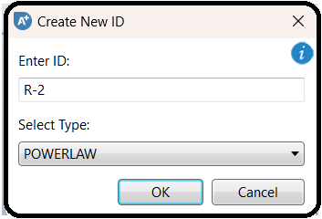

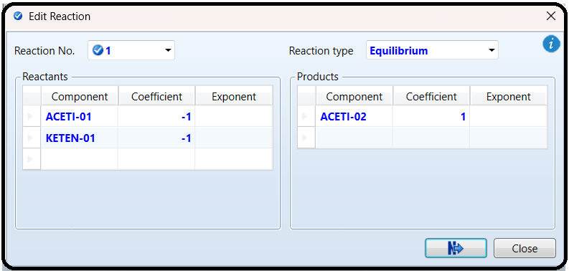Click on “**OK**” button shown in Figure 6.32 and Aspen Plus will revert to “**Stoichiometry**” tab window where we need to define the stoichiometry of the equilibrium reaction. Click on “**New**…” button at the bottom of the “**Stoichiometry**” tab window, the “**Edit Reaction**” window will pop-up as shown in Figure 6.33, where we enter the stoichiometry of each reacting species, whether it is reactant or product, and the reaction type.



Click on “N→” button at the bottom of the “Edit Reaction” window and Aspen Plus will bring you back to reaction R-2 window. Click on “Equilibrium” tab and its window will show up as in Figure 6.34. Select the reacting phase as vapor and select the first choice.

If *Keq*=*f(T)* is given, then you may go with the second option.

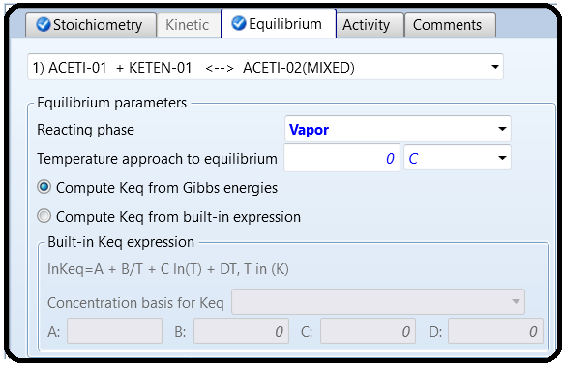

You will notice that everything is now defined for Aspen Plus except for “RCSTR” block where we need to associate “R-2” reaction set with “RCSTR” block. Click on “Next→” button and Aspen Plus will bring you to “RCSTR” block as shown in Figure 6.35. Highlight R-2 from the “Available reaction sets” and move it to the “Selected reaction sets” side.

After selecting “**R-2**” reaction set, the blue checkmark will replace the half-filled red circle.

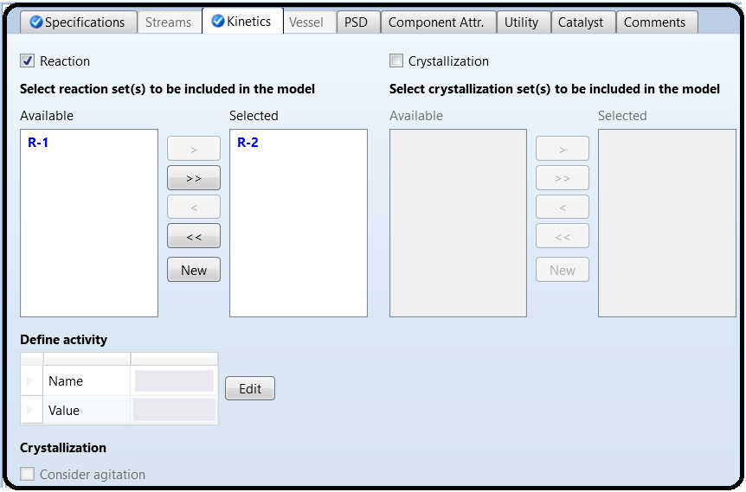

15. Aspen Plus is ready to start the simulation. Click on “Reset” followed by “Next→” button and Aspen Plus will start the process of simultaneously solving the set of steady-state total mass-balance, component mass-balance, and energy-balance equations around each block, augmented by all thermodynamic and equation of state relationships.

Check “Control Panel” to see if there is any error or serious warning.

Figures 6.36 and 6.37 show the simulation results pertaining to “RCSTR” block.

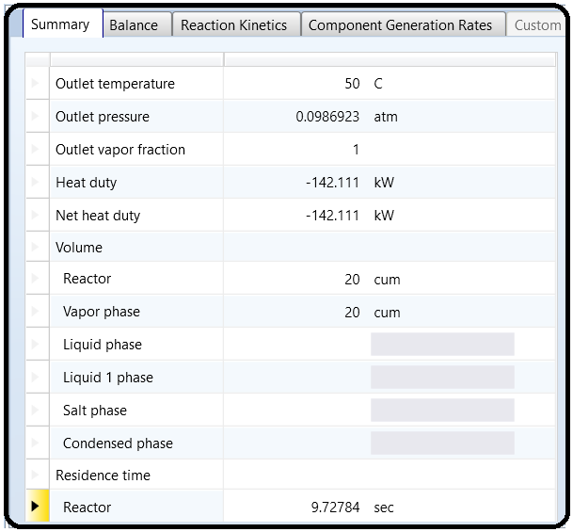

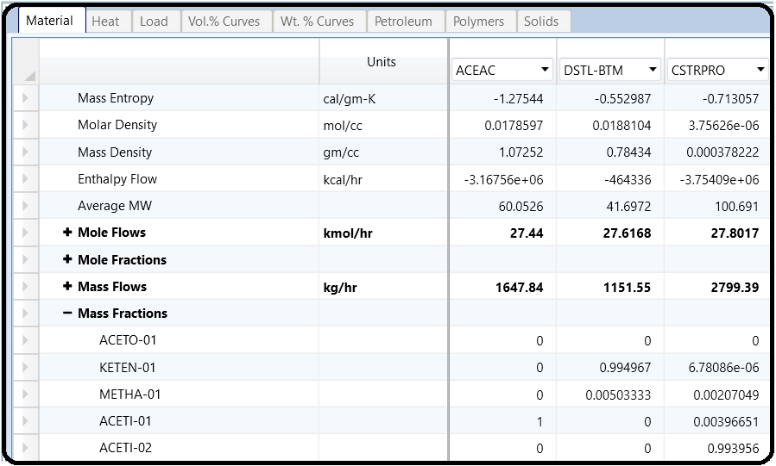

Finally, notice that the mass fraction of acetic anhydride in the product stream is 0.997 with trace amounts of other chemical species.

Part 2:

Problem Definition:

From Al-Malah

How to Simulate

1. Choose “ChemicalswithMetricUnits” template to create a steady-state flowsheet. The default property model will be “NRTL”. However, as mentioned in NOTE #2, “NRTL” will be replaced by “SRK”. Moreover, in “Methods” | “Specifications” | “Global” tab window set the “Free-water method” to “*STEAMNBS*”. Give a title for the project and add the five components: CO, CO2, H2, H2O, and CH3OH.Under “Properties” environment, go to “Methods” | “Parameters” | “Binary Interaction” | “SRKKIJ -1” sheet and ensure that the “*Estimate missing parameters by* *UNIFAC*” option is selected. Click on “Reset” followed by “Next” button to run the simulation and assure that properties analysis completed successfully. Switch to “Simulation” environment.

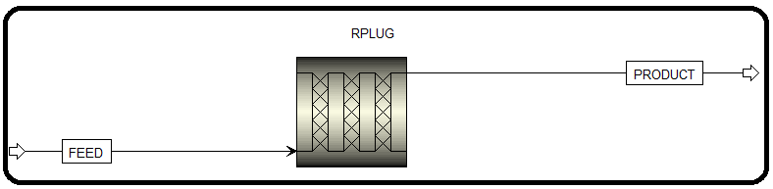2. In general, a multitubular non-adiabatic packed-bed reactor, with the heat transfer fluid flowing on the shell side, is used. Let us add one “**RPLUG**” block and hook one feed and one product stream to it, as shown in Figure 7.1.

3. Click on “**Next**→” button where you will be gliding at “**FEED**” stream specifications; enter the input parameters (in terms of *T*, *P*, flow rate, and composition) as shown in Figure 7.2. Such numbers were quoted from [3].

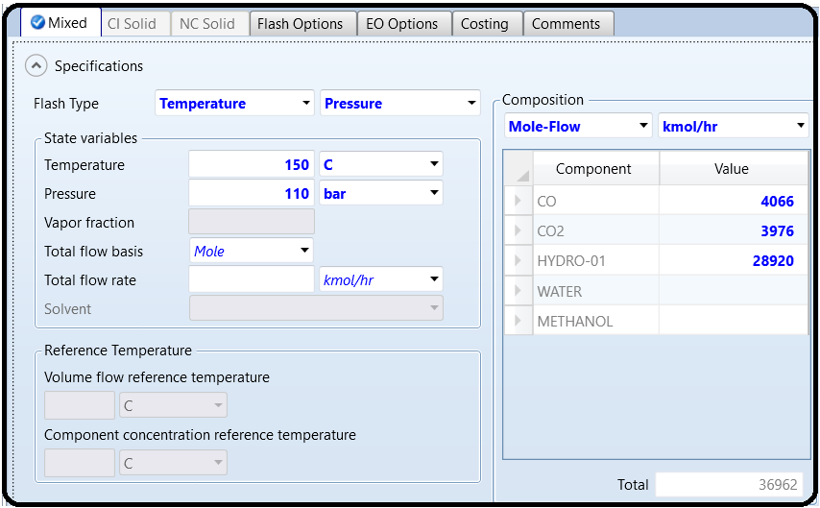

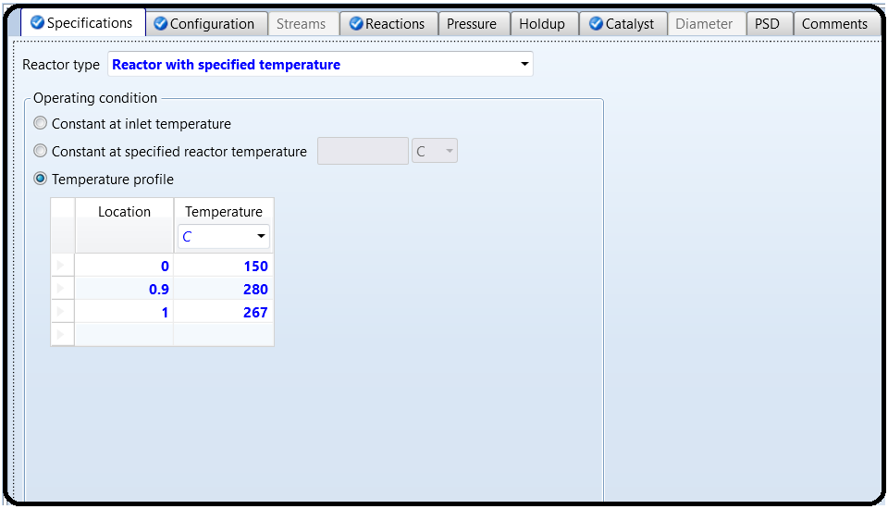4.Figure 7.3 shows **RPLUG** specifications in terms of *heat transfer mode and temperature profile.* Again, numbers were taken from [3]. However, it will be left as an exercise for theuser to try other numbers as well as other configurations of heat transfer and temperatureprofile.

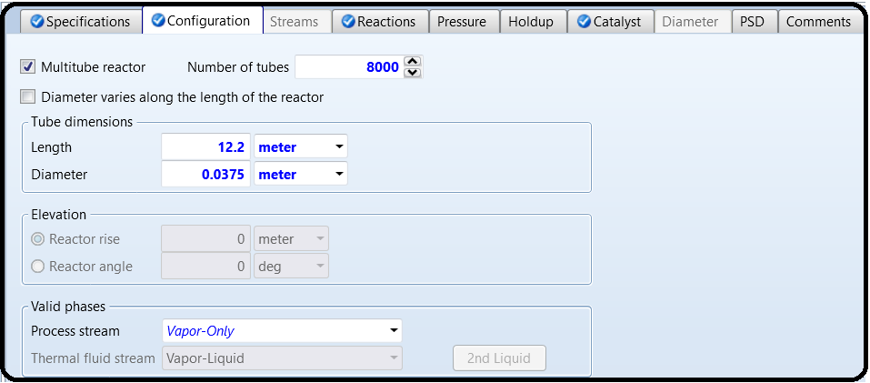Click on “**Next**→” button or directly go to “**Configuration**” tab so that we can enter reactor dimensions as shown in Figure 7.4.

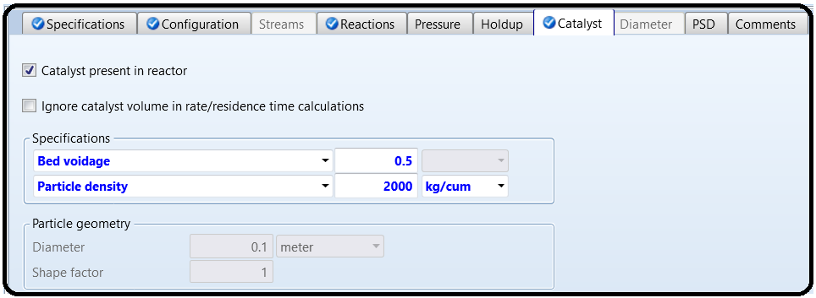The combination of number of tubes, the pipe diameter, and its length, will be merely judged by the ability of Aspen Plus to converge to a “reasonable” solution without having any simulation errors. Of course, we have to assume reasonable values for length and diameter. We have the choice to use a multitube reactor or a single-tube reactor but with a different pipe length and diameter for each case. Luyben [3] data were used for the sake of comparison; nevertheless, this does not prevent the user from trying other geometrical configurations, as well. We will leave the “**Reactions**” tab for a while and go to “**Catalyst**” tab window where we define the catalyst properties. Figure 7.5 shows the properties of catalyst in terms of its particle density and bed voidage. Alternatively, the catalyst loading could be entered instead of one of the aforementioned properties.

Notice that the “Reactions” tab (see Figure 7.5) is labeled by a half-filled red circle, indicating that we must associate a reaction set to the reactor. Both Equations 7.1 and 7.4 will be defined as “LHHW” type. Go to “Reactions” folder; click on “New…” button, and the “Create New ID” window will pop-up. Choose the default ID (R-1) and select “*LHHW*” for the reaction type. Click on “OK” button and Aspen Plus will bring you to “Stoichiometry” tab window. At the bottom of “Stoichiometry” tab window, click on “New…” button and

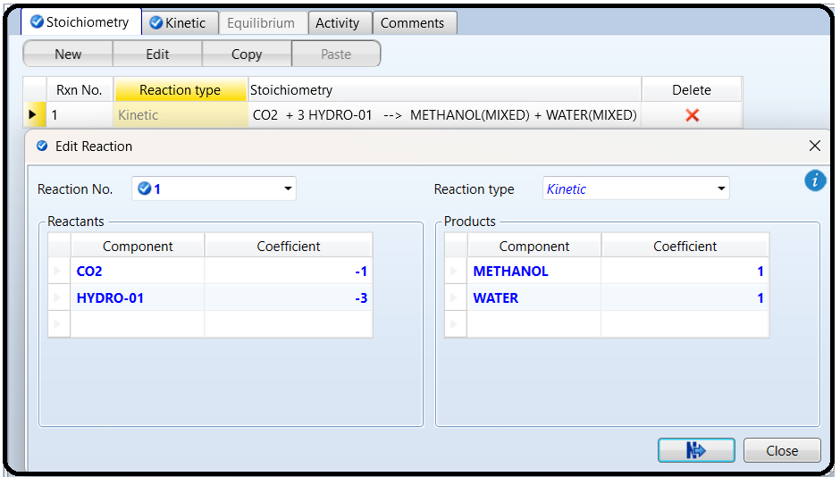the “Edit Reaction” window will show up where you need to plug in the stoichiometric data as shown in Figure 7.6. Unlike the case for a simple kinetic expression, used in Chapter 6, the exponents will be defined later in “Driving Force Expression” window. Click on “Close” or “Next” button at the bottom of the Edit Reaction window (Figure 7.6). Go to “Kinetic” tab window where you need to enter the kinetic data for the first reaction (Eq. 7.3b). Enter the data as shown in Figure 7.7. The kinetic factor will reduce to unity as we merge it into the driving force expression.

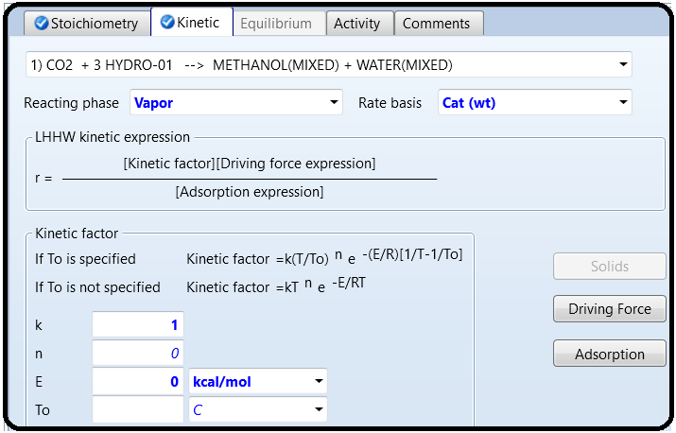

Based on Equation 7.3b form, the driving force expression is represented by the reversible case (Eq. 7.14), where *kf* = 1*.*07 × 10−13 × *e*(4413*.*76∕*T*) and *kb* = 4*.*182 × 107 × *e*(−(2645*.*966∕*T*)). Click on “**Driving Force**” button (shown in Figure 7.7) and the “**Driving Force Expression**” window will show up as shown in Figure 7.8. Enter [Ci] basis, which is the partial pressure of component in the gas-phase. From the drop-down list, select “*Term1*” first and fill the concentration exponent for each component involved in the forward direction and leave the exponent for others empty or make it zero.

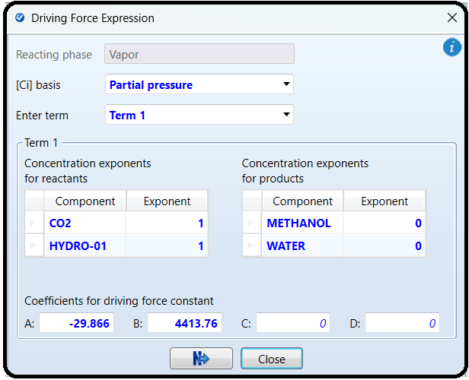

For **“Term 1”: *A*** + ***B T*** = ln (1*.*07 × 10−13 × *e*(4413*.*76∕*T*)) ⇒ ***A*** = −29*.*866; ***B*** = 4413*.*76.While the “**Driving Force Expression**” windowis still active, select “*Term 2*”, instead of“*Term1*”, and fill the concentration exponent for each component involved in the backwarddirection. For CO2, you may enter zero for the exponent or leave it empty.

For “**Term 2**”**:** *A* + *BT* = ln(4*.*182 × 107 × *e*(−2645*.*966*T*))⇒ ***A*** = 17*.*5489;***B*** = −2645*.*97.

Figure 7.9 shows the “**Driving Force Expression**” window for “**Term 2**”.Click on “**Adsorption**” button (see Figure 7.7) and the “**Adsorption Expression**” window will show up as shown in Figure 7.10. The bracketed term in the denominator of Equation 7.3b is raised to power 3; hence, the “**Adsorption expression exponent**” is set to *3.* Table 7.1 will reduce to Table 7.2 (see below), simply because the denominator of Equation 7.3b, which represents the adsorption term, can be put in a form similar to that of Adsorption ={1 + *Kw*[*W*] + *KX*[*X*] + *KY* [*Y*] + *Kz*[*Z*]}*n*7.19:

{1(H2)0(H2O)0 + *K*H2O∕H2 (H2)−1(H2O)1 + *K*H2 (H2)0*.*5(H2O)0 + *K*H2O[H2]0[H2O]1 }3

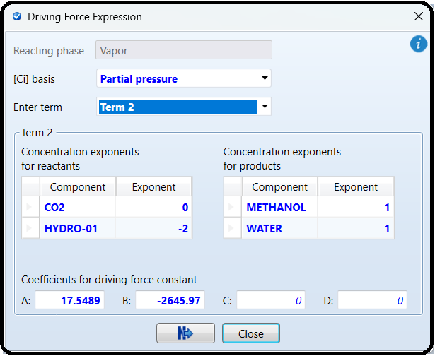

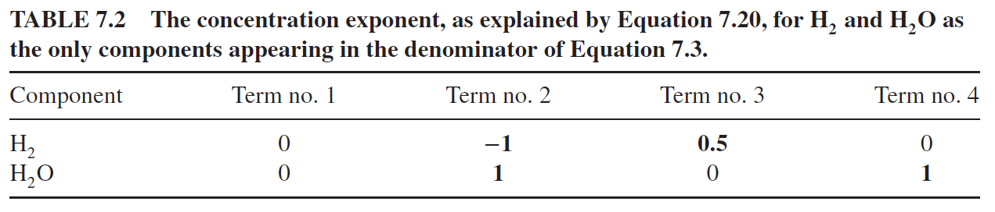

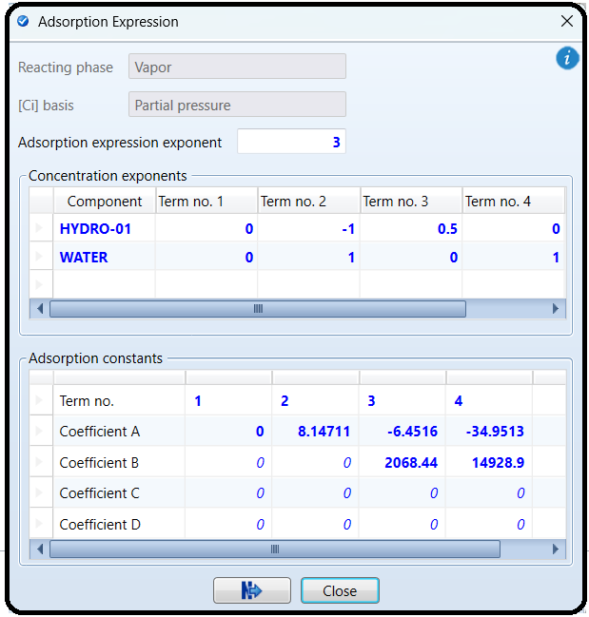

This explains why the exponent is 0 for both components in “**Term no. 1**”; −1 for H2 and 1 for H2O in “**Term no. 2**”; 0.5 for H2 and 0 for H2O in “**Term no. 3**”; and finally 0 for H2 and 1 for H2O in “**Term no. 4**”.

For **“Term no. 1”**: *A*=ln(1)=0; *B*=*C*=*D*=0.

For **“Term no. 2”**: *A*=ln*(3453.38)*=*8.1471087*; *B*=*C*=*D*=0.

For **“Term no. 3”**: *A* + *BT* = ln(1*.*578 × 10−3 × *e*(2068*.*44∕*T*)) = −6*.*4516 + 2068*.*44*T* → *A*=−*6.4516; B*=*2068.44; C*=*D*=*0.*

For **“Term no. 4”**: *A* + *BT* = ln(6*.*62 × 10−16 × *e*(14 928*.*915∕*T*)) = −34*.*9513 + 14 928*.*915

*T*→*A*=−*34.9513; B*=*14,928.915; C*=*D*=*0.*

Let us define the second reaction (Eq. 7.4) also as “**LHHW**” type. Go to “**Reactions**” folder; click on “**New**…” button, and the “**Create New ID**” window will pop-up.

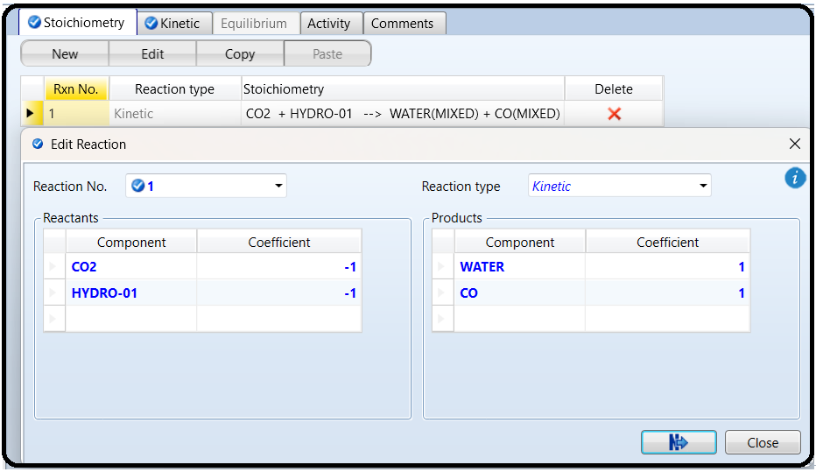Choose the default ID (**R-2**) and select “*LHHW*” for the reaction type. Click on “**OK**” button and Aspen Plus will bring you to “**Stoichiometry**” tab window. At the bottom of “**Stoichiometry**” tab window, click on “**New**…” button and the “**Edit Reaction**” window will show up where you need to plug in the stoichiometric data (coefficients only) as shown in Figure 7.11. The exponents will be defined later in “**Driving Force Expression**” window.

Click on “Close” or “Next” button at the bottom of the “Edit Reaction” window. Go to “Kinetic” tab window where you need to enter the kinetic data for the second reaction (Eq. 7.4). Enter the data as shown in Figure 7.12. Again, the kinetic factor will reduce to unity as we merge it into the driving force expression.

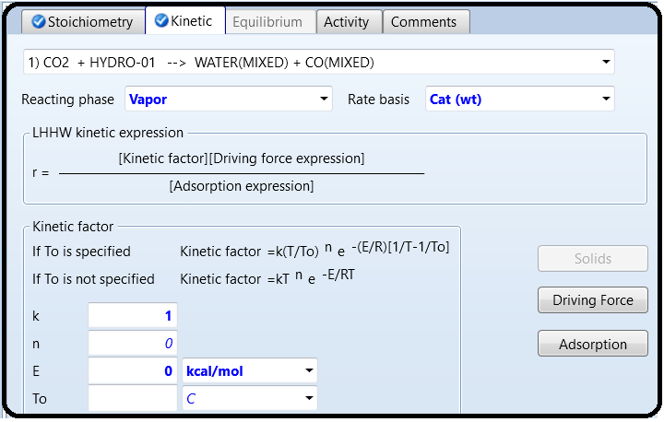

Based on Equation 7.6b form, the driving force expression is represented by a reversible case (Eq. 7.14), where *kf* = 122 × *e*(−11*,*398*.*24∕*T*) and *kb* = 1*.*1412 × *e*(−6624*.*98∕*T*). Click on “**Driving Force**” button (shown in Figure 7.12) and the “**Driving Force Expression**” window will show up as shown in Figure 7.13. Enter [Ci] basis, which is the partial pressure of component in the given gas phase. Select “**Term1**” first and fill the concentration exponent for each component involved in the forward direction and leave the exponent for others empty or make it zero. For **“Term 1”:** *A* + *BT* = ln(122 × *e*(−(11*,*398*.*24∕*T*))) ⇒ ***A*** = 4*.*804;***B*** = −11*,* 398*.*24.

While the “**Driving Force Expression**” window is still active, select “**Term 2**”, instead of “**Term1**”, and fill the concentration exponent for each component involved in the backward

direction. For CO2, you may enter zero for the exponent or leave it empty. For **“Term 2”:** *A* + *B*

*T* = ln(1*.*1412 × *e*(−6624*.*98∕*T*)) = 0*.*13208 + −6624*.*98*T*

. This implies that **A**=0*.*13208 and ***B*** = −6624*.*98.

Figure 7.14 shows the “**Driving Force Expression**” window for “**Term 2**”.

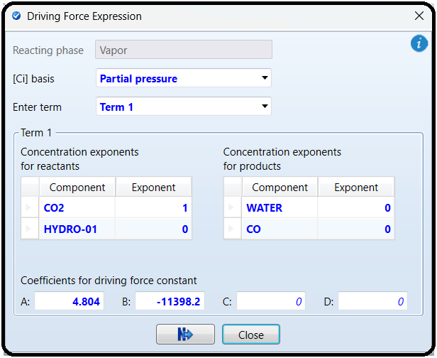

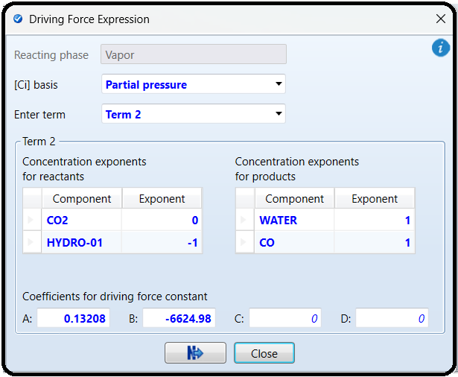

Click on “**Adsorption**” button (see Figure 7.12) and the “**Adsorption Expression**” window will show up as shown in Figure 7.15. The bracketed term in the denominator of Equation 7.6b is raised to power 1; hence, the “**Adsorption expression exponent**” is equal to *1*. Notice that other entries for the “**Adsorption Expression**” window are exactly the same as those shown in Figure 7.10, for the first reactor. This is simply because, the bracketed term appearing in the denominator of Equation 7.3b is identically the same as that in the denominator of Equation 7.6b.

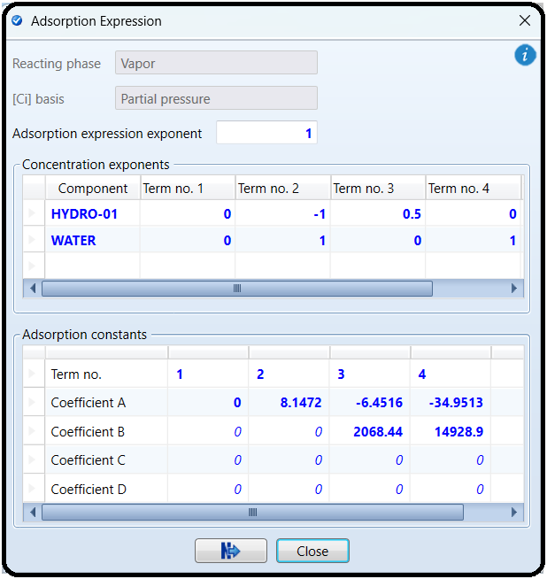

After defining both reactions, associate them to “**RPLUG**” block under “**Reactions**” tab. The simulator is now ready via noticing that life is blue like the sky and ocean and no red (hell) signs are present. Click on “**Reset**” followed by “**Next**” button to run the show and watch for any simulation error/warning. Figure 7.16 shows summary results for “**RPLUG**” block where it shows a relatively very large heat duty, indicating the presence of highly exothermic reactions. To verify which direction is exothermic for a given reversible

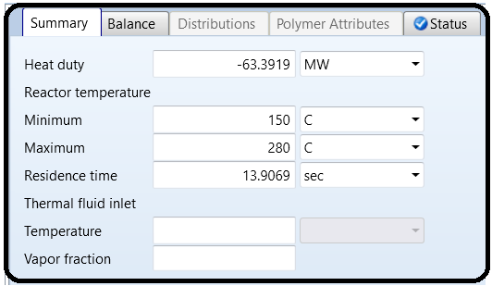

reaction, select one reaction at a time in the reactor unit, reinitialize, and rerun the show. Performing such a procedure will reveal to us that the first reaction is exothermic in the forward reaction (i.e., formation of methanol), whereas the second reaction is exothermic in the backward direction (i.e., consumption of CO and H2O). The molar flow rate of each component in the feed and in the product stream, as shown in Figure 7.17, will tell us that the first reaction went in the forward direction (i.e., in favor of methanol formation) and the second reaction in the backward direction (i.e., in favor of CO consumption); hence, it explains why CO flow rate in the product stream is less than that in the feed stream.

Figure 7.17 shows stream results summary for the reactor inlet and outlet streams, where methanol is present in the product stream. For the sake of comparison, Luyben’s data [3] for the product stream were 1468, 21,673, and 3292 kmol/h for CO, H2, and CO2, respectively. The data here are 1234, 20,716, and 3129 kmol/h for CO, H2, and CO2, respectively.

The difference in results in my judgment is due to: first, the kinetic model being used; for example, the adsorption term in our case is made of four terms but in Luyben’s case the first two terms were only incorporated (see table 11.1 on page 190 [3]); second, the thermodynamic property method used in simulation; and third, the version of Aspen Plus itself.

A useful source of information about a plug-flow reactor performance is provided by Aspen Plus via what is called the reactor profile. Go to “**Blocks**” | “**RPLUG**” | “**Profiles**” and select “**Process Stream**” tab window, if it is not already selected by Aspen Plus, where it shows properties, such as pressure, temperature, residence time, molar vapor fraction, and molar composition as function of either reactor length or residence time. Figure 7.18 shows such reacting medium properties as a function of both reactor length and residence time. You can at this stage (“**Process Stream**” tab window is active),make use of the “**Plot**” group, found in “**Home**” ribbon, and choose any combination of *x* and *y* variables to generate *y*=*f(x)* or generate a parametric plot where you show *y*=*f(x)* evaluated at different z

values, where z is the parametric variable. You may wish to see the molar composition for each component as a function of the reactor length via selecting “*Molar composition*” option from the drop-down list of the “**View**” item shown in Figure 7.18. Figure 7.19 shows the molar composition profile in the axial direction. Again, you may wish to generate a profile plot making use of “**Plot**” group found in “**Home**” ribbon, while the “**Process Stream**” tab window is active.

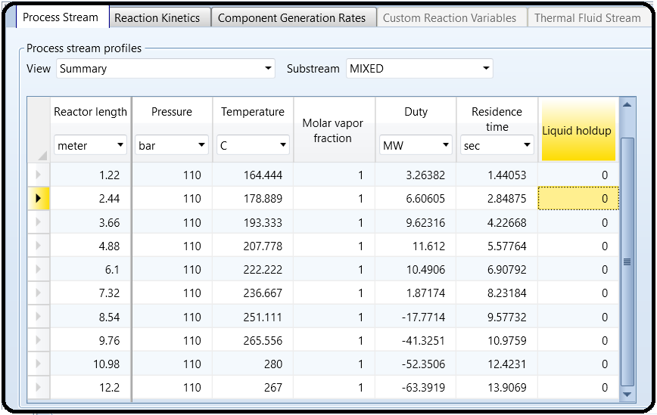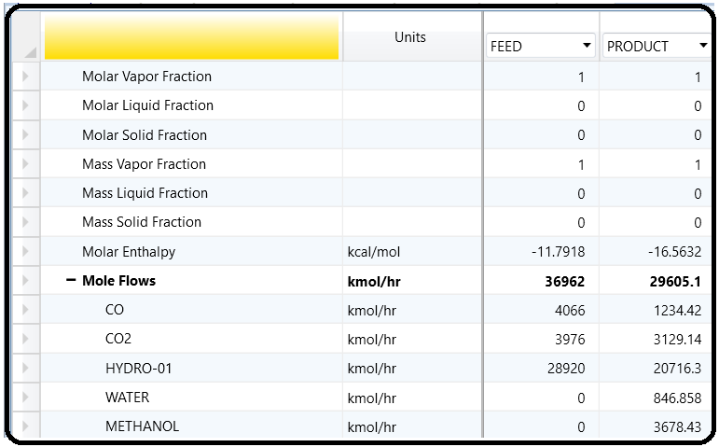

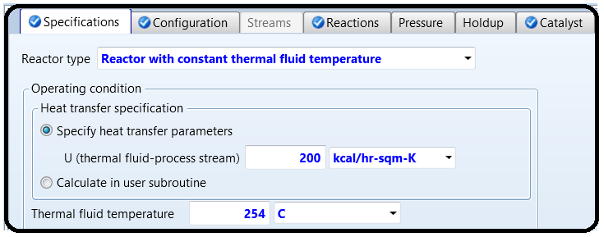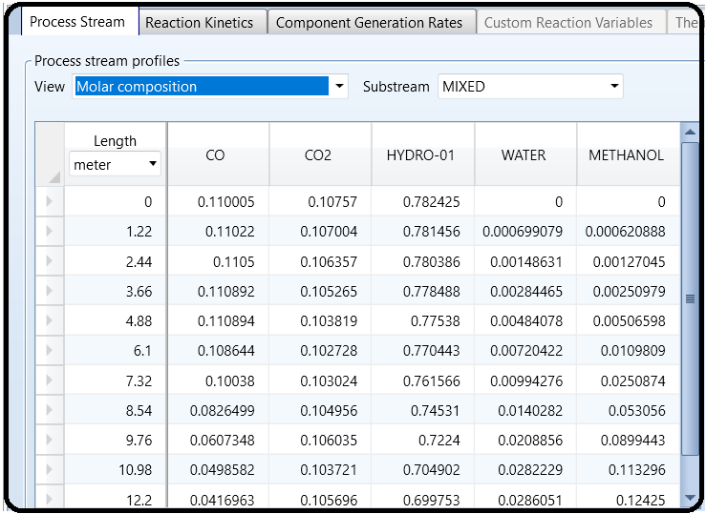It is worth mentioning that instead of using Reactor with specified temperature option as shown in Figure 7.3, one may also attempt to use “Reactor with constant thermal fluid temperature” option with a specified overall heat transfer coefficient between the tube and shell sides of the reactor (also as a heat exchanger), as shown in Figure 7.20 and obtain another convergent solution (i.e., no simulation error/warning).

SENSITIVITY ANALYSIS: EFFECT OF TEMPERATURE AND PRESSURE ON SELECTIVITY

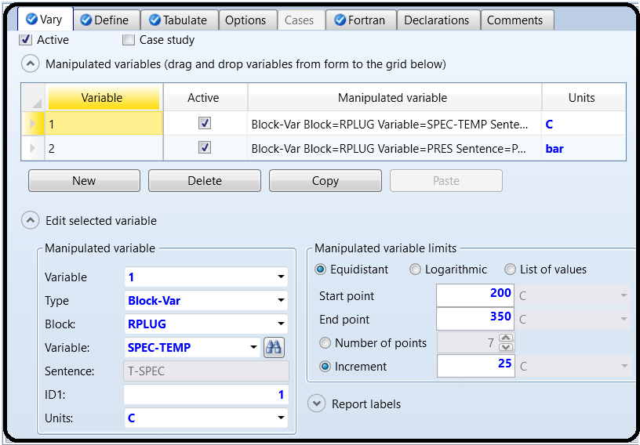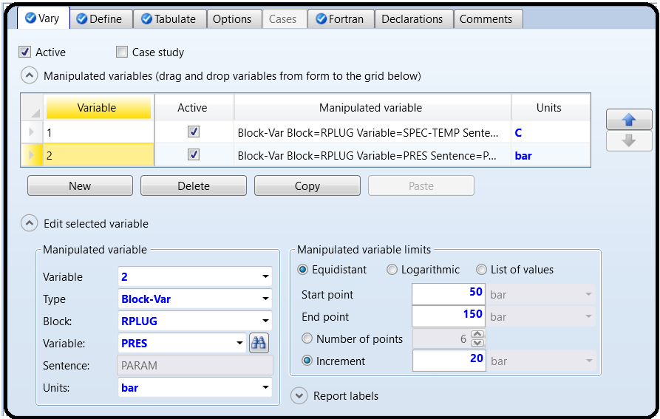Create “S-1” set under “Model Analysis Tools” | “Sensitivity” subfolder. Figure 7.21 shows the first manipulated variable, that is, the specified temperature of the reactor at which the gas-phase reaction takes place.

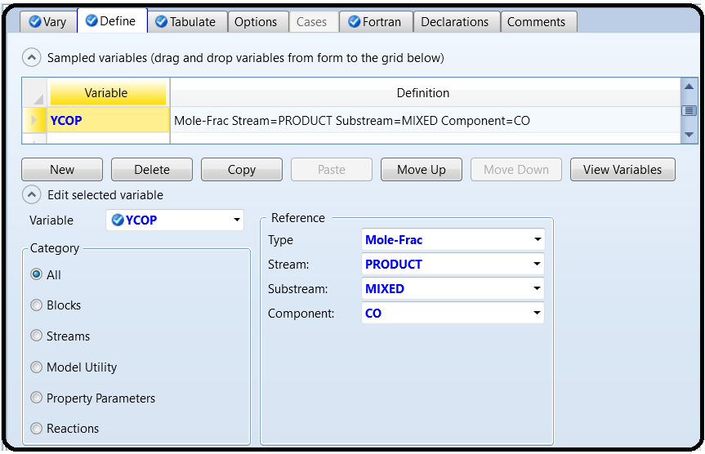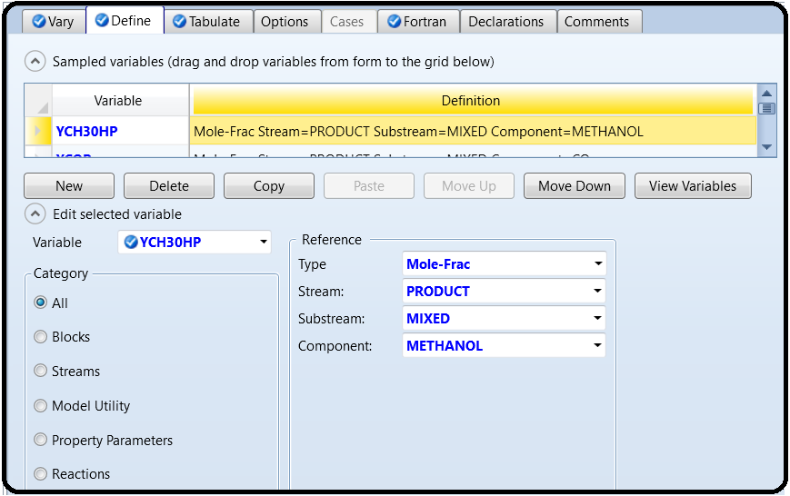We will define the mole fraction of CH3OH and CO in the product stream. Figure 7.23 shows the definition of two variables: “**YCH3OHP**” the mole fraction of methanol and “**YCOP**” the mole fraction of CO in the product stream.

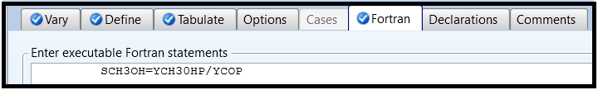In “**Fortran**” tab window, we define the selectivity of methanol, “**SCH3OH**”, as the mole fraction ratio of CH3OH to CO, as shown in Figure 7.24.

Reinitialize and run the show. Go to “**Model Analysis Tools**” **|** “**Sensitivity**” **|** “**S-1**” **|**“**Results**” | “**Summary**” tab window, then from **Plot** group found in “**Home**” ribbon, clickon “**Results Curve**” button and “**Results Curve**” window will pop-up. Select *X*, *Y*, and theparametric variable, click on “**OK**” button at the bottom of the given window, and a plotwill be generated as shown in Figure 7.26. For the given feed composition, it is found that

the maximum value of methanol selectivity occurs at *T*=*250*∘*C* and *P*=*150 bar*.

Part3

SPECIFICATION WITH RYIELD

In the previous parts, you worked with kinetics-based models, which are pretty advanced. In order to use those models, you needed lots of information, such as rate law kinetics and size. In this part, you will briefly work with two models that are very simple and do not require kinetic information or sizing information at all. In this section, we will work with the reaction of lactic acid with ethanol to form ethyl lactate and water, as shown in Figure 7.8.

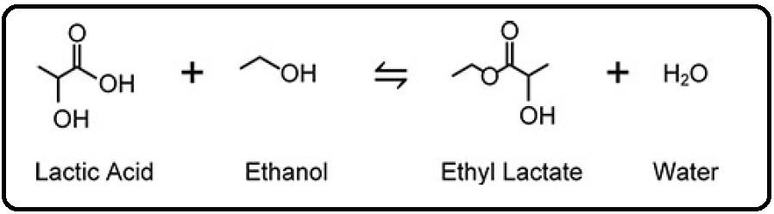

The RYield reactor model is incredibly simple. In fact, you literally tell it what the products of the reaction are, and it obliges by assigning the products to the output, even if your numbers do not

make any sense. Let’s do an example. Suppose we have 100 kmol/hr of lactic acid reacting with 100 kmol/hr of ethanol at 200°C and 1 atm. Suppose we desire that there will be 80% conversion of ethyl lactate in this reactor.11 All we have to do in RYield is enter the flash conditions of the reactor (let’s say it is adiabatic with nopressure drop to keep it simple), and then in the Yield tab, specify the component yield, which is what you want to come out of the

reactor. The tricky part is that the way you define the yield is a little strange. Instead of defining the absolute yield (as in the moles or mass of each chemical of output), you define the yield basis. For example, the mole basis yield of a chemical is the number of moles of that chemical that leave in the outlet per total *mass* of the feed.Similarly, the mass basis yield is the mass of the chemical found in the outlet per total mass of feed. You can choose which basis you would like to use for each chemical based on whichever is more convenient for you (I almost always prefer to work in moles whenever possible). Let’s do a simple example. For the ethyl lactate example, if I know that I have exactly 100 kmol/hr of each reagent, and I know the stoichiometry of the feed, then I can basically calculate what the outputs will be on paper if there is 80% conversion of ethyl lactate. Very simply, this means that 80 kmol/hr of both lactic acid and ethanol will be reacted away. We know from mass balances that there should be 80 kmol/hr of water and ethyl lactate each leaving the reactor, together with 20 kmol/hr of the two reagents each. So, now we want to use RYield to make this happen. Set up a simulation with the given feed conditions using UNIQ-RK. We need to figure out the mole basis yield to type into RYield. We can do this in many different ways. One way is to use the molecular weights of the chemicals to figure out the total mass of the feed, and then since we know the individual component molar flow rates we want from the outlet, simply divide those outlet flow rates by that total mass flow rate. For example, you can find the molecular weights in the Properties tab by clicking the Retrieve Parameters button in the Home ribbon and looking at the MW row of the results. Or, you can be lazy about it and just type random garbage into the RYield model and run the simulation. Then look at the results for your feed stream to find the total mass.

Either way, I computed a basis yield of 0.00146899 kmol/kg for lactic acid. Type that into your RYield model as a mole basis yield.

Note that there is no indication of units, but it uses the default units for mole and mass in your selected units set, which for MET and SI are kmol and kg and for ENG are lbmol and lb. In all of these sets, you still get the same number either way. So now, type in the remaining numbers into the RYield and run.

One very important thing to remember is that RYield will only satisfy total mass balances. It does not actually satisfy the mass balance of each individual chemical, and as such it does not satisfy the first law of thermodynamics. This is because, by design, Ryield will do its best to do exactly what you tell it to, regardless of how bad your instructions are. So go back and do something really dumb and change one of the numbers for your yield, maybe even setting one of them to zero. Now you know that it is impossible, but run it and watch what happens.

First, you get a warning. A quick check of the warning in the control panel shows the following (noting yours may be a little different):

……………………………………………………………………………………………………………….

* WARNING

SPECIFIED YIELDS HAVE BEEN NORMALIZED BY A

FACTOR OF (0.867676)

TO MAINTAIN AN OVERALL MATERIAL BALANCE.

* WARNING

THE FOLLOWING ELEMENTS ARE NOT IN ATOM BALANCE:

C H O

……………………………………………………………………………………………………………….

Basically, RYield is doing two things. First, it is telling you that, hey, the molar basis that you entered doesn’t make sense because if you calculate the outputs based on what you typed in, you get a mass yield that is less than the total input mass. So, the warning is telling you that it went ahead and scaled the molar bases that you gave down (or up in my case by dividing them all by 0.87 or so) such that the total outlet mass flow rate is still equal to the inlet mass flow

rate (go ahead and check).

The second warning is telling you, hey, the basis yields that you gave cause the atoms themselves to be imbalanced. For example, in my case, I would have more or less carbon, nitrogen, and oxygen atoms (which, in fact, are the only kinds of atoms I have in this

simulation) in the outputs than the inputs (even with the scale up). Remember, you did not actually type any stoichiometry or define a reaction, so Aspen is trying to tell you that, well, you probably made a mistake because what you typed in is physically impossible. In practice, you may get this error even when you’ve essentially done everything correctly, because of issues related to significant figures, differences in molecular weight values that occur in the 6th digit, etc., so this message can be hard to put a lid on.

So why would you use RYield at all? It may seem really strange at first because you are basically forced to do all of the calculations and logic by hand and type it in, so the only information you are really getting out of the simulation is the heat duty calculation to compute its relationship with temperature. One thing to note is you can create a Calculator block to automatically overwrite the basis yield parameters for you based on the inputs (see Tutorial 9). That way, the block can be used in a situation in which the composition of the feed might vary from run to run (such as when inside a convergence

loop). But even that seems like a lot of work. Instead, there are two very convenient uses for this block. The first is when you have experimental data for a reaction that may be very complex. Consider if you have a reaction with many possible chemical outputs, which might be common especially for biological reactions. In many cases, you may be able to measure the contents of the reaction broth but have almost no idea what the reaction pathway was that obtained it. And, because experimental data is noisy and contains measurement error, it is unlikely that the atom balance holds exactly. Therefore, it is very convenient just to type in your reaction yield in a moles per kg of reaction product basis and just put that directly into RYield. Sure, you might get an atom balance warning, but as long as you are cognizant of what you are doing, you can keep this error in mind when analyzing the results of your simulation. By the way, you can turn up the control panel diagnostics by going to the Block Options | Diagnostics tab for the RYield block and cranking the On-Screen message level up to 5.12 Then you can see the details of the mole balance to see how far off it is.

The second convenient use is when you are connecting this model to a much more complex reactor model. Suppose you have made your own special reactor model, say, in a Calculator block (see Tutorial 9), or in an external Microsoft Excel flowsheet (which you will also learn in Tutorial 9). You can use an RYield in which the complex model computes the basis yields and simply overrides that information in the RYield block. In that way, the RYield acts as a stand-in for the more complex, external model.

Part 5

SPECIFICATION WITH Rstoic

The RStoic model is similar to RYield in that you simply specify the reaction conversion, except with this block you are required to provide the reaction stoichiometry. Go ahead and make an Rstoic block and feed the same lactic acid and ethanol mixture into it as in Part 4. Keep the feed and flash conditions the same (adiabatic and no pressure drop). In the Reactions tab, you have to specify the reaction, namely one mole of lactic acid and one mole of ethanol react to form one mole of ethyl lactate and one mole of water. You can do this by clicking on NEW in the Reactions tab and then entering the corresponding information for reactions and products.

The coefficient of a component is the number of moles you need of that chemical in the stoichiometry equation, and a negative sign means it is a reagent instead of a product. Go ahead and enter this information. You then have to specify the products being generated. In this case, you can choose either a fractional conversion (a number between 0 and 1) or the molar extent of the reaction (which is the number of moles reacted divided by its stoichiometric coefficient). Again, simulate an 80% conversion.

The convenience over RYield in this situation is obvious since you have to do less math personally, and mole balances are always held. Moreover, as long as you are using fractional conversion instead of extent of conversion, you will never have a problem with limiting reagents. Try it with 80% fractional conversion, and change one of your feed chemicals to have only 10 kmol/hr and leave the other at 100 kmol/hr and run it.

Finally, it is useful to note that Aspen Plus is assuming that it is actually physically possible to obtain the reaction conversion you typed in. For example, this is actually a reversible reaction, and so it is limited by equilibrium. Is it even possible to achieve 80% conversion at this temperature, or did you just violate the second law of thermodynamics? Again, Aspen Plus will dutifully do the math with what you have given it, so remember, garbage-in, garbage-out!

Part 6

EQUILIBRIUM REACTIONS WITH Requil AND Rgibbs

The REquil block is used to model a reversible reaction system assuming that it achieves (or nearly achieves) chemical and phase equilibrium. The way it works is that the user enters the

stoichiometric reaction equations, and using this, Aspen Plus will compute the equilibrium constants directly from the Gibbs free energy of reaction at the temperature of the reaction conditions. Using the equilibrium coefficient combined with mass balances, energy balances, and a flash calculation, Aspen Plus can then calculate the outputs of the reaction. The mathematical details are best left for another day. Let’s try and see how the ethyl lactate system example works. Again, use the same 200 kmol/hr feed (containing 100 kmol/hr each of the two reagents) at 200°C and 1 atm; feed it to an REquil block where the flash conditions are again adiabatic and zero pressure drop. In the Reactions tab, define the reaction in much the same way as in RStoic. Note here that you can define an extent of reaction just like in RStoic, but you can also type an approach temperature instead. For now, leave the definition as having an approach temperature of zero. Now one quick catch: REquil requires you to have separate liquid and vapor outlet ports, so you need two outlet streams in this case. Note that the liquid stream should be completely empty because everything should be in the vapor phase in this system. This may seem strange, but it is just a model. As long as you know that an empty stream would never really be there, then there is no problem. The extent of conversion should actually be a lot lower than 80%. What does this mean? It means that my results of the RYield and RStoic examples above are basically complete garbage for the equimolar feed examples, and you never really knew that until now. Sure, Aspen Plus dutifully computed numbers for me, but now I know that the 80% conversion is thermodynamically impossible. Equilibrium is the absolute most I can ever achieve under these circumstances! So, this is an important lesson in the principles of garbage-in, garbage-out! Aspen Plus is not magic; it will only do what you tell it to (at best). Even worse, the conversion computed here is the absolute best conversion that is thermodynamically possible, which can rarely be achieved in practice, especially when a lot of catalyst is needed or very large reactors. Fortunately, you can use REquil to approximate sub-equilibrium conditions, meaning that they approach equilibrium conditions but never actually get there. The reaction would be slightly less than the true equilibrium, which is more realistic. To do this in practice, you can use an approach temperature. Essentially, what happens is that you intentionally use the equilibrium constant at the wrong temperature, one that is close to the actual temperature but off by about 10°C or so (this number is purely heuristic, you can choose other numbers). In this way, when you compute the yield at the actual temperature using the

intentionally wrong equilibrium coefficient, you get a little lower yield than you otherwise would. In this way, we can approximate a morerealistic situation which approaches equilibrium but never actually quite achieves it. In REquil, you can achieve this by typing an approach

temperature into the corresponding box on the reaction stoichiometry definition form. Aspen Plus defines the number you type as the number of degrees above the system temperature that you want to use for computing the new (intentionally slightly wrong) equilibrium coefficient. So in your case, since this is an endothermic reaction, we want to use a temperature that is a little bit lower than the actual temperature because conversion is generally lower at lower temperatures for endothermic reactions. In case you are confused about whether to type a positive or negative number for this system, just pick one and try it. If you get better conversion than the true equilibrium, this is thermodynamically impossible, and so you know

this was the wrong one to pick!

Lastly, there is one more equilibrium-based reactor model that is very convenient and interesting, RGibbs. This model can compute the chemical equilibrium conditions of the reaction without even being told the reaction equation at all! Without getting into the details very much, the second law of thermodynamics tells us that chemical equilibrium will eventually be achieved given an infinite amount of reaction time, and, that this chemical equilibrium will occur when the

product mixture reaches its lowest possible Gibbs free energy state (in the absence of outside influences). So what the RGibbs block does is solve an optimization problem that tries to find the exact reactor outlet mixture which has the lowest possible Gibbs free energy. It does this by a complex algorithm which essentially guesses the composition of the product mixture, computes its Gibbs free energy, and repeats this again and again until it decides that it has found the outlet mixture with the lowest possible Gibbs free energy. While it does this, however, it also ensures that the first law of thermodynamics always holds, so it makes sure that all of the atoms themselves balance (in other words, the total carbon in the reagents equals the total carbon in the products, etc.), the energy balances, and the flash conditions hold. It does not use any reaction equation information at all, which is really helpful because, in practice, the reaction equations could be incredibly complex and even unknown. Try it yourself using the same feed conditions again as the other test cases. The only things you have to tell it are the flash conditions (again, use adiabatic and zero pressure drop) and which chemicals to consider in the outputs. By default, RGibbs will consider all chemicals in your chemicals list to be chemicals that could exist in the output when guessing-and-checking. However, if you know that some chemicals simply will not be products or should otherwise not participate, you can define a subset of your products to consider.

Note that your output should be exactly the same as in the first REquil case, which is amazing considering we did not even tell it what reactions there were!

However, like all models, you must use this block with caution. First of all, remember that this will only consider chemicals that exist in your model. So if you are missing important chemicals from your list because you do not know much about the chemistry of the system, it will dutifully report an output mixture that might be totally meaningless.Second, be sure to ask yourself if true chemical equilibrium is really what you want to model. For example, consider a case in which you have one set of reactions that are very fast (perhaps with the benefit of a catalyst) and another set of reactions which are very slow. In practice, a real reactor might be designed such that it is only long enough such that the fast set of reactions approach equilibria, but the slow set of reactions do not because they are not catalyzed or simply very slow. In that case, RGibbs would be a terrible choice of a model, because RGibbs does not care about the speed of the reaction—it considers equilibrium after an infinite amount of time. If you used RGibbs, it would report that the slow reaction has reached equilibrium, when that would be physically unlikely in practice. In this case, you could consider either using REquil and specifically only modeling the fast reaction set, or using RGibbs and removing any unique products that might be in the second reaction set to prevent them from being considered, depending on the situation. As an example, consider the reaction of methane with oxygen (using plenty of excess air) to produce carbon dioxide and water. In practice, this reaction does not even need a catalyst at a high temperature because methane will readily burn under these conditions, effectively achieving equilibrium very quickly. However, suppose you had an air-deprived environment such that you did not have enough oxygen to combust all of the methane according to stoichiometry in the flame. In practice, there would still be some combustion, but this would leave lots of methane remaining leaving the furnace. The carbon monoxide produced is higher, but it is still relatively small comparatively. However, were you to model this with an RGibbs block, it would predict surprisingly large amounts of CO leaving the flame, which would be unrealistic. However, given infinite time, the CO would indeed form because the methane would eventually react with the steam, to form carbon monoxide and hydrogen gas (which is called the steam reforming reaction), and similarly, the carbon dioxide would also react with the hydrogen gas to form carbon monoxide and water (known as the reverse water gas shift reaction). These reactions are slow at normal furnace temperature without a catalyst, which is why they only proceed to a small degree in practice. But given infinite reaction time, sure, they would eventually react, which is why RGibbs would give that result.