Part 1

Properties in Aspen Plus



Setup

The Setup section consists of the followings:

1.Specification

3.Calculation Options

4.Comp-group

5.Unit Sets

6.Report Options

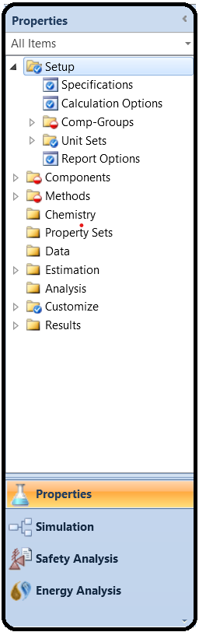

Use the Setup Calculation Options form to override defaults for calculation options set by Aspen Properties. Aspen Propertiesprovides defaults for performing energy balances and convergence calculations. Aspen Properties also has default time limits. You can use this form to override these defaults. You also can specify calculation options at the individual block level.

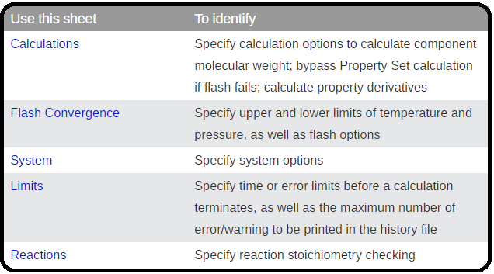

Specification

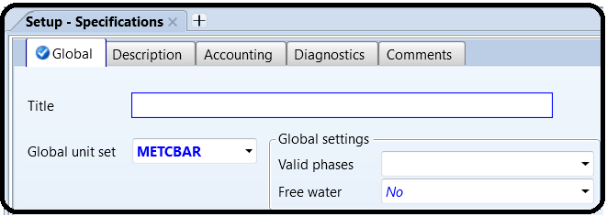

Use this sheet to specify:

* A run title, which appears on each page of the report file
* Default units of measurement. When you change the global units, Aspen Properties converts values on previously entered forms, except for those variables which use local units sets specified on the Comments sheet.
* Global settings

Global settings include Valid Phases and Free Water.

Valid Phases

Lists the valid phases to be considered in calculations. The global value can be overridden locally.

Free Water

When Free Water is *Yes* or *Dirty water*, Aspen Properties handles the presence and decanting of water as a second liquid phase in water-hydrocarbon systems or other water-organic systems. For Free Water (*Yes*), the water phase is pure water. For *Dirty water*, the second liquid phase contains a trace amount of hydrocarbon (calculated by the Hydrocarbon Solubility model). The global value can be overridden locally elsewhere.

You may select from among the available methods for calculating water solubility and free water phase properties on the Methods | Specifications | Global sheet; these apply to both free water and dirty water. These global property specifications may also be overridden elsewhere.

The selection made in the Valid Phases field elsewhere (which includes both valid phases and free water) overrides the specification here.

Calculation Options

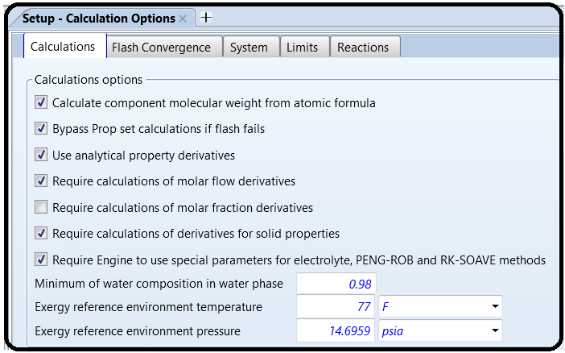

Use this sheet to specify calculation options for:

Calculating component molecular weight from the atomic formula. This option never overrides the databank molecular weight for HE-3. Do not use this option with other components which represent specific isotopes with molecular weights intentionally differing from atomic weight averages. Molecular weight is available in all Aspen Properties databanks. However, the databank MW value may not contain enough significant figures for certain applications for which atomic balance is important, such as reactor modeling. The calculated MW is more accurate than the databank MW. By default, if the formula is entered on the Components | Molecular Weight | Formula sheet, the calculated MW is used in the calculation.

If you do not want Aspen Properties to calculate the molecular weight but instead use databank values, then clear the Calculate Component Molecular Weight from Atomic Formula check box.

**Note:** When this option is selected, reviewing property parameters will show these calculated molecular weights identified as coming from the databank from which the formula was retrieved.

Bypassing Property Set calculations if flash fails.

If you clear the Bypass Property Set Calculations If Flash Fails check box, the property set will be calculated even if a flash error occurs. If flash errors are severe, the property set calculations may be unreliable and may cause further errors.

Using analytical derivatives in property calculations. When unchecked, Aspen Properties calculates the physical property derivatives numerically.

The Aspen Properties property system has the ability to calculate property derivatives either analytically or numerically. The calculated derivatives include derivatives with respect to temperature (T), pressure (P), mole number (n) and mole fraction (x). The properties include fugacity coefficients, enthalpies, entropies, Gibbs free energies, molar volumes, diffusivities, viscosities, thermal conductivities, and surface tensions.

The derivatives calculated using analytical methods are usually more accurate when compared with those calculated using numerical methods. However, there are situations in which the use of analytical methods may encounter convergence difficulties. In such situations the calculation of derivatives using numerical methods may be useful.

Changing options for calculating property derivatives with respect to composition. By default, mole flow derivatives are calculated and mole fraction derivatives are not calculated.

You can reduce the memory requirements of Aspen Properties by not calculating these derivatives if you do not need them. Aspen Properties does not use the mole fraction derivatives but external models which call the CALPRP or CALUPx property monitors may need them. See the *Aspen Properties Toolkit* manual, Chapter 3, for more information about these monitors.

Whether Aspen Properties automatically loads electrolyte, PENG-ROB, and RK-SOAVE parameters from certain databanks even when those databanks are not selected. If this option is selected, these databanks are searched before the ones in the databank search path. Only parameters specified on Methods | Parameters supersede these. Specifically, if this option is checked:

* ELECPURE (pure databank) is used when the ELECNRTL method is selected.
* ENRTL-RK (binary databank) is used when the ELECNRTL method is selected.
* PITZER (binary databank) is used when the PITZER method is selected.
* EOS-LIT (binary and pure databank) is used when the PENG-ROB or RK-SOAVE method is selected.

The minimum water mole fraction which must be in the water phase when using dirty-water specifications. As long as there is at least this much water, the hydrocarbon solubility model is used to predict the amount of hydrocarbons in the dirty-water phase.

The reference temperature and pressure for the EXERGYML and EXERGYMS property sets.

Flash Convergence

Use this sheet to specify the upper and lower limits of temperature and pressure and flash options for flash calculations.

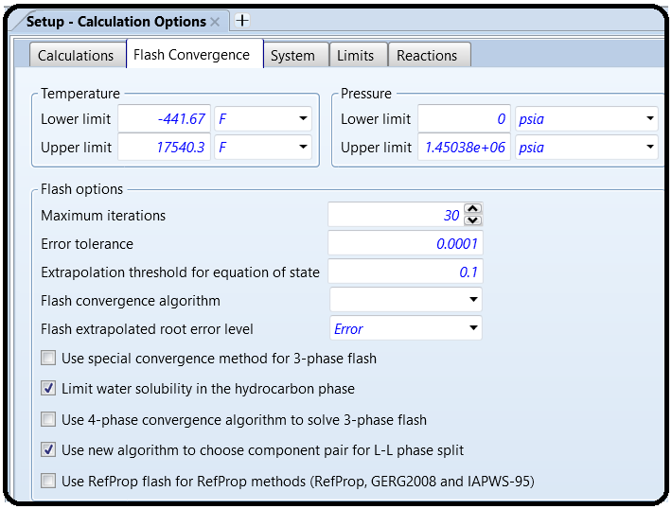

System

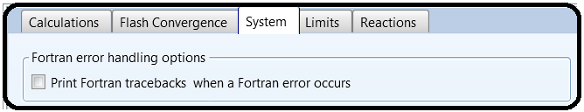Use this sheet to have Aspen Properties print Fortran tracebacks in the calculation history when a Fortran error occurs.

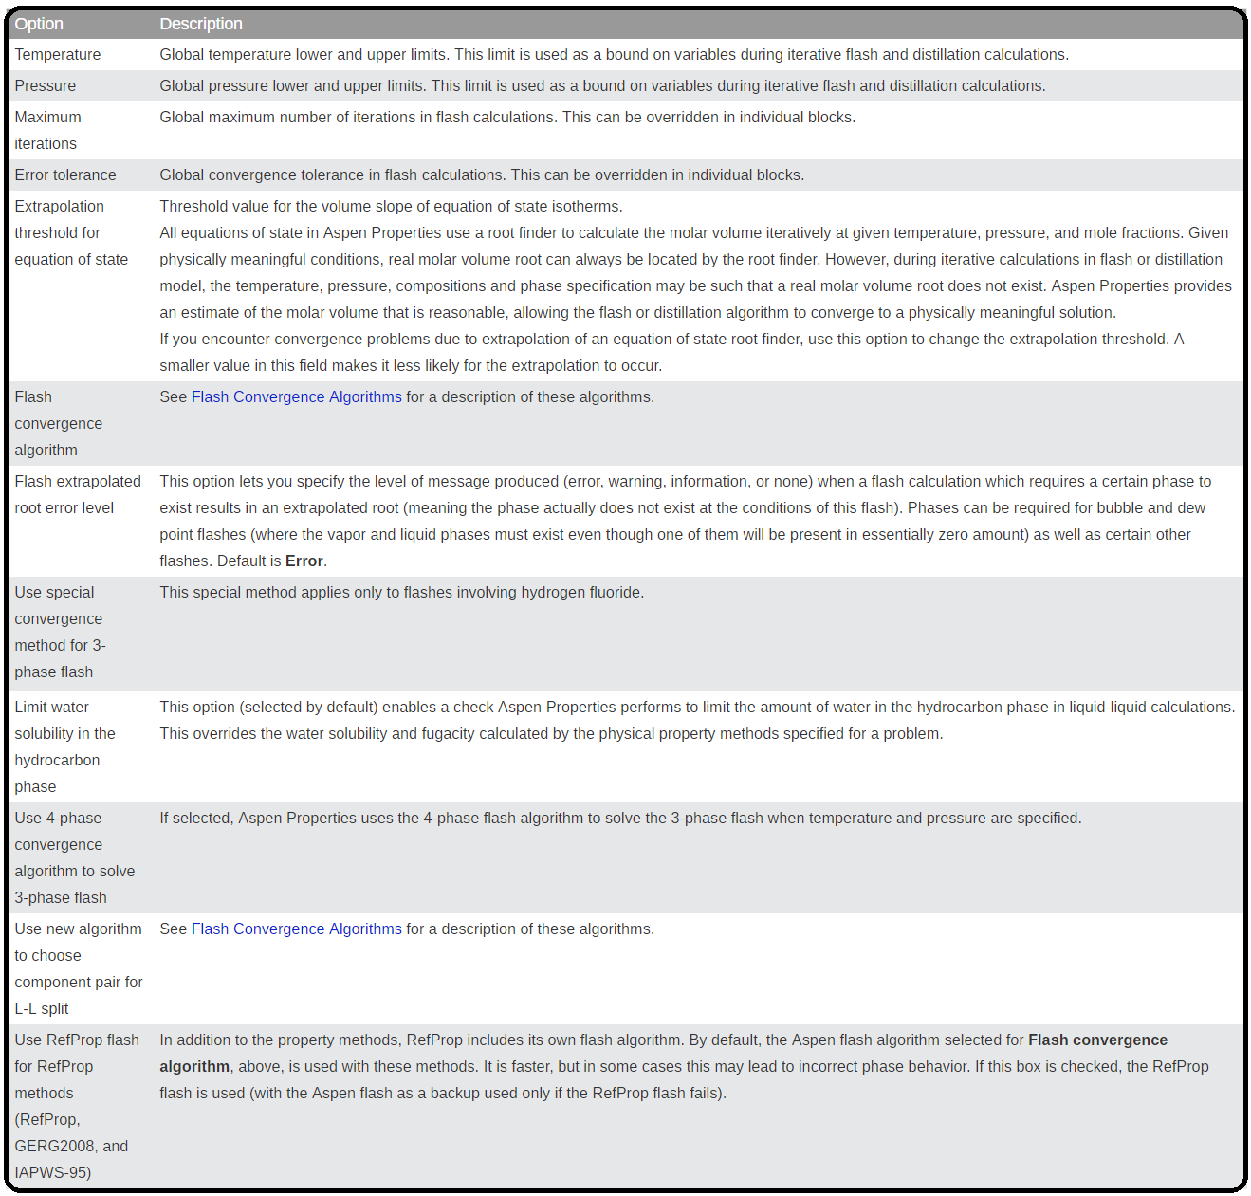

Limits

Use this sheet to override the default error limits and maximum CPU time for background runs. A background run is terminated and an error message is generated if any of these limits is exceeded, except the history file limit. The limits do not apply to interactive runs.

The history file limit is approximate, checked only about once a minute, and is intended to avoid letting runaway simulations fill the entire disk with history information. When this limit is reached, execution stops with a severe error message, but in a way that you can continue after increasing the limit and/or decreasing diagnostic levels.

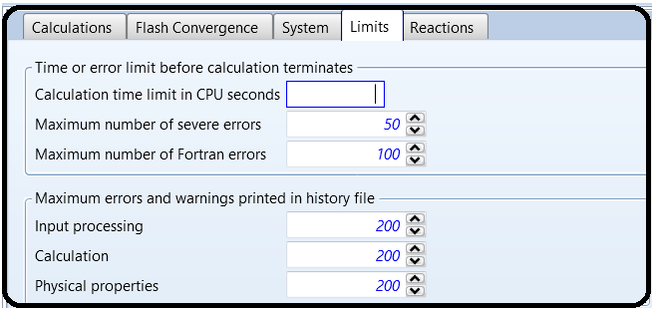

Reaction

You can use this sheet to specify reactions stoichiometry error checking options and the activity coefficient basis.

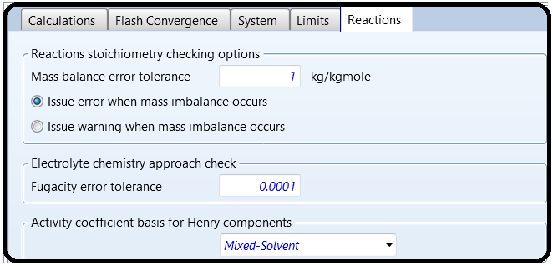

Reactions Stoichiometry Checking Options

If reactions stoichiometry (such as Chemistry) is specified, Aspen Properties checks the mass balance of stoichiometry based on the stoichiometric coefficient and molecular weight of the components. You can select whether an error or a warning should be given during input processing if mass imbalance occurs. Calculation will not proceed if an error occurs during input translation. You can specify that Aspen Properties will issue an error or a warning during input processing when the absolute error of mass balance of stoichiometry is greater than Mass balance error tolerance (default is 1.0 kg/kmol).

* If the absolute error is greater than the tolerance, Aspen Properties will issue a warning or error depending on the option selected.
* If the absolute error is less than the tolerance but greater than 0.01 kg/kmol, Aspen Properties will issue a warning even if you select Issue error when mass imbalance occurs.
* If the absolute error is less than 0.01 kg/kmol, Aspen Properties will not issue an error or warning.

Electrolyte Chemistry Approach Check

When volatile species are generated in electrolyte chemistry, the apparent component approach is not able to maintain the generated components in vapor-liquid equilibrium. The recommended solution for this problem is to use the true component approach.

When the Electrolyte chemistry approach check is enabled, if the apparent component approach is used and there are species generated in electrolyte chemistry, a check is performed to verify that the vapor and liquid phases are in equilibrium, to avoid generating wrong results.

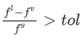The check performed is:

If, where *fl* and *fv* are the liquid and vapor fugacities, respectively and *tol* is the

specified Fugacity error tolerance, then an error is issued.

Activity Coefficient Basis for Henry Components

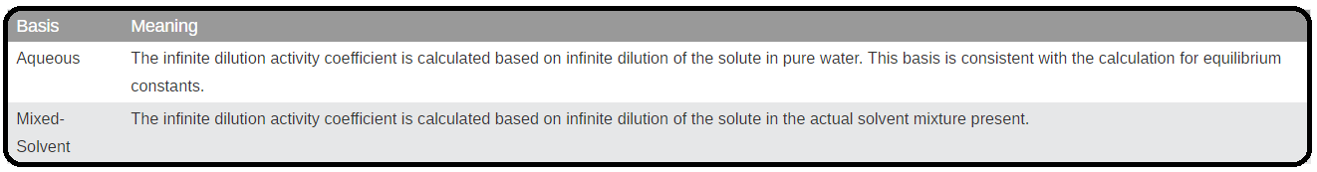Let’s you specify the basis for the infinite dilution activity coefficient in the calculation of the unsymmetrical activity coefficient for solutes. This only has an effect when there is a solvent other than water:

Comp-Group

Use this form to define component groups for property sets or for plotting composition and K-value profiles. This form contains the following sheets:

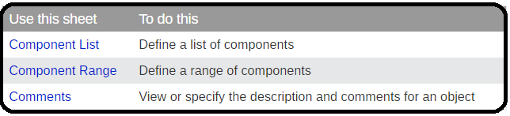

A component group consists of either a:

* List of components
* Range of components from the Components | Specifications form
* Combination of component lists and ranges

A component may appear in more than one group.

Component groups are used to:

* Plot composition and K-value profiles of groups of components in distillation and reactor models
* Specify a group of components in some property sets

The properties plotted for a component group are based on the sum of individual component properties. For example, the mole fraction of a component group is the sum of the mole fractions of the individual components in the group. Group molar-K values are ratios of summed mole fractions.

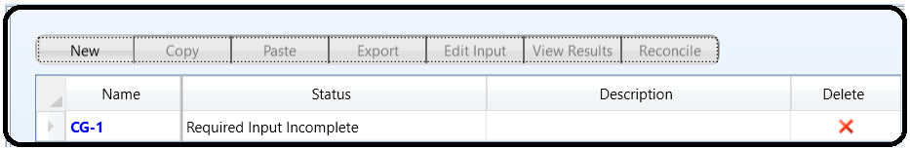Each component group is identified by an ID you supply. Use the component group IDs that you define to identify component groups on other forms.

Component List

Use this sheet to define a list of components to include in the component group.

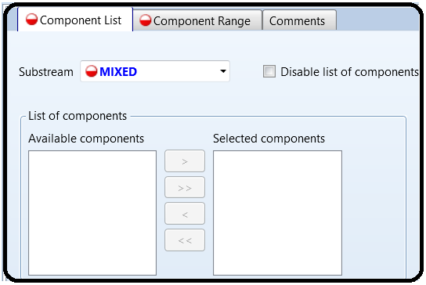

Component Range

Use this sheet to define a range of components to include in the component group. The components selected on the Component List sheet cannot be within the range of the components specified on this sheet.

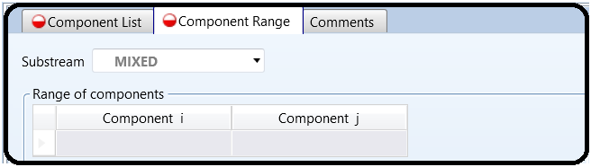

Setup Units-Sets Form

Use the Units-Sets form to create new user-defined units sets and to view existing units sets. A unit’s set is a collection of units for each dimensional quantity in Aspen Properties.

A units set defined using this form can be specified in the Input Data or Output Results fields on the Setup Specifications Global Sheet or on the Units field at the top of most input and results forms.

For a detailed list of the units in each of the built-in units sets and the other options available for each unit type, see chapter 11 of the [OOMF Script Language Manual](https://esupport.aspentech.com/apex/S_Homepage#productDocumentation). Search for this document in the Knowledge Center.

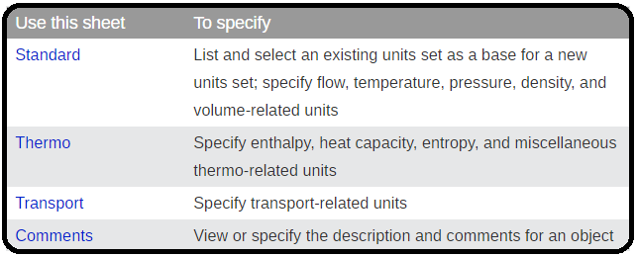

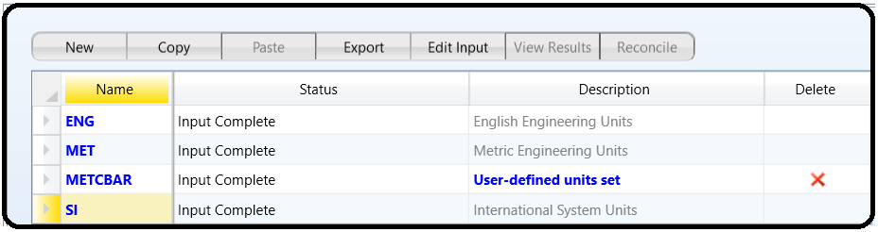**Note:** In the SI units set, molar properties are defined using *kmoles* rather than *moles*, to correspond with the mass unit of kilograms. This ensures that molecular weight has the same value for all units sets, without the need for a conversion factor.

### Setup Units-Sets Standard Sheet

Use this sheet to specify flow, temperature, pressure, density, and volume-related units.

You can use Copy from to copy the definition from an existing unit set as the basis for a new unit set. Click Search to display the Units-Sets Search dialog box which lists, in alphabetical order, the units of all dimensional quantities of the selected units set.

Note: In the SI units set, molar properties are defined using kmoles rather than moles, to correspond with the mass unit of kilograms. This ensures that molecular weight has the same value for all units sets, without the need for a conversion factor.

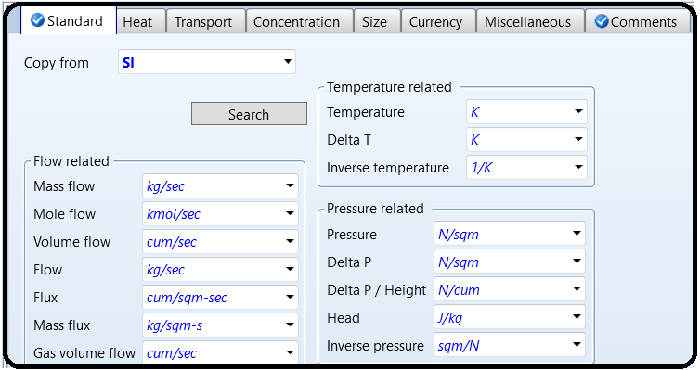

### Setup Units-Sets Thermo Sheet

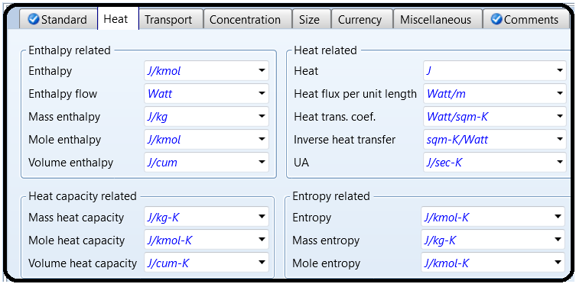Use this sheet to specify enthalpy, heat capacity, entropy, and miscellaneous thermo-related units.

### Setup Units-Sets Transport Sheet

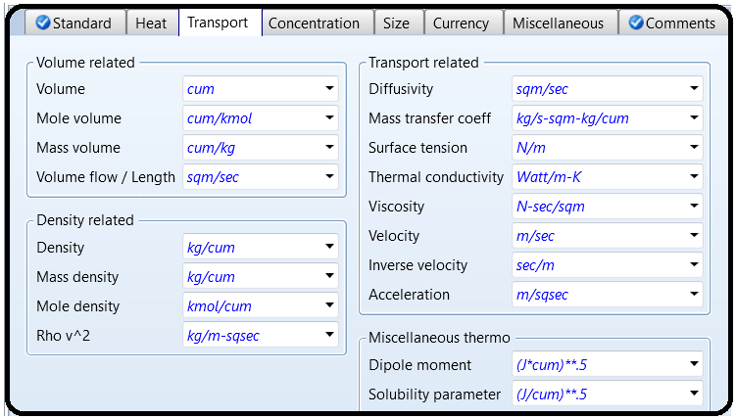Use this sheet to specify transport-related units.

Setup Report Options Form

Use the sheets on this form to specify which sections of the report to included or suppressed.

Aspen Properties results are available in a report file you can print out. Use Export from the File pulldown menu to generate a file containing the report. Use the following sheets to control the contents of the report file generated on your computer.

The Setup Report Options form within a Hierarchy block contains only the Flowsheet, Block, and Stream forms. Use these forms to specify options for the report for that level of Hierarchy.

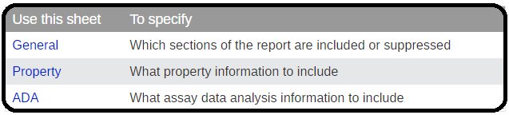

### Setup Report Options General Sheet

Use this sheet to specify which sections of the report are included or suppressed. The report documents all of the input data and defaults used in an Aspen Properties run as well as the results of the calculation.

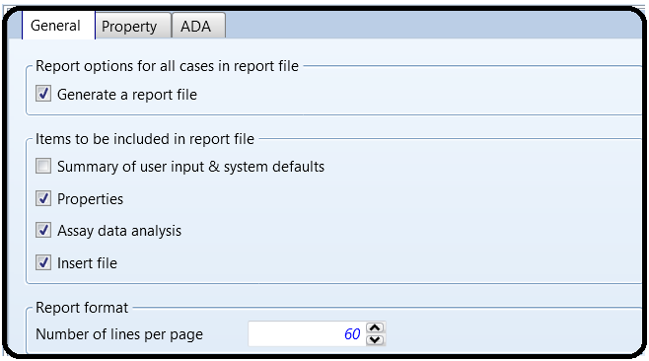

### Setup Report Options Property Sheet

Use this sheet to specify whether to include or suppress in the property report the listing of component IDs, aliases, and names used in the calculation, values of physical property parameters, results of property constant estimation, and property parameters' descriptions, equations, and sources of data.

You can also use this form to generate:

An .APRDFM file containing property parameter results of PCES and data regression, user-entered data, and data retrieved from databanks in the Data File Management System format (DFMS)

A project data file (.APRPRJ) containing parameters (pure component, binary, electrolyte pair) used in the calculation run in the form of Prop-Data paragraphs

A property data format file (. APRPRD)

These files are generated automatically when you export a report file (Select Export from the File menu).

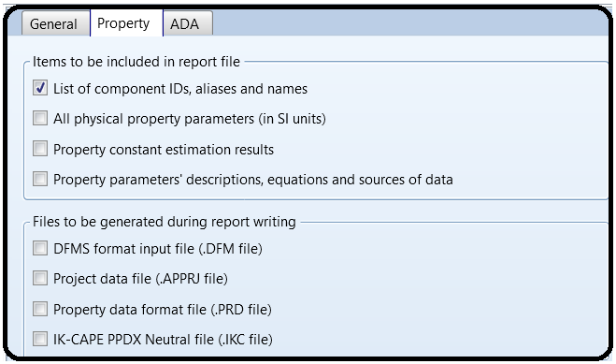

### Setup Report Options ADA Sheet

Use this sheet to specify whether to include or suppress the listing of generated pseudo components, the distillation curve report, and the values of all pseudocomponent property parameters in the assay data analysis report.

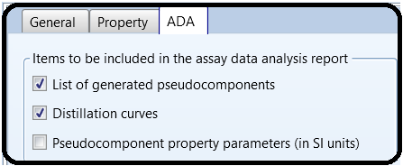

Part 2

Problem Definition

It is customery in process plants, refinaries and petrochemicals to transport a liquid or products from one storage tank to another in case of emergencies or for storage purposes. For instance, in some large methanol plants or refinaries there are a daily product storage tank as well as a weekly storage tank. When the capacity of the daily tanks reaches its maximum, the control room operators start transporting the purified methanol from daily tanks to weekly tanks. In this regard, as shown below, in order to transport the liquid some equipment such as piping for transport, control valve for measurement and level control and pumps for increasing the pressure are required.

Example:

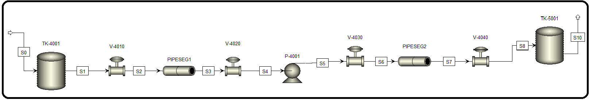In a utility plant, the operator in control room is supposed to transport the water from TK-4001 to TK-5001. As shown on the following P&ID, through passing the pipes, water passes through valves LV-4010, FV-4010 and then a pump P-4010 and FV-4020, LV-4020 and finally reaches TK-5001.

How to simulate

1. Choose “Specialty Chemicals with Metric Units” template to create a steady-state flow sheet.

2. Go to Properties/Set-up/Specification and in Global Tab, give it the name of “Water Transport”

3. Go to Properties/Component/ and Find water.

4. Given the fact that the ASME steam tables are less accurate than the NBS/NRC steam tables, set the property method to “STEAMNBS”. The NBS/NRC steam tables are embedded, similar to any other equation of state, within the built-in “Aspen Physical Property System”. These steam tables can calculate any thermodynamic property of water. There are no parameter requirements.

5. Click “Reset” followed by “Next” button to run the simulation and assure that properties’ analysis completed successfully. Switch to “Simulation” environment.

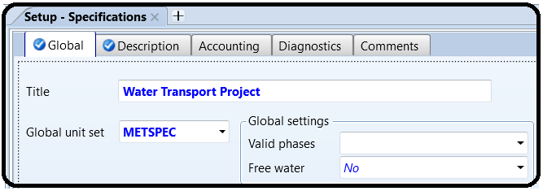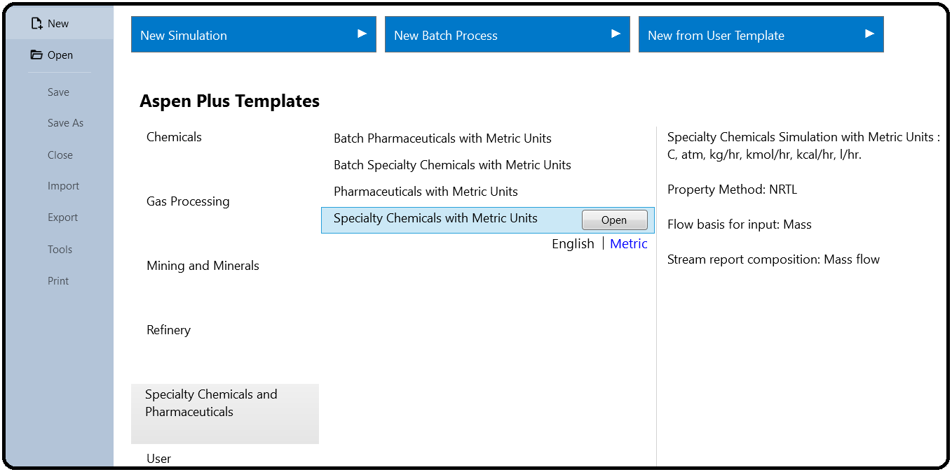

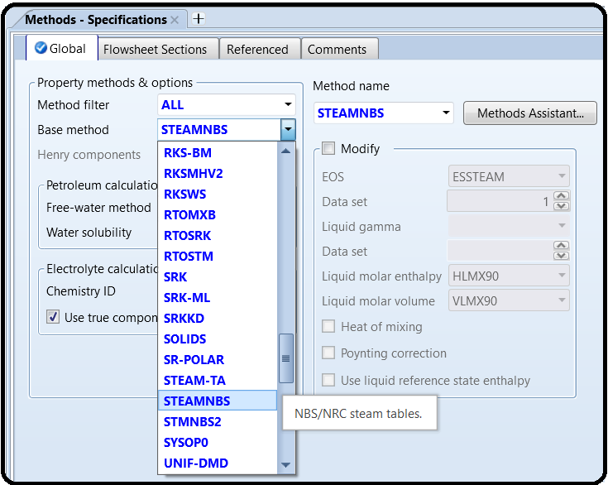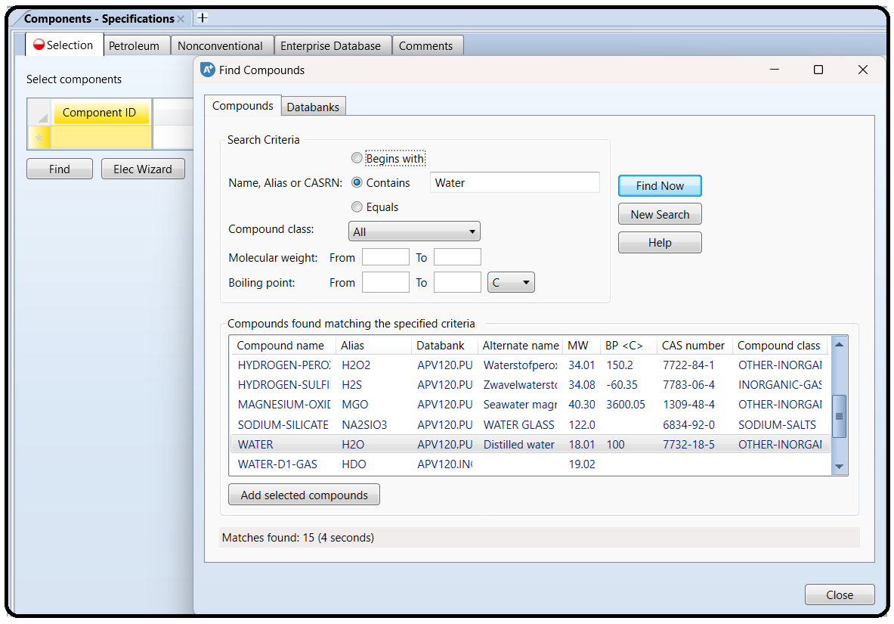

The models contained within Aspen Plus are quite well understood and are generally accepted by the process systems engineering community as being “correct” in terms of their derivation and

implementation (when used in the proper circumstances). This is especially true for empirical and first-principles modeling for unit operations, physical properties for pure chemicals and chemical

mixtures, and mass and energy balances. However, even though the equations themselves may be correct, in order for them to have any meaning or use, the parameters and assumptions on which they are based need to also be correct. Although Aspen Plus may run the simulations with no warnings or errors, you still have to decide if the numbers it provides you are valid and accurate. One wrong parameter and any model that uses it or uses information derived

from it will be inaccurate. For process modeling, the most fundamental models on which everything is based are the physical property models. These include things like pure component properties (heat capacity, surface tension, viscosity, vapor pressure, etc.), equations of state or other correlations between state properties (temperature, pressure, molar volume), and then the complex ways in which chemicals interact in mixtures (phase equilibria, solution chemistry, heats of mixing, etc.). In Aspen Plus, the built-in databanks contain this information for an extremely large number of chemicals. For the most part, the models and parameters for pure component properties (e.g., the equation for how the vapor pressure of a chemical changes with respect to

temperature) are quite sound. Other types of property models can be either quite good or quite terrible, depending on the circumstances. The proper way to validate any kind of model is to compare it against experimental data. That means rigorously comparing all aspects of the model: every single physical property model, empirical correlation, reaction and mass transfer kinetics, and unit operation. For most cases, especially with conceptual process design, that can be extremely hard to do. This is because in many cases the actual unit operations themselves may not have been built yet, or there are simply too many models embedded within a large flowsheet to test them all. The model developer has a limited amount of resources available for validation and so it has to decide which are the most important areas to validate. Although every situation is different, the modeling community has generally accepted this practice, and the risk that goes with it. However, there is one important type of model that is very often wrong and should be validated in almost all circumstances—phase equilibria. Therefore, this tutorial is meant to help you determine the correct physical property models with regard to the phase equilibria of chemical mixtures. Because equilibrium calculations are a key component of nearly every unit operation model in the flowsheet involving fluids, choosing the wrong model can mean garbage results everywhere. If there is one thing you should spend time validating, it is this.

PROPERTY METHOD TYPES

There are many types of physical property models within Aspen Plus. The Methods Assistant can help you filter the list to find some of the best ones for your specific case. You can find this in the

Properties | Methods | Specifications form, with the button to the right of the method name dropdown. This takes you to a place in the help file where you can answer a few basic questions about your scenario, and after a few clicks it presents you with a list of suggested options for property packages. Usually, there are many, and further links are provided to find out more about them. This does not usually answer the question of what model to pick nor does it mean that these are necessarily the correct or even the best options for your circumstance. But this can be quite helpful for narrowing down the possibilities in your search. It helps to understand the different types of methods. They can be classified roughly into three categories, and in each I have highlighted my favorites and some of the most common options. There are more than these to explore, but these are common starting points.

Equation of State Models

Equation of state models are sets of equations that relate state variables (i.e., temperature, pressure, and molar volume) to each other through a set of parameters. The parameters are determined through regression of experimental data combined with some fundamental thermodynamic theory. Most chemical engineers learn some of these early in their training and so are generally familiar with their use. What is remarkable (and even quite beautiful) about them is that you can derive analytical equations for enthalpy, entropy, and Gibbs free energy directly from the equation of state that relates temperature, pressure, and molar volume through the use of partial derivatives and thermodynamic theory. From those equations, you can get other properties like heat capacity, fugacity, and fugacity coefficients by doing a little more calculus. Although I will spare you the thermodynamics lesson,1 it means that if you have very good parameters that map temperature, pressure, and molar volume together, you then also know entropy, enthalpy, heat capacity, and other properties in the liquid, gas, and supercritical states. It also means that if those parameters are not so good, then all of those properties will be incorrectly computed, and everything in your model can fall apart. The most common and interesting models of this category are as follows:

Ideal Gas*:* IDEAL is the classic ideal gas law. I would suggest that for most chemical processes, you should not use it because you have better models available to you at basically no extra effort.

However, it is very useful for model validation or understanding basic principles. For example, if you are testing a new model, it would be useful to first use ideal gas because you could work the

equations out yourself on paper and then determine if Aspen Plus is computing things in a way that you expect. It is useful in debugging sometimes because you can eliminate a physical

property model as a variable.

Redlich-Kwong Variants: This is a cubic equation of state, which means that it relates temperature, pressure, and molar volume in such a way that if temperature is known, the equation can be written such that pressure is a third-order polynomial function of molar volume. This structure makes it possible to represent liquid, vapor, vapor-liquid mixtures, and supercritical phases. There are many variants. The most common in Aspen are RK-SOAVE (Soave-

Redlich-Kwong), RK-ASPEN (Redlich-Kwong-Aspen, which is basically RK-SOAVE but extended for better handling of polar molecules like water and alcohols), PSRK (Predictive Soave-

Redlich-Kwong, which allows for UNIFAC prediction of unknown parameters—more on that later), RKS-BM (Soave-Redlich-Kwong with Boston-Mathias extensions) and others. You can read each

help file entry to see if you think it fits your situation best. my all-time favorite is PSRK. Although I have encountered situations where it does not work well, it very often was the best choice.

*Peng-Robinson Variants*: The classic cubic Peng-Robinson equation of state (PENG-ROB) is available, but two variants are quite good: PRWS expands Peng-Robinson with Wong-Sandler mixing rules (which helps with binary phase equilibria) and has some UNIFAC predictive capability, and PR-BM has some additional parameters available through the Bost-Mathias modification which increases the potential for model accuracy. It is similar to RKS-BM. In my experience, I have found PR-BM to be the best choice in many circumstances and is one of the first methods I will usually explore.

Activity Coefficient Models

Although the theory behind equation of state models is quite elegant, in practice, it does not always work so well for complex phase equilibria, especially with multiple liquid phases. Activity coefficient models attempt to improve on accuracy by using separate models for the gas and liquid phases. In particular, the liquid phase model uses activity coefficients to compute liquid phase fugacity instead of an equation of state method (see Tutorial 2). The parameters for the liquid phase model are fit to the activity coefficients directly, and so they (in theory) could be more accurate than the equation of state method. On top of that, they no longer use equation of state

information for the liquid phase, and so other empirical correlations are used instead for liquid phase properties, such as a polynomial equation to predict heat capacity as a function of temperature. Again, since each model is tailored to each specific property, each model should in theory have less error than an equation of state based approach. However, using separate models like this creates inconsistency between models because the elegant thermodynamic

theory is not used. As a result, this will necessarily introduce some error, although the hope is that the model consistency error it introduces is less than the error it avoids. Some examples are:

*Classic Methods:* The WILSON and VANLAAR methods are some of the most famous activity coefficient methods. Plain vanilla WILSON and VANLAAR assume ideal gases. There are many variants (WILS*something* or VANL-*something*) where what comes after the dash usually refers to an equation of state model for the vapor phase. However, I generally do not recommend any of these, as they have been supplanted by more modern methods.

*Non-Random-Two-Liquid:* The NRTL method is a common activity coefficient method that is actually the default property method on many of the existing templates. However, I do not recommend this default NRTL since it uses the ideal gas law in the vapor phase (usually the first thing I do when I load up a template to start a new simulation is to go and delete the NRTL method and replace it before I do anything else). The variants are much better. These are intended for systems which can form two liquid phases, but often work well for vapor-liquid equilibria (VLE) generically. Personally, I find NRTL-RK often is the best activity coefficient model for my applications (the RK means the Redlich-Kwong equation of state). The electrolyte variants (ELECNRTL, ENRTL-RK, ENRTL-HOC, etc.) allow complex electrolyte chemistries and are

explored more fully in Tutorial 12.

*Universal Quasi-Chemical Models:* The UNIQUAC method is similar to NRTL, and uses the ideal gas law by default. Again, I recommend the UNIQ-RK or UNIQ-HOC variants. I have personally found UNIQ-RK to be very similar to NRTL-RK, and often indistinguishable.

*UNIQUAC Functional Activity Coefficient Predictions:* The UNIFAC method is a way of estimating the binary interaction parameters for many of the above methods by using the shapes of the molecules themselves, which is extremely useful when binary pair information is missing (as it quite often is). UNIFAC can be incorporated into any of the UNIQUAC, NRTL, or PSRK methods

and variants just by checking a box (see Figure B4.1). It also has its own property method definition called UNIFAC (which is UNIQRK with UNIFAC parameters instead of the ones in the database) and some variants. In most cases, I recommend that you start with UNIQ-RK and then only use UNIFAC to estimate the missing parameters, so you can take advantage of the regressed

UNIQUAC parameters. But you can always try and see if UNIQFAC outperforms UNIQ-RK if you need to.

Specialty Models

While the above models are meant to be general for most situations, there are a lot of one-off specialty models that have been developed for certain subsets of chemicals or particular applications. There are more than I have had the opportunity to use, but if you work in a very particular or common type of process, there may be a model that has been designed specifically for it. The ones that I use most commonly are:

*Steam Tables:* Classic steam tables are equation correlations based on tabulated, experimentally determined physical properties of water at various phases. STEAMNBS should be your first choice for any model that uses pure water in the liquid, vapor, or supercritical phases. Although you usually will have other chemicals in your system, it is quite common that you would use

STEAMNBS in individual unit operation models that use all water. For example, you may have a heat exchanger with a complex set of chemicals cooled by cooling water. You might choose PSRK for the hot side of the HEATX and STEAMNBS for the cold side (you can individually specify your preference in the Block Options of any model). In fact, when adding cooling water or steam as utilities ,you will be asked if you want to add STEAMNBS to your simulation if you have not already so it can use it for all of its water utility calculations. STMNBS2 is the same thing, it just has a different solver algorithm which you can use in case you get root finding errors. Legacy versions include RTOSTM and STEAM-TA and generally are only used in very particular circumstances such as free-water calculations.

*Amines*: AMINES is designed specifically for amines which are primarily used for gas sweetening applications (such as H2S or CO2 capture) specifically for mono ethanolamine, diethanolamine,

di-glycolamine, and di-isopropanolamine. Although this may seem very specific, it is of major interest right now due to its use in CO2 capture systems. This is not necessarily the best method to use in all amine applications since ENRTL-RK can also be good. I cannot recommend one or the other in these cases; I use both and you should try them both if you are serious about gas sweetening.

*Polymers*: The POLY*something* variants are intended for polymer and copolymer use. POLYSRK is an extension of PSRK for polymers. POLYSAFT model uses the statistical associating fluid theory (SAFT) equation of state for polymers, circa the 1990s. A more modern version from the 2000s, PC-SAFT, is intended for polymers, copolymers, and mixtures with normal liquids and gases. Although polymerization is not covered in the book, custom PC-SAFT models have found widespread use for the CO2 capture solvent Selexol. There’s a lot to choose from. At the end of the day, I recommend starting with PSRK, PR-BM, and NRTL-RK as your first three candidates unless you have a special situation.

Part 3

Problem Definition

Petroleum Assay Characterization in Aspen Plus

A crude oil assay with the bulk specific gravity of 0.85 g⋅cm–3 is to be processed in a refinery. A

TBP distillation curve of the crude is given in Table 13.1. Total fraction of light ends is 0.00352, and its composition is shown in Table 13.2.

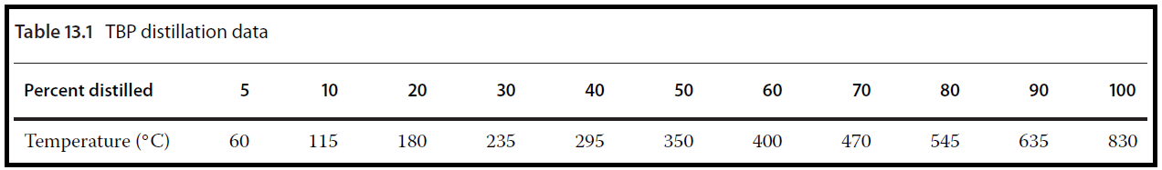Provide the petroleum assay characterization and generate pseudocomponents for process simulation in Aspen Plus.

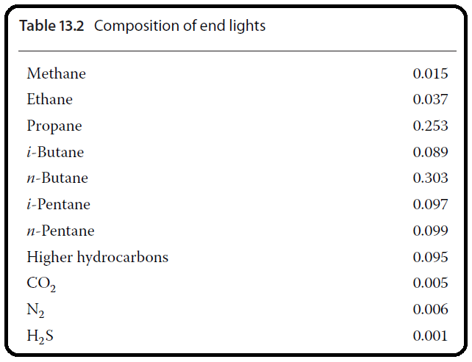

Solution:

* Open Aspen Plus and select an installed refinery template as shown in Figure 13.10.

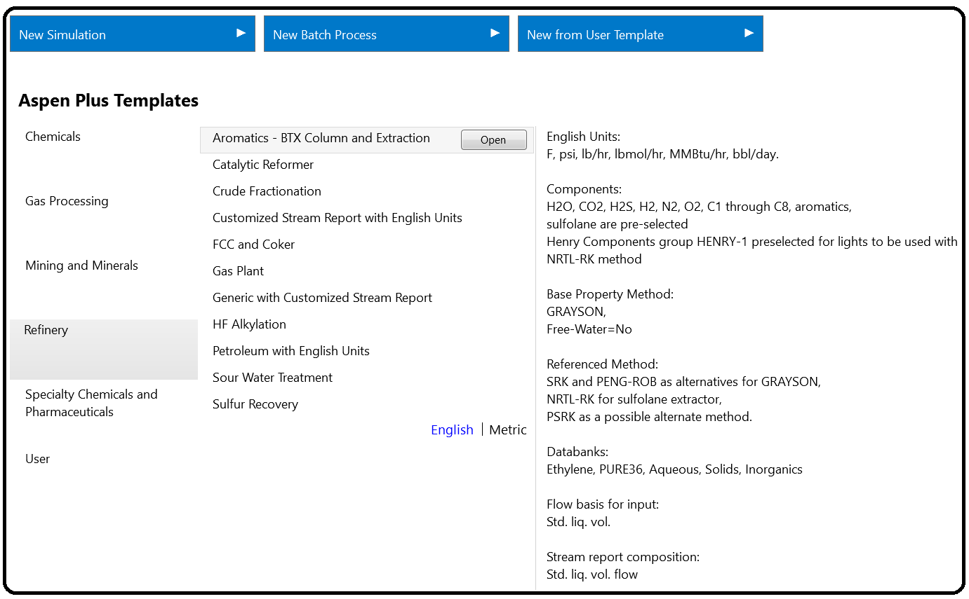

* Aspen automatically generates a component list, which contains, besides conventional light components, also a crude assay (Figure 13.11).

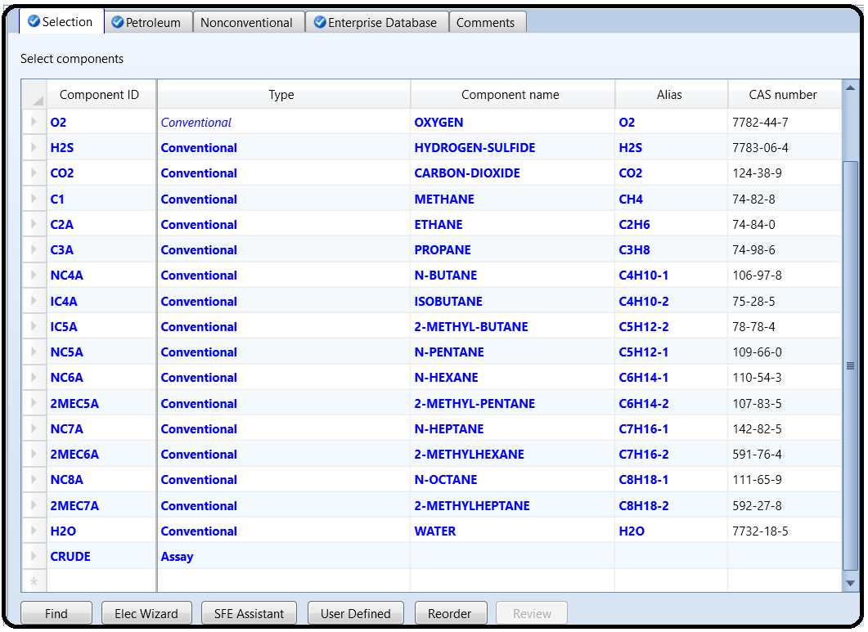

* Chao–Seader, Grayson or Grayson 2, and BK10 models are the most often used thermodynamic models for petroleum fractionation. The Grayson model is automatically

selected in this template.

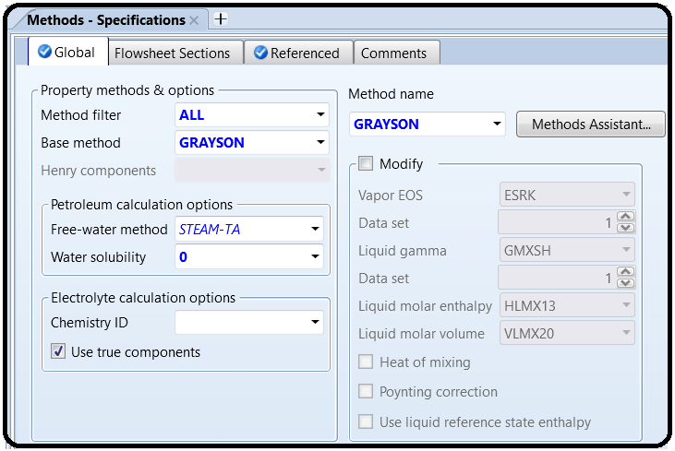

* Continue with assay basic data specification following the steps shown in Figure 13.12; select the distillation curve type and enter the bulk specific gravity and the distillation curve data.

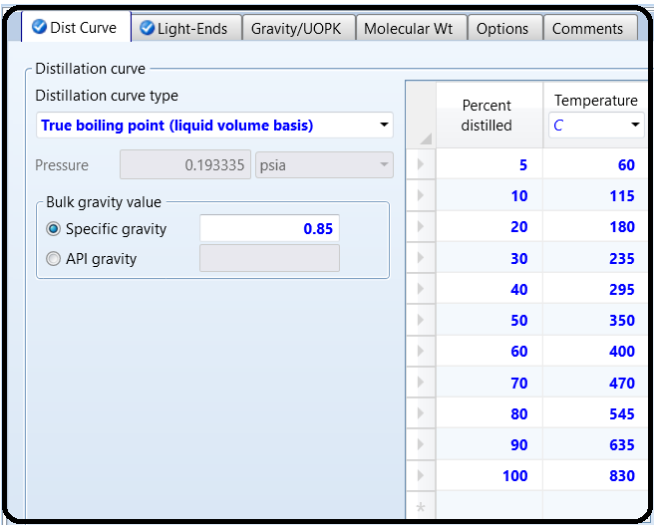

* If the light ends fraction is not specified, Aspen considers the light ends fraction as a fraction of whole crude. In this example, we know the total fraction of light ends. Enter the information together with its composition in the Light-Ends tab as shown in Figure 13.13.

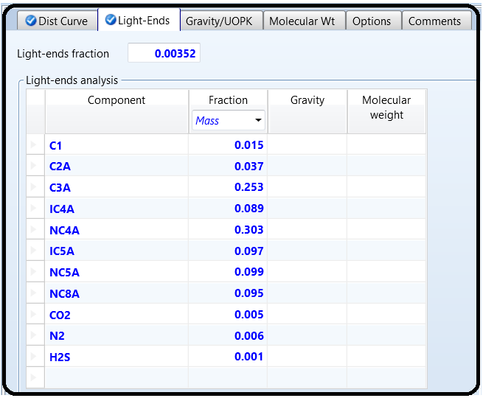

* To generate pseudo components, define a new *Generation* under *Petro characterization* and specify the assays and blends that may be included in the set of pseudo components (Figure 13.14).

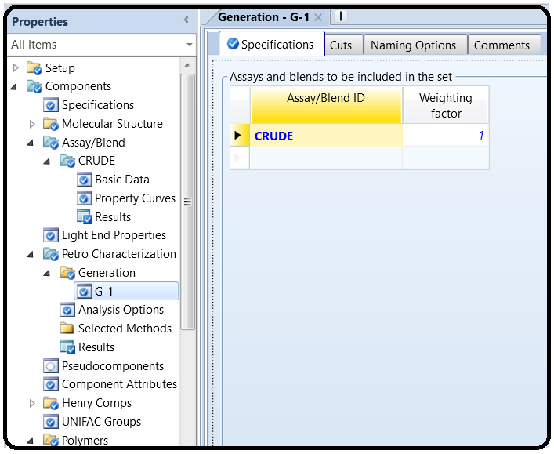

* Aspen enables user definition of cut points and component generation points; the default cut points should be used in this simulation.
* The set of pseudo components is generated after running the simulation.
* 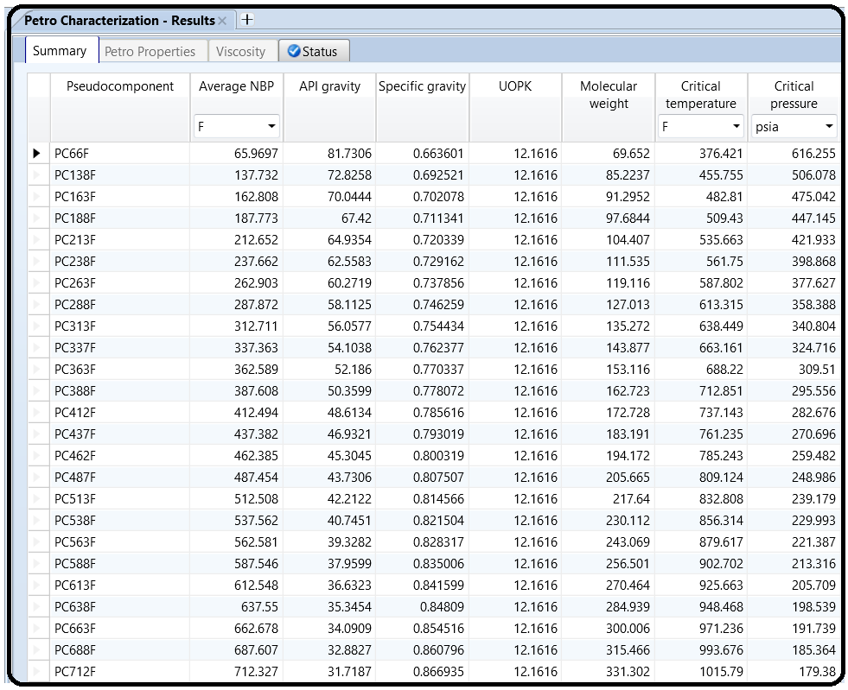Results of pseudo component generation are shown in Figure 13.15.

Part 4

Problem Definition

4,900 kg⋅h−1 of styrene monomer is the subject of polymerization in a series of three CSTR

reactors each with a volume of 15 m3. The reactor feed contains 97.9 wt% of styrene, 2 wt% of ethylbenzene, and 0.07 wt% of *N*-dodecyl-mercaptan (DDM) acting as the chain transfer agent and 0.03% di-t-butyl-peroxide (TBP) as the initiator. The unreacted styrene containing

also some EB, TBP, and DDM is separated from the polymer and, after cooling and mixing with makeup streams, returned back to the first reactor. The process flow diagram (PFD) is shown in Figure 16.13. All reactors work at atmospheric pressure. The temperature is 120, 160, and 200 ◦C, in the first, second, and third reactor, respectively. Calculate the conversion, polydispersity index (PDI), weight-averaged molecular weight(MWW), and the number-averaged molecular weight (MWN) at the outlet of each reactor. Use the free-radical kinetic model with kinetic constants available in (2).

Component Characterization

Components participating in a polymerization process are as follows:

Polymer: A product of the polymerization process, large molecules, or macromolecules where a smaller constituting structure is repeated along the chain. It can be a homo- or copolymer.

Oligomer: Small polymer chains contain up to 20 repeating units.

Segment: Structural units of a polymer or oligomer are divided into types depending on their location on the polymer chain: repeat units, end groups, and branch points.

Monomer: A molecule can be bonded to other identical molecules to form a polymer. Other conventional components act as the Initiator, Coinitiator, Catalyst, Solvent, and so on.

The polymer component is not a single species but a mixture of many species. In addition, it can be considered as a live (reacting polymer) or as a dead (inert) polymer. Properties such as molecular weight and composition may vary throughout the flowsheet and with time. When a component is specified as a polymer, it has associated attributes used to store information on molecular structure, distribution, and product properties. The polymer attributes enable tracking different properties of live and dead polymers including

* number-average degree of polymerization and molecular weight,
* weight-average degree of polymerization and molecular weight,
* segment fraction,
* segment flow,
* number of long and short chain branches,
* long and short chain branching frequencies,
* number and frequency of cross-links,
* number-average block length (sequence length), and
* flow and fraction of terminal double bonds.

More details on polymer attributes can be seen in Aspen Plus as shown in Figure 16.1 or in (1).

Oligomers do not require component attributes. Therefore, if a unit operation model cannot handle polymer attribute data, polymer can be treated as an oligomer. For an oligomer, we should specify the number and type of segments that it contains. Polymer attributes are solved/integrated together with the material and energy balances in the unit operation models. The segment type has to be specified. A segment name comes from the name of the monomer from which it originates. A label is added to the monomer name to identify the segment as either a repeat unit, −R, an end group, −E, or a branch point, −B. To create a component list for styrene bulk free-radical polymerization, follow the next steps:

Start Aspen Plus by creating a new Polymers template with metric units as shown in Figure 16.1.

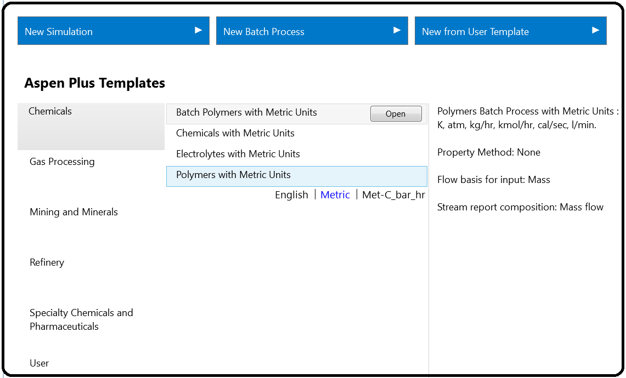

If available unit sets (ENG, MET, and SI) are not suitable for all quantities in this simulation, you can define a new unit set and modify the existing set as necessary. Figure 16.2 shows how a unit set can be defined, and new units for temperature, pressure, and volume flow selected.

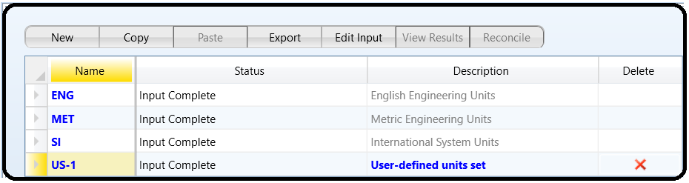

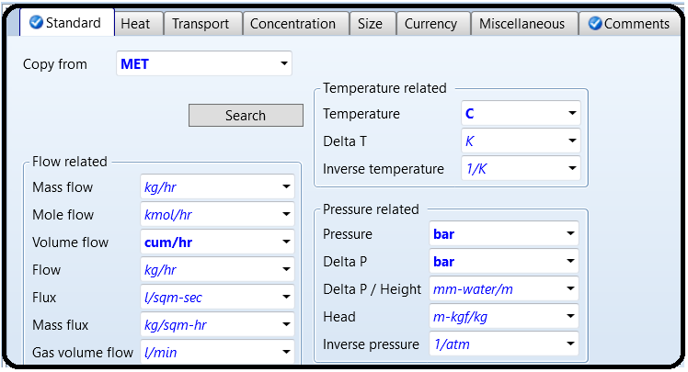

On the Specifications page under Components, create a list of components as shown in Figure 16.3. For PS, select Polymer as the component type and for styrene- R select Segment. All other components are Conventional type. Styrene acts as a monomer (STY) and also as a coinitiator (CINI); therefore, it is selected two times.

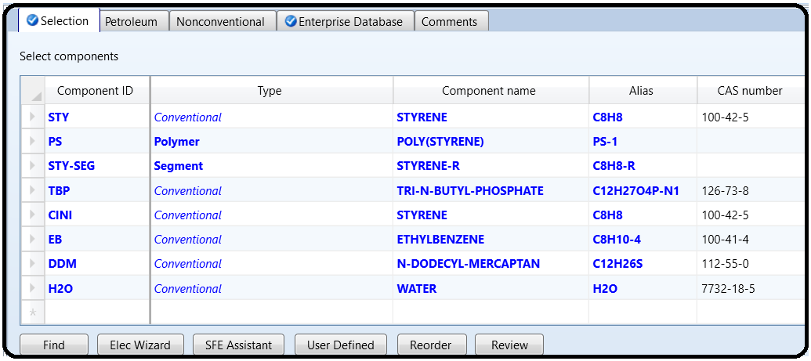

From the main navigation panel, select Polymers under Components.

Select REPEAT as the segment type in the Segments tab under Characterization (Figure 16.4).

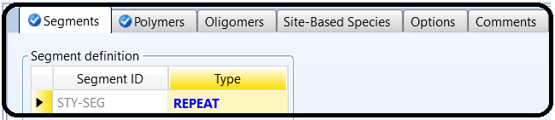

In the Polymers tab under Characterization, chose Free Radical Selection for the group of polymer attributes (Figure 16.4).

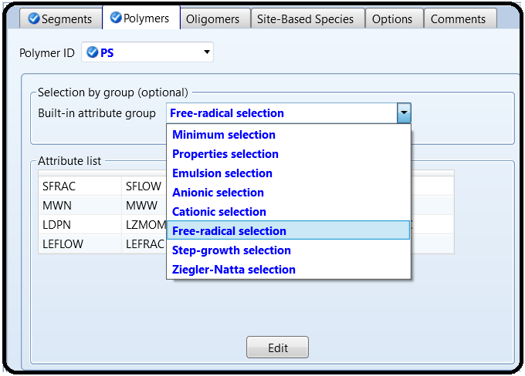

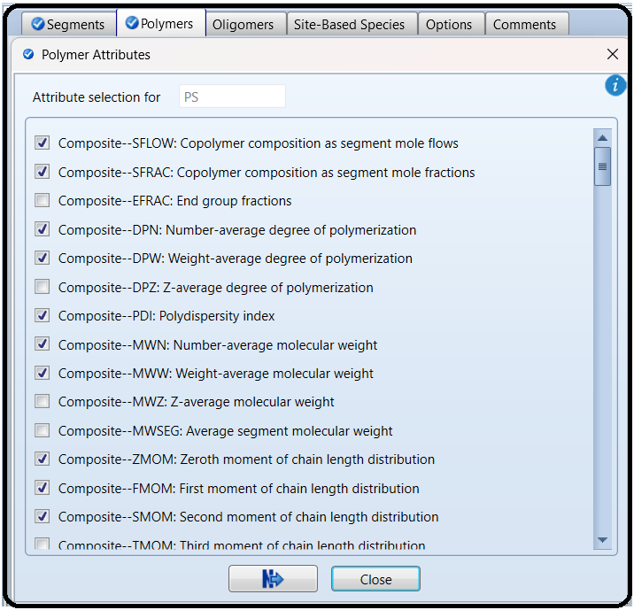

To check details of selected component attributes, follow the steps shown in Figure 16.5.

From the main navigation pane, select Distribution under Polymers and enter 100 as the number of points to calculate the distribution function for PS.

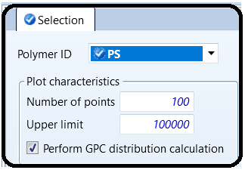

Property Method

A number of property methods for modeling polymer systems are available inAspen Plus.A summary of principles and application fields of polymer property methods available in Aspen plus is given in Table 16.1. The information in this table was extracted from the Aspen Polymer user guide (3).

For PS bulk free-radical polymerization studied in this example, the POLYNRTL property method can be used.

On the Specification page under Methods, select the POLYNRTL property method.

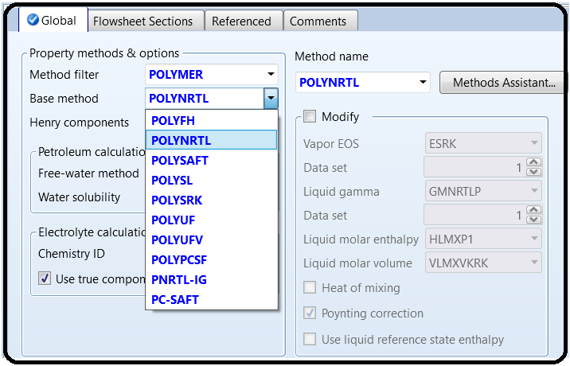

To define molecular weight for component TBP, select Pure Components under Parameters under Methods from the main navigation panel.

Define new pure component parameters, select Scalar type and define the value of 216.32 for the TBP molecular weight as shown in Figure 16.6. Switch to the simulation environment to continue in the simulation.

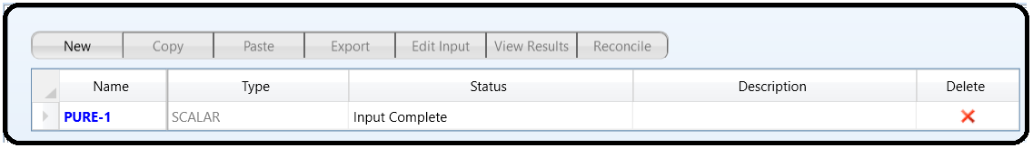

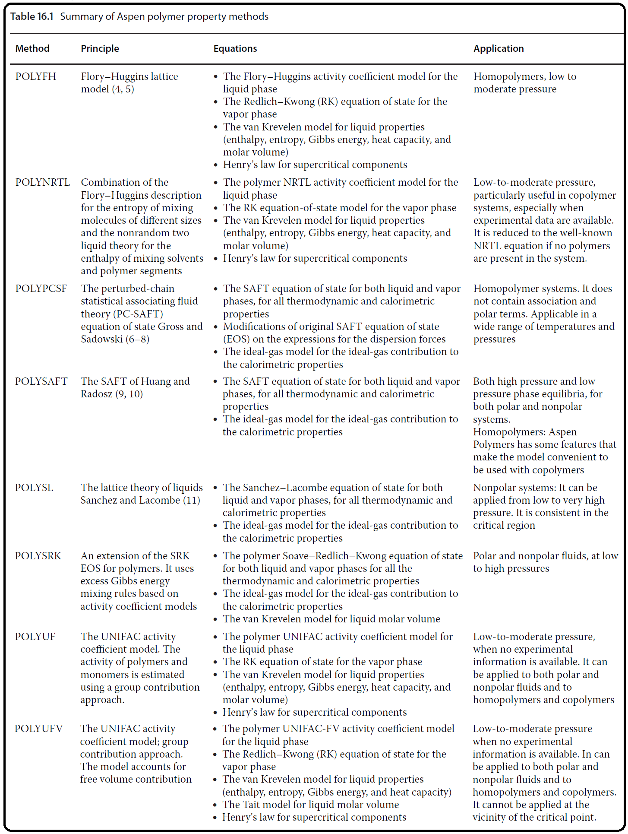

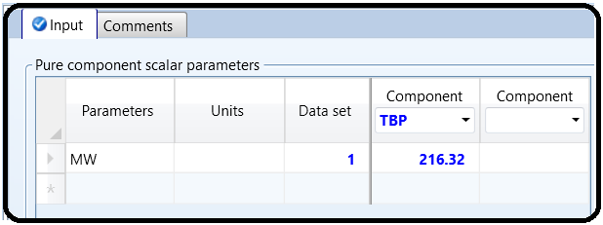

Part 5

PROBLEM DESCRIPTION: WATER DE-SOURING

A sour water stream, which contains 0.20 wt% CO2, 0.15wt% H2S, and 0.1wt% NH3 at a temperature of 85∘C and pressure of 1 atm with a mass flow rate of 5000 kg/h, is to be treated by a dry steam at 1.1 atm and a mass flow rate of 1500 kg/h. The water polluting compounds will be stripped off the sour water and vented, with some amount of water vapor, off the top of the stripping tower. The sweet water will be withdrawn from the bottom of the stripper with almost nil carbon, nitrogen, and sulfur content. The dry stream, entering from the bottom, will act as the vapor stream within the column; hence, there is no need for a reboiler. On the other end, the rising vapor stream will be substantially condensed and recycled to the top of the column as a liquid reflux, whereas the rest of it will be vented off the top of the tower.

WHAT IS AN ELECTROLYTE?

In general, an electrolyte system is made of chemical species that can dissociate partially or totally into ions in a polar liquid medium (i.e., solvent). The liquid phase reaction always exists at its chemical equilibrium condition between the associate (i.e., condensed state) and dissociate (i.e., loose or ionic) form. The presence of ions in the liquid phase requires non-ideal solution thermodynamics, where the activity coefficient, in general, is not unity. Some examples of electrolytes are solutions of acids, bases, or salts, sour water solutions, aqueous amines, and hot carbonates. An electrolytic component can be classified under one of the following categories:

• Solvent: the polar medium. Examples are water, methanol, ethanol, and acetic acid.

• Soluble Gas: a non-condensable gas where its gas liquid equilibrium (alternatively, its solubility in the given solvent) is described by Henry’s law. Examples are N2, O2, Cl2, NH3, and CO2.

• Ion: an ionic (cationic or anionic) moiety with a formal charge. Examples are H3O+, OH−, Cl−, Na+, HCO3 −, CO3 −2, Ca+2, Fe+2, and Fe+3.

• The condensed (aggregate) matter: this form represents the associate (lattice) form of an ionic substance, which can exist in either solid (e.g., salt) or liquid form. Examples are NaCl(s), NaOH(s), H2SO4(l), HCOOH(l), CH3CH2COOH(l), CaCO3(s), CaSO4•2H2O(s), K2SO4(s), Na2HPO4(s), and NaHCO3•2H2O(s).

How to Simulate

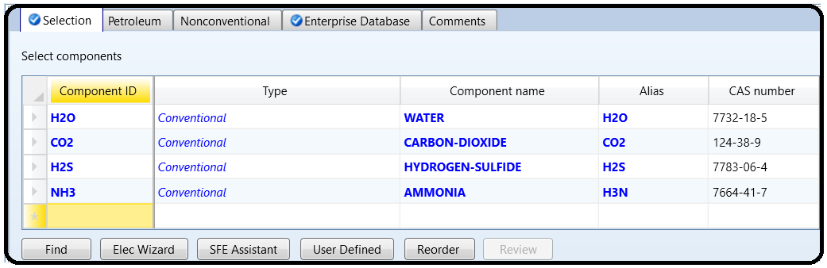1. Using Aspen Plus®, choose “Electrolytes with Metric Units” template to create the process flowsheet. The default property model is “ELECNRTL”. By default, water is added to the “Components” list. Add the three components: CO2, H2S, and NH3, as shown in Figure 11.1.

However, we will show here how to properly define each component as part of the electrolyte system.

2. In “Components” | “Specifications” | “Selection” tab window, click on “Elec Wizard” button (shown in Figure 11.1). This will bring the first “Electrolyte Wizard” window where the user can choose between symmetric and unsymmetric reference state for ionic components.

• For the unsymmetric reference state of ions, the equilibrium constants are calculated from the reference state Gibbs free energies of the participating components. Activity coefficients of ions are based on infinite dilution in pure water. We must have already defined water as a component to use electrolyte wizard for this case.

• For the symmetric reference state of ions, the equilibrium constants are not automatically calculated, and must either be entered here or regressed from data. Activity coefficients of ions are based on pure fused salts. Water is not necessary (though it may be included as a solvent).

We will choose the unsymmetric reference state for ionic components, as it does not require any further input about the equilibrium constants as functions of temperature for the dissociation reactions, as shown in Figure 11.2.

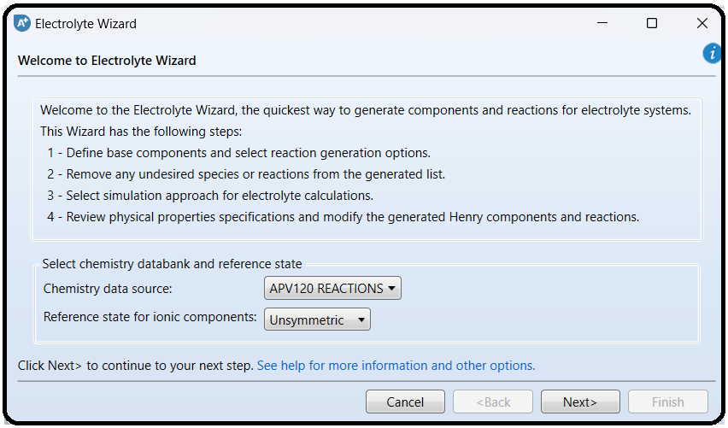

Click on “Next” button to proceed to the next step. Figure 11.3 shows the second “Electrolyte Wizard” window where the user selects what components to include in the electrolyte system. All components are selected to participate in the electrolytic scene. Moreover, the user may select/deselect the appropriate option and how hydrogen ion should be expressed.

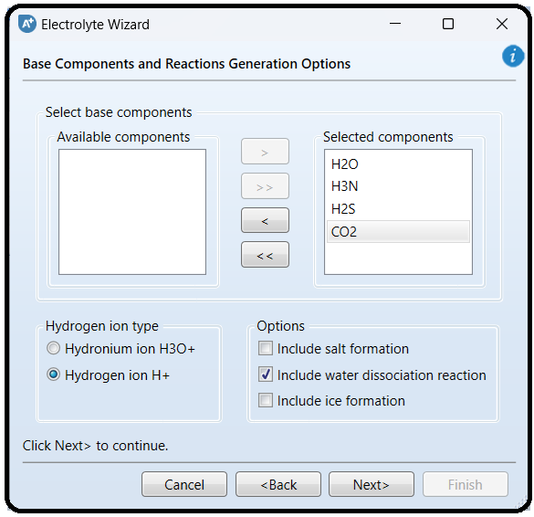

NOTE: It is a multifaceted decision, made by the user, to decide what to include in the list of participating players in the electrolytic portray and the extent of participation each player will do, in addition to the interplay between one player and another. Precisely speaking, let us take CO2 species as an example. We have to decide first whether or not to include CO2 in the first place. If the decision is yes for considering CO2 as an important electrolytic player, then we will have to decide on the assigned task for this player, that is, telling Aspen Plus what reactions are associated with this chemical species. Shall we consider its dissociation into water in the form of HCO3 − only?

Or, shall we consider further dissociation of HCO3 − into CO3 −2? Finally, what about the interplay between HCO3 − and NH3? Keep in mind that the more reactions you add to the electrolytic portray, the more complex the picture will be (or, longer CPU time), which may end up under some circumstances in a non-converging solution, (i.e., errors reported by Aspen Plus simulator), because of missing some pairwise interactions, which need to be plugged in by the user. If it happens that Aspen Plus fails to converge, then you may attempt to remove what you think is the least important electrolytic player (i.e., chemical reaction/species).

Click on “Next” button to proceed to the next step. Figure 11.4 shows the third “ElectrolyteWizard” window where Aspen Plus provides a list of potential reactions based on the stand-alone or interplay role of each of the chemical players nominated in the previous step.

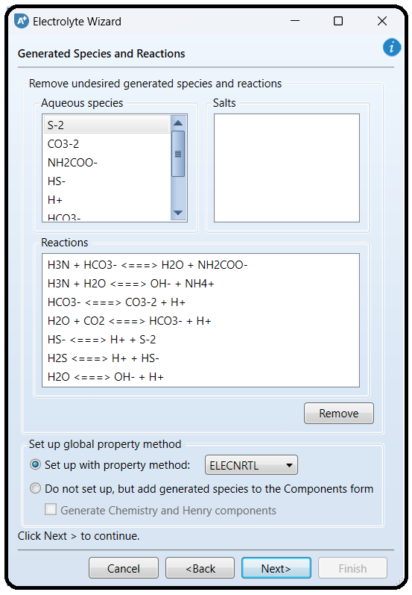

Notice that the user may select to remove one or more of ionic species that are listed and Aspen Plus will remove the corresponding reaction(s). Of course, the decision will be based on experimental observations that a particular ionic species is absent or its presence in the aqueous medium can be neglected. Alternatively, the user may directly remove a specific reaction out of those suggested by Aspen Plus, with the understanding that this reaction contributes little or nothing to the electrolytic portray and thus can be neglected. In other words, at a given pH, the *pKa/pKb* will tell the user if the dissociation extent for an acid/base is significant or can be ignored.

We will proceed without removing any chemical species or chemical reaction. Moreover, the third “Electrolyte Wizard” window (Figure 11.4) allows the user to stick to the default (“ELECNRTL”) method or change to “ENRTL-RK” method. The “ELECNRTL” property method will be selected as it is the most versatile electrolyte property method. Both methods, however, can be used in our case.

NOTE: Electrolyte solutions are extremely non-ideal because of the presence of charged species. The electrolyte-NRTL-based property methods: “ELECNRTL”, “ENRTL-RK”, and “ENRTL-SR” can all handle mixed-solvent systems at any concentration. The “ELECNRTL” property method is the most versatile electrolyte

property method. It can handle very low and very high concentrations. It can handle aqueous and mixed-solvent systems as well. The “ELECNRTL” is fully consistent with the “NRTL-RK” property method (i.e., the molecular interactions are calculated exactly the same way; therefore, “ELECNRTL” can inherit from the databank for binary molecular interaction parameters of the “NRTL-RK” property method). On the other hand, the solubility of supercritical gases can be modeled using Henry’s law. Henry coefficients are available from the databank. Heats of mixing are calculated using “ELECNRTL” model. Moreover, the “ENRTL-RK” method is identical to “ELECNRTL” for systems containing a single electrolyte. However, for mixed-electrolyte systems, the “ENRTL-RK” method uses the mixing rules only to calculate pairwise interaction parameters, instead of calculating both pairwise interaction parameters and Gibbs free energy from mixing rules. Furthermore, the “ENRTL-RK” uses a single thermodynamics framework to calculate the activity coefficients, Gibbs free energy, and enthalpy, instead of using separate models as in “ELECNRTL”. Finally, “ENRTL-RK” uses the Redlich–Kwong equation of state for all vapor-phase properties, except for association behavior in the vapor phase; the unsymmetric reference state (infinite dilution in aqueous solution) for ionic species; Henry’s law for solubility of supercritical gases; and unsymmetric Electrolyte NRTL method of handling zwitterions.

Click on “Next” button to proceed to the next step. The fourth “Electrolyte Wizard” window will show up as shown in Figure 11.5, where the user is given the choice to select between *true-* and *apparent-*component approaches.

The difference in the approaches lies in the level of technical details on how Aspen Plus shall present the results of calculation of electrolyte solution properties. The “True component approach”, I call it the chemist’s approach, reports results in terms of the ions, salts, and molecular species present (i.e., showing the details of solution chemistry). On the other hand, the “Apparent component approach”, I call it the chemical engineer’s approach,

reports results in terms of base components present without showing the details of solution chemistry. In the latter approach, ions and precipitated salts cannot be apparent components; specifications must be expressed in terms of apparent components and not in terms of ions or solid salts. Of course, results of both approaches are equivalent. Let us take a simple example, that is, *NaCl* in water.

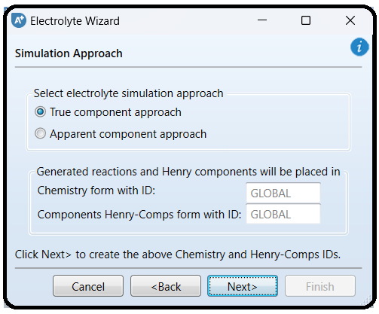

a) For the “True component approach” (i.e., showing solution chemistry):

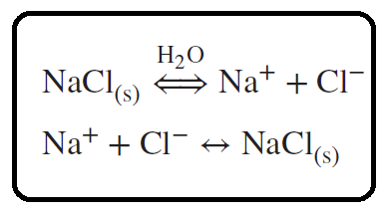

Results are thus reported in terms of Na+*,* Cl−*,* NaCl(s)*,* and H2O.

b) For the “Apparent component approach” (i.e., hiding the solution chemistry), the results are reported in terms of NaCl (Conventional)andH2Oonly.

Click on “Next” button to proceed to the next step. The “Update Parameters” window will pop up requesting to update the form parameters (i.e., list of components). Click on “Yes” button to proceed. You may have to click more than once. Figure 11.6 shows the fifth “Electrolyte Wizard” window summarizing what the user has already selected in previous steps and giving the chance to review and modify the chemistry of the electrolyte system under study.

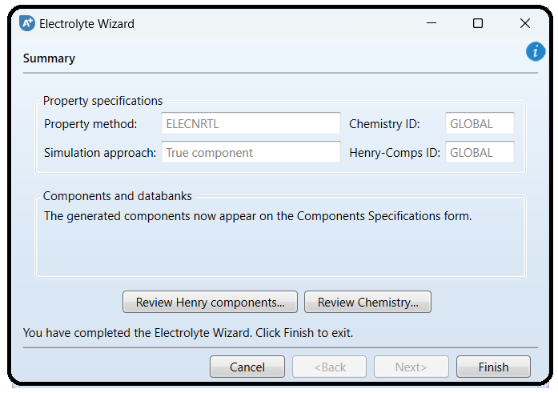

The user ought to click on “Review Henry components…” button to review the list of components that should be dealt with as Henry’s case (Figure 11.7). Alternatively, Henry’s set can been seen via visiting “Components” | “Henry Comps” | “Global” | “Selection” tab form.

On the other hand, the user may click on “Review Chemistry…” button to see the list of electrolytic equilibrium reactions, which are considered important players in the arena of the given electrolytic system (Figure 11.8). The user may edit, modify, or delete a given reaction and/or add a new one. Alternatively, the user may later go to “Chemistry” | “GLOBAL” | “Input” | “Chemistry” tab window and modify them from there. Moreover, if you click on “Equilibrium Constants” tab (the second tab in Figure 11.8), you will notice that Aspen Plus has already taken care of calculating the equilibrium constant, *K*eq, for each electrolytic equilibrium reaction.

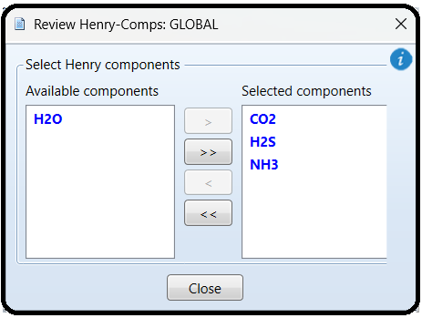

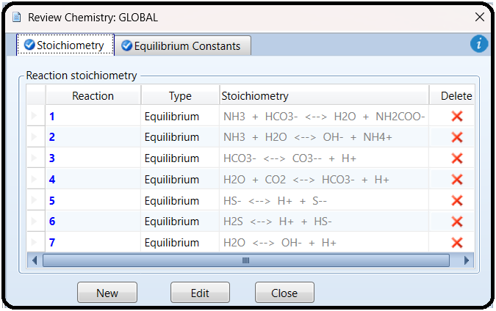

Click on “Finish” button (Figure 11.6) to close the wizard. Figure 11.9 shows that, under “Components” list, more chemical species are added, reflecting the types of ionic species

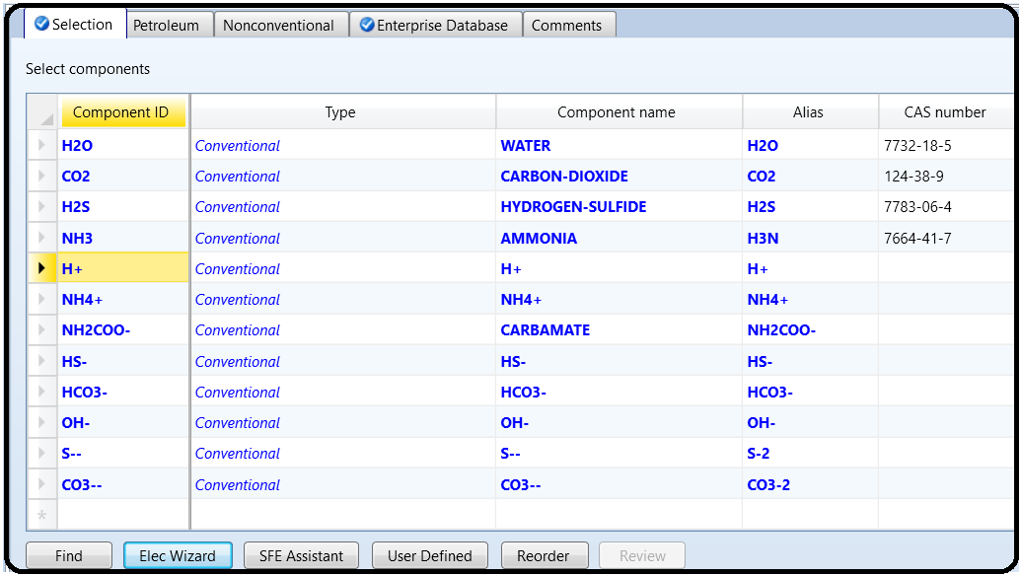that are considered important in portraying the electrolytic picture, as agreed upon earlier in Figure 11.4.

From “**Navigation**” pane, you will notice that there are half-filled red circles, which

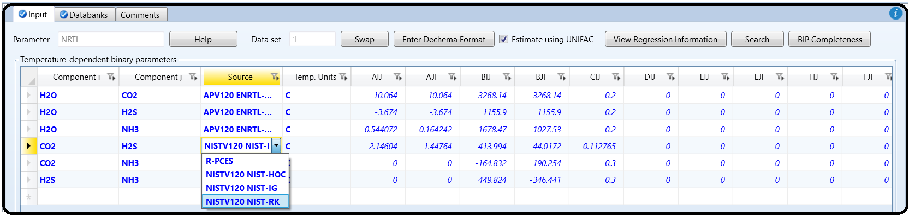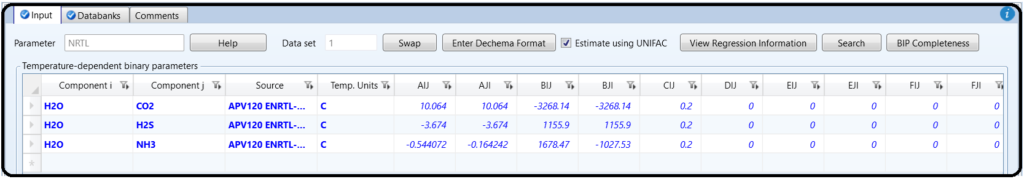means that they require either more input data or parameter estimation. Click on “**Next**” button more than once until you get rid of all red signs and the Aspen Plus sky becomes clear blue. Assure that the missing pairwise interaction parameters can be calculated by “**UNIFAC**” method. Once the properties analysis completed successfully, switch to “**Simulation**” environment.

Part 6

SOLIDS CLASSIFICATION

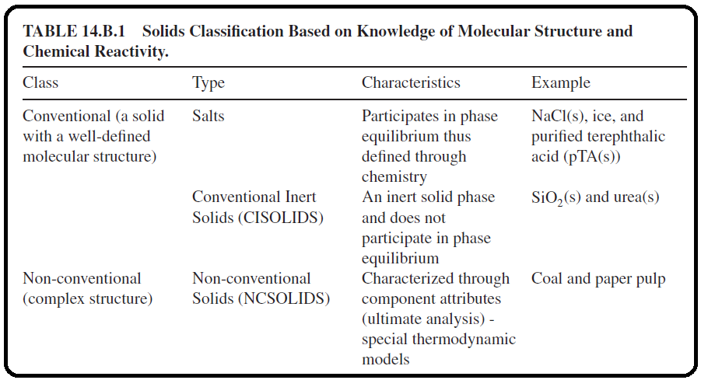Solids are classified by Aspen Plus as shown in Table 14.B.1.

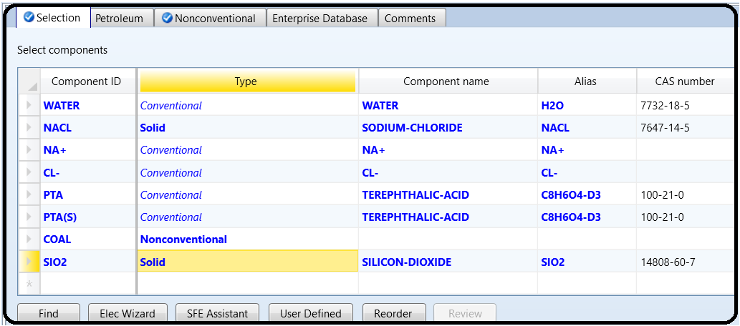Figure 14.B.1 shows how one can define the same component using different types; hence, a different “Component ID” will be created each time. For example, if “NACL” is defined as “*Conventional*”, then it will be part of the aqueous medium (i.e., participates in phase equilibrium); on the other hand, if it is defined as “NACL(S)”, that is, “*Solid*”, then it will be treated as inert (i.e., will not be part of the aqueous medium). Silica being defined as “*Solid*” means it is with a known molecular structure; on the other hand, coal being defined as “*Nonconventional*” means that it has a complex structure.

Part 7

PROBLEM DESCRIPTION

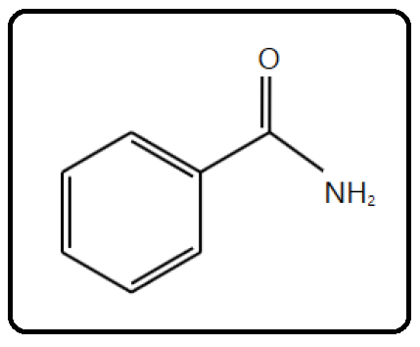

Benzamide (C7H7NO), with a molecular weight (MW) of 121.14, is an aromatic amide that consists of benzene bearing a single carboxamido substituent. Its **S**implified **M**olecular-**I**nput **L**ine-**E**ntry **S**ystem (SMILES) formula is NC( O)C1 CC CC C1. It is a transparent crystalline substance, obtained by the action of ammonia upon chloride of benzoyl, as also by several other reactions with benzoyl compounds. It has a melting point of 130∘C, a normal boiling point of 288∘C, and a density of 1.341 g/cm3. It is slightly soluble in water and more soluble in ethyl alcohol and carbon tetrachloride. It is used in chemical synthesis. Benzamide is the most potent poly(ADP-ribose) polymerase (PARP) inhibitor in the family of benzamides (PARP inhibitors can be used as anticancer agents, radiosensitizers, and antiviral agents). Benzamide is used as a potent antiemetic (against vomiting), antidepressant, and anticholinergic (a substance that opposes or blocks the action of acetylcholine, sleep aid, daytime sedative, when more potent agents are contraindicated).

In this chapter, I guide the reader through the procedure for estimating the physical properties for this component as if it were not present in the Aspen Plus databanks. Plugging the molecular structure and some known molecular properties of benzamide will be sufficient for Aspen Properties to estimate typical thermodynamic and transport properties. It should be noted that benzamide is already an Aspen Plus databank member (i.e., fully characterized). So, why do we need to use a known databank member? Well, it is simply for the sake of comparison; the estimated properties will be contrasted versus those of the built-in (Aspen Plus databank member) benzamide component. At the same time, it will be used as an example to demonstrate how to use Aspen Properties as a tool to almost fully characterize a material with a little information about it.

How to Simulate

1. Using Aspen Plus, start a new simulation by choosing the “Pharmaceutical” category and selecting “Pharmaceuticals with Metric Units” template to create a steady-state flow sheet. Notice that the default property method is set to “NRTL” (Figure 13.1).

2. Next, we will define a component called BNZMD-UD. The suffix “UD” means User-Defined. In the first line of the “Component ID” column, enter “BNZMD-UD”. Diligently, hit “tab” or “enter” key and Aspen Plus will automatically assign the “*Conventional*” type for such an unrecognized name of a component. Notice that “BNZMD-UD” is not present in any of the Aspen Plus databanks; hence, “Component name” and “Alias” column remain empty, as shown in Figure 13.2.

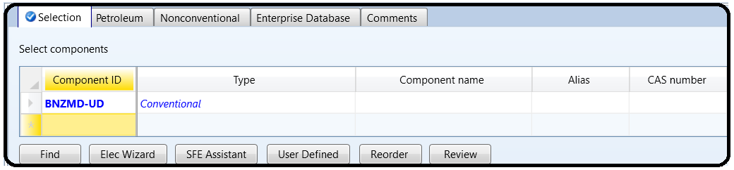

Next, we will tell Aspen Plus to estimate missing parameters using “UNIFAC”. Under “Properties” environment, go to “Methods” | “Parameters” | “Binary Interaction” | “NRTL-1” sheet and be sure that the “Estimate missing parameters by UNIFAC” option is selected. Next, enter the molecular structure of BNZMD-UD. Click on “Next (N→)” button and Aspen Plus will bring you to “Components” | “Molecular Structure” | “BNZMD-UD” | “General” tab sheet.

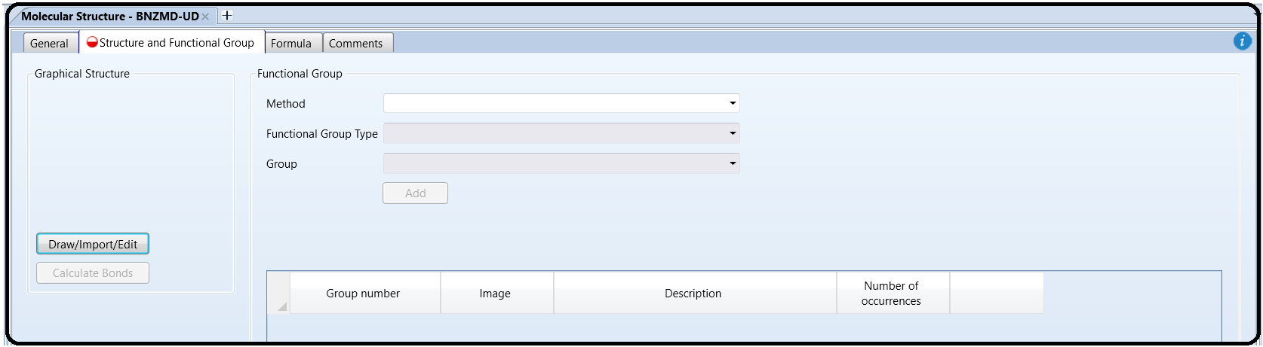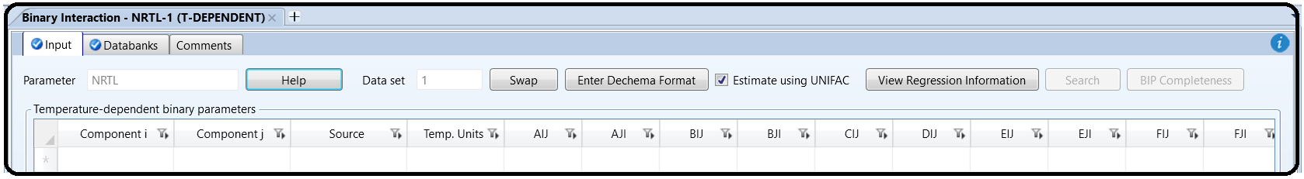

Note: You can define the molecular structure in different ways: Using the “General” sheet, which is based on individual atoms and bonds (i.e., molecular connectivity); using the “Functional Group” tab sheet in which you indicate the functional groups specific to a particular estimation method; or using “Structure” tab sheet. In old versions of Aspen, we used to define the molecular structure via the “General” tab sheet, or import *.mol file. In this chapter, we explain how to define the structure of a molecule using the “Molecule Editor” of Aspen Plus.

Figure 13.3 shows the “Structure” tab sheet where it is still empty as we did not yet define the molecular structure of “BNZMD-UD”. Click on “Draw/Import/Edit” button, shown in Figure 13.3, to open the “Molecule Editor” window as shown in Figure 13.4. This window is made of the main window and three left panes. The first (i.e., top left) pane represents the types of bonds (i.e., single, double, triple, neutral, or charged) to be used; the second (i.e., middle) pane allows the user to select the atom to be installed alone (for the first time), or attached to an existing structure with a type of bond already selected in the first pane; and the third (i.e., bottom left) pane gives the user the flexibility to choose a segment or fragment as part of a molecule, such as the phenyl aromatic ring, without having to build the segment itself from scratch. Once you click on the phenyl ring from the “Fragments” panel, drag it to the working area, decide on the proper location of the phenyl ring, release the mouse, and hit one left-click. The phenyl group will then show up, as shown in Figure 13.5. Alternatively, click on the proper fragment and go to the proper location in the working area and hit one left-click. Either way, to stop adding more blocks of the same type, just right-click the mouse or press “Escape” key. Click on the arrow icon found in the top-left tool (second raw) and in drag (left mouse pressed) mode, you can draw a rectangle around any existing object, then you may delete that enclosed object. Figure 13.6 shows that once I highlight the “*C atom*” icon from “Atoms” pane and select the “*Single bond*” icon from “Bonds and Charges” pane; I move the mouse to one of the corners (i.e., ring carbon atoms) of phenyl ring, where “CH” group will appear exactly beneath the mouse at the selected corner; and then I left-click the mouse once. Right-click to stop adding more of the same type. As I did in the previous step, highlight the “*O atom*” icon from “Atoms” pane and select the “*Double bond*” icon from “Bonds and Charges” pane; move the mouse exactly onto the top of the methyl group; left-click and drag away the mouse; and then release the left mouse. Right-click the mouse to stop adding more of the same type. Figure 13.7 shows the new changes after the attachment of “*O*” atom to the methyl group via the double bond. Finally, highlight the “*N atom*” icon from “Atoms” pane and select the “*Single bond*” icon from “Bonds and Charges” pane; move the mouse exactly onto the top of the carbon atom of the carbonyl group, where “CH” group will appear underneath the mouse; left-click and drag away the mouse; and then release the left mouse. Right-click the mouse to stop adding more of the same type. Figure 13.8 shows the latest changes after the attachment of “NH2” group to the carbonyl group via the single bond.

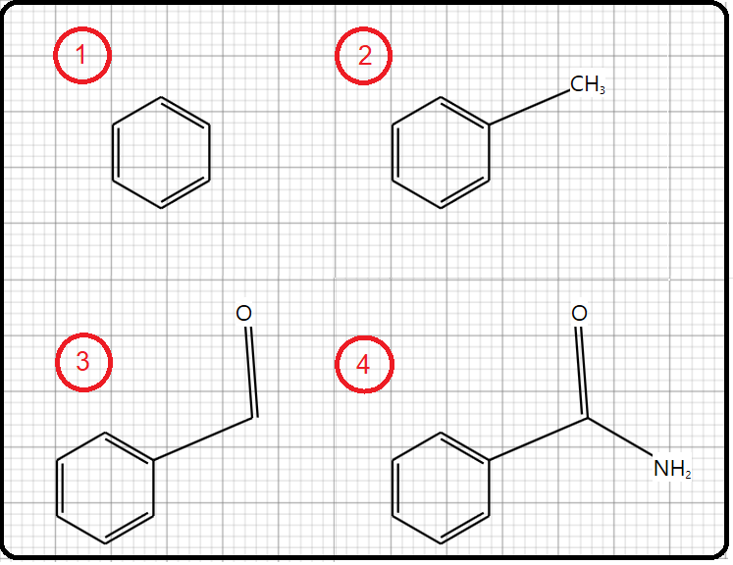

Click on “Calculate Bonds” button so that Aspen Plus will transform the image into known bonds and atoms (i.e., their bond energies and lengths will be calculated). Figure 13.11 shows the “General” tab window where the atomic connectivity has been automatically calculated by Aspen Plus, based on the defined molecular structure under “Structure” tab.

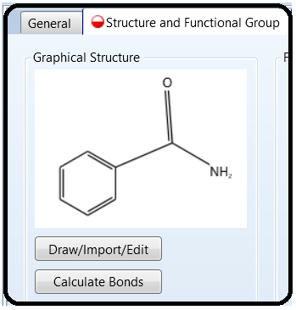

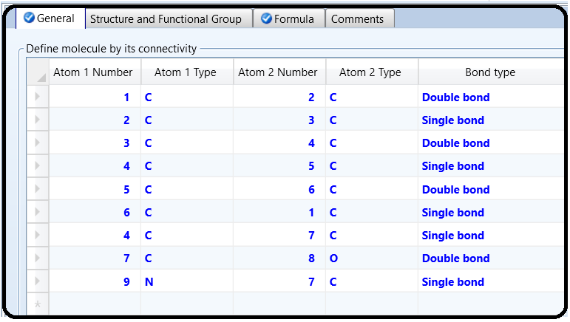

Figure 13.12 shows the formula tab window where Aspen Plus tells us that our lovely benzamide molecule is made of seven carbon atoms, seven hydrogen atoms, one nitrogen atom, and finally one oxygen atom.

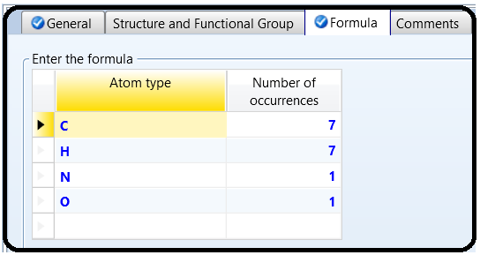

Next, we will enter the known property data for “BNZMD-UD”. The molecular structure information is sufficient for Aspen Plus to estimate properties. However, entering all available data will further improve the accuracy of the Aspen Plus properties estimation. To demonstrate this point, if the user attempts to run the property estimator at this point, then Aspen Plus will do its best to carry out the property estimation process; nevertheless, the estimated properties will not be accurate enough. Figure 13.13 shows some of the estimated properties where the estimated boiling point (“TB”) is given as 239.49∘C. The experimental value is 288∘C. This means that more experimental data are to be supplied by the user in order to have a better property estimate.

To enter the boiling and freezing point for “BNZMD-UD”, execute the following steps:

1. In “Navigation” pane, go to “Methods” | “Parameters” | “Pure Components” and click on “New…” button.

2. In the “New Pure Component Parameters” dialog box, select “*Scalar*”, as shown in Figure 13.14.

3. Enter the new name “BNZMDPRP” and click on “OK” button. The “Methods” | “Parameters” | “Pure Components” | “BNZMDPRP” | “Input” tab sheet appears.

4. In the first “Component”-labeled column, click the drop-down arrow and select “*BNZMD-UD*”.

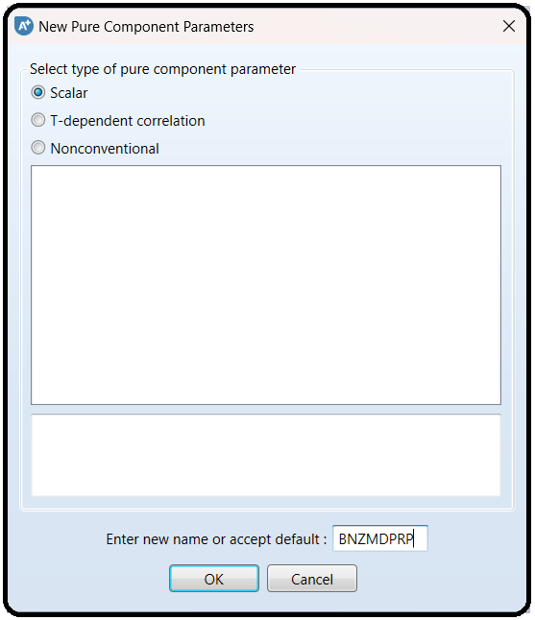

5. Click beneath the “Parameters” column, and select “*RHOM*” (mass density).

6. Click the second horizontal cell under the “Units” column, and select *gm/cc* (g/cm3) and in the corresponding cell, beneath the fourth column, enter *1.341* as the value of density.

7. Click below “*RHOM*” cell and select “*TB*” (normal boiling point).

8. Select ∘*C* for “*TB*” unit and in the corresponding cell, beneath the fourth column, enter *288* as the value of normal boiling point.

9. Click below “*TB*” cell and select “*TFP*” (freezing point).

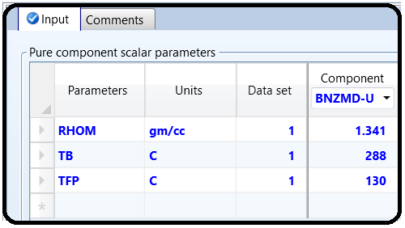10. Select ∘*C* for “*TFP*” unit and in the corresponding cell, beneath the fourth column, enter *130* as the value of freezing point. Figure 13.15 shows that “BNZMDPRP” property is now defined and contains the mass density (“RHOM”), the normal boiling point temperature (“TB”), and the freezing point temperature (“TFP”) for “BNZMD-UD” compound.

We have already entered the pure component property data for “BNZMD-UD” compound. Aspen Plus is now ready to compute the missing properties of “BNZMD-UD” compound. Run the simulator and monitor warning and errors (if any) via the “Control Panel”. There might be some warnings as shown in Figure 13.16 but such a warning can be ignored.

Figure 13.17 shows a portion of estimated properties under “PCES-1” sheet for our lovely “BNZMD-UD” molecule. Typical physical (thermodynamic and transport) properties are also shown under the sheets starting from “CPIG-1” and ending up with “SIGDIP-1”.

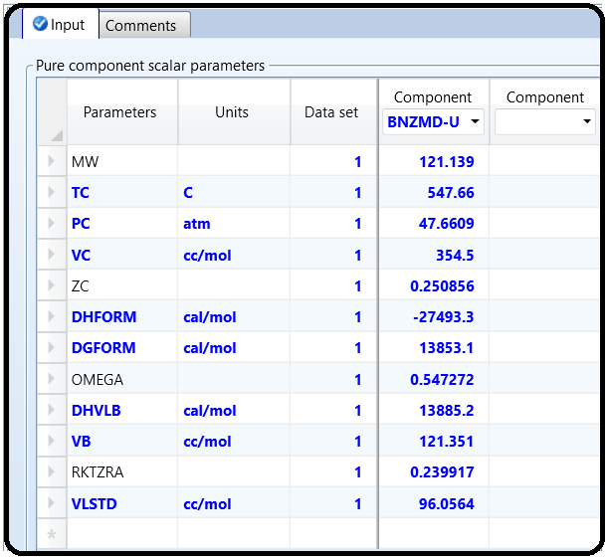

Reference

1.Our team experience

2. Aspen Plus – Chemical Engineering Application by KAMAL I.M. AL-MALAH

3.Chemical Process Design and Simulation

4.Aspen Plus build-in help

5.Aspen Technology. *Aspen Polymers, Unit Operations and Reaction Models*. Burlington, MA: Aspen Technology, Inc.; 2013.

6.Aspen Technology. *Aspen Polymers, Examples and Applications*. Burlington, MA: Aspen Technology, Inc.;2013.

7.Aspen Technology. *Aspen Polymers User Guide, version 3, Vol. 1*. Burlington, MA: Aspen Technology,Inc.; 1997.

8.Flory PJ. Thermodynamics of high polymer solutions. *J. Chem. Phys.* 1941;9(8):660–660.

9.Huggins ML. Solutions of long chain compounds. *J. Phys. Chem.* 1941;9(5):440–440.

10.Gross J, Sadowski G. Application of perturbation theory to a hard-chain reference fluid: An equation of state for square-well chains. *Fluid Phase Equilib*. 2000;168(2):183–199.

11.Gross J, Sadowski G. Perturbed-chain SAFT: An equation of state based on a perturbation theory for chain molecules. *Ind. Eng. Chem. Res.* 2001;40(4): 1244–1260.

12.Gross J, Sadowski G. Modeling polymer systems using the perturbed-chain statistical associating fluid theory equation of state. *Ind. Eng. Chem. Res.* 2002;41(5): 1084–1093.

13.Huang SH, Radosz M. Equation of state for small, large, polydisperse, and associating molecules. *Ind. Eng.Chem. Res.* 1990;29(11):2284–2294.

14.Huang SH, Radosz M. Equation of state for small, large, polydisperse, and associating molecules: Extension to fluid mixtures. *Ind. Eng. Chem. Res.* 1991;30(8): 1994–2005.

15.Sanchez IC, Lacombe RH. An elementary molecular theory of classical fluids. Pure fluids. *J. Phys. Chem.* 1976;80(21):2352–2362.

16. Aspen Plus ®V9 Help. Burlington,MA: Aspen Technology, Inc.; 2016. [www.aspentech.com](http://www.aspentech.com)

17. Haydary J, Tom´aˇs P. Steady-state and dynamic simulation of crude oil distillation using Aspen Plus and Aspen Dynamics. *Pet. Coal* 2009:51(2):100–109.

18**.** Chao KC, Seader JD. A general correlation of vapor–liquid equilibria in hydrocarbon mixtures. *AIChE J*. 1961;7(4):598–604.

[1] Wang, Lawrence K., Pereira, Norman C., Hung, Yung-Tse, “*Air Pollution Control Engineering*”, Springer Science & Business Media, LLC, New York, (2004), 276.

[2] Chen, C.-C., Britt, H.I., Boston, J.F., and Evans, L.B. (1982) Local compositions model for excess Gibbs energy of electrolyte systems: part I: single solvent, single completely dissociated electrolyte systems. *AIChE Journal*, **28** (4), 588–596.

[3] Chen, C.-C. and Evans, L.B. (1986) A local composition model for the excess Gibbs energy of aqueous electrolyte systems. *AIChE Journal*, **32** (3), 444–459.

[4] Mock, B., Evans, L.B. and Chen, C.-C. Phase equilibria in multiple-solvent electrolyte systems: a new thermodynamic model. Proceedings of the 1984 Summer Computer Simulation Conference, p. 558–562 (1984), held in Boston, Massachusetts, USA.

[5] Mock, B., Evans, L.B., and Chen, C.-C. (1986) Thermodynamic representation of phase equilibria of mixed-solvent electrolyte systems. *AIChE Journal*, **32** (10), 1655–1664.

[6] Eisa, O. and Shuhaimi, M. (2010) Thermodynamic study of hot potassium carbonate solution using Aspen Plus. *World Academy of Science, Engineering and Technology*, **4** (2), 221–225.