Part 4

Pressure Change in Aspen Plus



Objectives:

1.Learn to use different pressure change elements such as pumps, valves, pipe segments.

2.Become familiar with pages and Tabs of each element and how to fill in the required inputs.

3.Get to know the critical conditions and its causes for each pressure change elements.

4.Learn to use Sensitivity in Aspen Plus

5.Learn to use Design Specs in Aspen Plus

6.Understand pressure level heuristics for compressors and turbines

7.Understand the difference between heat, material, and work streams

Problem Definition

Forty tons per hour of water with the temperature of 20 ◦C has to be pressured from 1 to 6 bar.

a. Calculate the electricity requirement of the pump if its efficiency is 70%.

b. The pump characteristic curve *H*=*f*(*Q*) provided by the producer is given in Table 4.1; considering the same efficiency as in point *a*, calculate the discharge pressure, head developed, and NPSH available.

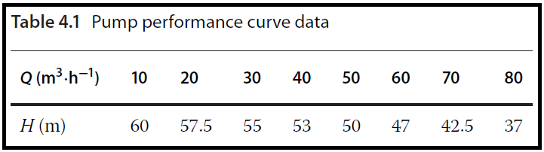

Use Aspen Plus in this simulation.

* Open Aspen Plus, select a component list and the appropriate thermodynamic method as explained in Chapters 1 and 2.

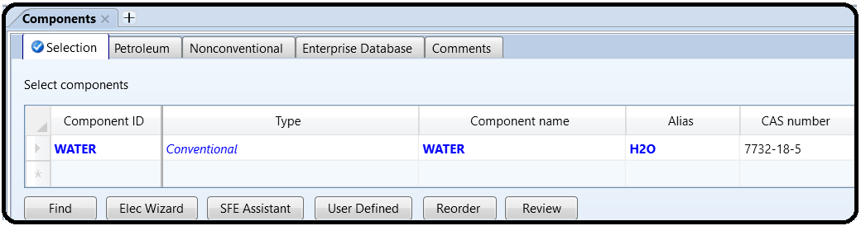

* Switch to *Simulation* environment and prepare the process flowsheet by the same method as shown in Example 2.12; we need only a *Pump* block, which can be selected from the menu of *Pressure Changers;* the flowsheet is completed by drawing one input and one output material streams. Rewrite the block name from B1 to Pump (see Figure 4.2).

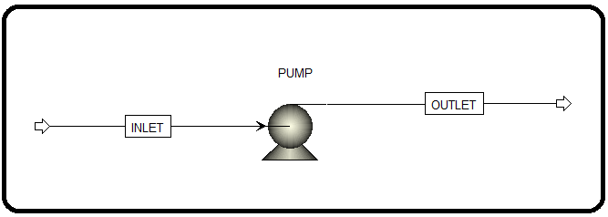

* Specify the inlet stream by the same method as in Example 3.1.

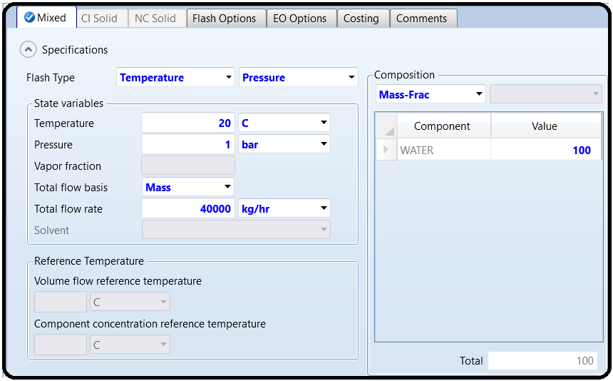

* To find a solution for case *a* in the *Setup* page of *Pump* block, select *Discharge Pressure* and specify the required value as shown in Figure 4.3; on the same page, specify also the value of pump efficiency.

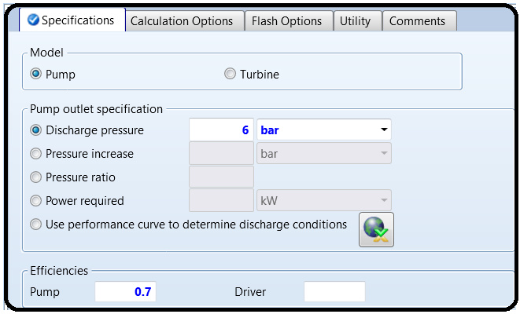

* Run the simulation; after the calculation is done, check the results for case *a* on the *Results* sheet (Figure 4.4); required electricity has the same value as *Brake power*which is around 8 kW.

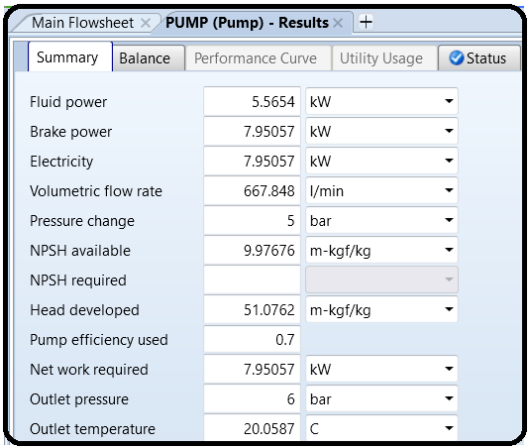

* To find a solution for case *b*, select *Use Performance Curve* on the *Setup* page to determine discharge conditions.
* Use the value of efficiency from previous calculation.
* Move to the *Performance Curve* sheet; and on the *Curve Setup* page, select *Head* as the performance variable and *Vol-Flow* as the flowvariable; select curve format as *Tabular Data* and number of curves as *Single Curve at Operating Speed*.
* On the *Curve Data* page, select unit of head as meter and unit of flow as m3⋅h−1, then enter curve data as shown in Figure 4.5*.*

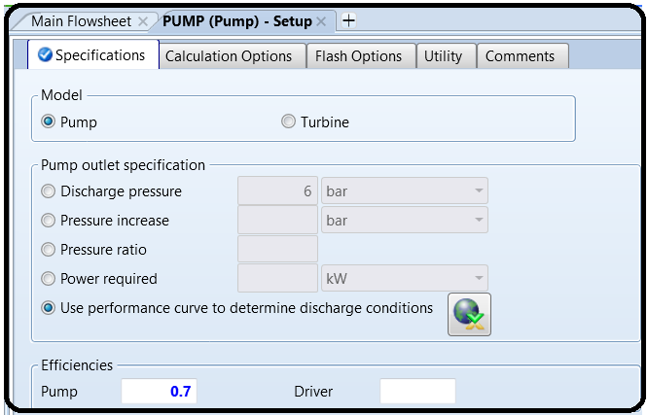

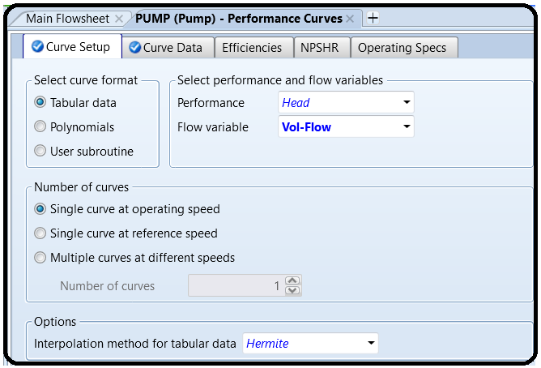

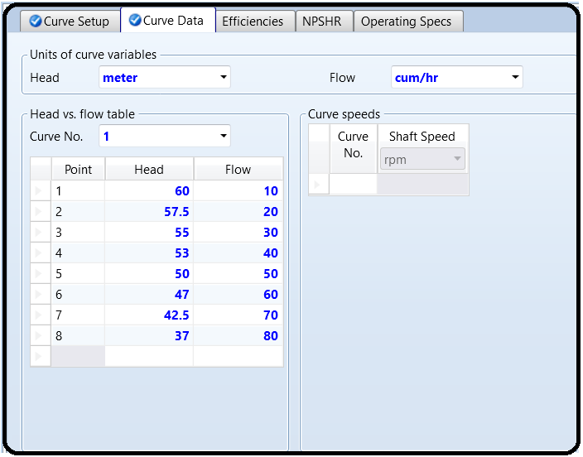

* Run the simulation and check the results on the *Results* page.
* As it results from Figure 4.6, the outlet pressure is around 6.2 bar, head developed is near 53 m, and NPSH available is 9.97 m.

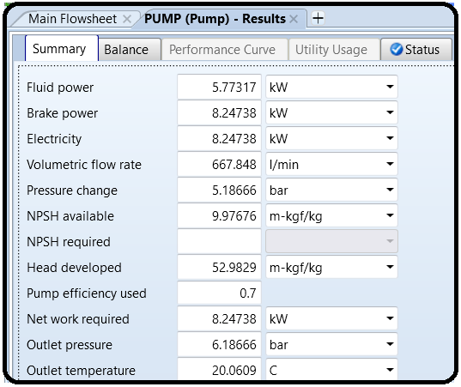

Problem Definition

It is customery in process plants, refinaries and petrochemicals to transport a liquid or products from one storage tank to another in case of emergencies or for storage purposes. For instance, in some large methanol plants or refinaries there are a daily product storage tank as well as a weekly storage tank. When the capacity of the daily tanks reaches its maximum, the control room operators start transporting the purified methanol from daily tanks to weekly tanks. In this regard, as shown below, in order to transport the liquid some equipment such as piping for transport, control valve for measurement and level control and pumps for increasing the pressure are required.

Example:

In a utility plant, the operator in control room is supposed to transport the water from TK-4001 to TK-5001. As shown on the following P&ID, through passing the pipes, water passes through valves LV-4010, FV-4010 and then a pump P-4010 and FV-4020, LV-4020 and finally reaches TK-5001.

How to simulate

1. Choose “Specialty Chemicals with Metric Units” template to create a steady-state flow sheet.

2. Go to Properties/Set-up/Specification and in Global Tab, give it the name of “Water Transport”

3. Go to Properties/Component/ and Find water.

4. Given the fact that the ASME steam tables are less accurate than the NBS/NRC steam tables, set the property method to “STEAMNBS”. The NBS/NRC steam tables are embedded, similar to any other equation of state, within the built-in “Aspen Physical Property System”. These steam tables can calculate any thermodynamic property of water. There are no parameter requirements.

5. Click “Reset” followed by “Next” button to run the simulation and assure that properties’ analysis completed successfully. Switch to “Simulation” environment.

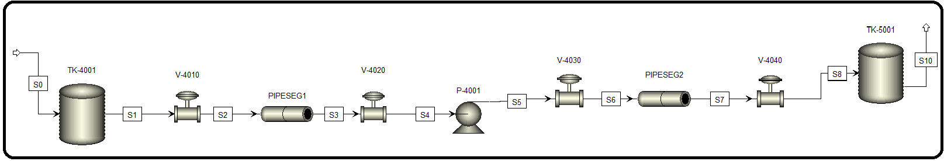6. Set-up the flowsheet based on the P&ID or the following Aspen Plus flowsheet.

In “Model Palette”, click on “Pressure Changers” tab. Under this tab, you will have many options that you can choose from for fluid flow purposes. Those unit operations can be used to model fluid flow processes. Pipes, pumps, and valves are chosen from such a category. On the other hand, the storage tank is chosen from the “Mixers/Splitters” tab under “Mixer” category. Figure 8.2 shows that water is brought to “TANK-4001” from an external source and it will be transported to “TANK-5001” *via* means of connecting pipes, valves, fittings, and a pump. Moreover, “TANK-4001” exists at a pressure of 2 atm where it suffices to push the liquid water until the entrance of the installed pump (installed at the midpoint between the two tanks). Water will continue its journey to “TANK-5001” by the virtue of the pump work (i.e., compression).

7.Click Next and fill-up the inputs for stream 0 based on table XX and the figure XX:

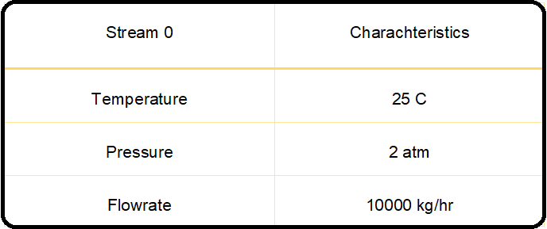

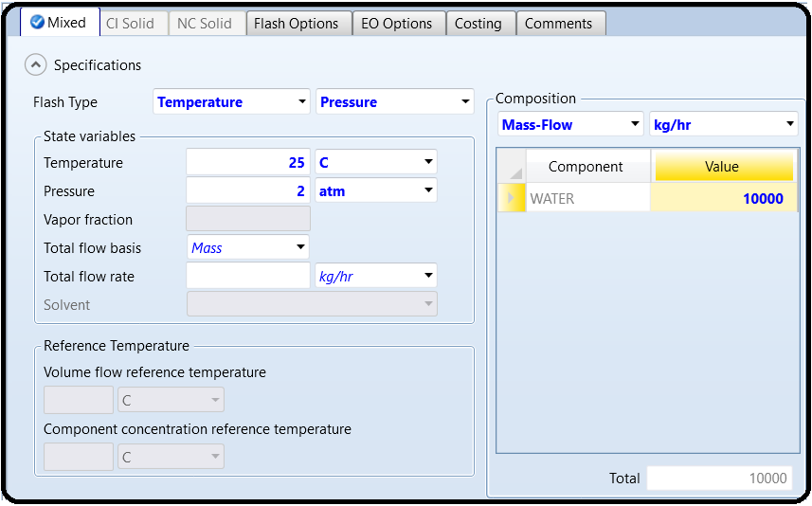

8. Click Next and fill-up the inputs for P-4001 based on the figure:

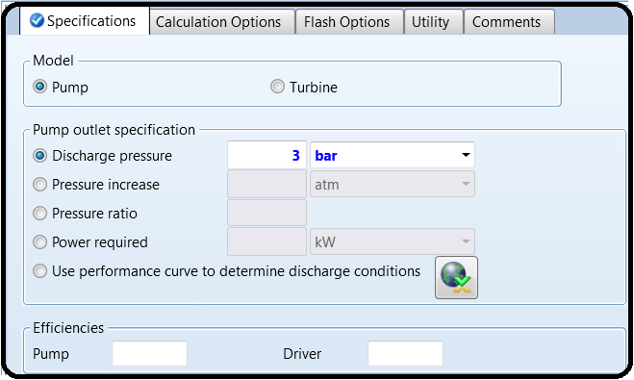

9. Click Next and fill-up the inputs for Pipe segment 1 and 2 based on the figure:

Figure 8.7 shows specifications for “PIPE-1” block, where its length is set to 1 km and diameter to 2.5′′ nominal, with 40S schedule number, in “Thermal Specification” tab window, select the “Thermal specification type” to be “*adiabatic*”. In “Fittings1” tab window, the screwed connection type was selected as shown in Figure 8.8. The AWWA [2] states that “Isolating valves in the distribution system should be located less than 500 ft apart (150 m) in business districts and less than 800 ft (240 m) apart in other parts of the system”. Let us install three valves at 250, 500, and 750m from the start of the pipe. We have already one valve just before and another just after the pipe. In addition, we have six 90∘elbows and ten straight tees. In general, screwed (threaded) ends, usually but not necessarily confined to pipe sizes of 150mm or less, are widely used for bronze valves and to a lesser extent in iron and steel valves. On the other hand, flanged end valves are made in sizes from 150mm upward. A flanged fitting is a type of connection used to join two or more pipes. Each of the pipes must be equipped with a flange, or raised ridge that runs around the outside perimeter of the pipe. Installers connect the two flanges *via* compression using bolts, clamps, or other fasteners. A flanged fitting may be used, however, in place of traditional threaded connectors, welding, or soldering. Some types of flanges are used in conjunction with welding or soldering to create a stronger pipe joint.

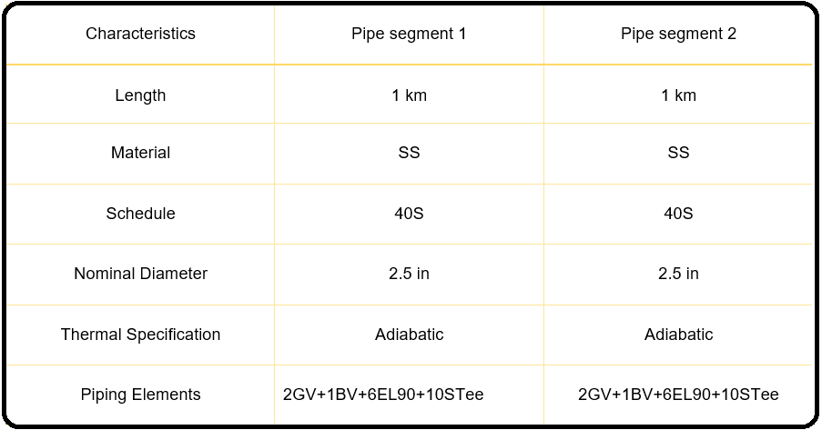

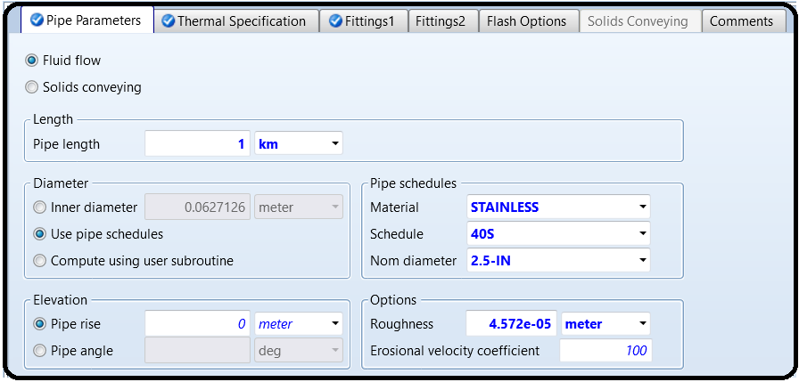

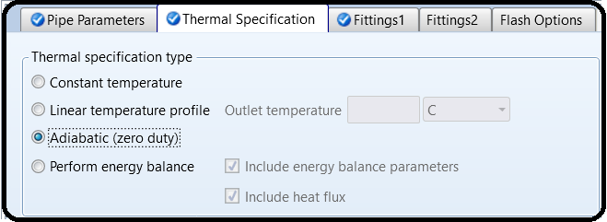

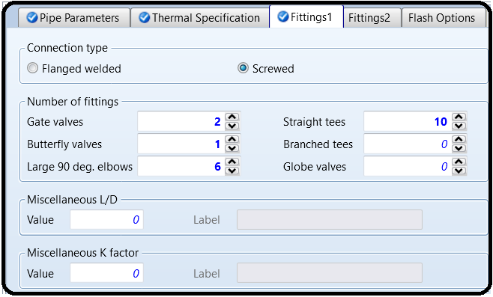

10. Click Next and fill-up the inputs for V-4010, V-4020, V-4030, V-4040 based on the figure:

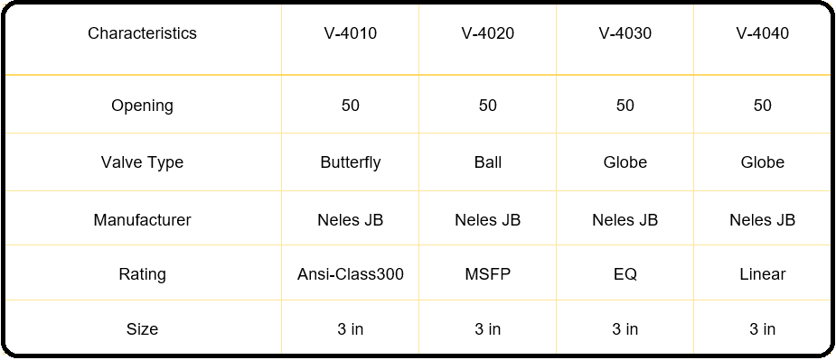

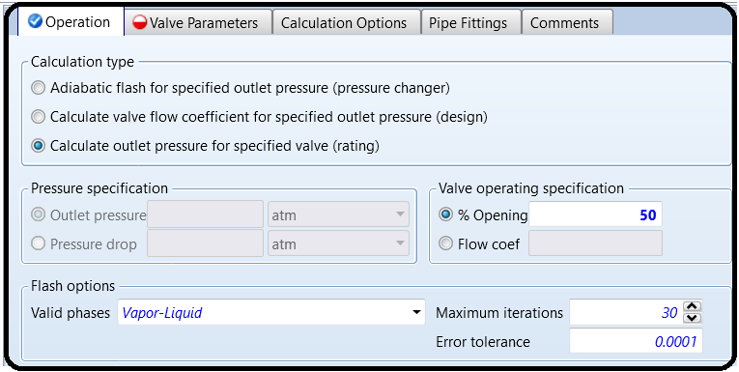Figures 8.4 shows the options for calculating the outlet pressure and specification for percent valve opening pertaining to the first valve, that is, “VALVE-1” block.

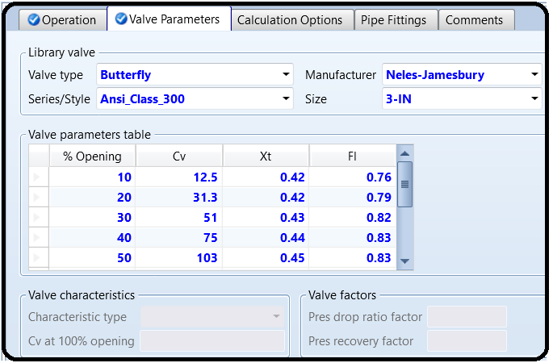Figure 8.5 shows “Valve Parameters” tab window where the user enters the valve type and its manufacturer. Notice that the butterfly type valve is used to regulate the flow rate of fluid *via* increasing or decreasing the opening area available for flow.

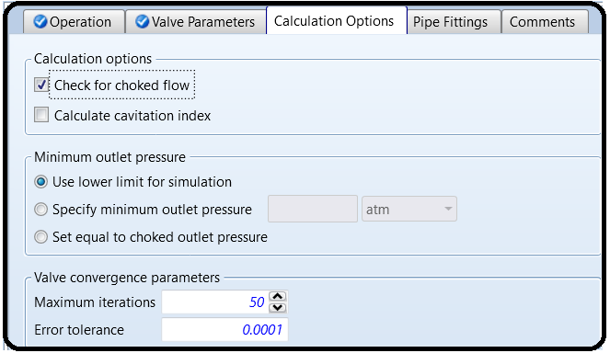

Figure 8.6 shows “Calculations Options” tab window where Aspen Plus checks for the existence of choking condition. Notice that the choked flow for a compressible fluid, such as gases and vapors, is a limiting condition at which the choking occurs for an isentropic expansion condition (i.e., reduction in pressure below a certain critical value) such that the exit plane velocity is at sonic conditions or at a Mach number of 1 (velocity of sound in an open air). At a choked flow condition, the mass flow rate is primarily dependent on the cross-sectional area of the hole, the upstream pressure, *P*0, and weakly on the fluid temperature. The rate does not depend on the downstream pressure, at all. On the other hand, for liquids, if the fluid is a liquid, a different type of limiting condition (also known as choked flow) occurs when the *venturi effect* acting on the liquid flow through the restriction decreases the liquid pressure to below that of the liquid vapor pressure at the prevailing liquid temperature. At such a point, the liquid will partially flash into bubbles of vapor (cavitation) and the subsequent collapse of the bubbles (implosion).

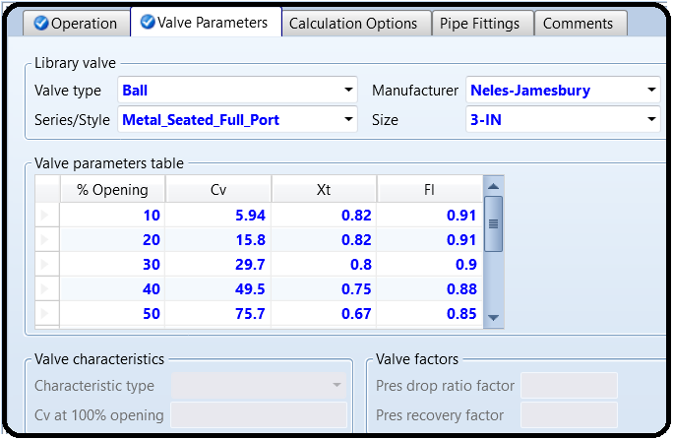

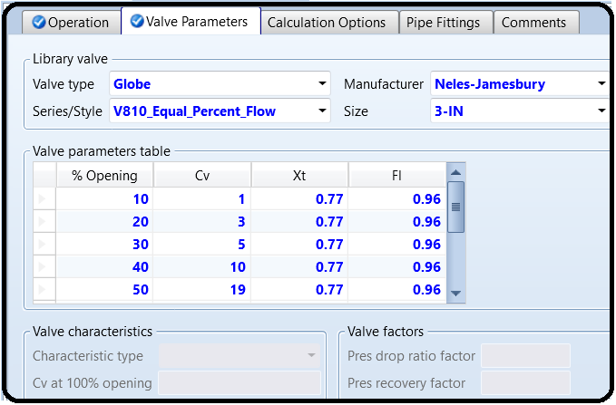

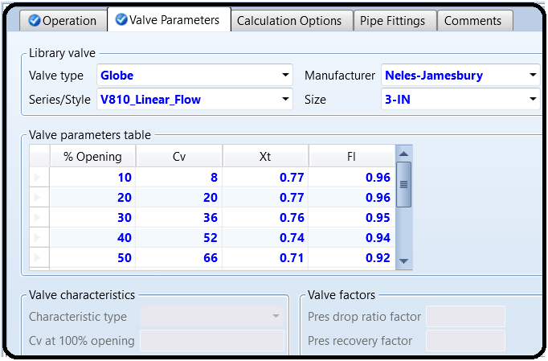

When you click the Reset and then Next, you get the following warning; simply click ok and continue running the simulation.

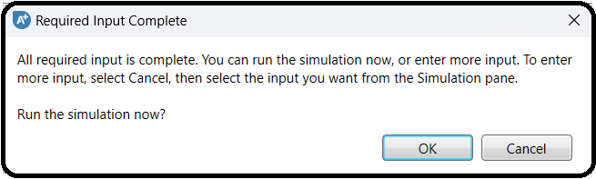

Results

PIPESEG 1/2

Let us look at some simulation results and show where they can be accessed. Figure 8.13 shows the results summary pertaining to “PIPE Segment-1” block that is 1 km long. Notice here that there is a significant pressure drop due to friction along the pipe, in addition to the presence of 19 fitting objects (see Figure 8.8). That is why the pressure inside “TANK-4001” is at 2 atm, which is sufficiently large to overcome all types of friction along fittings-augmented “PIPE Segment-1” pipeline. Moreover, the reported equivalent length is 1025.11m*>*1000m (original length). What does this mean? From fluid mechanics point of view, such an extra length of 25.11m accounts for the resulting friction due to the presence of fitting objects in a manner equivalent to having a pipe of a total length equal to 1025.11m but with no installed fitting objects.

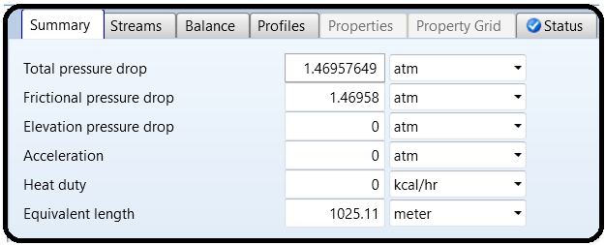

Figure 8.14 shows the fluid and flow properties throughout the pipe itself. For example, you can see *P*, *T*, the mixture velocity (in this case liquid velocity as there is only one phase), and Reynolds number that tells we have a turbulent regime prevailing within the pipe.

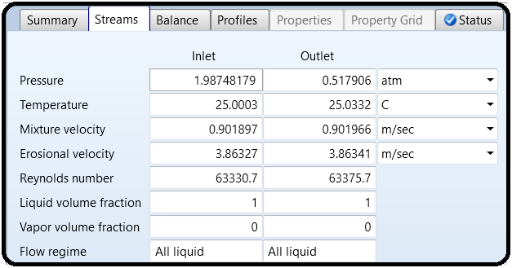

If you click on “Profiles” tab, you will be able to see the pressure profile along the pipe. For example, while the “Profile” tab window is active, you may go to “Home” ribbon |“Plot” group and make use of the available buttons that can be clicked on to generate the corresponding plot. Figure 8.15 shows the pressure profile (or, pressure gradient) throughout “PIPESEG-1” pipeline.

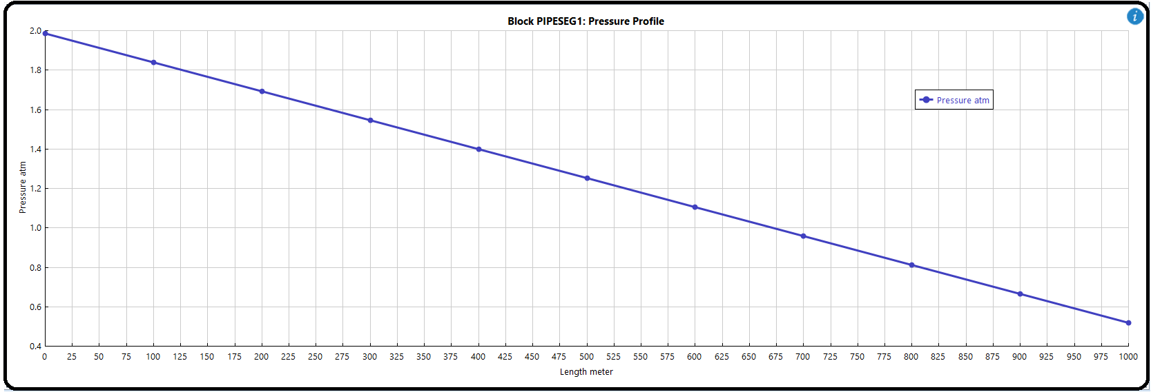

The slope of the line is negative (i.e., Δ*P/*Δ*X<0*) simply because we have a friction that will result in a drop of pressure with increasing *X* along the pipe. If the pipe is frictionless, then we will have a constant pressure value along a horizontal pipe.

P-4001

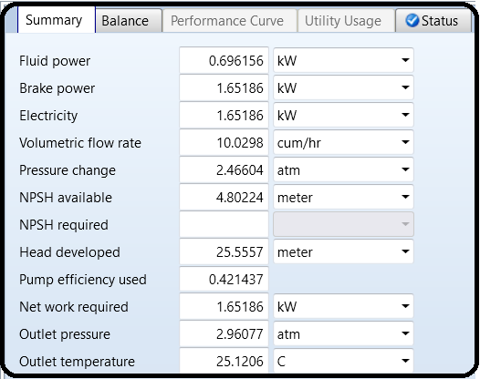Figure 8.16 shows the results summary pertaining to the pump characteristics and performance. First, the fluid power is 0.69616kW, which is equal to the brake power times the pump efficiency; that is 0.69616kW=1.65186kW\* 0.42144. This means that out of the input power supplied to the pump, only 42.14% is utilized to elevate the pressure of the fluid; the rest goes in the form of viscous dissipation (frictional heating as a result of moving fluid and pump rotor/blades). The brake power is equal to the supplied electricity as the motor efficiency is assumed one. The pressure change is about 2.5 bar, which is the difference in pressure between the inlet and outlet streams. The available net positive suction head (ANPSH) of the pump is 4.8 m. If ANPSH value is equal to or less than the required net positive suction head (RNPSH), the pump will then suffer from cavitation (see next section). Cavitation means formation of vapor bubbles at the inlet of the pump, which will travel with the liquid until they hit the solid boundaries (such as blades or vanes) where they burst (implode) or collapse causing a negative pressure pulse, or vibration. This continuous cycle of formation and collapse of bubbles will cause an early wear and tear ofthe pump blades/vanes, in addition to the reduction in its pumping performance.

V-4010/V-4020/V-4030/V-4040

Figure 8.17 shows the summary of the first valve (“VALVE-1”) results where again it shows if the reduction in pressure due to the reduction in flow area as a result of being semi-closed (i.e., valve % opening is 50%) may cause valve choking. The liquid flow through the restriction decreases the liquid pressure to below that of the liquid vapor pressure at the prevailing liquid temperature. At that point, the liquid will partially flash into vapor bubbles and the subsequent collapse of the bubbles (i.e., cavitation).

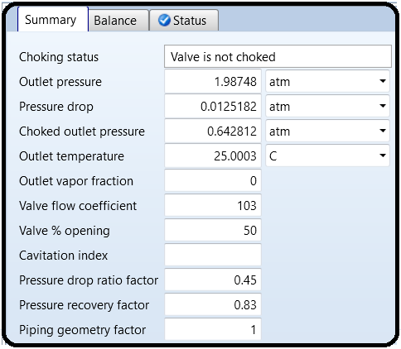

Cavitation is quite noisy and physically damages valves, pipes, and associated fitting objects. The outlet pressure is 2.014 bar that lies above the calculated choked outlet pressure of 0.651 bar. If the “Calculate cavitation index” option is enabled in “Calculation Options” tab window (see Figure 8.6), Aspen Plus will provide a cavitation index for each of the four valves as shown in Figure 8.18. The likelihood of cavitation in a valve is measured by the cavitation index. Aspen Plus calculates the cavitation index as

Kc = ((Pin − Pout) ∕ (Pin − Pv))

Where

KC Cavitation index

Pin Inlet pressure

Pout Outlet pressure

Pv Vapor pressure at the given temperature

In principle, we should run our liquid flow system such that 0 ≤ *K*c *<* 1. If *K*C is exactly one, then we will have cavitation (boiling or formation of gas bubbles) and the valve will choke. Obviously, if *P*out drops below *P*v, then we will end up with *K*C *>*1. This means that the process liquid will be converted into superheated vapor. This will make the situation even worse than cavitation condition. Notice that transport of vapor/gas is different from that of liquid in terms of used pieces of equipment as well as the extent of heat transfer, mass transfer, or both.

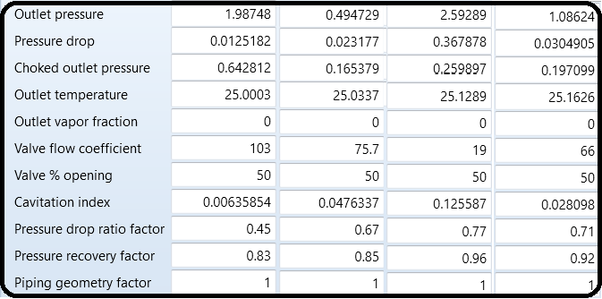

Finally, the pressure at the end of the journey (i.e., inside TANK-2) is 1.123 bar, which is larger than atmospheric so that it can discharge liquid water to an open (i.e., ventilated) tank.

MODEL ANALYSIS TOOLS: SENSITIVITY FOR THE ONSET OF CAVITATION OR VALVE CHOKING CONDITION

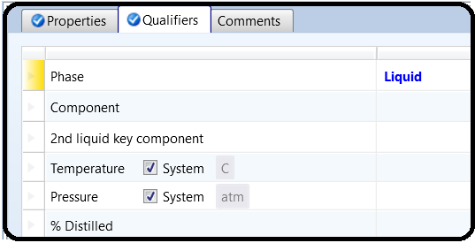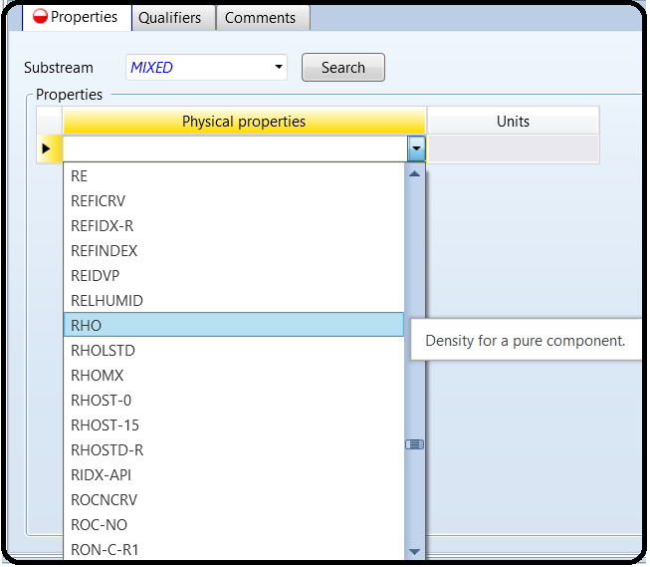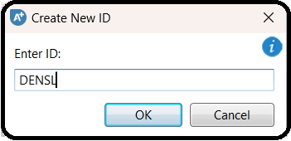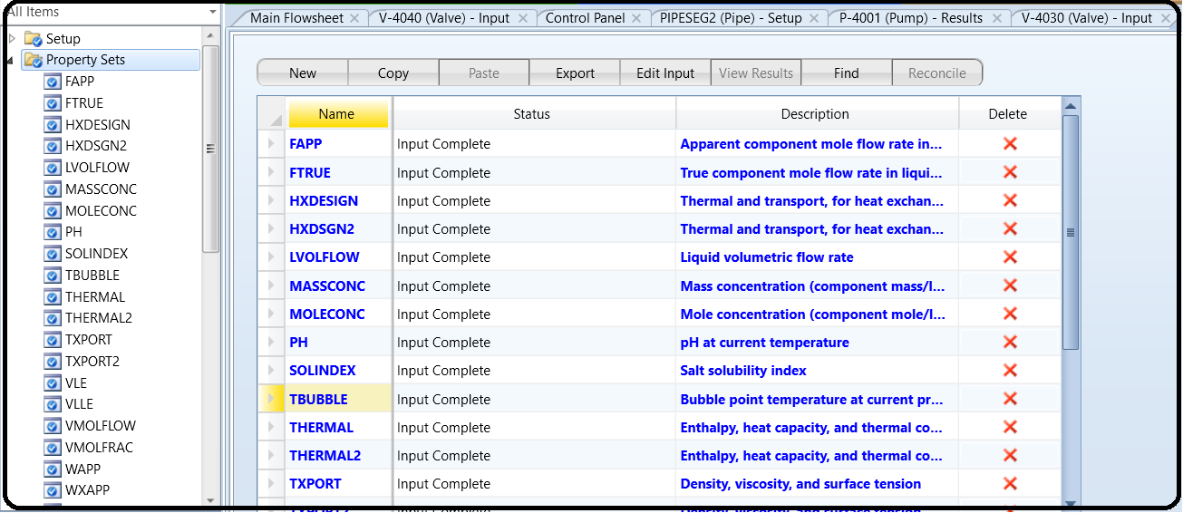Before we move to “Model Analysis Tools”, let us define two stream properties using “Property Sets” in “Navigation” pane. The first property will be the density of stream “DENSL” as shown in Figure 8.19. Under “Qualifiers” tab, select the phase to be “liquid”. Notice here that the mixture property “RHOMX” must be used in case we have a liquid mixture, not a pure liquid as is the case here.

The second property will be the vapor pressure of water at the given temperature as shown in Figure 8.20. Again, under “Qualifiers” tab, select the phase to be “*liquid*”.

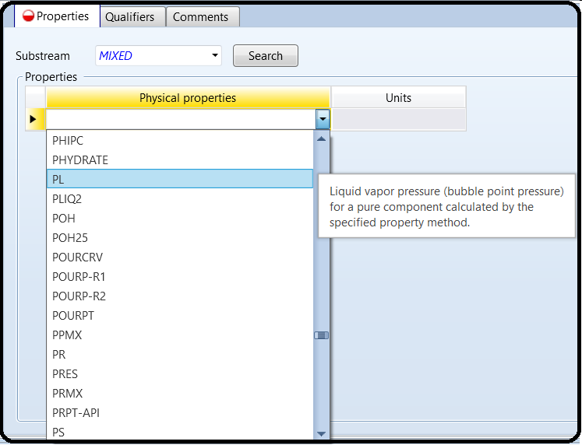

We would like to show heremore useful calculations regarding the fluid and flow characteristics. In “Navigation” pane, under “Model Analysis Tools” folder, choose “Sensitivity” subfolder and click on “New…” button and “Create New ID” window will pop up with the default name “S-1”. Click on “OK” button to accept the default name. Figure 8.21 shows “Vary” tab window, where we define a range and increment for the mass flow rate of liquid water (i.e., manipulated variable). In other words, changing the mass flow rate of liquid water means changing Reynolds number, which, in turn, will affect the rest of Reynolds-dependent defined variables. Moreover, at the bottom of the window (“Report labels” section), the user may enter one word for each line so that it will describe the manipulated variable in the “Results” section.

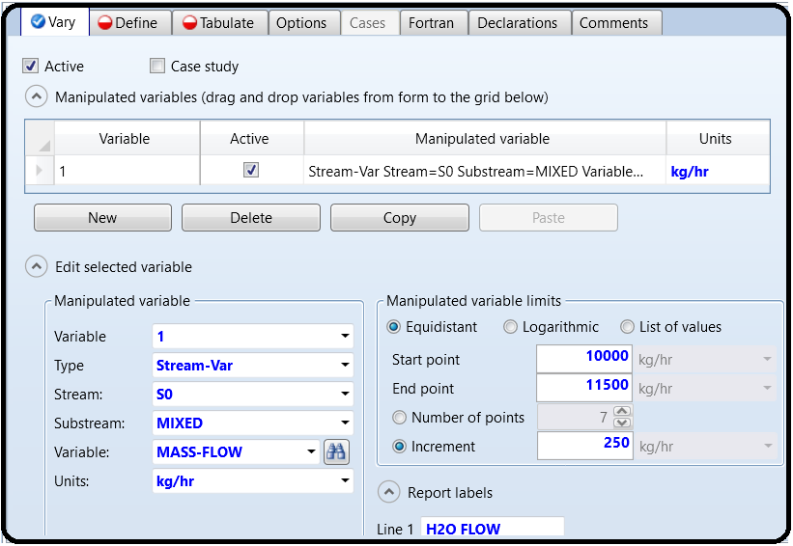

Figure 8.22 shows “Define” tab window, where we define a number of variables so that we can reference them either in “Tabulate” or in “Fortran” tab window. The variables defined here refer to a block-variable, stream-variable, or stream-property variable that refers to a previously defined property set. The defined variables will give us more insight on the nature of fluid and flow when we attempt to change the total mass flow rate of water being transported from “TANK-1” to “TANK-2”. “V1CHOKST” up to “V4CHOKST” account for the choking status of valves 1 up to 4, respectively. “ANPSH” accounts for the available net positive suction head of the pump. “PIPENRE” accounts for Reynolds number in “PIPE-1”. “STRMDEN” accounts for the liquid density (kg/m3) of stream“4”, entering the pump. Finally, “STRMPRS” accounts for the vapor pressure (Pa) of liquid water at the given temperature for stream “4” entering the pump. We will go now to “Fortran” tab and be back later to “Tabulate” tab window. Figure 8.23 shows one line FORTRAN (Formula Translation) code that will evaluate the required net positive suction head (RNPSH).

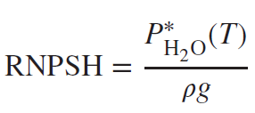

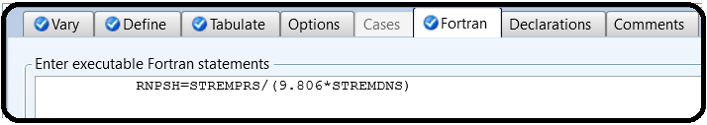

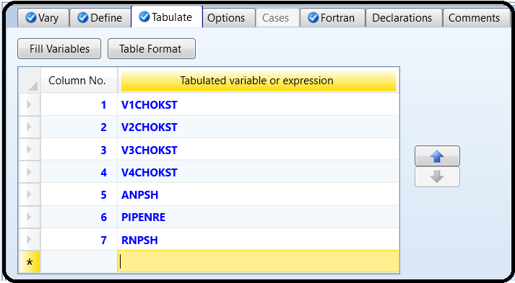Now, let us get back to “Tabulate” tab window where we decide what variables to present in the “Results” table. To import the list of variables, click on “Fill Variables” button at the bottom of “Tabulate” tab window. There is no need to keep “STRMDEN” and “STRMPRS” variable in the tabulated list; hence, highlight (right click on) the assigned number and select “Delete Row” submenu item from the context menu. On the other hand, manually enter “RNPSH” variable, which is defined in “Fortran” tab window.

Figure 8.24shows the rows that will appear as columns in “S-1” Results, after deleting “STRMDEN” and “STRMPRS” and adding “RNPSH” row. Notice that the tabulated variables are either defined in “Define” or in “Fortran” tab window. Reinitialize and run the show. Figure 8.25 shows the “Summary” tab sheet for tabulated columns in “Model Analysis Tools” | “Sensitivity” | “S-1” | “Results”. The number “*3*” for the valve status indicates that there is no choking condition. Although valves do not show any choking condition, nevertheless, the pump will suffer from cavitation at a water massflow rate higher than or equal to 11,500 kg/h.

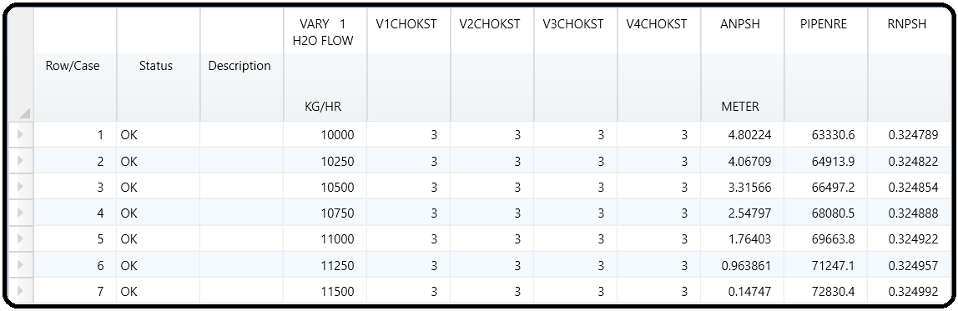

Notice at a water flow rate of 11,500 kg/h (*NRe* =*72,830*) or above, ANPSH is less than RNPSH. Of course, *the higher the mass flow rate is, the worse will be the situation* *in terms of cavitation*. One can say that at the given operating pressure and temperature, a mass flow rate of 11,250 kg/h represents the critical value above which cavitation will occur. This means that the pump entrance is vulnerable to the phenomenon called cavitation. Cavitation means the formation of vapor (in this case water vapor) along with the liquid stream itself. Such vapor bubbles will burst at the vanes (impellers or blades) of the pump. In addition to the intermittent flow, the bursting of bubbles will cause an oscillation in pressure values and result in early wearing of pump blades. The valve choking status is fine with all four valves; there is no valve choking in any of them.

Let us imposemore restriction on the fluid flow using “VALVE-2”. Go to “VALVE-2” | “Input” | “Operation” tab window, change the percent opening from 50 to 40%, as shown in Figure 8.26. Reinitialize and run the show. Figure 8.27 shows the “S-1” sensitivity analysis results. Obviously, at last run, both “VALVE-2” and “VALVE-3” do suffer now from choking condition.

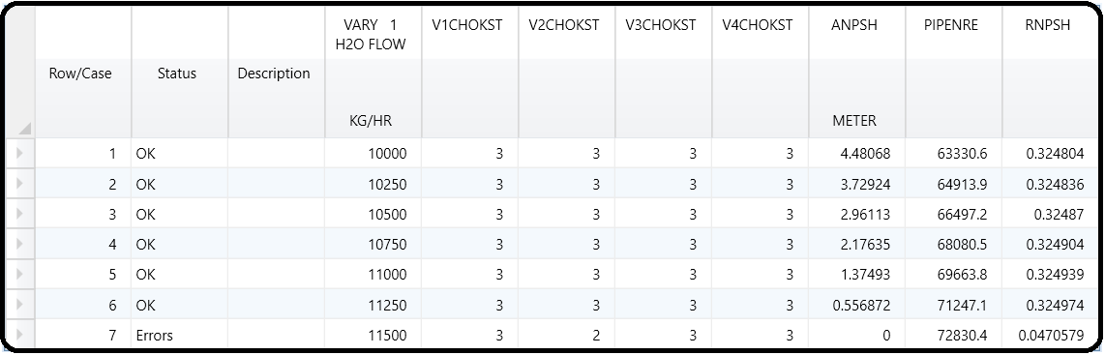

Moreover, the “Control Panel” of Aspen Plus warns the user that there is a choking condition in “VALVE-2” and VALVE-3 and pump cavitation, as shown in Figure 8.28.

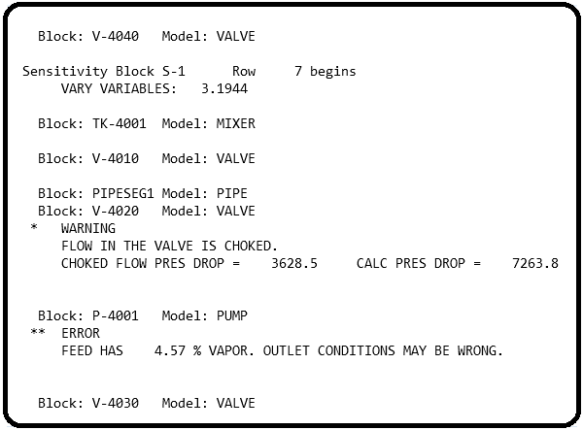

Part 2

Problem Definition

In this section, we will be working on a process involving an exothermic reactor whose products exit at 420°C. These need to be cooled before downstream treatment and separation. Rather than

just rejecting this heat to the environment, this high-temperature heat can be used for something more useful: electricity generation. To do this, let us consider the addition of a steam power plant to the process, as shown in Figure 3.1. In this process, boiler feedwater (BFW) just below the boiling point at 95°C and 1 bar (stream 1) is pumped to high pressure at 20.5 bar (stream 2). The high-pressure BFW enters a heat exchanger where it is boiled to high-pressure steam (HPS) at 360°C (stream 3) using heat from the reactor effluent. The reactor effluent is subsequently cooled to 150°C. The HPS is then sent through a series of two turbines, which produce electricity in each. The steam exits the second turbine at low pressure again (1 bar) and at a temperature just above its boiling point (still a vapor, stream 5). Then, cooling towers are used to condense the steam into a liquid at 95°C and provide a little additional subcooling.

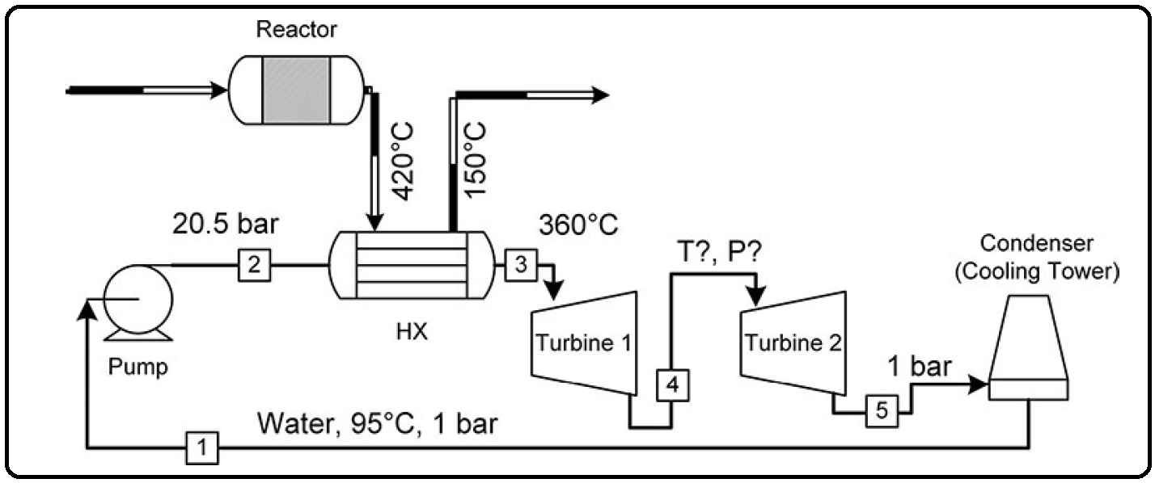

The problem is that we don’t know what intermediate pressure to select for the two stage turbines; that is, we don’t know what the discharge pressure of turbine 1 should be. Clearly, anything between 1 and 20.5 bar will theoretically work. The question is, which is best? In addition, we do not know what the flow rate of steam should be. So how can we find these answers?

The strategy is as follows:

(1) Create a model in Aspen Plus for the steam plant using what we know.

(2) Use a model with a Design Spec to figure out how much steam we need to achieve a steam temperature of 360°C and a hot outlet temperature of 150°C.

(3) Complete the model to determine how much power is produced for one specific guess of the intermediate pressure.

(4) Use a sensitivity analysis (Part 2) to vary the pressure and determine how the power produced changes with the intermediate pressure.

Let’s do it! Two more things we need to know before we start: (1) Assume for now that we know that 200 MW of cooling is needed to take the reactor effluent from 420°C to 150°C.2 This means that we can use a Heat stream to model the heat transfer without needing to model the reactor effluent or the reaction.

How to simulate

1. Choose “Specialty Chemicals with Metric Units” template to create a steady-state flow sheet.

2. Go to Properties/Set-up/Specification and in Global Tab, give it the name of “Water Transport”

3. Go to Properties/Component/ and Find water.

4. Given the fact that the ASME steam tables are less accurate than the NBS/NRC steam tables, set the property method to “STEAMNBS”. The NBS/NRC steam tables are embedded, similar to any other equation of state, within the built-in “Aspen Physical Property System”. These steam tables can calculate any thermodynamic property of water. There are no parameter requirements.

5. Click “Reset” followed by “Next” button to run the simulation and assure that properties’ analysis completed successfully. Switch to “Simulation” environment.

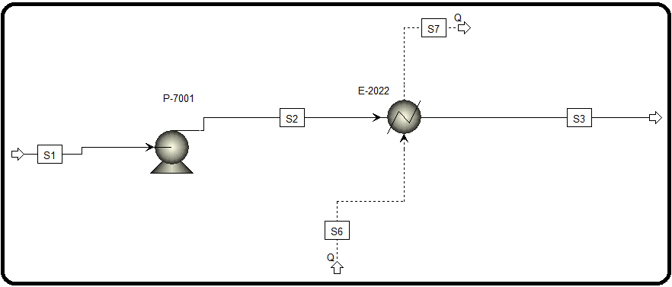6. Set-up the flowsheet based on the P&ID or the following Aspen Plus flowsheet.

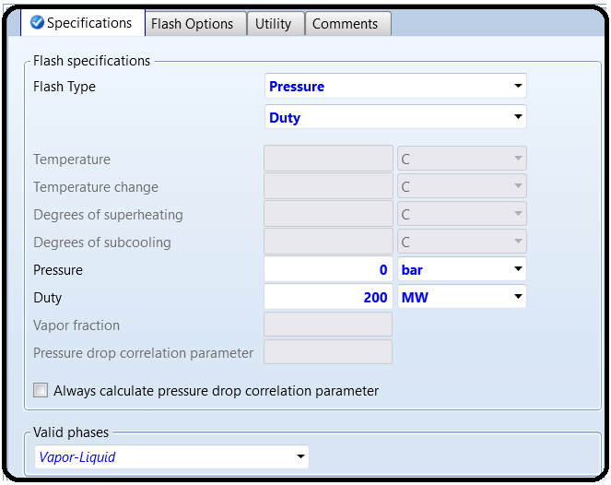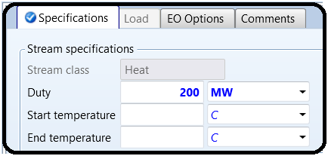7.Specify the E-2022 and Q6 stream input based on above explenation and P&ID.

8.Specify P-7001 inputs and S1 inputs based on PFD.

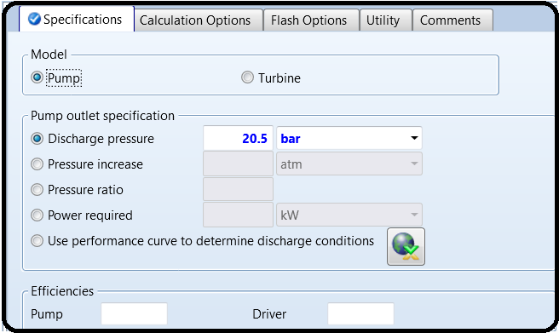

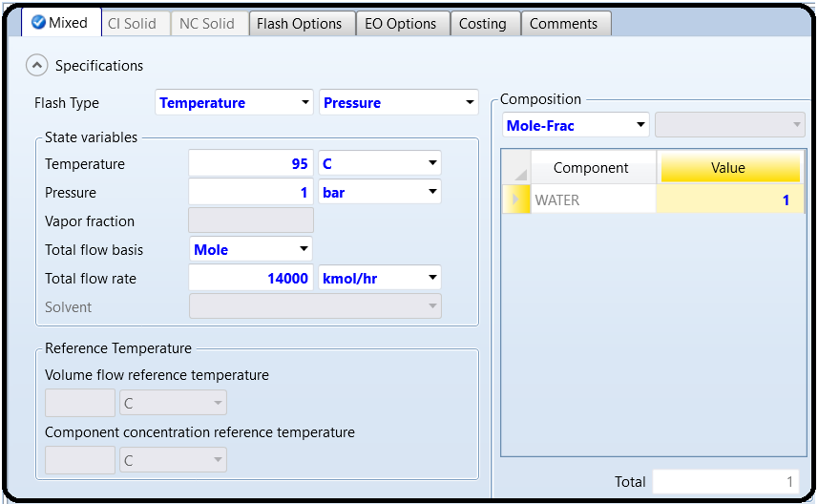

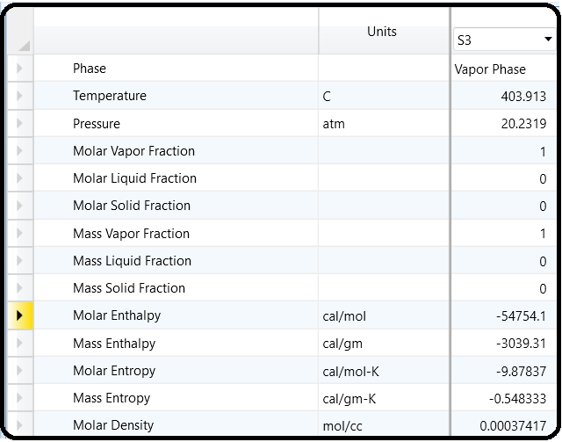9. Click Reset and Next and run the Aspen Plus. Based on above explonation the desired E-2022 outlet tempreture should be 360 C but based on 14000 kmol/hr flowrate the outlet temperature is 403.9 C, which means we have to increase the flowrate.

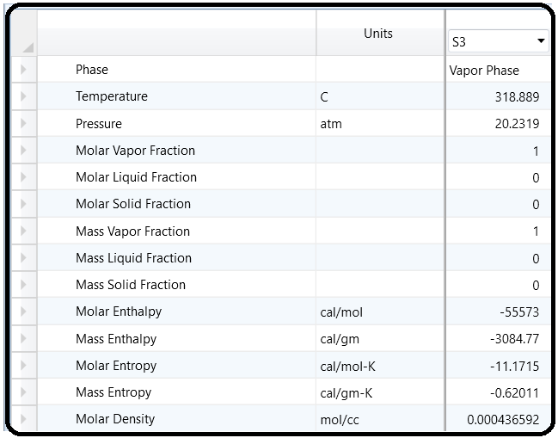10.Now we increase the flowrate to 15000 to see what happens.

Ok, so we know that the flow rate of water that will achieve a stream 3 temperature of 360°C will be between 14,000 and 15,000 kmol/hr, but you can see how tedious this is going to be if we keep changing and checking by hand until we get 360°C to exact precision. So let’s automate the process by using the Aspen Plus Design Specs tool.

Under the Simulation tab, go to Flowsheeting Options | Design Specs. Here, you will see an Object Manager that lists the set of design specifications you have created. Click New to make a new one, and give it a name (or leave it at the default of DS-1). The

Design Specs tool works like this:

You tell it what output you want to achieve. For example, you want to achieve 360°C in stream 3. You do this with a combination of the Define and Spec tabs. You tell it what input specification or block model parameter you want Aspen Plus to change until your specification is met. For example, you want to change the water flow rate of stream 1. You do this in the Vary tab. The other tabs are advanced. For example, in the Fortran tab, you can write a program to make complicated decisions. We won’t do that here.

Let’s start with item 1. Go to the Define tab. This is where you define variables to be used later in the Spec tab. This is like defining a variable in a programming language, except instead of making a blank variable we will be getting the value from Aspen Plus.

Click New to make a new variable. Give it a name. You are going to make a variable that is the temperature of steam in stream 3, so perhaps T3 might be a good name. Then when you click OK, you get another dialogue that shows you more details. This is where you search for all the variables in your model that you can get. Here, you can access anything that can be seen on the Results tab of a stream or block (Crtl+R), or typed into an input box for a block.

In the Reference section at the right, choose Stream-Var from the Type drop-down. This filters out the variables to be only stream variables. Then in the Stream drop-down just below it, choose your stream 3.

Whatever names you used on your flowsheet will appear here. Leave the substream as MIXED (this book does not cover substreams). Then, in the Variable drop-down, select TEMP, and then

select the appropriate units. Now, you have selected the temperature of stream 3.

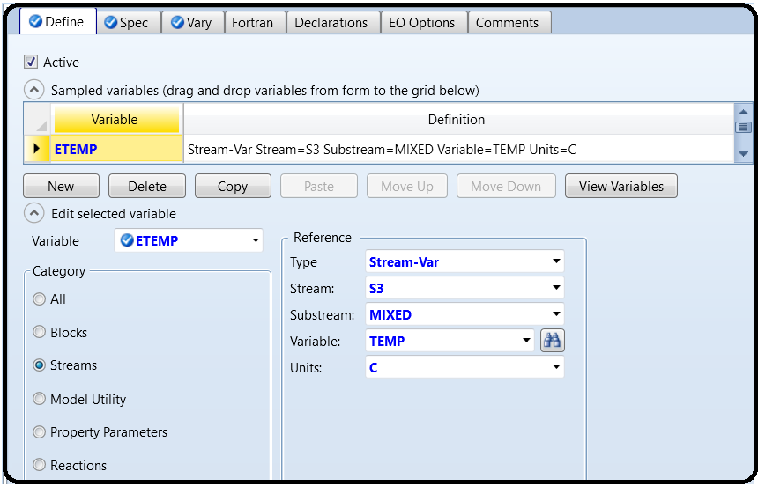

Go to the Spec tab. This is where you tell Aspen Plus the exact specifications you want. We want the temperature of stream 3 to be 360°C. To do this, type T3 into the Spec box and 360 into the Target box. The meaning should be obvious. Note that you cannot change the units on the Spec tab, so your units will be whatever you defined on the Define tab. But what is not obvious is tolerance. Since this is a guess-andcheck algorithm, and floating points3 are imprecise, Aspen Plus will never get exactly 360°C, or at least take a very long time to get there. However, it could get 359.938382°C rather quickly, for example, and you have to decide if you are ok with that. You need to define your tolerance, that is, you need to tell Aspen Plus how close to 360 is acceptable. Type 0.1 into the tolerance box. This means that anything within 0.1°C of 360°C is acceptable. So once Aspen Plus has reached a value between 359.9°C and 360.1°C, it will stop.

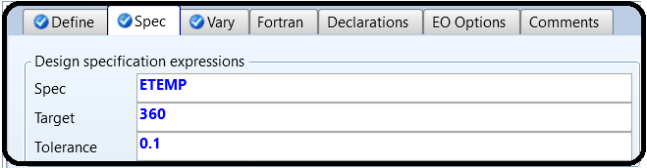

Last, we go to the Vary tab. This is where you tell Aspen Plus what to change, which is the molar flow rate of stream 1.4 Use the Stream-Var type, select your stream 1, and choose MOLE-FLOW as thevariable. Then you have to change your manipulated variable limits.

You have to tell Aspen Plus what is the lowest guess it can make (the Lower field on the right) and the highest guess it can make (the Upper field on the right). From Q1 and Q2, we know that the range will be from 14,000 to 15,000 since one was too high and one was too low when we were exploring “by hand.”

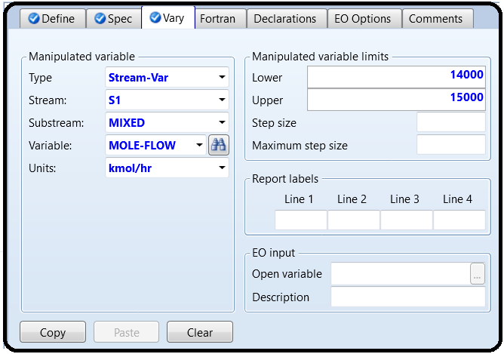

The other tabs can be left at the default. You could make changes such as limiting the step size of the guess to a certain amount (i.e., how big of a jump Aspen Plus is allowed to make between the previous guess and the next guess), but it is almost always better to use the default settings except in very special cases. That’s it. If you’ve done it correctly, rerun the simulation. You can

see the stream results (Crtl+R) of the input or any of the other streams to find out the final water flow rate. Or, you can go to the results tab of the Design Spec that you made and see where the

variables ended up. Make sure you get the Results Available message! Also, verify that your Design Spec (temperature) was met within tolerances.

It can be useful and interesting to look at the actual guesses that the solver took when arriving at the final value. Go to Convergence | Convergence and look for the solver that goes with your Design Spec (for this example, it should be the only one there). Go to the Spec History tab on the form for this solver, and you will see what guesses it made in each iteration. In my case, it only required four guesses. Readers who are savvy about numerical methods will notice that the solver is using a classic Secant method, where the second guess is exactly 1% of the range away from the initial point.

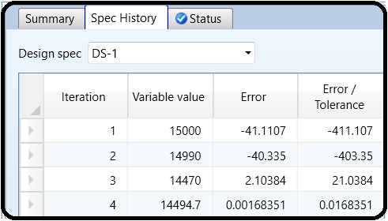

If you do not know what this means, it suffices to know that if the system of equations of interest is linear, this means it will always converge on the third guess as long as a feasible solution exists and the specification is well posed. The more the system deviates from linearity (which happens most of the time), the more guesses will be required. Sometimes, the Design Spec never converges. This can be either because the solver did not have enough iterations to find the solution, the system is so nonlinear or stiff that it just simply cannot find it without very good guesses, the specification is attempting to vary something that does not impact what is being measured, or the solution simply may not exist at all within the bounds that you specify and so there is nothing to find. If your Design Specs do not converge, you should focus on identifying which of the three this could be before continuing on with the rest of the flowsheet. For example, it is quite common for beginners to create Design Specs that are thermodynamically impossible without realizing it.

Ok, now that we know the steam flow rate, we can design the rest of the system. First, add the remaining streams and blocks into the model according to Figure 3.2. For the turbine models, you’ll find them in the Model Palette under the Pressure Changers | Compr model section drop-down. Aspen Plus uses the same model for both compressors and turbines, so it actually does not matter which icon you select, but try to get into the habit of choosing the correct icon anyway. Make sure the models use an isentropic turbine and leave the efficiencies empty (meaning that Aspen will use default efficiency correlations which are somewhat complex). Let’s make a guess at the outlet pressure of the first turbine of 5 bar. You can specify the outlet pressure of the second turbine according to the process diagram in Figure 3.2. You should be able to handle the condenser already. (You know the requirements for the hot stream and don’t know anything about the cold stream, so which block do we use?) Assume no pressure drop in the condenser.

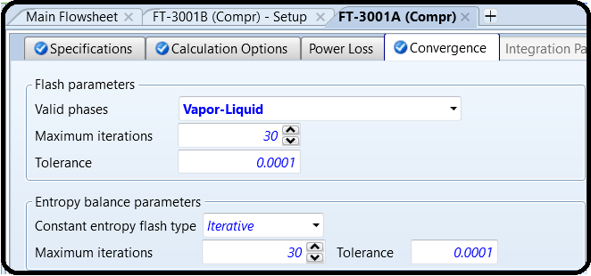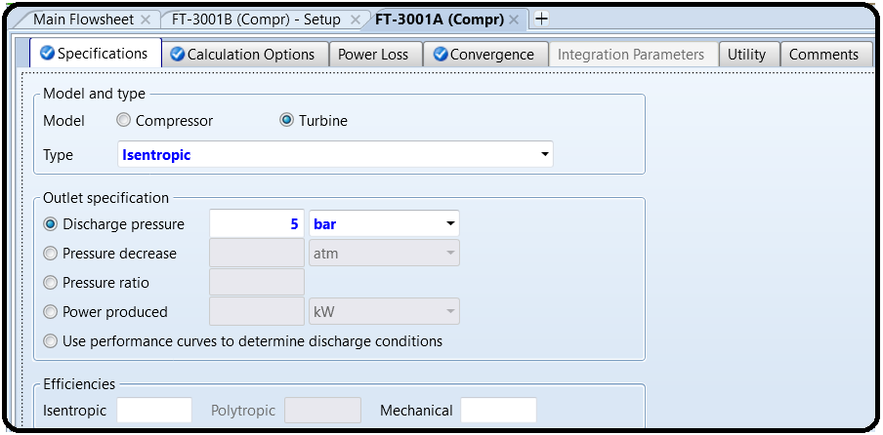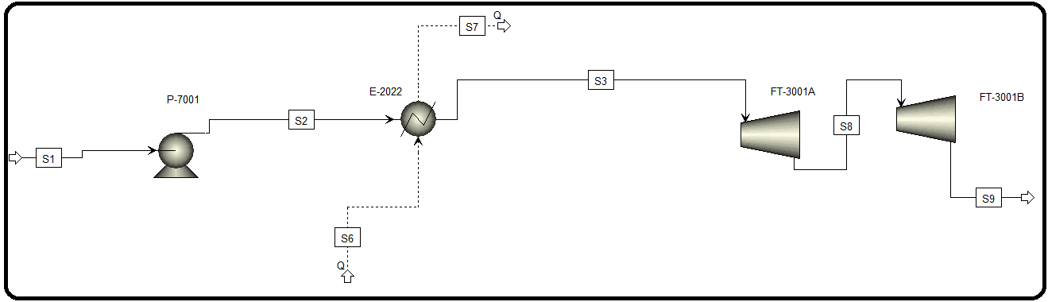In the convergence tab of turbine setup, change valid phases from Vapor to Vapor-Liquid. This will allow the model to function properly in case a liquid phase is formed in the output since the stream will get colder after expansion. In most real cases we don’t want liquid formation in our turbines, but we can always go back and see if this is a problem and avoid it. Do this for both turbines, as shown in Figure 3.6.

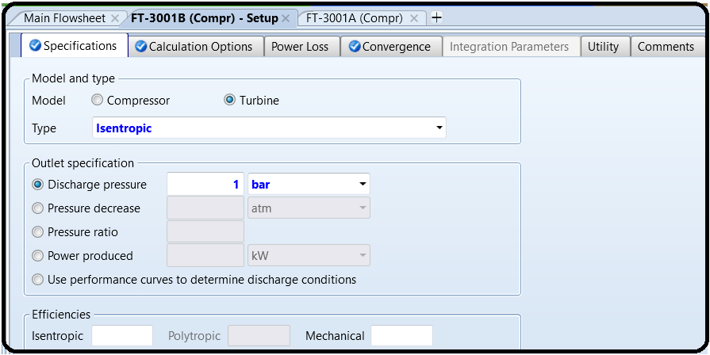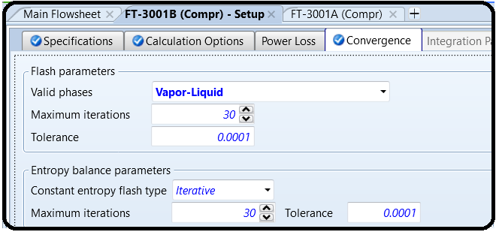

Now Reset and click Next to run Aspen Plus and see the results.

Finally, we are interested in the total work produced by the system. To find this conveniently, use Work streams (like Heat streams, but different). Add Work streams to the outlets of the two

turbines and the pump (which consumes some of the power). This represents what in reality might be a shaft for a compressor/turbine system to transmit mechanical work, or an electrical connection for electrical work. Now we can model the magic that appears in calculations.

To get the total work, we can either add them together by hand, or have Aspen Plus add them for us by using a Work Mixer. This is not a physical thing in itself (don’t go around asking people for a work mixer), it just lets us add the work together to get a sum easily. The Work Mixer icon is in the regular Mixer section, but you have to get it from the drop-down arrow, as shown in Figure 3.7. Unlike other cases, the icon for the work mixer represents a completely different

model than the others in this case. Add a third Work stream to the outlet of the Work Mixer to make a stream that has both turbine works combined. So, it’s just like a mass mixer, but for work.

Run the simulation, using the correct water flow rate that resulted from the Design Spec and the assumed 5 bar outlet pressure in the first turbine.

Next we want to find the turbine 1 discharge pressure that maximizes our work produced by the turbines. We can’t use a Design Spec because we don’t know what the exact power output

we want to produce actually is, we just know we want the highest possible. So, we’ll use another tool called Sensitivity. This is basically just the “guess” part of the guess-and-check. It just reruns your simulation a bunch of times and tells you the results. We will use a Sensitivity to run many different simulations and different turbine outlet pressures and record the net work produced in each case. Then, we can look at the result and choose the one that has the

highest net work.

In other words:

*Design Spec:* You tell it exactly what you want and it changes something in your simulation until you get it (or it can’t find it and it gives up). The thing you change is almost always something you normally type into a box by hand. It does the work of figuring out the right value to type in the box for you and actually uses that value in the simulation. Only the final result is reported.

Sensitivity: This changes a value in a box, just like the Design Spec, but it shows the results in a separate place because it doesn’t pick any one of them for you. You get a nice table of results instead and you can decide what to pick later.

Let’s do it! Make a new Sensitivity in Model Analysis Tools |Sensitivity. This is going to look a lot like the Design Spec, but now we have the Define, Vary, and Tabulate tabs. The Define and Vary tabs are just like in a Design Spec. The Tabulate tab is where you tell Aspen Plus what you want it to report.

Start with the Vary tab. In this tab, we can have Aspen Plus vary one or more variables. We’ll just do one for now: the specified outlet pressure for turbine 1. Select this variable just like you did for the Design Spec | Vary case. Select <New> from the Variable drop-down button, choose Block-Var for the type, and then select your turbine 1 unit. For the variable, choose PRES. If you hover your mouse over the long list of options, you’ll see that PRES is “Specified outlet pressure.” You can see that there is a lot here you can mess with. Once selected, you should see the units pop up in bar. If not, change it here, and/or make sure your simulation units are set to METCBAR. For the range, vary from 2 to 20 bar in increments of 0.1 bar. You should be able to specify this on the right side since it is similar to the vaporliquid equilibria (VLE) stuff we did in Tutorial 2. Leave the Report labels blank. See Figure 3.8 for final form settings.

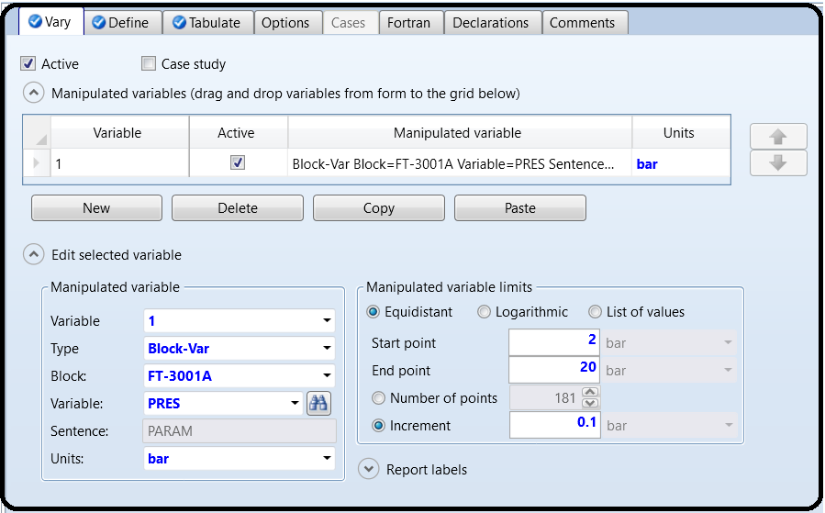

Ok, we told Aspen Plus what to vary. Now we have to tell it what to report to us, that is, what do we care about? We care about the total work produced by the turbines. So to do this, first go to the Define tab, and make a new flowsheet variable and give it a name (I called it TOTALW for total work, as shown in Figure 3.9). You want thisvariable to be the total work produced by the turbines, so select Work-Power from the drop-down for type and select the Work stream

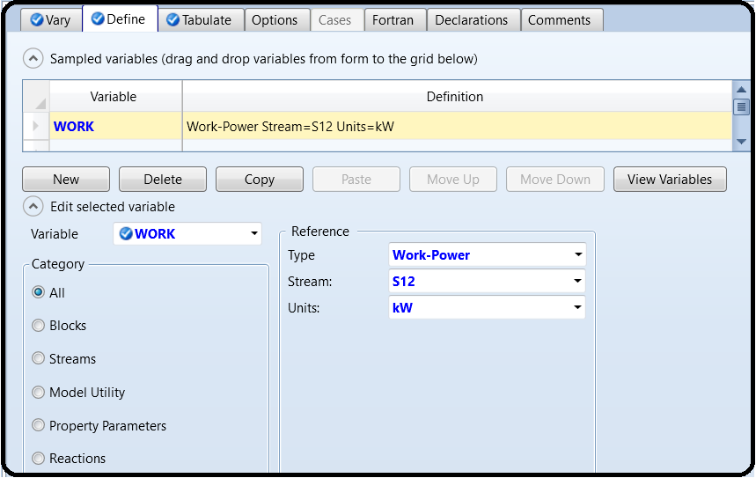that is leaving your WORK Mixer. (See why we did this now?)

Once you are done, click Close and go to the Tabulate tab, as shown in Figure 3.10. This is where you tell Aspen Plus which values it should report for each iteration of your Vary variables. To do this, you pick the variable name or expression on the right side and select which column you want it to go into on the left. The column number doesn’t really matter much; it’s just the order in which you want to see the results.

For the tabulated variable or expression, you can start by just typing your variable name. For my case, I would type TOTALW because that’s what I called it in the design tab.

You can also write whole mathematical expressions. For example, I know that TOTALW is in kW but I want to see the results in MW. I could type TOTALW/1000 to do this. It uses Fortran syntax, but it’s just like Microsoft Excel equations without the = sign. So it’s not scary.

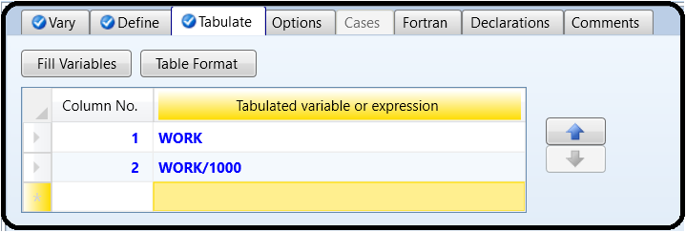

Ok, when you’re done, you should see the yellow Input Changed message, and then run the simulation. It may take a little while. If everything worked, you’ll get the Results Available message. Now, if you were to go look at the stream results in the simulation, you would still see the same results as your Q4 and Q5 answers. This is because by default, after the sensitivity analysis is finished, it runs the flowsheet one last time using your original settings, so nothing

will look different on your flowsheet. What you want to do is go to the special place where sensitivity results are held. So, on the left go to Model Analysis Tools | Sensitivity | S-1 |Results. Now, you should get a little table showing each of the Vary values (going from 2 to 20 bar in steps of 0.1), the values of anything you put into the Tabulate tab, and a status message under the Status tab saying completed normally (if it is not ok then there was an error or warning in your simulation).If you want to see the results visually, you can copy-paste the table into Microsoft Excel or some other software and make a plot there if you like. If you click the little grey area on the upper left handof the results table (just to the left of the “Row/Case” column header), it will highlight the whole table. You can right-click and choose Copy or hit CTRL+C, then paste into your desired software. Now, if you’re being observant, you’ll notice that the very sneaky

Aspen Plus has added another menu option in the menu bar that only appears when you are looking at sensitivity results! The Plot menu has just appeared in the Home ribbon to help you plot the data in a table. Although we can copy-paste into Excel and make plots there, it is often convenient to use the Aspen Plus plotting tool to plot the results quickly. Ultimately, we would like a plot similar to the one in Figure 3.11.There are a few ways you can do this easily:

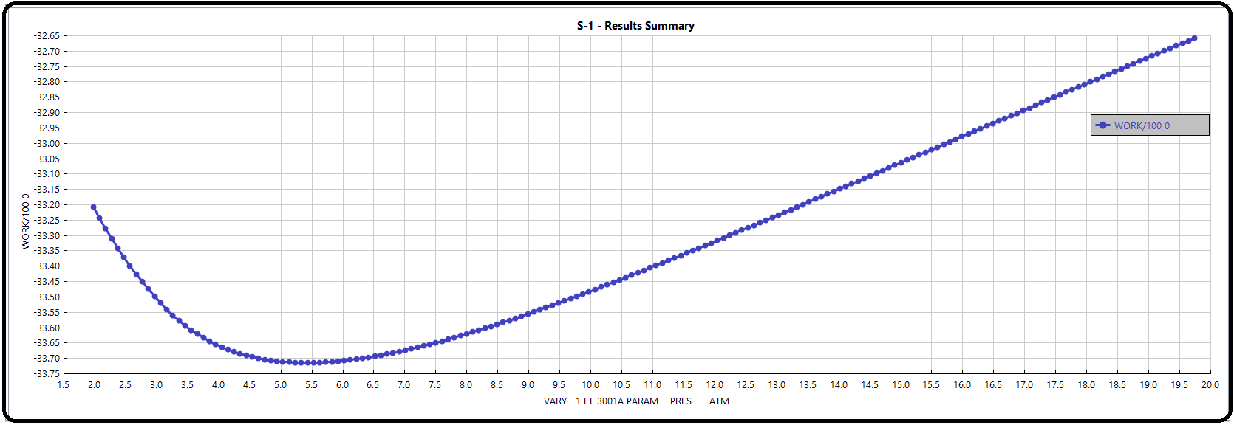

Lastly, let’s update our final simulation using the results from the Design Specs and the sensitivity block. (Remember, what’s on the current flowsheet does not reflect the sensitivity results, only your initial guess.) Type your final value for the water flow rate into the parameter specifications box for stream 1 (i.e., where you normally type flow rates and temperature). Type the final value for the pressure into the input box for discharge pressure in turbine 1. Now, go back to the Design Specs and Sensitivity Tabs and disable them. It is not obvious how. Go to Flowsheeting Options |Design Specs. Look on the left-hand side where it lists the different Design Specs, right-click your Design Spec (whatever name you gave to it in Part 1 or DS-1 by default), and choose DEACTIVATE. It will then have a grey symbol and all related folders will be grey (see Figure 3.13). This means that Aspen Plus will ignore the Design Spec completely. You can always reactivate it again later. It’s a nice way of saving you from the work of deleting and remaking it when you are playing around. Do the same for the sensitivity analysis. Rerun your final design.

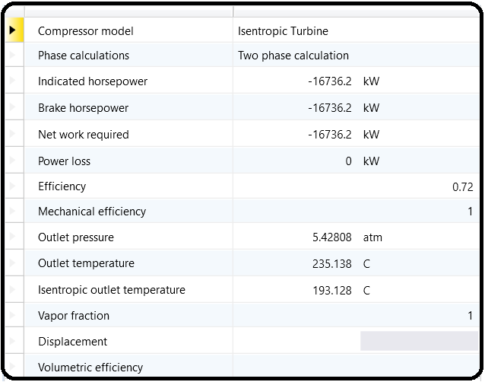Results

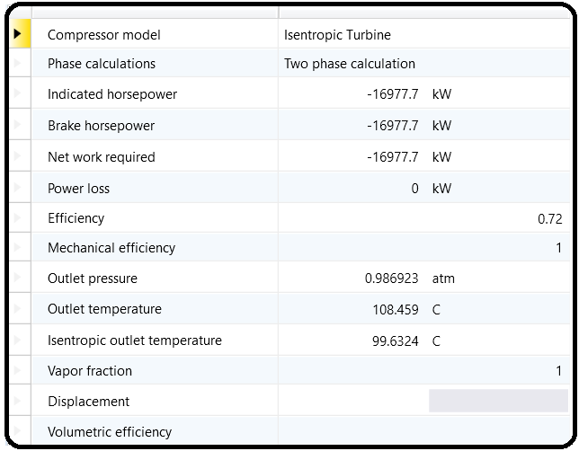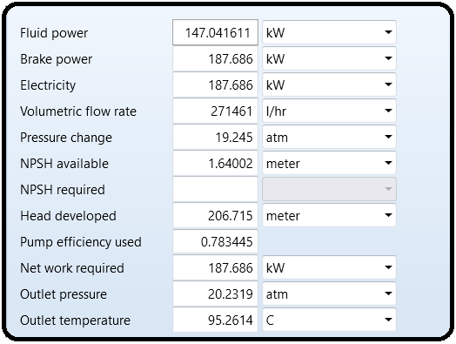

References

1.Our team experience

2.Aspen Plus – Chemical Engineering Application by KAMAL I.M. AL-MALAH

3.Peters and Timmer Haus (M. S. Peters and K.D. Timmer Haus) (1991) Plant Design and Economics for Chemical Engineers, 4 edn, McGraw-Hill, Inc., New York, USA, p. 496.

4. AWWA (1986) Introduction to Water Distribution, American Water Works Association, Denver,

Colo.

5. Learn Aspen Plus in 24 hr. by Thomas A. Adams II