Part 10

Polymerization in Aspen Plus



Objectives:

1.Learn to use different pressure change elements such as pumps, valves, pipe segments.

2.Become familiar with pages and Tabs of each element and how to fill in the required inputs.

3.Get to know the critical conditions and its causes for each pressure change elements.

4.Learn to use Sensitivity in Aspen Plus

5.Learn to use Design Specs in Aspen Plus

6.Understand pressure level heuristics for compressors and turbines

7.Understand the difference between heat, material, and work streams

Production of synthetic polymers is a significant part of chemical industry. More than 100 million tons of synthetic polymers are produced annually worldwide. Different types of plastics, rubbers, fibres, panels, adhesives, and many other materials used in different areas of life have originated from polymers. Modeling and simulation of polymer production processes can crucially affect their economy and ecology. Optimization of process conditions can result in considerable savings of energy and resources. However, polymer production processes represent very complex systems, which require unique and specific modeling approach. For example, polymer properties such as molecular weight and segment composition are not necessarily constant and may vary throughout the flowsheet and with time. Production of polymers begins with monomer synthesis and purification. It continues with monomer polymerization, separation, and processing. Modeling of monomer synthesis and purification processes was discussed in previous chapters. An example of monomer synthesis and purification is the styrene production, which is discussed in Example 8.2. In this chapter, we focus on the polymerization step, which is considered as the most important step in terms of economic viability of polymer production. The scope of this book does not enable to deal with all reaction mechanisms and tools for modeling polymer production processes available in Aspen Plus. However, available manuals of Aspen polymers published by Aspen Tech (1, 2) are written in sufficient detail and provide very good basis for modeling polymer production processes. The aim of this chapter is to provide only necessary basic information on polymerization processes simulation to have a complete overview on Aspen plus capabilities in process modeling.

Overview of Modeling Polymerization Process in Aspen Plus

Aspen Polymers integrated in Aspen Plus provides wide possibilities modeling and simulation of polymerization processes, including estimation of thermophysicalproperties, polymerization kinetics, rheological and mechanical properties, polymer molecular structure, and mass and energy balances. Kinetic models for all types of polymerization reactions are available. Polymerization reactions take place under different mechanisms and conditions. Many classifications of polymerization reactions are known: for example, condensation and addition polymerizations, or stepgrowth and chain-growth polymerizations. Examples of

step-growth polymerization are production processes for polyethylene-terephthalate (PET), polyamide 6.6, polyurethane, and so on. As examples of chain-growth polymerization, production of polyethylene, polystyrene (PS), polyvinylchloride (PVC), and so on can be provided. Another classification of polymerization processes is based on the reaction phase. Bulk, solution, emulsion, melt phase, and interfacial words specify the environment in which the polymerization process is carried out. The polymerization reaction models available in Aspen

Plus, Polymers can be listed as follows:

1. Chain-growth models

a. The FREE-RAD model uses free-radical polymerization usually taking place with the monomer in the liquid phase. A bulk monomer or a solution is used as the single liquid phase. Examples of bulk free-radical polymerization are production of: PS, PVC, polyvinyl acetate, polymethyl methacrylate, and so on.

b. The EMLSION model uses also free-radical chemistry, but the polymerization takes place in an emulsion (monomer and micelles dispersed in a water phase with surfactants). Examples of emulsion polymerization processes are the production of: styrene–butadiene–rubber and acrylonitrile– butadiene–styrene.

c. The ZIEGLER-NAT model uses the Ziegler–Natta polymerization kinetics describing a variety of stereospecific multisite and single site catalyzed addition polymerization systems (1). Both bulk and solution processes are used. Examples of polymerization processes described by the Ziegler–Nattamodel are high density polyethylene process, linear low density polyethylene process, and polypropylene (PP) process.

d. The IONIC model is used to model cationic, anionic, and group transfer addition polymerization.

Bulk or solution processes are used for ionic polymerization. Ionic polymers fall in the category

of addition polymers, that is the reactive species grow in length by continuous addition of monomer units. Examples of ionic processes are polyisobutylene, PS, polyoxides (PEO, PPO), and other specialty polymers production.

2. Step-growth models

The STEP-GROWTH model uses step-growth condensation chemistry. Step-growth polymerization can be carried out in a melt phase, solution, or in an interfacial of organic and aqueous phases. A number of polymerization processes can be modeled using the STEPGROWTH model. The examples are polyesters such as polyethylene–terephthalate, polyamides such as nylon 6 and nylon 6.6 and polycarbonate, and so on. The SEGMENT-BAS, the segment-based power-law reaction model, can be used to simulate polymerization reactions using a simple power-law type rate expression. The segment-based power-law model is the best choice to simulate the step-growth addition processes, for example, the production of polyurethane. More details on polymers and polymerization reactions and kinetic models of each type of polymerization models can be found in the polymer-related literature and textbooks or in the previously mentioned Aspen Polymer manual (1). In this chapter, we explain the basic principles of polymerization processes modeling in Aspen Plus using the example of bulk styrene polymerization and free-radical kinetic model. Each step of the solution contains a summary of general information and instructions for the solution of this specific example.

Problem Definition

4,900 kg⋅h−1 of styrene monomer is the subject of polymerization in a series of three CSTR

reactors each with a volume of 15 m3. The reactor feed contains 97.9 wt% of styrene, 2 wt% of ethylbenzene, and 0.07 wt% of *N*-dodecyl-mercaptan (DDM) acting as the chain transfer agent and 0.03% di-t-butyl-peroxide (TBP) as the initiator. The unreacted styrene containing

also some EB, TBP, and DDM is separated from the polymer and, after cooling and mixing with makeup streams, returned back to the first reactor. The process flow diagram (PFD) is shown in Figure 16.13. All reactors work at atmospheric pressure. The temperature is 120, 160, and 200 ◦C, in the first, second, and third reactor, respectively. Calculate the conversion, polydispersity index (PDI), weight-averaged molecular weight(MWW), and the number-averaged molecular weight (MWN) at the outlet of each reactor. Use the free-radical kinetic model with kinetic constants available in (2).

Solution: In the following sections, different steps of a polymerization process simulation are described and instructions for styrene free-radical bulk polymerization simulation in Aspen Plus are provided.

Component Characterization

Components participating in a polymerization process are as follows:

Polymer: A product of the polymerization process, large molecules, or macromolecules where a smaller constituting structure is repeated along the chain. It can be a homo- or copolymer.

Oligomer: Small polymer chains contain up to 20 repeating units.

Segment: Structural units of a polymer or oligomer are divided into types depending on their location on the polymer chain: repeat units, end groups, and branch points.

Monomer: A molecule can be bonded to other identical molecules to form a polymer. Other conventional components act as the Initiator, Coinitiator, Catalyst, Solvent, and so on.

The polymer component is not a single species but a mixture of many species. In addition, it can be considered as a live (reacting polymer) or as a dead (inert) polymer. Properties such as molecular weight and composition may vary throughout the flowsheet and with time. When a component is specified as a polymer, it has associated attributes used to store information on molecular structure, distribution, and product properties. The polymer attributes enable tracking different properties of live and dead polymers including

* number-average degree of polymerization and molecular weight,
* weight-average degree of polymerization and molecular weight,
* segment fraction,
* segment flow,
* number of long and short chain branches,
* long and short chain branching frequencies,
* number and frequency of cross-links,
* number-average block length (sequence length), and
* flow and fraction of terminal double bonds.

More details on polymer attributes can be seen in Aspen Plus as shown in Figure 16.1 or in (1).

Oligomers do not require component attributes. Therefore, if a unit operation model cannot handle polymer attribute data, polymer can be treated as an oligomer. For an oligomer, we should specify the number and type of segments that it contains. Polymer attributes are solved/integrated together with the material and energy balances in the unit operation models. The segment type has to be specified. A segment name comes from the name of the monomer from which it originates. A label is added to the monomer name to identify the segment as either a repeat unit, −R, an end group, −E, or a branch point, −B. To create a component list for styrene bulk free-radical polymerization, follow the next steps:

Start Aspen Plus by creating a new Polymers template with metric units as shown in Figure 16.1.

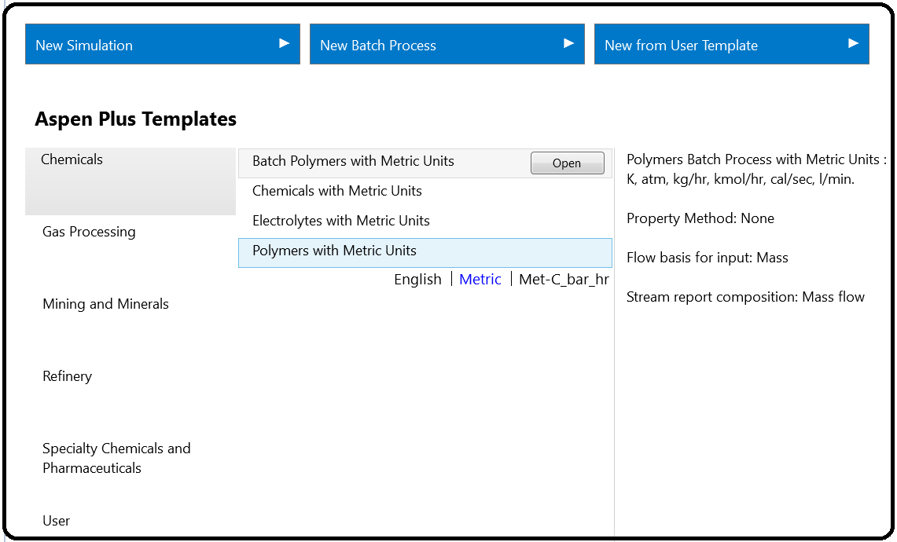

If available unit sets (ENG, MET, and SI) are not suitable for all quantities in this simulation, you can define a new unit set and modify the existing set as necessary. Figure 16.2 shows how a unit set can be defined, and new units for temperature, pressure, and volume flow selected.

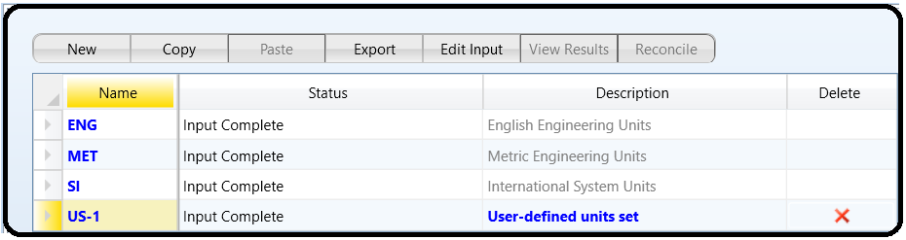

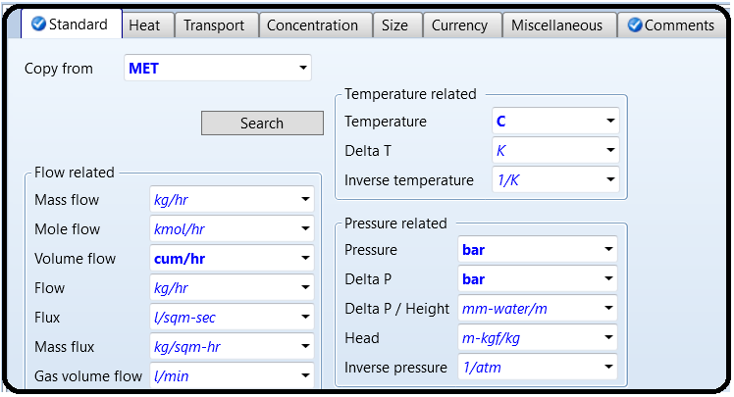

On the Specifications page under Components, create a list of components as shown in Figure 16.3. For PS, select Polymer as the component type and for styrene- R select Segment. All other components are Conventional type. Styrene acts as a monomer (STY) and also as a coinitiator (CINI); therefore, it is selected two times.

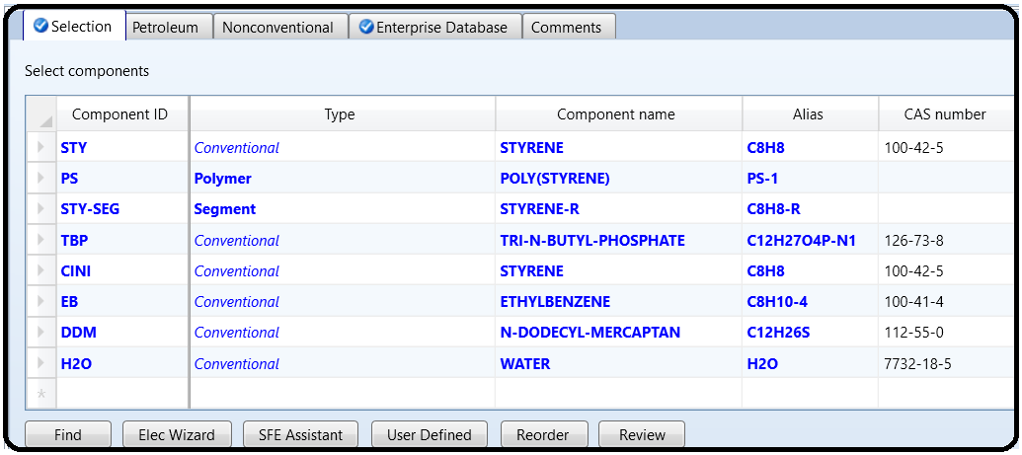

From the main navigation panel, select Polymers under Components.

Select REPEAT as the segment type in the Segments tab under Characterization (Figure 16.4).

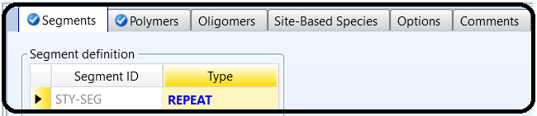

In the Polymers tab under Characterization, chose Free Radical Selection for the group of polymer attributes (Figure 16.4).

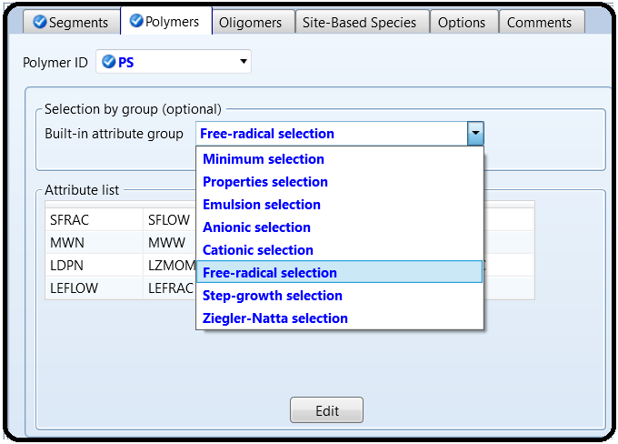

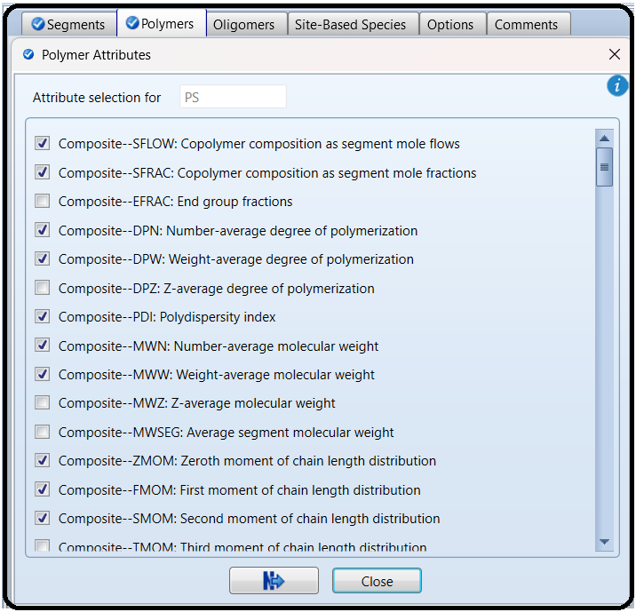

To check details of selected component attributes, follow the steps shown in Figure 16.5.From the main navigation pane, select Distribution under Polymers and enter 100 as the number of points to calculate the distribution function for PS.

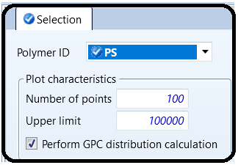

Property Method

A number of property methods for modeling polymer systems are available inAspen Plus.A summary of principles and application fields of polymer property methods available in Aspen plus is given in Table 16.1. The information in this table was extracted from the Aspen Polymer user guide (3).

For PS bulk free-radical polymerization studied in this example, the POLYNRTL property method can be used.

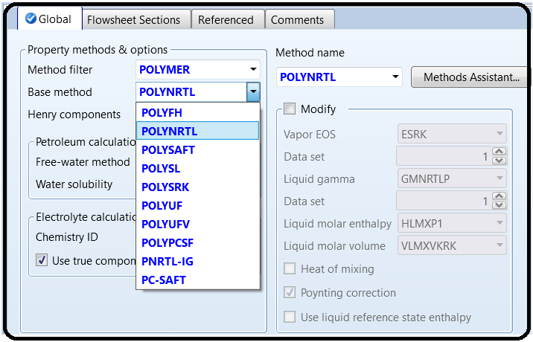On the Specification page under Methods, select the POLYNRTL property method.

To define molecular weight for component TBP, select Pure Components under Parameters under Methods from the main navigation panel.

Define new pure component parameters, select Scalar type and define the value of 216.32 for the TBP molecular weight as shown in Figure 16.6. Switch to the simulation environment to continue in the simulation.

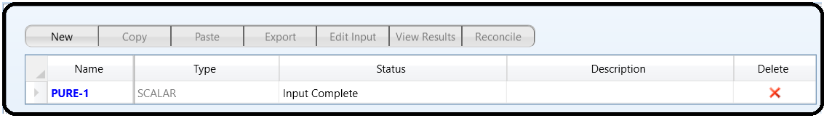

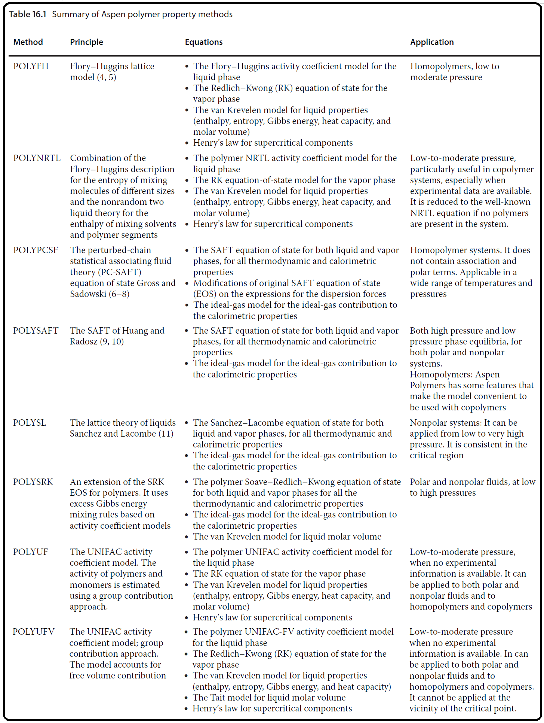

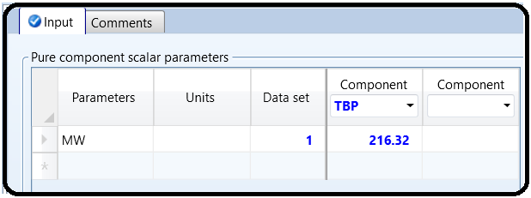

Reaction Kinetics

Aspen Polymer provides detailed kinetic models for all polymerization mechanisms discussed in Section 16.1.

Free-radical polymerizations have at least four basic reaction steps (1):

initiation (generation of reactive free-radicals followed by the addition of a monomer molecule to form chain radicals),

* propagation (growth of chain radicals by the addition of monomer molecules),
* chain transfer to a small molecule (transfer of chains to monomer, solvent, or transfer agent),and
* termination (destruction of chain radicals and conversion of live polymers to dead polymers).

Each reaction step includes different reaction types, where one or more reactions take place in the polymerization process. Initiation reactions are initiator decomposition reaction, induced initiation reaction, and catalyzed initiation reaction. Bulk PS polymerization uses initiators with two active sites. These bifunctional initiators decompose in two stages. The primary decomposition

reaction generates a pair of radicals, an undecomposed initiator fragment, and optional by-products. The initiator fragment decomposes in the secondary decomposition reaction generating a free radical and a polymeric radical. The propagation step besides the addition of monomer radicals to the active chain can also include the so-called head-to-head propagation. Chain transfer to small molecules includes chain transfer to solvent, chain transfer to agent, and chain transfer to monomer. Termination occurs by combination and/or disproportionation. Styrene studied in this example is terminated predominantly by combination. Inhibition can also be added as an additional termination mechanism. Moreover, many other reactions such as long-chain

branching, short-chain branching, cis and trans propagation, and so on are included in the model.

The free-radical model includes an option to modify the reaction rate expressions using a gel-effect correlation. At high polymer concentrations or high conversions, the diffusion becomes the limiting factor for termination, as a result the polymerization rate increases which is known as the gel effect. In this example, the following reactions for bulk freeradical polymerization of styrene are considered:

1. Initiator decomposition. The initiator decomposition reaction (R16.1) can be modeled as a first-order reaction. Generally, initiator decomposition is accompanied by the formation of by-products; however, it was not considered in this example. Therefore, coefficients a and b in (R16.1) were assumed to be zero:

I → R∗ + aA + bB

The rate of initiator thermal decomposition, *r*ID, is given by

rID = kIDCI

where kID is the rate constant of the initiator thermal decomposition calculated by a modified Arrhenius equation (equation 16.10) and CI is the initiator concentration. An initiator mass decomposition rate is used to calculate the rate of primary radicals’ formation,

rRADID , by

rRADID = kIDCINr𝜀

the formation of one or two radicals and 𝜀 is the initiator efficiency factor, which specifies the fraction of radicals that are not destroyed by the cage effect.

2. Thermal initiation. Thermal initiation represents the production of free radicals from monomers in the presence of initiator or promoter. Styrene at temperatures above 120 ◦C has a significant thermal initiation rate:

M + CINI → P1(Sty-Seg) (R16.2)

The reaction rate is given by equation (16.3).

rTI = kTICaMCbC

3. Chain initiation. The initiation process is completed by a reaction of the reactive primary radical with the monomer to form polymer chain radicals:

R∗ +M → P1

rP1 = kP1CMCR∗

Consumption of primary radicals by the chain initiation reaction is given as

rRADP1 = −kP1CMCR∗

4. Propagation. The growth of chain radicals (propagation) by an addition of monomer molecules is represented by

Pn +M → Pn+1 (R16.4)

where monomerMis added to a polymer chain of the length n to form a polymer chain of the length n + 1. The reaction rate can be calculated as

rP = kPCMCR∗ (16.6)

5. Chain transfer to monomer. If a live polymer abstracts a hydrogen atom from a monomer, it results in a dead polymer and the monomer which losses a hydrogen becomes a live polymer end group with an unreacted double bond. This reaction is known as the chain transfer to monomer.

Pn +M → Dn + P1

rTM = kTMCMCPn

6. Chain transfer to agents (EB andDDM). Chain transfer to agents (EB andDDMin this example) takes place by the same mechanism as that to monomer. It leads to the formation of a dead polymer and a free radical:

Pn + EB → Dn + R∗

Pn + DDM → Dn + R∗

The reaction rate of chain transfer to an agent is given as

rTA = kTACACR∗

7. Termination by combination. In termination by combination, two live polymer end groups react with each other forming a single dead chain with a head-to-head segment pair:

Pn + Pm → Dn+m

rTC = kTCCPnCPm

Rate constants in equations (16.1)–(16.9) were calculatedusing a modified Arrhenius equation

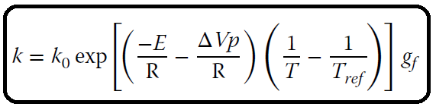

where k0 is the preexponential factor in s−1 for the first-order reactions, and m3⋅kmol−1⋅s−1 for the second-order reactions, E is the activation energy in mole enthalpy units, ΔV is the activation volume in volume/mole units, and gf is the gel effect factor. The gel effect factorwas considered to be 1 in this example. To define the reaction kinetic model of styrene bulk free-radical polymerization follow the next steps in Aspen Plus:

In the simulation environment, select Reaction from the main navigation panel.

Create a new reaction set and select FREE-RAD reaction type as shown in Figure 16.7.

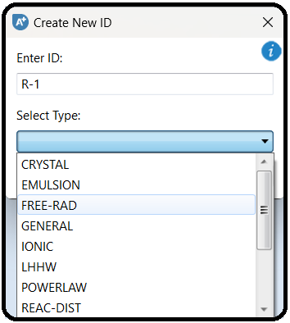

In the Species tab under created Reaction set, define the species participating in the polymerization reactions as shown in Figure 16.8. As polymer select polystyrene, as monomer styrene. In the “goes to” field, choose the polystyrene segment. The standard initiator is TBP, and the coinitiator is CINI (styrene). As transfer agents, select EB and DDM.

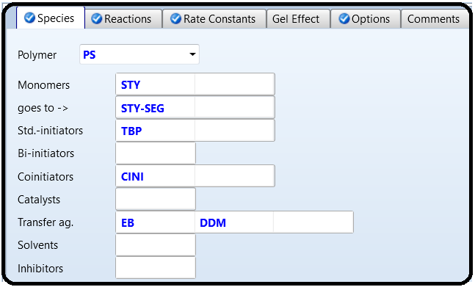

Under Reactions, define the polymerization reactions described above by selecting New and specifying reactants and products as shown in Figure 16.9. An alternativemethod is to select the Generate Reactions button; Aspen will automatically generate a set of reaction that can be modified based on the assumptions made in the process. The complete list of reactions is shown in Figure 16.10.

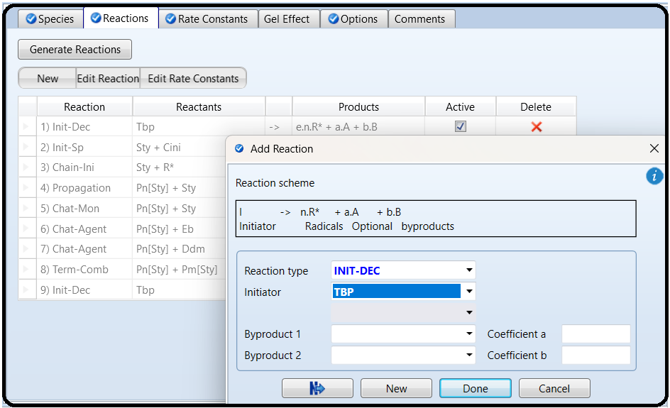

In the Rate Constants tab, enter the values of kinetic parameters, the preexponential factors, activation energy, initiator decomposition efficiency, parameter Nr of equation (16.2) and other parameters given in Figure 16.11 were taken from (2).

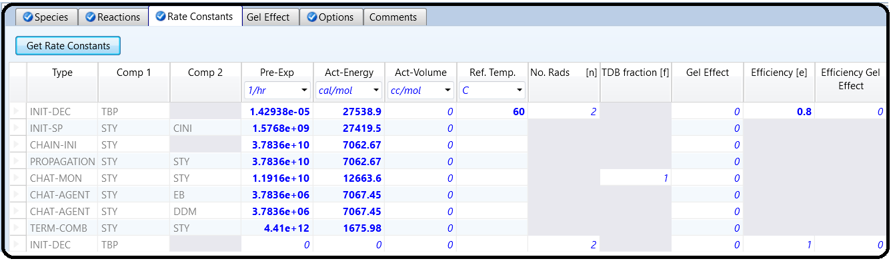

In the Options tab, select Quasi Steady State and Special Initiation and enter the parameters of Special Initiation as shown in Figure 16.12. The gel effect is not considered in this example.

Now, the reaction set is ready to be added to a polymerization reactor model.

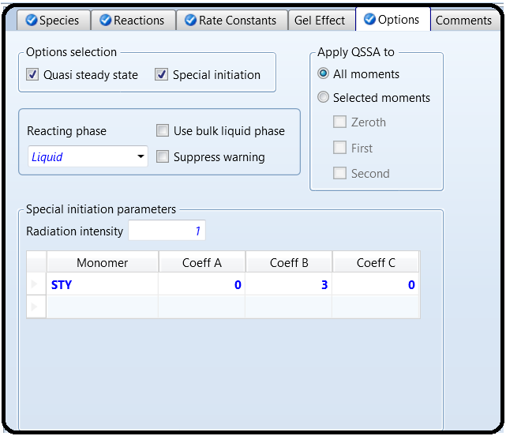

Process Flow Diagram

There are no significant differences in building a PFD for a polymer process and for processes with conventionalcomponents. Polymerization reactions are modeled usuallyby kinetic models using RCSTR, RPlug, and Rbatch unit operation blocks. Versions of Aspen Plus used in this book do not enable modeling of polymerization reactions in the distillation column model RadFrac. For this reason, the distillation column model RadFrac has to be combined with a RCSTR to model a polymer reactive distillation column. The process flow diagram of styrene bulk free-radical polymerization as it is described in this example is given in Figure 16.13.

To calculate feed makeup for each component of feed, a Design Specification (DS) block has to be defined.

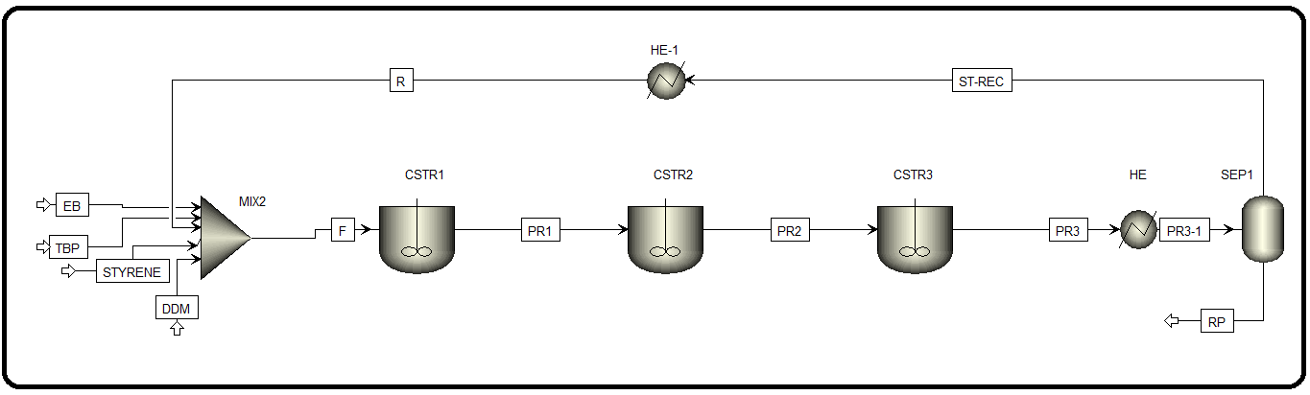

Under Flowsheeting Options on the main Navigation panel, define a new DS.

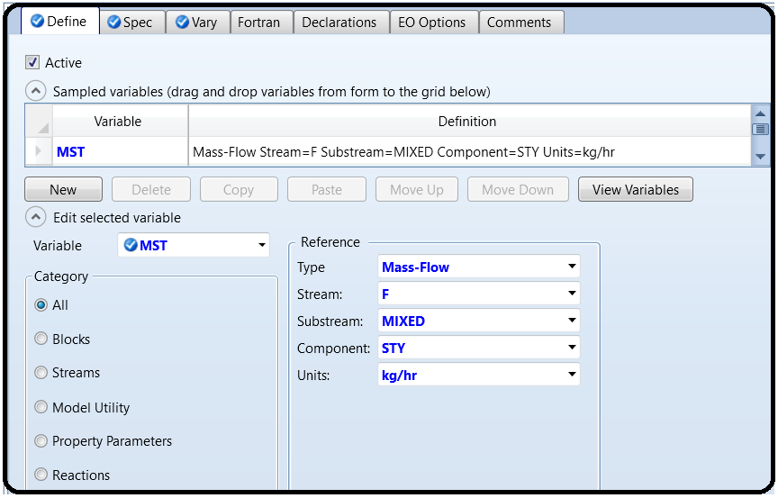

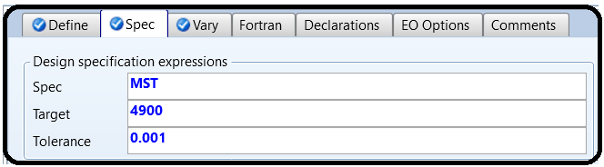

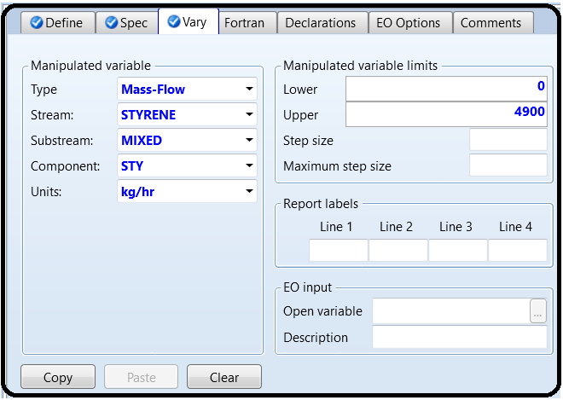

As Define variable select mass flow of styrene in the reactor feed stream F.

In Spec tab, specify the target value of styrene mass flow and the tolerance.

As manipulated variable Vary select the mass flow of the styrene makeup stream (STYRENE) as shown in steps 5 and 6 in Figure 16.14.

Use the same method to define DS blocks for all components of the feed: EB, TBP, and DDM.

Specify all inlet streams by temperature, pressure, mass flow and composition, note that there are no differences in the specification of material streams between polymer processes and conventional component processes. Specify all three CSTR reactor models by temperature and pressure; select the liquid phase as the reaction phase and add the same defined reaction set to all three CSTRs.

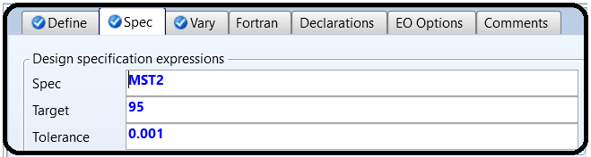

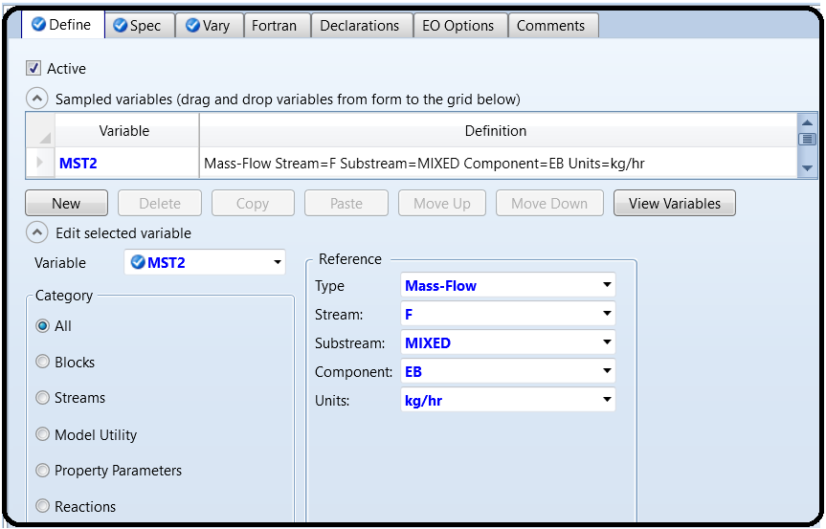

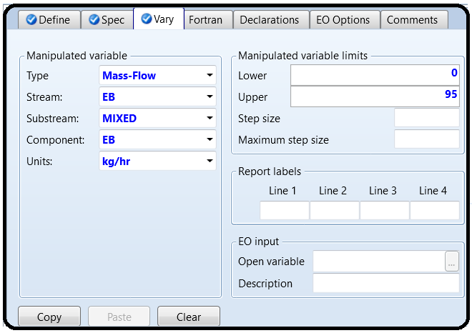

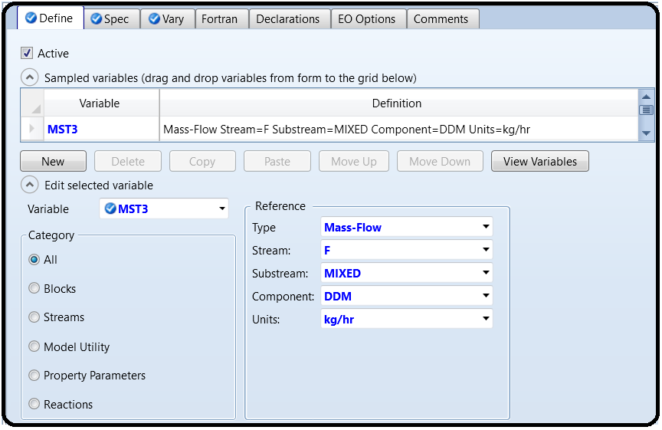

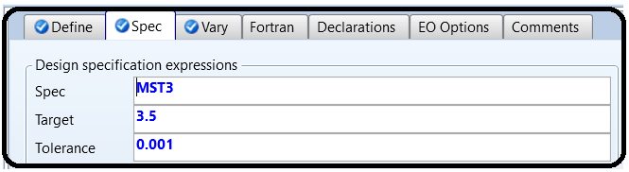

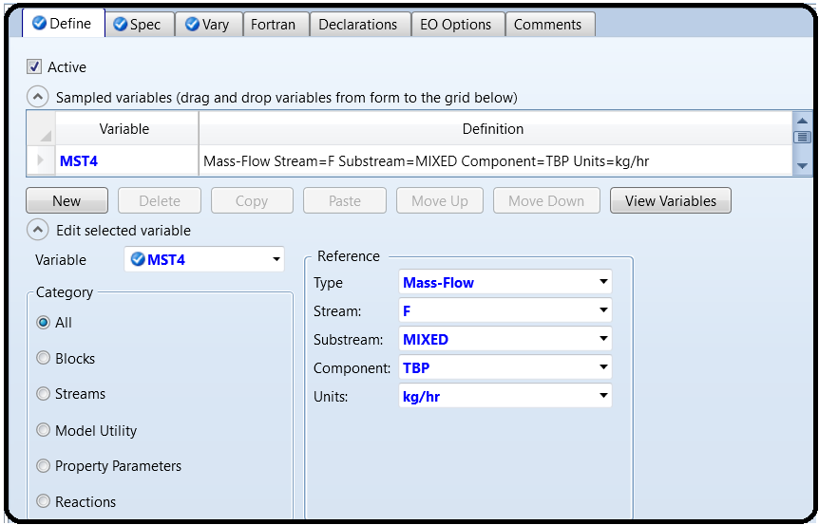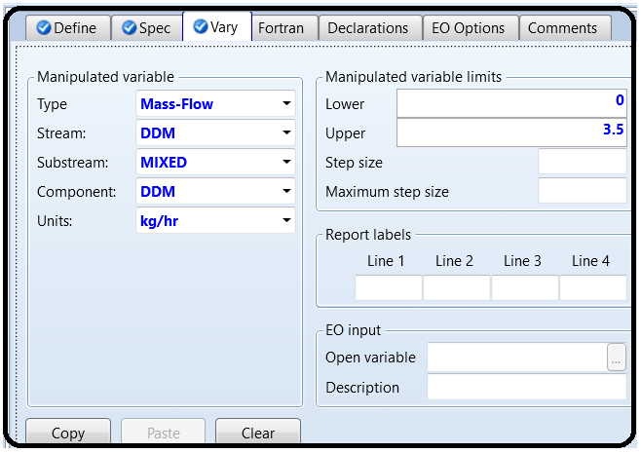

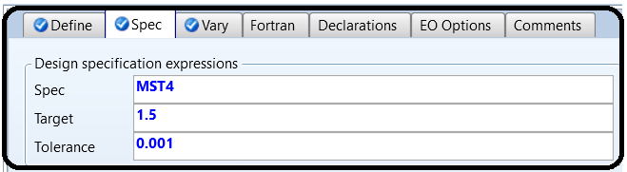

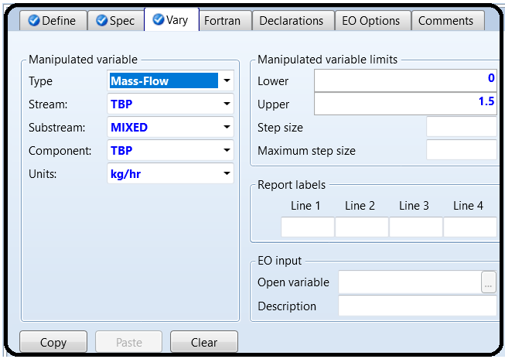

Results

The material stream results are shown in Table 16.2. Conversion and characterization of polymer after each reactor are given in Table 16.3. For default reactor temperatures of 120, 160, and 200 ◦C, the mass flow of PS after the first, second, and third reactor was 956.6, 2,994.64, and 4,248.33 kg⋅h−1, respectively. These mass flows correspond to the total conversion of 19.52, 61.11, and 86.68%, respectively. The PDI increased from 1.81 measured after the first reactor to 2.14 after the last one. Both weight-averaged and number-averaged molecular weights of polymer decreased with the increasing reactor order because of the temperature increase.

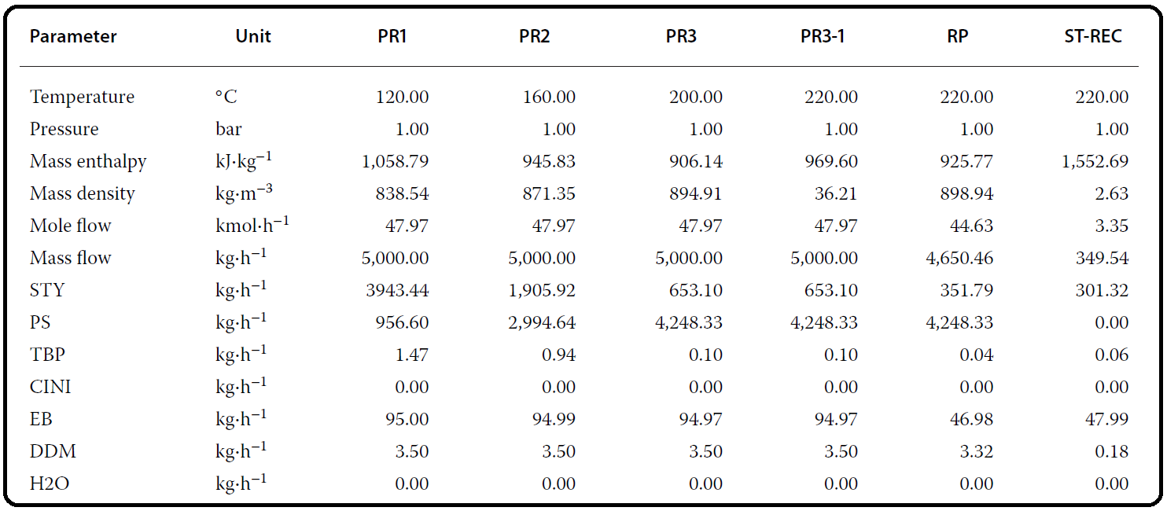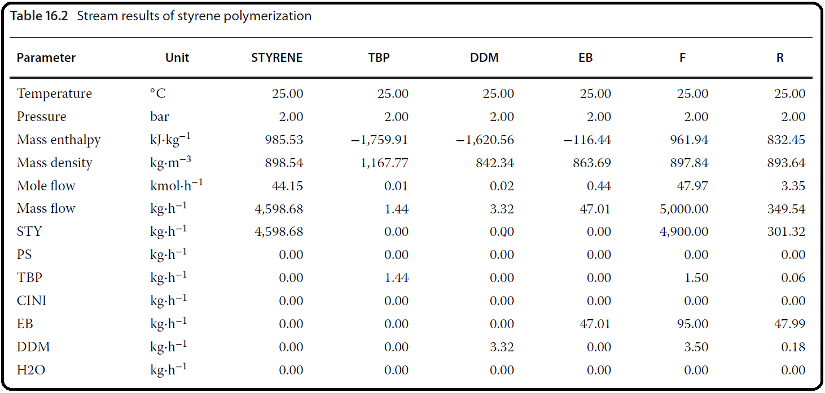

For each stream, the polymer chain size distribution and molecular weight distribution can be displayed in tables (Figure 16.17) and plots (Figure 16.18). To display chain size distribution curveswith logarithmic *x* axis, follow the steps shown in Figure 16.17. The effect of the second reactor (CSTR2) temperature on conversion, PDI, MWW, MWN, mass flow of polymer produced, and mass flow of styrene to be recycled are presented in Figures 16.19–16.22. Increasing the temperature in the second reactor from 120 to 180 ◦C affects mainly the conversion and parameters of the second reactor products. The first reactor is not influenced because of constant conditions at the reactor inlet. However, conversion and polymer parameters after the third reactor are influenced.

While conversion in the third reactor increased with the increasing temperature in the second reactor, the PDI, in the third reactor decreased down to 443 K, where a minimum was observed. Both weight-averaged and number-averaged MW of the polymer from the second reactor decreased with the temperature increase; however, MWW from the third reactor showed a maximum at the second reactor temperature of 403 K and MWN from the third reactor showed this maximum at 423 K. As it is seen from Figure 16.23, increasing the temperature in the second reactor increases the mass flow of the polymer produced and decreases the amount of styrene to be recycled. However, higher temperature means shorter polymer chain size. The maximum of the MWW and MNW curve and the minimum of the PDI curve for the polymer from the last reactor indicate that the optimum temperature of the second reactor is between 150 and 160 ◦C.

To determine the effect of the second reactor temperature on conversion, PDI, MWW, andMWN at the outlet of each reactor, a sensitivity block has to be defined

As *Vary* in the sensitivity block, select the temperature of the second reactor.

In the *Define* tab of the sensitivity block, define parameters to be observed or necessary for the calculation of conversion. The list of *Define Variables* of the sensitivity block is shown in Figure 16.15.

In the Fortran tab of the sensitivity block, write equations for the calculation of conversion as shown in Figure 16.16.

In the *Tabulate* tab, create the list of variables to be displayed in the table of results.

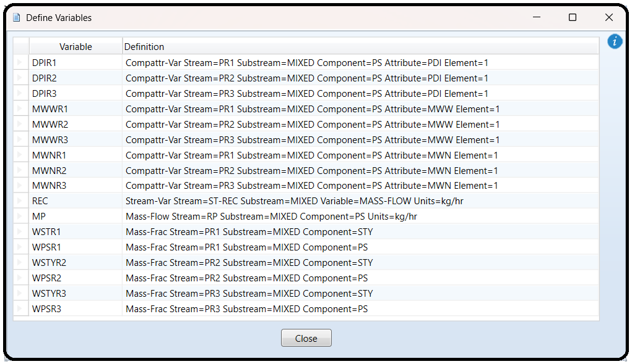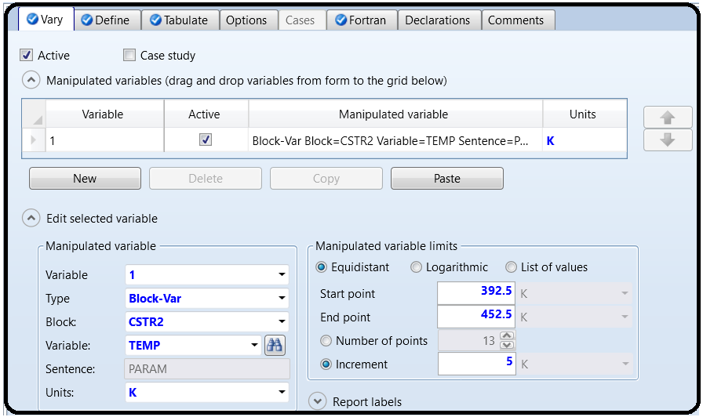

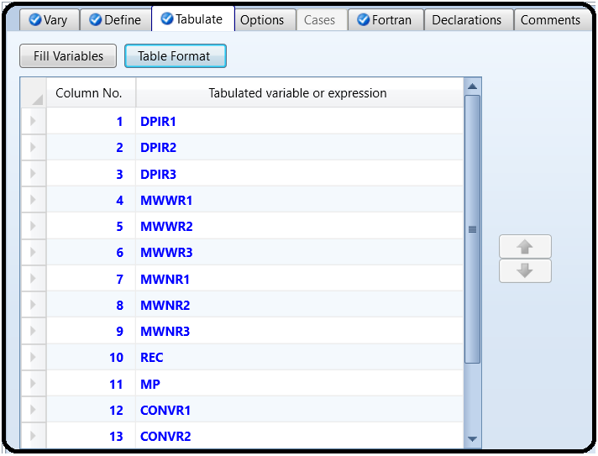

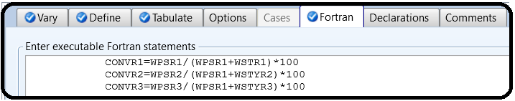

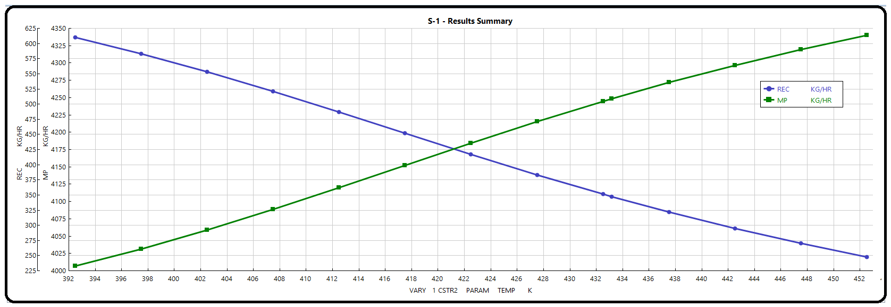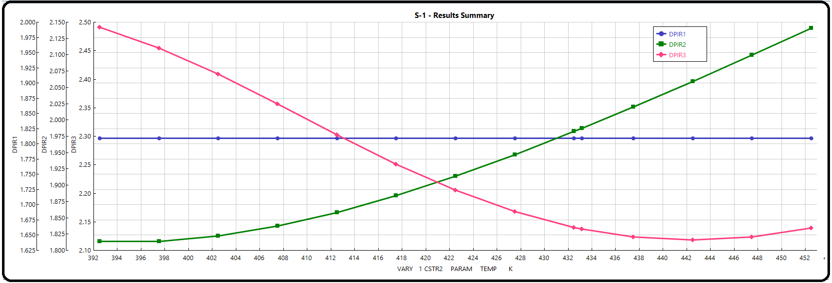

Part 2

Problem Definition

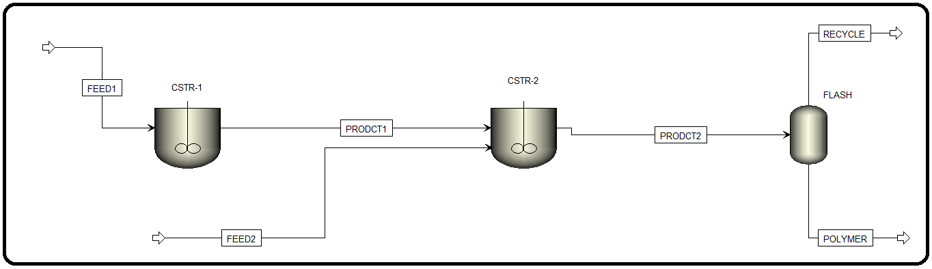In this example, the solution polymerization of ethylene is carried out at 160∘C using *n*-hexane as a solvent. Hydrogen is used as a chain transfer agent to control the molecular weight. The flowsheet consists of two reactors and a flash unit as shown in Figure 12.2.

The first reactor produces a high-molecular-weight polymer while the second produces a low-molecular-weight polymer. Solvent, unreacted monomer, and hydrogen are removed from the product in a flash tank. An intermediate feed stream going to the second reactor is used to set the concentration of hydrogen in that reactor to be several times higher than in the first reactor.

Process Conditions

The process conditions are shown in Table 12.1:

I discuss in the next section polymer-related input data that are specific to polymer industries and are quite uncommon in the previous chapters.

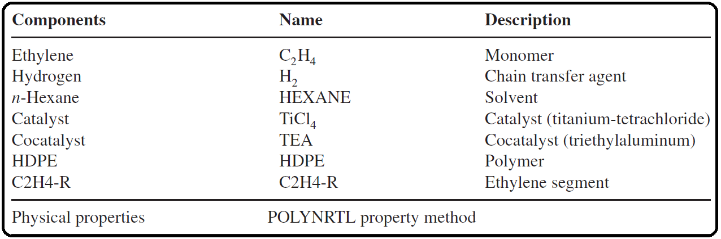TABLE 12.1 Process Conditions for High-Density Polyethylene High-Temperature Solution Process with Two Reactors and a Flash Unit.

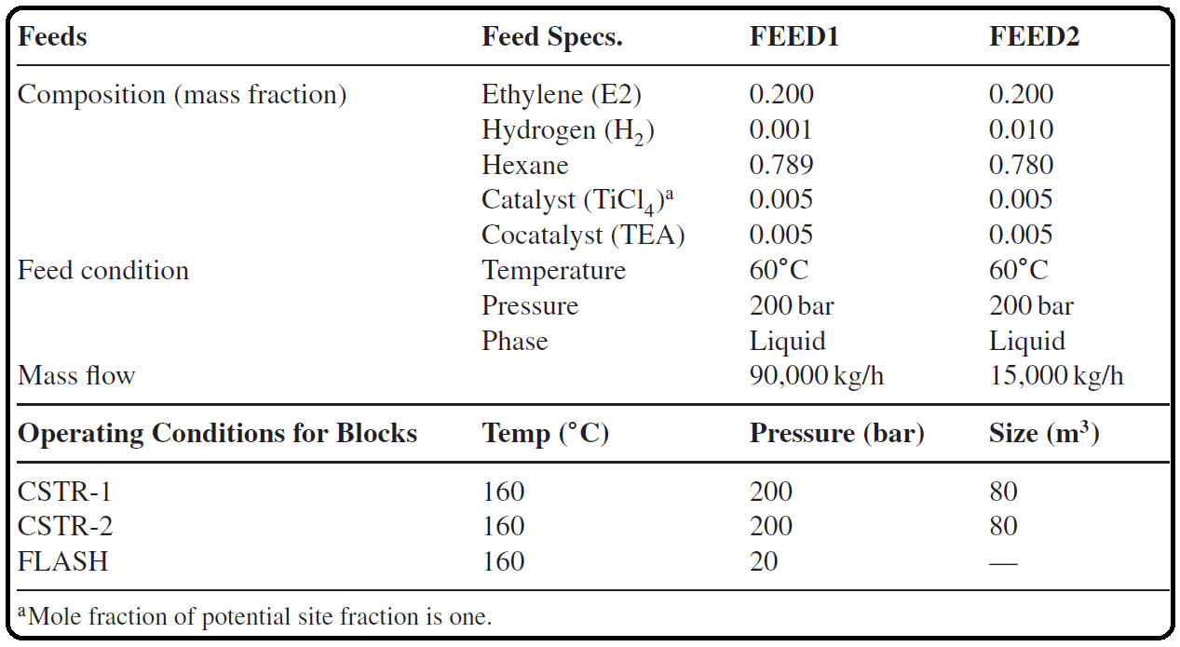

CREATING ASPEN PLUS FLOWSHEET FOR HDPE

Using Aspen Plus, start a new simulation by choosing the “Polymers” category and selecting “Polymers with Met-C_bar_hr Units” template to create a steady-state flowsheet. Notice that the property method originally used in: “Aspen Polymers: Examples & Applications” was set to POLYPCSF; nevertheless, it requires more input parameters, such as “PCSFTM”, “PCSFTU”, and “PCSFTV” both for the catalyst and cocatalyst. “PCSFTM” was supplied by Aspen Plus Polymers manual; unfortunately, the other two parameters are missing and must be supplied by the user as input parameters, or else there will be no solution and no chance to negotiate with Aspen Plus in this regard. Consequently, I tried all other property methods as recommended by the “Property Method Selection Assistant” and found that “POLYNRTL” gives reasonable results and requires the least input data. Moreover, there is no need to externally link with USERFORT.DLL file. However, if more data are available regarding properties of the monomer, solvent, polymer, catalyst, and cocatalyst, then it will be more accurate to switch to such property methods that can exploit the additional input data. Using “POLYNRTL” method will be good enough to touch the premises of polymerization reaction technology. Moreover, the free water method was set to “SYSOP0” instead of “STEAM-TA” in “Methods” | “Global” sheet. Give a title for the project and add the components as shown in Figure 12.3. Do not forget to change component “Type” of both “C2H4-R” and “HDPE” from *Conventional* to *Segment* and *Polymer*, respectively.

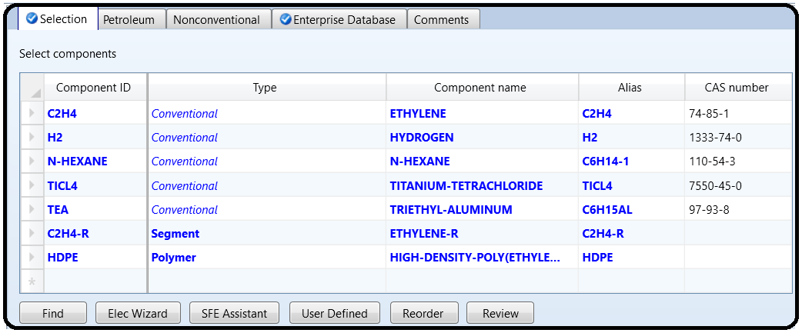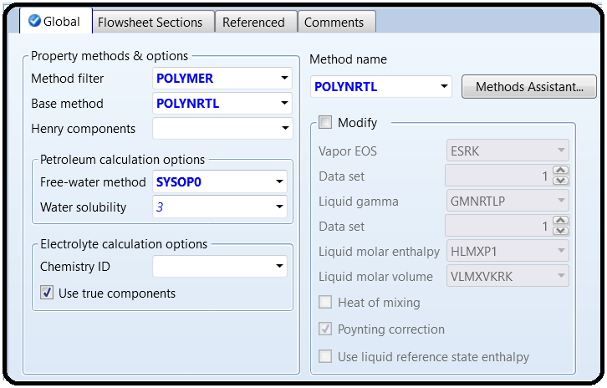

Figure 12.4 shows “Components” | “Polymers” | “Characterization” | “Segments” tab window, where “C2H4-R” is defined as the repeat segment or building block for the polymer.

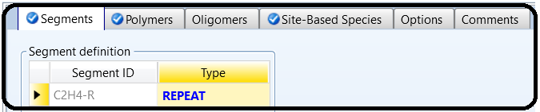

Figure 12.5 shows the “Polymers” tab window where the user identifies the polymer, which is HDPE in this case, and selects the “Built-in attribute group” as “*Ziegler–Natta* *selection*” from the drop-down list. For more information on what these symbols stand for, refer to “APPENDIX 12.A” | “Calculated Polymer Properties” section and also refer to Aspen Plus built-in help for further information. Notice that only streams containing HDPE will be augmented by such attributes.

Figure 12.6 shows that a total of four site types are used for the catalyst (TiCl4). Two sites will be considered active in the first reactor and all four sites in the second reactor. Moreover, the molar concentration of catalytic sites is assumed as 0.0001 (kmol/kg catalyst).

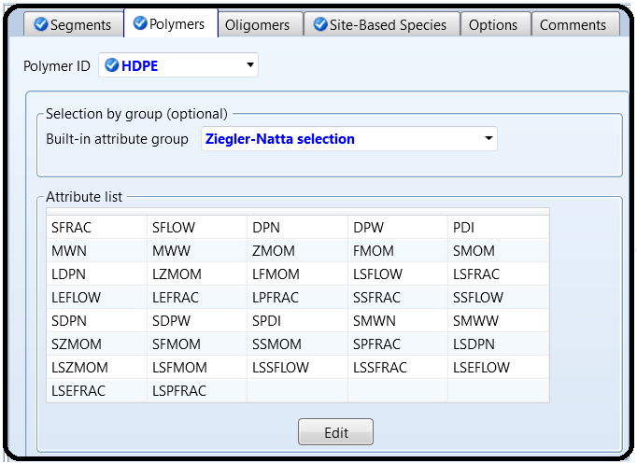

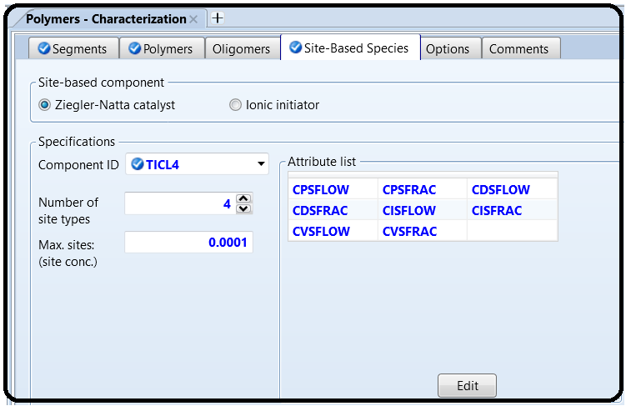

Figure 12.7 shows the selection to perform Gel Permeation Chromatography (GPC) to request tracking of distributions. You need to specify the type of distribution, the polymer, and the display characteristics for the generated distribution data. In order to track distributions in your simulation, you must select the distribution characteristics. After the simulation is complete, you must retrieve the distribution data for plotting purpose. *You can display/plot the distribution data for the polymerization reactor, for* *a stream, or for the entire flowsheet*. In “Plot characteristics” box, select “Perform GPC distribution calculation” option. The distribution is calculated as *rW*(*r*) versus *r*, where *r* is the number-average degree of polymerization. The common polymer structural properties for which distributions (i.e., *W*(*r*)) are typically considered include the chain length distribution (CLD) and molecular weight distribution (MWD). In order to accurately characterize a polymer component, and maintain a control of polymer product properties, engineers must be acquainted by these distributions. For further information, refer to Aspen Plus built-in help under “Verifying the Accuracy of Distribution Calculations” and “Calculating Distribution Increments”.

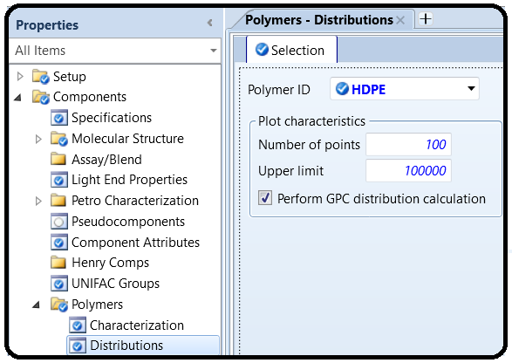

Under “Properties” environment, go to “Methods” | “Parameters” | “Binary Interaction” | “NRTL-1” sheet and be sure that the “Estimate missing parameters by UNIFAC” option is enabled. Click on “Reset” followed by “Next” button to run the simulation and assure that properties analysis completed successfully. Switch to “Simulation” environment.

From “Model Palette”, select “Reactors” tab, click on “RCSTR” icon, and add it twice to the flowsheet area. In addition, add one “Flash2” type separator. Add the proper input and output streams, as shown in Figure 12.2. The feed stream input properties and the operating conditions of each of three blocks are shown in Table 12.1.

Figure 12.8 shows “Streams” | “FEED1” | “Input” | “Mixed” tab window, where part of, or all catalyst attributes (Table 12.2) may be entered. Keep in mind that the catalyst is introduced to the reactor with the feed stream (i.e., not present in the reactor).

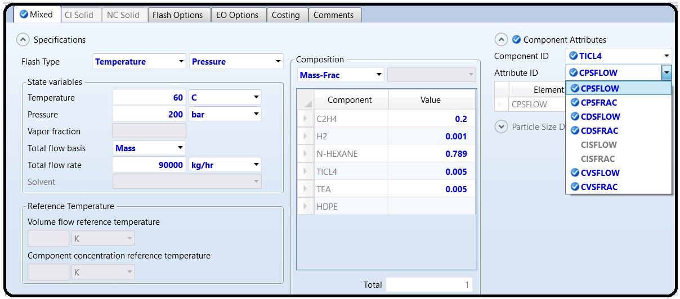

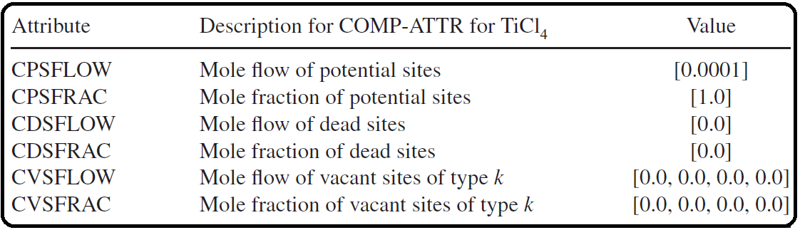 TABLE 12.2 The Entered Catalyst (TiCl4) Component Attributes and Their Description.

Component attributes are used to track the multisite Ziegler–Natta catalyst site activity, in terms of mole flow and fraction of potential, vacant, inhibited, dead, and occupied sites. The occupied sites are not tracked since that information may be obtained from the live polymer zeroth moment of chain length distribution (ZMOM). The site types are defined as follows:

• Potential sites: sites that are not yet activated.

• Vacant sites: activated sites without an attached growing polymer.

• Inhibited sites: activated sites that are temporarily in an inactive state.

• Dead sites: sites that have permanently lost their catalytic activity.

• Occupied sites: activated sites with an attached growing polymer.

Table 12.2 lists the entered catalyst component attributes and their description: Notice that the values of catalyst (TiCl4) attributes are exactly repeated for “FEED2” stream.

Let us show the critical part of polymerization reactions. Under “Reactions” folder, click on “New…” button to create a reaction. Figure 12.9 shows the creation of “R-1” reaction set of *Ziegler–Natta* type.

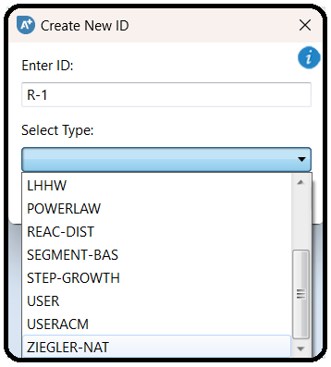

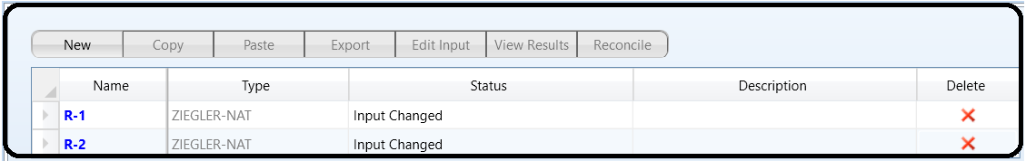

Figure 12.10 shows the “Species” tab window where the user defines the polymer, the monomer, the repeat or building unit, the catalyst, the cocatalyst, the solvent, and the hydrogen (also acts as a transfer agent).

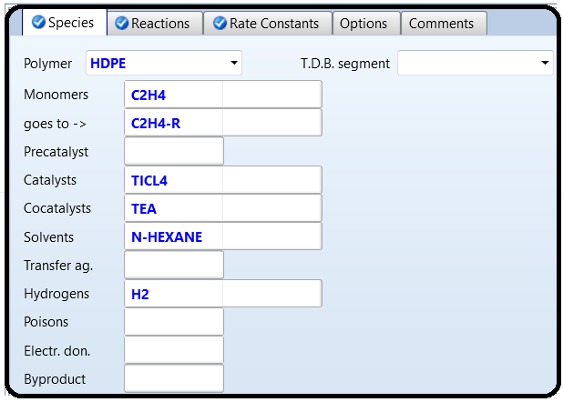

Once you select “Generate reactions” option (deselect later), as shown in Figure 12.10, Aspen Plus will create many different reaction steps that all in all describe the overall mechanism of conversion of ethylene to HDPE using Ziegler–Natta approach. We will retain reaction substeps with known kinetics, as given in Figure 12.11 for “R-1” set and

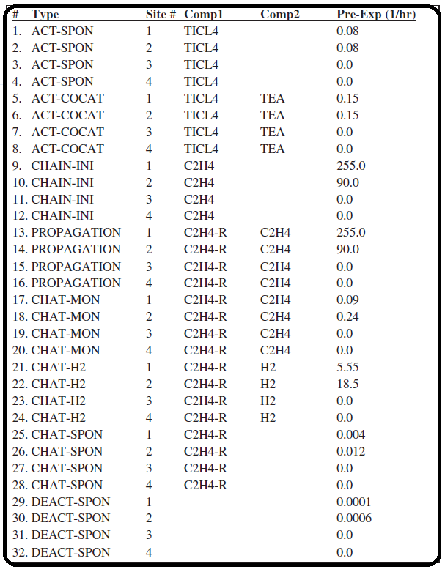

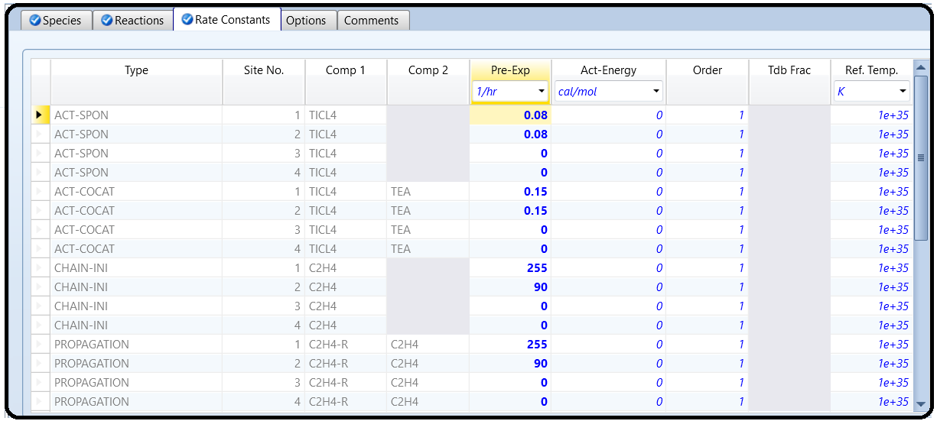

in Figure 12.12 for “**R-2**” set. This means that you delete all other reaction substeps that are not listed here, using “**Delete**” button at the bottom of “**Reactions**” tab window. Notice that the pre-exponential factor is entered, under “**Rate Constants**” tab, for each considered substep.

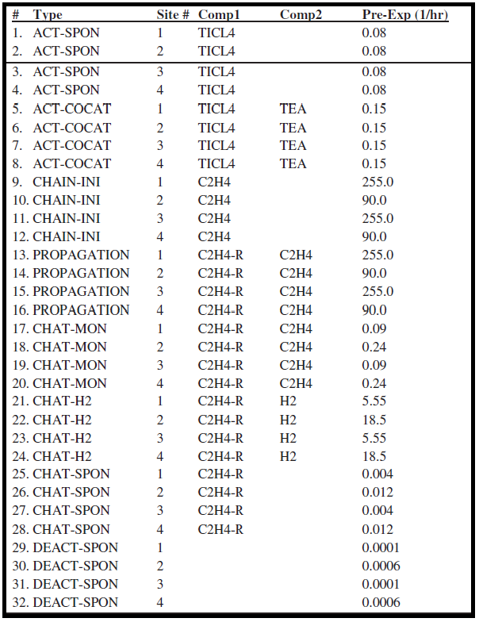

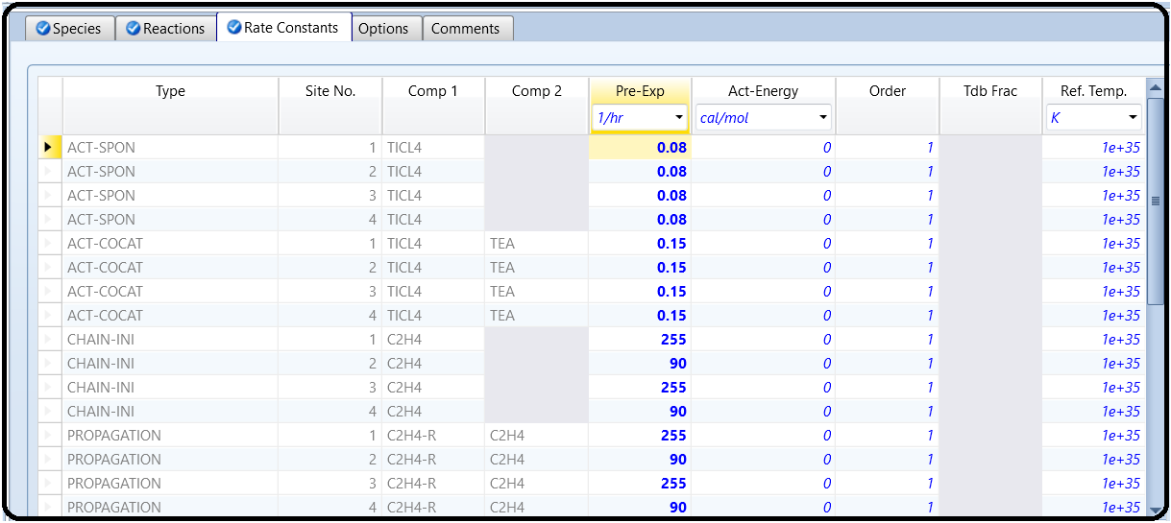

IMPROVING CONVERGENCE

Polymer reaction kinetics present very difficult convergence problems, so the standard convergence options are frequently insufficient. To resolve this problem, perform the following steps:

a) Go to “Blocks” | “CSTR-1” | “Convergence” form.

b) Click on “Parameters” tab and change the “Solver” to “*Newton*”.

c) Click on “Newton Parameters” button and change the “Stabilization strategy” to “*Line-Search*”. Click on “Close” button.

NOTE #3: *Implementing these two steps (b and c) are recommended for all chain polymerization kinetics*.

d) In the “Parameters” tab sheet, click on “Advanced Parameters” button and change the “Scaling method” to “*Component-based*”.

NOTE #4: *Component-based scaling is recommended for all Aspen Plus Polymers simulations*.

e) In the “Parameters” tab sheet, select “*Initialize using integration*” option under “Initialization” section. When this option is selected, CSTR uses an integrator to provide an initial guess to the simultaneous equation solver.

f) Repeat previous steps for “CSTR-2” block.

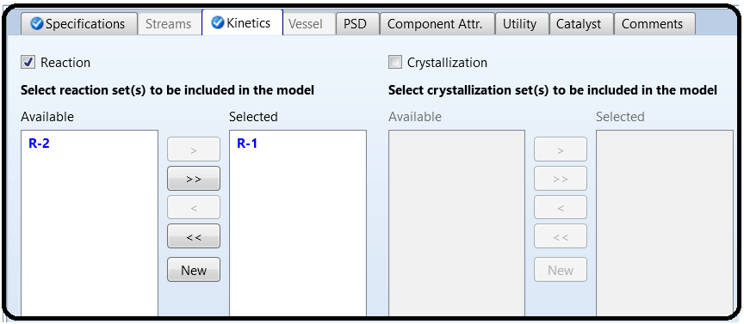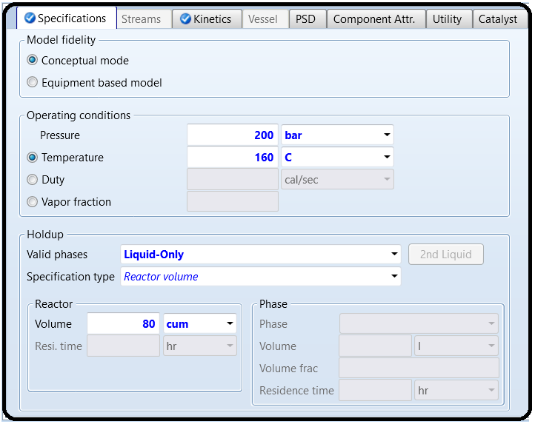

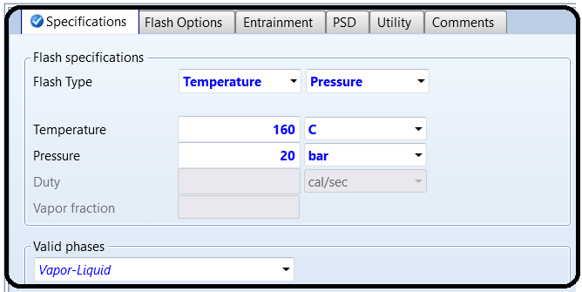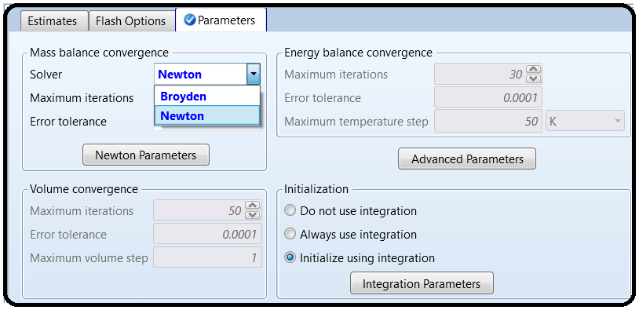

PRESENTING THE PROPERTY DISTRIBUTION OF POLYMER

After finishing the “one thousand and one night” novel about entering such an immense number of input parameters, reinitialize, run the show, and check for warnings and errors (if any).

To see some HDPE polymer characteristics for either a block or a stream object, in “Navigation” pane, select that object and then from the top toolbar go to “Plot” tab found in “Home” ribbon followed by clicking on “Chain Size Distr”. button. Follow the steps instructed by the plot wizard to show some polymer characteristics.

Figure 12.13 shows the chain length distribution (CLD) for HDPE polymer inside “CSTR-1”, based on two calculation methods for average molecular properties: Instantaneous distribution and Moments of distribution. The word “Composite” in Figure 12.13 refers to the sum of the four types of catalyst active sites (two sites are considered active in the first reactor).

Notice that DPW=DPN × PDI.

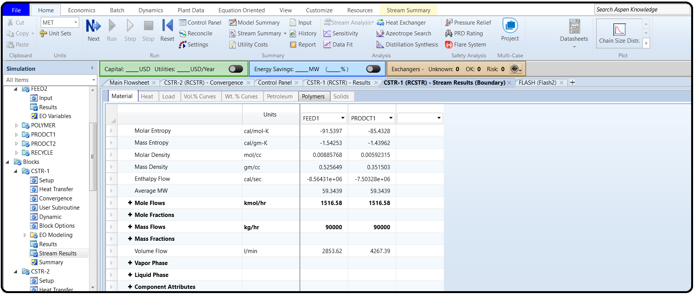

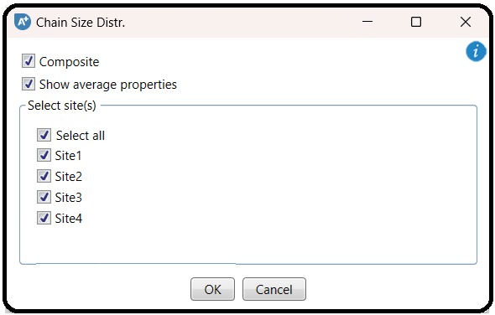

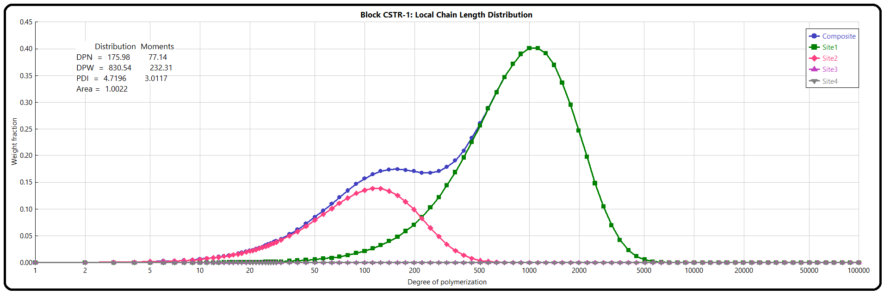

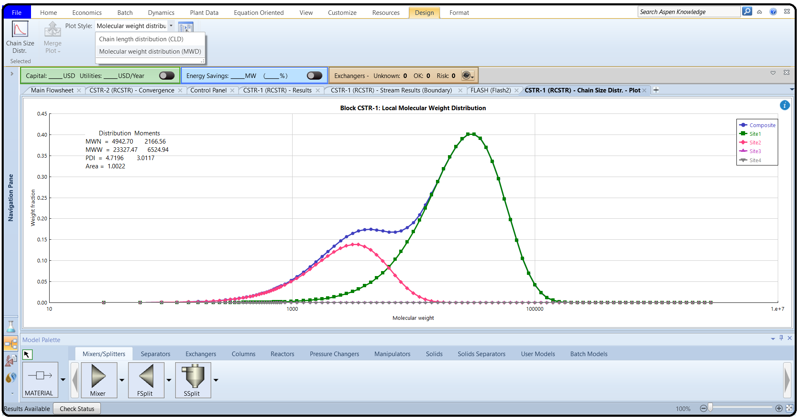On the other hand, to get the molecular weight distribution, you have to select that from the drop-down list shown in “Top Toolbar” under “Design” tab as shown in Figure 12.14. Of course, the plot (“CSTR-1 (RCSTR) – Chain Size Distr. – Plot”) window has to be active.

Referring to Aspen Plus built-in help, here is a summary about the assessment methods of polymer properties or attributes. Keep in mind that the polymer is a mixture of chains; hence, there is normally a distribution

of these structural characteristics. It will be a more convenient way to examine polymer molecular properties in terms of averages instead of considering only the complete distribution. Average properties must be determined from the actual distributions either through distribution moments or through instantaneous properties.

Method of moments (called Moments in Figures 12.13 and 12.15), developed by Tompa [8], continues to be the preferred approach for calculating average properties whether the distribution is unimodal (e.g., binomial, Poisson, or Gaussian) or non-unimodal (such complex distributions having a shoulder, or are even bimodal in behavior as in a

Multi reactor system). Nevertheless, applying the method of moments for the calculation of property distributions has several drawbacks; in addition to CPU requirements and computational complexity, a larger number of moments than currently calculated would be required. A better approach is to use the instantaneous distribution (called Distribution in Figures 12.13 and 12.15) method for generating molecular weight distributions via storing reaction rate data throughout the kinetic calculations, and later using them to construct the full distribution of polymer accumulated in the reactor system. Such an approach was developed by Hamielec [5]. In the simplest case, a linear polymerization in a single CSTR reactor, the ratios of termination and chain transfer reaction rates to propagation reaction rates are stored. The instantaneous chain length distribution is expressed as a function of these ratios and chain length. For the case of two CSTRs in series, at steady-state, the outlet polymer distribution function is the weighted average of the distribution function in each CSTR taken separately. The case of a plug-flow reactor can be approximated using multiple CSTRs, and similarly for a batch reactor.

Finally, the method of instantaneous distribution assumes that the polymer molecules are conserved once they are formed; unfortunately, this assumption can be invalid in the presence of certain side reactions, such as

• random (thermal) scission, which destroys polymer molecules;

• chain transfer to polymer, which causes inactive polymer molecules to become

active again, leading to long-chain branch formation and significantly increasing the weight-average molecular weight and PDI. Keep in mind that the molecular weight distribution charts display the MWW and PDI calculated both by the method of moments and the method of instantaneous properties. If the predicted values for the PDI are not in reasonable agreement (but not necessarily equal) with each other, it will be most likely due to these types of side reactions. Figure 12.16 shows the chain length distribution (CLD) for HDPE polymer inside “CSTR-2”, based on the previously explained two calculation methods for average molecular properties. Again, the word “Composite” in Figure 12.16 refers to the sum of the four types of catalyst active sites. A similar figure can be obtained for the molecular weight distribution (MWD) for HDPE polymer inside the same reactor.

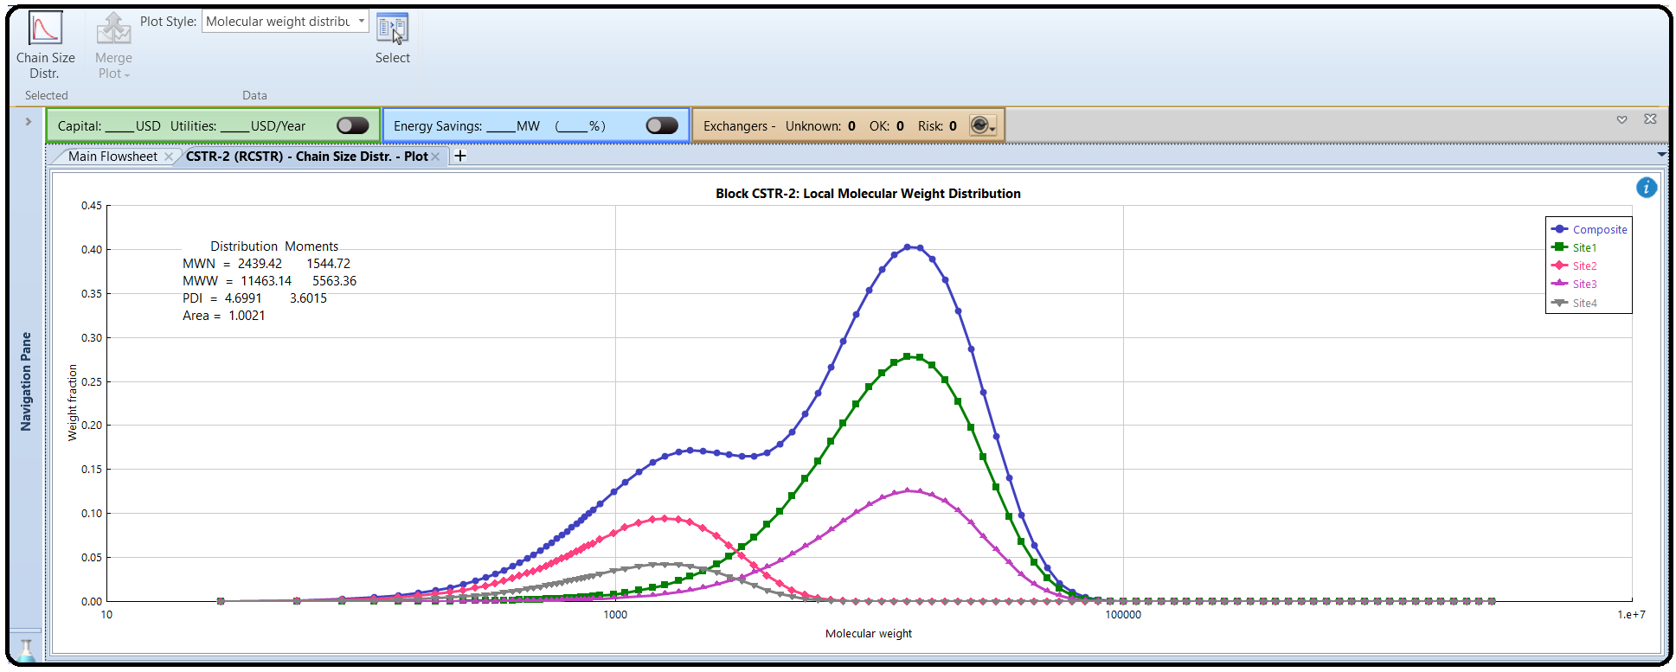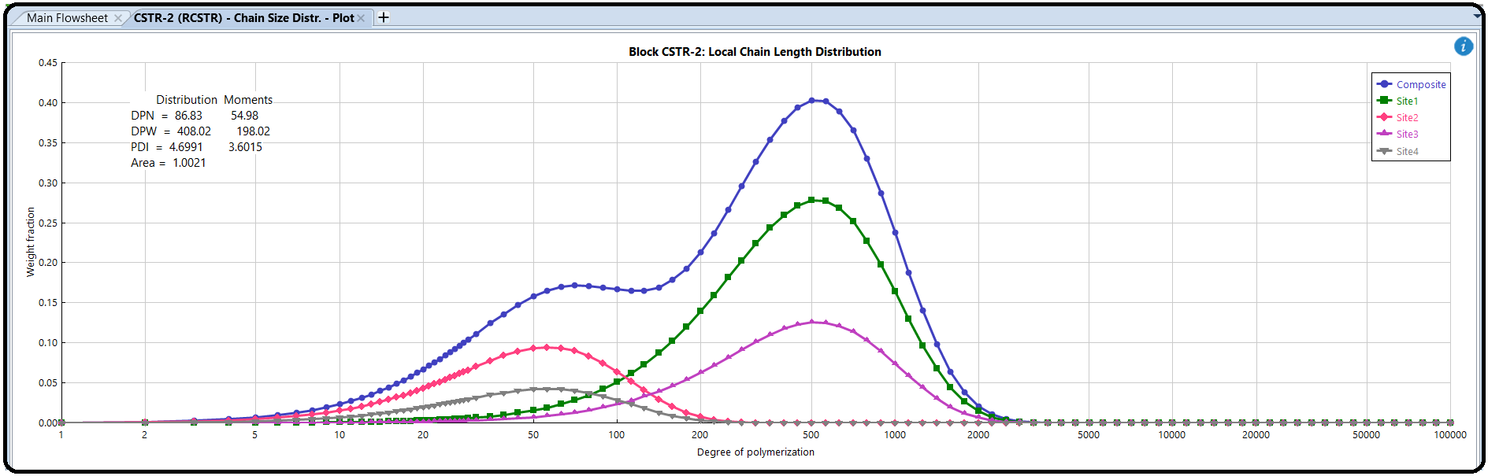

Figure 12.17 shows a portion of product streams properties where HDPE average molecular properties of “PRDCT1” stream are essentially the same as those for “CSTR-1”. On the other hand, the “PRDCT2” stream average molecular weight properties fall somewhere between those of “CSTR-1” and “CSTR-2”. For example, DPN for “PRDCT2” stream, which is 61.2119 (Figure 12.17), lies between DPN of 54.98 (Figure 12.16) for “CSTR-2” and 77.14 (Figure 12.13) for “CSTR-1”.

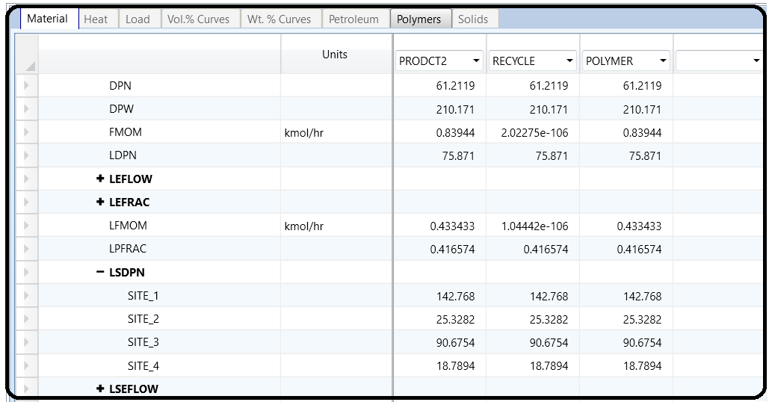

References

1 Aspen Technology. Aspen Polymers, Unit Operations and Reaction Models. Burlington, MA: Aspen Technology, Inc.; 2013.

2 Aspen Technology. Aspen Polymers, Examples and Applications. Burlington, MA: Aspen Technology, Inc.; 2013.

3 Aspen Technology. Aspen Polymers User Guide, version 3, Vol. 1. Burlington, MA: Aspen Technology, Inc.; 1997.

4 Flory PJ. Thermodynamics of high polymer solutions. J. Chem. Phys. 1941;9(8):660–660.

5 Huggins ML. Solutions of long chain compounds. J. Phys. Chem. 1941;9(5):440–440.

6 Gross J, Sadowski G. Application of perturbation theory to a hard-chain reference fluid: An equation of state for square-well chains. Fluid Phase Equilib. 2000;168(2):183–199.

7 Gross J, Sadowski G. Perturbed-chain SAFT: An equation of state based on a perturbation theory for chain molecules. Ind. Eng. Chem. Res. 2001;40(4):

1244–1260.

8 Gross J, Sadowski G. Modeling polymer systems using the perturbed-chain statistical associating fluid theory equation of state. Ind. Eng. Chem. Res. 2002;41(5):

1084–1093.

9 Huang SH, Radosz M. Equation of state for small, large, polydisperse, and associating molecules. Ind. Eng. Chem. Res. 1990;29(11):2284–2294.

10 Huang SH, Radosz M. Equation of state for small, large, polydisperse, and associating molecules: Extension to fluid mixtures. Ind. Eng. Chem. Res. 1991;30(8): 1994–2005.

11 Sanchez IC, Lacombe RH. An elementary molecular theory of classical fluids. Pure fluids. J. Phys. Chem. 1976;80(21):2352–2362.

12. Albright, L.F. (1985) *Processes for Major Addition-Type Plastics and Their Monomers*, 2nd edn, Krieger Publishing, Florida.

13. Brockmeier, N.F. (1983) Latest commercial technology for propylene polymerization, in *Transition Metal Catalyzed Polymerizations: Alkenes and Dienes* (ed. R.P. Quirk), Harwood Academic,New York.

14. Choi,K.-Y. and Ray,W.H. (1985) Recent developments in transition metal catalyzed olefin polymerization: a survey. I. Ethylene polymerization. *Journal of Macromolecular Science: Reviews* *in Macromolecular Chemistry and Physics*, **C25** (1), 1.

15. Debling, J.A., Han, G.C., Kuijpers, F. *et al.* (1994) Dynamic modeling of product grade transition for olefin polymerization processes. *AIChE Journal*, **40** (3), 506.

16. Hamielec, A.E. (1992) Polymerization processes, in (eds B. Elvers S. Hawkins and G. Schulz). *Ullmann’s Encyclopedia of Industrial Chemistry* (5th Ed.), Vol. A21, (pp. 324-330). New York: VCH.

17. Nowlin, T.E. (1985) Low pressure manufacture of polyethylene. *Progress in Polymer Science*, **11**, 29.

18. Short, J. N. Low pressure ethylene polymerization processes. In R.P. Quirk (Ed.), *Transition Metal Catalyzed Polymerizations: Alkenes and Dienes*. New York: Harwood Academic Publishers,New York. (1983).

19. Tompa, H. (1976) The calculation of mole-weight distributions from kinetic schemes, in *Chap.7 in Comprehensive Chemical Kinetics*, Vol. 14A (eds C.H. Bamford and C.F.H. Tipper), AmericanElsevier, New York.

Appendix

12.1.1 Polymerization Reactions

Polymerization is a reaction where monomers are converted into a polymer. There are two types of polymerization reactions:

1. Step-Growth Polymerization (decrepit name: Condensation Polymerization). It applies to monomers with functional groups such as –COOH, –COOR, –COOOC–, –COCl, –OH, –NH2, –CHO, and –NCO.

2. Chain Polymerization (decrepit name: Addition Polymerization). It applies to monomers having double bonds or ring structure. The polymerization of a given monomer may proceed by the free radical, anionic, or cationic mechanism, depending on the chemical structure of the monomer (steric and electronic effect). Both classes of reaction can lead to the formation of either linear polymers or branched polymers (i.e., polymer networks). Whether the polymer is of linear or branched chains only depends on the number of reactive entities per monomer. The degree or extent of polymerization can be expressed in terms of number average molecular weight (MWN) and weight average molecular weight (MWW). For example, step-growth polymerization usually hasMWN*<*30,000 and MWW/MWN≈2. On the other hand, chain polymerization usually has MWN*>*50,000 and MWW/MWN=[1.01–50]. For definition of MWW and MWN, refer to APPENDIX 12.B.

*The Ziegler–Natta polymerization is of the second type*. The term Ziegler–Natta polymerization is used here to describe a variety of stereospecific multisite and single-site catalyzed addition polymerization systems, including the traditional Ziegler–Natta catalyzed systems, chromium-based catalyzed systems (Phillips type), and the more recent

metallocene-based catalyzed systems. Several examples for applications based on the Ziegler–Natta polymerization model are given in the *Aspen Polymers Examples &* *Applications Case Book*. In addition, the *Examples & Applications Case Book* provides process details and the kinetics of polymerization for specific monomer–polymer systems. In addition, some polymer-based processes are also shown in “**C:\Program Files** **(x86)\AspenTech\Aspen Plus V8.8\GUI\Examples\Polymers**” folder. The Ziegler–Natta polymerization model is applicable to processes that utilize coordination catalysts for the production of stereospecific polymers. Some examples are as follows:

• Linear low-density polyethylene (LLDPE): Ethylene is copolymerized with an *𝛼*-olefin, such as 1-butene, 1 hexene, or 1-octene. Commercial processes include low pressure, slurry phase, solution phase, and gas phase.

• High-density polyethylene (HDPE): Ethylene homopolymers or copolymers with high *𝛼*-olefins with a density of 0.940 g/cm3 and higher. Commercial processes include solution, slurry or suspension, and gas-phase polymerization.

• Ethylene–propylene elastomers: Polymerization proceeds by solution or slurry processes. Both are operated continuously in liquid-phase back-mixed reactors.

• Polypropylene: Commercial processes include liquid pool, diluent slurry, and gas-phase polymerization.

Ziegler–Natta polymerization accounts for a significant chunk of the polyethylene polymers and all the polypropylene homopolymers and copolymers commercially produced. The commercial production of such polyolefins is exclusively carried out by continuous processes using several different processes and reactor types operating over a wide range of conditions. A high-density polyethylene (HDPE) and linear low-density polyethylene (LLDPE) are produced via catalyzed polymerization processes. The operating conditions for the catalyzed processes are relatively less severe compared with the high-pressure LDPE (HP-LDPE) process. The pressure generally varies between 10 and 80 atm while the temperature between 80 and 110∘C. The pressure and temperature may jump to 200 atm and 250∘C, respectively, for the solution polymerization processes.

12.1.2 Catalyst Types

There are several catalysts used for ethylene polymerization, including both *supported*and *unsupported* heterogeneous and homogeneous catalyst systems. The Ziegler–Nattatransition metal titanium-based catalysts are often used. Some vanadium-based catalystsare also used. Recently, several commercial processes have been developed usingmetallocene-based catalysts, including zirconium- and titanium-based types. These catalysts

are thought to be single-site catalysts that are capable of producing high yields, combined with narrow molecular weight and copolymer composition distributions. All commercial brands of isotactic polypropylene homopolymer are manufactured using heterogeneous Ziegler–Natta catalyst systems. The catalyst consists of a solid transition

metal halide, usually *TiCl*3, with an organoaluminum compound cocatalyst, such as diethylaluminum chloride or an *MgCl*2-supported triethylaluminum chloride catalyst.

12.1.3 Ethylene Process Types

There are three types of catalyzed ethylene polymerization processes in commercial use today:

1. Liquid slurry

2. Solution

3. Gas phase.

For the liquid slurry process, a hydrocarbon diluent is used, typically a *C*4–*C*7 paraffin, isoparaffin, or cycloparaffin. Under the process conditions, polyethylene is essentially insoluble in the diluent; hence, a slurry is formed.

For the solution process, the conditions are such that the polyethylene is completely dissolved in the solvent.

For the gas-phase process, gaseous ethylene and co-monomers are contacted with a polymer–catalyst powder. Polymerization occurs in the monomer-swollen polymer particles, which contain embedded catalyst fragments with active sites. Ethylene polymerization processes have been extensively reviewed; more details of such processes are available in the open literature [1, 3, 6, 7].

12.1.4 Reaction Kinetic Scheme

The Aspen Plus Polymers built-in catalyst/polymerization kinetic scheme represents the typical scheme described in the open literature [9]. Although a number of reaction mechanisms have been proposed to describe stereospecific Ziegler–Natta polymerization, there is still no perfect reaction mechanism to completely describe the kinetic behavior of these complex catalyst/polymerization systems. Most of the proposed mechanisms include a detailed set of reactions. However, not all of these reactions are applicable to every catalyst system nor can they be verified. The kinetic scheme for chromium- and metallocene-catalyzed systems can be considered to be a subset of a comprehensive Ziegler–Natta kinetic scheme.

12.1.5 Reaction Steps

There are a few key elementary reactions that apply to almost all catalyzed chain polymerization systems. These include the three basic reaction steps:

1. Chain initiation

2. Propagation

3. Chain transfer (spontaneous from and to small molecules such as monomer, solvent, and chain transfer agents).

For chromium and metallocene catalyst systems, additional reactions for long-chain branching via terminal double-bond (TDB) polymerization must also be included. In addition to the polymerization reactions, there are reactions affecting the catalyst active sites on which the polymerization reactions take place. These include catalyst site activation, inhibition, and deactivation. These catalyst reactions and the polymerization reactions occur simultaneously during the polymerization. A comprehensive kinetic scheme for the catalyzed multisite homo- and copolymerization of any number of monomers has been built into Aspen Plus Polymers.

12.1.6 Catalyst States

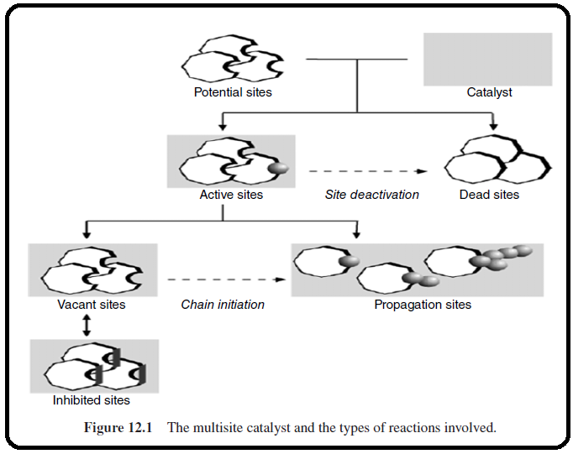The multisite catalyst and the accompanying reactions are shown in Figure 12.1.

In setting up a simulation, the user specifies the catalyst flow rate for the feed stream, and a catalyst parameter, that is, the moles of sites per unit mass of catalyst. This parameter together with the catalysts flow rate is used to compute the total moles of sites. The total moles of sites are made up of potential sites, active sites of different reactivities, and dead sites. Site activation reactions convert potential sites to active sites, while site deactivation reactions convert active to dead sites. There are several different site activation/ deactivation reactions found in the built-in “Ziegler–Natta Catalysts and Polymerization Kinetic Scheme”.

In Figure 12.1, potential and dead sites are considered to be independent of one another. The following analogy is drawn. In this regard, a dead site (a dead woman) is either a deactivated (rendered dead) state of an active site or is originally born dead (i.e., defected catalyst site). Under both circumstances, such as death, the dead state is irreversible.

The user specifies the number of site types to be included for a particular simulation.

• A vacant site (an uncoupled single woman) is an active (vivid) site that does not have a polymer or other molecule attached to it.

• A propagation site (a woman with a series of kids) has a *growing polymer molecule* attached to it. Here, a woman can have one, two, three, or more kids at a time.

• An inhibited site (a divorced woman from a bad ex-husband; hence, temporarily unwilling to socialize) is attached to *small molecules (toys)*, such as hydrogen or poisons, temporarily blocking them from becoming propagation sites. The small molecule may dissociate from an inhibited site, which then becomes a vacant site once again. Therefore, the site inhibition reaction is considered reversible; similar to saying a divorced woman is cured from the past history and now she is ready for a new relationship with a new guest (or ghost).

**NOTE #1:** When a vacant site is involved in a chain initiation reaction (marriage relationship), it is converted to a propagation site. When a propagation site is involved in a chain transfer reaction (expiry of marriage contract), a vacant site (an uncoupled woman) and a dead polymer molecule (a series of kids alone with no parents) are

formed.

For more information on mechanism of polymerization, copolymerization, and different catalyst site reactions, refer to APPENDIX 12.A at the end of this chapter. Moreover, the Aspen Plus Polymers built-in model features and assumptions are also explained in APPENDIX 12.A.

12.2 HIGH-DENSITY POLYETHYLENE (HDPE) HIGH-TEMPERATURE

SOLUTION PROCESS

The following example is borrowed from: “Aspen Polymers: Examples & Applications, Version 7.0, July, 2008”. However, changes were made with respect to feed flow rates, their compositions, and most important the property method.

The HDPE high-temperature solution process model illustrates the use of Aspen Plus Polymers to model a Ziegler–Natta solution polymerization of ethylene. The model is used to study the effect of feed flow rate on conversion and polymer properties, and to study the effect of hydrogen concentration on melt index and polydispersity index. Ziegler–Natta catalysts are multisite catalysts containing different site types, with each type having different reactivities. For this reason, each site type produces a polymer with a distinct molecular weight. As a result, the composite polymer has a broad molecular weight distribution. The Ziegler–Natta model in Aspen Plus Polymers takes into account the important reactions found in this chemistry, including site activation, chain initiation, chain propagation, chain transfer, site deactivation, site inhibition, branching reactions, and so on. So, unlike previous chapters, dealing with polymers requires the user to input so many kinetic parameters that describe the complex interplay among all different reaction steps. The model is quite flexible and can be configured for homo- or copolymerization with any number of monomers. The user can also specify any number of site types for the catalyst. The model predicts the various polymer properties, such as molecular weight, polydispersity index, melt index, and copolymer composition, and returns this information for the polymer produced at each catalyst site.