Additional Part 1

Pharmacy in Aspen Plus



CHARACTERIZATION OF DRUG-LIKE MOLECULES USING ASPEN PROPERTIES

1.INTRODUCTION

Aspen Properties is a useful tool in characterization of drug-related compounds. In this content, the compound to be characterized can be the solvent itself and how it interacts with other solvents, such as examining the solubility of polar organic solvents in water or vice versa (i.e., mutual solubility). Alternatively, the compound can be the solute, or what is called the active ingredient, which is, in general, scarcely water soluble and requires a set of solvents, cosolvent, and/or emulsifying agent to make it soluble. Organic solvents nowadays have many applications in almost all avenues of industrial life. They are used in emulsion and microemulsion formulations as a solvent, cosolvent, or cosurfactant as is the case in detergent, cosmetic, paint, and pharmaceutical industries. They are also used in liquid–liquid extraction and absorption processes. Moreover, solvents may be used as a reaction medium to bring reactants together, as a reactant to react with a solute when it cannot be dissolved, and as a carrier, to deliver chemical compounds in solutions to their point of use in the required amounts [1]. Organic solvents are constantly present in the pharmaceutical production processes. The pharmaceutical industry is one of the largest users of organic solvents per amount of the final product [2]. They are usually used at any step of the synthesis pathway of an active substance or excipients, and sometimes during the drug product formulation process. In pharmaceutical industries, crystallization from solution iswidely used for the purification of pharmaceutical products during the final stages of manufacture. The type of solvent being used influences the morphology of obtained crystals. For example, the polarity of the solvent affects the crystalmorphology of ibuprofen. The use of methanol results in symmetrical and smooth crystals while the use of a low polarity solvent (such as acetone) results in elongated crystals [3].

With increasing pressure to identify high-quality drug candidates, it is critical to assess the absorption, distribution, metabolism, excretion (ADME) attributes of compounds early during the drug discovery phase. This may include properties such as aqueous solubility, permeability, metabolic stability, and *in vivo* pharmacokinetics. One of the properties crucial to candidate screening is the solubility of the compound. Aqueous solubility is an important property of drugs, which are administrated orally or by injection due to the fact that oral drugs must be absorbed through the gastrointestinal tract and should remain in solution to reach the intended therapeutic target. On the other hand, injectable drugs must be sufficiently water soluble to get a “free” ride in the blood and lymph system. *In silico* models that can predict the solubility without expending the compound are of great value to the pharmaceutical industry. Nevertheless, models can fail or result in little value if the data used to generate the model are of a poor quality or were obtained under varied experimental conditions.

PROBLEM DESCRIPTION

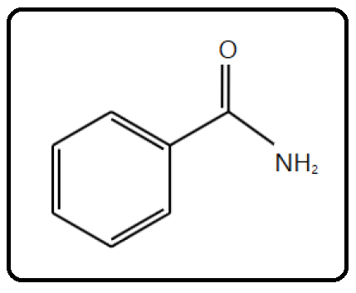

Benzamide (C7H7NO), with a molecular weight (MW) of 121.14, is an aromatic amide that consists of benzene bearing a single carboxamido substituent. Its **S**implified **M**olecular-**I**nput **L**ine-**E**ntry **S**ystem (SMILES) formula is NC( O)C1 CC CC C1. It is a transparent crystalline substance, obtained by the action of ammonia upon chloride of benzoyl, as also by several other reactions with benzoyl compounds. It has a melting point of 130∘C, a normal boiling point of 288∘C, and a density of 1.341 g/cm3. It is slightly soluble in water and more soluble in ethyl alcohol and carbon tetrachloride. It is used in chemical synthesis. Benzamide is the most potent poly(ADP-ribose) polymerase (PARP) inhibitor in the family of benzamides (PARP inhibitors can be used as anticancer agents, radiosensitizers, and antiviral agents). Benzamide is used as a potent antiemetic (against vomiting), antidepressant, and anticholinergic (a substance that opposes or blocks the action of acetylcholine, sleep aid, daytime sedative, when more potent agents are contraindicated).

In this chapter, I guide the reader through the procedure for estimating the physical properties for this component as if it were not present in the Aspen Plus databanks. Plugging the molecular structure and some known molecular properties of benzamide will be sufficient for Aspen Properties to estimate typical thermodynamic and transport properties. It should be noted that benzamide is already an Aspen Plus databank member (i.e., fully characterized). So, why do we need to use a known databank member? Well, it is simply for the sake of comparison; the estimated properties will be contrasted versus those of the built-in (Aspen Plus databank member) benzamide component. At the same time, it will be used as an example to demonstrate how to use Aspen Properties as a tool to almost fully characterize a material with a little information about it.

How to Simulate

1. Using Aspen Plus, start a new simulation by choosing the “Pharmaceutical” category and selecting “Pharmaceuticals withMetric Units” template to create a steady-state flow sheet. Notice that the default property method is set to “NRTL” (Figure 13.1).

2. Next, we will define a component called BNZMD-UD. The suffix “UD” means User-Defined. In the first line of the “Component ID” column, enter “BNZMD-UD”. Diligently, hit “tab” or “enter” key and Aspen Plus will automatically assign the “*Conventional*” type for such an unrecognized name of a component. Notice that “BNZMD-UD” is not present in any of the Aspen Plus databanks; hence, “Component name” and “Alias” column remain empty, as shown in Figure 13.2.

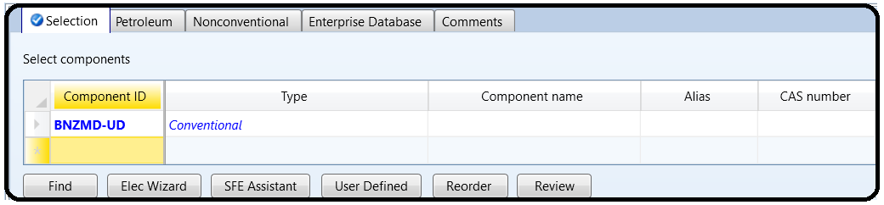

Next, we will tell Aspen Plus to estimate missing parameters using “UNIFAC”. Under “Properties” environment, go to “Methods” | “Parameters” | “Binary Interaction” | “NRTL-1” sheet and be sure that the “Estimate missing parameters by UNIFAC” option is selected. Next, enter the molecular structure of BNZMD-UD. Click on “Next (N→)” button and Aspen Plus will bring you to “Components” | “Molecular Structure” | “BNZMD-UD” | “General” tab sheet.

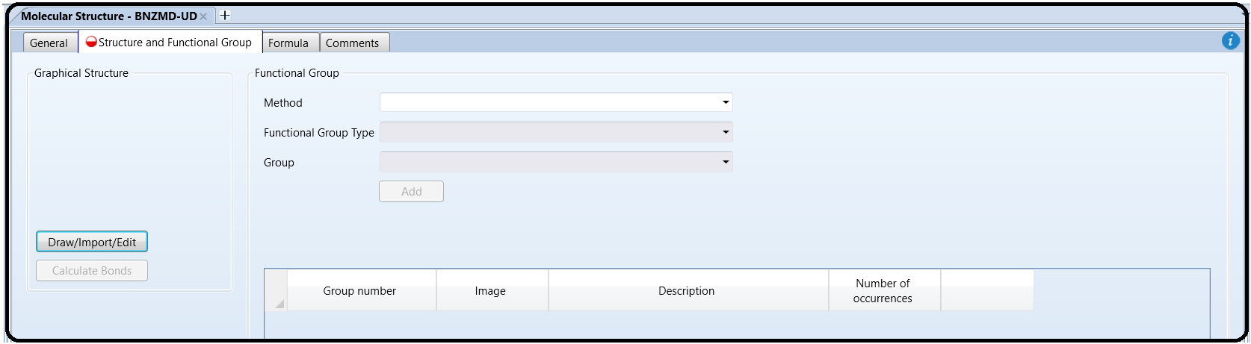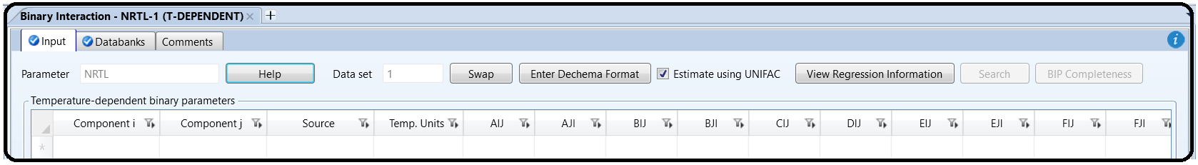

Note: You can define the molecular structure in different ways: Using the “General” sheet, which is based on individual atoms and bonds (i.e., molecular connectivity); using the “Functional Group” tab sheet in which you indicate the functional groups specific to a particular estimation method; or using “Structure” tab sheet. In old versions of Aspen, we used to define the molecular structure via the “General” tab sheet, or import *.mol file. In this chapter, we explain how to define the structure of a molecule using the “Molecule Editor” of Aspen Plus.

Figure 13.3 shows the “Structure” tab sheet where it is still empty as we did not yet define the molecular structure of “BNZMD-UD”. Click on “Draw/Import/Edit” button, shown in Figure 13.3, to open the “Molecule Editor” window as shown in Figure 13.4. This window is made of the main window and three left panes. The first (i.e., top left) pane represents the types of bonds (i.e., single, double, triple, neutral, or charged) to be used; the second (i.e., middle) pane allows the user to select the atom to be installed alone (for the first time), or attached to an existing structure with a type of bond already selected in the first pane; and the third (i.e., bottom left) pane gives the user the flexibility to choose a segment or fragment as part of a molecule, such as the phenyl aromatic ring, without having to build the segment itself from scratch. Once you click on the phenyl ring from the “Fragments” panel, drag it to the working area, decide on the proper location of the phenyl ring, release the mouse, and hit one left-click. The phenyl group will then show up, as shown in Figure 13.5. Alternatively, click on the proper fragment and go to the proper location in the working area and hit one left-click. Either way, to stop adding more blocks of the same type, just right-click the mouse or press “Escape” key. Click on the arrow icon found in the top-left tool (second raw) and in drag (left mouse pressed) mode, you can draw a rectangle around any existing object, then you may delete that enclosed object. Figure 13.6 shows that once I highlight the “*C atom*” icon from “Atoms” pane and select the “*Single bond*” icon from “Bonds and Charges” pane; I move the mouse to one of the corners (i.e., ring carbon atoms) of phenyl ring, where “CH” group will appear exactly beneath the mouse at the selected corner; and then I left-click the mouse once. Right-click to stop adding more of the same type. As I did in the previous step, highlight the “*O atom*” icon from “Atoms” pane and select the “*Double bond*” icon from “Bonds and Charges” pane; move the mouse exactly onto the top of the methyl group; left-click and drag away the mouse; and then release the left mouse. Right-click the mouse to stop adding more of the same type. Figure 13.7 shows the new changes after the attachment of “*O*” atom to the methyl group via the double bond. Finally, highlight the “*N atom*” icon from “Atoms” pane and select the “*Single bond*” icon from “Bonds and Charges” pane; move the mouse exactly onto the top of the carbon atom of the carbonyl group, where “CH” group will appear underneath the mouse; left-click and drag away the mouse; and then release the left mouse. Right-click the mouse to stop adding more of the same type. Figure 13.8 shows the latest changes after the attachment of “NH2” group to the carbonyl group via the single bond.

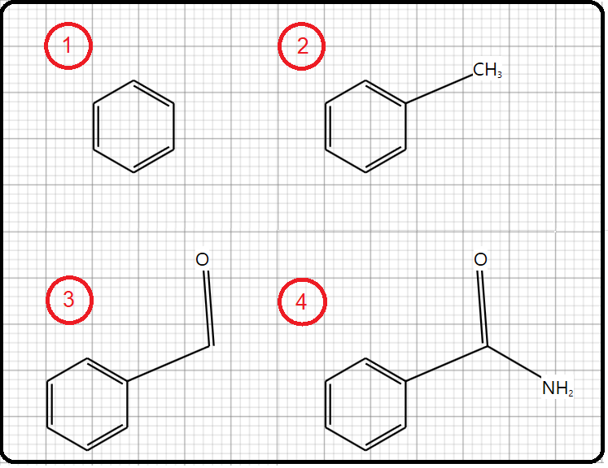

Click on “Calculate Bonds” button so that Aspen Plus will transform the image into known bonds and atoms (i.e., their bond energies and lengths will be calculated). Figure 13.11 shows the “General” tab window where the atomic connectivity has been automatically calculated by Aspen Plus, based on the defined molecular structure under “Structure” tab.

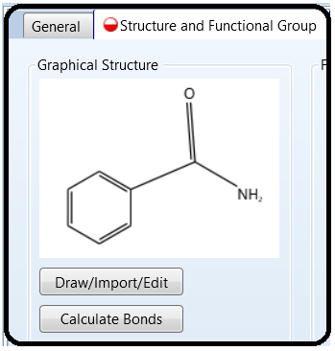

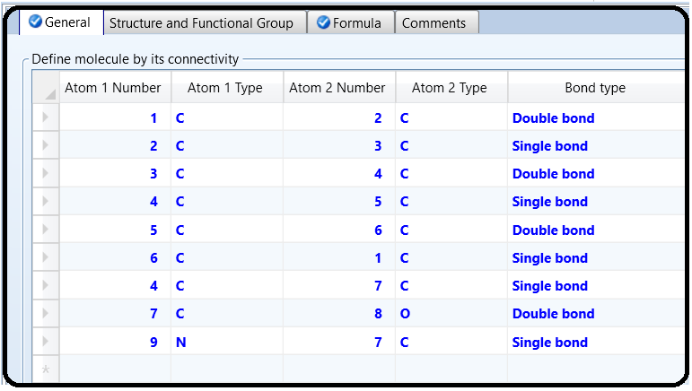

Figure 13.12 shows the formula tab window where Aspen Plus tells us that our lovely benzamide molecule is made of seven carbon atoms, seven hydrogen atoms, one nitrogen atom, and finally one oxygen atom.

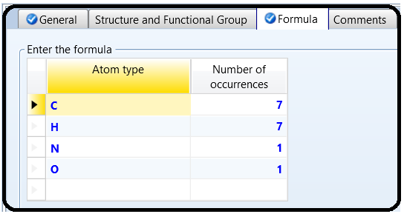

Next, we will enter the known property data for “**BNZMD-UD**”. The molecular structure information is sufficient for Aspen Plus to estimate properties. However, entering all available data will further improve the accuracy of the Aspen Plus properties estimation. To demonstrate this point, if the user attempts to run the property estimator at this point, then Aspen Plus will do its best to carry out the property estimation process; nevertheless, the estimated properties will not be accurate enough. Figure 13.13 shows some of the estimated properties where the estimated boiling point (“**TB**”) is given as 239.49∘C. The experimental value is 288∘C. This means that more experimental data are to be supplied by the user in order to have a better property estimate.

To enter the boiling and freezing point for “**BNZMD-UD**”, execute the following steps:

1. In “Navigation” pane, go to “Methods” | “Parameters” | “Pure Components” and click on “New…” button.

2. In the “New Pure Component Parameters” dialog box, select “*Scalar*”, as shown in Figure 13.14.

3. Enter the new name “BNZMDPRP” and click on “OK” button. The “Methods” | “Parameters” | “Pure Components” | “BNZMDPRP” | “Input” tab sheet appears.

4. In the first “Component”-labeled column, click the drop-down arrow and select “*BNZMD-UD*”.

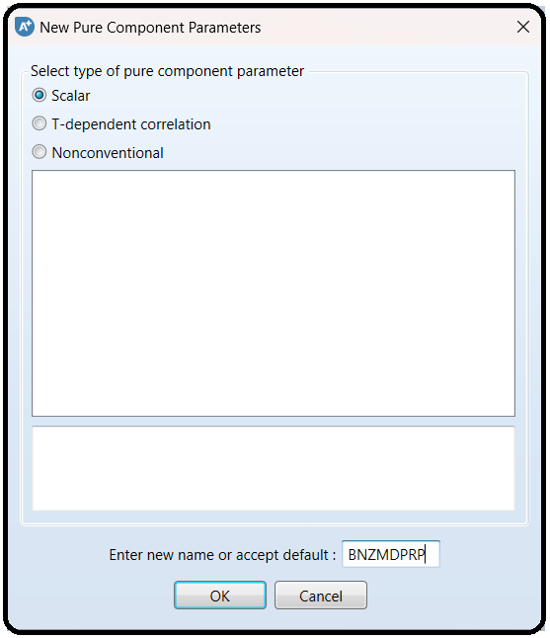

5. Click beneath the “Parameters” column, and select “*RHOM*” (mass density).

6. Click the second horizontal cell under the “Units” column, and select *gm/cc* (g/cm3) and in the corresponding cell, beneath the fourth column, enter *1.341* as the value of density.

7. Click below “*RHOM*” cell and select “*TB*” (normal boiling point).

8. Select ∘*C* for “*TB*” unit and in the corresponding cell, beneath the fourth column, enter *288* as the value of normal boiling point.

9. Click below “*TB*” cell and select “*TFP*” (freezing point).

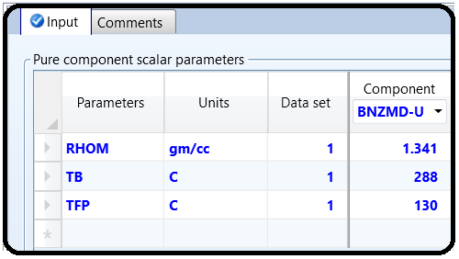10. Select ∘*C* for “*TFP*” unit and in the corresponding cell, beneath the fourth column, enter *130* as the value of freezing point. Figure 13.15 shows that “BNZMDPRP” property is now defined and contains the mass density (“RHOM”), the normal boiling point temperature (“TB”), and the freezing point temperature (“TFP”) for “BNZMD-UD” compound.

We have already entered the pure component property data for “BNZMD-UD” compound. Aspen Plus is now ready to compute the missing properties of “BNZMD-UD” compound. Run the simulator and monitor warning and errors (if any) via the “Control Panel”. There might be some warnings as shown in Figure 13.16 but such a warning can be ignored.

Figure 13.17 shows a portion of estimated properties under “**PCES-1**” sheet for our lovely “**BNZMD-UD**” molecule. Typical physical (thermodynamic and transport) properties are also shown under the sheets starting from “**CPIG-1**” and ending up with “**SIGDIP-1**”.

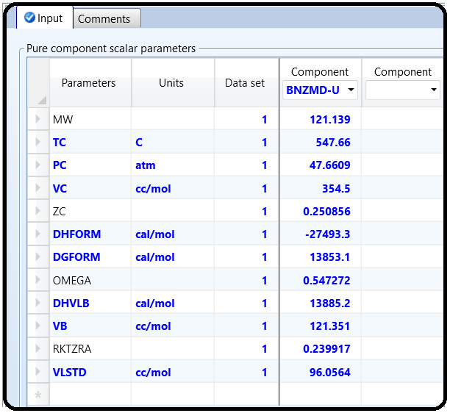

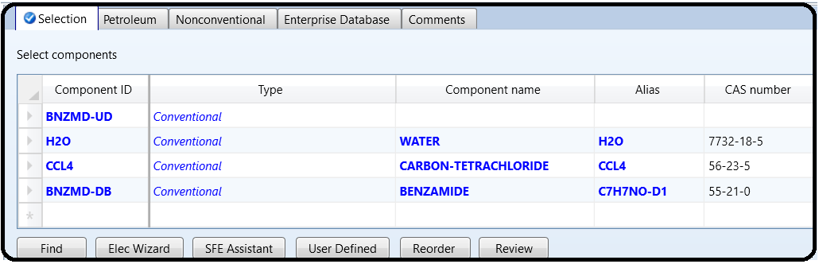Next, add the following components: water (“**H2O**”), carbon tetrachloride (“**CCl4**”), and Aspen Plus databank benzamide (“**BNZMD-DB**”) to the list of components. Figure 13.18 shows the new list of components.

In “Setup” | “Specifications” | “Global” tab sheet, change “Free water” option from “*No*” to “*Dirty water*”. This is to account for any dispersed organic moiety in aqueous phase. Click on “Next” button, run the show, and watch any simulation error or serious warning. At this stage, if the user wishes to remove the yellow-color exclamation mark that appears on both “Estimation” and “Results” folders found in “Navigation” pane, he/she may deselect “Estimate missing parameters by UNIFAC” option found in “Methods” | “Parameters” | “Binary Interaction” | “NRTL-1” sheet, rerun the show, and Aspen Plus sky becomes blue. This is simply because we have already calculated all possible permutations of pairwise interaction parameters using “UNIFAC” method. Switch to “Simulation” environment.

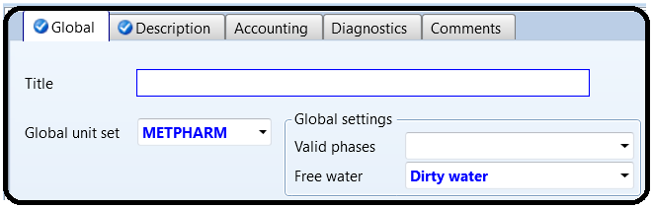

CONTRASTING ASPEN PLUS DATABANK (BNZMD-DB) VERSUS BNZMD-UD

Add two mixing units and attach streams as shown in Figure 13.19. It shows a simplified flowsheet that mainly consists of the first mixer (MIXER-1) for handling the mixing process of the built-in databank benzamide (BNZMD-DB) and a second mixer (MIXER-2) for doing the same job as the first mixer but this time for the non-databank, user-defined benzamide (BNZMD-UD). Water and CCl4 will be mixed with benzamide to create a mixture that will be separated into two streams one is mainly water phase and another is CCl4 phase. Notice that for bothmixers, set the “Valid phases” option to “*Liquid-DirtyWater*” option, under “Blocks” | “MIXER-1” or “MIXER-2” | “Input” | “Flash Options” tab sheet. The word “dirty” here is coined for water systems whenever water is polluted by any organic substance. Yet, it will do the job here. Next, we need to define the inlet streams for both mixers in terms of *T*, *P*, flowrate, and composition. All inlet liquid (both H2O and CCl4) streams are assumed at 50∘C, 1 atm, anda flow rate of 50 kmol/h; on the other hand, “BNZMD-DB” and “BNZMD-UD” streams have the same flow rate of 5 kmol/h for each and are at the same *T* and *P* of other streams. Reinitialize, run the simulation, and watch out any serious warning or error. Figure 13.20 shows the results of the outlet stream for each mixer. One can see the outlet conditionsand properties in terms of pressure, temperature, molar flow rate, and mole fraction of each species are accurately identical for “DRUG1” and “DRUG2” streams. This assures that the estimated properties of the user-defined “BNZMD-UD” are essentially the same as those of the built-in databank “BNZMD-DB” compound. Moreover, Aspen Plus predicts that benzamide substance whether it is a databank member or properly user-defined is much more soluble in CCl4-phase than in water phase. In addition, trace amounts of benzamide are scarcely dispersed in the aqueous phase.

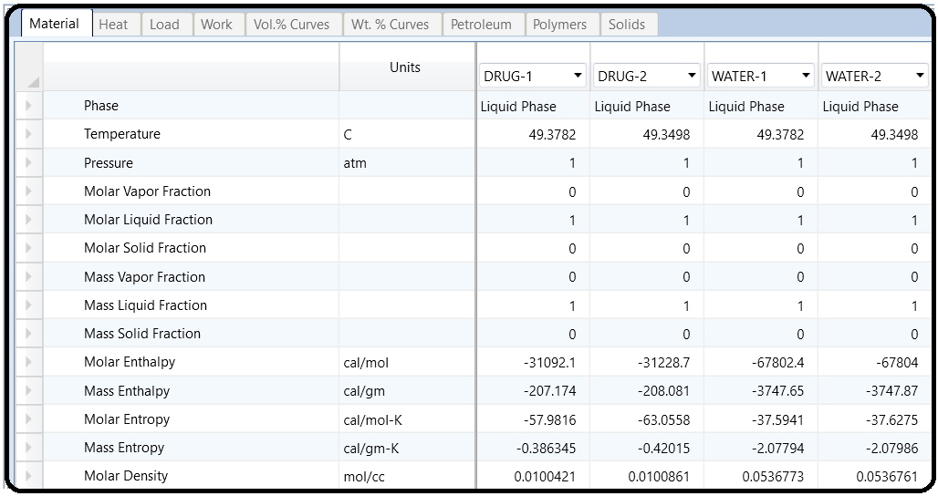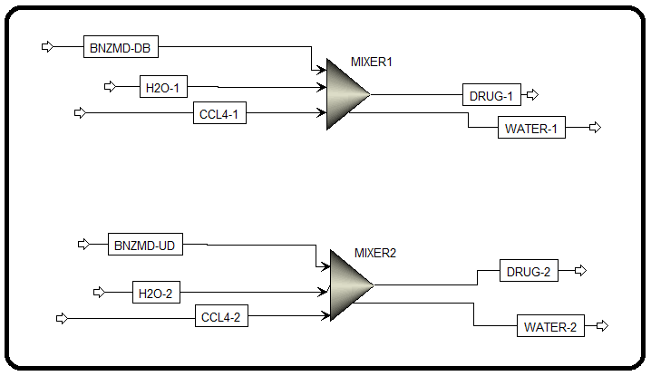

Reference

1.Our team experience

2. Aspen Plus – Chemical Engineering Application by KAMAL I.M. AL-MALAH

3.Al-Malah, K.I. (2012) Prediction of aqueous solubility of organic solvents as a function of selected molecular properties. *Journal of Pharmaceutics and Drug Delivery Research*, 1, 2.

4.Grodowska, K. and Parczewski, A. (2010) Organic solvents in the pharmaceutical industry. *Acta*

*Poloniae Pharmaceutica: Drug Research*, 67 (1), 3–12.

5.Karunanithi, A.T., Acquah, C., and Achenie, L.E.K. (2008) Tuning the morphology of pharmaceutical compounds via model based solvent selection. *Chinese Journal of Chemical Engineering*,16, 465–473.