Ewfre

EIEPD Aspen E-Lerning Map

Content

Which Aspen Software will you learn?...........................................................................................4

What you will learn………………………………………………………………………………………..5

Details of EIEPD Map…………………………………………………………………………….………7

Which Aspen software will you learn?

At EIEPD we have a comprehensive plan for you! Not only does it contain the professional instruction of a number of Aspen software, but also it is all free of charge.

You as a process engineer will learn how to use professionally the following Aspen products:

1.Aspen Plus

2.Aspen Energy Analyzer

3.Aspen Capital Cost Estimator

4.Aspen EDR

5.Aspen Flarenet

6.Aspen Hysys

7.Aspen Plus Dynamic







Our free, professional, comprehensive courses are presented in sessions:

|  |  |
| --- | --- |
| Sessions | Contents |
| 1 | Aspen Plus Properties |
| 2 | Binary Mixture in Aspen Plus |
| 3 | Seperation and Mixing in Aspen Plus |
| 4 | Pressure Change in Aspen Plus |
| 5 | Heat Exchanger in Aspen Plus |
| 6 | Distillation Column in Aspen Plus |
| 7 | Reactor Modeling in Aspen Plus |
| 8 | Utility in Aspen Plus |
| 9 | Solid Modeling in Aspen Plus |
| 10 | Polymer Modeling in Aspen Plus |
| 11 | Electrolytes in Aspen Plus |
| 12 | Aspen Energy Analyzer-Basic |
| 13 | Aspen Capital Cost Estimator-Basic |
| 14 | Aspen Safety Analysis |

|  |  |
| --- | --- |
| Sessions | Contents |
| 15 | Aspen EDR |
| 16 | Batch Modeling in Aspen Plus |
| 17 | Review of Templates in Aspen Plus |
| 18 | EO Configuration |
| 19 | Utility Plant Simulation in Aspen Plus |
| 20 | Methanol Plant Simulation in Aspen Plus |
| 21 | Aspen Energy Analyzer-Advanced |
| 22 | Aspen Capital Cost Estimator-Advanced |
| 23 | Aspen Plus Dynamic - Basic |
| 24 | Aspen Plus Dynamic – Advanced |
| 25 | Aspen Hysys Dynamic-Basic |
| 26 | Aspen Hysys Dynamic-Advanced |
| 27 | Aspen Flarenet |
| 28 | AP: Additional Parts, Case Studies |

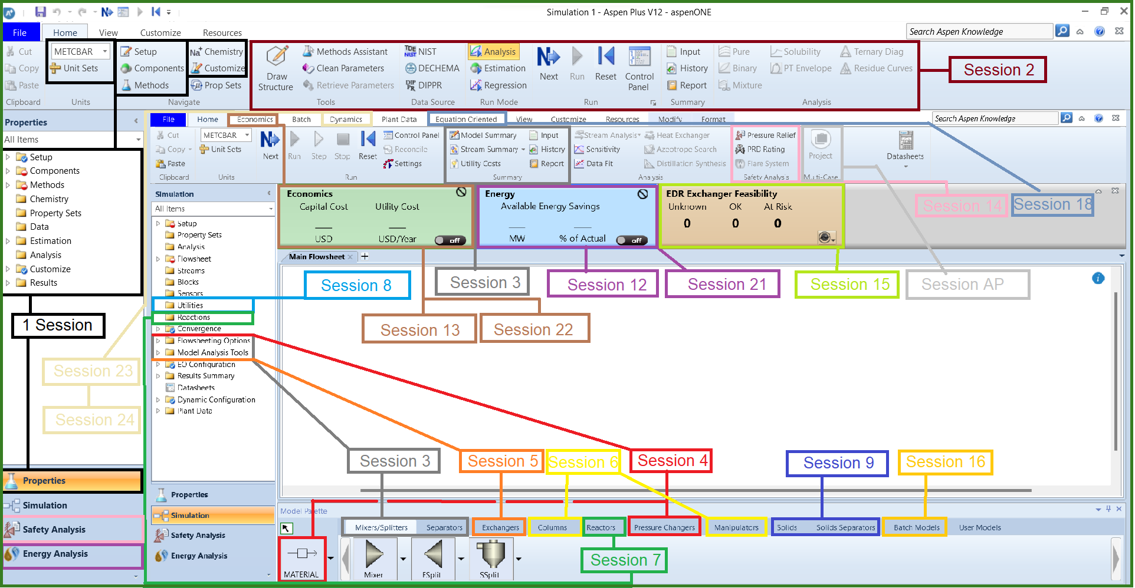EIEPD Map

|  |  |
| --- | --- |
| Session | Contents |
| 1 | 1.Set-up Definition  2.Example-Water Transport  3.Property Methods  4.Example-Petroleum Assay Characterization  5.Example-Polymer Characterization  6.Example-Water De-souring  7.Example-Solid Classification  8.Example-Pharmecutical Application |
| 2 | 1.Physical Properties  2.Retrieving physical property data  3.Example-Creating a VLE Diagram  4.Example-Pressure Swing Distillation  5.Example-Validation of Property Methods  6. Azeotrope Search and Analysis of Ternary Systems  7. PT Envelope Analysis |
| 3 | 1.Example-Mixing  2.Example-Seperation  3.Input, History, Report, Printing  4.Model Summery, Stream Summery |
| 4 | 1.Example-Pump calculation  2.Example-Water transport  3.Example-Steam-Electricity Generation loop  4.Sensivity Analysis  5.Design Spec |
| 5 | 1.Simple Heat Exchanger  2.HeatX |
| 6 | 1.Example-DSTW  2.Example-RadFrac  3.Example-Column Sizing  4.Convergence Solution |
| 7 | 1.Plug Flow Reactor  2.CSTR  3.RYield  4.RStoch  7.REquil  8.RGibbs |
| 8 | 1.Definition of utilities  2.Example-Usage of utilities in Distillation Unit + Pump |

Details

|  |  |
| --- | --- |
| Session | Contents |
| 9 | 1.Example-Crusher  2.Example-Fluidized Bed  3.Example-Drying  4.Example-Crystallization |
| 10 | 1. Component Characterization  2.Reaction Definition  3.Polymerization Reactor Modeling |
| 11 | 1.Example-Water Desouring  2.Example |
| 12 | 1.Scenario Definition  2.Data Input  3.Utility Input  4.Checking proposed Design |
| 13 | 1.Example-Distilation Column Capital Cost Estimation  2.Cost calculation procedure  3.Integrated Economics in Aspen Plus |