Part 5

Heat Exchangers in Aspen Plus



Problem Definition

In basic stage of an Ammonia project the process engineering department has decided that the saturator blow down should be cooled to 65 C before introducing the stream to treatment facility. In order to do so a water-cooled shell and tube heat exchanger is used to serve the purpose. The process conditions of the fluids are provided below.

Please using Aspen Plus calculate the followings:

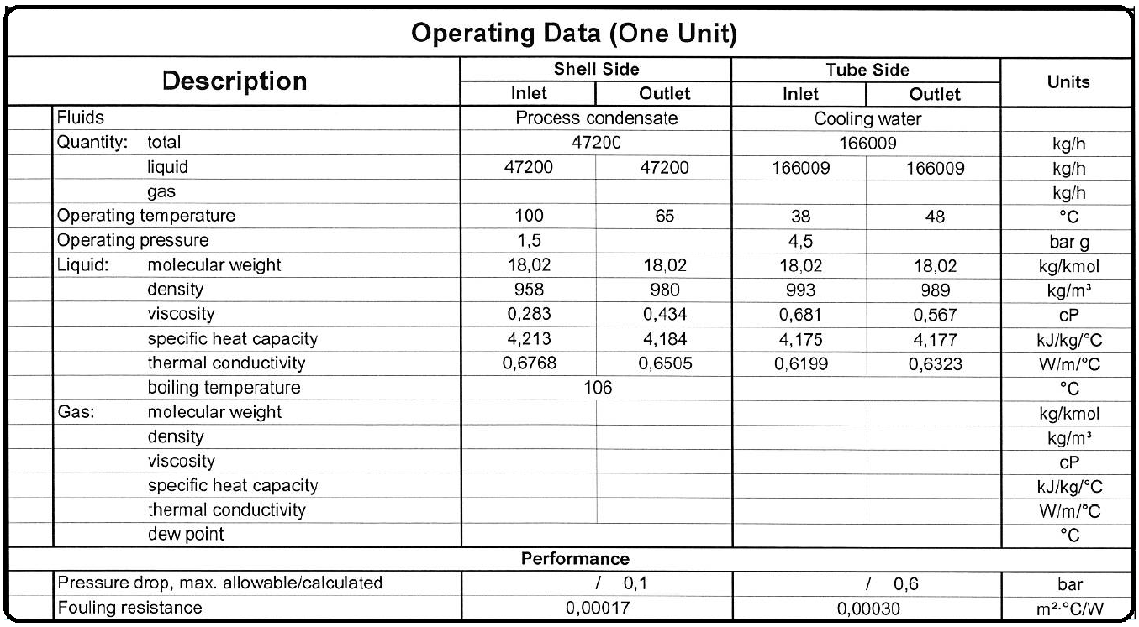1.The amount of cooling water needed. 2.The duty of the Heat exchanger. 3.Using HeatX, determine surface area,

How to simulate

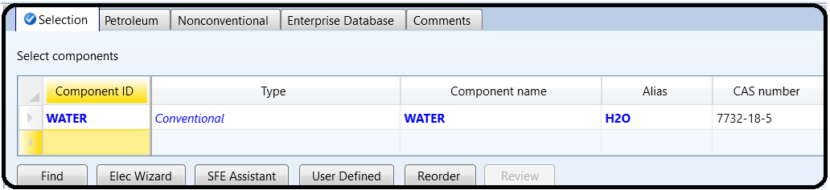1.Open a new simulation

2. Select Water as the component

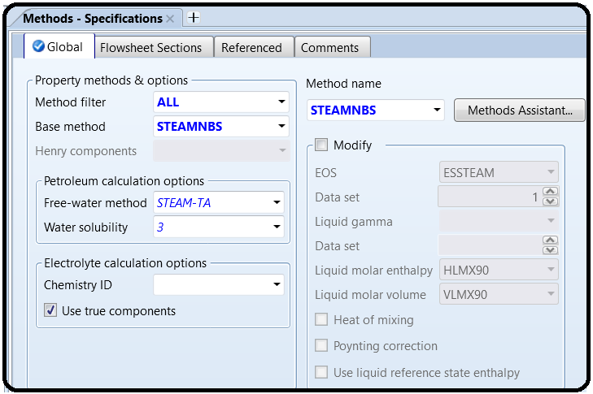3. Select STEAMMNBS as the property package and click Next.

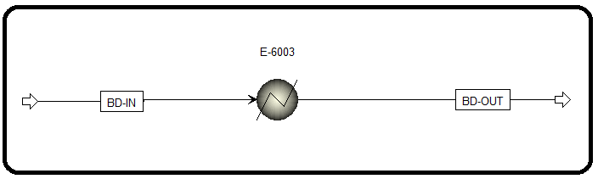4.Create the flowsheet like below and add inputs for the stream and the block like below:

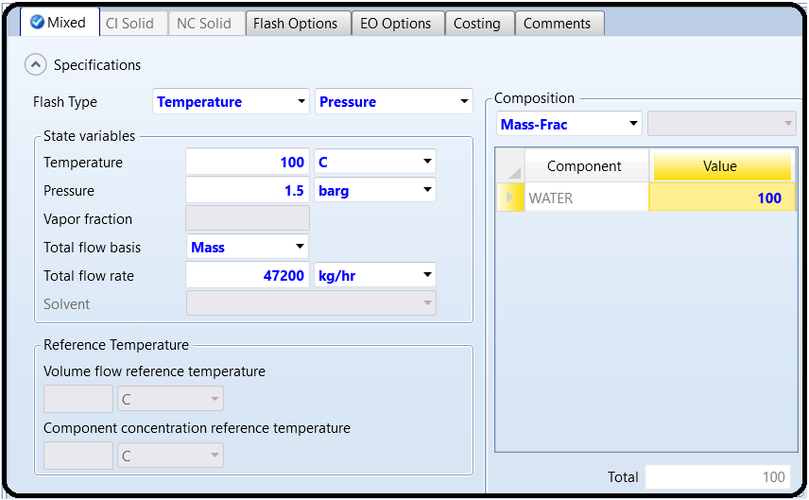

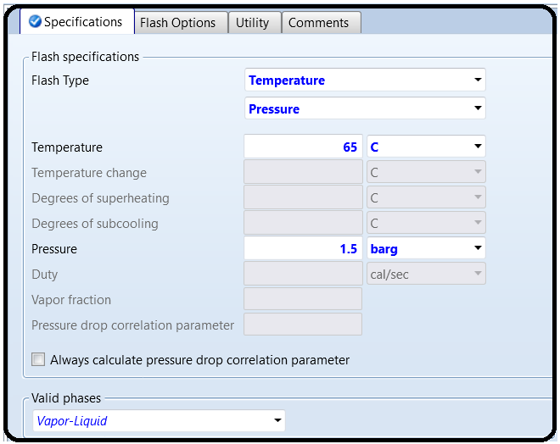

5.Run Aspen Plus and check the results.

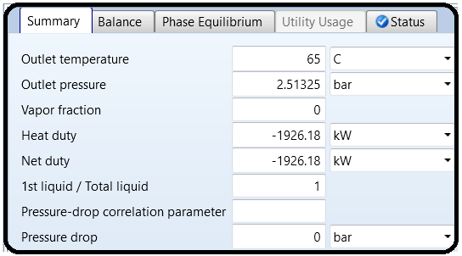

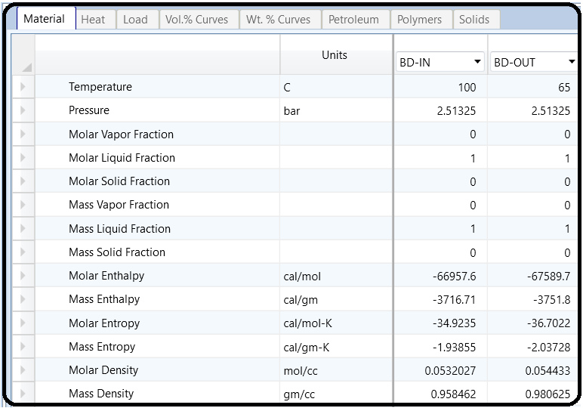

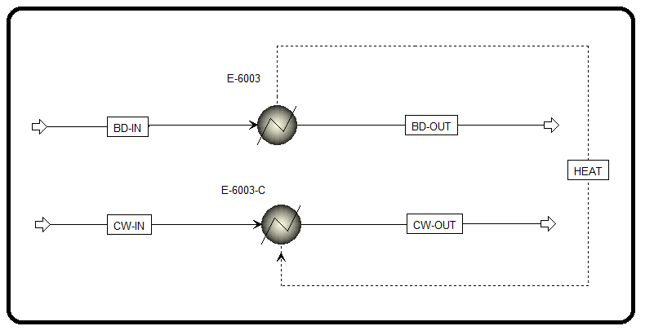6.Perform the same procedure for cooling water but this time the heat exchanger needs just one input since the Q is calculated in last step and is connected to this block.

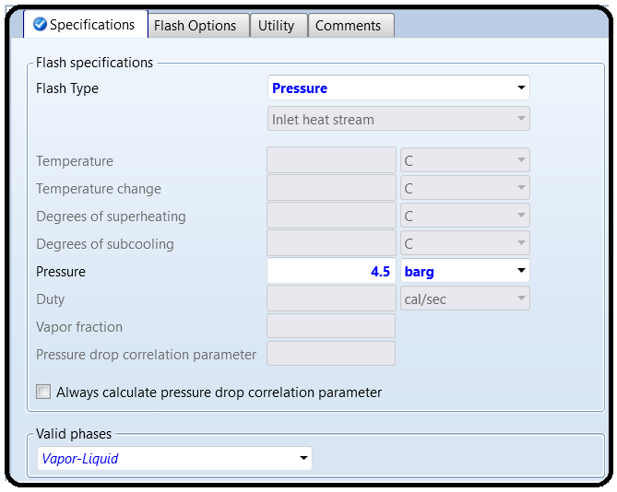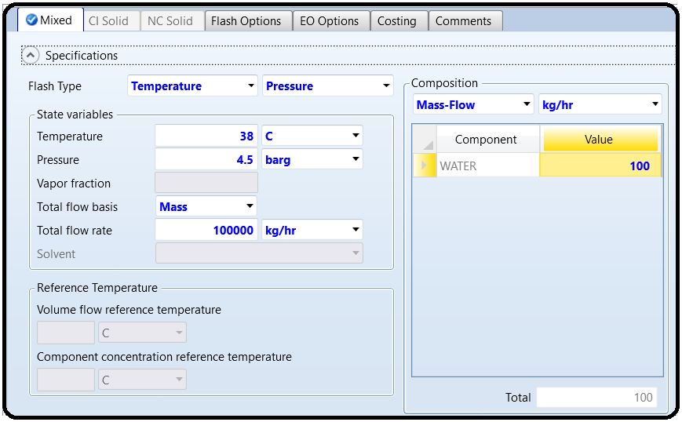

7.Run Aspen Plus and check the results.

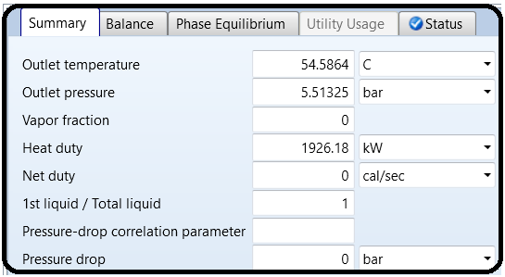

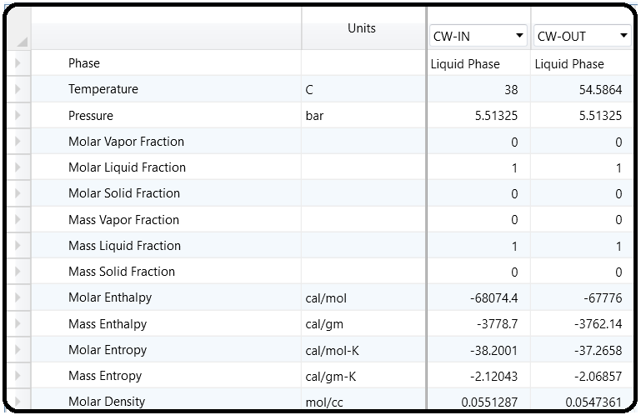

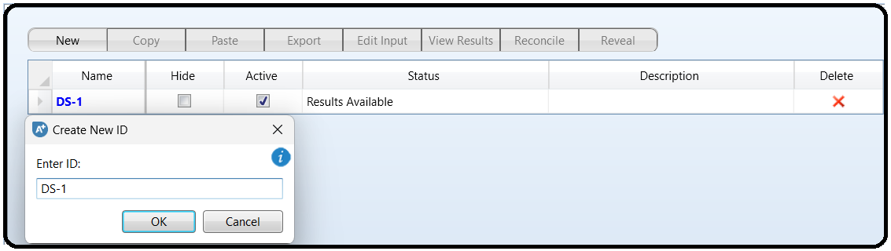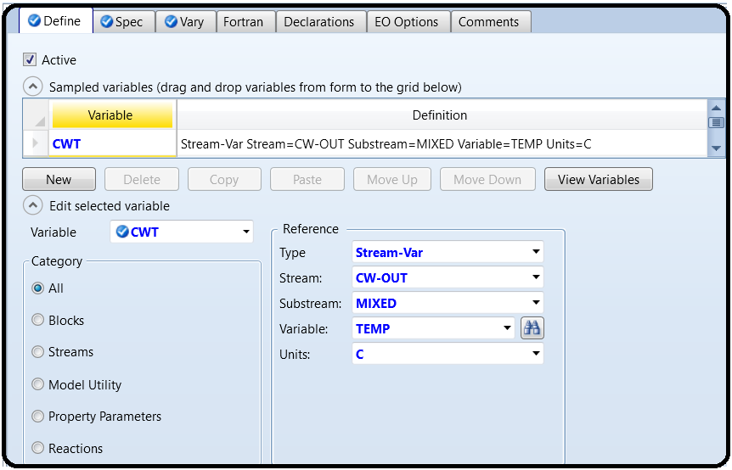8.To calculate the exact cooling water needed, we should create a Design Spec under Flowsheeting Option. Act like below:

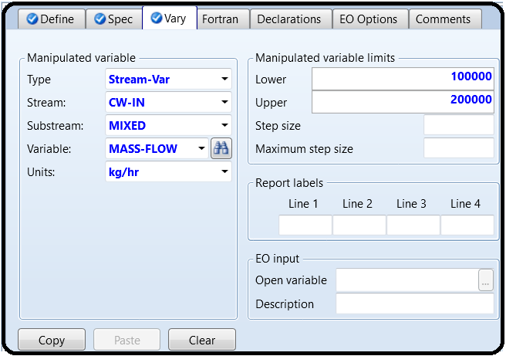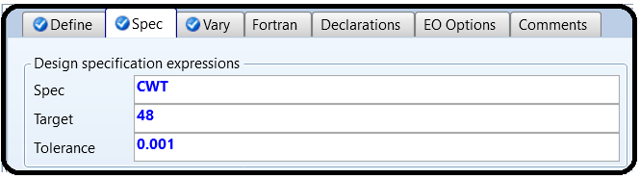

9.Check the results:

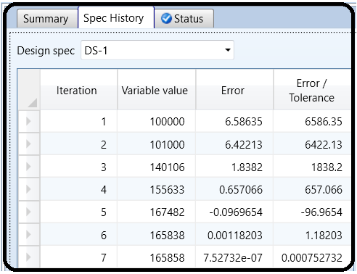

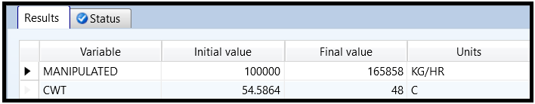

So now we can see that we need 165858 kg/hr to be able to reduce the saturator blow down to 65C. Now we switch to HEATX type to calculate other charachteristics of the heat exchanger.

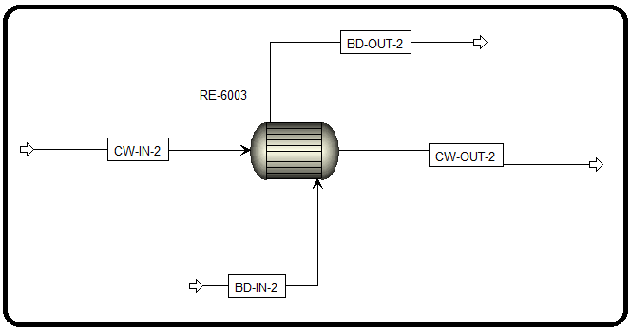

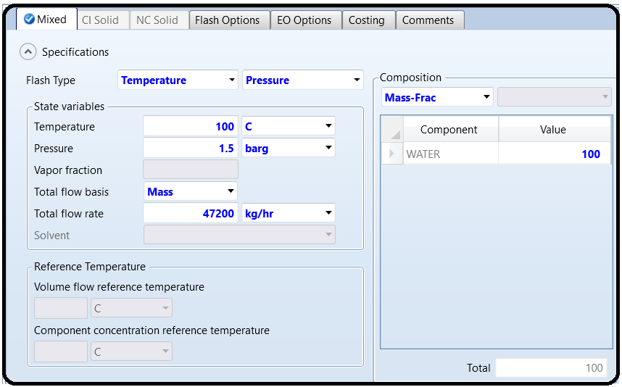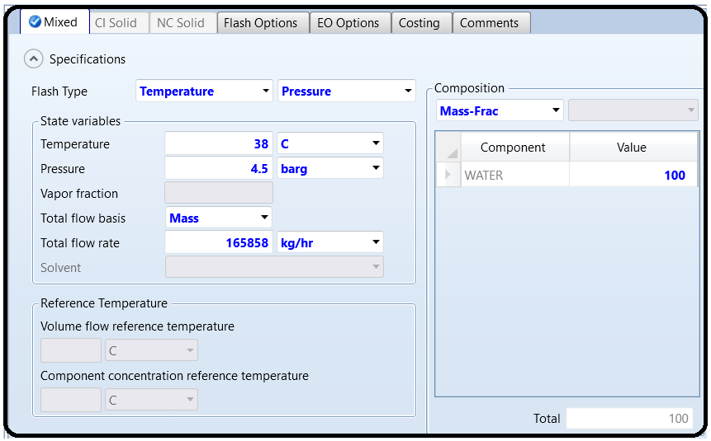

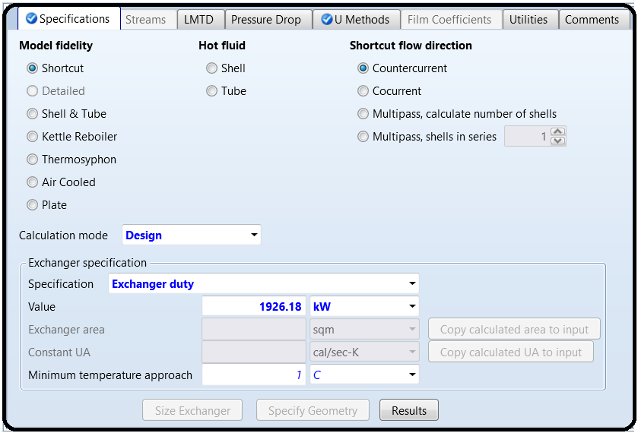

Note:

For “Exchanger specification” option, there are different options to choose from. Remember that each specification gives a different calculation scenario for Aspen Plus to execute. They are as follows:

1. Hot stream outlet temperature: Specifies the outlet temperature of the hot stream, used forsituations where there is no phase change on the hot stream side.

2. Hot stream outlet temperature decrease: Specifies the temperature decrease for the hot stream.

3. Hot outlet–cold inlet temperature difference: Specifies the temperature difference between the hot stream outlet temperature and the cold stream inlet temperature, used with the countercurrent flow.

4. Hot stream outlet degrees subcooling: Specifies the outlet temperature below the dew point for the hot stream, *used for boiling and condensation*.

5. Hot stream outlet vapor fraction: Specifies the outlet vapor fraction for the hot stream (1.0=sat. vapor and 0.0=sat. liquid), used for boiling and condensation.

6. Hot inlet–cold outlet temperature difference: Specifies the temperature difference between the hot stream inlet temperature and the cold stream outlet temperature, used with the countercurrent flow.

7. Cold stream outlet temperature: Specifies the outlet temperature of the cold stream, used for situations where there is no phase change on the cold stream side.

8. Cold stream outlet temperature increase: Specifies the temperature increase for the cold stream.

9. Cold stream outlet degrees superheat: Specifies the outlet temperature above the bubble point for the cold stream, used for boiling and condensation.

10. Cold stream outlet vapor fraction: Specifies the outlet vapor fraction for the cold stream (1.0=sat. vapor and 0.0=sat. liquid), used for boiling and condensation.

11. Exchanger duty: Specifies the amount of energy transferred from one stream to another.

12. Hot/cold outlet temperature approach: Specifies the temperature difference between the hot/cold stream outlet temperature and the cold/hot stream inlet temperature, *used with the countercurrent flow.*

10.Now run Aspen Plus and check the results.

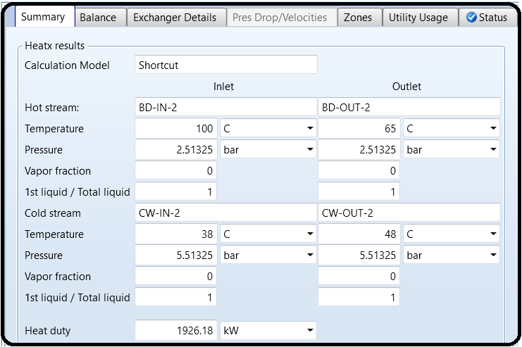By going to the thermal result, you can check the followings:

11.Click TQ Curves and get the results.

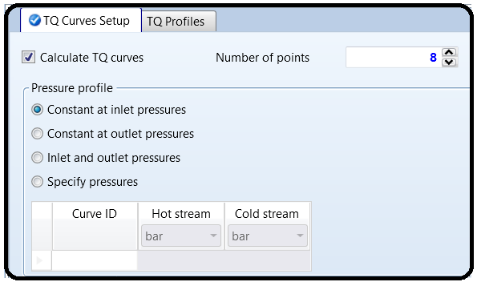

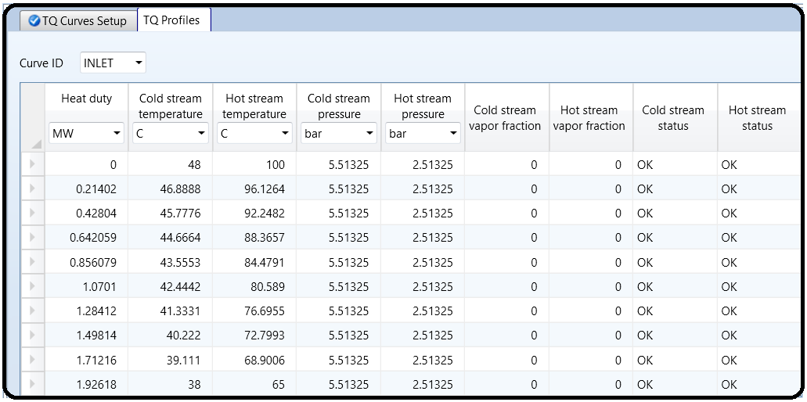

Appendix

The description of each item is quoted from Aspen Plus built-in help.

1. “Heater”: The basic heat exchanger model that performs simple energy balance calculations; it requires only one process stream. You can use “Heater” to represent heaters, coolers, valves, pumps (whenever work-related results are not needed), and compressors (whenever work-related results are not needed). You can also use “Heater” to set the thermodynamic condition of a stream. When the user specifies the outlet conditions, “Heater” will determine the thermal and phase conditions of a mixture with one or more inlet streams.

This block will be initially used in this running tutorial for calculating the heat duty, which will then be used to calculate heat-transfer area requirement.

2. “HeatX”: The fundamental heat exchanger model that is used in a rigorous design; it will calculate energy balance, pressure drop, exchanger area, velocities, and so on and requires two process streams: hot and cold. “HeatX” can model a wide variety of shell and tube heat exchanger types and perform heat transfer related tasks, including

a) countercurrent and co-current exchangers

b) TEMA E, F, G, H, I/J, K, X shells (see Figure 10.19), and double pipe and multitube exchangers

c) bare, low-finned, and longitudinal-finned tubes exchangers

d) single and double segmental baffles, rod baffles, and unbaffled exchangers

e) “HeatX” will perform the required calculations (all combinations of a

single-phase boiling or condensing heat transfer, with associated pressure drop calculations), returning key calculation results to be viewed within Aspen Plus.

f) perform mechanical vibration and Rhov2 (*𝜌v*2) analysis

g) estimate maximum fouling

h) display setting plan and tube-sheet layout drawing.

“HeatX” can perform a full zone analysis with heat transfer coefficient and pressure drop estimation for single- and two-phase streams. For rigorous heat transfer and pressure drop calculations, you must supply the exchanger geometry. If exchanger geometry is unknown or unimportant, “HeatX” can perform simplified shortcut rating calculations. For example, you may want to perform only heat and material balance calculations. “HeatX” has correlations to estimate sensible heat, nucleate boiling, and condensation film coefficients. “HeatX” uses a rigorous heat exchanger program to perform these calculations. Available programs include “Shell&Tube”, “AirCooled”, and “Plate”. Collectively, these programs are referred to as Aspen Exchanger Design and Rating (EDR).

This block will be used in this running tutorial for design calculations.

3. “MHeatX”: As its name tells, a multi-heat-exchanger model can be used to represent heat transfer between multiple hot and cold streams, as in an LNG exchanger, for example. “MHeatX” can perform a detailed and rigorous internal zone analysis to determine the internal pinch points and heating and cooling curves for all streams in the heat exchanger. “MHeatX” can also calculate, UA, the multiplication of the overall heat transfer coefficient by the area, for the exchanger and model heat leak to or from an exchanger. “MHeatX” uses multiple heater blocks and heat streams to enhance flowsheet convergence. Aspen Plus automatically sequences block and stream convergence unless you specify a sequence or tear stream.

4. “HXFlux”: A heat exchanger model that is used to perform heat transfer calculations between a heat sink and a heat source, using convective heat transfer and does not require any input or output material stream; nevertheless, you may add heat streams to substitute the heat exchange duty. The driving force for the convective heat transfer is calculated as a function of log-mean temperature difference (LMTD). The user has to specify all variables, except one, among inlet and outlet stream temperatures, duty, heat transfer coefficient, and heat transfer area. “HXFlux” calculates the unknown variable and determines the LMTD, using either the rigorous or the approximate method.

For the sake of calculating the heat duty that will be used to calculate the area requirement, let us use the first type, that is, “Heater”.

Reference

1.Our team experience

2. Aspen Plus – Chemical Engineering Application by KAMAL I.M. AL-MALAH

3.Aspen build-in help