Part 11

Electrolyte in Aspen Plus



PROBLEM DESCRIPTION: WATER DE-SOURING

A sour water stream, which contains 0.20 wt% CO2, 0.15wt% H2S, and 0.1wt% NH3 at a temperature of 85∘C and pressure of 1 atm with a mass flow rate of 5000 kg/h, is to be treated by a dry steam at 1.1 atm and a mass flow rate of 1500 kg/h. The water polluting compounds will be stripped off the sourwater and vented, with some amount ofwater vapor, off the top of the stripping tower. The sweet water will be withdrawn from the bottom of the stripper with almost nil carbon, nitrogen, and sulfur content. The dry stream, entering from the bottom, will act as the vapor stream within the column; hence, there is no need for a reboiler. On the other end, the rising vapor stream will be substantially condensed and recycled to the top of the column as a liquid reflux, whereas the rest of it will be vented off the top of the tower.

WHAT IS AN ELECTROLYTE?

In general, an electrolyte system is made of chemical species that can dissociate partially or totally into ions in a polar liquid medium (i.e., solvent). The liquid phase reaction always exists at its chemical equilibrium condition between the associate (i.e., condensed state) and dissociate (i.e., loose or ionic) form. The presence of ions in the liquid phase requires non-ideal solution thermodynamics, where the activity coefficient, in general, is not unity. Some examples of electrolytes are solutions of acids, bases, or salts, sour water solutions, aqueous amines, and hot carbonates. An electrolytic component can be classified under one of the following categories:

• Solvent: the polar medium. Examples are water, methanol, ethanol, and acetic acid.

• Soluble Gas: a non-condensable gas where its gas liquid equilibrium (alternatively, its solubility in the given solvent) is described by Henry’s law. Examples are N2, O2, Cl2, NH3, and CO2.

• Ion: an ionic (cationic or anionic) moiety with a formal charge. Examples are H3O+, OH−, Cl−, Na+, HCO3 −, CO3 −2, Ca+2, Fe+2, and Fe+3.

• The condensed (aggregate) matter: this form represents the associate (lattice) form of an ionic substance, which can exist in either solid (e.g., salt) or liquid form. Examples are NaCl(s), NaOH(s), H2SO4(l), HCOOH(l), CH3CH2COOH(l), CaCO3(s), CaSO4•2H2O(s), K2SO4(s), Na2HPO4(s), and NaHCO3•2H2O(s).

How to Simulate

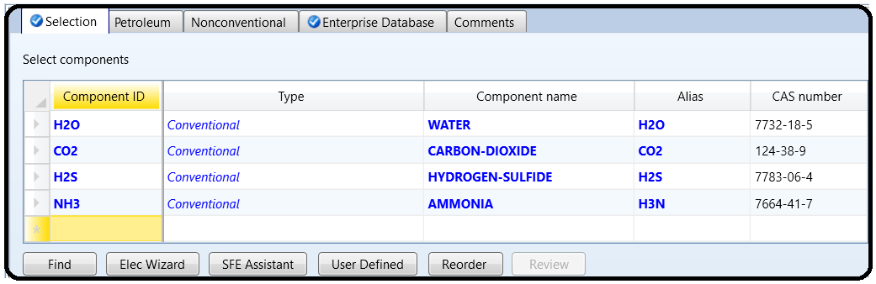1. Using Aspen Plus®, choose “Electrolytes with Metric Units” template to create the process flowsheet. The default property model is “ELECNRTL”. By default, water is added to the “Components” list. Add the three components: CO2, H2S, and NH3, as shown in Figure 11.1.

However, we will show here how to properly define each component as part of the electrolyte system.

2. In “**Components**” **|** “**Specifications**” **|** “**Selection**” tab window, click on “**Elec Wizard**” button (shown in Figure 11.1). This will bring the first “**Electrolyte Wizard**” window where the user can choose between symmetric and unsymmetric reference state for ionic components.

• For the unsymmetric reference state of ions, the equilibrium constants are calculated from the reference state Gibbs free energies of the participating components. Activity coefficients of ions are based on infinite dilution in pure water.We must have already defined water as a component to use electrolyte wizard for this case.

• For the symmetric reference state of ions, the equilibrium constants are not automatically calculated, and must either be entered here or regressed from data. Activity coefficients of ions are based on pure fused salts. Water is not necessary (though it may be included as a solvent).

We will choose the unsymmetric reference state for ionic components, as it does not require any further input about the equilibrium constants as functions of temperature for the dissociation reactions, as shown in Figure 11.2.

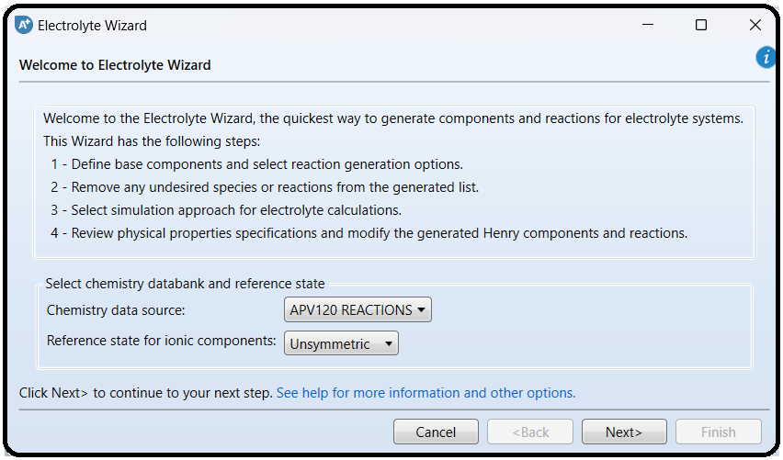

Click on “**Next**” button to proceed to the next step. Figure 11.3 shows the second “**ElectrolyteWizard**” windowwhere the user selectswhat components to include in the electrolyte system. All components are selected to participate in the electrolytic scene. Moreover, the user may select/deselect the appropriate option and how hydrogen ion should be expressed.

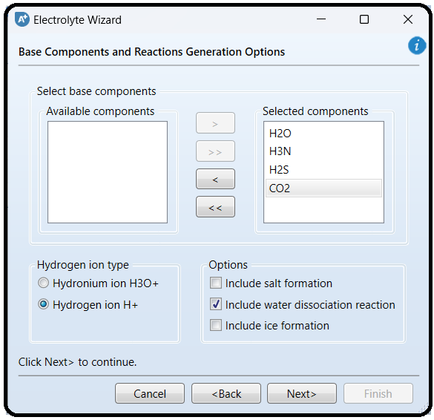

NOTE: It is a multifaceted decision, made by the user, to decide what to include in the list of participating players in the electrolytic portray and the extent of participation each player will do, in addition to the interplay between one player and another. Precisely speaking, let us take CO2 species as an example. We have to decide first whether or not to include CO2 in the first place. If the decision is yes for considering CO2 as an important electrolytic player, then we will have to decide on the assigned task for this player, that is, telling Aspen Plus what reactions are associated with this chemical species. Shall we consider its dissociation into water in the form of HCO3 − only?

Or, shall we consider further dissociation of HCO3 − into CO3 −2? Finally, what about the interplay between HCO3 − and NH3? Keep in mind that the more reactions you add to the electrolytic portray, the more complex the picture will be (or, longer CPU time), which may end up under some circumstances in a non-converging solution, (i.e., errors reported by Aspen Plus simulator), because of missing some pairwise interactions, which need to be plugged in by the user. If it happens that Aspen Plus fails to converge, then you may attempt to remove what you think is the least important electrolytic player (i.e., chemical reaction/species).

Click on “Next” button to proceed to the next step. Figure 11.4 shows the third “ElectrolyteWizard” window where Aspen Plus provides a list of potential reactions based on the stand-alone or interplay role of each of the chemical players nominated in the previous step.

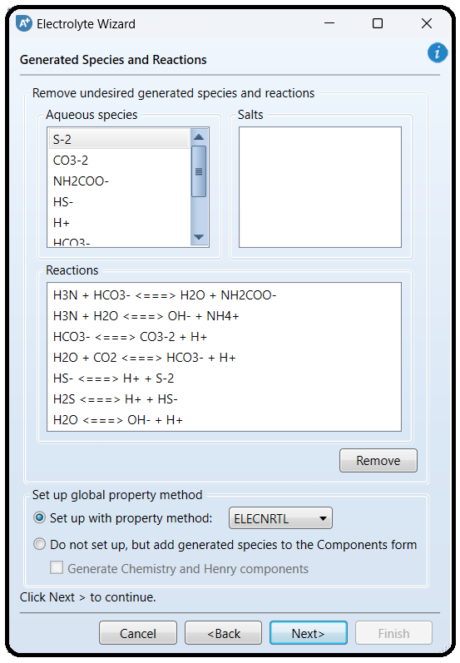

Notice that the user may select to remove one or more of ionic species that are listed and Aspen Plus will remove the corresponding reaction(s). Of course, the decision will be based on experimental observations that a particular ionic species is absent or its presence in the aqueous medium can be neglected. Alternatively, the user may directly remove a specific reaction out of those suggested by Aspen Plus, with the understanding that this reaction contributes little or nothing to the electrolytic portray and thus can be neglected. In other words, at a given pH, the *pKa/pKb* will tell the user if the dissociation extent for an acid/base is significant or can be ignored.

We will proceed without removing any chemical species or chemical reaction. Moreover, the third “Electrolyte Wizard” window (Figure 11.4) allows the user to stick to the default (“ELECNRTL”) method or change to “ENRTL-RK” method. The “ELECNRTL” property method will be selected as it is the most versatile electrolyte property method. Both methods, however, can be used in our case.

NOTE: Electrolyte solutions are extremely non-ideal because of the presence of charged species. The electrolyte-NRTL-based property methods: “ELECNRTL”, “ENRTL-RK”, and “ENRTL-SR” can all handle mixed-solvent systems at any concentration. The “ELECNRTL” property method is the most versatile electrolyte

property method. It can handle very low and very high concentrations. It can handle aqueous and mixed-solvent systems as well. The “ELECNRTL” is fully consistent with the “NRTL-RK” property method (i.e., the molecular interactions are calculated exactly the same way; therefore, “ELECNRTL” can inherit from the databank for binary molecular interaction parameters of the “NRTL-RK” property method). On the other hand, the solubility of supercritical gases can be modeled using Henry’s law. Henry coefficients are available from the databank. Heats of mixing are calculated using “ELECNRTL” model. Moreover, the “ENRTL-RK” method is identical to “ELECNRTL” for systems containing a single electrolyte. However, for mixed-electrolyte systems, the “ENRTL-RK” method uses the mixing rules only to calculate pairwise interaction parameters, instead of calculating both pairwise interaction parameters and Gibbs free energy from mixing rules. Furthermore, the “ENRTL-RK” uses a single thermodynamics framework to calculate the activity coefficients, Gibbs free energy, and enthalpy, instead of using separate models as in “ELECNRTL”. Finally, “ENRTL-RK” uses the Redlich–Kwong equation of state for all vapor-phase properties, except for association behavior in the vapor phase; the unsymmetric reference state (infinite dilution in aqueous solution) for ionic species; Henry’s law for solubility of supercritical gases; and unsymmetric Electrolyte NRTL method of handling zwitterions.

Click on “Next” button to proceed to the next step. The fourth “ElectrolyteWizard” window will show up as shown in Figure 11.5, where the user is given the choice to select between *true-* and *apparent-*component approaches.

The difference in the approaches lies in the level of technical details on howAspen Plus shall present the results of calculation of electrolyte solution properties. The “True component approach”, I call it the chemist’s approach, reports results in terms of the ions, salts, and molecular species present (i.e., showing the details of solution chemistry). On the other hand, the “Apparent component approach”, I call it the chemical engineer’s approach,reports results in terms of base components present without showing the details of solution chemistry. In the latter approach, ions and precipitated salts cannot be apparent components; specifications must be expressed in terms of apparent components and not in terms of ions or solid salts. Of course, results of both approaches are equivalent. Let us take a simple example, that is, *NaCl* in water.

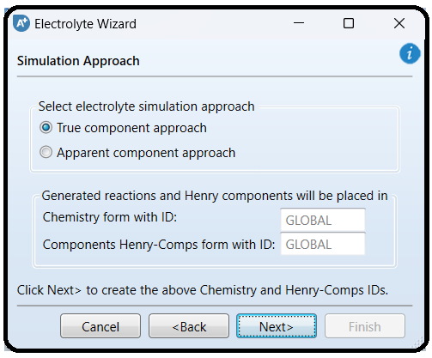

a) For the “True component approach” (i.e., showing solution chemistry):

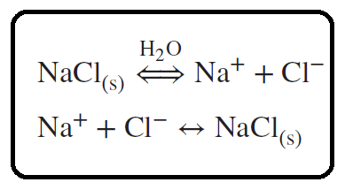

Results are thus reported in terms of Na+*,* Cl−*,* NaCl(s)*,* and H2O.

b) For the “Apparent component approach” (i.e., hiding the solution chemistry), the results are reported in terms of NaCl (Conventional)andH2Oonly.

Click on “Next” button to proceed to the next step. The “Update Parameters” window will pop up requesting to update the form parameters (i.e., list of components). Click on “Yes” button to proceed. You may have to click more than once. Figure 11.6 shows the fifth “Electrolyte Wizard” window summarizing what the user has already selected in previous steps and giving the chance to review and modify the chemistry of the electrolyte system under study.

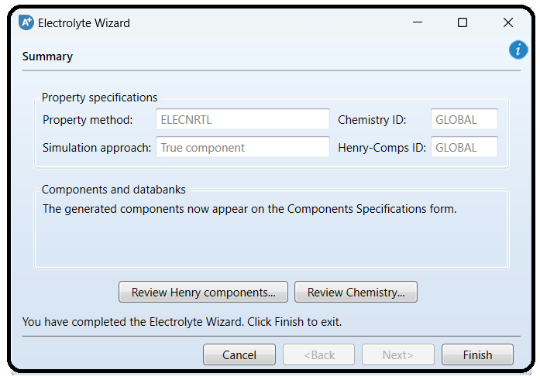

The user ought to click on “Review Henry components…” button to review the list of components that should be dealt with as Henry’s case (Figure 11.7). Alternatively, Henry’s set can been seen via visiting “Components” | “Henry Comps” | “Global” | “Selection” tab form.

On the other hand, the user may click on “Review Chemistry…” button to see the list of electrolytic equilibrium reactions, which are considered important players in the arena of the given electrolytic system (Figure 11.8). The user may edit, modify, or delete a given reaction and/or add a new one. Alternatively, the user may later go to “Chemistry” | “GLOBAL” | “Input” | “Chemistry” tab window and modify them from there. Moreover, if you click on “Equilibrium Constants” tab (the second tab in Figure 11.8), you will notice that Aspen Plus has already taken care of calculating the equilibrium constant, *K*eq, for each electrolytic equilibrium reaction.

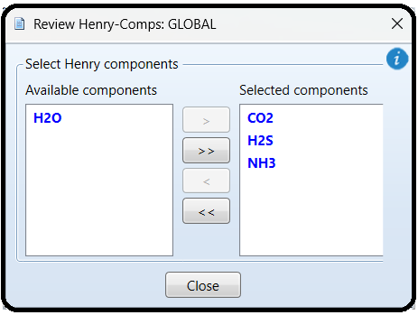

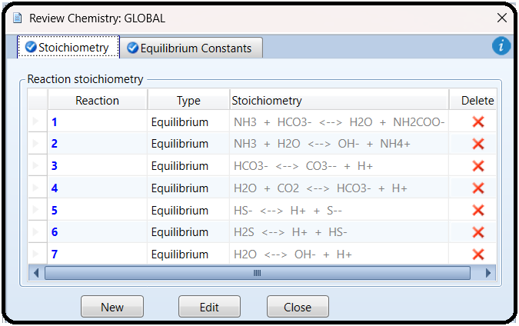

Click on “Finish” button (Figure 11.6) to close the wizard. Figure 11.9 shows that, under “Components” list, more chemical species are added, reflecting the types of ionic species

that are considered important in portraying the electrolytic picture, as agreed upon earlier in Figure 11.4

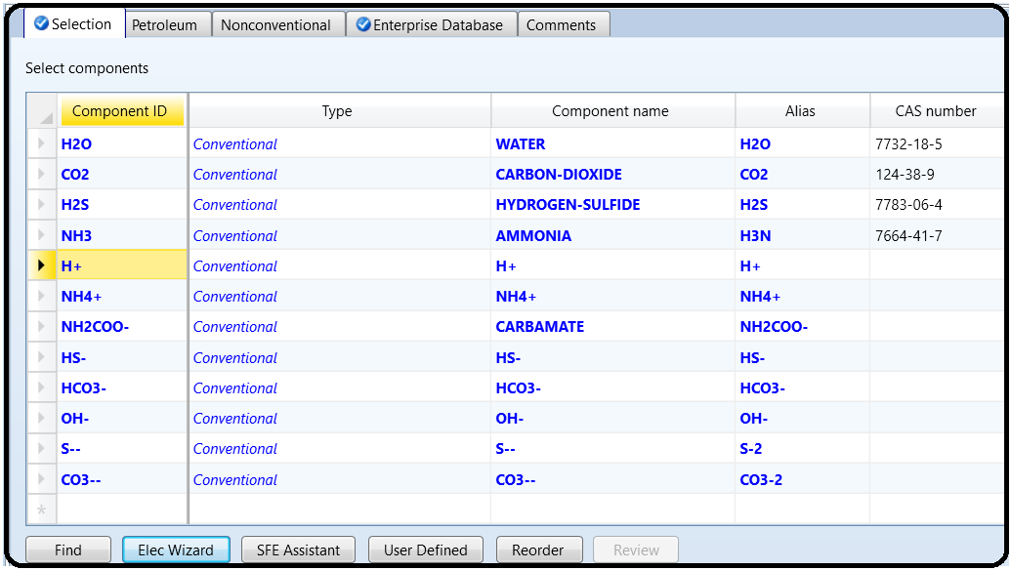.

From “Navigation” pane, you will notice that there are half-filled red circles, which

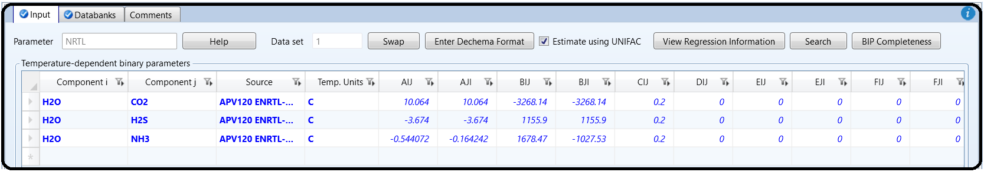means that they require either more input data or parameter estimation. Click on “Next” button more than once until you get rid of all red signs and the Aspen Plus sky becomes clear blue. Assure that the missing pairwise interaction parameters can be calculated by “UNIFAC” method. Once the properties analysis completed successfully, switch to “Simulation” environment.

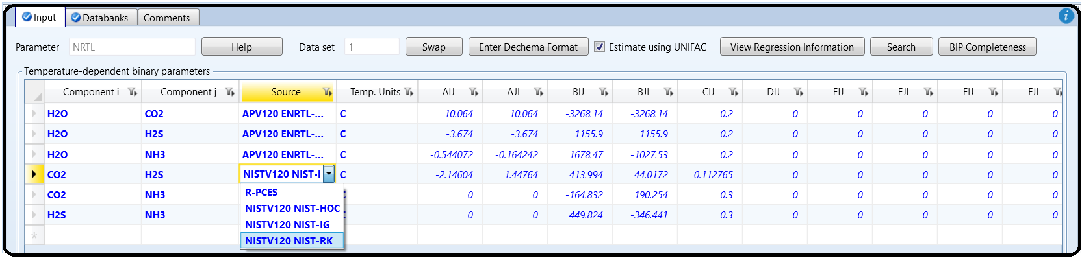

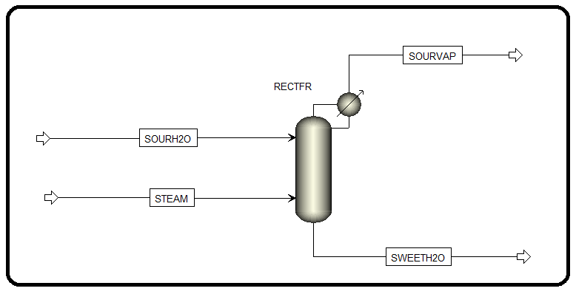3. From “Model Palette” select “Columns” tab. Go to “RadFrac” subcategory and select the icon that shows a column with a condenser but without a reboiler, as shown in Figure 11.10. If themouse hovers over the column icon, the tooltip will tell that it is “RECT” type column. Add the proper input and output streams. Notice that the distillate will be the top vented off sour vapor stream and the bottom will be the sweet liquid water stream. Two feeds are used: one for the sour water stream that enters into the top and another enters into the bottom as a saturated dry steam.

It is worth mentioning here that there might be more than one school in describing what a stripper means as opposed to a scrubber. I refer toWang *et al*. [1] in defining the stripping condition: “It is a stripping process if (1) the gas stream is the scrubbing agent (such as air with or without gaseous chemicals depending on the waterborne pollutants to be removed) and (2) the liquid stream contains the targeted pollutant (such as ammonia, chlorine, and VOCs) that will be removed by the reactor”. Notice that how they describe the gas stream as the scrubbing agent, not the stripping, although the phrase is inserted within the definition of a stripping process. We will go with describing the removal of pollutants from a liquid by a dry steam as stripping process.

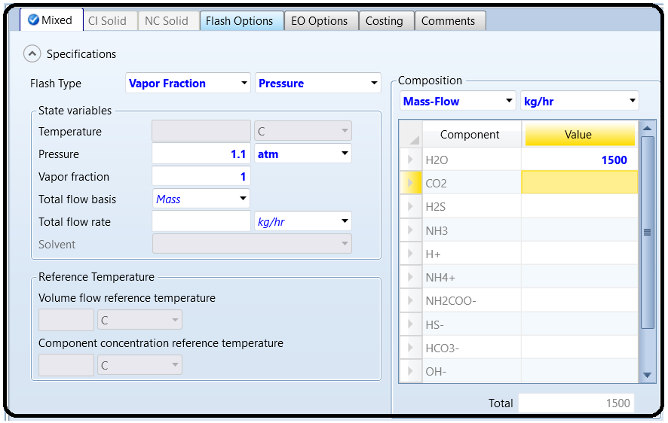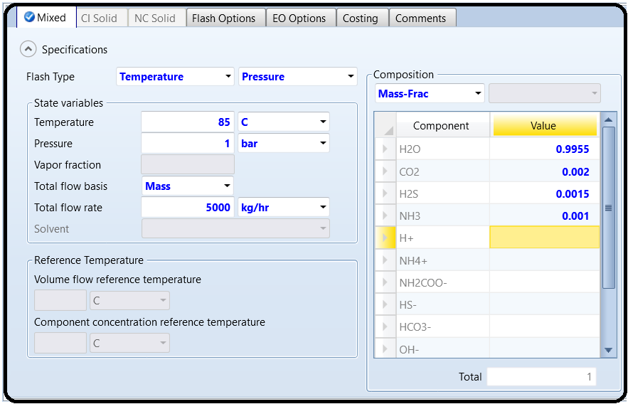

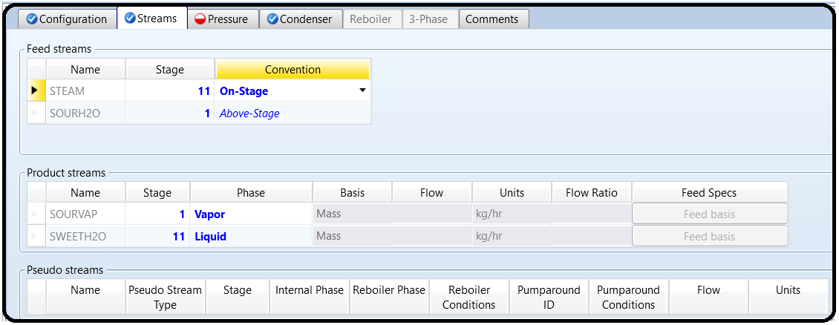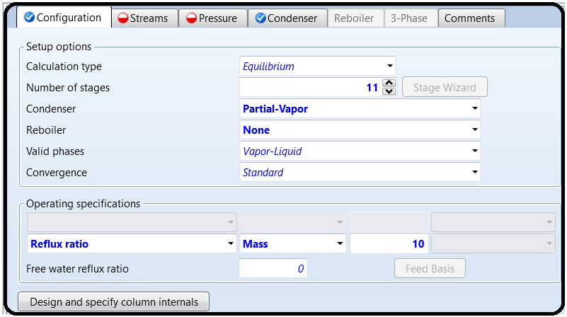Figure 11.13 shows the Stripper’s specification starting with the “Configuration” tab window. A partial vapor condenser is used and there is no need for a reboiler, because we have the steam acting as the vapor phase within the column. We have chosen 11 trays and a reflux mass ratio of 10.

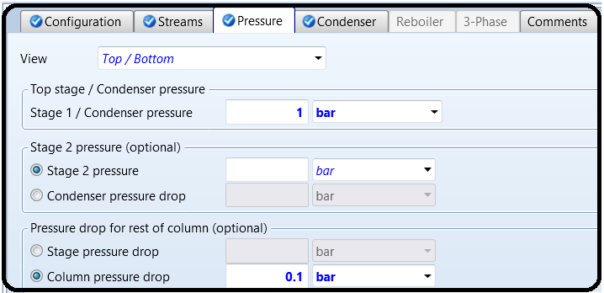

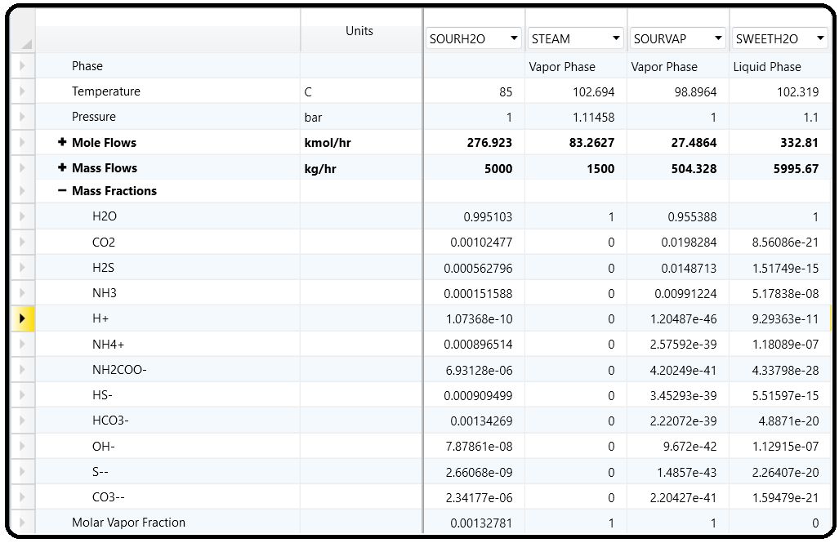For the “Pressure” tab window, the pressure at the condenser is set to 1 bar with a column pressure drop set to *0.1 bar*. For the “Condenser” tab window, both reflux and distillate are set at *0* degrees subcooled temperature, which means that both reflux and distillate exist at the equilibrium saturation temperature and pressure; however, the reflux will be saturated liquid mixture and “SOURVAP” will be withdrawn as saturated vapor mixture. Reinitialize, run the show, and watch if there is any error or serious warning. Figure 11.15 shows the composition of product streams where the contaminants were completely removed off the sour water stream and knocked out into the vapor stream. One more important thing, which is, with the “True componentapproach” option being selected (see Figure 11.5), the concentration for each ionic species is also shown here.

On the other hand, all previous steps can be repeated except for one thing, which is, selecting “Apparent component approach” instead of “True component approach” option shown in Figure 11.5. Doing so will end up with results similar to Figure 11.15 but this time only the non-ionic species concentrations are shown, as can be seen in Figure 11.16. Notice that the stream flow rates and operating conditions are the same as those of “True component approach” option.

Part 2

For certain liquid mixtures, the formation of electrolytes can be an important consideration when considering fluid properties. In particular, vapor-liquid equilibria (VLE) predictions can be inaccurate when predicting electrolyte formation. For example, in the simple mixture of CO2 and H2O, the CO2 dissociates to form H3O+ (or H+, as some chemists prefer to model), CO3=, and HCO3–. That’s what makes it so tasty!1

Aspen Plus can help you predict what electrolytes will form. For CO2 in bulk water, for example, you can use the electrolyte wizard on the Component Specifications sheet (see Figure 12.1). Make a new simulation file in Aspen Plus V12 (use the Electrolytes with Metric Units template this time). Enter CO2 in the Component | Specifications form (water should already be in there, and if you did not use the Electrolytes template, you should add water in as well) and then click the Elec Wizard button. Select the default database on the first page (AVP120 Reactions) and leave the reference state as unsymmetric. Then, on the second page, make sure that both CO2

and H2O are selected as base components, that the hydronium ion is modeled (H3O+) instead of H+, and that salt formation (only) is included. When you click next, you should see two reactions which are in their database involving the ions H3O+, CO3 =, and HCO2–.

Then, you should see the option to use the Electrolyte NRTL with Redlich-Kwong physical property package (ENRTL-RK). Select ENRTL-RK and click Next. On the next page, keep the default setting using a True component approach.

We will discuss the difference between True and Apparent components later.

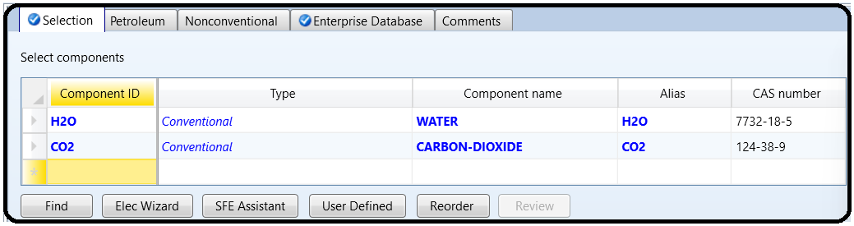

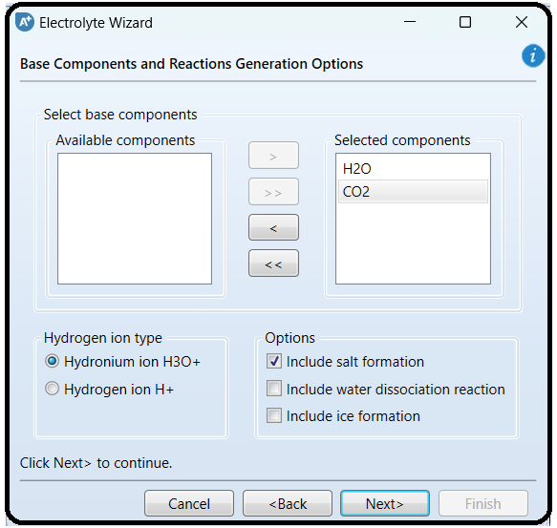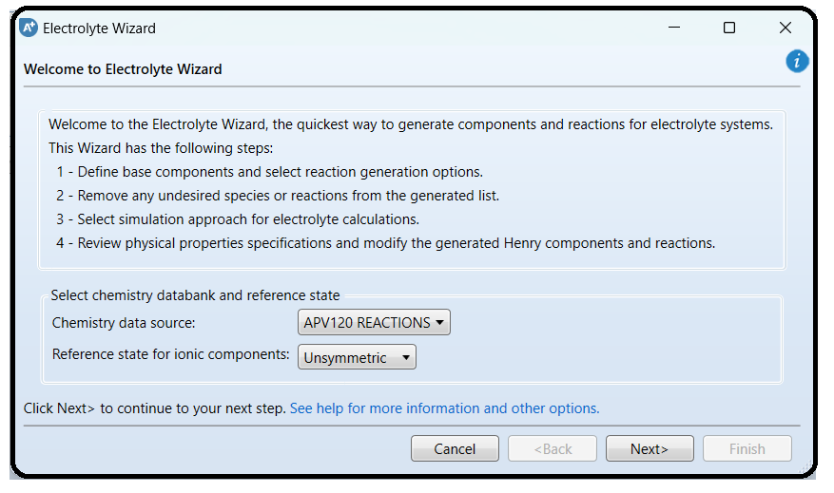

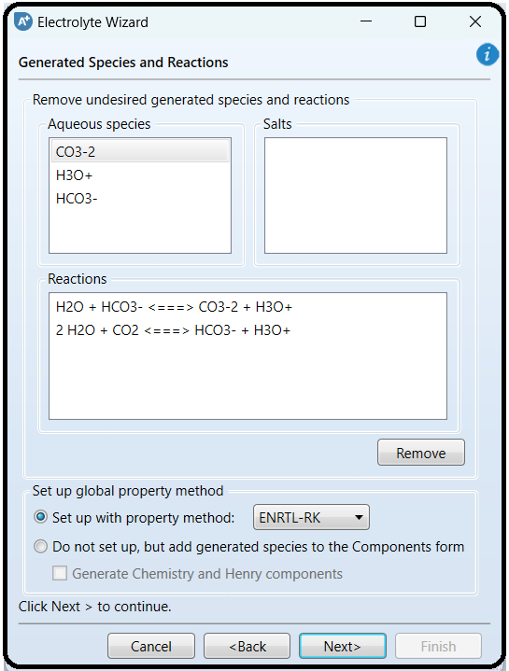

After a final confirmation page where you are invited to review the information (and you click Finish), you can see that Aspen Plus added the three chemicals to the components form and has added the two equilibrium reactions to the chemistry section. Also, it has changed your physical property model to ENRTL-RK. You should see something similar to Figure 12.2 in the Methods | Specifications folder. You will need to click on the Components | Henry Comps folder, Parameters | Binary Interaction (check the HENRY-1 subfolder) and Parameters | Electrolyte Pair folders (check the five GME subfolders) of your properties ribbon to have Aspen Plus finish the job and fill in these parameters.

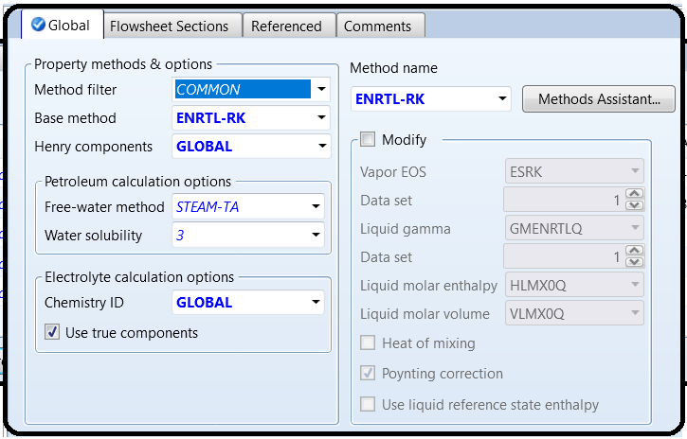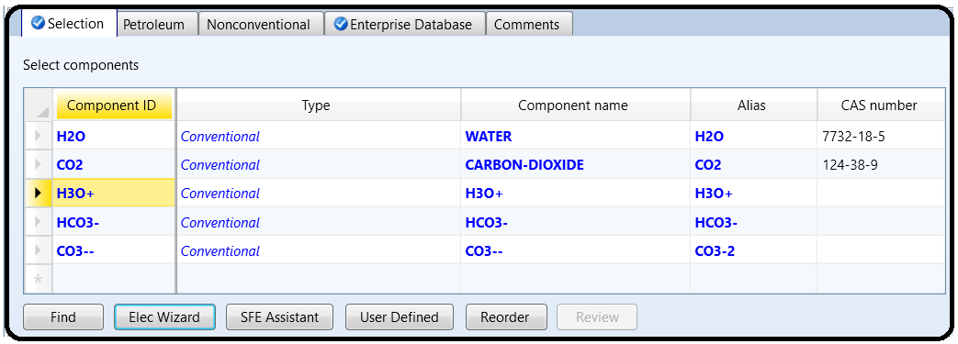

Looking at the updated Properties | Methods | Specifications form, you will notice that the base method has changed. So have the Components | Henry Comps and Chemistry folders, which both now have folders called Global (you can change the name). For example, the Global chemistry specifications are in the Chemistry | GLOBAL section, as depicted in Figure 12.3.

Finally, in Figure 12.4 are the electrolyte pairs that are modeled in ENRTL-RK. These are similar in function to the parameters you find in the Methods | Parameters | Binary Interaction | NRTL-1 subfolder except now these guides the ion interactions. Ok. Now we have that settled, let’s start a simulation using it. The way the ENRTL-RK model works is that it uses the electrolyte

interactions to help predict more accurate VLE. So, let’s try it out. Using this property model, you have created, perform a constant pressure adiabatic flash of an equimolar mixture of CO2 and water at 40 bar and 35°C (choose any nonzero flow rate you want). For the inlet streams, just specify the CO2 and H2O components and leave the ions at zero flow or mole fraction (as explained later).

Note: Check your control panel. If you get a warning about all your NRTL binary pair values being zero, go back to Properties | Methods | Parameters | Binary Interactions | NRTL-1 | Input tab and see if there is anything there. If not, then go to the Databanks tab and move the APV120 ENRTL-RK database over from Available to Selected. Then go back to the Input tab and the parameters should be there just like they are in Figure 12.5. Then rerun.

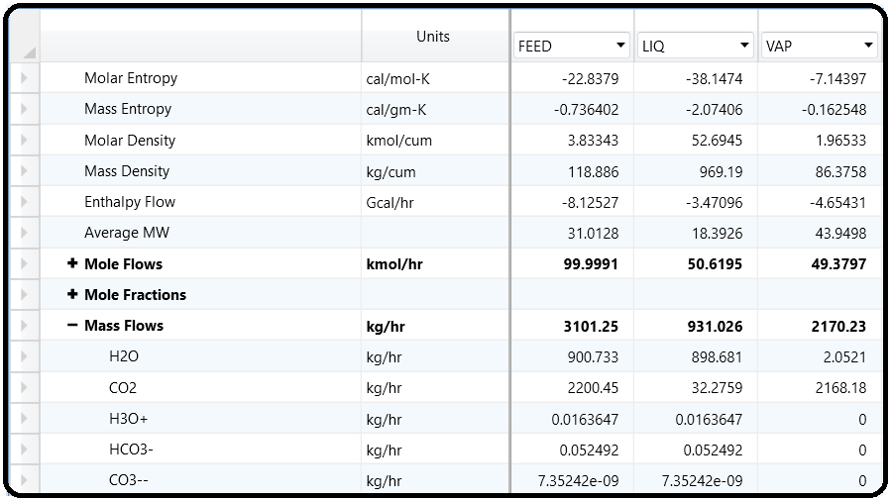

By themselves, electrolyte-based property models are pretty simple to use, but integrating them into flowsheets that also use nonelectrolyte models, or even just additional chemicals that are not

a part of the electrolyte chemistry, can be a serious headache. This is why I encouraged you to use a separate flowsheet for the NRTLRK model. Here are some tips in case you ever need to use both electrolyte and nonelectrolyte models in the same flowsheet. To start with, it is helpful to understand the difference between True and Apparent components. (Apparent components means not checking the “Use True Components” box on physical property definition forms.) Almost all physical property models use “true” component approaches, meaning that each chemical present in a mixture, including ions, is considered when making physical property

calculations such as phase equilibria. The problem, though, is that usually only the electrolyte models have data available for individual ions like hydronium or carbonate. For example, suppose you have a flash drum with water and CO2 in it and you are modeling with ENRTL-RK. The liquid output of that flash drum will contain trace amounts of ions in it, as you can see in your answer to Q1. Suppose that liquid is then sent to another block which uses PSRK or some other nonelectrolyte model. That block will try to access physical property parameters for those trace ions (which it does not have) thus potentially causing a solver failure due to missing parameters. One solution to this is to set each individual unit operation on a flowsheet that uses the electrolyte model to use “apparent” components (go to the blocks’ Block Options form). This means that the ion concentrations will in fact be considered and computed during flash calculations as desired, except that when the results are reported, the ions are bundled back into their “apparent” components (water and CO2) when reported in the stream. As such, the liquid output stream leaving the flash drum will have exactly 0% ions in it (not even a trace amount). This way, downstream units using nonelectrolyte property models do not see electrolytes at all, preventing lots of problems later. The second option is to uncheck the “Use true components” option on the Properties | Methods | Specifications form for the default method, if that method is an electrolyte method. In either case, the electrolytes are considered “under the hood,” you just don’t see them in the stream conditions.

There are some minor under the hood differences between True and Apparent component approaches, which can sometimes, but not often, give meaningfully different results. However, RGIBBS, REQUIL, and some of the shortcut distillation models like DSTWU, Distil, and BatchSep, must use Apparent components, and sometimes RCSTR or RPlug depending on reaction details. Also, certain special models, like for CO2 capture, work only in True component mode, which we

will do next. You can refer to the help documentation included with the software for the minutiae. In most cases, it does not matter which you choose, and so I recommend starting with Apparent unless you really need True. It is more challenging, however, if you want to change property

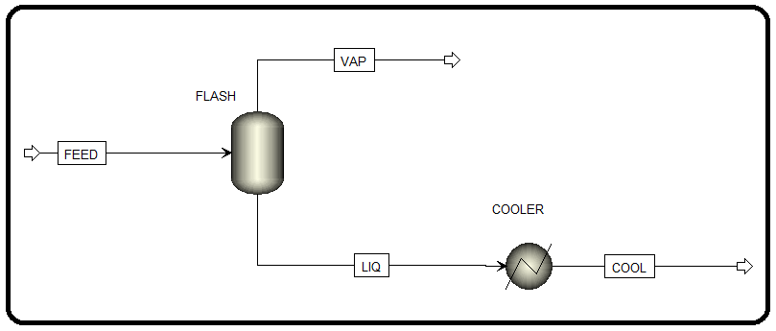models between blocks, to switch from one that supports electrolytes to one that does not. For example, if a downstream unit does not require electrolyte considerations and if it is better modeled in some other fashion, you should use the Block Options to set the immediate upstream unit operation(s) to Apparent components such that no ions will be present in the stream feeding to the downstream unit. In fact, on the downstream block, you may need to right-click the Chemistry ID and hit clear to get rid of the chemistry specification when changing the property model, because the Chemistry ID dropdown box does not have a “none” option. An example is shown in Figure 12.6.

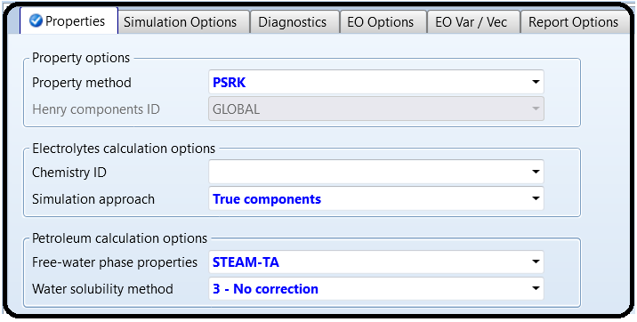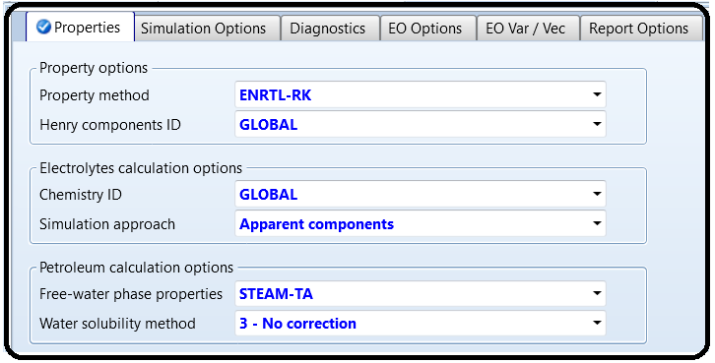

Reference

1.Our team experience

2.Wang, Lawrence K., Pereira, Norman C., Hung, Yung-Tse, “*Air Pollution Control Engineering*”, Springer Science & Business Media, LLC, New York, (2004), 276.

3. Chen, C.-C., Britt, H.I., Boston, J.F., and Evans, L.B. (1982) Local compositions model for excess Gibbs energy of electrolyte systems: part I: single solvent, single completely dissociated electrolyte systems. *AIChE Journal*, **28** (4), 588–596.

4. Chen, C.-C. and Evans, L.B. (1986) A local composition model for the excess Gibbs energy of aqueous electrolyte systems. *AIChE Journal*, **32** (3), 444–459.

5. Mock, B., Evans, L.B. and Chen, C.-C. Phase equilibria in multiple-solvent electrolyte systems: a new thermodynamic model. Proceedings of the 1984 Summer Computer Simulation Conference, p. 558–562 (1984), held in Boston, Massachusetts, USA.

6. Mock, B., Evans, L.B., and Chen, C.-C. (1986) Thermodynamic representation of phase equilibria of mixed-solvent electrolyte systems. *AIChE Journal*, **32** (10), 1655–1664.

7. Eisa, O. and Shuhaimi, M. (2010) Thermodynamic study of hot potassium carbonate solution using Aspen Plus. *World Academy of Science, Engineering and Technology*, **4** (2), 221–225.

8. Aspen Plus – Chemical Engineering Application by KAMAL I.M. AL-MALAH