Part 6

Distillation Modelling in Aspen Plus



Part 1

In this tutorial, we will learn how to design a separation column using the various models and tools we have available in Aspen Plus. The basic strategy is:

1.Use a shortcut column to get an approximation for the optimal value of key parameters, such as reflux ratio and number of stages.

2.Use a rigorous column to get more accurate results using the

suggested values.

3.Use optimization to narrow in on the best choice.

For this example, we will separate an equimolar mixture of acetone, isobutyraldehyde, ethyl acetate, and *n*-heptane, with normal boiling points shown below (note that it may differ from

Aspen Plus’s Databanks).

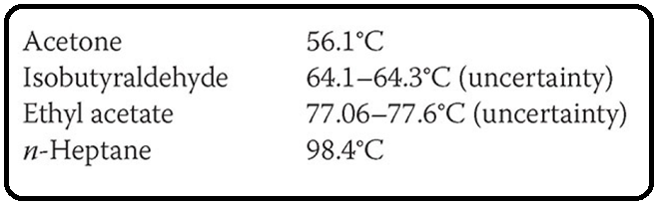

The mixture is at 30°C and 1 bar, at a rate of 200 kmol/hr. (I am not sure you’d ever find this mixture in the industry, but it makes for a good, contrived example with the precise properties I was looking

for.)

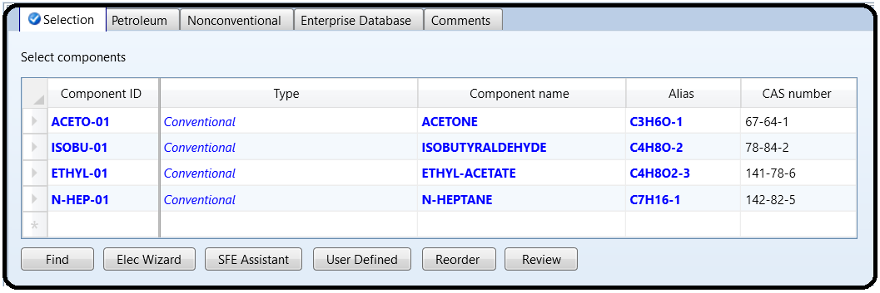In this example, we will create a properties backup file. This means that all of your physical property settings are loaded in one file. You can then import that file over and over again into new simulations and flowsheets so that you can keep reusing the same physical properties package on all of them. Create a blank simulation and add the four above components.

For the Methods type, choose UNIQ-RK. Verify that it worked by going to the Binary Interaction folder and looking at the UNIQ-1 parameters. Verify that the source is VLE-RK. If it is VLE-IG, it means you did something weird earlier, such as setting the wrong physical property package, and then when you switched to UNIQ-RK, these parameters did not change. If this is the case, change the source to VLE-RK and verify that the numbers changed. There should also be

five pairs.

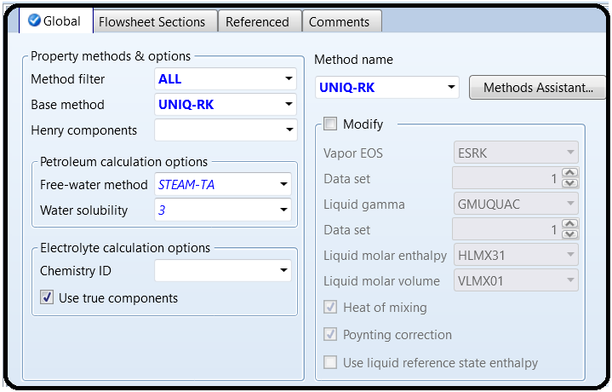

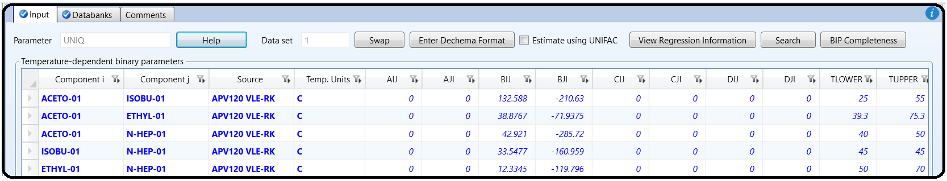

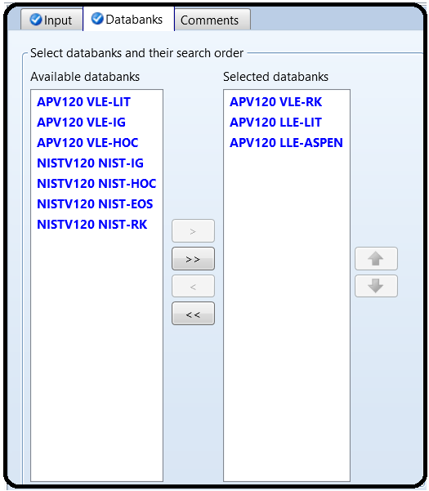

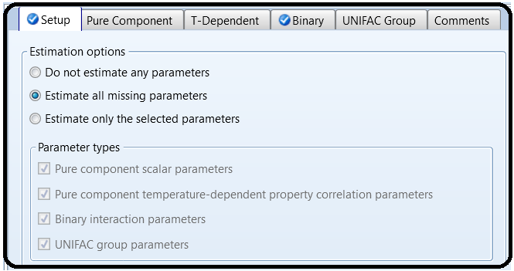

Notice that one of the pairs, Isobutyraldehyde–Ethyl Acetate, does not exist in the databank. When this happens, you can either find your own in the literature or you can try to use the UNIFAC method to estimate the vapor-liquid equilibria (VLE) parameters for you. The UNIFAC method is a group-contribution method that looks at the shape and structure of a molecule and then uses certain heuristics to try to predict how it will interact with other molecules. This is built into Aspen Plus, and so we’re going to use it here to predict the missing UNIQUAC coefficients.

So, let’s get the Properties feature to finish the job for us. Go to the Properties | Estimation | Binary tab. The Binary tab is disabled unless, on the Setup tab, you select Estimate all missing parameters (see Figure 5.1).

Click New to create a new parameter to estimate and choose UNIQ. For the method, choose UNIF-DMD (the UNIFAC method with the Dortmund modification—the most modern and accurate in the general case). Then below that, select the two missing binary pairs. To the right, you select the temperature range of validity. The UNIFAC method may generate different parameters that are better at different temperatures. So, you can choose to have it be optimized for one specific temperature, or sort of averaged out over a range of temperatures. Typically, it makes sense to choose the two normal boiling points (64.3°C and 77.6°C) as shown in Figure 5.2, because two-phase behavior will usually occur inside that range. However, you may want to try different temperatures if your application calls for higher pressures, if there is a low-boiling azeotrope, or if it will be apart of a VLE mixture with other chemicals at different temperatures.

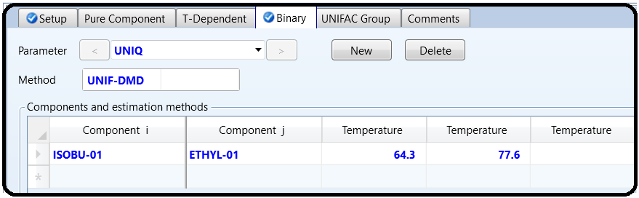

Ok! Next, in order to use the UNIFAC method, we have to tell Aspen Plus what the molecular structure of the components is, since they are not kept in the databank. To do this, go to Properties |Components | Molecular Structure. Click on Isobutyraldehyde for now.

The idea is that you list the atoms and how they are bonded to their neighbors. You can make up any numbering system you want.

Note, there is a shortcut you can apply. Often the structure is already stored in the databank for many molecules, even though the table is empty. So you can do a trick to get the structure to be

automatically loaded into the table for you, so you don’t have to type it. We’re going to do this for ethyl acetate. Go to the Structure tab of ethyl acetate and ensure that the picture of the molecule is there. If it looks right, click on Calculate Bonds to convert it to the same kind of table as before

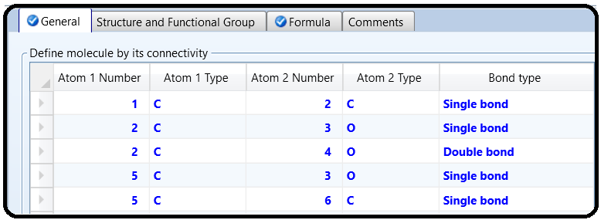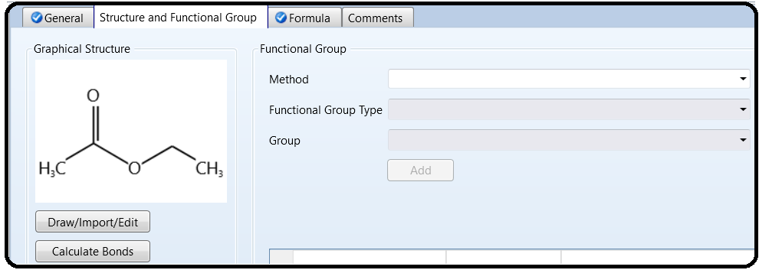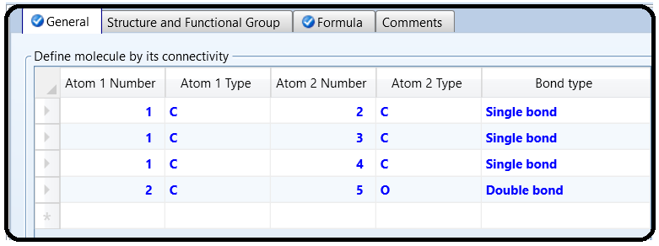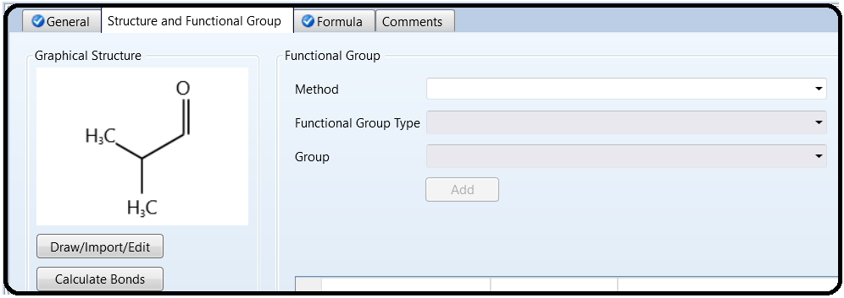

You can also draw a molecule graphically with the Draw/Import/Edit button (see Figure 5.5). This is really useful later in life for drawing molecules if you just want nice images to use, or if you are making a new molecule that isn’t in the database. Although the Aspen Properties database is quite extensive, you may need to do this someday for specialty chemicals, pharmaceuticals, or just rare chemicals. When you are done looking at the molecule, make sure ethyl acetate has data in the General tab too.

Almost done! Next, we just need to check a box that tells Aspen Plus to put the results in a convenient place rather than burying them in a text file somewhere. Go to Setup | Report Options | General, and make sure the box “Generate a report file” is checked. Ok, now click Run (or hit F5). This will compute your estimate. You should see the result in the Methods | Parameters | Binary Interaction | UNIQ-1 form, with a new column added for Isobutyraldehyde–Ethyl Acetate. Double-check and make sure the TLOWER and TUPPER are in the temperature units you expected. Otherwise, you need to revise your Estimation | Input entry.

Now, save your result. Then go to File | Export | File, and export to an Aspen Properties Backup File (. aprbkp). This file can be used for all future Aspen Plus files (and even likely future versions of the program) so you don’t have to do this again every time you want to make a new file.

Ok, let’s start the distillation design process with a shortcut distillation column model. Although you could just go to the Simulation tab to get started, let’s do it a different way so we can

practice how to use the backup file. So, for example, in a team design project, someone might probably want to make a master properties backup file that everyone else uses for their own

flowsheets. That way, everyone on your team has the exact same physical property models with the same chemicals named exactly the same way and in the same order. Create a new blank simulation. Once it opens, go to File | Import | File and import the. aprbkp file that you just made.

To verify that it worked, check out the binary interaction pairs and the property methods.

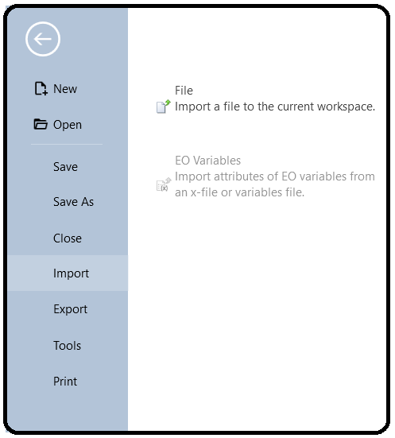

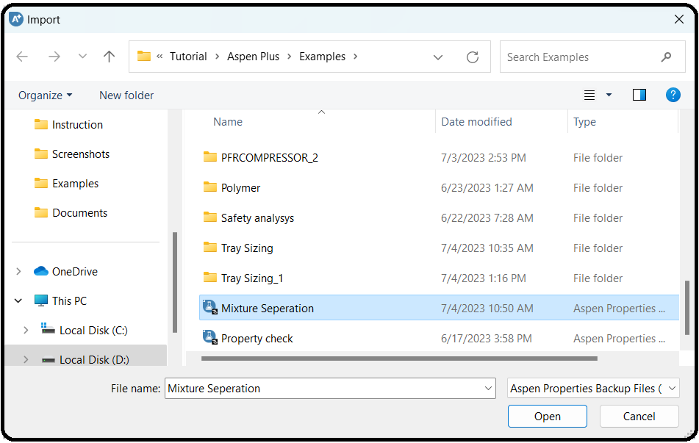

DSTWU is a shortcut distillation model in which an estimate of the reflux ratio or the number of stages can be made given the desired separation result. In this case, you tell Aspen Plus what the recovery factors should be and it computes the rest. However, this assumes ideal behavior, which never happens in reality.

Therefore, it serves mostly as a great starting guess for something more rigorous down the road.

Simulate the separation of a 200 kmol/hr of 30°C, 1 bar equimolar mixture of the four components shown in the table.

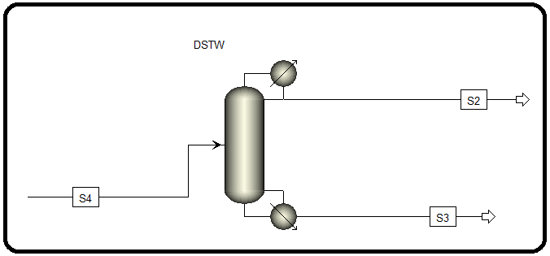

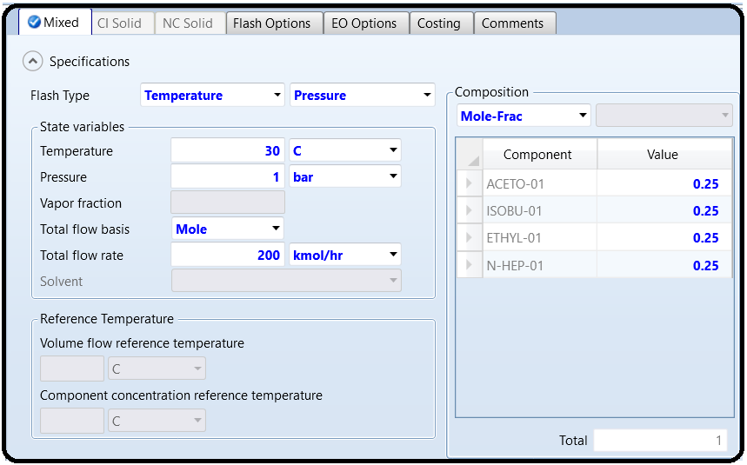

Use the DSTWU model. Assume the column is also at 1 bar throughout. Let’s assume the goal is to obtain 96.5% recovery of isobutyraldehyde in the distillate. In addition, we want 96.5% recovery of ethyl acetate in the bottoms. This is summarized in Table 5.1.

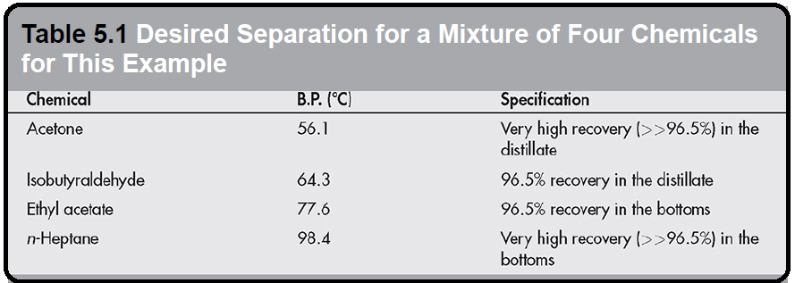

DSTWU requires the desired output conditions to be specified in terms of the molar recoveries of the heavy and light keys. This can be a little confusing at times. Looking at Table 5.1, you can see that the chemicals are arranged from top to bottom in terms of increasing boiling points, meaning that acetone is the lightest and *n*-heptane is the heaviest. For this example, we desire that in the ideal case, we want all of the acetone and isobutyraldehyde to leave via the distillate and the ethyl acetate and *n*-heptane to leave through the bottoms. The *light key* characterizes what is leaving in the distillate: it is the *heaviest* (or least volatile) of all of the chemicals that we want to leave through the distillate, so in this case, it is isobutyraldehyde. Similarly, the *heavy key* characterizes the bottoms product: it is the *lightest* (or most volatile) of the chemicals leaving through the bottoms, so in this case, it is ethyl acetate. So, we enter into DSTWU that isobutyraldehyde is the light key, and we want 96.5% of it to leave through the distillate (we are being realistic that we can’t get all of it). Note that molar recovery is not mole purity! We also must specify ethyl acetate to be the heavy key, but instead of saying that we want 96.5% of it to leave through the bottoms, we have to actually specify the opposite, that is, we want 3.5% recovery of ethyl acetate in the distillate. Tricky, but that’s how it is. Then, the model already knows that acetone is more volatile than isobutyraldehyde, so it will also leave mostly through the distillate (with much higher recovery than isobutyraldehyde, in fact), and that *n*-heptane will leave through the bottoms since it is less volatile than ethyl acetate.

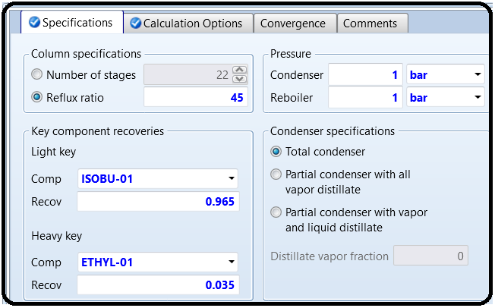

The DSTWU model uses shortcut calculations developed over seven decades ago, and is limited in accuracy because it uses certain assumptions to greatly simplify the calculations to make it possible to design a distillation column “by hand.” Despite this, it is still useful in the modern computer age because it can be used to make predictions about the trade-offs between reflux ratio and the number of stages required to achieve a certain purity in the products. In

general, the higher the number of stages, the lower the reflux ratio required, and vice versa.

Often, at the beginning stage of designing a distillation column, the designer has little information about what the number of stages and the reflux ratio should be or even a feasible range. DSTWU is useful to estimate these numbers. In general, you specify either the reflux ratio or the number of stages, and then it will estimate what the other value should be in order to achieve the separation objectives that you require.

Be careful though: it is possible to guess a number that is too low. There is a certain minimum number of stages and minimum reflux ratio that are necessary to achieve your desired separation. So if you guess too low, you’ll get an error message. Since it’s hard to know what that minimum is when you are first getting started, it makes sense to guess something extremely high, just so you avoid the error. Sure, you’d probably never want to design a column with that large a reflux ratio or number of stages, but we need something to work for our first run-through. So, let’s guess an extremely high reflux ratio of 45. Run the simulation. Check the stream results to make sure they make sense, and then answer the following by looking at the Results tab of the DSTWU block.

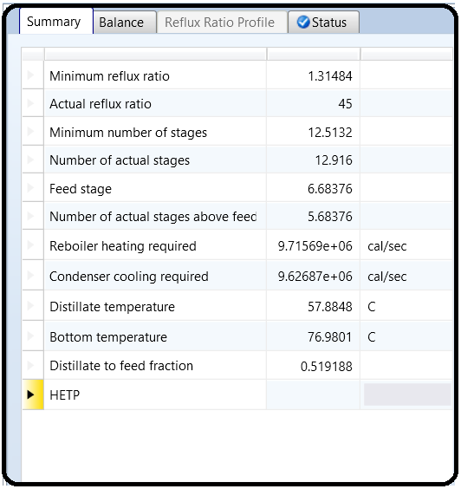

Ok, so since 45 is high, let’s look at what happens if we change the reflux ratio. Fortunately, DSTWU will give us a nice plot. In the Block | Input, go to the Calculation Options tab, then check “Generate table of reflux ratio versus number of theoretical stages.” Sounds good! But we need a range. The lowest number of stages is going to be your answer from Q3, as this signified operation at total reflux. We don’t really know the highest number of stages yet. Let’s try something large, like 50. We can see if this is a good guess later. Change the “increment size” to be 1. Basically, Aspen Plus will rerun the simulation for stage numbers from Q3 to 50 in steps of 1 and then compute a reflux ratio required for each. Rerun the simulation. Go back to the DSTWU Results form and then go to the Reflux Ratio Profile tab. Remember, you can use the Custom button in the Plot section of the Home ribbon, or the Ctrl+Alt+X, Ctrl+Alt+Y, Ctrl+Alt+P shortcuts to plot, hopefully getting something like Figure 5.6. The idea of the plot is to choose something that has a low reflux ratio, but before it gets “flat” (adding extra stages doesn’t really help much). That’s a good heuristic to use in the absence of cost data to have a reasonable trade-off between

capital and operating costs. In general, increasing the number of distillation stages increases its capital cost and reduces its operating cost, while reducing the number of stages reduces its capital cost and increases its operating cost.

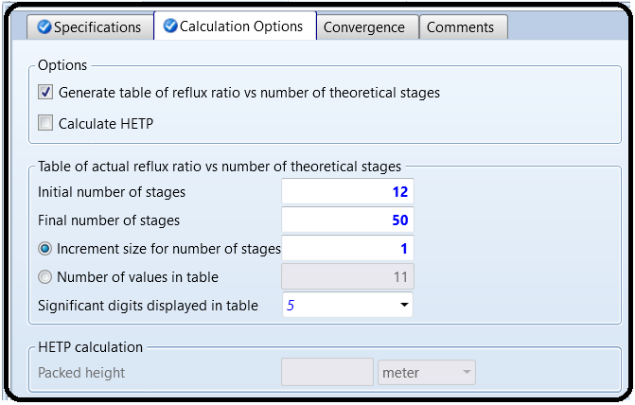

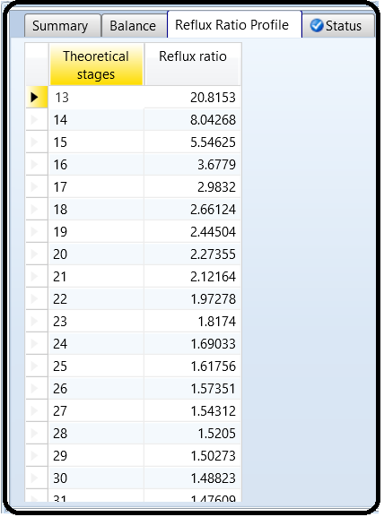

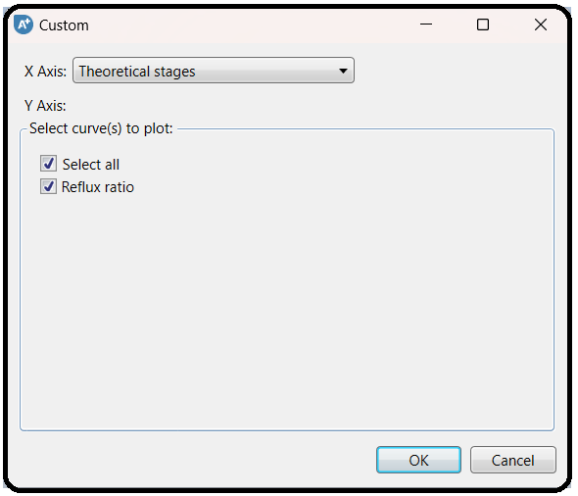

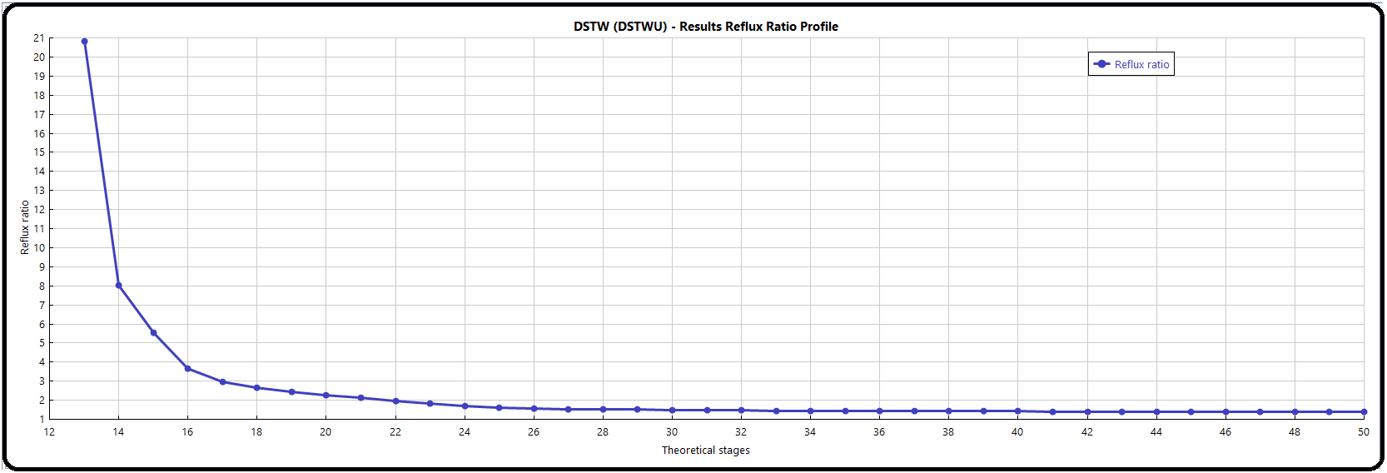

For example, if I have a column with 14 stages, I would require a reflux ratio of around 8, but if I pay for just one more stage, I can bring the reflux ratio down to about 5.5, for roughly a 32% reduction in energy costs. So, it’s worth it to go from 14 to 15. And I would argue it’s worth it to go further to 16 stages. On the other hand, if I have a column that is 24 stages, I can only get a very small reduction in the reflux ratio if I add a 25th stage, so it might not be worth paying for the extra tray at that point.

**Q5)** What is the fewest number of stages in which the reflux ratio is below 2?

Choose your answer in Q5 as the final design condition. Now, let’s predict the best possible location for the feed tray. Simply rerun the simulation again with your new choice. Verify that the actual reflux ratio calculated is the same as the plot from Q5.

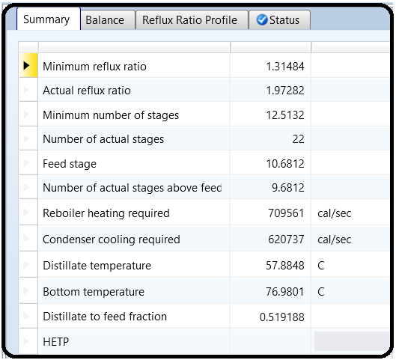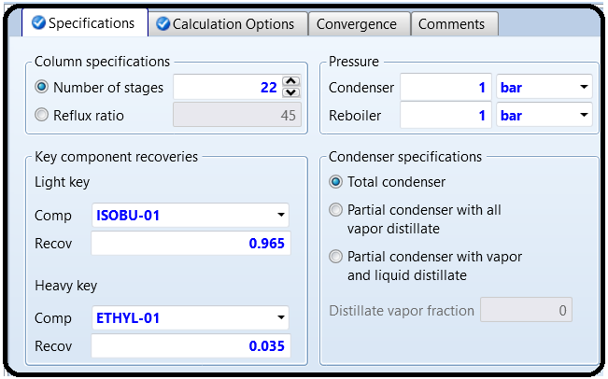

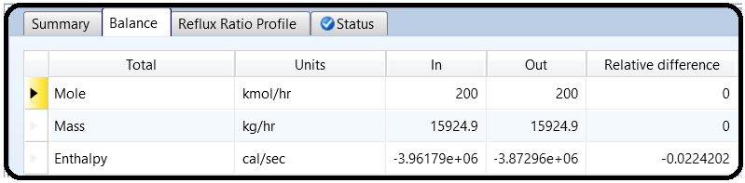

Duplicate your feed by using Dupl block from the Manipulators section of the Model Palette. Dupl basically takes an input and makes copies of it (all the same flow rate and everything). It’s there

for convenience in modeling and is usually used for “what-if” scenarios, where each branch downstream of the Dupl is a different model or a different option to consider. It is not an actual piece of equipment. Have one stream leaving the Dupl route to the DSTWU block (so it should be the exact same thing as before). Have another stream leave the Dupl block and route into a new RadFrac block. Use your answers from above as the new settings in the RadFrac block.

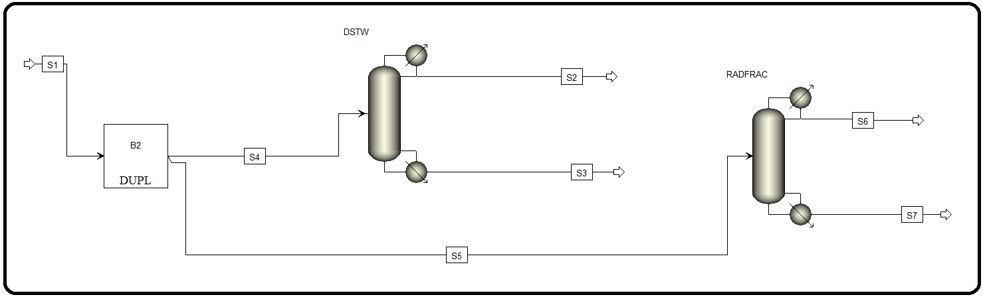

Let’s use Murphree vapor efficiencies to make our simulation somewhat less ideal. Go to Efficiencies of the RadFrac block. In the Vapor-Liquid tab, specify that the Murphree stage efficiencies from stages 1 to 10 will be 82% (0.82), and from 11 until the bottom of the column will be 73% (0.73). You need not type each stage in the box, and Aspen Plus will linearly interpolate between them. So, for example, if you enter just stage 1 as 0.82 and 10 as 0.82, then stages 2 through 9 will also be 82%. Note these are stage efficiencies, so even though stage 1 is the condenser/flash drum and the highest stage is the reboiler, they too have efficiencies.

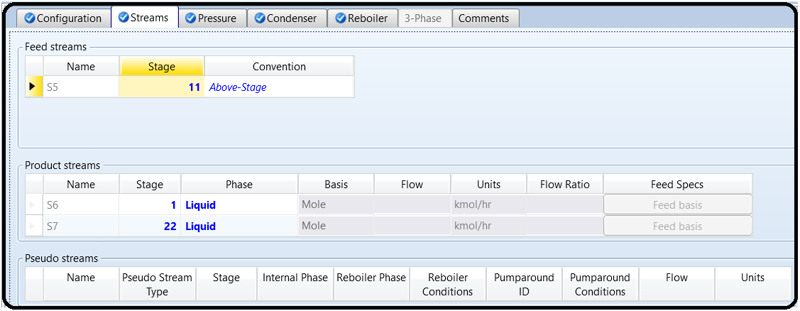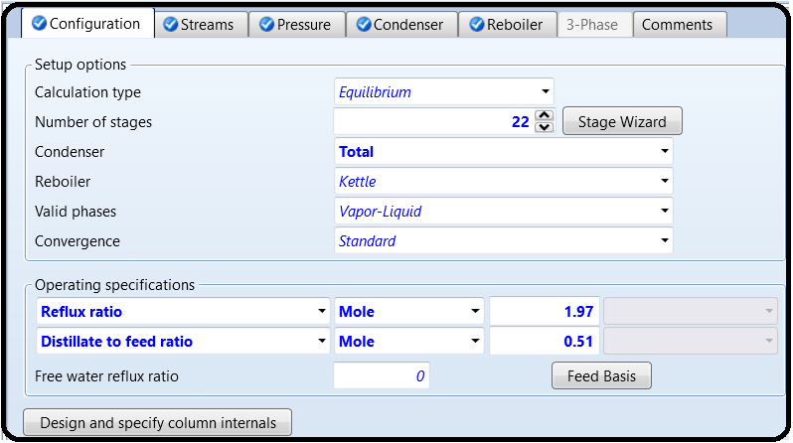

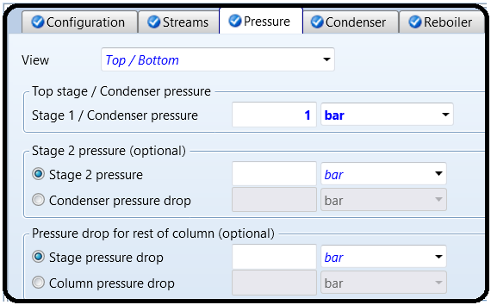

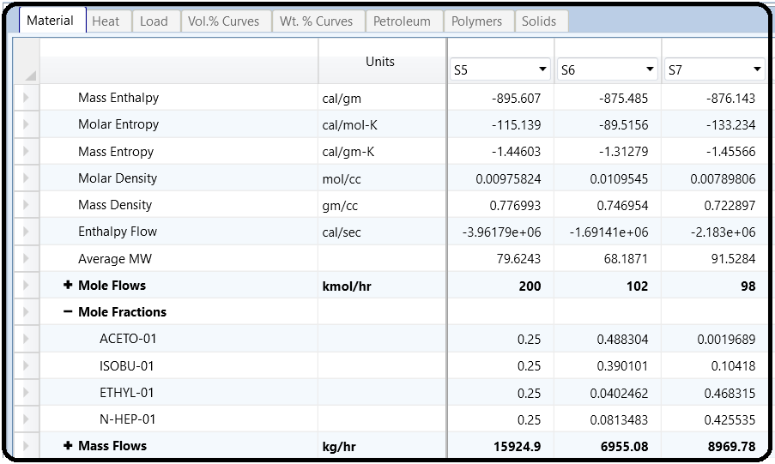

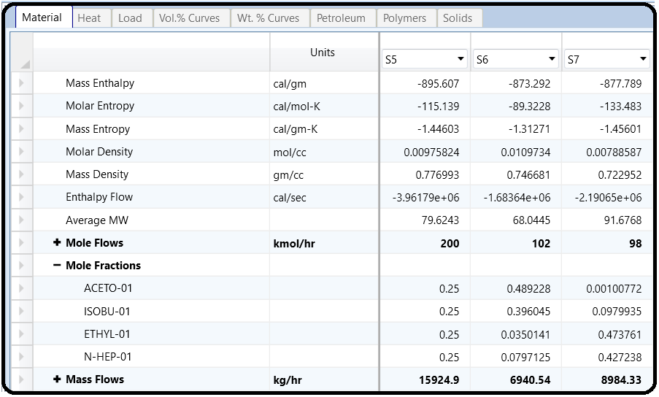

Part 2

Design a distillation column that will separate a feed of 100 kmol/hr of 50 mol% water and 50 mol% methanol at 25°C and 1.4 bar, into 99 mol% methanol and 99% water. Use PSRK as the property method. The following procedure is recommended to design the column:

1.Use a DSTWU model to obtain a number of stages (N) versus RR profile for the separation and pick a suitable N.

2.Use DSTWU to estimate the RR, distillate-to-feed (D:F) ratio, and feed stage at that N.

3.Using the conditions obtained from DSTWU remodel the separation using the more rigorous RadFrac (equilibrium-based mode) model.

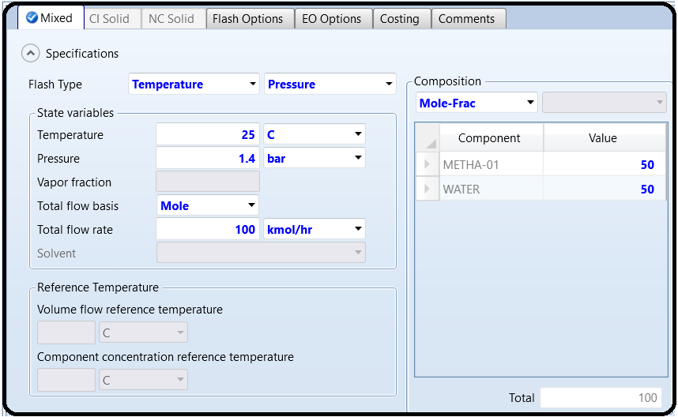

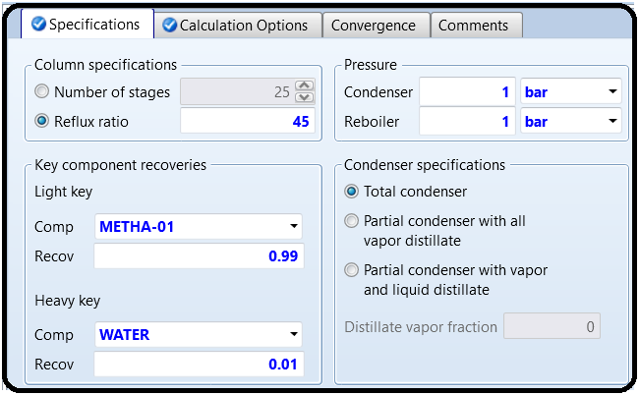

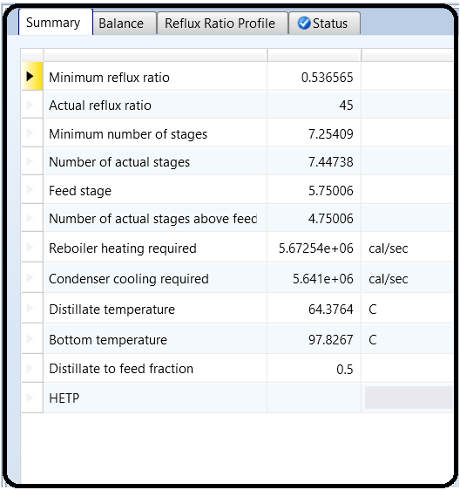

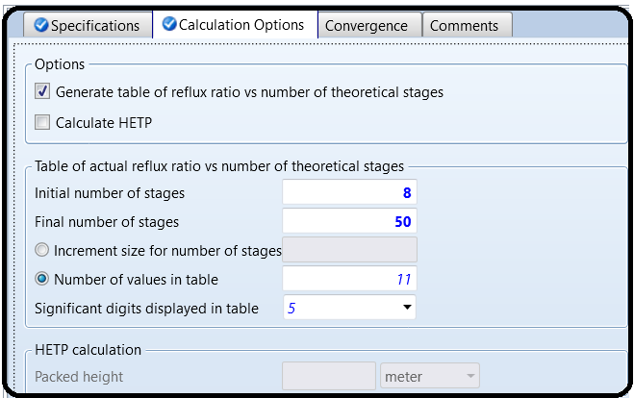

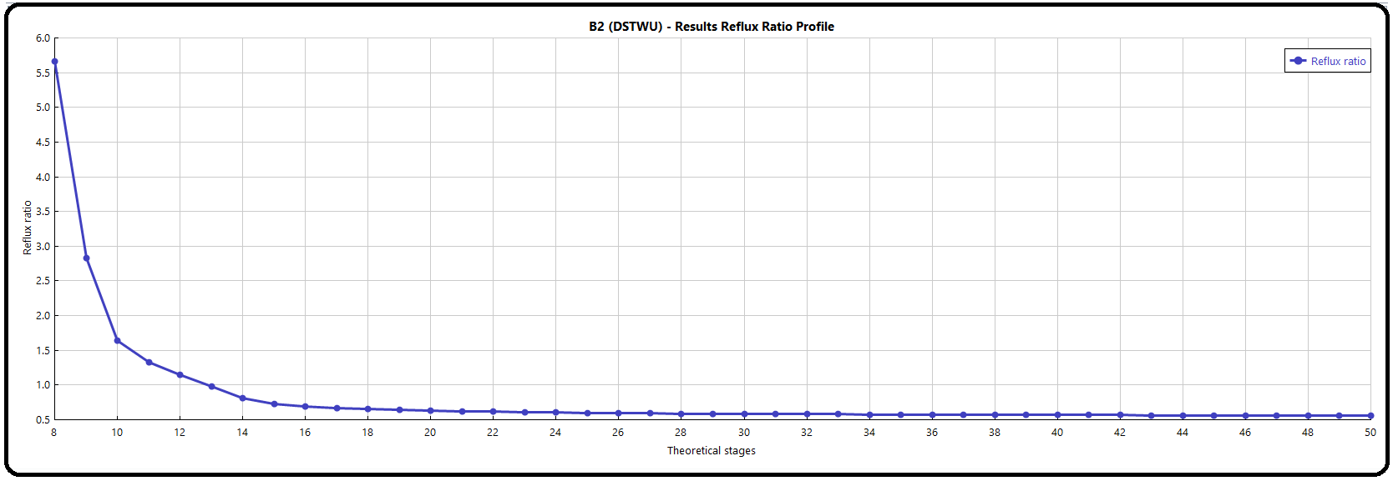

Let’s use a 25-stage column as an example (change the number of stages in your column). Remember, the trays are on stages 2–24 since stage 1 is the (total) condenser and stage 25 is the reboiler. To make sure we are on the same page, feed to stage 12 (abovestage).

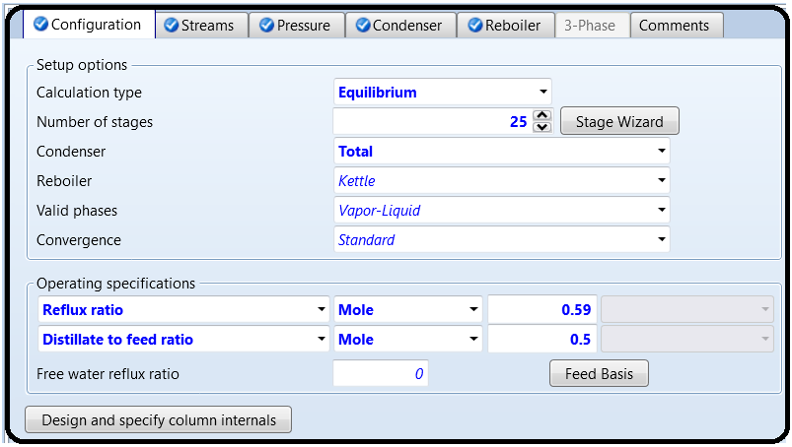

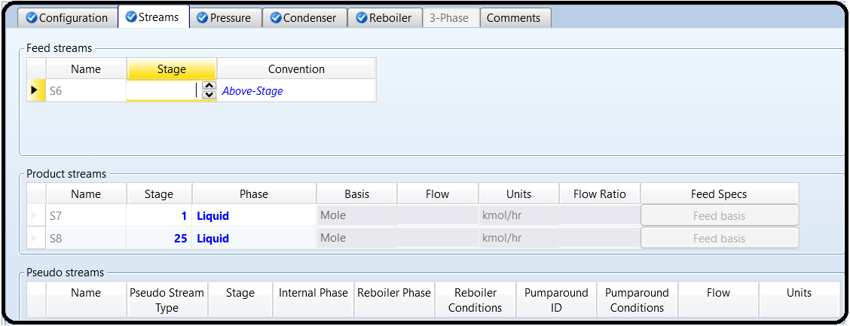

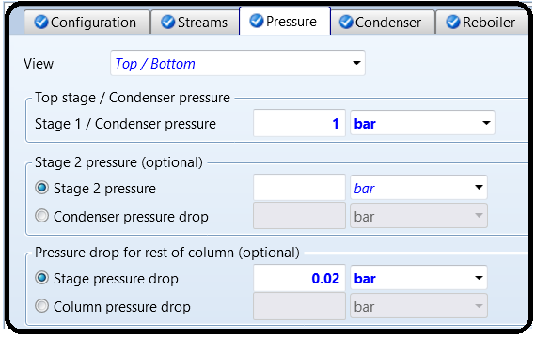

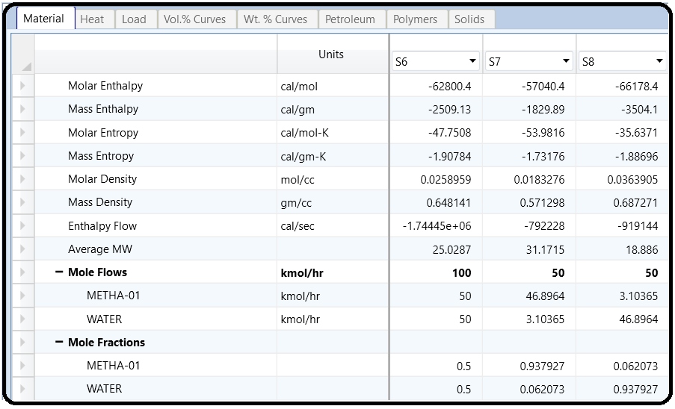

In your RadFrac model, go to Column Internals and add a new internals folder (mine is called INT-1). If you get a message about the simulation missing hydraulic data, click Generate. If you click Cancel, that’s ok. You will just need to run the simulation again later. In [internals folder] | Sections, select Based on Flows from the Auto Section drop-down button, as shown in Figure 8.5. This will automatically create column sections for you by grouping stages together based on similar internal flow rates.

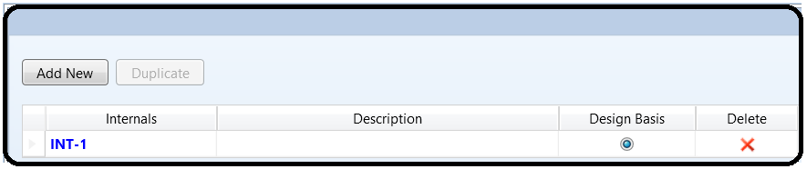

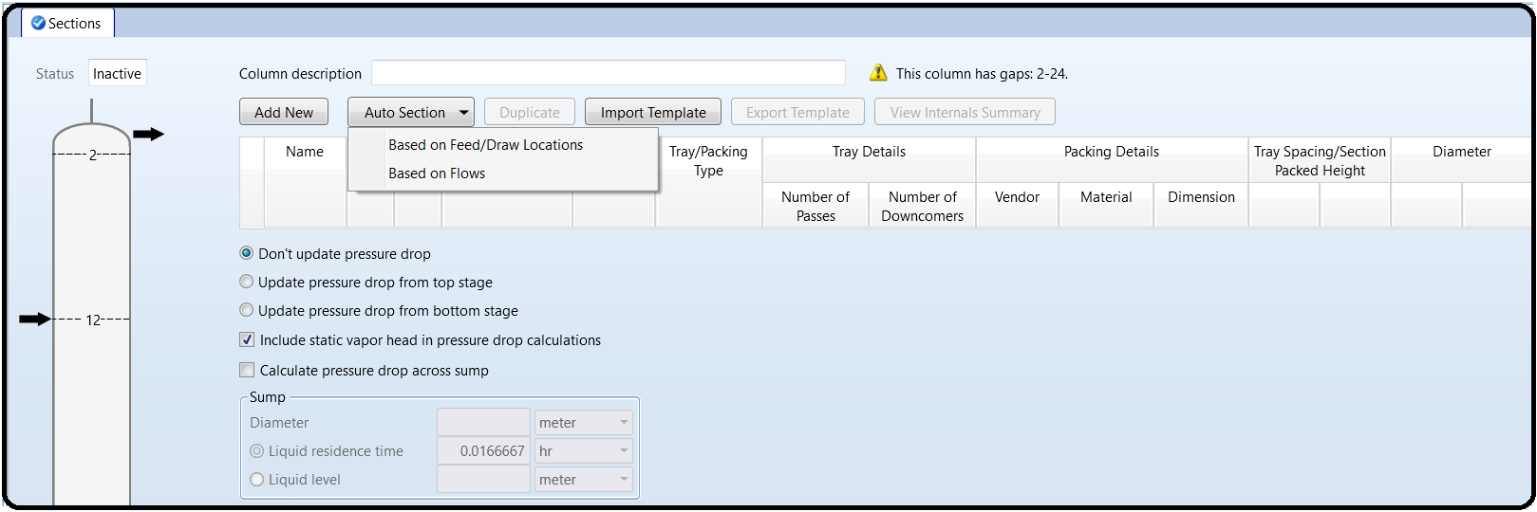

Aspen Plus divides the column into sections and automatically calculates the diameter of these different sections. Although the numbers that Aspen Plus calculates are called the “diameter,” it is really a *minimum* diameter that is required to ensure that flooding is avoided within a certain safety factor. Check that the tray spacing of the column sections is 2 ft. (0.6096 m). The only other common standard option used in industry is 1.5 ft. (0.4572 m), but often the 1.5 ft. option is too close together and may cause flooding. Anything else except those two are usually custom orders, and way more expensive than just buying off-the-shelf tray stacks with 2 ft. spacing. If you had clicked Generate in response to the warning message when adding the column internals, then you should see somenumbers in the Diameter column of the Column Internals table, indicating what the minimum diameter should be. If you had clicked Cancel, run the simulation again and the numbers should be generated and appear on this form. You are welcome to play with other criteria such as grouping by where feed and side draws are located, or defining your own

sections. We can do more advanced stuff for our column design. For example, in Sections | CS-1 | Design Parameters there are several changes we can make to the Sizing criterion, Hydraulic plots/Limits, Design factors, and Calculation methods. The two key items are the % Jet flood for design and the Jet flood calculation method, as shown in Figure 8.6. The Fair72 method is the most commonly used way of computing the flooding velocity. Basically, it is an equation that takes as input the tray diameter, the tray spacing, the liquid and vapor compositions, the liquid and vapor surface tensions, and the liquid and vapor flow rates, and computes what the flow rate of the liquid has to be for the tray to start flooding. So above this flow rate, the tray will flood (and fail), but below it, the tray will function. Bigger diameters mean the flooding velocity will also be bigger (i.e., they can handle a higher capacity because it takes more flow to flood the tray). So what we are asking Aspen Plus to do is to solve this equation backward to predict the diameter at which flooding will occur, and return a value for each column section. You would then want to make sure your actual diameter is bigger than this.

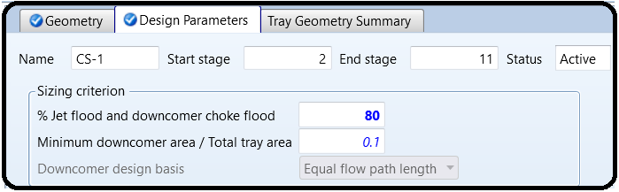

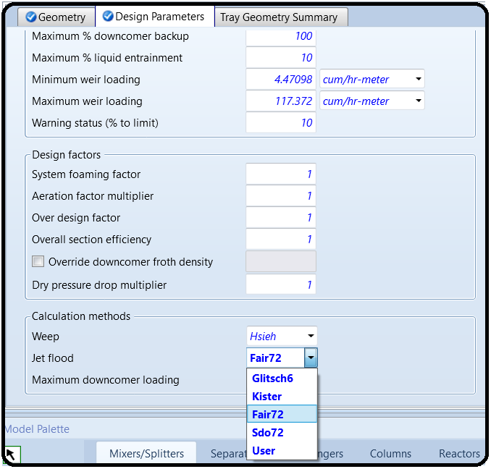

Well actually, the “80% Jet flood for design” is a slop factor. We don’t want to pick the diameter to be such that we are right at the flooding velocity, but rather, we want to have a safety factor (we want to always be lower than 80% of the flooding velocity). So what Aspen Plus is going to do is find the diameter of my column which will have the liquid flow rates to be 20% lower than what would actually flood (as predicted by the model). We can make changes to this but the

default 80% is a reasonable value to use. Select the Fair72 method as the jet flood calculation method in all your column sections, as shown in Figure 8.6. Reinitialize and rerun the simulation.

In North America, trays and columns are often sold in standard diameters in 6 in. increments. Usually, the benefits of custom-sizing a diameter to a very particular size do not outweigh the high costs of custom manufacturing. So, usually diameters are rounded up to the nearest half foot. My results from Q2 and Q3 show that both flooding calculation methods agree: I should actually use a rounded-up column diameter of 2.5 ft.

Also, you may have noticed from your calculations that Aspen Plus computes different diameters for different column sections. This is because the flow profiles in different sections of the column can be quite different in different sections. However, in your case, although the minimum diameters are different, when you round up to the nearest 6 in. diameter, both sections should have the same diameter in the final design.

This is a common result, but it is not always the case. For example, consider a column that separates A (which is lighter and more volatile) from B (which is heavier and less volatile), but the feed stream contains, say 10 mol% A and 90 mol% B. This imbalance means that the tray liquid flow rates below the feed would be much larger than above it, since so much more B would be present in the bottom half of the column. In these cases, it may be worth it to design a dual-diameter column. If you would like, see what happens if your feed was 10% methanol and 90% water. In my case, I required a 1 ft. diameter for the section above the feed and a 1.5 ft.

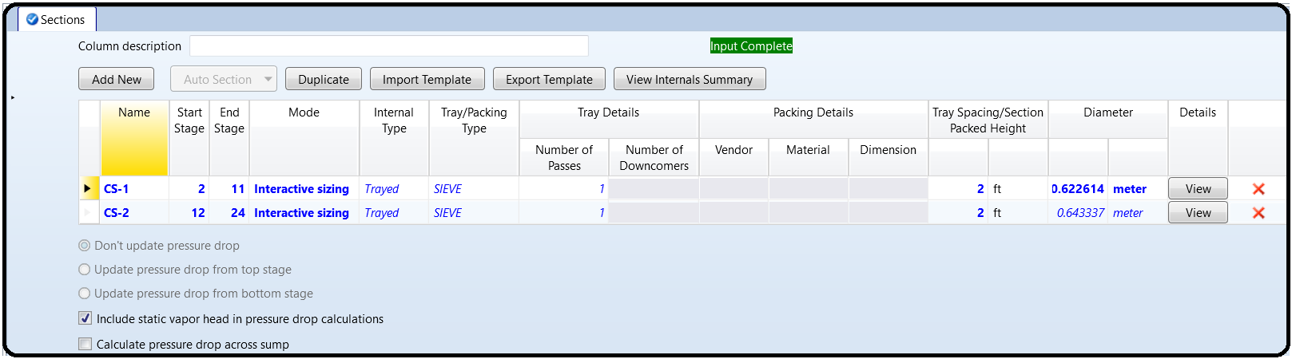diameter below it. So the distillation column would look similar to Figure 8.7, as is nicely illustrated on the column internals form. Even so, it can sometimes be more cost-effective and easier to maintain if both sections have the same diameter, especially for high-pressure applications where minimizing joints and welds can be important. If this is the case, you might be able to just make the whole column 1.5 ft. in diameter.

Now in order to answer the question of what tray spacing to use, rerun your simulation using a tray spacing of 1.5 ft. (0.4572 m) instead of 2 ft. (the only other option). In my case, my minimum diameter increased. So I could choose now between a shorter but wider column, or a taller but thinner column (both having the same number of trays). That tradeoff would be very case dependent. If your minimum diameter (when rounded up) stays the same, you should go with the smaller tray spacing in most cases.

Now that you have a working equilibrium-based model, we can go one step further in accuracy by doing rate-based simulations. This is a mass-transfer-based, kinetically-driven, complex model that does not assume phase equilibria. This is more accurate because sometimes trays don’t have enough residence time to sufficiently approach phase equilibria. However, in order to use rate-based calculations, the model requires more detailed information about the trays themselves.

First, switch your calculation type over to rate-based, as shown in Figure 8.8. This will remove the assumption of chemical equilibrium, and instead use rate-based mass-transfer kinetics, which is

complicated, but kept under the hood. Next, go back to Column Internals | [internals folder], and in the Mode column of the Sections window, change all your column sections from Interactive sizing to Rating. This means that instead of asking Aspen Plus to determine a minimum tray diameter based on the equilibrium assumption, the problem is reversed: you are now telling it to compute what the results will be for a given tray diameter that you specified, based on the mass transfer kinetics. Don’t forget to change the tray spacing back to 2 ft. Next, go to the RadFrac Blockname | Rate-Based Modeling | Rate-based Setup | Sections tab and activate Rate-based

calculation for all your column sections.

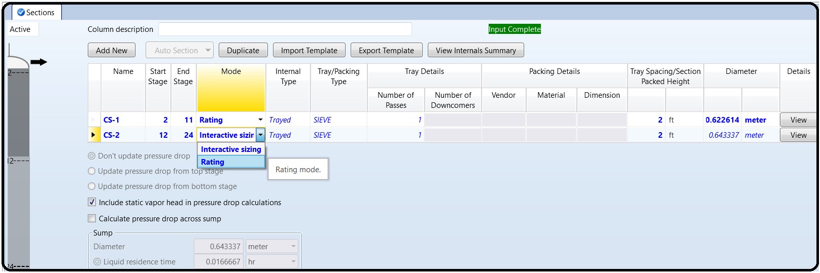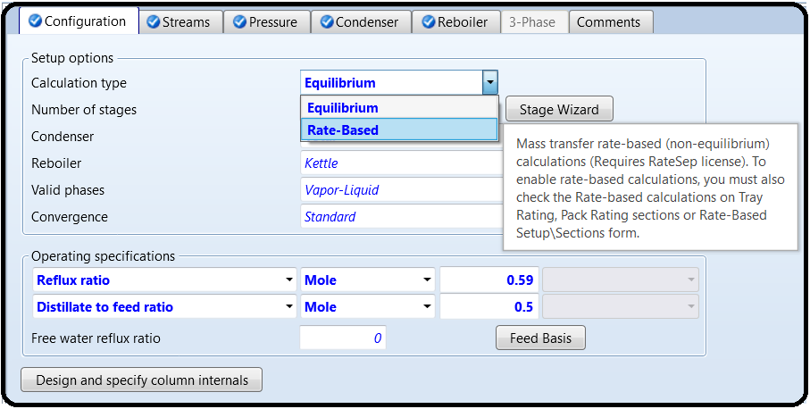

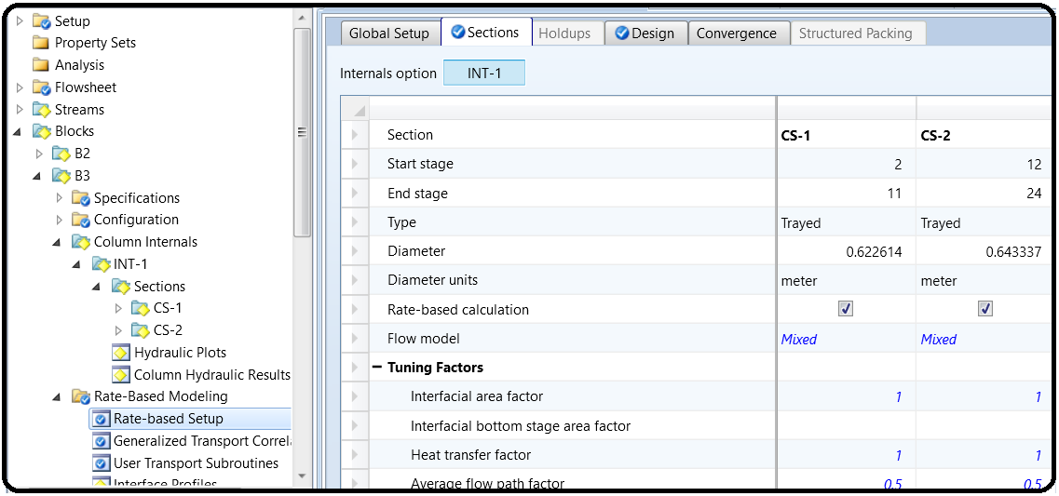

Now if you go to the column section folders of your column and look at the geometry form, you will notice that you have a lot of column section design options including Section type (Trayed or

Packed), tray type, tray dimensions, etc. You can get very specific such as to the diameter of the holes and the number of holes on the tray, as shown in Figure 8.9. You can also modify details about the weir and downcomer dimensions, as shown in Figure 8.10. Just use the default values for this tutorial, but it is useful to know that you can change this for future applications.

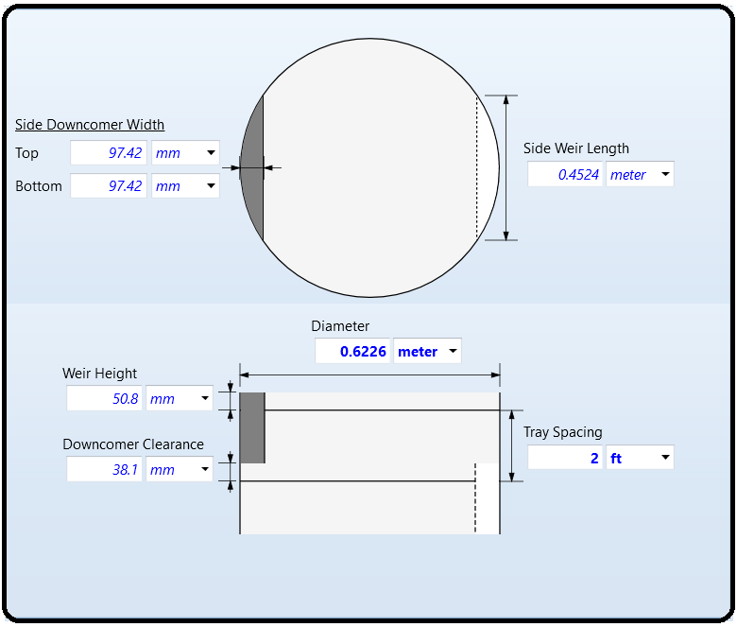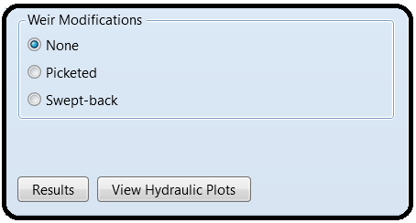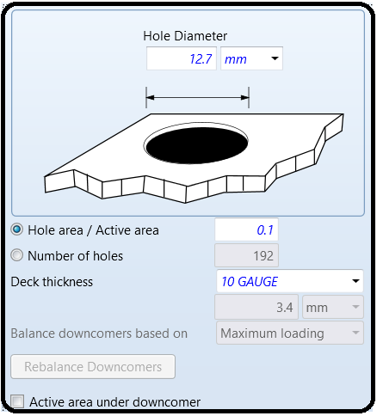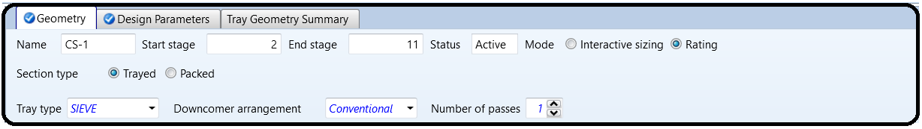

Let’s leave everything as they are. Don’t mess with anything unless you know what you are doing. Now run the simulation! Did it work? If not, check the Tom’s Tips for ideas to try to get it to work. Once it works, you get all sorts of useful results. For example, look in RadFrac Blockname | Column Internals | [internals folder] | Column Hydraulic Results and you can see, for example, the actual pressure drop for each section. So our 0.02 bar estimate was not that bad (conservative really), whereas it is mostly about 0.005 bar on every stage. If it doesn’t converge, check the control panel tosee what happened. One common problem is that RadFrac needed more iterations because the default of 25 is often not enough. There are two places to change these. The first is in the Blockname | Convergence | Convergence as we learned in previous tutorials. However, this only affects certain parts of the solution procedure. If this is the problem, you will 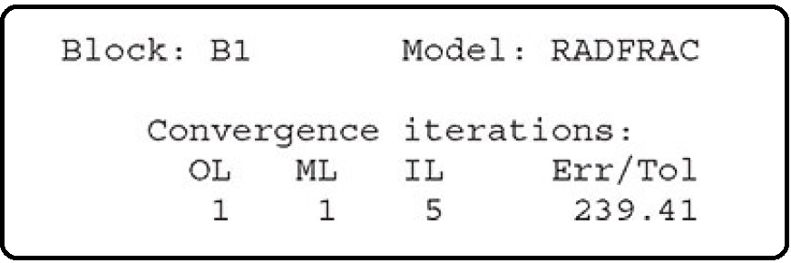see the problem crop up in this section of the control panel output:

There is a second set of algorithms that is specific to rate-based mode. If it runs out of iterations in that step, the “Convergence Iterations” would actually converge first, and then you would see

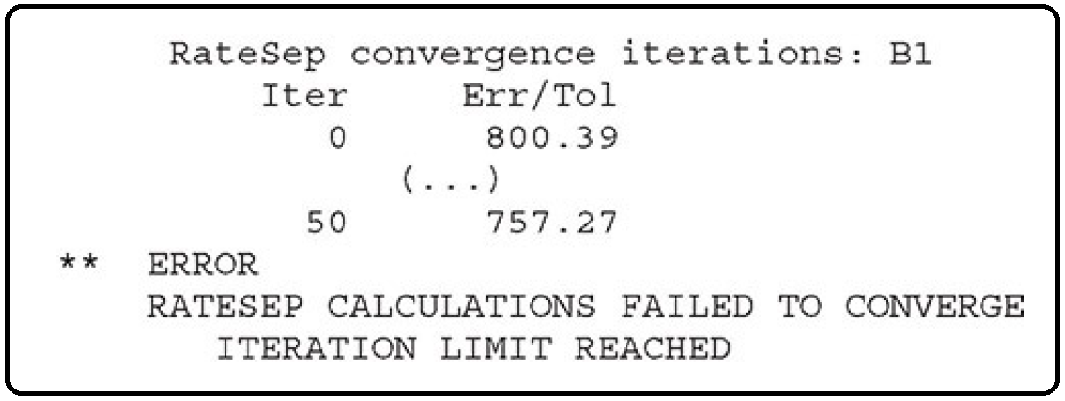something like:

Note that RATESEP is the old name for this model—you’ll see the legacy name pop up from time to time. In this case, you can try increasing your rate-based convergence iterations in Blockname | Rate-Based Modeling | Rate Based Setup | Convergence, as shown in Figure 8.11.

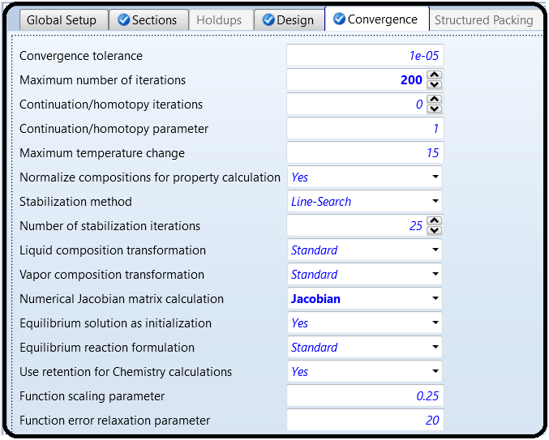

Since the model has so many equations, you may find a need to increase your maximum convergence iterations or turn on numerical Jacobians in order to achieve convergence. Jacobians are essentially a way of computing how the model equations change with regard to the model variables at the current solution guess, which the solver uses to generate new and better guesses for each iteration. Calculating them numerically (instead of analytically, which is the default) can be useful when the equations are not behaving “nicely.” But that was probably more than you needed to know.

Reference

1.Our team experience

2. Learn Aspen Plus in 24 hr. by Thomas A. Adams II