Part 2

Binary Mixture in Aspen Plus



Objectives:

1.Learn to use different pressure change elements such as pumps, valves, pipe segments.

2.Become familiar with pages and Tabs of each element and how to fill in the required inputs.

3.Get to know the critical conditions and its causes for each pressure change elements.

4.Learn to use Sensitivity in Aspen Plus

5.Learn to use Design Specs in Aspen Plus

6.Understand pressure level heuristics for compressors and turbines

7.Understand the difference between heat, material, and work streams

PART 1: PHYSICAL PROPERTY BASICS

In this section we will experiment with different physical property models and use some of the special property tools which are included with Aspen Plus. We will use the tools to help us synthesize certain separation flowsheets. Let’s synthesize a process which will separate a stream containing 70 mol% methanol and 30 mol% chloroform into highpurity methanol and high-purity chloroform. At this point, we know nothing else, so let’s use Aspen Properties to get some useful information about these two chemicals and their VLE. Make a new, blank simulation. For convenience, use the METCBAR units set (either check in the Properties | Setup | Specification form, click the Unit Sets icon in the Home ribbon to go there, or just select from the drop-down box right above the Unit Sets icon). Under the Properties | Components form, add methanol and CHCL3 (chloroform) to the components list.5 Now, we are going to use the Non-Random-Two-Liquid model with the Redlich-Kwong equation of state (NRTLRK). This is one of the most popular models and is often a great choice when dealing with phase equilibria for mixtures, especially with azeotropes.6 In Methods | Specifications, if you look in the base

method, only NRTL exists (which is different from NRTL-RK; NRTL assumes ideal gas). This is because, by default, Aspen Plus filters out the property models to be only the common ones (see the process type drop-down). Thus, change the process type to All to be able to see all possible selections, and then go back to the base method box and select NRTL-RK. Now what happens next is a little irritating, but incredibly important to understand. If you look in the Methods | Parameters | Binary Interaction | NRTL-1 folder of the data browser, you’ll see that the red half-circle has appeared in the Binary Interactions folder, as shown in Figure 2.1.

What has happened is that we now need to add the binary interaction parameters between methanol and chloroform. The NRTL part of the NRTL-RK model is an activity coefficient–based model, which is used to predict liquid-phase activity coefficients as a function of temperature and composition. I am sure you remember activity coefficients? They form the basis for writing *fugacity* *balances*. Yeah, I just went there.7 At VLE, the fugacity of each component *i* in the liquid phase equals the fugacity of each component *i* in the vapor phase.

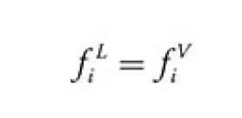

So, let’s say I have a mixture of water and ethanol at VLE. The fugacity of water in both the liquid and vapor phase might be 6.5 bar, and the fugacity of ethanol in both the liquid and vapor phase might be 2.5 bar. I made up those numbers, but you get the idea. An activity coefficient model like NRTL lets you compute *liquid*phase fugacities like this:

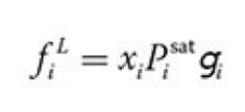



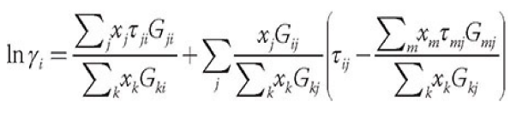where is the liquid mole fraction, is the saturation pressure (a.k.a. vapor pressure), and is the activity coefficient of *i*. The vapor pressure is a known function of temperature (e.g., you could use Antoine’s equation). The activity coefficients are also a function of temperature and composition. The model that NRTL uses in particular to compute this is as follows:

Where:

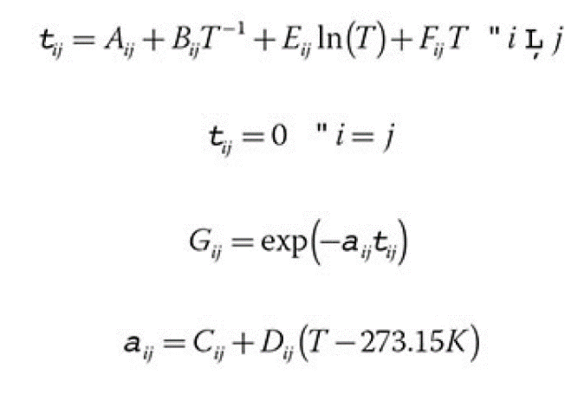



 Ok, that’s a lot to handle. For now, just worry about this: the terms through are *constants* that are determined by regression of experimental data. They are the same for each pair of chemicals at any temperature, pressure, or composition. They are just fixed numbers and Aspen Properties has a nice database containing thousands of these constants for many different pairings of chemicals. To load them, click on the red half-circle in the Binary Interaction Folder in the subheading NRTL-1. If the data exist, then they will automatically load from the databank. On the right-hand side, you should see the numbers fill in. Note, however, that we have no idea how good these actually are, but it’s a start. So in the end, it’s a lot of number crunching, but as long as I know the liquid mole fractions and the temperature, I can compute the activity coefficients (well, we let Aspen Properties do it). Ok, so what does the RK part of NRTL-RK mean? That is the equation of state (Redlich-Kwong) used to describe the properties of the *vapor* phase. It is also used to compute the vapor-phase fugacity, like this:

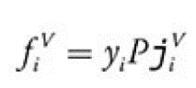



Where is the mole fraction in the vapor phase, is the pressure, and is the fugacity coefficient of the vapor phase. I won’t get into the equations for it now, but the RK method is used to predict as a function of composition and temperature.

Note that if you had just chosen NRTL instead of NRTL-RK, Aspen would use the ideal gas law instead of the Redlich-Kwong equation. In that case, . However, since the computer is doing all the work for us, it’s just as easy to use a more rigorous model instead of the ideal gas law, so you might as well (assuming it is accurate).

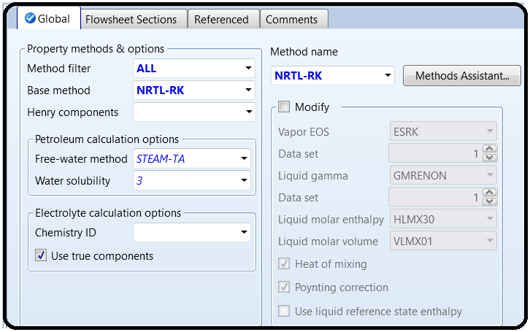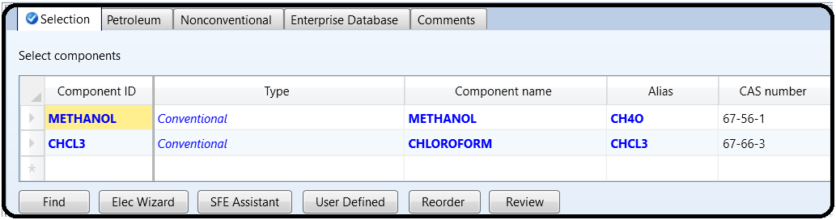

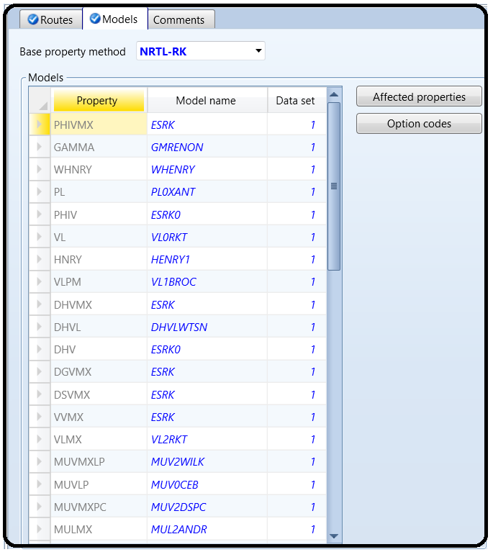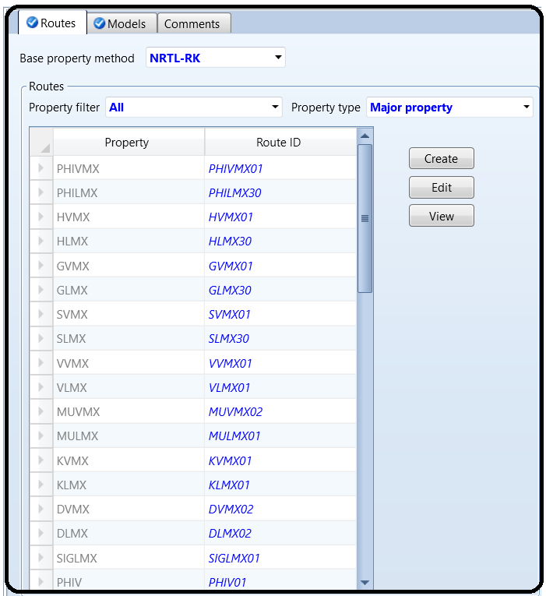

PART 2: RETRIEVING PHYSICAL PROPERTY DATA

Aspen has a lot of physical property data that aren’t shown on this form. You can get to it by pressing Retrieve Parameters (see Figure 2.2) and then hitting OK on the next form (you do not need to copy or overwrite any data right now, so leave those boxes unchecked). Then head down to the Methods | Parameters | Results tab to see all of the different physical properties or property parameters that are in the database. They are all stored in a sort of coded form. For example, in the Pure Components section, you can find PC, which is critical pressure. In order to figure out what they mean, try searching for them in the help file (F1). These are usually legacy variables from very early versions of the program, which is why they are usually allcaps

and have six characters or less.

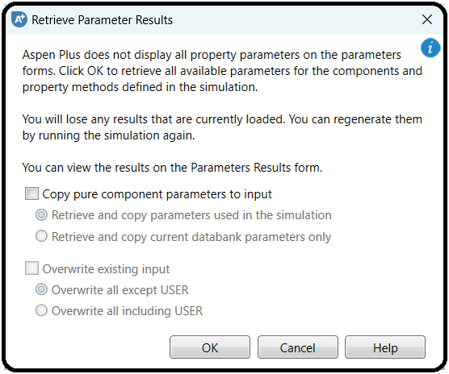

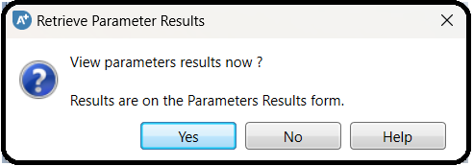

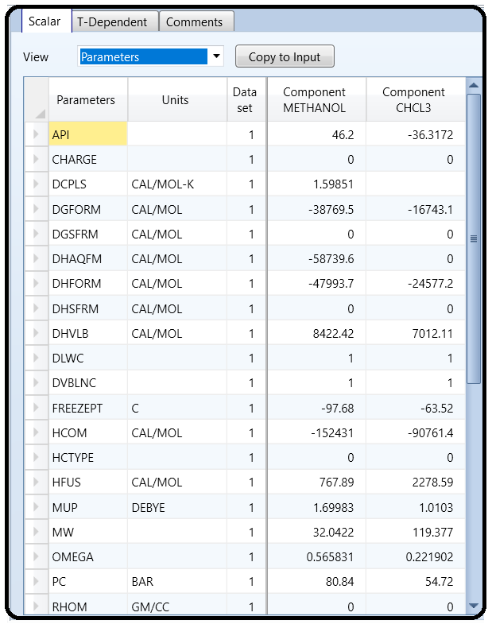

Look in the T-dependent tab of this form to find out what the equation used for the vapor pressure is (PLXANT-1). Elements c1 through c7 are the coefficients through in Antoine’s equation: where is in K.

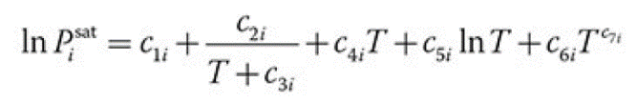

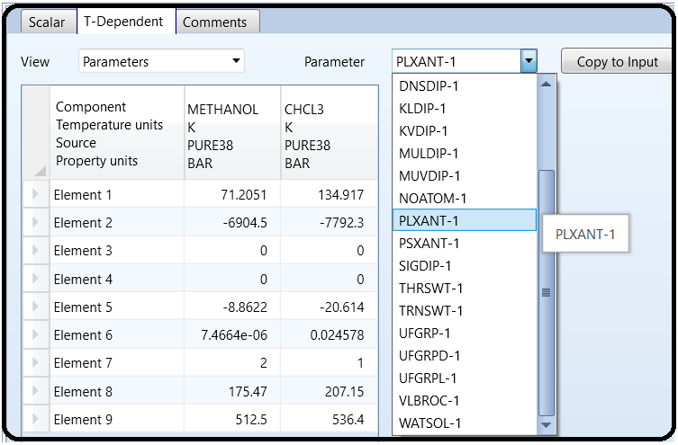

PART 3: CREATING A VLE DIAGRAM

One of the first stages of answering “how do we separate these chemicals?” is to look at the VLE. This will tell you a lot about how difficult it will be to use distillation. Let’s first use Aspen Properties to do this.

Aspen Properties has a collection of tools that lets you use the physical property models to make physical property estimations without having to create a flowsheet. Go to the Analysis section of the menu and then select Binary. This will bring up a little dialog where you can perform equilibria calculations. To understand the VLE, it is usually most convenient to consider a T-xy diagram. Set the analysis type to Txy. You then choose the two components you want to compare (your only two chemicals should already be selected by default). You can also select the range of mole/mass fractions of the primary component that you want to look at. Usually, you can just leave it at 0 (0% species A, and 100% species B) and 1 (100% species A, and 0% species B). However, sometimes you need to focus on just a particular range, so you can change that here. For example, you may need a higher resolution in a particular range, or the temperatures/pressures at certain compositions are extremely high or low such as for normal gases, or for the separation of chemicals in which some are not very volatile.9

You can choose the level of resolution for the analysis within the range you specify. The default is 50 intervals, which since you chose a range between 0% and 100% is every

What the binary analysis will do is run a loop, using liquid-phase mole fractions starting from the low end of your range (0% methanol in the liquid phase, by default) to the high end (100% methanol in the liquid phase, by default) in steps of 2 mol%. For each iteration of that loop, it will run a flash calculation at that concentration and at the given pressure (1.01325 bar by

default). The flash calculation will determine what temperature and vapor mole fractions will result in a VLE such that the liquid mole fractions are equal to the mole fractions of that iteration. For example, suppose the current iteration is to run the flash calculation

at a liquid mole fraction of 5% methanol and 1.01325 bar. The analysis would determine that the equilibrium temperature under these conditions is about 330 K (about 57°C) and that the vapor

phase is about 16 mol% methanol. This is important to understand, because if you set your range such that it will perform flash calculations for liquid mole fractions that are not realistic or do not exist in practice, you may get errors or garbage results. Change the interval of your analysis to 100 so that we get one data point at every 1 mol%. In the upper right of the form, we can pick the phases we are looking at. Leave it at vapor-liquid-liquid for now, but note that you

can also choose other variants if you know for sure that you want to consider them.10 The screen capture in Figure 2.3 demonstrates this. In the pressure box we perform the T-xy analysis at a certain pressure. We can also choose multiple pressures. Let’s use 1.01325

bar, 5 bar, and 10 bar. This goes in the little list of values. (Just type them into empty cells to the right of 1.01325 bar. It is ugly, but it is what it is.)

Finally, we could change our property method here, but let’s leave it at the default of NRTL-RK. Changing it is useful if you have a collection of candidate property models that you are investigating and want to see how each of them performs (see Bonus Tutorial 4 for more about this), without changing your default property model for the flowsheet. Hit the Run Analysis button. What you should get are three different T-xy diagrams on the same plot, one for each of the pressure ranges, as shown in Figure 2.4.

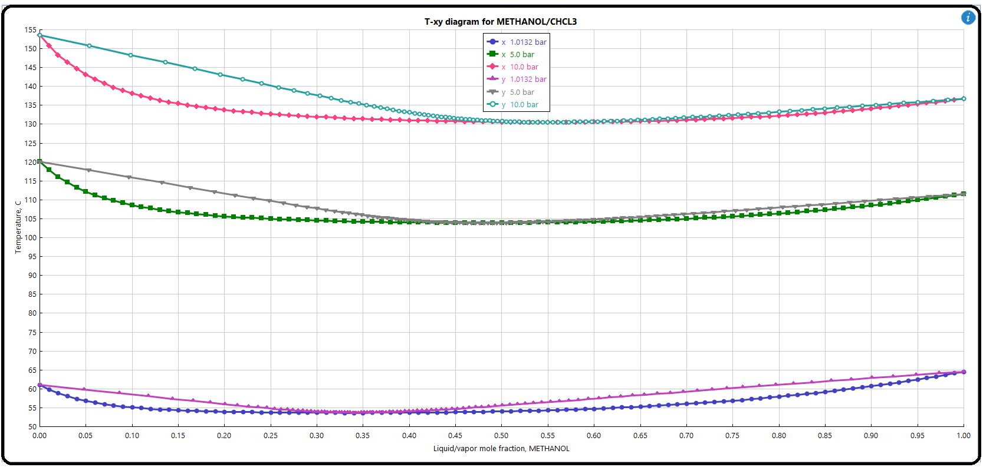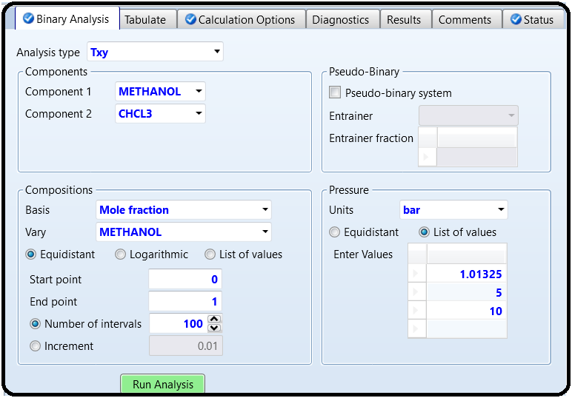

This tells us a lot! For each of the T-xy curves, the top line is the dew point and the bottom line is the bubble point. This also means that at 0% methanol (100% chloroform) on the left side, they come together at the boiling point of chloroform. On the right side, the two lines come together at the boiling point of methanol. Note how it changes with pressure. When the saturated vapor and liquid curves are close together, you need more stages for distillation. When they meet at a place other than the left or right side of the diagram, that’s called an

azeotrope, or commonly a “pinch point.” But we’re serious professionals here, so we’ll use the term “azeotrope.” This forms two separate phase envelopes on either side of the azeotrope. A

distillation column can only operate within one phase envelope at a time. That means we cannot make a single distillation column that produces both high-purity methanol and high-purity chloroform. We can have only one high-purity product with the other near the

azeotrope (so we operate on either one side of the azeotrope or the other). Notice also how everything changes with pressure (see Figure 2.4). As pressure increases, the overall temperature gets higher and the azeotrope shifts toward higher methanol

concentrations. In addition, all of this data appears in table form. Just expand the BINRY-1 folder, go to the item called Input, and go to the Results tab. It’s the same data; you could copy-paste it into a spreadsheet program like Microsoft Excel and make your own plot if you wanted

and it would look the same. The table has extra data though such as the *K*-values and activity coefficients (called gamma) which are calculated from the NRTL-RK method. Use the table to answer these questions.

So there are some key separation points we can take away from this analysis. If we do distillation at any pressure, we will have the azeotrope to deal with and can operate on only one side of the azeotrope or another in a single column. The azeotrope moves “to the right” with increasing pressure and moves significantly. For the 10-bar case, the “left side” of the azeotrope has the fattest phase envelope between the vapor and liquid lines. For the 1-bar case, the “right side” of the azeotrope has the fattest phase envelope compared to the other pressures.

The highest temperatures, even at 10 bar, are still low enough to use steam in the reboiler if we use distillation. That’s good because we don’t want to build a furnace if we don’t have to.

PART 4: PRESSURE SWING DISTILLATION

You can use the VLE diagrams directly to help you design the system. Figure 2.5 takes the original VLE diagram and shows an example of how the streams could flow between the different process sections. Here, I have chosen to collect high-purity chloroform (D) at about 153–155°C in the bottoms of the 10-bar column because that part of the VLE envelope is the fattest, and therefore would require the least number of stages and/or lowest heat and cooling duties. The distillate (E), which will be near azeotropic conditions, is fed to the 1-bar column; the rightmost envelope is the fattest at that pressure (we could even think about vacuum pressures, but that brings its own challenges, so let’s keep it atmospheric). There, methanol (B) is recovered in the bottoms near its normal boiling point, and the distillate on the 1-bar column (C),

which will be close to the 1-bar azeotrope in composition, is fed back to the first process. The feed stream (A) is sent to the 1-bar column because its composition (70% methanol) falls in the working range of that column (35–100% methanol). It could still potentially work if it were fed to the 10-bar column instead, and similarly, the two columns could theoretically be swapped (methanol is recovered from the 10-bar column instead of the 1-bar column). However, this is

unlikely to be better.

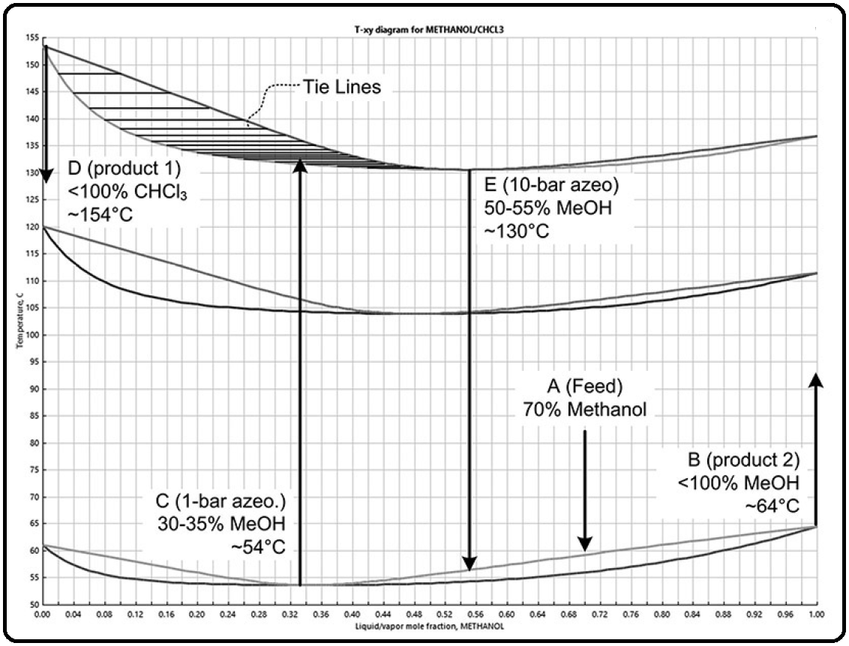

Figure 2.6 shows how you can overlay the process operations on top of that. You can tell which part of the column that a product will leave from (the distillate or the bottoms) by looking at the

temperatures. For example, the azeotropes will always leave through the distillate because the azeotrope temperature is lower than the boiling point of the pure components. For example, the temperature of the azeotrope is about 54°C at 1 bar, but the boiling point of the methanol is about 65°C. This is why it is called a “low-boiling azeotrope.”

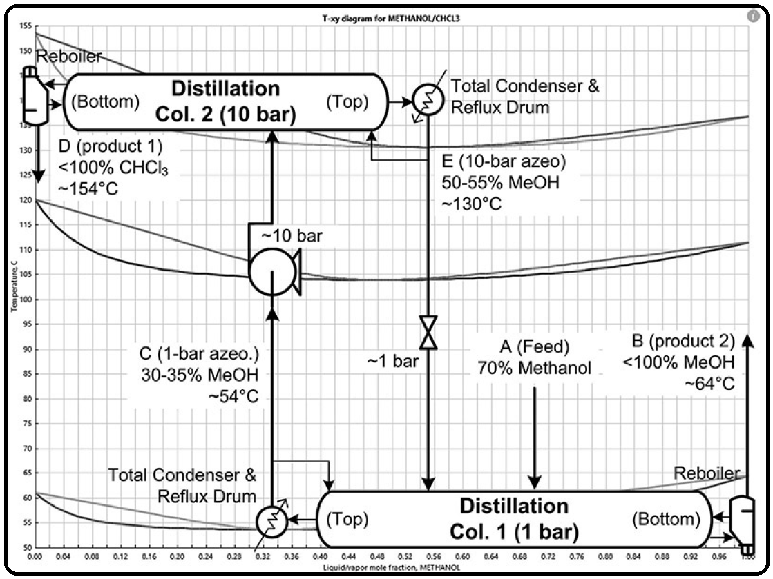

Figure 2.7 then gives the final process in a nice form. Note that pumps and valves do the job of changing pressures. In addition, there are two feeds to the first column because the azeotrope stream E can be recycled. It just increases conversion because otherwise there will be considerable waste.

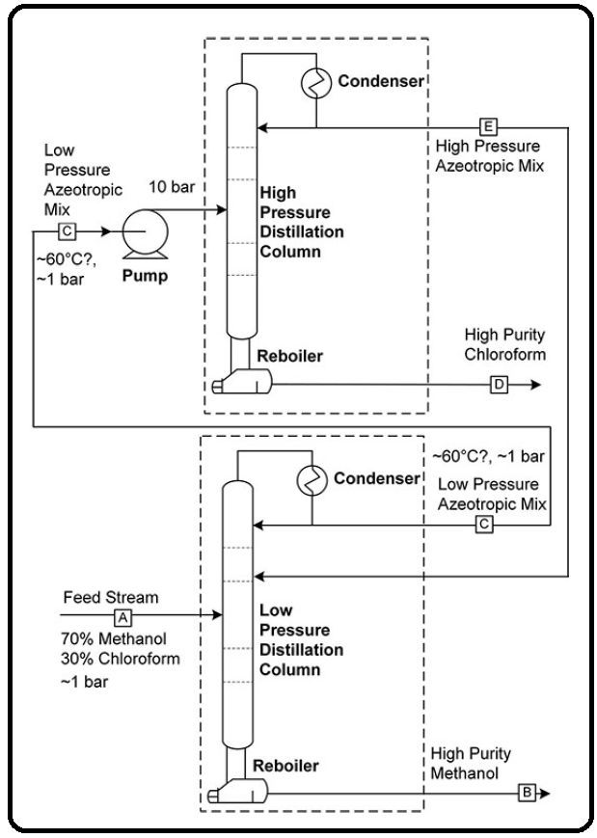

Well, look at that! The process pretty much writes itself from the VLE diagram. Note that we have a choice to feed E to the same tray as A, or feed to some higher tray. And, by looking at the graph, it shows us a great guess as to where to feed the streams (i.e., about halfway between the top and the bottom). Go to the flowsheet window and simulate the first column using a feed of stream A with the 70 mol% methanol (see beginning of tutorial) and 200 kmol/hr at 30°C and 1.01325 bar.

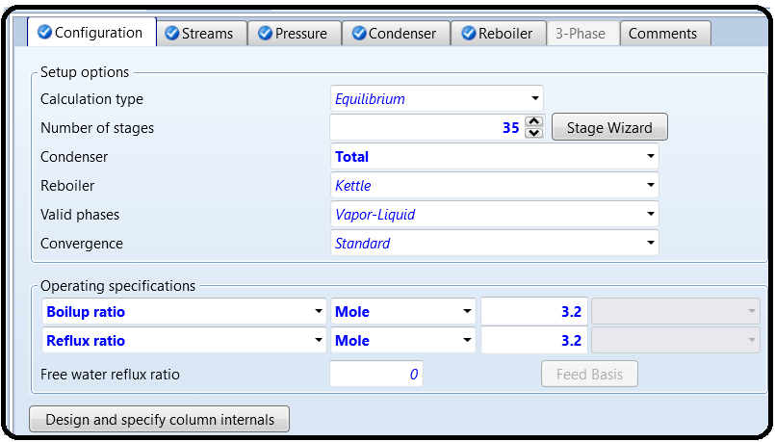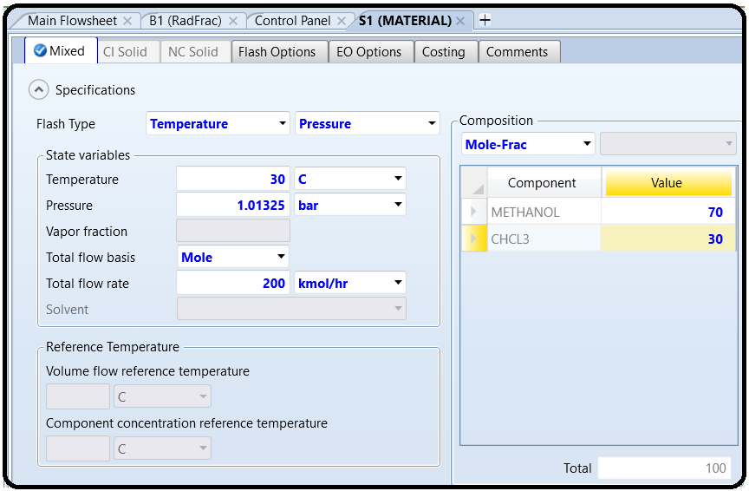

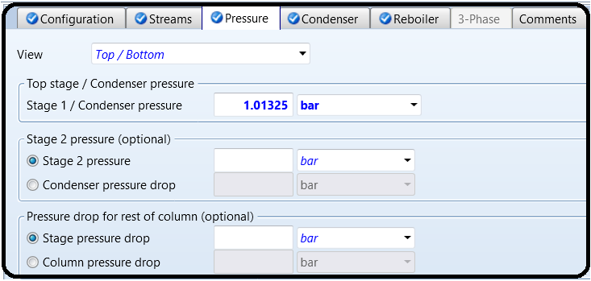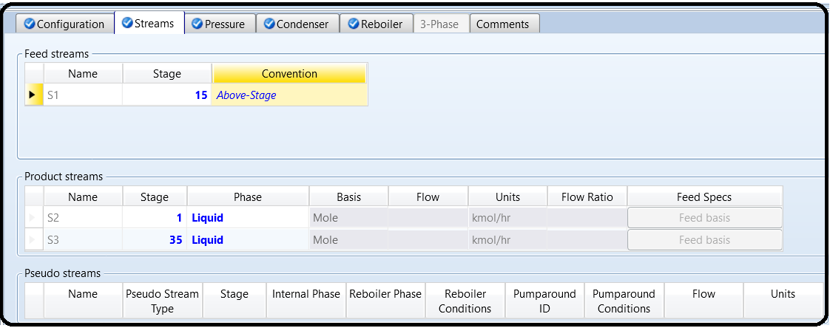

(The actual flow rate doesn’t really matter though right now.) Use RadFrac for the column with 35 stages, a total condenser, and reflux and boilup ratios of 3.2 each. Feed stream A to stage 15. Set the pressure of the top stage in the condenser to 1.01325 bar (also, the feed stream should be at the same pressure). Run the simulation. You’ll notice you get error messages, including the general red “Results Available with Errors” message, a “blocks were completed with errors” message in the Run Summary, and possibly a red X icon near the column on the flowsheet. A quick look at the control panel (Run | Control Panel or F7) gives you the details shown in Figure 2.8.

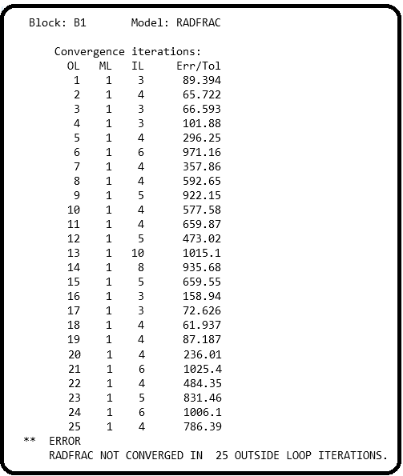

Basically, what has happened is that the simulation model did not successfully get a result. Why not? The Fortran routine which solves the RadFrac block uses an iterative guess-and-check procedure, and after 25 guesses it did not find a solution (did not converge). However, the Err/Tol number tells us how close it is to converging.

This *error* of the simulation is the norm of all model equation residuals. The residuals are the left-hand sides of the equations minus the right-hand sides of the equations. If the residual of an

equation is exactly zero, then the equation is perfectly balanced. The *tolerance* is the maximum amount of error that is allowed. So if Err/Tol is above 1, then we’re not done converging because some of the equations have too much error, so not all of the variables have been solved to our satisfaction. If Err/Tol is below 1, then we have solved the problem within tolerances. The point is that if it is heading toward 1, we are on the right track. It can be a bit of an art form to look at a sequence of Err/Tol numbers and decide whether the solver is approaching a solution, or, it is going nowhere. A good rule of thumb is that if the Err/Tol is staying below 1000, is generally decreasing (perhaps going up and down but generally is tending toward 0), and has not recently risen above 100,000, then it is probably on the right track. So, let’s tell the program to keep trying. To do this, go to Blocks | Column Name | Convergence | Convergence (or double-click on the column to get to Blocks | Column Name). Under Basic, you will see that “maximum iterations” is at 25 by default. Change it to 200 (the maximum), as shown in Figure 2.9.

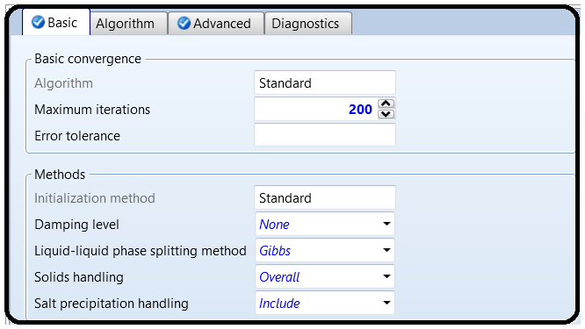

Rerun the simulation. It should converge now.

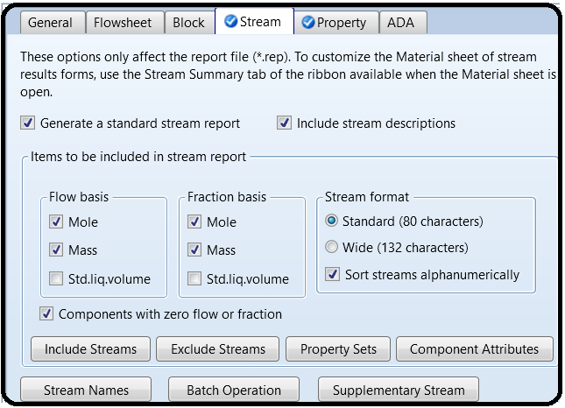Verify that the bottoms stream should be high-purity methanol, and that the distillate should be close to the azeotrope composition. If your stream results have empty spaces for mole fractions, go to Setup | Report Options | Stream, check the appropriate boxes, and then rerun the simulation.

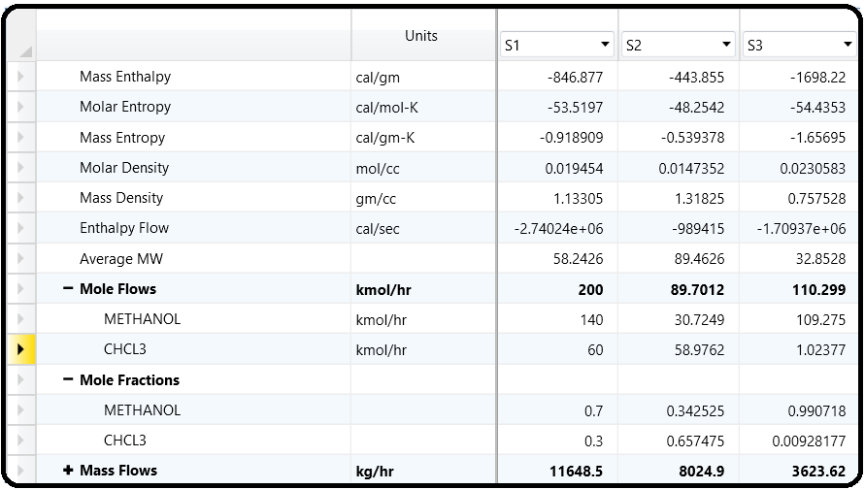

Ok, great! Let’s add the second column. Let’s also use 35 stages, with a reflux ratio of 3.2 and a boilup ratio of 7. The condenser pressure should be 10 bar (again, assume no pressure drop for the rest of the column). Let’s guess 10 for the feed stage. You’ll also

need to add the pump appropriately, because if not you will get warnings that you are trying to put a low-pressure stream into a highpressure column. Don’t recycle the distillation stream to the 1-bar column yet. *Never add the recycle stream until everything else is* *working to expectation! Remember this*. If you have problems with convergence, try getting the column to converge with 10 stages, then 20, and then 30. The program uses the previous results as guesses for the next run, so this is why you want to (a) start with something small that works and then work your way up, and (b) not add recycle until everything else is working. Alternatively, you can try changing convergence algorithm (i.e., the way in which it guesses and checks its way to the solution of the model equations for the column). The default setting is Standard, which you can see on the Configuration page for the second column. I switched it to Azeotropic and found better performance (go figure).

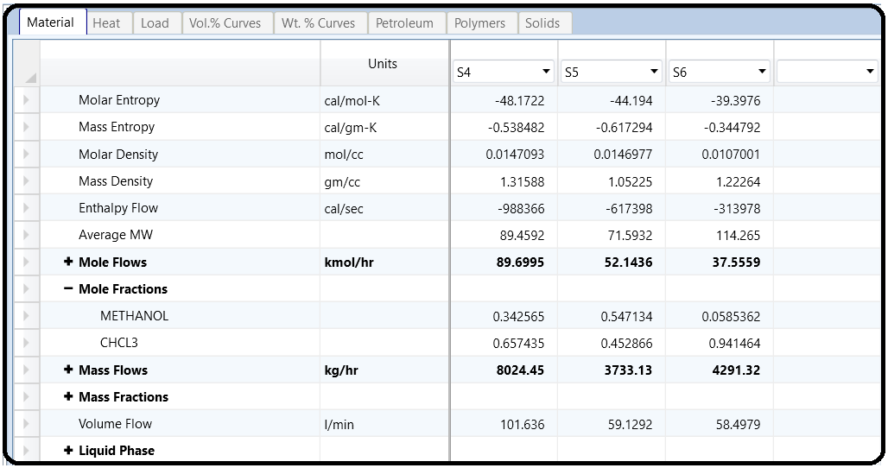

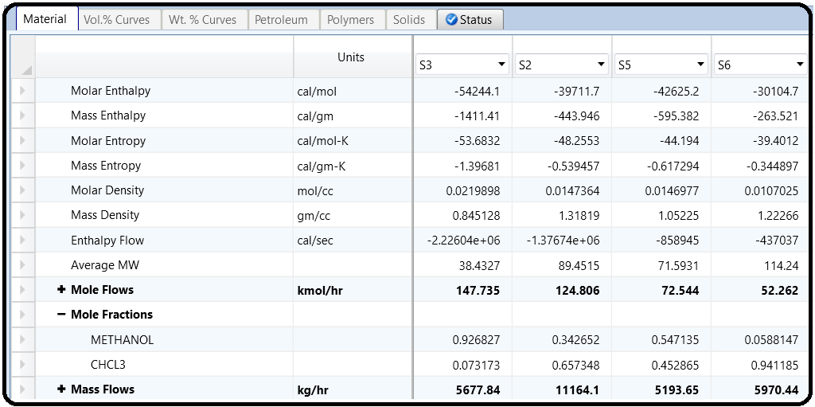Verify that the mole fraction of the azeotrope is what you expected, and then connect the recycle stream to the first column (try stage 811); do not mix it with the main feed! Using a valve to reduce the pressure is optional. As long as the pressure of the stream going into the column is higher than on the stage to which it is fed, the model assumes it will automatically flash to the lowerpressure anyway through the inlet nozzle. Rerun the simulation. Ok, so even though both purities are not what we wanted, we have a wonderful starting point with which to improve the system. We will not explore this, but we will learn techniques for how to do this in later tutorials. Ok, now let’s learn a few more things about this system. The physical property system lets us find out considerably more information about a stream than what is in the stream results (by the way, clicking on a stream and hitting Crtl+R is a fast shortcut). To get more properties, click on a stream, and under Home | Stream Analysis you can see many options. Do this with your chloroform product stream, and choose Bubble and Dew Point curve (Figure 2.10). Leave the options at the default, but you can see they are similar to your previous analysis. Click go and you’ll see the plot of the bubble and dew points for temperature and pressure. For example, pick a pressure, and then where the vapor line intersects that pressure is the dew point, and where the liquid line intersects that pressure is the bubble point. Similarly, at a constant temperature, you can get the 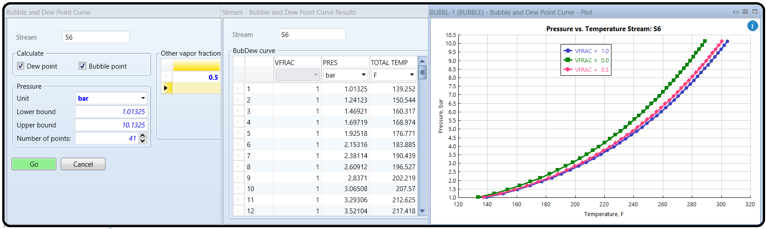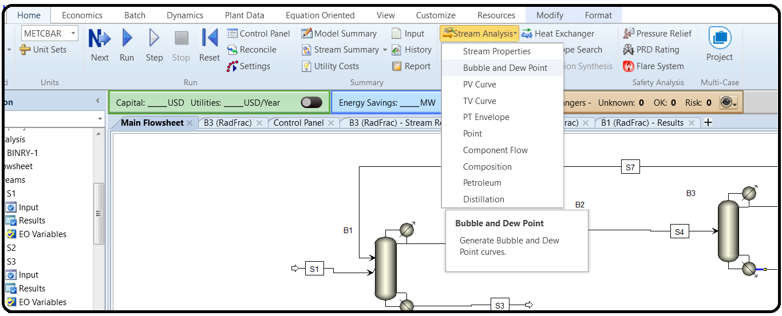dew/bubble point pressures.

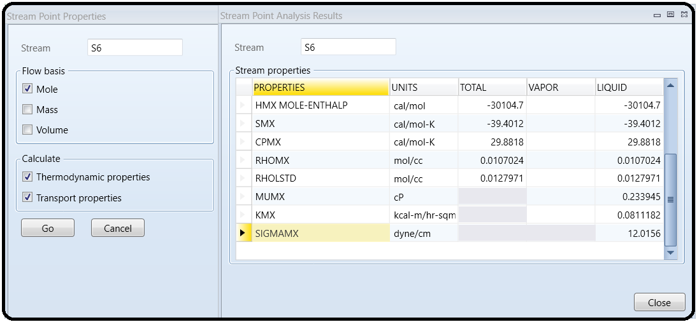 You can get additional information not in the results section, such as viscosity of the mixture (MUMX, MU is μ), thermal conductivity (KMX), or surface tension (SIGMAMX). To do this, close the previous analysis windows, select the appropriate stream, choose Home | Stream Analysis | Point, and select both thermodynamic and transport properties options.

Additionally, you can add other properties to your stream summaries (i.e., the stream results form) by customizing your stream template. This is nice because it is persistent across runs and shows up for all streams in the future. Click on <add properties> at the bottom of the stream results form for any stream. You are then presented with a search dialog where you can find properties that you want to add to your stream template. As shown in Figure 2.11, I have searched for “fugacity” and added the pure component fugacity and fugacity coefficients to my template.

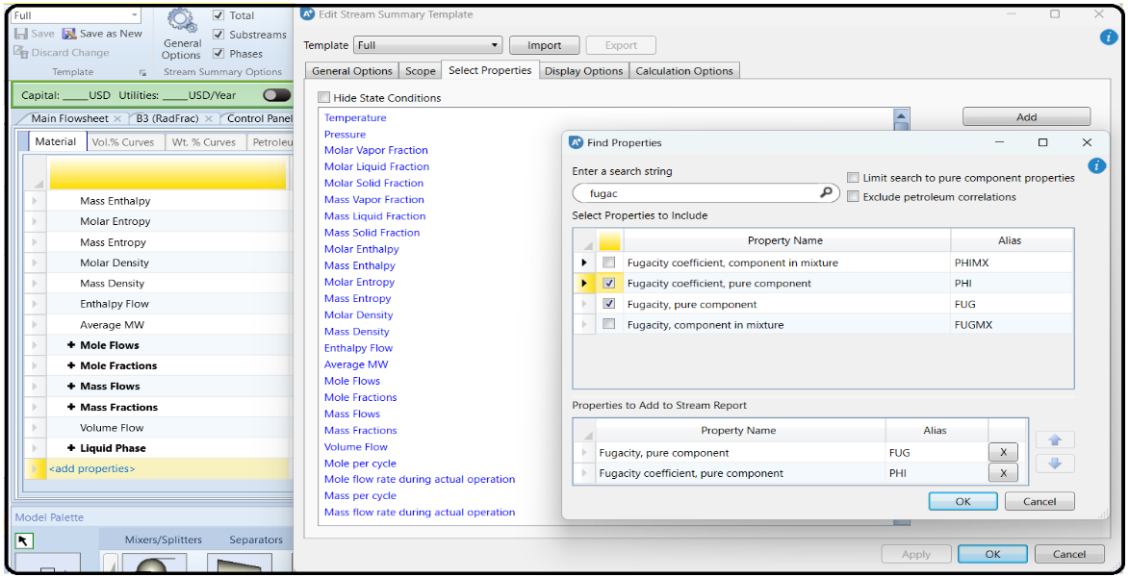

You can see that I have already added the higher heating value as well. There are a lot of properties to search from, so hopefully you will find what you need. Note that when you modify this template, and you attempt to close the software, you may be prompted as to whether you want to save this template or not. If you do, you can reuse this for other simulations you make in the future, so you don’t need to go back and add everything yourself again. You can find all sorts of physical property information on just specific individual properties such as heat capacity, density, enthalpy, and latent heats. This works at any time and does not require you to select a stream. Under Properties, go to Analysis | Pure. The Property drop-down box contains lots of options. Hover your mouse over them to see the full-text description in the status bar at the bottom. The rest of the form should be familiar.

PART 3: VALIDATING NORMAL LIQUID SYSTEMS WITH EXPERIMENTAL DATA

Once you have selected a few candidate models using the guidance from Part 1, you will have to pick one to use based on experimental data. For this tutorial, we will focus on phase equilibrium data. You can find such data in scientific research publications in journals such as *Fluid Phase Equilibria* and the *Journal of Chemical & Engineering* *Data*. Common search terms should be something like “Water + Methanol Binary VLE” or “Water + Methanol + Ethanol Ternary

Vapor-Liquid Equilibria,” or “Methanol + Ethanol + Propanol + Butanol Quaternary VLLE.” Those are often found in the titles or keywords of research papers which have this information. You can either search the journal websites directly or use indexing services like Engineering Village, Web of Science, or Google Scholar.2 If your institution does not have a subscription to the journals, you may have to pay for the article. However, before you stoop to reading the literature,3 Aspen Plus comes with three tools, the NIST database, the DECHEMA database, and the DIPPR database, accessible from the Properties | Home ribbon (see Figure B4.2). The latter two are essentially links to external search engines where you can search for the data you want and then pay for access. However, NIST is provided with the data already available to you without additional charge, so let’s use NIST!

Start up a new simulation and add water and ethanol to it. Let’s use the NIST database to find binary physical property data for these two chemicals using the self-explanatory dialogs (see Figure B4.3). Click the NIST button in the home ribbon, choose the “binary mixture” radio button, enter the two chemicals, and hit retrieve data. After a wait, you should see a pop-under window with a left-hand pane that contains a very long list of experimental data, grouped into

categories like azeotropic data, binary VLE, density, surface tension, etc. Those can be expanded to show individual sets of data collected in those categories. We are interested in Binary VLE, so go there, and specifically, we want isobaric (constant pressure) data. There are multiple pages of data sets in that example. Find an isobaric data set for 1 bar or 1 atm pressure (100,000 or 101,325 N/m2; I chose data set 091 for this example). Clicking on a data set brings up the

corresponding table of data on the right-hand side. Each data set contains experimental data from some publication, usually a peerreviewed journal article, technical report, or conference proceeding, which is shown on the bottom of the rightmost pane. Each data set has different data because each experiment is different, so in practice you have to dig around for what you are looking for. You can visualize the data quickly with the T-xy (for isobaric) or P-xy (for isothermal) plot buttons in the home ribbon.

In some cases like this one, you might be overwhelmed with options. The key is selecting experimental data sets that represent the pressure and temperature ranges that are most relevant to your own application. It is a good idea to test out a few different experimental data selections, since these too could have different erroneous aspects to them. However, experimental thermophysical data in the peer-reviewed literature (even very old data) is usually trustworthy. Just because data is old, does not mean it is wrong. Our next step is to compare this experimental data against model predictions using my three recommended starting-point models: PSRK, NRTL-RK, and PR-BM. There are a lot of ways to do this, and ultimately what we want to do is determine how well the models predict the data and select the best one. Sometimes a visual

comparison is easiest, so let’s use some outside tools to do that. Copy-paste the experimental data set into Excel or some other spreadsheet or graphing app. Then, set up your simulation to use PSRK as the property method, and use the Binary analysis tool to generate a T-xy plot (see Tutorial 2). Then, copy-paste those results into the spreadsheet as well, and plot them on top of

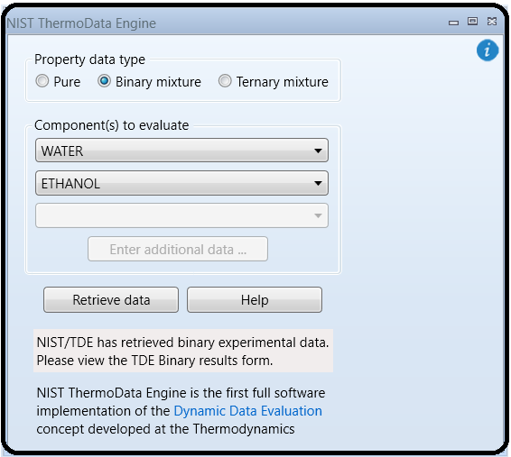

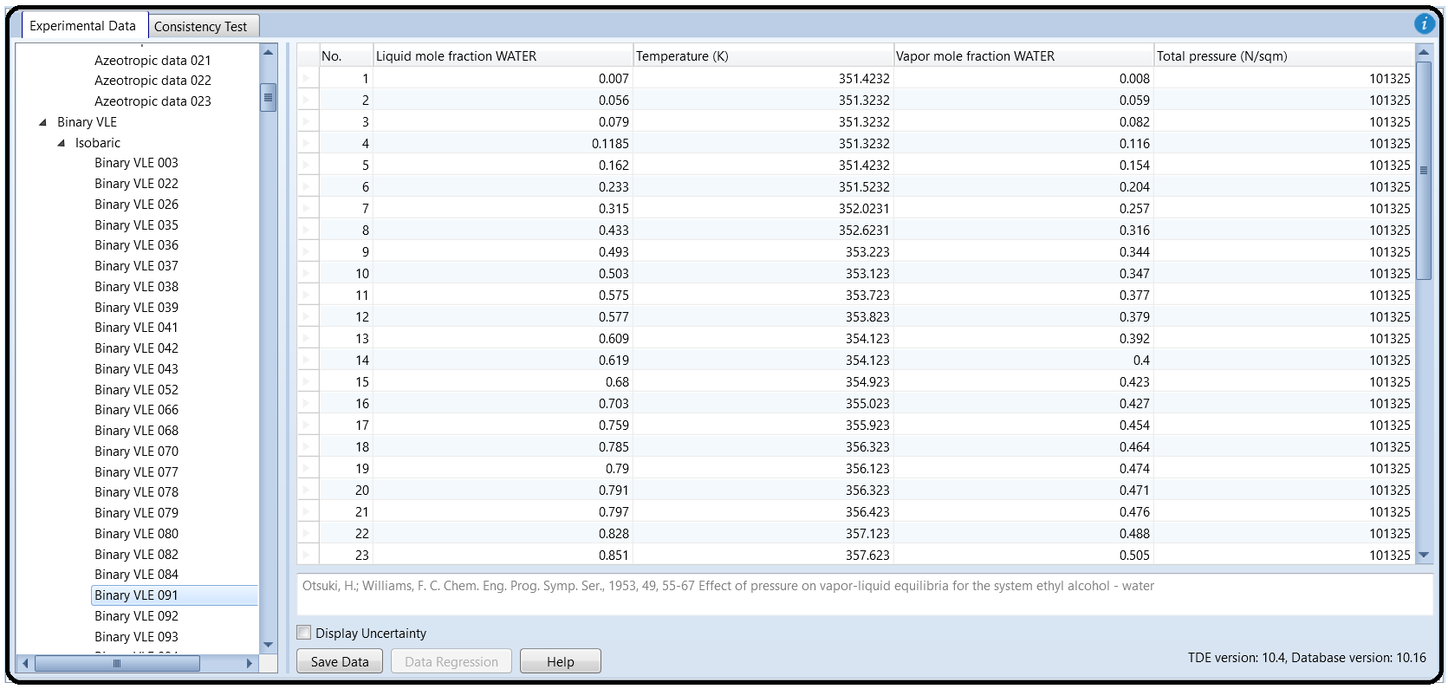

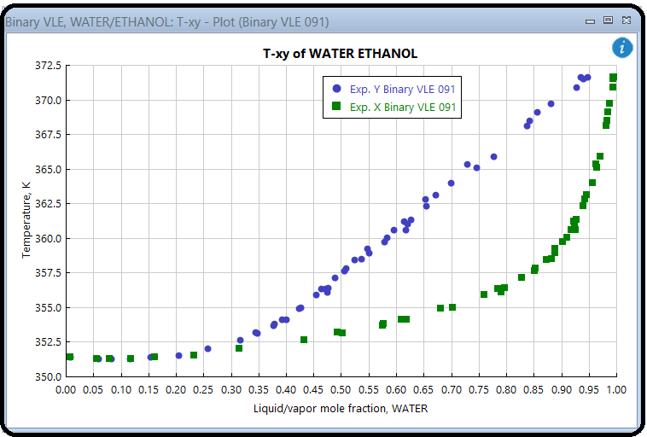

each other. Typically, one easy way to communicate this is to show the experimental data points as points with no lines (since they are discrete quantities with experimental error and noise), and the model results as lines with no points (because they are continuous and have no noise, so are valid in the in-betweens). If the lines go through the points, then you have a very good model (well, for the range of pressures and temperatures that you have tested at least). Repeat the Binary analysis for the two other property methods (PR-BM and NRTL-RK). Ideally, all you have to do is add them to the Methods section, load the binary parameters (if applicable), rerun the Binary Analysis (just change the property method in the Calculation Options tab of the Binary Analysis), and then copy-paste the results into your spreadsheet or plotting software to easily generate the new plot. I suppose it’s easier said than done but if you set the first one

up thoughtfully, it is trivial to do the rest. My results are shown in Figure B4.4. You can see immediately that PSRK and NRTL-RK are both very good, but PR-BM is quite terrible. This is important to recognize because PR-BM is so widely used, and yet how often is it checked? Between the other two options, you can see visually that NRTL-RK fits the data more closely than PSRK because the left-hand side of the azeotrope fits it better. At this point, I would say that no further analysis is needed, NRTL-RK is the clear winner here. What is going on with PR-BM? The first is that the azeotrope point is a few degrees too low, and so the VLE region to the left of it (i.e., having low water mole fraction) is quite off. To the right of the azeotrope, the large triangle shape actually indicates that the flash calculations simply did not converge, or converged at the trivial (azeotrope) solution. The Binary T-xy tool works by taking the range of liquid mole fractions you specify (by default it is 0–100 mol% of whichever is your primary liquid) and works through that range iteratively in small steps (default is every 2 mol%). For each of those points, it tries to solve a flash calculation problem in which it finds the temperature at which a mixture would flash into vapor and liquid phases, where the liquid phase has that desired composition. It doesn’t always work. When you get T-xy plot results that look like the PR-BM example, you have to decide if the model is bad, or if the T-xy plot generator is just not working (or both!). You can test that by running a simulation of a flash drum explicitly on a flowsheet and seeing if you get the same kind of garbage results or if you get valid results.

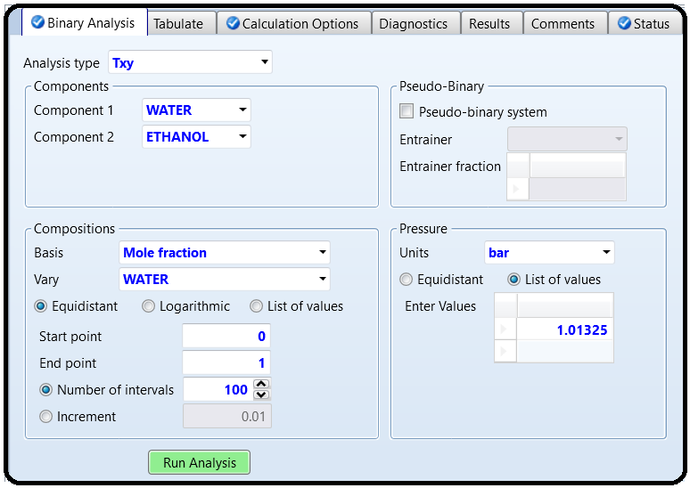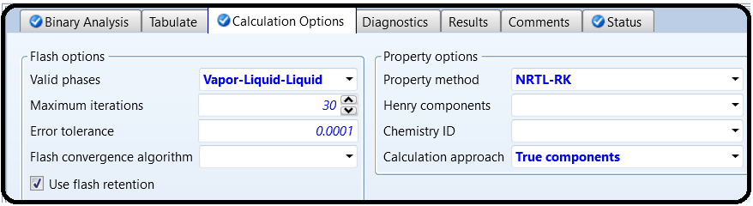

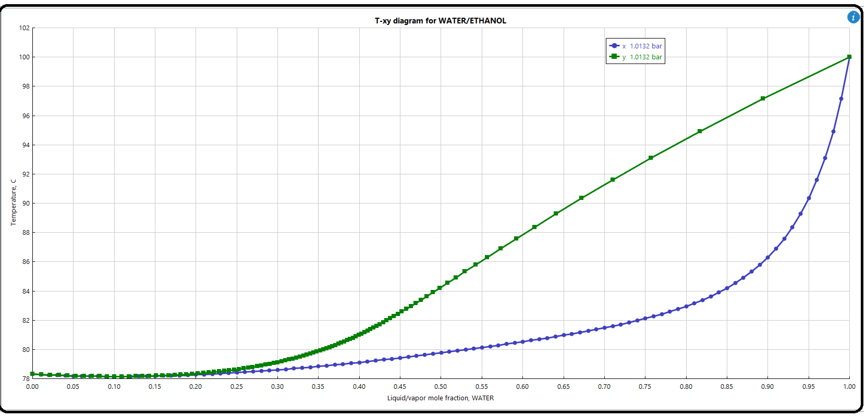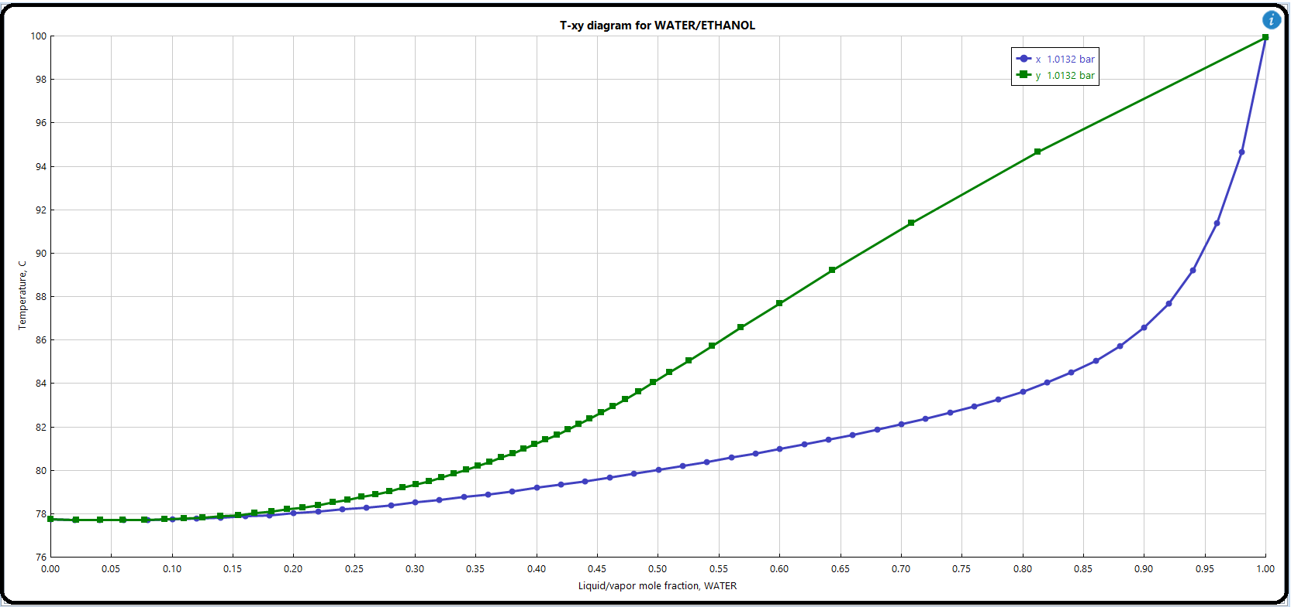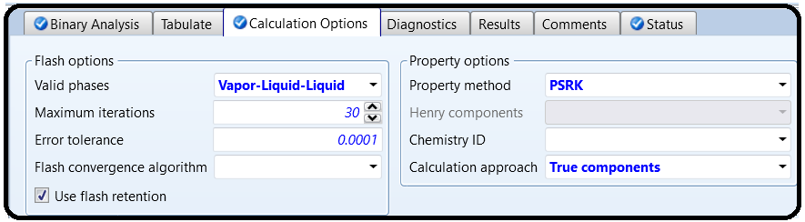

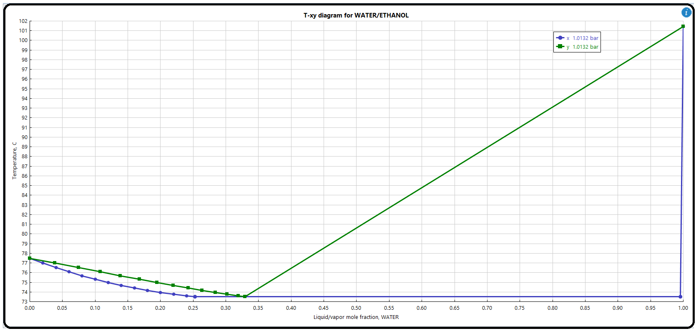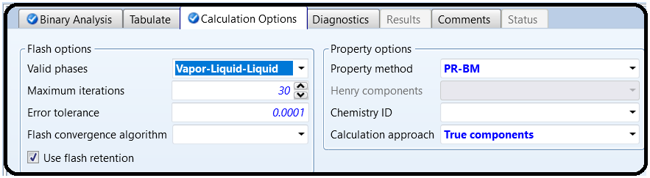

The Aspen Physical Property System enables analyzing pure component properties and their temperature dependence. Pure component analysis together with binary analysis, ternary diagrams, residue curves, mixture analysis, and PT envelope create an analysis tool in Aspen Plus. The Pure Component Analysis tool enables calculating temperature dependence of different thermodynamic and transport properties of pure components.

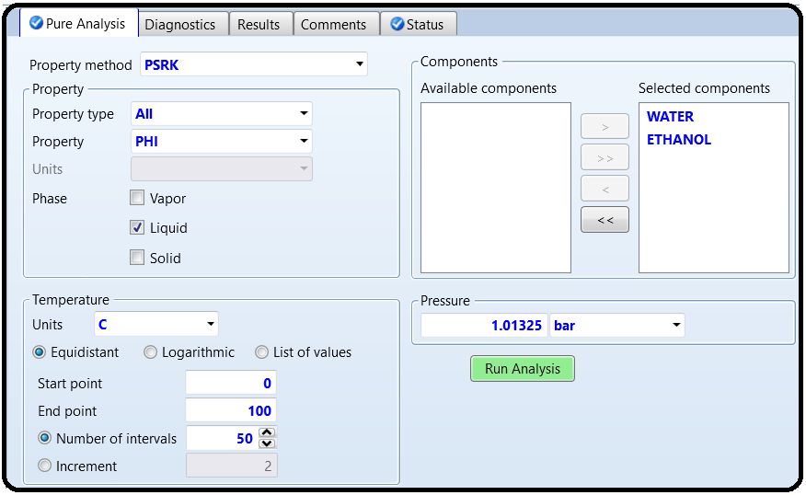

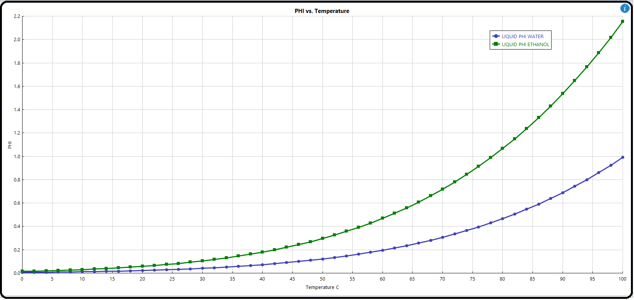

Part 3

Azeotrope Search and Analysis of Ternary Systems

Apowerful tool calledAspen distillation synthesis is integrated into Aspen Plus to perform azeotrope search and to construct ternary maps. Distillation synthesis enables the user to

* identify all azeotropes (homogeneous and heterogeneous) present in any multicomponent mixture,
* compute distillation boundaries and residue curve maps for ternary mixtures,
* compute multiple liquid phase envelopes (liquid–liquid and vapor–liquid–liquid) for ternary mixtures, and
* determine the feasibility of splits for distillation columns.

In addition, Aspen Plus ternary maps and residue curves can be used to plot ternary plots and residue curve maps.

Problem Definition

Using Aspen distillation synthesis, find all azeotropes forming a mixture of ethyl acetate, ethanol,

and water at 101.325 kPa using the NRTL-HOC model. Specify the type of azeotropes and singular points. Draw distillation boundaries and residue curve maps for thisternary mixture. Based on the synthesis of the ternary map, propose a split of distillation columns for the separation

of ethyl acetate.

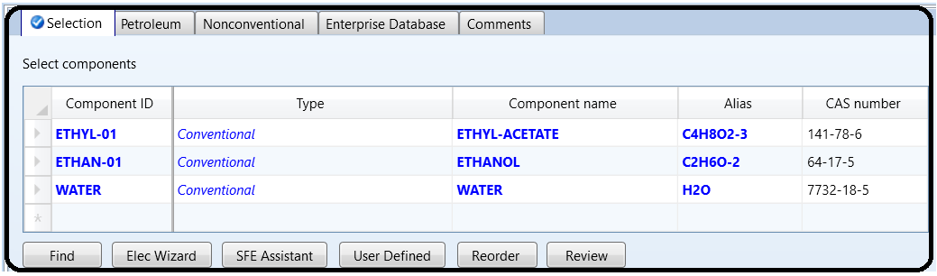

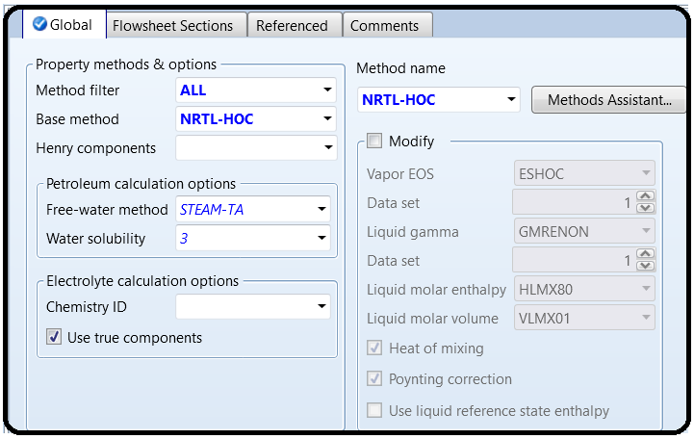

Solution:

* Select *Ternary Diag* fromthe *Analysis* toolbar (step 1in Figure 2.47).
* From the *Distillation Synthesis* menu which appears, select *Use Distillation Synthesis ternary maps* as shown in step 2 in Figure 2.47.

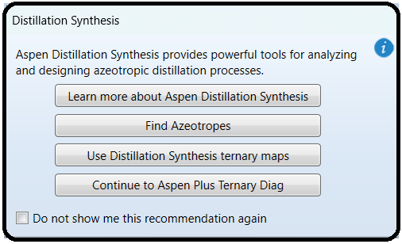

* The page shown in Figure 2.48 appears. Following the steps shown in Figure 2.48, select the property model, components 1, 2, and 3 and also pressure.

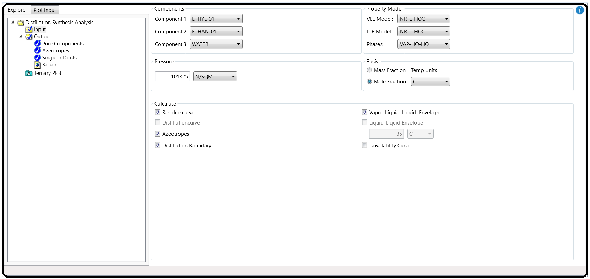

* Check if the calculation of azeotropes, distillation boundaries, and residue curves is activated.

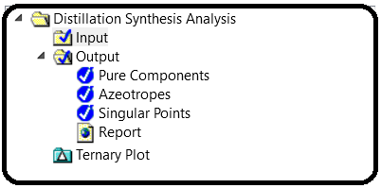

* To view information on the azeotropes, click on *Azeotropes* as shown in step 4 in Figure 2.48.

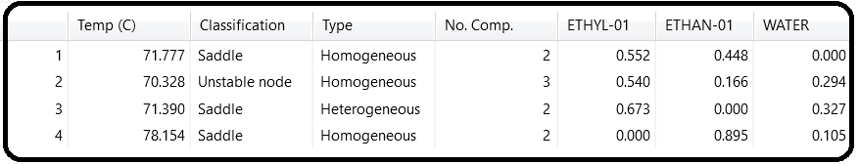

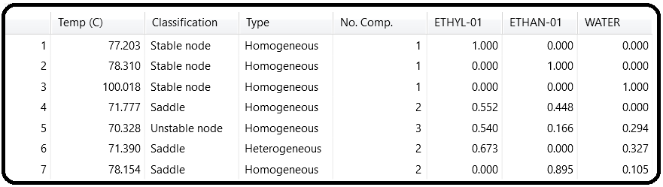

Aspen distillation synthesis found four different azeotropes, three homogeneous and one heterogeneous: homogeneous binary azeotrope of ethanol and water, homogeneous binary azeotrope of ethyl acetate and ethanol, heterogeneous binary azeotrope of ethyl acetate and water, and, finally, homogeneous ternary azeotrope of water, ethyl acetate, and ethanol. Except

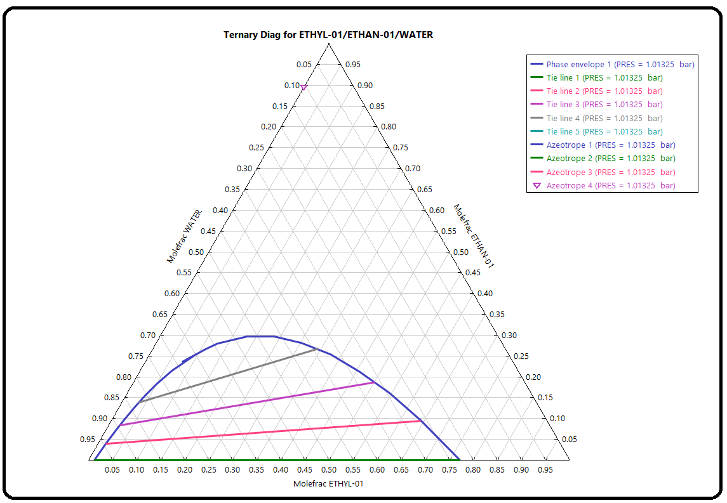for a ternary azeotrope, which is an unstable node, all binary azeotropes are saddles. Table 2.6 shows detailed information on all azeotropes. The complete list of singular points can be displayed by selecting *Singular* *points*. The results are shown in Table 2.7. Choose the *Ternary plot* on the input page (Figure 2.48) to display the ternary diagram of the ethyl acetate–ethanol–water system. Aternary diagram can be shown in formof a right-angled triangle or an equilateral triangle (Figure 2.49). It is very easy to change the form of the diagram using the appropriate icon at the right side of the displayed diagram. Aspen distillation synthesis provides both VLE and LLE data, and the plot of the LLE curve specifying the area where two liquid phases is formed. Position of the azeotropes and distillation boundaries are shown as well. As shown in Figure 2.49, distillation boundaries divide the diagram into three distillation areas. Depending on the initial concentration 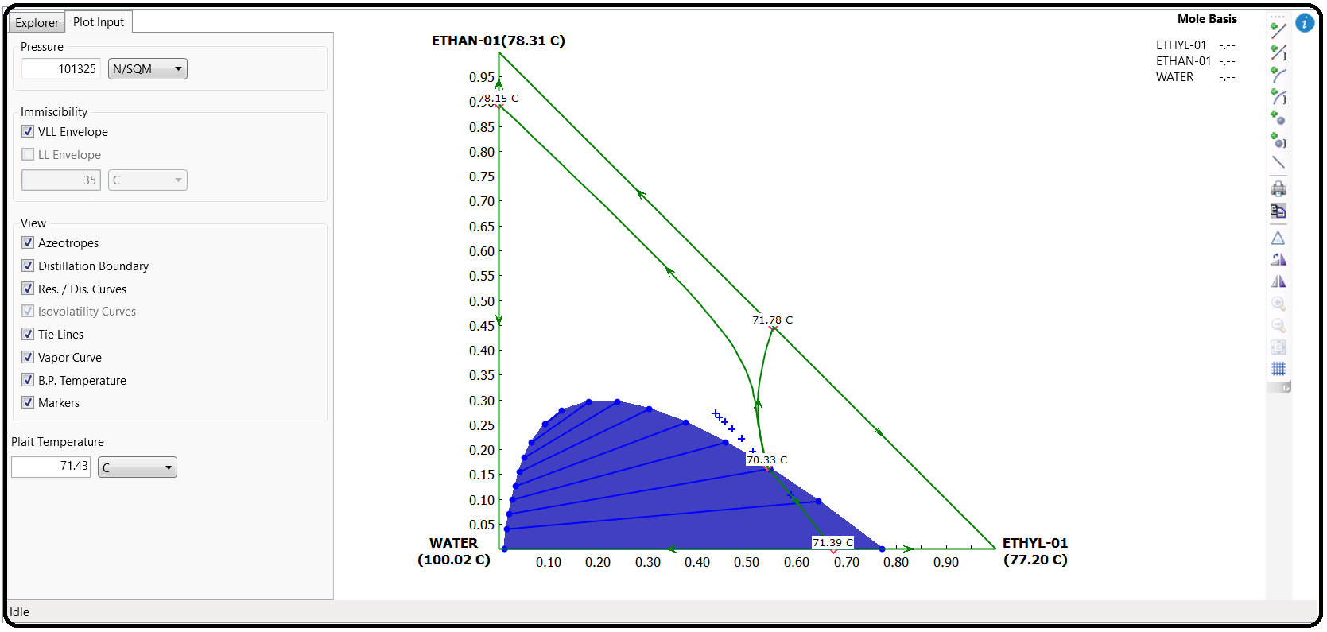of feed, different distillation products can be expected.

A residue curve (or distillation curve) can be added to the diagram by using *Add a curve* or *Add curve by value* icons at the right side of the displayed diagram. You can add any number of curves and tie lines in the heterogeneous area. Figure 2.50 shows a ternary diagram with added residue curves.

Ternary diagrams with distillation boundaries and residue curve maps enable determining the configuration of distillation columns. Consider a mixture with the concentration from area 1. When such a mixture is fed to a distillation column based on the residue curves map as a distillate product, a ternary azeotrope of ethyl acetate–ethanol–water or its mixture with the azeotrope

acetate–ethanol is obtained, and a mixture of ethanol and water is obtained as the bottom product. By adding a specific amount ofwater to the distillate product, a heterogeneous ternary mixture, which can be separated to a water phase and an acetate phase, is obtained. The acetate phase is distilled to produce practically pure ethyl acetate as the bottom product. The distillate product composition is near the composition of the ternary azeotrope, and it can be recycled to the liquid–liquid separator. The steps mentioned are shown on the residue curve maps in Figure 2.51, and the scheme of the process is proposed in Figure 2.52.

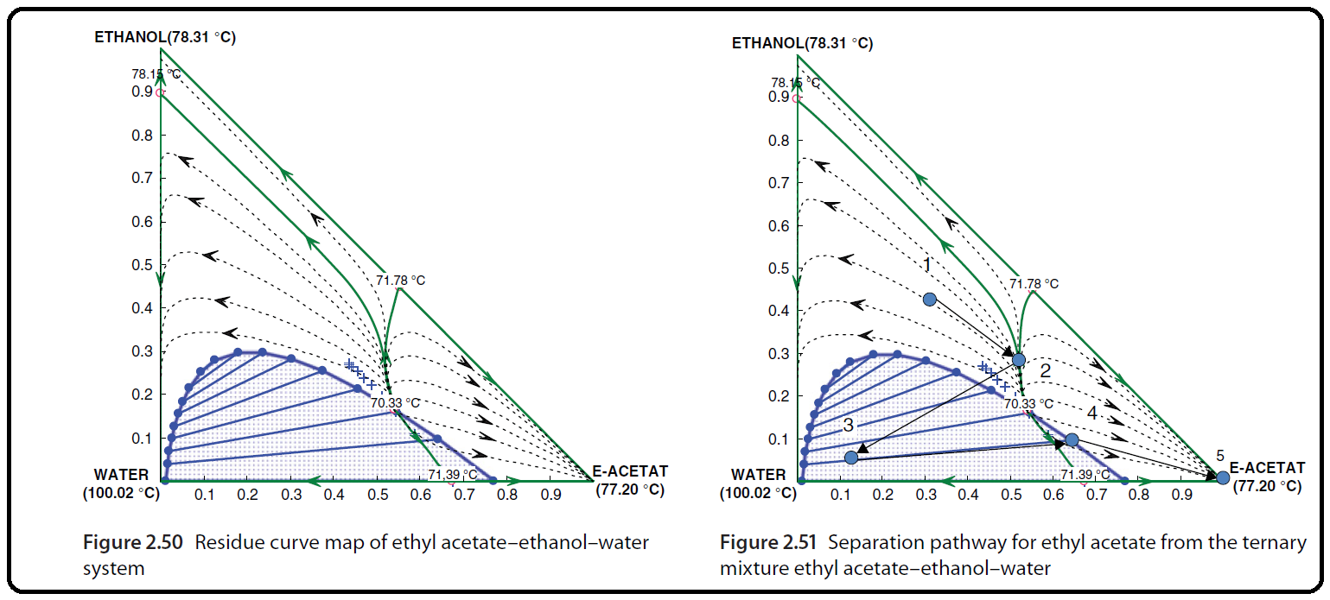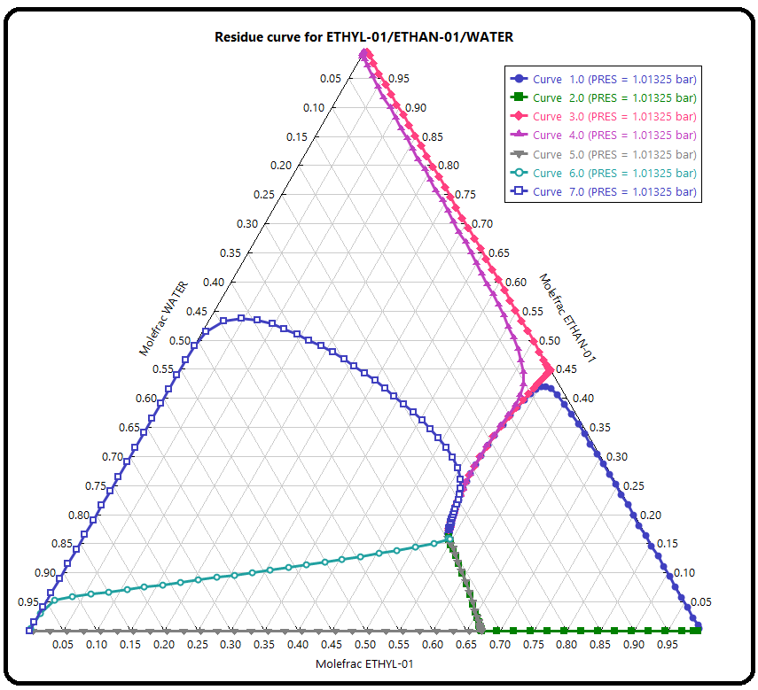

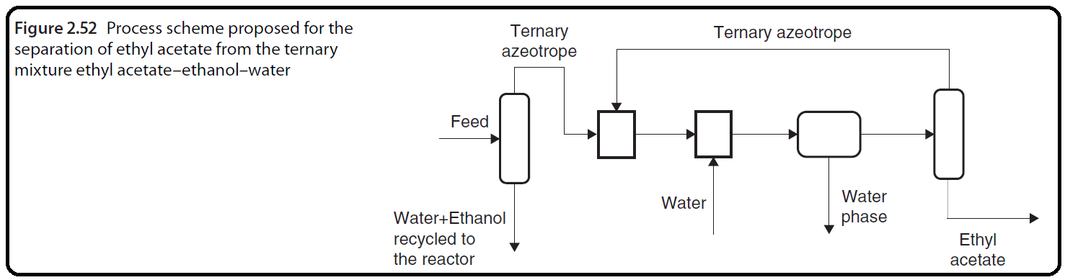

Part 4

PT Envelope Analysis

PT envelope analysis enables generating tables and graphs showing the relationship between temperature, pressure, and vapor fraction of mixtures with different compositions. With default settings, this analysis calculates the dew point temperature (vapor fraction=1) and the bubble point temperature (vapor fraction=0) at different pressures. The user can specify additional vapor

fractions. This analysis in Aspen Plus is limited to vapor– liquid phases; if two liquid phases are formed, another type of analysis should be used.

Problem definition

Calculate the relationships between bubble point/dew point temperature and pressure of a mixture containing 0.51 kmol⋅h−1 of ethanol, 0.21 kmol⋅z h−1 of ethylacetate, and 0.18 kmol⋅h−1 of acetic acid. Besides vapor fractions 0 and 1, carry out calculation also for vapor fractions 0.25, 0.5, and 0.75.

Solution:

* From the *Analysis* toolbar, select *PT Envelope*.
* On the PT Envelope page, specify the mixture composition, additional vapor fractions, and maximum points as shown in Figure 2.53.
* After pressing *Run analysis*, the graphical relationship shown in Figure 2.54 is displayed.
* Relationship between temperature and pressure of the liquid–vapor ternary mixture is displayed for temperatures and pressures from 49 ◦C and 0.3 bar to their respective critical values. To draw a graph showing this relationship in a defined range of temperatures and pressures, transfer the table of results to an Excel sheet.

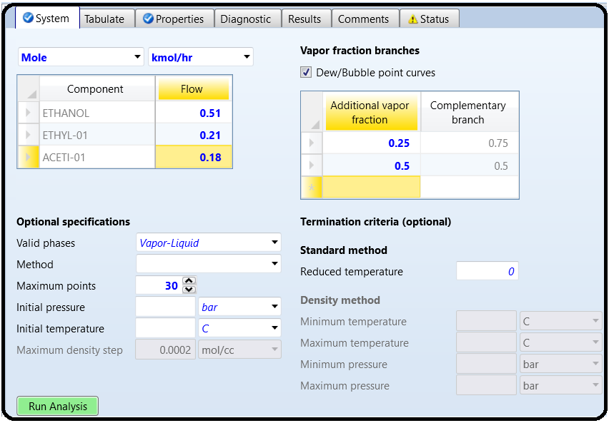

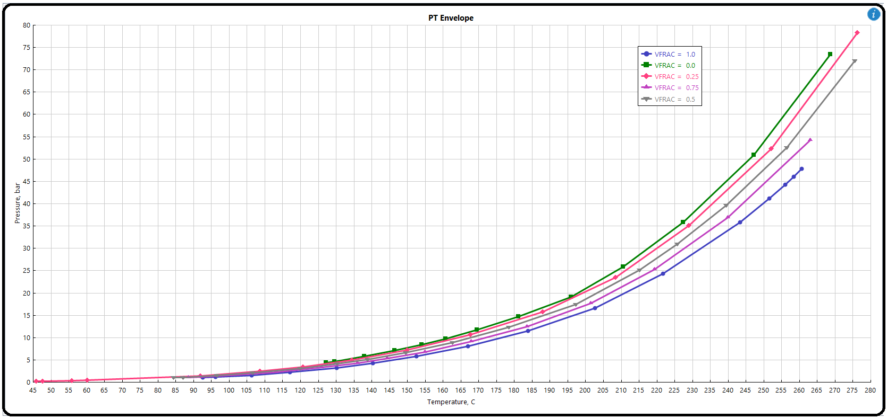

References

1.Our team experience

2. Learn Aspen Plus in 24 hr. by Thomas A. Adams II

3.Aspen build-in help

4.Chemical Process Design and Simulation by Juma Haydary