Part 12

Aspen Energy Analyzer (AEA)



GENERATING HENs USING MANUAL PROCESS STREAM DATA ENTRY IN AEA

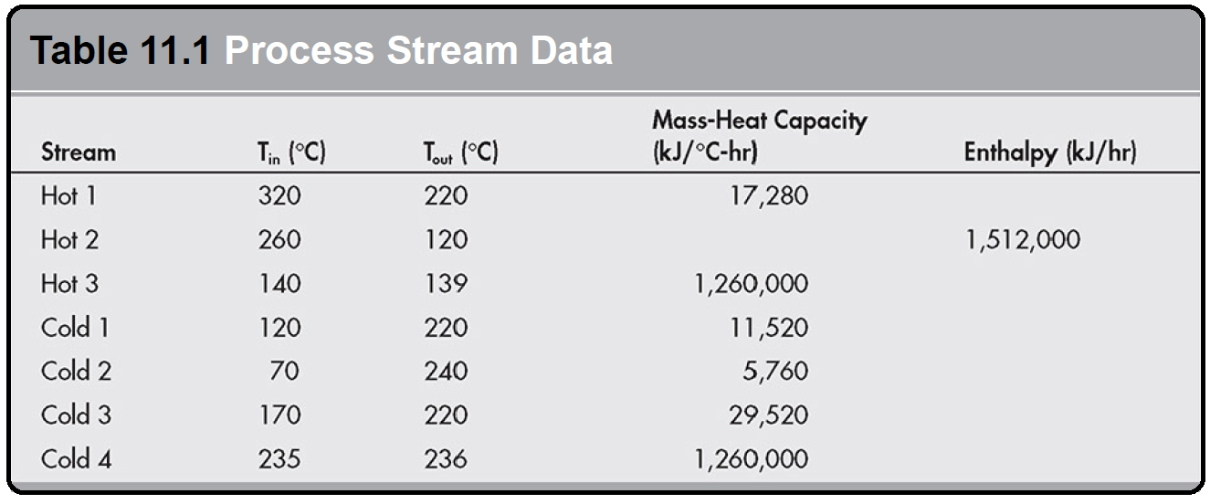Table 11.1 contains process stream data from which a HEN is to be built. As you recall, hot streams refer to process streams that require cooling, while cold streams refer to process streams that require heating. We will enter the data shown in Table 11.1 into AEA as a first step to building our HEN.

Load the AEA software. Once AEA loads, save a new file. Now go to Managers on your menu bar and click on Heat Integration Manager. A window pops up as shown in Figure 11.1.

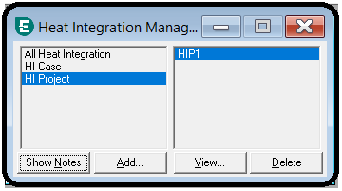 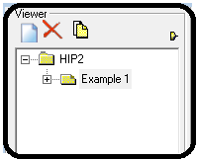

Click on HI Project and Add. Next, right-click on HIP1 and select Add Scenario. A small window pops up and indicates the scenario should be named. I’ll call mine Example 1.

Select your scenario (Example 1 in my case) and then the Data tab at the bottom left of your window, as shown in Figure 11.3. In the Data window, select Process Streams. A table view appears on the bottom right of the window in which you can enter your process stream data from Table 11.1. In the form shown, enter the information given in Table 11.1. Start with Hot 1. Under the name column, click on **New** shown with the blue text. Type Hot 1 as the name of the new process stream. Also, enter the inlet temperature (Inlet T), outlet temperature (Outlet T), and mass heat capacity2 (MCp) data from the table. Notice that the enthalpy and heat transfer coefficient (HTC) fields become populated, as shown in Figure 11.4. The enthalpy is calculated based on the temperature and heat capacity information you provided, while the HTC is set at a default AEA value. Also, notice the downward-pointing red arrow in the Hot 1 row. AEA uses it to indicate that the stream is a hot stream whose temperature will be going down. For a cold stream, you will see a blue arrow pointing upward.

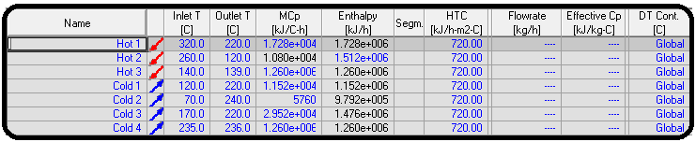

Now enter Hot 2 in the same way as Hot 1, but enter the enthalpy instead of the heat capacity. AEA will calculate the heat capacity for us. In AEA, you can enter either the heat capacity or enthalpy data (Whichever is available). Ok, that was easy. In the same way, enter the remaining information shown in Table 11.1. The next step is to choose your utility streams and enter the

required information for them. When designing a HEN, utilities are required to supply any additional cooling or heating demands that cannot be met by matching hot and cold process streams together. Enter the utility information under Data | Utility Streams. In the utility streams section, we can select the hot and cold utility streams. Take a look at the bottom of your AEA window and note that the Hot utility (Hot) and Cold utility (Cold) statuses are labeled Insufficient in red (see Figure 11.5). This is because the process still requires external heating (for the cold process streams) and external cooling (for the hot process streams) in order to reach their specified temperature.

Now add a cold utility and see what happens. On your screen, under the name column, click on the drop-down for <empty> shown and select Cooling Water. Note that the cold utility status is now labeled as Sufficient in green, as shown in Figure 11.6. This is because you have selected cooling water, which is at a temperature cold enough to cool the hot process streams (second law of thermodynamics). So now it is physically possible for you to meet all of your temperature change objectives. In practice, be sure to select appropriate utilities that meet your temperature requirements but don’t cost more than necessary.

Add a hot utility. Select LP Steam (low-pressure steam) from the drop-down. Note that unlike the cooling water utility, LP steam is not hot enough to supply all the heat requirements of the process (see Figure 11.7). What do you think the reason is? Take a look at the inlet and outlet temperature of LP steam, and compare it to any of the cold process streams in the process stream data table. You will notice that LP steam can supply some of the heat for some parts of the cold process streams, say for Cold 2, but cannot supply the rest because its outlet and inlet temperatures are lower than the other cold streams. This means that hot utilities which are “hotter” than the cold streams are required. Ok, add HP Steam (high-pressure steam) as a hot utility. You will now notice that the Hot utility status at the bottom of your screen has now changed to Sufficient, with a green color. The temperatures of some of the hot process streams in Table 11.1 indicate that it is possible to generate LP steam, so add LP Steam Generation as a cold utility. Finally, your utility stream table should look as shown in Figure 11.8.

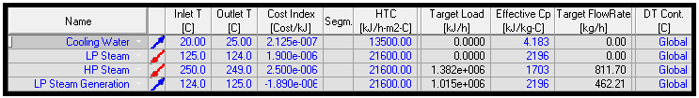

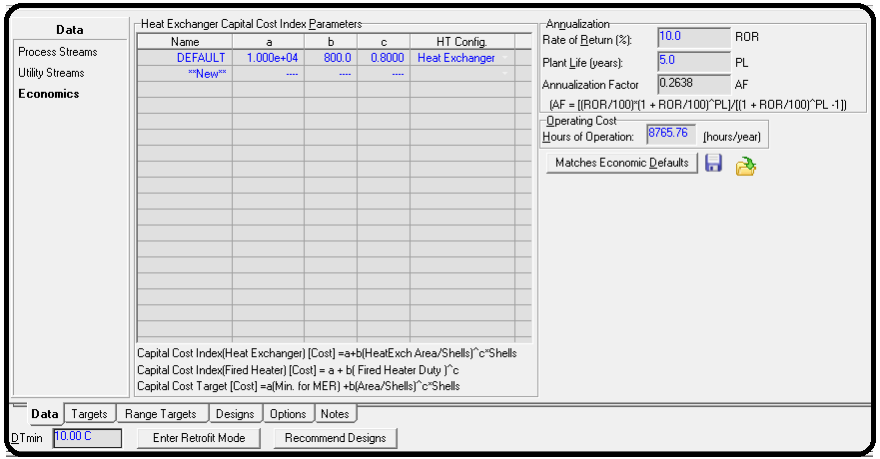Finally, in the data tab, you can edit the economics information by making changes in Data | Economics, as shown in Figure 11.9. The information provided here is used to compute the TAC of the HEN with this equation:

The TAC is a useful way to compare different HEN designs, since it incorporates a balance of both capital (one-time) and energy (ongoing) costs. By default, the AEA designs are determined using an optimization algorithm in which the objective is to minimize TAC. The Heat Exchanger Capital Cost Index Parameters are used to calculate the cost of the heat exchangers based on their attributes, such as heat exchanger area and number of shells. The Annualization Factor is calculated from the rate of return (ROR) and plant life (PL) time, while the capital cost is the total cost of all the heat exchangers in the HEN. This information can be changed if you have data that you prefer to use. For example, you can have a longer lifetime for the plant such as 10 years or a higher ROR such as 15%. It is also possible that you have real plant data or vendor information about the actual capital cost parameters for your heat exchangers. Also, the hours of operation for the particular process you are working on might be known. Let’s work with the AEA default values, so don’t make any changes.

The next step is to design the HEN. This means we will ask AEA to try to match process streams to process streams, and process streams to utilities in the best way possible, that is, to minimize the TAC. Click on Recommend Designs at the bottom of your window. A window pops up called Recommend Near-optimal Designs, as shown in Figure 11.10.

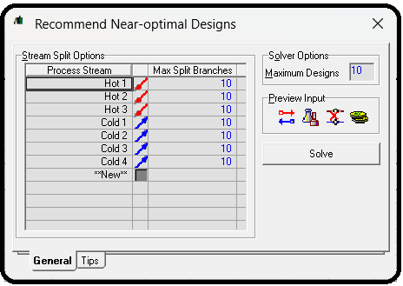

The recommended near-optimal designs feature uses an optimization approach to try to match your streams using heat exchangers. The maximum split branches option refers to the number of times a stream can be split into smaller pieces (e.g., it might want to use one very large heat source to heat lots of little streams by breaking it into pieces). If the solver is unable to find solutions, especially when the problems are large, try turning this number down to reduce the complexity of the problem and make it easier to solve (though possibly missing out on potentially better designs). Note also that these are “near” optimal designs. The best design reported may or may not be the true global optimum design. Even if it is not, it usually isn’t very far off, and it almost always is way better than what you could have come up with on your own.

Check to see that in the Stream Split Options table the maximum split branches of all the process streams is set to 10. This value can be more or less, but leaving it at 10 allows AEA to have a good number of options for matching streams without making the problem too complex to solve. Leave the Maximum Designs under Solver Options as 10. Again, this value can be more or less but 10 is a good value to choose to start. Click Solve. The AEA solver runs and generates 10 different designs which you can see in your scenario folder at the top left section of your window. If you go through the 10 designs, you will notice the green bars at the bottom of the HEN diagrams.

Green indicates that all heat exchanger matches are feasible, and the heat requirements (heating and cooling) of all the process streams are satisfied. If so, you will see text for that design that says “Infeasible HX: 0.” Some of the designs that result may be infeasible, and in fact, 7 out of the 10 designs AEA generated were infeasible in this example. If so you will see something like “Infeasible HX: 1” or some other number under the HEN diagram, without the green background. Infeasible designs are those which either violate the second law of thermodynamics (because they have temperature crossover), or they don’t technically violate the second law, but they have one or more heat exchangers in which the approach temperatures are so small that the costs and efficiency of the heat exchanger is likely to be very impractical.

Note:

In practice, sometimes AEA cannot find any feasible designs. It may then report only designs with at least one infeasible heat exchanger match. This is more likely to happen when there is a phase change. Obviously, the infeasible exchangers cannot be built in real life, but the cost numbers of that infeasible system are at least somewhat useful because they provide an estimate of the

lower-bound on cost (in other words, the real system should be more expensive than this and there will likely be nothing feasible that is cheaper than this). If AEA cannot find any

feasible designs, try any of the following: Try rerunning using fewer maximum stream matches.

Pick one of the better (but infeasible) HENs with a small number of infeasible heat exchangers. Manually delete the infeasible heat exchanger(s) and replace them with your own appropriate utility matches for the streams. Keep all the other feasible heat exchangers. Use Add Heat Exchanger button to manually add a heat exchanger connection to one of the utilities in the network, but it is tricky to figure out the right buttons to press. Right-click and hold the Add Heat Exchanger button (upper left of the HEN diagram), drag the icon to the stream that needs a new utility connection (should be a dashed line, which means the stream is unsatisfied and needs a heat exchanger), and release the rightclick when the cursor turns to a bull’s eye. Then you will get a single red circle somewhere on that line (look for it, it won’t likely be where you actually released the click). Left-click and hold the new circle, and drag to the utility connection line and release. That will make the connection and create the heat exchanger. Then, left-click that new heat exchanger to bring up its details. Click the “tied” checkbox, and then enter in one more degree of freedom. I like to specify the duty, because you can get the exact unspecified duty from the Unspecified Streams View (second button from the right above the HEN diagram). If you did it correctly, it should recalculate everything automatically and give you the green bar

with Infeasible HX: 0 message. Remove the offending streams one at a time and keep rerunning

each time until you get a feasible HEN. Then you would manually design the HEN for the missing streams, usually by direct use of utilities, or make a separate HEN for the missing streams.

Decrease the minimum approach temperature (Δ*T*min), which can be edited on the bottom left side of the Design | Data form (see bottom left of Figure 11.8). For example, when I changed the

Δ*T*min to 2°C for the current problem, all 10 designs were feasible. However, based on heuristics, you don’t usually want a Δ*t*min lower than 5°C, but on the other hand, it is just a heuristic. If you

go lower than this, and you find heat exchanger matches which are feasible and the costs are reasonable, then you may have to use it. In the process flow diagrams, all the hot process and utility streams are represented with red arrows, while the cold process and utility streams are represented with blue arrows. The gray heat exchangers are used to show heat exchange matches between a hot process stream and a cold process stream, the red heat exchangers

represent matches between a hot utility stream and a cold process stream, while the blue heat exchangers represent matches between a cold utility stream and a hot process stream.

Review these designs and make a HEN selection based on the TAC. The best design (mathematically speaking at least) will be the one with the lowest TAC. But, other design options are given because maybe there are other factors that may weigh into your decision, such as physical proximity within the plant, ease of construction, maintenance, control issues, safety issues, etc. Click on the Designs tab in your scenario folder, and take a look at the Total Cost Index column of the different designs. This is actually TAC in units of $/sec.

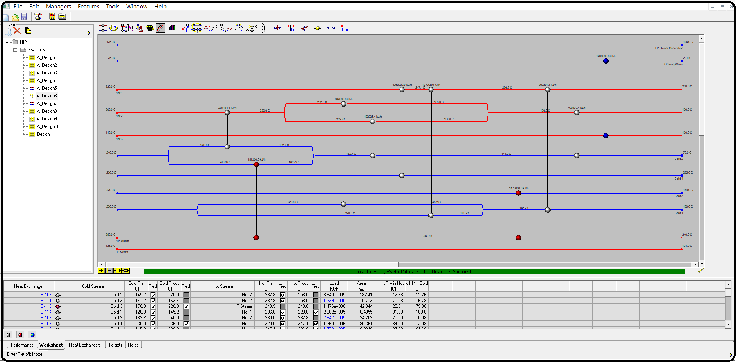

Questions:

**Q3)** What is the value of the lowest Total Cost Index?

**Q4)** In your scenario folder, click on the HEN design which corresponds to your answer from Q3 to see its diagram. How many heat exchangers are on the HEN diagram, and how many are process-to-process heat exchangers?

**Q5)** Go to the A_Design6 | Heat Exchangers tab of your scenario folder, and take a look at the heat duty (Load) of heat exchanger E-112. How much cooling water is used by this heat exchanger in kJ/hr? Note: If you can’t see the numbers clearly, you can expand the column (the same way as you would do it in Excel). You can also double-click the blue icon for the heat exchanger that is connected to the cooling water stream, and see the information there.

**Q6)** What is the total heat duty (kJ/hr) of the process-process stream heat exchangers of A_Design5? These are the heat exchangers with the light gray icons beside them.

Appendix

Aspen Energy Analyzer (formerly known as Aspen HXNet) is designed for analyzing and improving the performance of heat exchanger networks (HENs). Aspen Energy Analyzer's focus is on analyzing the networks from an operations’ as well as a design’s point of view. HEN operations features are designed to provide you with an understanding of current plant operation and related issues such as fouling. Furthermore, fouling mitigation strategies can be studied and simulated in Aspen Energy Analyzer.

HEN design features assist the designer in understanding the gap between current operation and the thermodynamic optimum operation. The designer can use Aspen Energy Analyzer to identify and compare options to improve the performance and reduce the gap between current and thermodynamic optimum operations. To perform any heat integration study from a design or operations perspective, Aspen Energy Analyzer needs the process requirements and the HEN that achieves the process requirements. The terminology that is used in Aspen Energy Analyzer is "scenario" for process requirements and "design" for the HEN.

Introduction to Heat Integration Manager

Heat integration in Aspen Energy Analyzer (formerly called HX-Net) is designed for analyzing and improving the performance of heat exchanger networks (HEN). Aspen Energy Analyzer focuses on analyzing the networks from operations' as well as design's point of view.

HEN operations features are designed to provide you with an understanding of current plant operation and related issues such as fouling. Furthermore, fouling mitigation strategies can be studied and simulated in Aspen Energy Analyzer.

HEN design features assist the designer in understanding the gap between current operation and the thermodynamic optimum operation. Furthermore, the designer can use Aspen Energy Analyzer to identify and compare options to improve the performance and reduce the gap between current and thermodynamic optimum operations.

To perform any heat integration study from a design or operations perspective, Aspen Energy Analyzer needs the process requirements and the HEN that achieves the process requirements. The terminology that is used in Aspen Energy Analyzer is "scenario" for process requirements and "design" for the HEN.

Aspen Energy Analyzer exposes the heat integration functionality through the HI Case and HI Project operations:

* HI Case limits you to working with one scenario and one design. Thus HI Case is suitable for users who want to perform a quick energy analysis or for users who wan to study current plant operation.
* HI Project enables you to work with multiple scenarios and each scenario could have multiple designs. Thus, HI Project is more suitable for users who want to make structured modifications and compare those modifications. HI Project is also suitable for performing revamp studies.

The Purpose of a Heat Integration Project

The Heat Integration (HI) Project operation is used to design a heat exchanger network (HEN). The HI Project is similar to the HI Case operation except for the following differences:

* The Project can contain multiple scenarios and designs.
* The Project can be switched to Retrofit mode.
* The Project cannot perform simulation analysis on the designs.

General Procedure

The following is a general procedure to setup the HI Project operation:

1. Open the HI Project operation view.
2. Select a scenario from the Viewer group and go to the Data tab.
3. Go to the Process Streams page, and enter the following information:

* Name, inlet temperature, outlet temperature, and MCp or enthalpy of the process stream.

1. Go to the Utility Streams page, and enter the following information:

* If you are specifying your own utility: name, inlet temperature, and outlet temperature of the utility stream.   
  If you want Aspen Energy Analyzer to calculate the operating cost of the utility you have to supply a cost per energy value.
* If you are using the utilities from Aspen Energy Analyzer utility database: click the down arrow  in the Name cell to open the drop-down list, and select the utility you want from the list.

|  |
| --- |
| Note: If the utility in the Name cell is a hot utility, you cannot replace that hot utility with a cold utility, until after you click on the Name cell and press DELETE. Once the previous utility occupying the row has been deleted, you can select a different type of utility to be added in that row. |

1. If any of the streams in the HEN has large varying values for the specific heat capacity, you can segment the streams. Click once in the Segm cell to access the Process Stream view. The Process Stream view contains options to segment the stream. Refer to for more information.
2. Go to the Economics page to manipulate the cost calculations of the operation.
3. Select the design associated to the selected scenario in the Viewer group. The Main pane will now display the Grid Diagram.
4. On the Grid Diagram, add heat exchangers and stream splitters to generate the HEN design.

Introduction to Retrofit

The day-to-day operation of a plant is usually subject to change. The average heat exchanger network (HEN) designs are flexible enough to handle these changes. In some cases, like rising energy costs, problems arise and cannot be resolved with the original HEN. The purpose of retrofit is to modify the existing HEN so that it satisfies the new operating conditions and keeps energy costs low.

|  |
| --- |
| Note: The design produced through HEN retrofit is limited by the existing HEN design and operation set up. |

Aspen Energy Analyzer has a feature called the Automatic Retrofit. This feature allows you to perform step-by-step retrofit options on an existing HEN design.

Heat Integration Case

The Heat Integration (HI) Case operation is a tool used to design heat exchanger network (HEN) and perform simulation analysis on the HEN. HI Case contains one scenario/one set of input parameters and one design/one Grid Diagram that displays one HEN.

The Heat Integration Case (HI Case) is the simplest of the three available operations used to design heat exchanger network (HEN). HI Case contains one scenario/one set of input parameters and one design/one Grid Diagram that displays one heat exchanger network.

General Procedure

The following is a general procedure to setup the HI Case operation:

1. Open the HI Case operation view.
2. Go to the Process Streams tab, and enter the following minimum information:

* Name, inlet temperature, outlet temperature, and MCp or enthalpy of the process stream.

1. Go to the Utility Streams tab, and enter the following minimum information:

* If you are specifying your own utility: name, inlet temperature, and outlet temperature of the utility stream. If you want Aspen Energy Analyzer to calculate the operating cost of the utility you have to supply a cost per energy value.
* If you are using the utilities from Aspen Energy Analyzer utility database: click the down arrow  in the Name cell to open the drop-down list, and select the utility you want from the list.

|  |
| --- |
| Note: If the utility in the Name cell is a hot utility, you cannot replace that hot utility with a cold utility, until after you click on the Name cell and press DELETE. Once the previous utility occupying the row has been deleted, you can select a different type of utility to be added in that row. |

1. If any of the streams in the HEN has large varying values for the specific heat capacity, you can segment the streams. Click once in the Segm cell to access the Process Stream view. The Process Stream view contains options to segment the stream. Refer to for more information.
2. Go to the Economics tab to manipulate the cost calculations of the operation.
3. Click the Open HEN Grid Diagram icon to access the HEN Design view.



1. On the HEN Design view, add heat exchangers and stream splitters to generate the HEN design.

Forbidden Matches View

The Forbidden Matches view allows you to specify which two process streams cannot exchange heat with each other. The process streams may not be able to exchange heat due to plant layout, corrosion, or available material for construction.

Click the icon in the cell until you achieve the allowed or forbid setting.

The Allow Match icon  allows heat transfer between the hot and cold streams intersecting the cell.

The Forbid Match icon  forbids heat transfer between the hot and cold streams intersecting the cell.

Reference

1.EIEPD members’ experience

2. Aspen Plus build-in help

3.Learn Aspen Plus in 24 hr. by Thomas A. Adams II