Part 13

Aspen Capital Cost Estimator



USING ASPEN CAPITAL COST ESTIMATOR AS A STAND-ALONE PRODUCT

Aspen Capital Cost Estimator is a beastly program, weighing in at a few gigabytes and containing an incredible amount of in-depth knowledge. Its purpose is to estimate the capital costs of common chemical process equipment. Costs are computed using a large database of detailed models of individual pieces of equipment, which is the most accurate method of estimation possible in the early stages of process design short of getting actual quotes. Other more traditional correlations are used to fill in the gaps in the data. Estimates are significantly detailed, which include labor costs to install (it varies depending on which part of the country/world you are in), what kind of ground you are putting it on (rocks? cement?), and

how much paint you need for the outside. It also literally has a section called “nuts and bolts.”

There are generally two ways to use the software. In this part, we will use the first way which is as a stand-alone product: Launch Aspen Capital Cost Estimator. It’s not going to look anything like Aspen Plus. When it loads, it will ask you if you want to also load the Aspen Process Economic Analyzer (Yes).

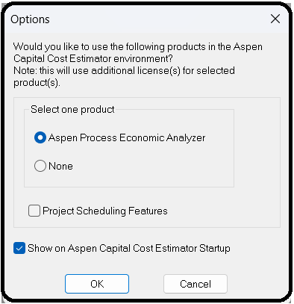

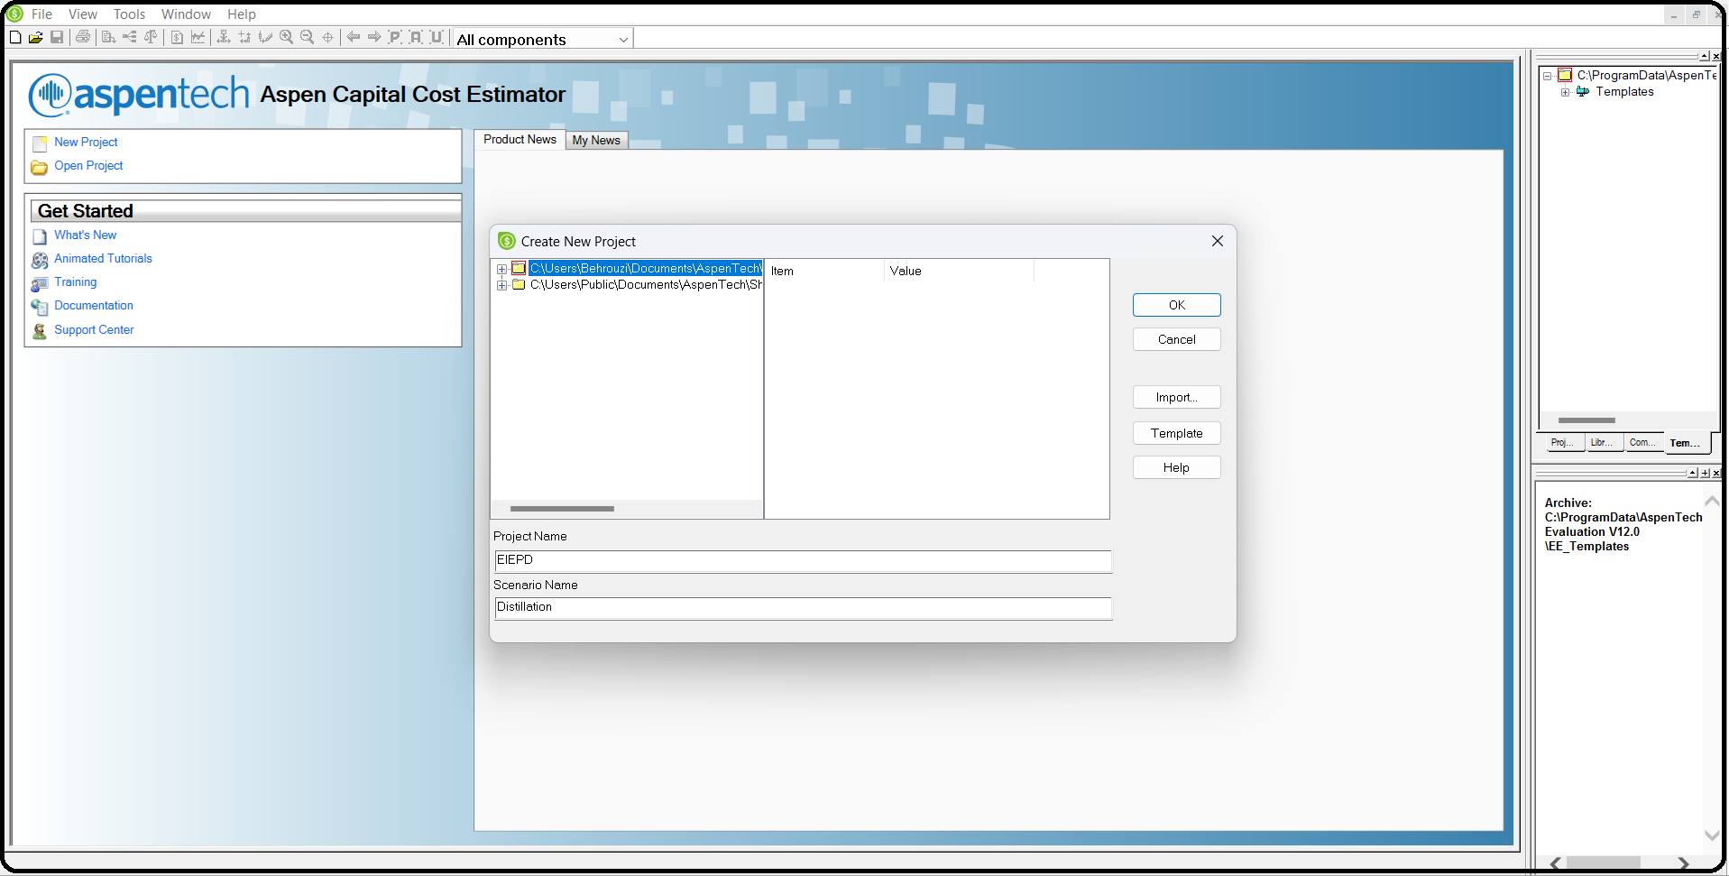First, you create Projects. A Project is basically a collection of pieces of equipment that are in your chemical plant. We’ll start by creating a new project. If the default folder is no good for you, go to Tools | Options | Preferences | Locations and then Add your preferred directory to the list. Now, create a new project (File | New), pick a name, and put it in your new folder (see Figure 10.1).

Then on the next screen, select IP units. The default, IP, is inchpound (also called “imperial”). Note that most American and Canadian companies still use IP for process equipment. For example, distillation columns are bought with diameters in standard sizes of 6-in. increments. If you want something that is 1 m in diameter (3 ft. 3.3 in.), that is a very expensive custom order.

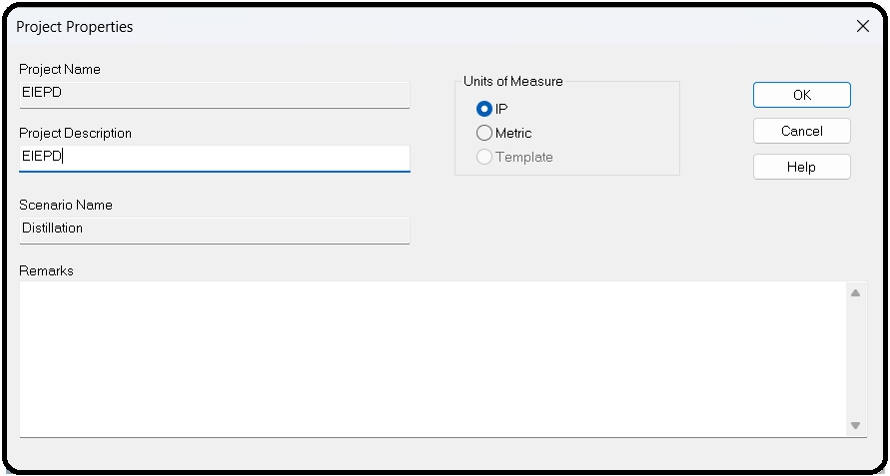

Once you create the new project, you are immediately presented with a request to modify the “Input Units of Measure Specifications,” as shown in Figure 10.2. Click on one, say Length and Area, and click Modify. This shows you the default measurements, as shown in Figure 10.3. You could, if you wanted, enter your own units here and a conversion. For example, if you want *pinky lengths* wherever inches are normally used, you could enter that here and put in the appropriate conversion amount. Let’s not do this.

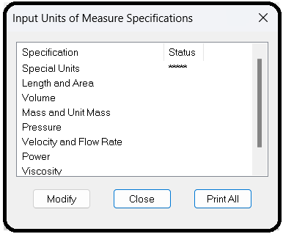

After this (cancel and close), you are presented with the General Project data screen (see Figure 10.4). Here are defaults such as

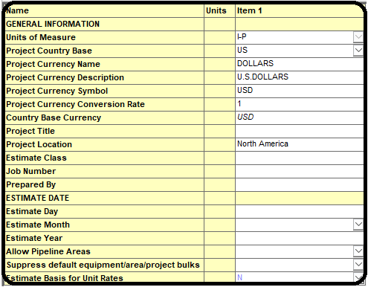

currency units, region, etc. We want to choose the United States as the Base country. In other words, all of their cost data are taken from American chemical plants and applications. However, suppose we are a Canadian company who will build this plant in Ontario, Canada, and thus prefer to work in Canadian dollars. For convenience, you can change the currency description, symbol, and conversion rate. Enter in whatever today’s exchange rate is or whatever you normally use for cost budgeting. For example, if you want to use the same number I did, 1.278 CAD = 1 USD, December 5, 2020, then type 1.278 in the box for Currency Conversion Rate, as shown in Figure 10.4. Update the description and other fields as necessary. At the bottom, enter the date at which you intend to purchase the plant (let’s say January 1, 2021). It doesn’t actually matter what the date is as far as the costs are concerned, but this is useful to make things easier to follow in other parts of the software.

Click OK. You are next shown the regular workspace screen. On the left column of your regular workspace screen, there are three tabs at the bottom. Choose the first tab (Project Basis View), as shown in Figure 10.5.

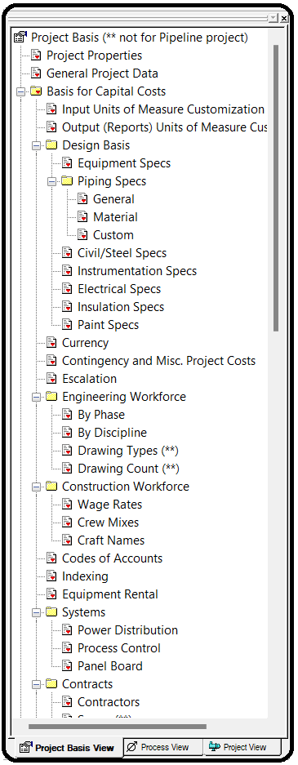

It is here that you can specify many more things. For example, go down to the Project Basis | Investment Analysis | InvestmentParameters tab and double-click on it. Here we can change the key economic parameters like tax rate, desired rate of return, depreciation methods, etc. Change the tax rate from 40% (a typical U.S. amount is 35% federal + 5% state but it varies by state) to 26.5% (a typical amount is 15% Canada Federal + 11.5% Ontario Provincial) and click OK. Also, as we are assuming Canadian costs, we also need to bump our labor costs up. Double-click the Project Basis | Investment Analysis | Operating Unit Costs tab and bump operators from 20 to 40 $/hr and supervisors to 60 $/hr (again these are Canadian dollars). Also, set the electricity price to 15 ¢/kWh (0.15 $/kWh), which was the average Ontario’s mid-peak price at the end of 2020, and click OK.

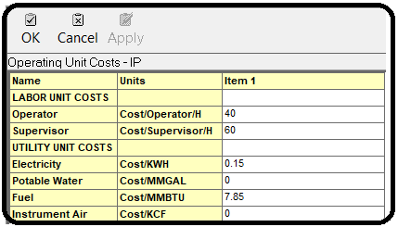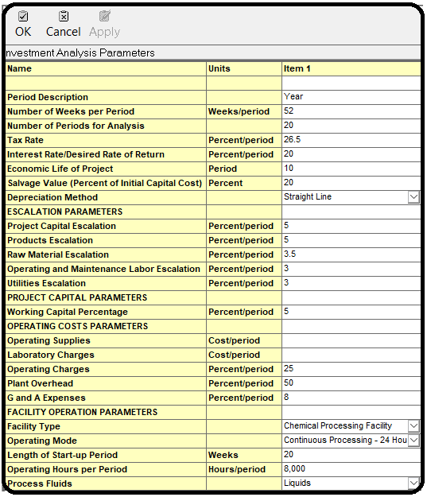

Similarly, we can change the cost indexing, that is, how much more we have to pay than the base cost due to inflation and changes in the market. In the version used in this edition (V12), the base

costs in the database are for the first fiscal quarter of 2019, and you can check yourself by looking in the title bar of the window of the program when you first open it. Because we left the Project Country Base as the United States, it will use its database of prices for things sold in the United States in the first quarter of 2019. If we wanted, the program also has databases for the United Kingdom, Japan, the European Union, or the Middle East as well. Let’s assume that right now in the first quarter of 2021, Americans have to pay 5% more for equipment than they did in 2019, and Canadians have to pay 10% more than in the United States even adjusting for the exchange rate. This means that we are assuming that our 2021 Canadian costs are 1.1 × 1.05 = 1.155 (or 15.5%) more than the basis costs for the United States in 2019. Aspen Plus defines the base factor as 100 for the base case. So for a 15.5% increase in cost, we need to change the index for equipment to 115.5.

Right-click on Project Basis | Basis for Capital Costs | Indexing and choose Select. You are picking between different index files. Just pick the default and click OK; it’s too complex to go into this further.

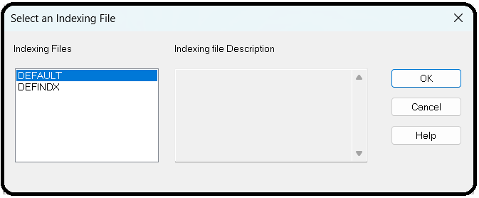

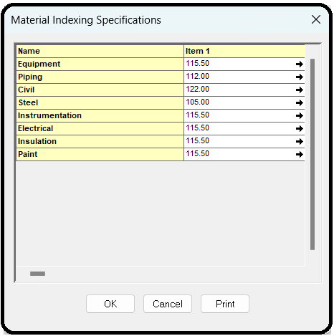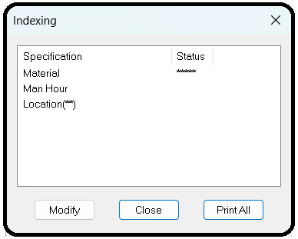Now right-click Basis for Capital Costs | Indexing item again, choose Edit, as shown in Figure 10.6. Select Material and hit Modify.

Now you can see that “100” is the basis for all of these, so change Equipment to 115.5. Modify the rest and say that Piping should be 12% higher, Civil is 22% higher, Steel is only 5% higher, and all the rest are 15.5% higher,2 as shown in Figure 10.7. Then click OK and Close.

Now that the base cost information is added, we can start adding and costing equipment to our plant. Switch to the Project View tab (third on the bottom right of the left column). It will show that you have a Main Area inside of your Main Project. Projects are like folders, you just group everything you are working on into one or more projects. Areas are geographical areas of your chemical plant, as in maybe the west wing of your factory, or some fenced-in place outside, etc. You assign pieces of equipment3 to an Area. On the right window pane, you should see the tab options for Projects, Libraries, Components, and Templates. Go to the Components tab. This is where all of the equipment models are located. Start by adding a Centrifugal single or multi-stage pump, as shown in Figure 10.8. You’ll find it under Process equipment | Pumps | Pump-Centrifugal | Centrifugal single or multi-stage pump. To add it, drag and drop the icon into the whitespace in the middle column.

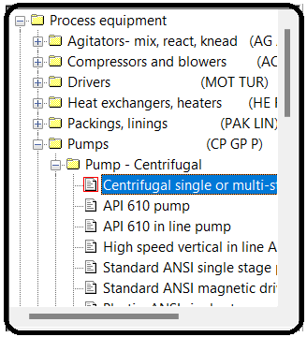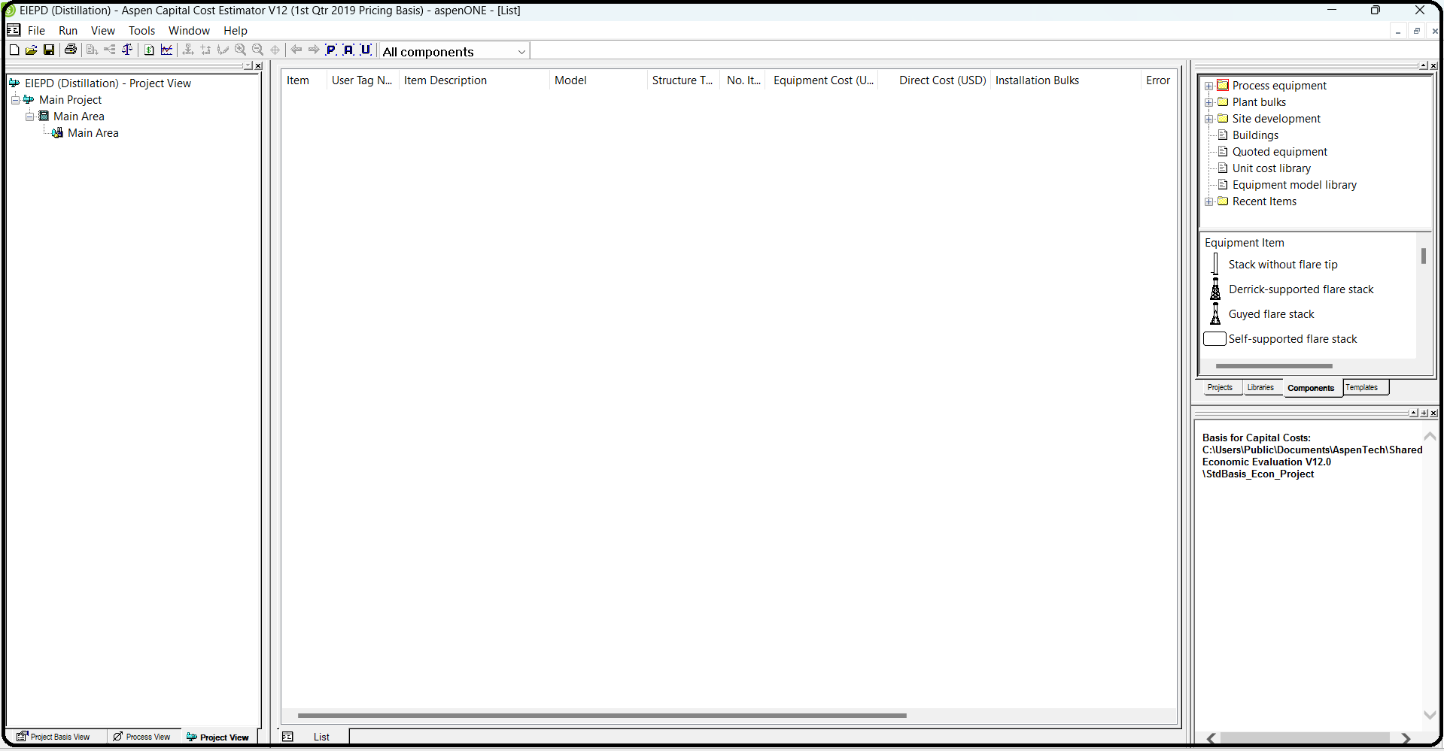

Give it a name such as Reflux Pump for the Item description. You are now presented with a form where you can fill in all sorts of information to ridiculous levels of detail, as shown in Figure 10.9.

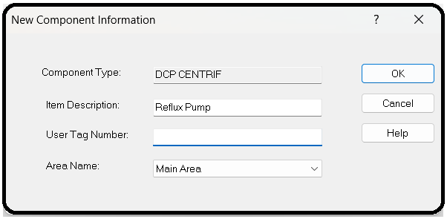

The red boxes are items which must be entered before proceeding. The boxes with blue text are items which must be entered for Icarus to calculate the cost, but have a default option selected for you. The empty boxes are optional but can also be factored into the cost if you have that information available. For this pump, change the casing material to stainless steel and update the flow rate, fluid head, and design gauge pressure according to the diagram on the next page. When ready, click OK. Your middle column on the main view should have something similar to Figure 10.10.

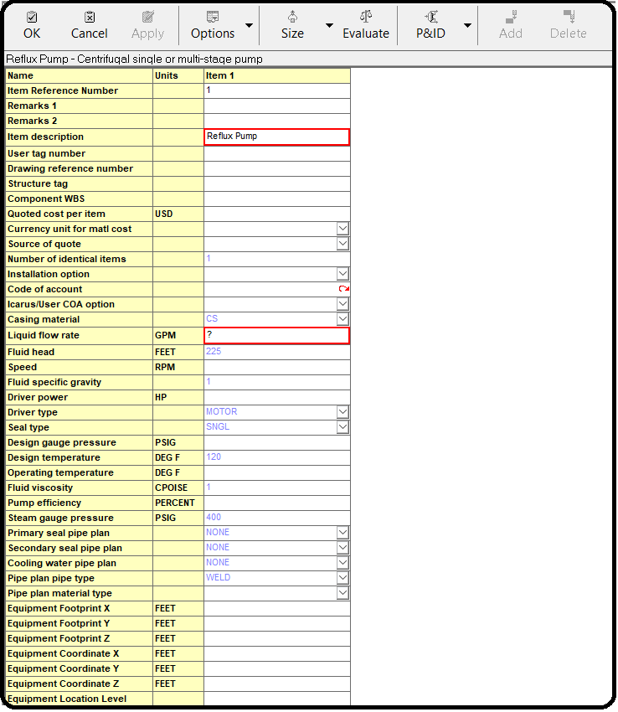

Now, let’s ask the program to compute the cost. Right-click on the pump in the item list, and choose Evaluate Item. ACCE will run something and produce an Item Report. Scroll down to the bottom, and see the equipment summary. You should see something similar to Figure 10.11.

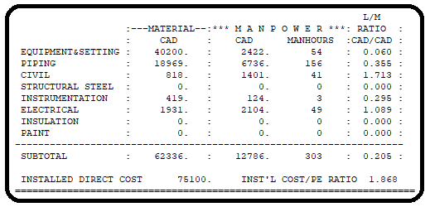

You can see that while the actual pump itself costs $40,200 (CAD), it costs $2,422 to install and required 54 worker-hours4 to do so. Then, there is the piping to connect it to the other parts of the plant, instruments such as flow meters, electrical wiring, and paint. The total material and installation labor cost, also known as the total direct cost, is at the very bottom ($75,100). It is this number that is the most important. It is the number that you’ll pay to have this piece of equipment magically appear in your chemical plant in working order. You’ll see it also back in the main screen, middle column, by selecting the List tab at the bottom.

Similarly, add the remaining equipment, as shown in Figure 10.12: the condenser, reboiler, reflux drum, and distillation column. Use the specifications given in the figure, and leave anything else at their default values.

The trayed tower (DTW TRAYED) model should be used for distillation, which includes the trays but does not include the condenser, reboiler, or reflux pump. It is located at Process equipment | Towers, columns-trayed/packed | Tower-single diameter | Trayed tower. Change the Application to Distillation with kettle reboiler (DIS-RB). For the condenser, you can use a Pre-engineered U-tube exchanger (DHE PRE ENGR). It is located at Process equipment | Heat exchangers, heaters | Heat exchanger | Pre-engineered (standard) U-tube exchanger. The reflux drum is a vertical process vessel (DVT CYLINDER). It is located at Process equipment | Vessel-pressure, storage | Vesselvertical tank | Vertical process vessel. In this case “height” is “Tangent to tangent height.” For the reboiler, use “Kettle type reboiler with floating head” (DRB KETTLE). It is located at Process equipment | Heat exchangers, heaters | Reboiler | Kettle type reboiler with floating head.

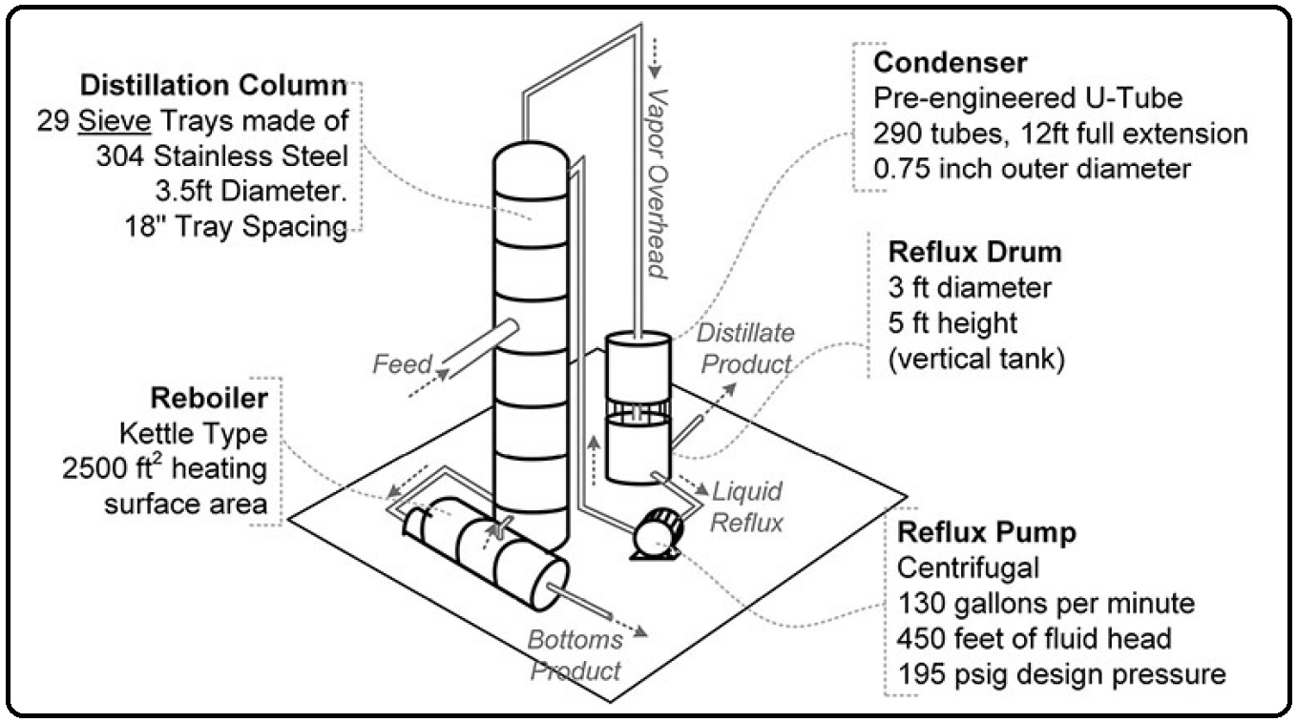

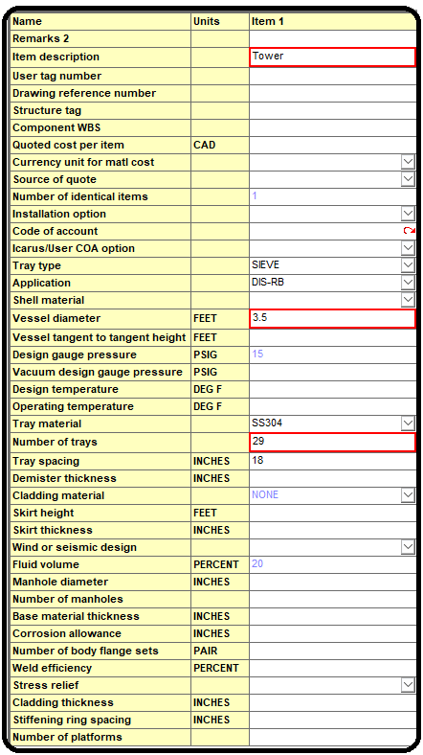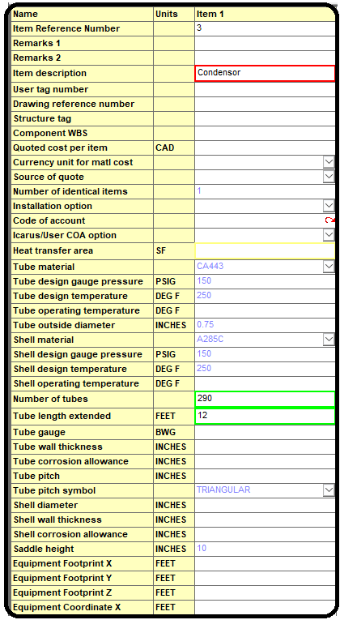

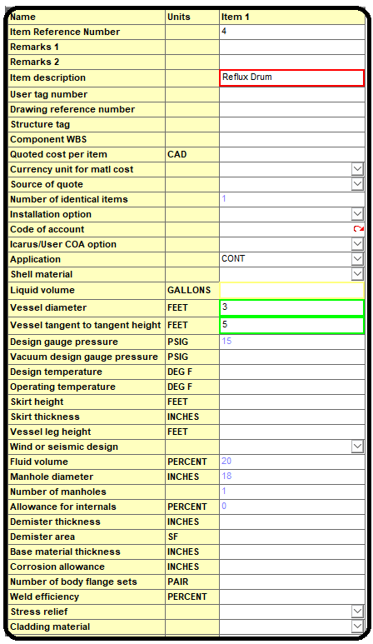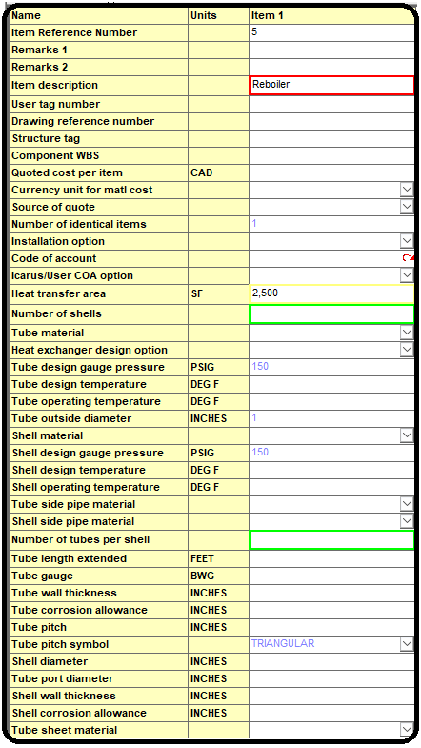

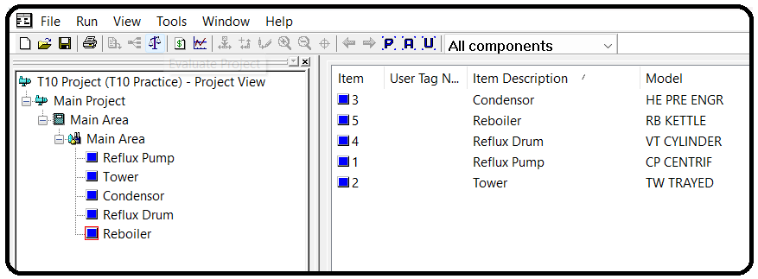Then, once the individual pieces of equipment are added, you can run an economic analysis for the whole plant which uses them. This includes labor, operations, utilities, maintenance, loans, taxes, inflation, and investments. We will not go into this now. We will do one more thing though. Let’s look into the depth of the calculations. When you have finished adding the equipment, click the Evaluate Project button in the toolbar and select Evaluate All Items, and let it do its magic (create a report). Note that you’ll get an error message. It’s okay for now as we are not designing a real plant and didn’t go into a lot of details. Just click continue for the Scan Messages window, and close for the Capital Cost Errors window. A new Report Editor window pops up in which Aspen gives you a suggested build-out plan for your plant containing this equipment (Mine is called CAP_REP.ccp—Report Editor). From the report we can see that Aspen is using vendor quotes from the first quarter of 2019, as shown in Figure 10.13.

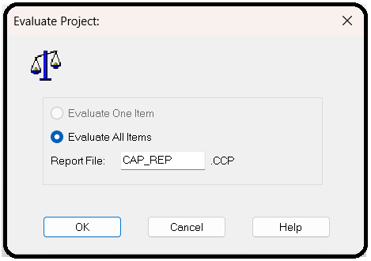

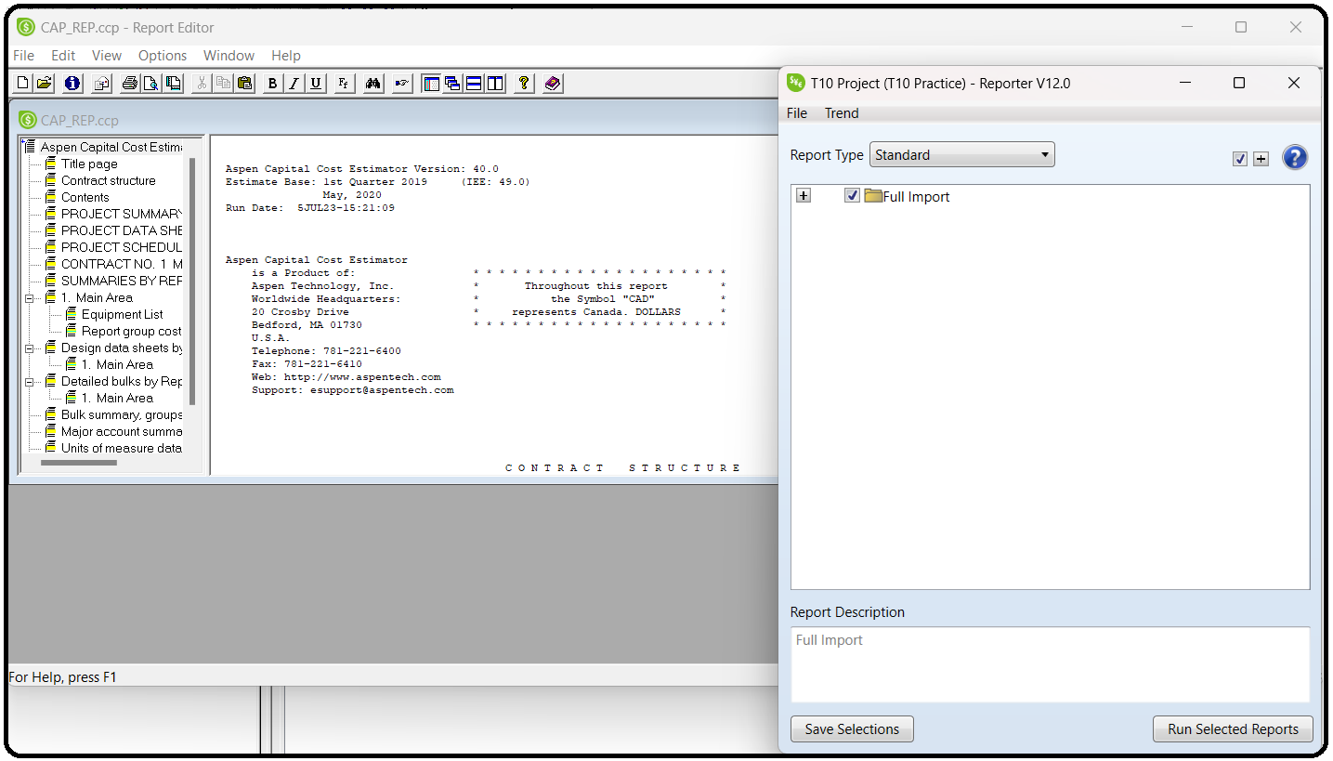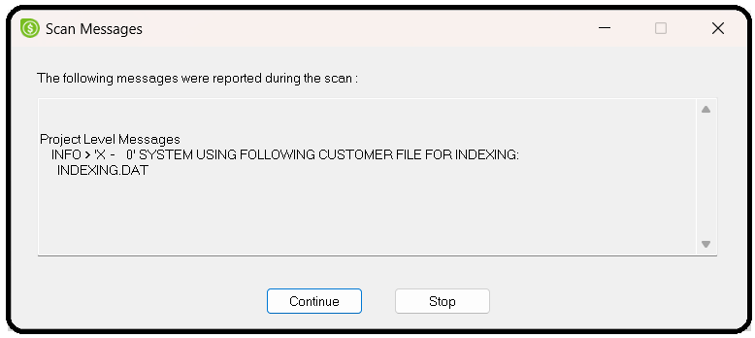

Part 2:

Performing Costing

Run the simulation. You must start with a converged simulation to perform costing. Then Activate costing. This starts APEA in the background.

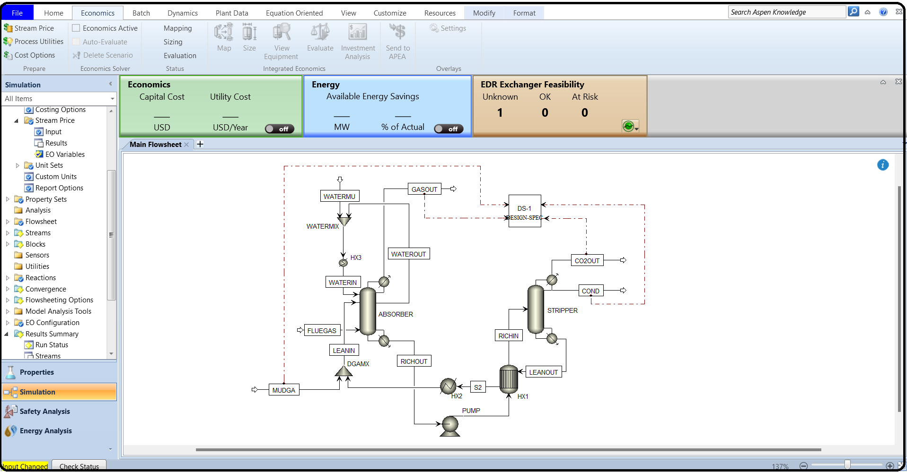Next, you must Map the Aspen Plus unit operation models into equipment models. In this step, Aspen Process Economic Analyzer loads data from Aspen Plus and generates a default mapping for each unit operation model to models of equipment whose cost can be estimated. This mapping may not be one-to-one; in particular, complex models such as distillation columns may be modeled as multiple pieces of equipment. Next, you must Size the equipment, determining appropriate sizes for the equipment based on data from the unit operation models and streams in Aspen Plus. Finally, you must Evaluate the model to determine costs for each piece of equipment.

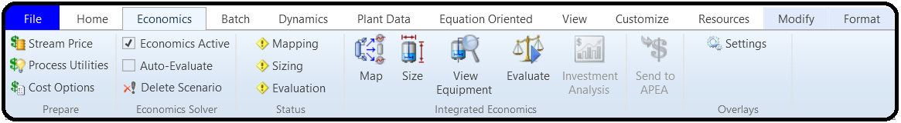Next in ribbon/Economics, check Economic Active like below:

When you click on Mapping the following pops up, proceed like below, so that everything is done manually.

Mapping is the process of associating an equipment model in Aspen Process Economic Analyzer with each.

Use the Map command in the Economics tab of the ribbon to view or modify the mapping of unit operation models from the simulation into equipment models from Aspen Process Economic Analyzer.

On the first screen, choose whether the basis should be the last mapping or the default mapping, and whether to size and evaluate automatically after mapping.

After you click OK, a second screen appears where you can adjust the mapping for each model. On the left, select a unit operation from the flowsheet. In the top right section, select the equipment model to map this unit operation into. Some unit operations map into more than one piece of equipment, and some have multiple configurations you can select in the bottom right section. For some models, diagrams of the different configurations are displayed which you can click on to see a larger version in a separate window. You can also click Add to add additional mappings or Delete to delete a selected mapping.

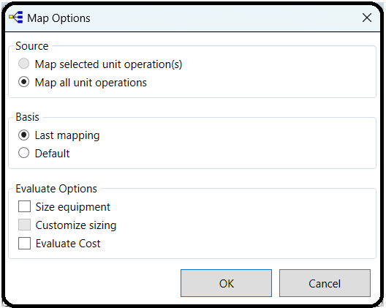

Now click Sizing:

Use the Size command in the Economics tab of the ribbon to have Aspen Process Economic Analyzer estimate the sizes required for equipment based on the simulation data provided. If equipment mapping has not been performed when this command is used, it will be done with the default mappings.

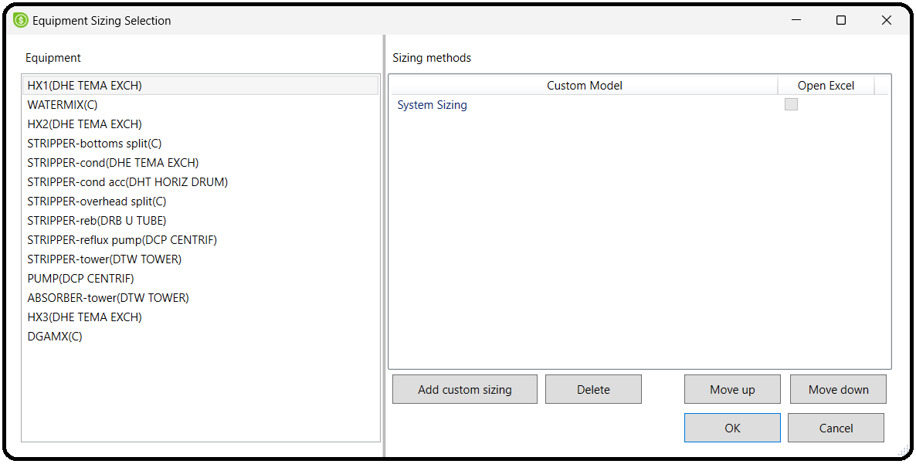You can also size individual equipment items of certain types interactively.

Now click Evaluate:

Use the Evaluate command in the Economics tab of the ribbon to have Aspen Process Economic Analyzer estimate the cost of your plant based on the data provided from the simulation. The results of this calculation are available in the Cost Grid.

If sizing has not been formed when this command is used, it will be performed before evaluating. If equipment mapping has not been performed when this command is used, it will be done with the default mappings.

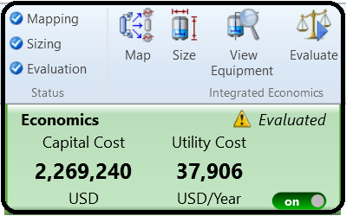

The Status group on the **Economics** tab of the ribbon displays three status indicators:

1.Mapping

2.Sizing

3.Evaluation

Each of these indicators can display these status icons:

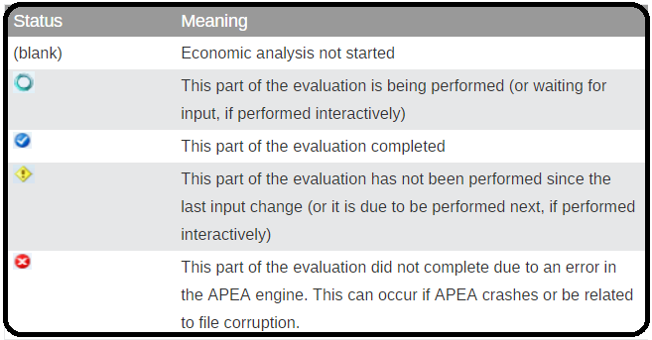

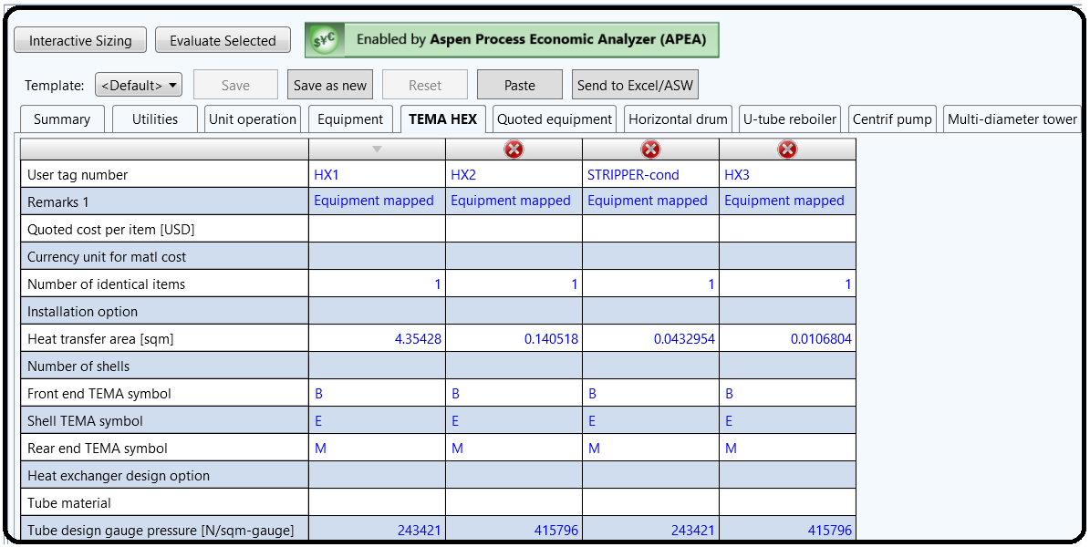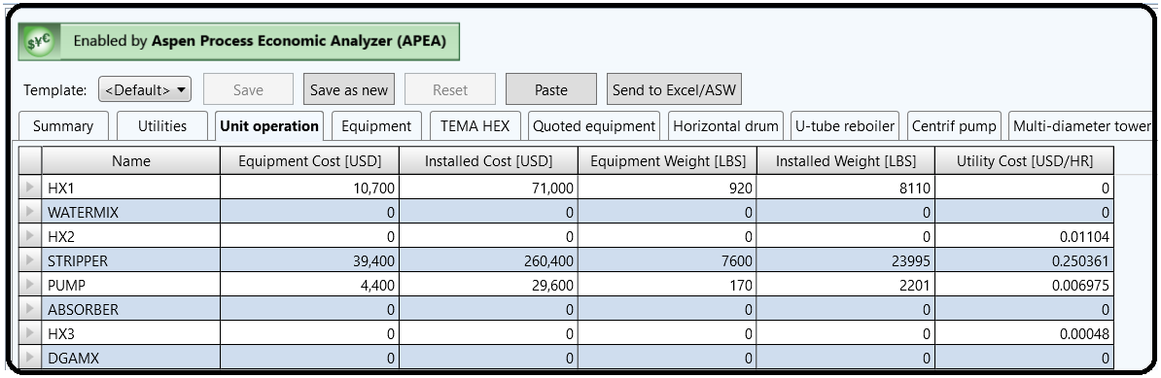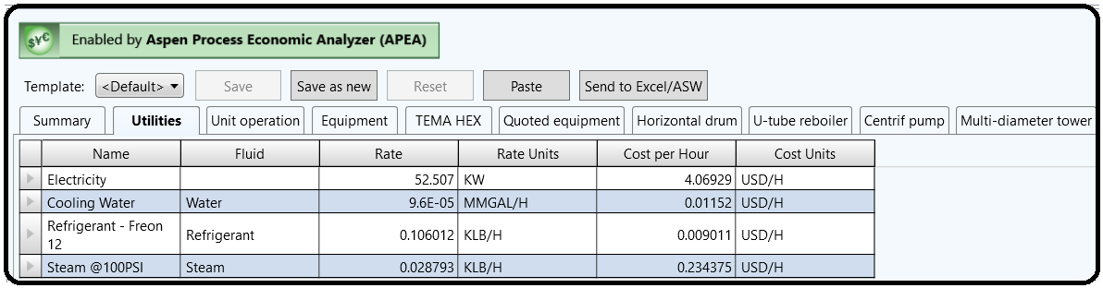Now click on the Economics Ribbon and check the result:

Part 3 :

INTEGRATED ECONOMICS IN ASPEN PLUS

Capital cost estimates can be directly integrated with Aspen Plus V12 in two ways. You can either export an Aspen Plus flowsheet into Aspen Capital Cost Estimator, or you can have capital costs

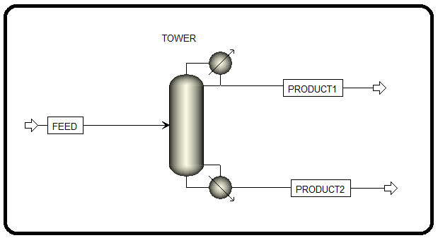predicted right in Aspen Plus itself. We will do the latter briefly here. Figure 10.14 shows a very simple distillation of an 80/20 mixture of ethanol and butanol using an ordinary distillation column. Simulate the column in Aspen Plus using a RadFrac model for the distillation column and NRTL-RK for the property method. Run the simulation first and ensure that it converges correctly.

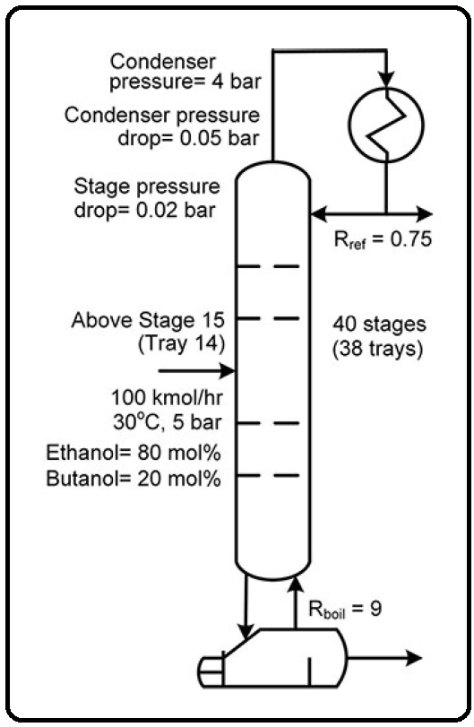

Now let’s make the Economics Active. If you haven’t yet, go to the Economics ribbon and check the box for Economics Active (see Figure 10.15). Then, go to the Cost Options button on the ribbon (or Simulation | Setup | Costing Options). You’ll see that you can enter in some of the basics that you could in Aspen Capital Cost Estimator. So go ahead and change the start of basic engineering to January 1, 2021. Although you have the ability to enter a currency symbol and conversion rate on the Currency tab, it does not get considered in the economic analysis. It will only work in USD (by default) while inside Aspen Plus, or you can select one of the other built-in templates (European Union, Japan, China, the United Kingdom, or the Middle East) by changing the template on the Costing Options tab. To use currencies outside of those options, you should use the stand-alone Aspen Capital Cost Estimator application instead or make the conversion

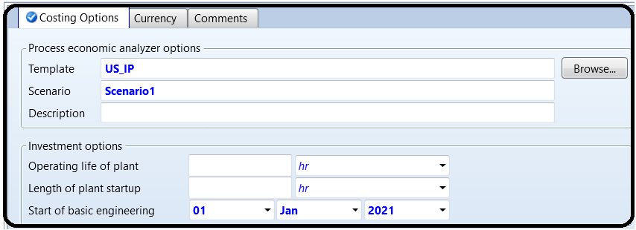from USD to your units after the fact.

At this point, we need to map our simulation models to actual pieces of equipment. For example, our RadFrac model is just a set of equations which can represent many things (adsorption, distillation, extraction, rectification, stripping), so you have to map the simulation equations to a physical piece of equipment (or multiple pieces in this case) in the database. So click Map in the Economics ribbon (you may need to rerun the simulation first). You’ll get a Map Options prompt (see Figure 10.16). In this case, you want to use the Default basis, and you want to size the equipment and evaluate the cost. Sizing the equipment is an important step; it means that your simulation results are used to compute the sizes of the equipment (e.g., the length and diameter of the reflux drum of the distillation column).

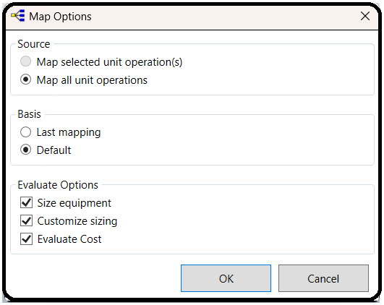

You should see that Aspen Plus maps the column and supporting equipment collectively modeled in the RadFrac block to a Trayed Column (DTW TOWER), a condenser (DHE TEMA EXCH), a horizontal drum (DHT HORIZ DRUM), a centrifugal pump (DCP CENTRIF), two splitters (C),

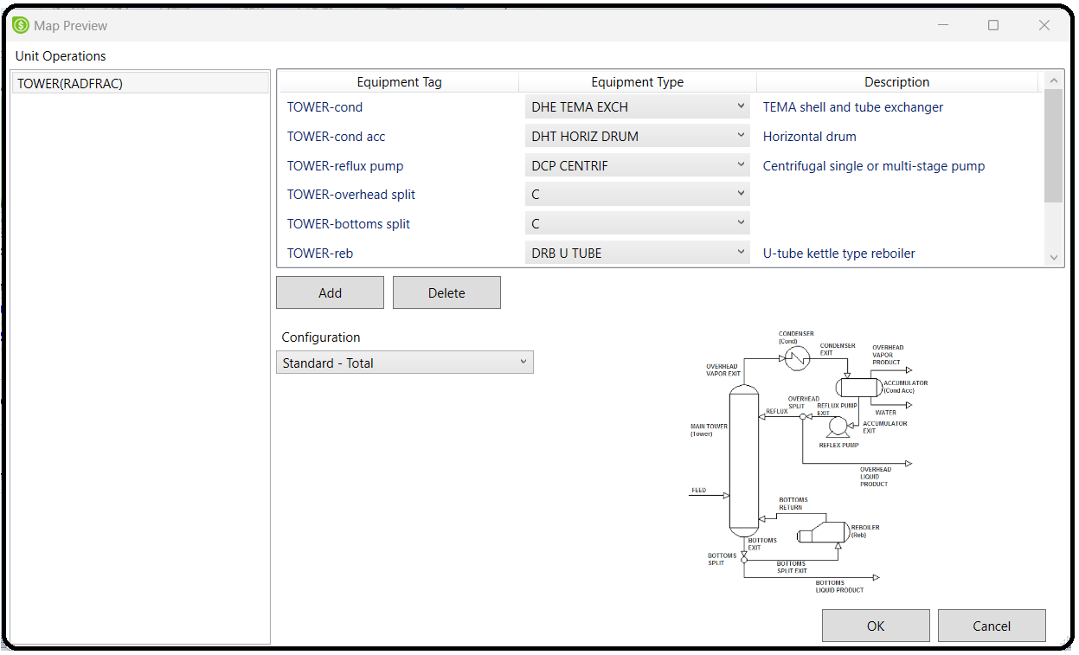and a reboiler (DRB U TUBE). This is the result of the Standard configuration chosen by default (i.e., choosing the Default basis on the Map Options form). Switch to the Full – Split w/Circ. configuration.

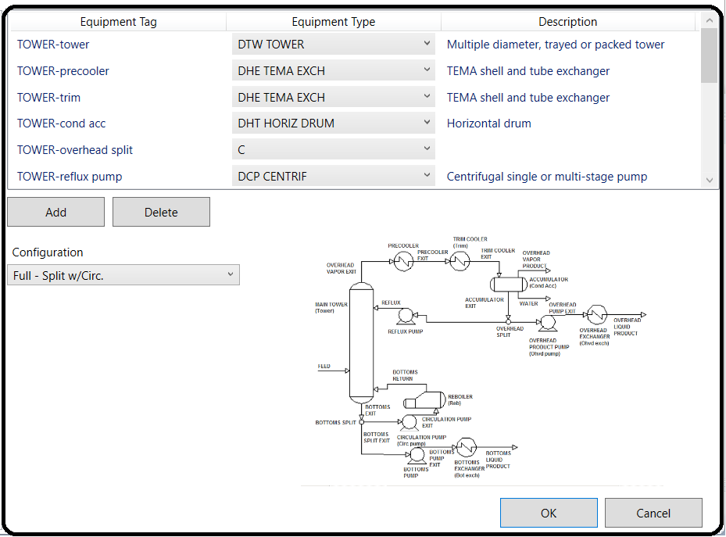

The mapping should then change to include more pumps, pre-coolers, etc. Let’s change the reboiler to a different model. Select the DRB U TUBE item and change it to DRB KETTLE

(Kettle type reboiler w/floating head) by selecting from the list, like was done in Part 1 (see Figure 10.17).

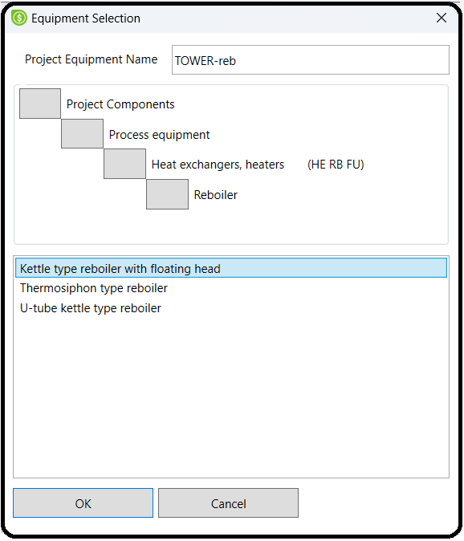

When you are done, click OK on the map preview page. You might get another prompt about custom sizing, if you checked that box by accident. Just leave it and click OK. You should see some familiar prompts. If it works then you should see the items checked in the ribbon, shown in Figure 10.18.

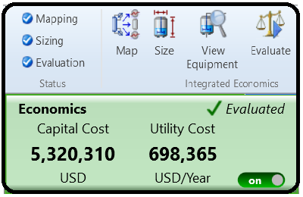

Let’s see the results! Hit View Equipment in the Economics ribbon. Explore the tabs, see what it comes up with and answer the following questions. Note that the Sizing step takes your simulation results and then does more calculations to determine how these translate into physical dimensions, heights, widths, etc.

Rerun the simulation using an inlet flow rate of 200 kmol/hr instead of 100 (doubling the capacity of the system). Then, when that is finished, hit Size in the Economics ribbon to resize everything and be sure to reevaluate the cost as well. Keep the “last mapping,” which means that your reboiler configuration change from DRB U TUBE to DRB KETTLE is remembered from when you did it last time. Confirm that the Full – Split w/Circ. configuration option is still selected (if it isn’t, reselect it).

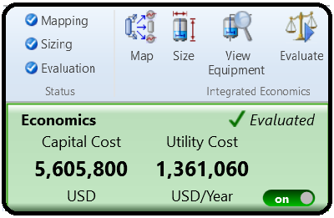

References:

1.Our team experience

2. Learn Aspen Plus in 24 hr. by Thomas A. Adams II

3.Aspen build-in help

4.Aspen build-in templates