Absorber Simulation



Example: In order to eliminate CO2 from a gas stream with flowrate of 300 kmole/hr. and composition of 20 mole% CO2 and 80% methane, a packing column functioning as absorber is used. In this regard, 2000 kmole/hr. pure propylene carbonate is used as solvent. The operating temperature and pressure are 60C and 6090 kPa respectively. Determine the mole fraction of CO2 in outlet gas stream. Use Sour PR as the fluid package.

How to simulate:

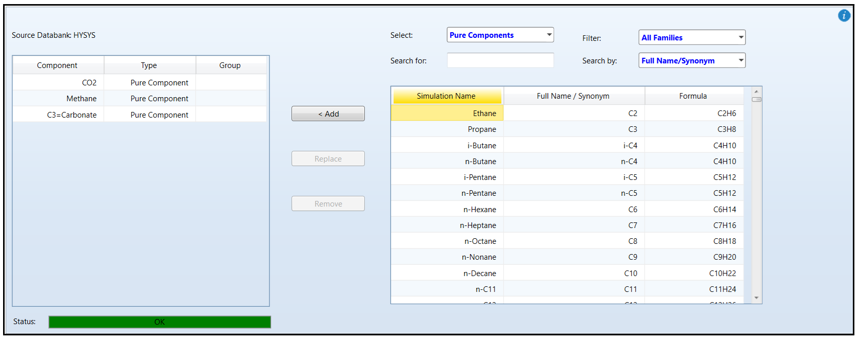1.Add the components to the component list

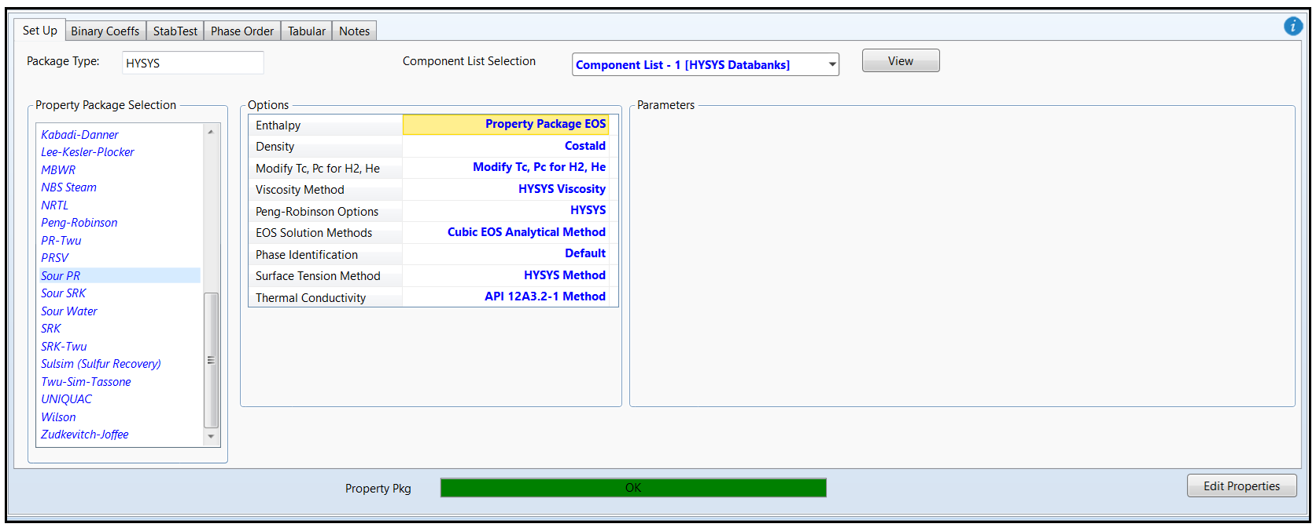2.Select Sour PR as the Fluid Package.

3.Enter Simulation Environment and select an Absorber from Model Pallete/Separator. Define streams Pure Solvent, Inlet Gas, Purified Gas, Impure Gas. Then click Next.

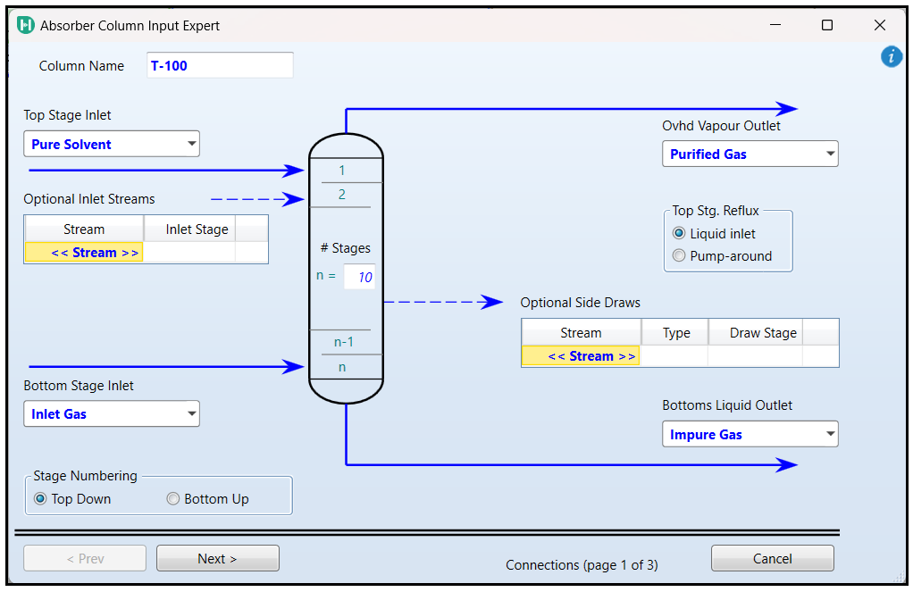

4. Specify the top and bottom stage.

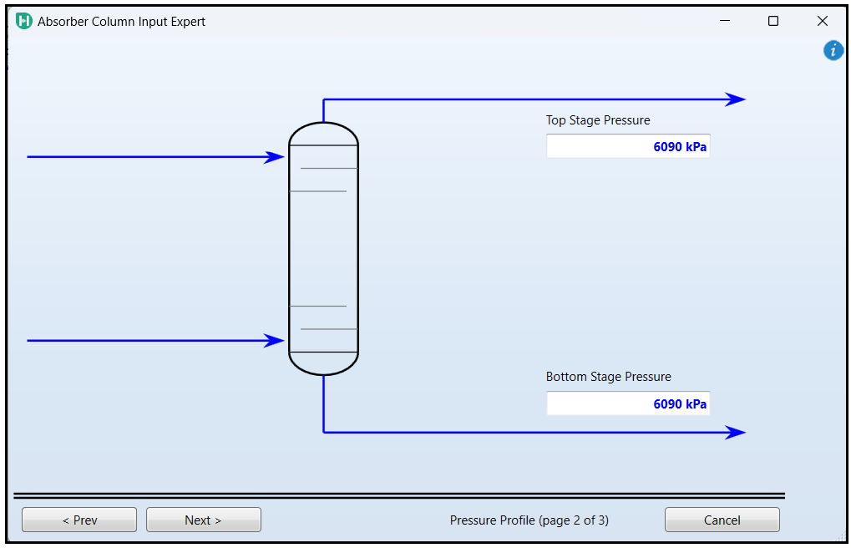

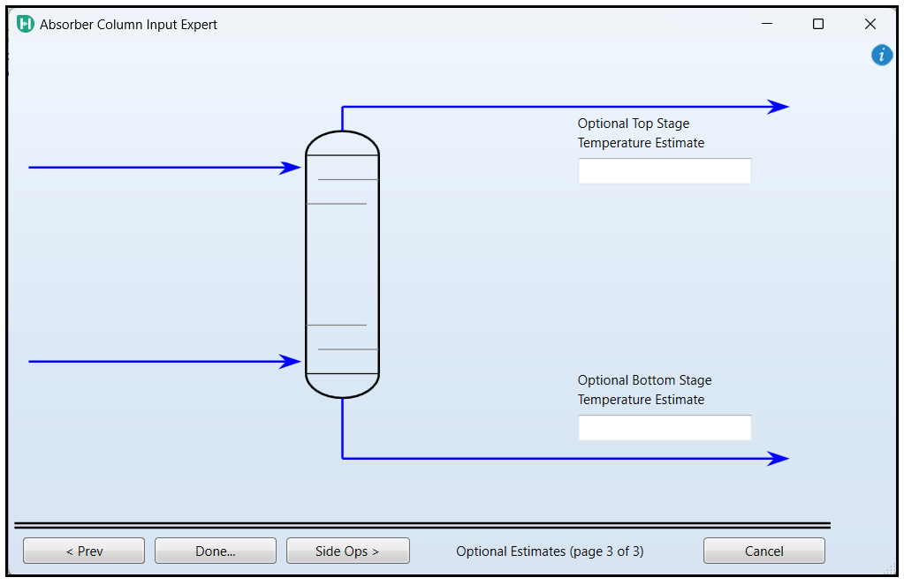5.Let Aspen decide for the page and click Done.

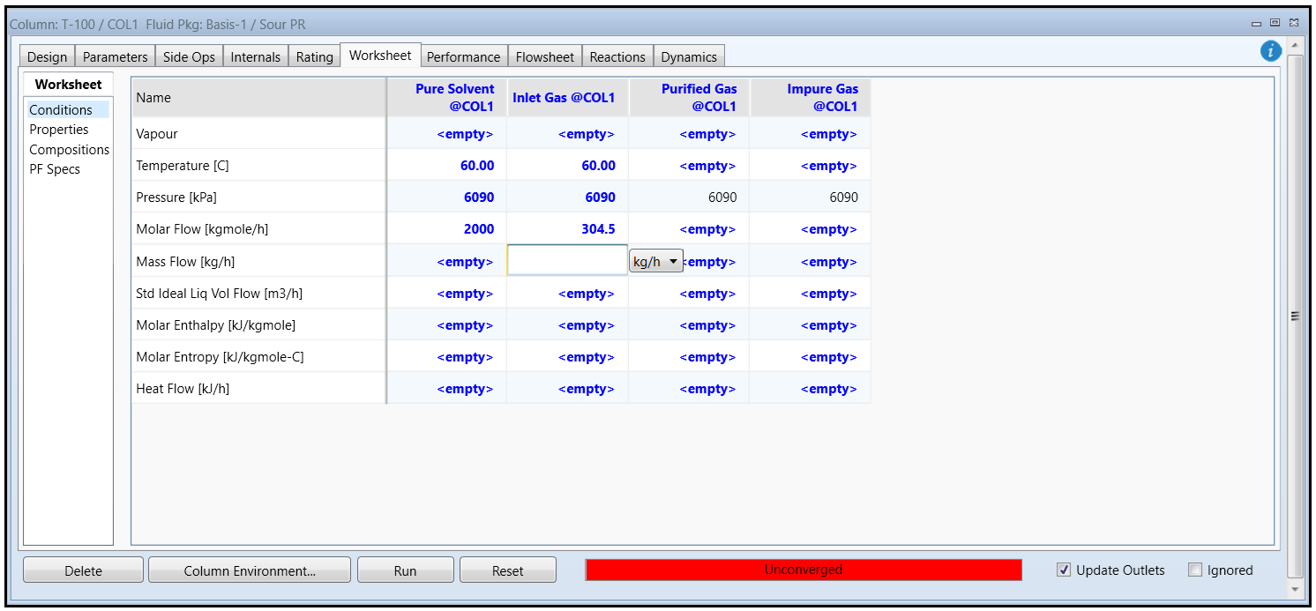6.Now go to Worksheet and provide the operating condition and composition.

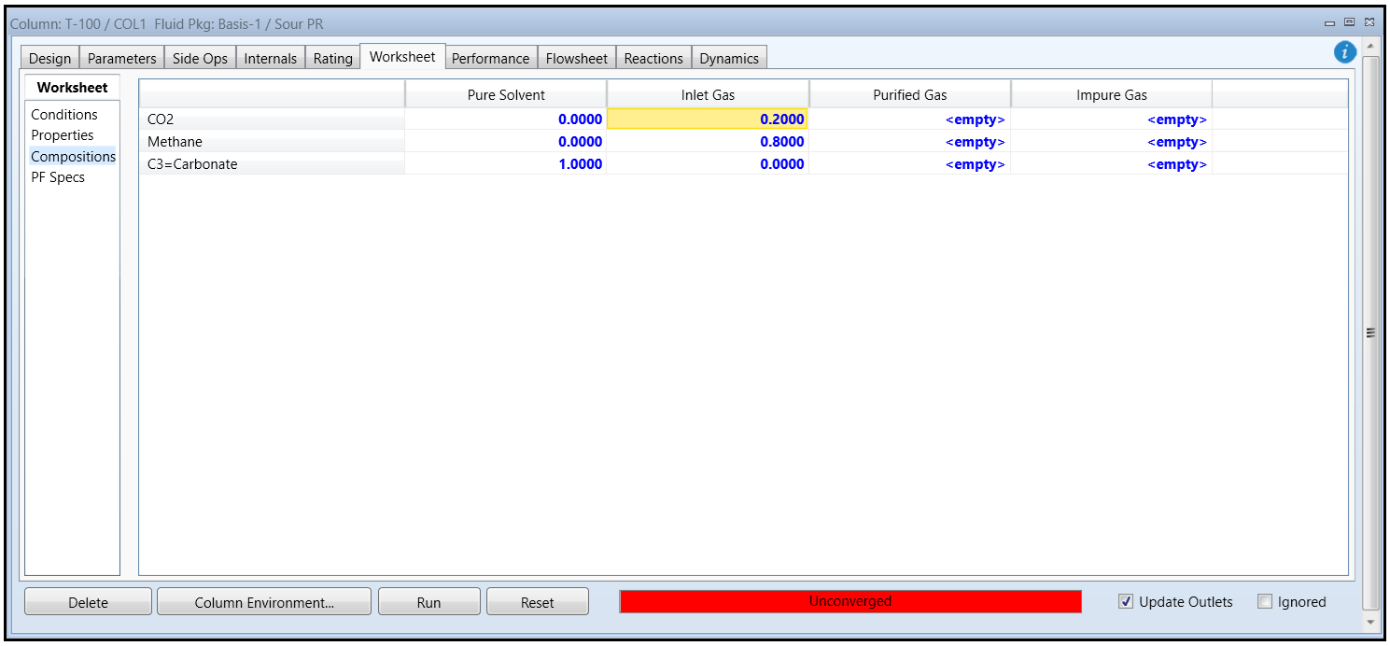

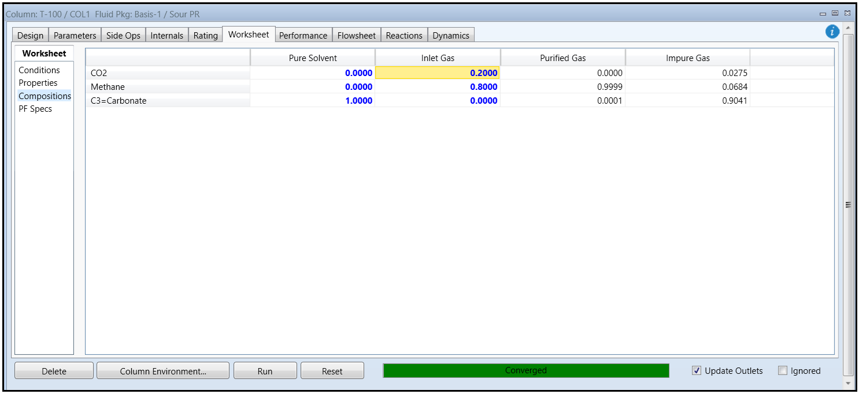7. Results

Based on the results, 99% of purified gas is methane which is our desired objective in the example.

